**Programming for Data Science**

**Lab DA 1**

**Lab Slot: L33 & L34**

**Name: Tejas Rahul Rokade**

**Reg. No.: 20BDS0033**

**Questions:**

1. Print Hello World

2. Input a number from prompt

3. Input two vectors and perform following operations a. Arithmetic Operators (+, -, *, /, %%, %/%, ^) b. Relational Operators (, <=, >=, ==, !=) c. Logical Operators (&, |, !, &&, ||, ) d. Assignment Operators (left assignment, right assignment) e. Miscellaneous Operators (:, %in%, , %*%)

4. Read a number and check whether it is odd or even (if…else)

5. Read the mark of a student and print his /her grade (if…else…if)

6. Design an arithmetic calculator (switch)

7. Find the factorial of a number (for)

8. Check the number is Armstrong number (while)

9. Print natural numbers till their sum reaches 100 (repeat)

10. Familiarize the use of break and next using sample code

Question 1:

Code:

print("Hello World")

Output:

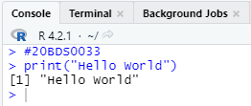

Question 2:

Code:

a = as.integer(readline())

print(a)

Output:

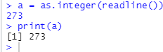

Question 3:

Code:

a = as.integer(strsplit(readline(), " ")[[1]])

b = as.integer(strsplit(readline(), " ")[[1]])

a + b

a - b

a * b

a / b

a %% b

a %/% b

a ^ b

a < b

a > b

a <= b

a >= b

a == b

a != b

a & b

a | b

!a

a && b

a || b

a[2:4]

Output:

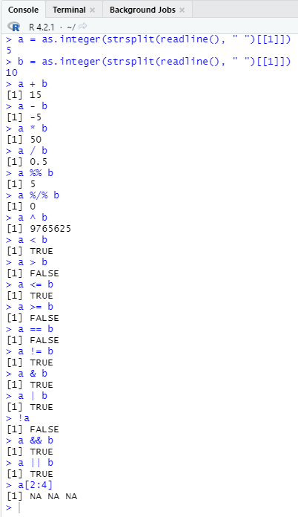

Question 4:

Code:

x = as.integer(readline())

if (x %% 2 == 0){

print("Even")

} else{

print("Odd")

}

Output:

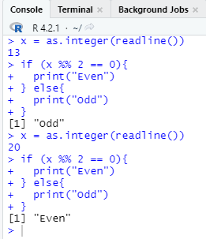

Question 5:

Code:

mark = as.integer(readline())

if(mark > 90){

print('S')

}

else if (mark > 80){

print('A')

}

else if (mark > 70){

print('B')

}

else if(mark > 60){

print('C')

}

else {

print('D')

}

Output:

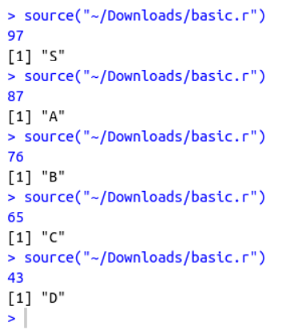

Question 6:

Code:

add <- function(x, y) {

return(x + y)

}

subtract <- function(x, y) {

return(x - y)

}

multiply <- function(x, y) {

return(x * y)

}

divide <- function(x, y) {

return(x / y)

}

print("Select operation.")

print("1.Add")

print("2.Subtract")

print("3.Multiply")

print("4.Divide")

choice = as.integer(readline(prompt="Choice: "))

num1 = as.integer(readline(prompt="Enter first number: "))

num2 = as.integer(readline(prompt="Enter second number: "))

operator <- switch(choice,"+","-","*","/")

result <- switch(choice, add(num1, num2), subtract(num1,num2), multiply(num1, num2), divide(num1, num2))

print(paste(num1, operator, num2, "=", result))

Output:

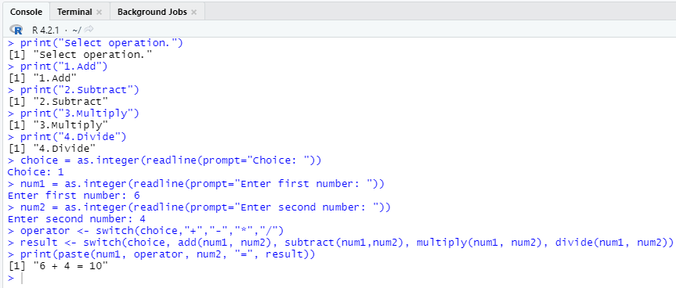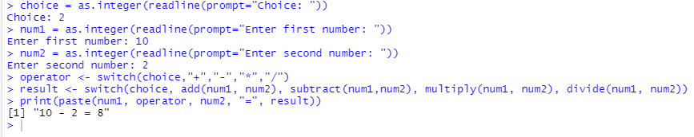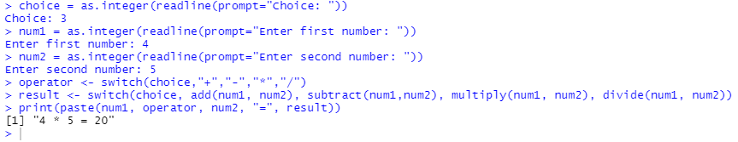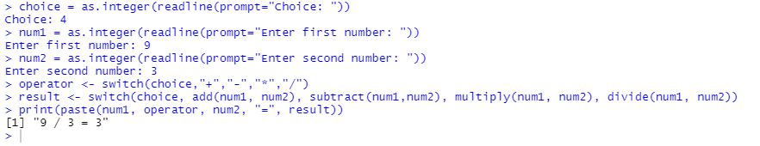

Question 7:

Code:

x = as.integer(readline())

fact = 1

while(x > 0){

fact = fact * x

x = x - 1

}

print(fact)

Output:

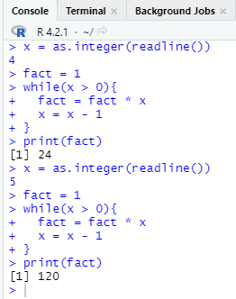

Question 8

Code:

n = 0

x = as.integer(readline())

c = x

d = 0

while(x > 0){

x = as.integer(x / 10)

d = d + 1

}

d

x = c

while(x > 0){

dig = x %% 10

n = n + dig ^ d

x = as.integer(x / 10)

}

if(c == n){

print("Armstrong")

} else{

print("Not Armstrong")

}

Output:

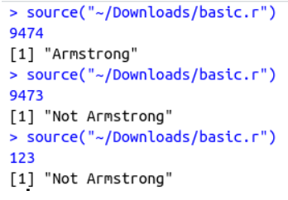

Question 9

Code:

sum = 0

i = 1

repeat{

print(i)

sum = sum + i

i = i + 1

if(sum >= 100)

break

}

Output:

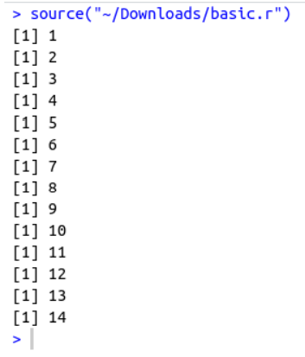

Question 10

Code:

= 1

for(i in 1 : 10){

if(i %% 2) print(i)

if(i == 8) break

else next

}

Output:

