**CAR RENTAL SYSTEM**

**PROJECT SYNOPSIS**

**BACHELOR OF TECHNOLOGY**

Computer Science and Engineering

SUBMITTED BY

Tejas Shinde (C24)

Akshata Mandalik (C29)

Adarsh Chougale (C30)

December 2020



GUIDE NAME

Mr. S.N. Palkar

**DEPARTMENT OF COMPUTER SCIENCE AND ENGINEERING**

**Kolhapur Institute of Technology’s**

**College of Engineering (Autonomous), Kolhapur**

**Academic Year 2020-21**

**Introduction:**

Car Rental System is based on a concept to rent cars and generate rental invoice of a rental company. Before stepping into the main system a user has to pass through a login system to get access then only the user can select cars with a different model and rent for certain days. This project contains limited features, but the essential one.

**1.1 Purpose**

* The system helps to maintain all details of the customers details, vehicle details, booking detail.
* Those people cannot by a car, so they can rent a car.

**1.2 Scope**

* The involes a very simple registration procedure to be done by the admin or the system manager.
* Provide car catalog for users as an alternative for them to select car if they want to choose car by their own.

**1.3 Definations, Acronyms, and Abbreviations**

SRS – Software Requirements Specification

CRS – Car Rental System

Subject satisfication - The overall satisfication of the system

End users – The people who will be actually using the system

**1.4 Overview**

Talking about the features of the Car Rental System, after logging in as a user he/she has to provide a name then the user can select available cars. After selecting a car, the system displays selected car details which contain maximum power, mileage and many more. Then user has to provide the information such as number of days to rent the cars. After all these procedure, the system calculates rent and displays customer’s name, car model, number of days and total rent amount .

**2 . The Overall Description**

**2.1 Product Perspective**

**2.1.1 Existing system function:**

A car rental system is a system where you can the transportation services temporarily, i.e. for a period of time with a fee. Renting a car assists people to get around even when they do not have access to their own personal vehicle or don't own a vehicle at all. The individual who wants to rent a car must first contact the car rental company for the desired vehicle. At this point, this person has to provide information such as; date of rental, and type of car and the services they wish to obtain from the system. After these details are worked out, the individual, renting the car must go under a valid Identification process.

Most companies throughout the industry makes a profit based on the type of cars that are rented. The rental cars are categorized into economy, compact, compact premium, premium and luxury. And customers are free to choose any car of their choice based on their purse and availability of such car at the time of reservation.

Car Rental System gives car rental service for local customers. The organization uses a manual system for reserving, renting, register and to keep record of all the rental activities and customer information. The detailed existing system functions are listed as follows -

* During car reservation the customers reserve a vehicle by making a phone call to the organization; otherwise he/she is expected to go to the organization to make reservation.
* During renting a car the customer’s personal information, payments status and rent agreements are filled in the car rent agreement form in order to hold legal contract between the customer and organization for renting the vehicle.
* The organization makes a general report about the rented cars once at the end of the month and generates a report.

**2.1.2 Product functionality:**

**2.1.2.1 Car Rental Management:**

The car rental system provides a car catalogue for the customers to select a car they want.

**2.1.2.2 Checking For Availability:**

Employee should check for the availability of the car. He/she maintains the daily records of vehicles. If there is no car is available, it is the responsibility of the employee to provide alternative options .

**2.1.2.3 Payment system:**

The payment system depends on the business policy that the management holds. We can choose one of a few options:

* Per Day

**2.1.2.4 Maintenance Manager:**

If any car requires maintenances like repair or replacement of any parts, then maintenance manager maintains the records about the particular requirement.

**2.3 Users and Characteristics**:

2.3.1 Admin:

* Admin can login/sign-up in the system.
* Verify the car information database.
* Generate price strategy.
* Handle the payment system.
* Finalize the order.
* Cancel the order.

2.3.2 Employee:

* It updates the database(information of the vehicles and the service that the system provides)
* Give information to the customer about the car.
* Provides the alternatives.
* Maintain contacts.

2.3.3 Maintenance Manager:

* It checks for the maintenance.
* Give to the maintenance.
* Give information to the admin.
* Update the database.

2.3.4 Customer:

* Customers can login/sign-up in the system.
* Place the order.
* Cancel the order.

**3.Specific Requirements**

**3.1External Interfaces**

**User Interfaces:**

* **LOGIN- Log into the system or sign-up and create an account.**
* **SELECT YOUR CITY- The city or area where the customer needs the rental car.**
* **START DATE/END DATE- The dates as to when the customer needs the car and till when (total hours/days)**
* **CHOOSE YOUR PLAN- The customer is open to many new options related to vehicle with interesting plans**
* **PAYMENT- Both options are open to the customer, i.e. cash or net banking.**
* **FEEDBACK- Honest review every from customer is taken at the end of their service that they opted to improve our quality.**

**3.1.2 Software Interfaces**

Windows 7,8,10. ; Code Block

**3.1.3 Hardware Interfaces**

The system shall run on Microsoft based system.

**3.1.4 Communication Interfaces**

This is a manually operated system with human to human communication

**4.2 Functional Requirements:**

These are statements of services the system should provide, how the system should react to particular requirements of the customer, and how the system should behave in particular situations.

**4.2.1 Reservation:**

* The system must allow the customer to register for reservation.
* The system shall allow the customer to view detail description of particular car.
* The system must notify on selection of unavailable cars while reservation.
* The system must allow the customers to select specific car using different search category while reservation.
* The system must view list of available car during reservation.

**4.2.2 Log in/Sign-up:**

* The system should allow admin to login/ Sign-up to the system using their Phone no. and password.
* The system shall allow the admin to create new user account.
* The system shall allow admin to change account password.

**4.2.3 Car:**

* The system shall allow customer to select cars in the list.
* The system shall allow staff to Search cars by specific record.

**4.2.4 Rent:**

* The system shall allow staff to register customers into rental list.
* The system shall allow staff to update about customer rent record details in the rental list.
* The system shall be able to save all changes made on the customer rent list.

**3.3 Nonfunctional Requirements**

Non-functional requirements, as the name suggests, are requirements that are not directly concerned with the specific services delivered by the system to its users. They may relate to emergent system properties such as reliability, response time, and store occupancy**.**

**Usability:**

The user can ask the system for support**.**

**Security:**

The system provides username and password to prevent the system from unauthorized access. The staffs’ password must be greater than eight characters. The subsystem should provide a high level of security and integrity of the data held by the system.

**Performance:**

Performance requirements define acceptable response times for system functionality.

**Availability:**

The system should always be available 7 days a week.

**Multi-language support**

Our rental management is compatible with multiple languages that enable users to use the application with ease. Having system in multiple languages is a delightful way to attract more customers **.**

**Calendar options**

Let your customers know the availability of yours rentals. Rental owners can choose their available dates from the calendar option to offer booking experience.

**Ratings and reviews**

Rating and reviews are important tooltips for any business. Customers can make a better buying decision based on the reviews. So, we are equipped with a better review management system.

**6.Supporting Information**

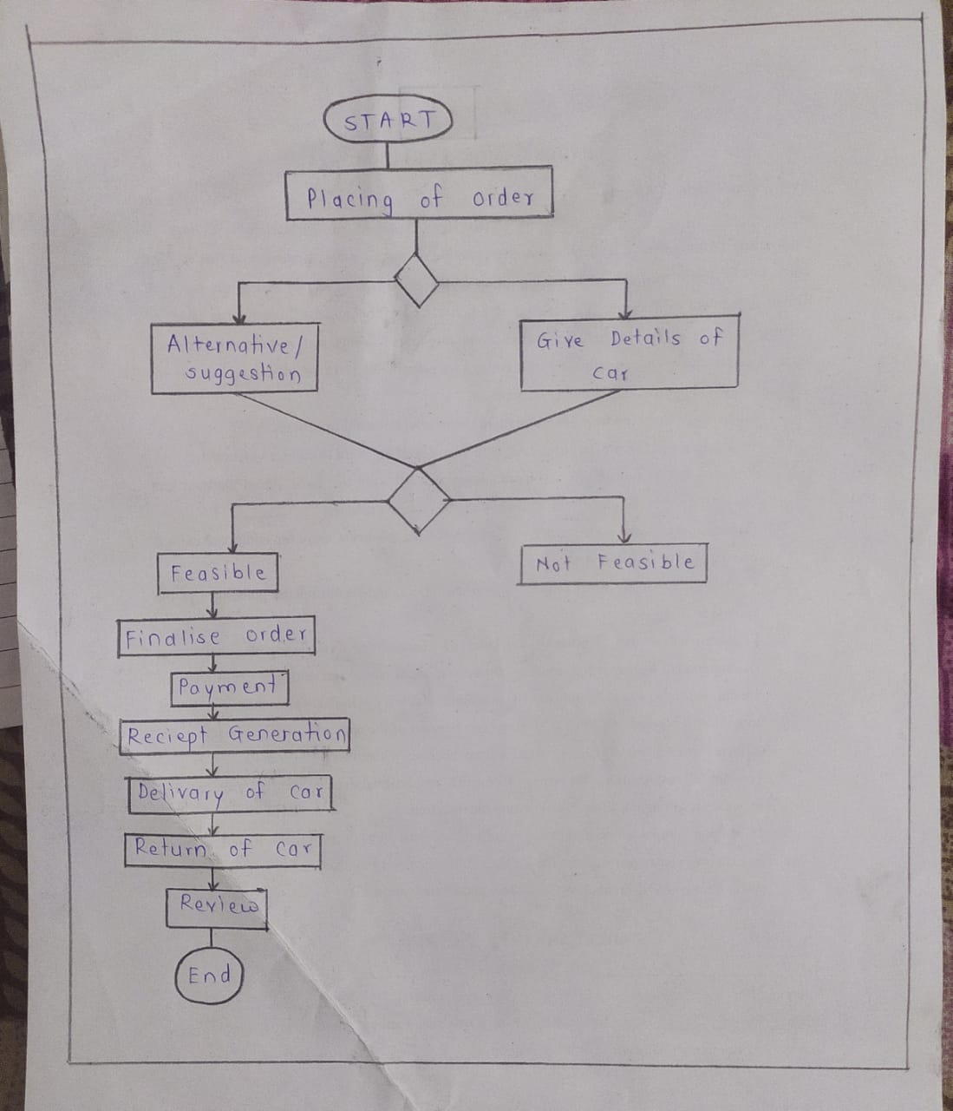

**7.Conclusion**

Aim to provide a very users-friendly customer registration system who want to take car for rent.

**References:**

1. https://en.wikipedia.org/wiki/Car_rental
2. https://www.altexsoft.com/blog/car-rental-reservation-system/
3. https://www.flightslogic.com/car-rental-system.php