A Project Report On

**NET CAFÉ NETWORK DESIGN**

Submitted

In Partial Fulfillment of Requirement

For the

Second Year B.Tech of CSE

Under the subject

PBL in Computer Network Lab

By

Tejas Shinde C24

Akshata Mandlik C29

Adarsh Chougale C30

**Under the Guidance of**

Mr. S. S. Palkar



**Department Computer Science and Engineering**

**KIT’s College of Engineering (Autonomous), Kolhapur**

**SEM: IV A.Y. : 2020-2021**

**Acknowledgement**

We are highly grateful to the Dr. Mamata Kalas, HOD CSE, KIT’s College of Engineering, Kolhapur, for providing this opportunity to carry out the PBL at CSE department. We would like to express our gratitude to other faculty members of CSE department for providing academic inputs, guidance and encouragement throughout this period. We would like to express a deep sense of gratitude and thank to Dr. Mamata Kalas and Mr. S. S. Palkar without whose permission, wise counsel and able guidance, it would have not been possible to carry out our project in this manner. We would also like to thank our client Mahalaxmi Net Café ,Mauli Computers who gave us chance to utilize our knowledge and perform our computer network PBL project.

Finally, we express my indebtedness to all who have directly or indirectly contribute to the successful completion of our PBL.

**Table of Content**

**Sr. No. Content Page No.**

1. Introduction
   * + - 1. Problem Statement
         2. Project purpose

2. Charactertcies

3. Network Design

4. Literature Review

5. Requirements

6. Proposed Work

7. Cost Estimate

8. Advantages

9. Disadvantages

**1.Introduction**

In this project , We are going to design net café network design. In this we have to work on local area netwok . In this project we have to include 10 computers, 2 switches, 1 Router and 1 Printer devices according to client need and these devices will be connected through Ethernet cables.

* 1. **Problem Statement**

Analyze the net café network design and improve structure according with client need.

* 1. **Project Purpose**

To provide suitable network design according to client need. To provide reliable communication between devices which are connected in this network.

**2.Charactertics**

➢Internet cafes offer the use of computers with high bandwidth internet access on the payment of a fee.

➢Usage is generally charged by the minute or part of hour.

➢An internet cafe will generally also offer refreshments or other services such as phone repair.

➢Internet cafes are often hosted within a shop or other establishment.

➢ They are located worldwide, and many people use them when traveling to access webmail and instantmessaging services to keep in touch with family and friends.

➢In many developing countries Internet cafes are the primary form of Internet access for citizens as a shared-access model is more affordable than personal ownership of equipment and/or software.

➢Internet cafés are a natural evolution of the traditional cafe. Cafes started as places for information exchange, and have always been used as places to read the paper, send postcards home, play traditional or electronic games, chat to friends, find out local information.

**3**. **Network Design**

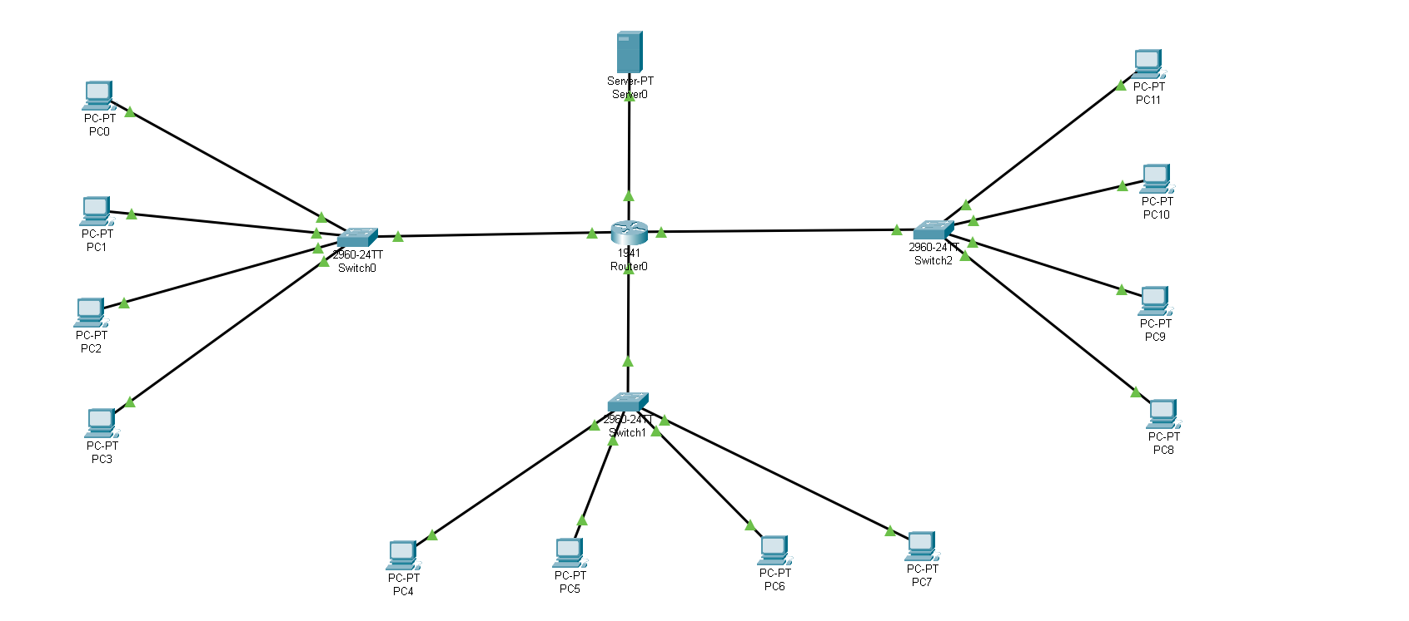

**4. Literature Review**

1. Internet Café are the primary form of internet access for citizens as a shared access model is more affordable than personal ownership of equipments .

2. We are working on local are network. Using hub , routers ,switches and pc’s.

3.We provide an ip address and connect the pc’s. Pc’s required are corei3, 4GB/8GB RAM intel processor , Windows 10, 1.5 graphics card.

4.Internet provide by BSNL Ethernet . Internet service provider provides BSNL speed-250 mbps/jio -186 mbps.

5.Fiber optics cables are used for best speed. We can charges on the customers as per the hour (like 30 rupees).

6.Suppose any one can download , then extra charges for their.

**5.Requirements**

**Router**

A router is a networking device that forwards data packets between computer networks. Routers perform the traffic directing functions on the Internet. When a data packet comes in on one of the lines, the router reads the network address information in the packet header to determine the ultimate destination.

**Switches**

A switch is a device in a computer network that connects other devices together. Multiple data cables are plugged into a switch to enable communication between different networked devices.Switches may also operate at higher layers of the OSI model, including the network layer and above.

**Printers**

A printer is a device in a computer network that connects other devices to print a document form connected computers.

**Personal Computer**

These are Minimum requirements

* Core i3
* 4/8 GB RAM
* Intel Processor
* Windows 8/10
* 1.5 Graphic Card

**6.Proposed Work**

1.We have to work on local area network. We have 1 router , 1 printer and 2 switches.

2 .1 Router is connected to 2 switches and that 2 switches connected to all 10 computers. Printer is connected to switch.

3. We can connect switch to pc’s through ip address . Internet provided by Ethernet **.**

**Dividation of bandwidth**

1.Speed of internet- 250 mbps then the speed internet is divided by the no of pc’s present in internet café.

2.Suppose their are 5 pc’s then we have to divide 250 mbps by 5(i.e no of pc’s) then we get the actual speed of internet in mega byte per second (50 mbps)then we have to convert into mega bit per second for that we have to divide 50mbps by 8 (1byte=8bits) At last we get 6.2 MBps speed to each pc’s.

**7.Cost Estimate**

**Routers**

1. TP-Link TL-WR845N Wireless N 300 mbps Router = $1199

2.TP-Link TL-R470T+ Load Balance Router = $2400

Finalised Router : TP-Link TL-WR845N

**Switch**

1.tp-link (TL-SF1008D) = $1000

2.tp-link (TL-SF1005D) = $560

Finalised Swtich : tp-link (TL-SF1005D)

**So Final Cost is Router($1199)+Two Switch($560*2) = $2319**

**8.Advantages**

**1.Comfort and Convenience**

Most Internet cafes are not as comfortable as your own home. The cafe could be crowded, smoky or have uncomfortable seats, making it difficult to patronize the cafe for hours on end. Most Internet cafes in the West are not open 24 hours, which limits your time for work or recreation. Downloads might be restricted to preserve bandwidth.

**2.Cost**

The cost of Internet at cyber cafes is relatively low and varies between countries. Most places charge hourly, though some offer a one-time purchase fee. If you are traveling, purchasing an hour at an Internet cafe to write home is significantly cheaper than paying for a monthly satellite fee. As Wi-Fi grows in abundance, more businesses are offering free Internet access to attract customers.

**9.Disadvantages**

**1.Business works 24/7.**

In practice this means that as an entrepreneur you have to be constantly in touch to solve problems that may arise (e.g., violation of the rules by clients, various unforeseeable situations etc.) At least in the beginning you need to be fully involved in order to understand the specifics of the business, the target audience, identify weak spots etc. It is also necessary to be aware of the latest innovations in the field of gaming and eSports.

**2.It is difficult to scale the business.**

Internet cafe business has its limits. Once a company is launched, pays back and starts to bring net profit, there are just a couple of options to scale:either to sell franchises or open a network of Internet cafes. You can establish a business and get a stable income, yet it will always remain at the same level.

**3.Regular update/replacement of equipment.**

Each product has its life cycle. Since computers in Internet cafes are used constantly, their wear and tear happens way faster. Besides regular maintenance, cleaning, and minor repairs of the computers, it is necessary to completely replace the equipment every 2-4 years. First of all, because of its wear and secondly, due to outdated parameters. Every year new games are released, increasing the requirements to the computer components processor, video card, memory etc. Fast and powerful computers are one of the reasons why gamers visit cyber cafes. Thus, if you do not update the equipment, you risk to lose part of the target audience.

**THANK YOU**