Name : ______________________________   
Seat No : ______________

**Paper IV(**Robotics and Artificial Intelligence **)**

|  |  |  |  |  |
| --- | --- | --- | --- | --- |
| **INDEX** | | | | |
| **NO** | **DATE** | **TITLE** | **PAGE NO** | **SIGN** |
|  | | | | |
| 1 |  | Write a program to create a robot  (i) With gear  (ii) Without gear  and move it forward, left, right |  |  |
| 2 |  | Write a program to create a robot with a two motor and move it forward, left, right |  |  |
| 3 |  | Write a program to do a square using a while loop, doing steps with a for loop, to change directions based on condition, controlling motor speed using switch case, |  |  |
| 4 |  | Write a program to create a robot with light sensors to follow a line |  |  |
| 5 |  | Write a program to create a robot that does a circle using 2 motors |  |  |
| 6 |  | Write a program to create a path following robot |  |  |
| 7 |  | Write a program to resist obstacles |  |  |
| 8 |  | Write a program to implement Torch following robot |  |  |

**Practical no. 1(a)**

import ch.aplu.robotsim.*;

class MoveWithGear

{

MoveWithGear()

{

NxtRobot robot=new NxtRobot();

Gear gear=new Gear();

robot.addPart(gear);

gear.forward(400);

gear.setSpeed(30);

gear.left(800);

gear.forward(200);

gear.right(480);

robot.exit();

}

public static void main(String args[])

{

MoveWithGear m=new MoveWithGear();

}

}

**Output:**

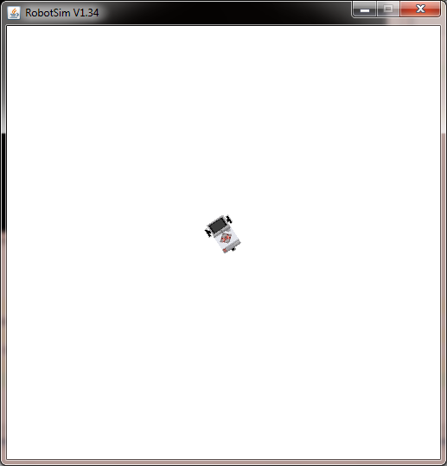

**Practical no. 1(b)**

import ch.aplu.robotsim.*;

class MoveWithoutGears

{

MoveWithoutGears()

{

TurtleRobot robot=new TurtleRobot();

robot.forward(100);

robot.left(45);

robot.forward(200);

robot.right(90);

robot.backward(100);

robot.exit();

}

public static void main(String args[])

{

MoveWithoutGears m=new MoveWithoutGears();

}

}

**Output :**

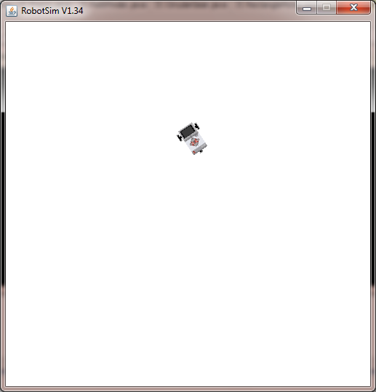

**Practical No. 2**

import ch.aplu.robotsim.*;

public class MoveWithMotors

{

public MoveWithMotors()

{

NxtRobot robot=new NxtRobot();

Motor motA=new Motor(MotorPort.A);

Motor motB=new Motor(MotorPort.B);

robot.addPart(motA);

robot.addPart(motB);

motA.forward();

motB.forward();

Tools.delay(2000);

motA.stop();

Tools.delay(1050);

motA.forward();

Tools.delay(2000);

motB.stop();

Tools.delay(1050);

motB.forward();

Tools.delay(2000);

robot.exit();

}

public static void main(String args[])

{

new MoveWithMotors();

}

}

**Output:**

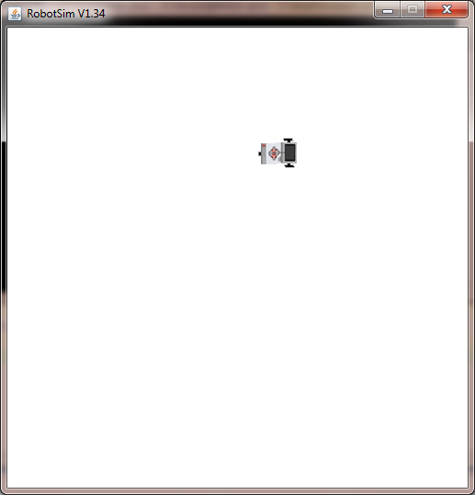

**Practical no. 3**

import ch.aplu.robotsim.*;

class square

{

square()

{

NxtRobot r = new NxtRobot();

Gear g = new Gear();

r.addPart(g);

g.setSpeed(100);

g.forward(1000);

g.left(275);

g.forward(1000);

g.left(275);

g.forward(1000);

g.left(275);

g.forward(1000);

Tools.delay(2000);

r.exit();

}

public static void main(String[] args)

{

new square();

}

}

**Output:**

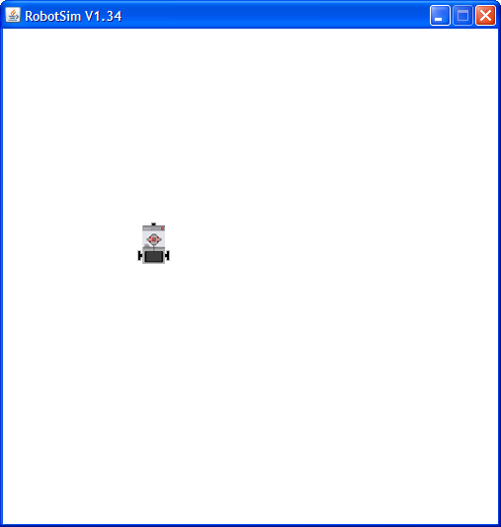

**Practical no. 4**

import ch.aplu.robotsim.*;

public class LineFollower

{

LineFollower()

{

LegoRobot robot=new LegoRobot();

Gear gear=new Gear();

LightSensor ls=new LightSensor(SensorPort.S3);

robot.addPart(gear);

gear.setSpeed(20);

robot.addPart(ls);

while(true)

{

int v=ls.getValue();

if(v < 100)//black

gear.forward();

if(v > 300 && v < 750) //blue

gear.leftArc(0.05);

if(v> 800) //yellow

gear.rightArc(0.05);

}

}

public static void main(String args[])

{

new LineFollower();

}

static

{

RobotContext.setStartPosition(50,490);

RobotContext.setStartDirection(-90);

RobotContext.useBackground("sprites/road.gif");

}

}

**Output:**

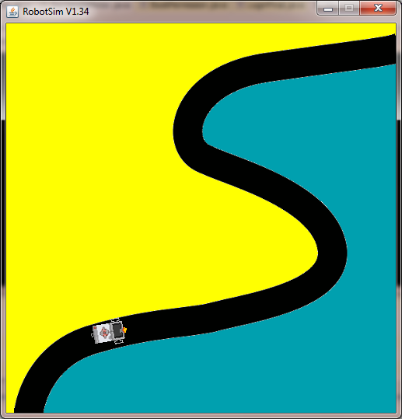

**Practical No. 5(a)**

import ch.aplu.robotsim.*;

public class Circlem

{

Circlem()

{

NxtRobot robot=new NxtRobot();

Gear gear=new Gear();

robot.addPart(gear);

gear.setSpeed(60);

gear.leftArc(0.2,7000);

gear.rightArc(0.2);

Tools.delay(5000);

robot.exit();

}

public static void main(String args[])

{

new Circlem();

}

}

**Output:**

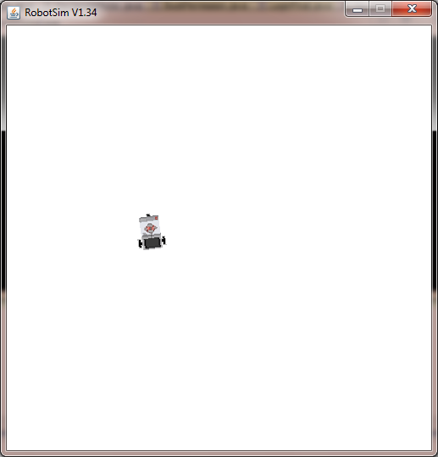

**Practical No. 5(b)**

import ch.aplu.robotsim.*;

class CircularGear

{

CircularGear()

{

NxtRobot robot=new NxtRobot();

Gear gear=new Gear();

robot.addPart(gear);

gear.forward(200);

gear.setSpeed(20);

gear.leftArc(0.2,7000);

gear.forward(200);

gear.leftArc(0.2,7000);

gear.forward(200);

gear.leftArc(0.2,7000);

gear.forward(200);

gear.leftArc(0.2,7000);

gear.forward(200);

robot.exit();

}

public static void main(String args[])

{

CircularGear m=new CircularGear();

NxtContext.setStartPosition(250,200);

NxtContext.setStartDirection(90);

}

}

**Output:**

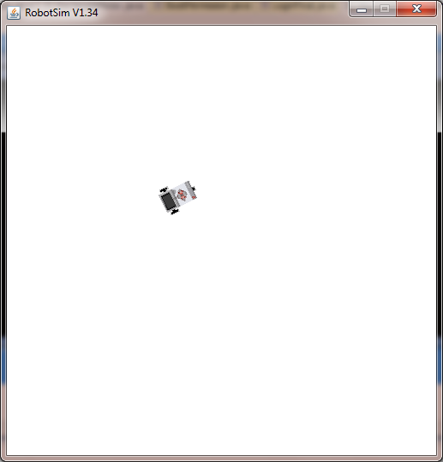

**Practical No. 6**

import ch.aplu.robotsim.*;

public class PathFinder

{

public PathFinder()

{

NxtRobot robot=new NxtRobot();

Gear gear=new Gear();

LightSensor ls1=new LightSensor(SensorPort.S1);

LightSensor ls2=new LightSensor(SensorPort.S2);

robot.addPart(gear);

robot.addPart(ls1);

robot.addPart(ls2);

gear.forward();

while(true)

{

int rightValue=ls1.getValue();

int leftValue=ls2.getValue();

int d=rightValue - leftValue;

if(d>100)

gear.rightArc(0.1);

if(d < -100)

gear.leftArc(0.1);

if(d > -100 && d < 100 && rightValue > 500)

gear.forward();

}

}

public static void main(String args[])

{

new PathFinder();

}

static

{

NxtContext.setStartPosition(250,490);

NxtContext.setStartDirection(-90);

NxtContext.useBackground("sprites/path.gif");

}

}

**Output:**

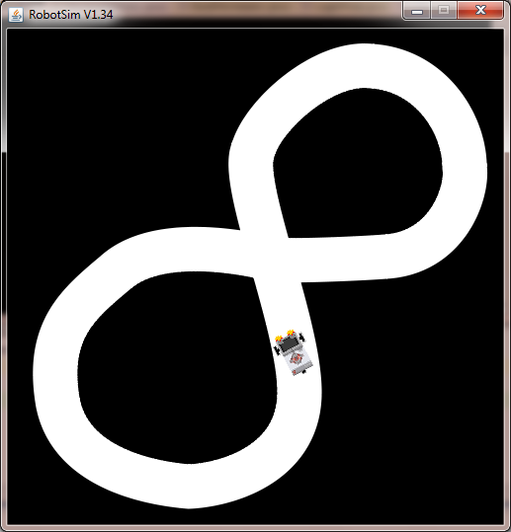

**Practical no. 7**

import ch.aplu.robotsim.*;

import ch.aplu.util.*;

public class resistobst

{

public resistobst()

{

LegoRobot robot = new LegoRobot();

Gear g = new Gear();

TouchSensor ts1 = new TouchSensor(SensorPort.S1);

TouchSensor ts2 = new TouchSensor(SensorPort.S2);

robot.addPart(g);

robot.addPart(ts1);

robot.addPart(ts2);

g.forward();

while(!QuitPane.quit())

{

Boolean t1 = ts1.isPressed();

Boolean t2 = ts2.isPressed();

if(t1 && t2)

{

g.backward(500);

g.left(400);

g.forward();

}

else

{

if(t1)

{

g.backward(500);

g.left(400);

g.forward();

}

else

{

if(t2)

{

g.backward(500);

g.right(100);

g.forward();

}

}

}

Tools.delay(20);

}

robot.exit();

}

public static void main(String [] args)

{

new resistobst();

}

static

{

RobotContext.setLocation(10,10);

RobotContext.setStartDirection(5);

RobotContext.setStartPosition(100,240);

RobotContext.useObstacle(RobotContext.channel);

}

}

**Output:**

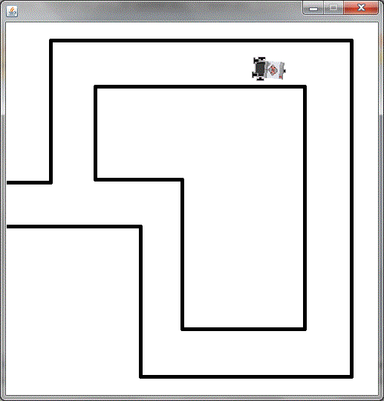

**Practical no. 8**

package TorchFollower;

import ch.aplu.robotsim.Gear;

import ch.aplu.robotsim.LegoRobot;

import ch.aplu.robotsim.LightSensor;

import ch.aplu.robotsim.RobotContext;

import ch.aplu.robotsim.SensorPort;

import ch.aplu.robotsim.Tools;

/**

*

*/

public class TorchFollower {

TorchFollower()

{

LegoRobot robot = new LegoRobot();

LightSensor lsFR = new LightSensor(SensorPort.S1, true);

LightSensor lsFL = new LightSensor(SensorPort.S2, true);

LightSensor lsRR = new LightSensor(SensorPort.S3, true);

LightSensor lsRL = new LightSensor(SensorPort.S4, true);

Gear gear = new Gear();

robot.addPart(gear);

robot.addPart(lsFR);

robot.addPart(lsFL);

robot.addPart(lsRL);

robot.addPart(lsRR);

gear.setSpeed(25);

gear.forward();

double s = 0.02;

while (!robot.isEscapeHit())

{

int vFR = lsFR.getValue();

int vFL = lsFL.getValue();

int vRR = lsRR.getValue();

int vRL = lsRL.getValue();

double d = 1.0 * (vFL - vFR) / (vFL + vFR);

if (vRL + vRR > vFL + vFR) // torch behind robot

gear.left();

else if (d > -s && d < s)

gear.forward();

else

{

if (d >= s)

gear.leftArc(0.05);

else

gear.rightArc(0.05);

}

Tools.delay(100);

}

robot.exit();

}

public static void main(String[] args)

{

TorchFollower t =new TorchFollower();

}

// ------------------ Environment --------------------------

static

{

RobotContext.useTorch(1, 150, 250, 100);

}

}

**Output**

