OS & OP
NAME:D.TEJA SADWIKA Roll no:2520030536
1. Hello.c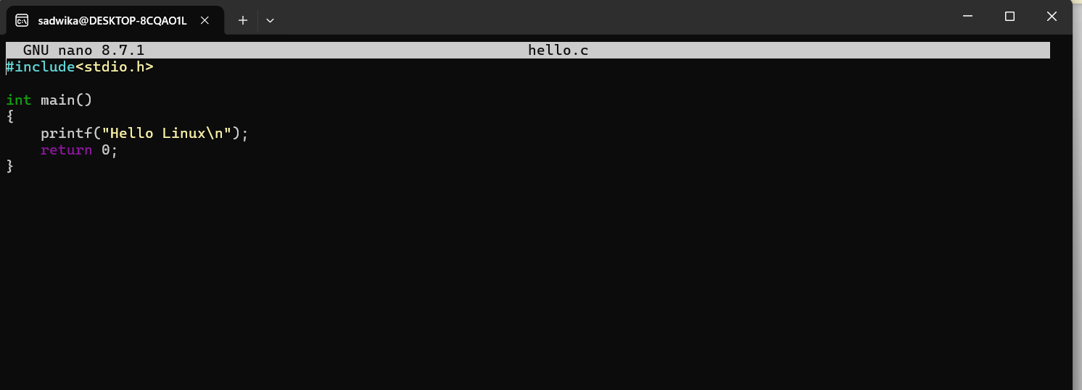

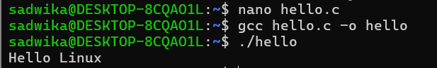

2.Read User Name
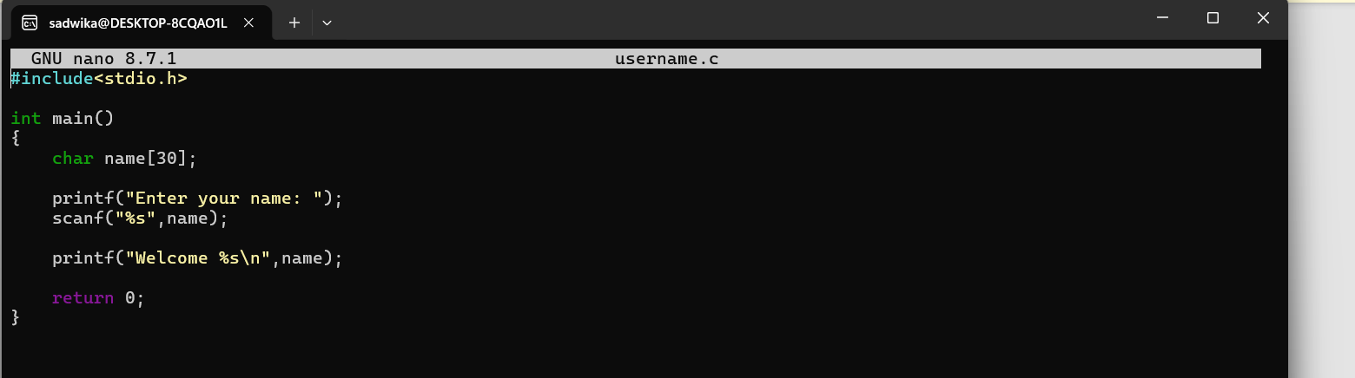
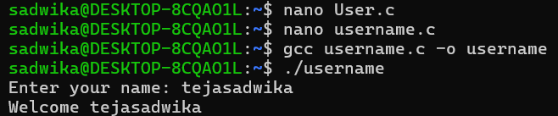

3.Display Process ID
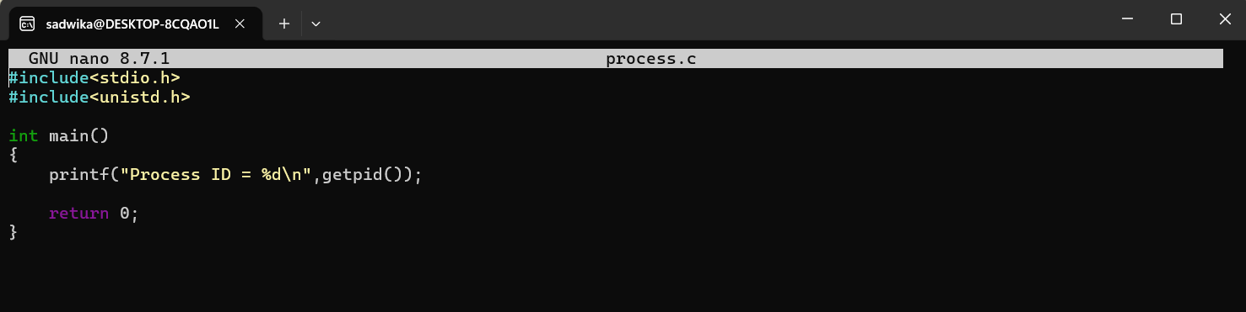
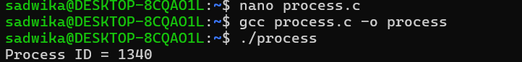

4.Fork()
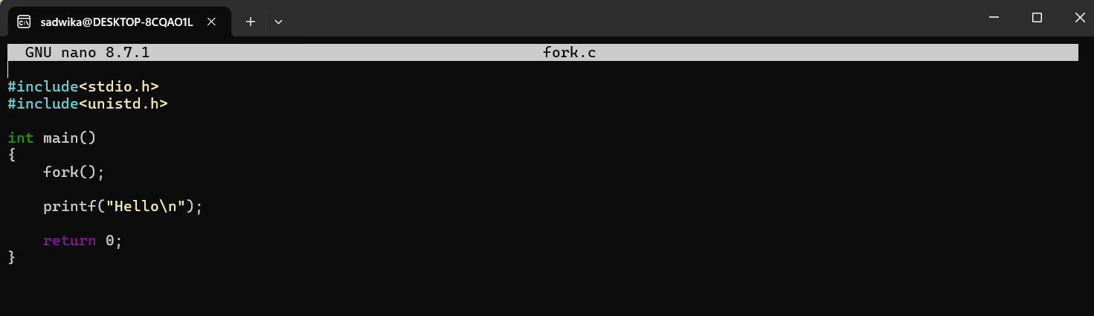
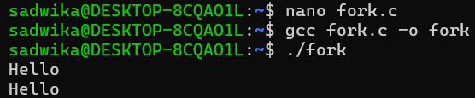

5.Parent and Child
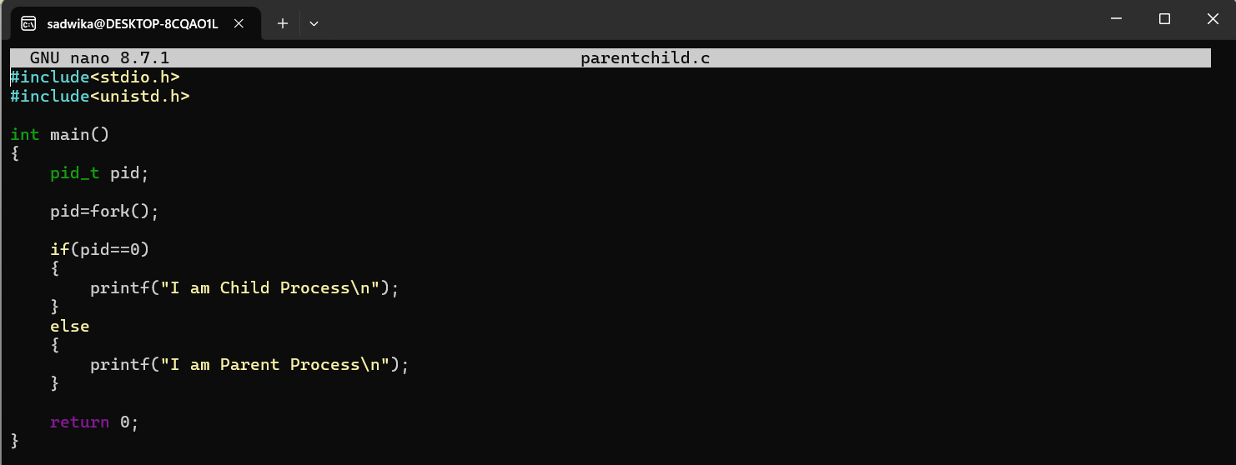
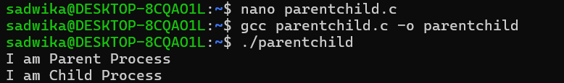

6.Display Parent and Child
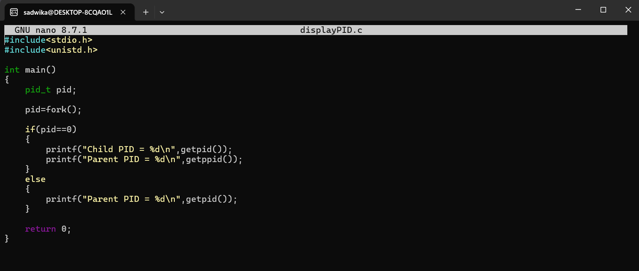
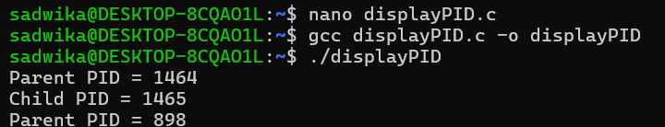

7.Wait()
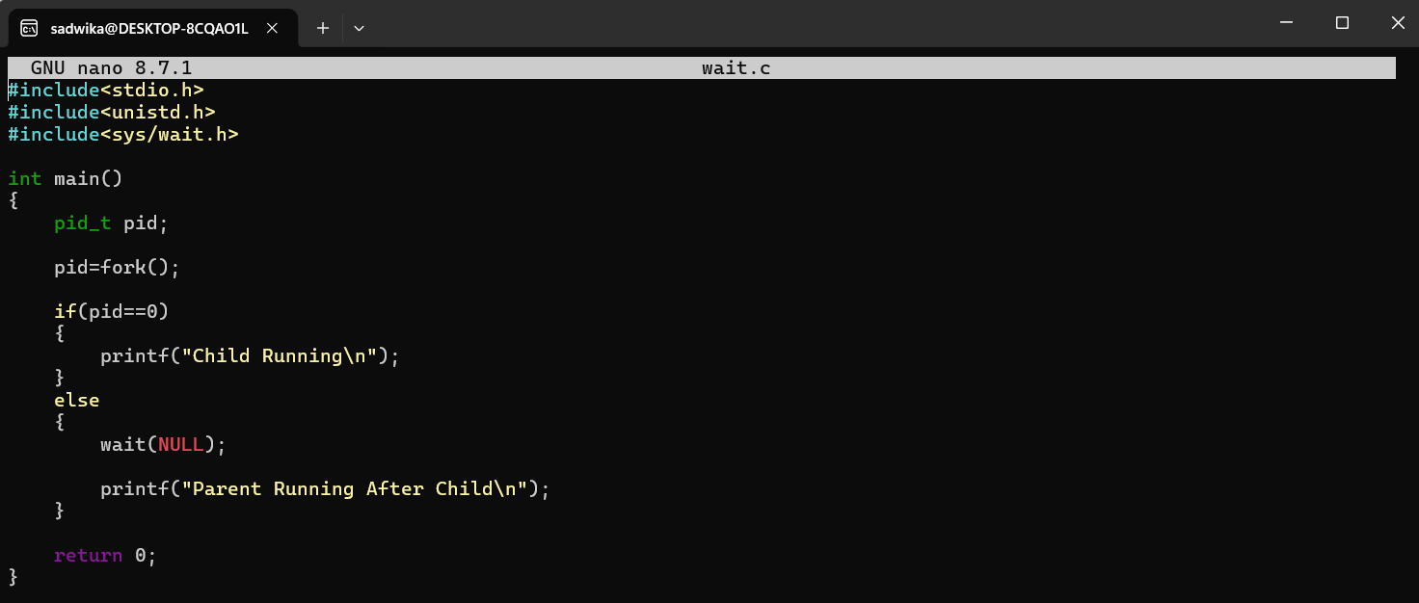
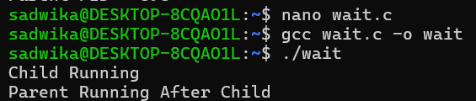

8.Wait()
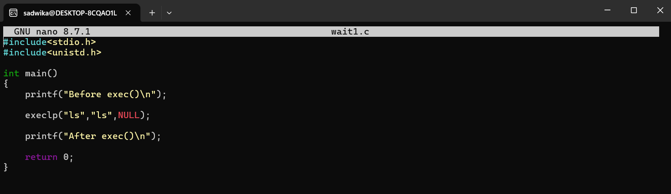
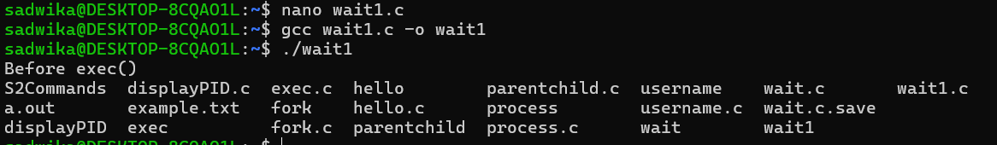

9. fork() + exec()
