1. Write the query to display productionid, production name with total number movies produced by each.

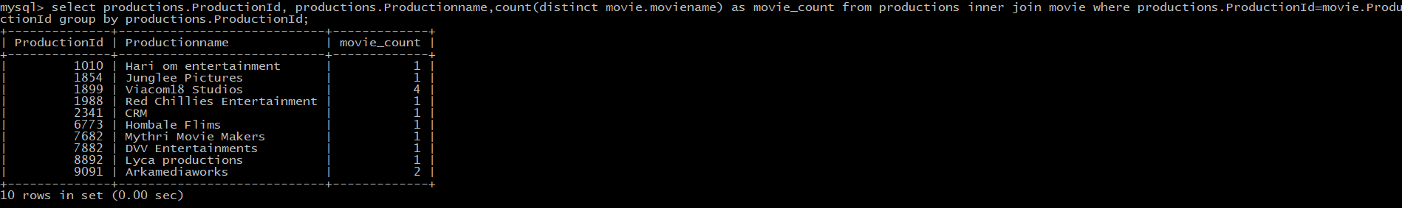

2. Write the query to display production name, owner name have produced more than 2 movies.



3. Write the query to display production name, owner name have produced maximum movies



4. **-** Write the query to display the moviename, heroname and productionname acted in the producer name= ’Subaskaran’



5. Write the query to display the moviename, heroname whose productionid ends with 82.

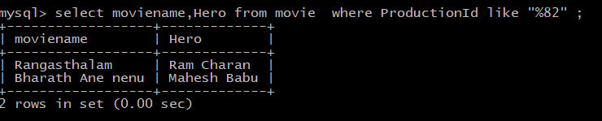

6. Write the query to display the productionname, ownername who has not produced the movie.



7. Write the query to display the productionname, ownername who has not produced the ‘hindi’ movie.

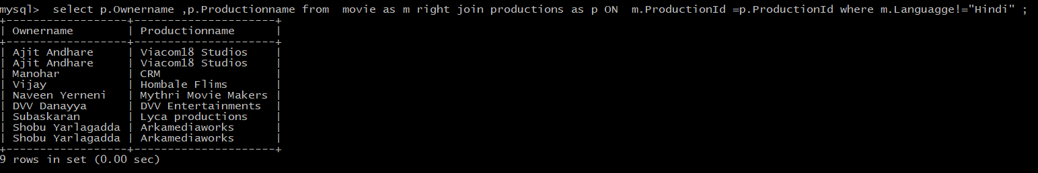

9. Write the query to display the heroname who acted in maximum languages



10. Write the query to display the production name, owner name who has produced movie for more languages

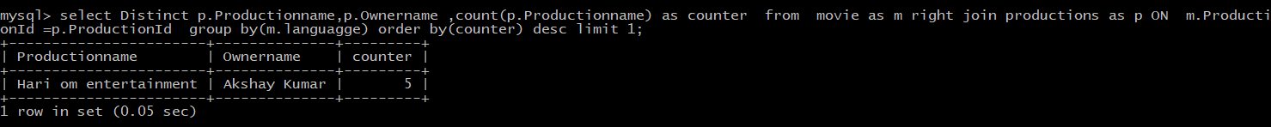

11. Write the query to display the productionname, producername who has not produced any movie

