1: VBA Homework

UTAUS201810DATA2

Prepared by : Tejas

2014:

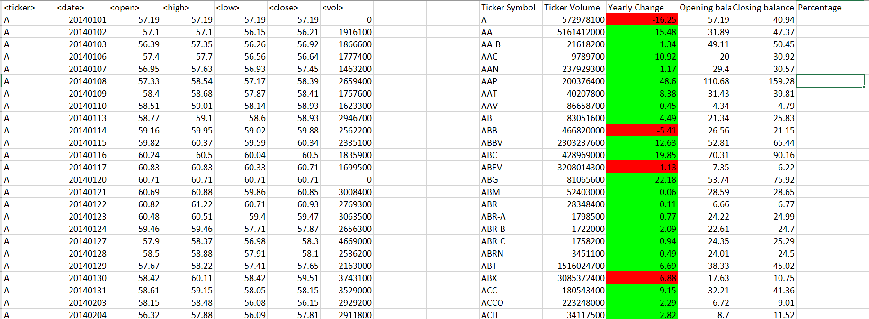

2015

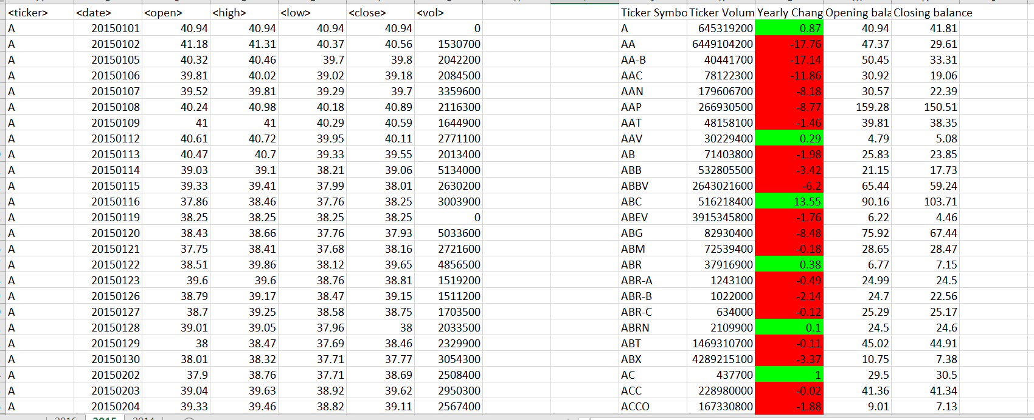

2016

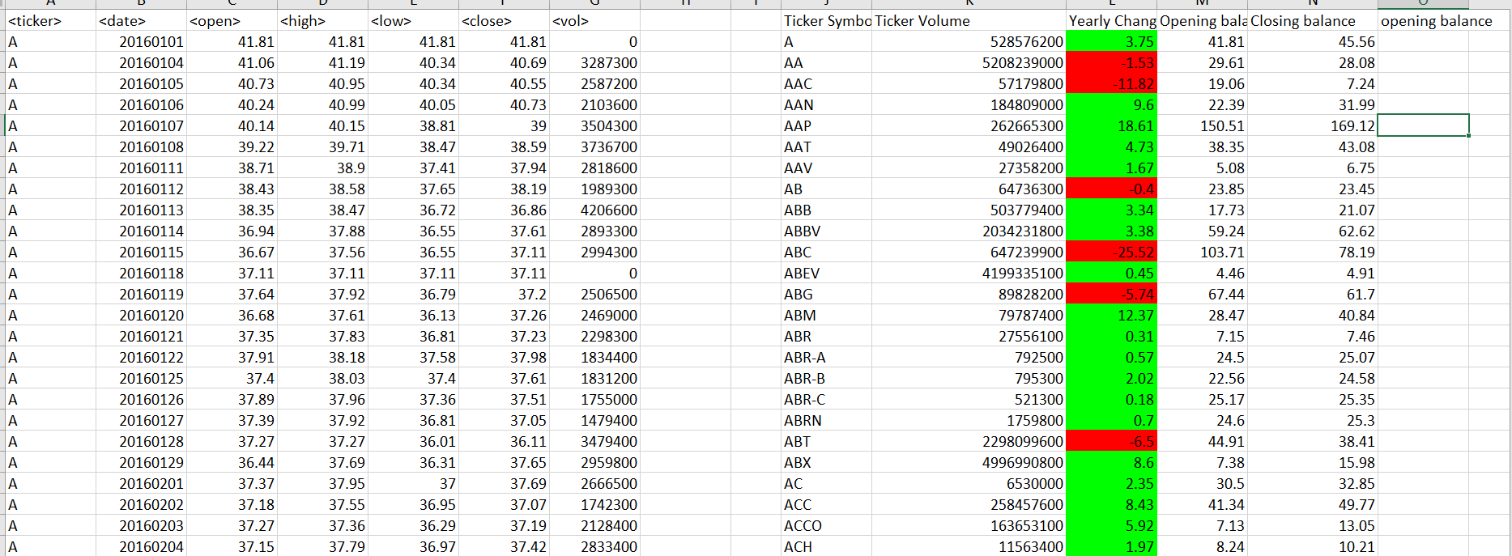

VBA code:

' Create a script that will loop through each year of stock data and grab the total amount of volume each stock had over the year.

' You will also need to display the ticker symbol to coincide with the total volume

' Yearly change from what the stock opened the year at to what the closing price was.

' The percent change from the what it opened the year at to what it closed.

' The total Volume of the stock

' Your solution will also be able to locate the stock with the "Greatest % increase", "Greatest % Decrease" and "Greatest total volume".

' Prepared by Tejas babu/ -- 10/26/2018

Sub multi_stock_vol()

' Declaring varriable

Dim total_volume As Double

Dim ticker_symbol As String

total_volume = 0

Dim LastRow As Long

Dim ticker_vol_Row As Integer

ticker_vol_Row = 2

Dim counter As Integer

Dim opening_balance As Double

Dim closing_balance As Double

Dim cpu_percentage As Double

Dim yearly_change As Double

' Looping all worksheet

For Each ws In Worksheets

' printing worksheet name

WorksheetName = ws.Name

MsgBox WorksheetName

LastRow = 0

' clearing all cell for each worksheet

ws.Range("J10:N3500").Clear

' assigning header

ws.Cells(1, 10).Value = "Ticker Symbol"

ws.Cells(1, 11).Value = "Ticker Volume"

ws.Cells(1, 12).Value = "Yearly Change"

ws.Cells(1, 13).Value = "Opening balance"

ws.Cells(1, 14).Value = "Closing balance"

' getting last row number for

LastRow = ws.Cells(Rows.Count, "A").End(xlUp).Row

MsgBox LastRow

' assigning row number to start for formated data table

ticker_vol_Row = 2

MsgBox ticker_vol_Row

' For loop to process all data in worksheet

For i = 2 To LastRow

' comparing current cells and next cells

If ws.Cells(i + 1, 1).Value <> ws.Cells(i, 1).Value Then

ticker_symbol = ws.Cells(i, 1).Value

total_volume = total_volume + ws.Cells(i, 7).Value

closing_balance = ws.Cells(i, 6).Value

' cpu_percentage = closing_balance - opening_balance / opening_balance

yearly_change = closing_balance - opening_balance

ws.Range("J" & ticker_vol_Row).Value = ticker_symbol

ws.Range("K" & ticker_vol_Row).Value = total_volume

If yearly_change >= 0 Then

ws.Range("L" & ticker_vol_Row).Value = yearly_change

ws.Range("L" & ticker_vol_Row).Interior.ColorIndex = 4

Else

ws.Range("L" & ticker_vol_Row).Value = yearly_change

ws.Range("L" & ticker_vol_Row).Interior.ColorIndex = 3

End If

ws.Range("M" & ticker_vol_Row).Value = opening_balance

ws.Range("N" & ticker_vol_Row).Value = closing_balance

'Range("O" & ticker_vol_Row).Value = cpu_percentage

' after prinitng records is in formated table increasing counter

ticker_vol_Row = ticker_vol_Row + 1

' resetting all vlaue once it is in formated table

total_volume = 0

opening_baance = 0

counter = 0

closing_balance = 0

cpu_percentage = 0

yearly_change = 0

Else

counter = counter + 1

total_volume = total_volume + ws.Cells(i, 7).Value

' storing opening balance in variable

If counter = 1 Then

opening_balance = ws.Cells(i, 3).Value

End If

End If

Next i

' printing message once processing complete for worksheet

MsgBox "complete" & WorksheetName

Next ws

MsgBox "Procesing complete"

End Sub