Monthly Energy Interval Data & Summary Report Application
Business Requirements Document (BRD), Functional Requirements Document (FRD) & End-User Operating Manual

PART 1: Business Requirements Document (BRD) & Functional Requirements Document (FRD)
1. Executive Summary & Purpose
The Monthly Energy Interval Data & Summary Report Application is a Flask-based web analytics platform designed for energy analysts, property managers, grid operators, and renewable energy managers. The application processes raw 15-minute or hourly utility interval data CSV files, aggregating electricity drawn from the utility grid against onsite energy generated via solar panel installations or other alternative energy sources (e.g., wind turbines, battery energy storage systems).
The system allows users to filter datasets by specific Meter ID (ESIID) and date boundaries (Start Date and End Date), renders interactive visual analytics (monthly bar charts and donut percentage breakdown charts), and exports automated, executive-ready PDF summary reports.
2. Business Requirements Document (BRD)
• BR-01 (Alternative Energy & Data Processing): The system must accept standard utility CSV interval data files containing grid electricity consumption alongside surplus exports generated by solar panels or alternative energy systems.
• BR-02 (Scope & Date Control): Users must be able to specify custom date boundaries (Start Date and End Date) to isolate target billing cycles, seasonal solar production periods, or specific operational ranges.
• BR-03 (Meter Identification): The system must identify the Meter ID (ESIID) associated with the dataset and display it clearly across all web visualizations, filter boxes, and exported PDF documents.
• BR-04 (Executive PDF Export): The application must generate an automated, downloadable PDF summary report containing metadata, key energy metrics (consumption vs. alternative generation), and embedded high-resolution analytics visuals.
• BR-05 (Zero-Storage Privacy & Stream Processing): Processing must occur in-memory using byte streams to ensure raw utility and proprietary alternative generation data are not unnecessarily persisted on physical server storage.
3. Functional Requirements Document (FRD)
3.1 File Upload & Input Controls (FR-01)
• FR-01.1 Accepted Format: The web interface accepts standard utility CSV files (.csv).
• FR-01.2 Form Controls: The interface provides user input controls including:
- File Picker: Upload field for selecting local interval CSV datasets.
- Chart Type Selector: Dropdown offering 'Monthly Bar Chart' and 'Total Energy Pie Chart'.
- Start Date Picker: Date selector input (YYYY-MM-DD).
- End Date Picker: Date selector input (YYYY-MM-DD).
3.2 Data Transformation & Metrics Engine (FR-02)
• FR-02.1 Date Grouping: Parses USAGE_DATE into monthly buckets (YYYY-MM).
• FR-02.2 Series Categorization: Categorizes records into two primary streams based on CONSUMPTION_SURPLUSGENERATION:
1. Consumption: Electricity pulled from the grid.
2. Surplus Generation: Excess electricity generated onsite via solar panels or alternative sources and exported to the grid.
• FR-02.3 Metric Aggregations:
- Total Consumption (kWh) = Sum of USAGE_KWH where category is Consumption.
- Total Surplus Generation (kWh) = Sum of USAGE_KWH where category is Surplus Generation.
- Net Grid Usage (kWh) = Total Consumption - Total Surplus Generation.
3.3 Visual Analytics Engine (FR-03)
• FR-03.1 Monthly Bar Chart: Grouped bar chart illustrating monthly grid consumption (Blue #1f77b4) vs. alternative surplus generation (Green #2ca02c).
• FR-03.2 Total Energy Pie/Donut Chart: Donut visualization showing exact percentage breakdown between total consumed energy and total surplus alternative energy generated over the scope period.
3.4 PDF Summary Report Generator (FR-04)
• Engine: Integrated ReportLab PDF engine rendering Letter-sized documents.
• Layout Structure:
1. Header: Document Title 'Energy Usage Summary Report'.
2. Metadata Table: Displays Meter ID (ESIID), Start Date, and End Date.
3. Metrics Summary Table: Styled table displaying Total Consumption, Total Surplus Generation (Solar/Alternative), and Net Grid Usage.
4. High-DPI Chart Embedding: High-resolution plot embedded seamlessly at the bottom.
PART 2: End-User Documentation & Operating Manual
1. System Overview
The Energy Interval Data Dashboard enables users to upload CSV interval energy datasets, evaluate electricity consumption against onsite alternative energy generation (solar/wind/storage), apply custom date and meter filters, view visual analytics, and download a formal executive PDF summary report with a single click.
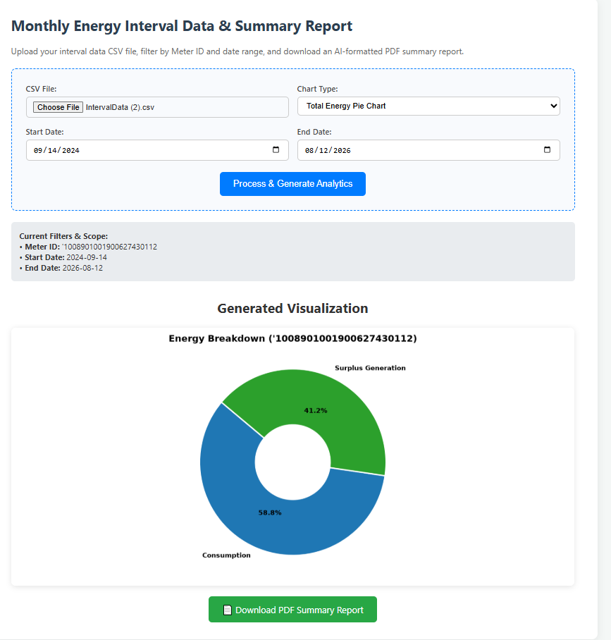
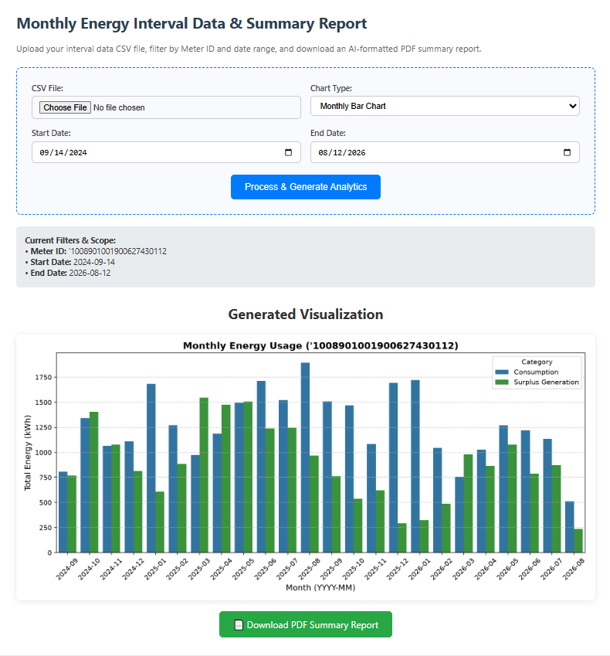
2. Step-by-Step User Instructions
1. Access the Web Dashboard: Open your web browser and navigate to the application web URL (e.g., http://127.0.0.1:5000).
2. Upload Interval CSV File: Click 'Choose File' under CSV File and select your utility interval dataset.
3. Choose Chart Type:
- Monthly Bar Chart: Displays month-by-month grid consumption vs. alternative energy surplus.
- Total Energy Pie Chart: Displays overall percentage offset between consumed grid energy and solar/alternative exports.
4. Set Scope Boundaries (Optional): Specify a Start Date and End Date to limit your analysis to a specific billing cycle or peak solar season.
5. Process Data: Click the blue 'Process & Generate Analytics' button.
3. Understanding Visualizations & Output
Chart Type | Sample Metrics / Result | Primary Use Case
Total Energy Pie Chart | Donut split: 58.8% Grid Consumption vs. 41.2% Solar/Alternative Generation | Evaluating total solar self-consumption efficiency and overall grid offset percentage.
Monthly Bar Chart | Monthly grouped bars spanning full period (e.g., 2024-09 to 2026-08) | Tracking seasonal energy usage patterns and peak summer solar production output.

4. Downloading the PDF Executive Report
After processing your file, click the green '📄 Download PDF Summary Report' button below the chart visualization. The system generates a clean, executive-formatted PDF containing:
• Meter Identification (ESIID) (e.g., '1008901001900627430112)
• Active Scope Dates (e.g., 2024-09-14 to 2026-08-12)
• Exact Aggregated Metrics:
- Total Consumption: 30,504.69 kWh
- Total Surplus Generation (Solar/Alternative): 21,386.50 kWh
- Net Grid Usage: 9,118.19 kWh
• Embedded High-DPI Chart matching your selected view.

