Electronic Supplementary Material

Habitat suitability for Sociable Lapwing (Vanellus gregarius) increases across its global range, but populations continue to decline

Tejas Bhagwat¹, Ruslan Urazaliyev², Leon Nill³, Matthias Baumann⁴, Maxim Koshkin⁵, Rob Sheldon², Johannes Kamp¹, Tobias Kuemmerle^{4,6}

¹Department of Conservation Biology, University of Göttingen, Bürgerstraße 50, Göttingen, Germany
²Association for the Conservation of Biodiversity in Kazakhstan (ACBK), Astana, Kazakhstan
³Geography Department, Humboldt-Universität zu Berlin, Unter den Linden 6, 10099 Berlin, Germany

⁴Conservation Biogeography Lab, Geography Department, Humboldt University, Unter den Linden 6, 10099 Berlin, Germany

⁵Ilbirs Foundation, office 7, 105/3 Isanova Street, Bishkek, Kyrgyzstan
⁶Integrative Research Institute on Transformations of Human-Environment Systems (IRI THESys), Humboldt-University Berlin, Unter den Linden 6, 10099 Berlin, Germany

*Corresponding author: tejas.bhagwat@biologie.uni-goettingen.de

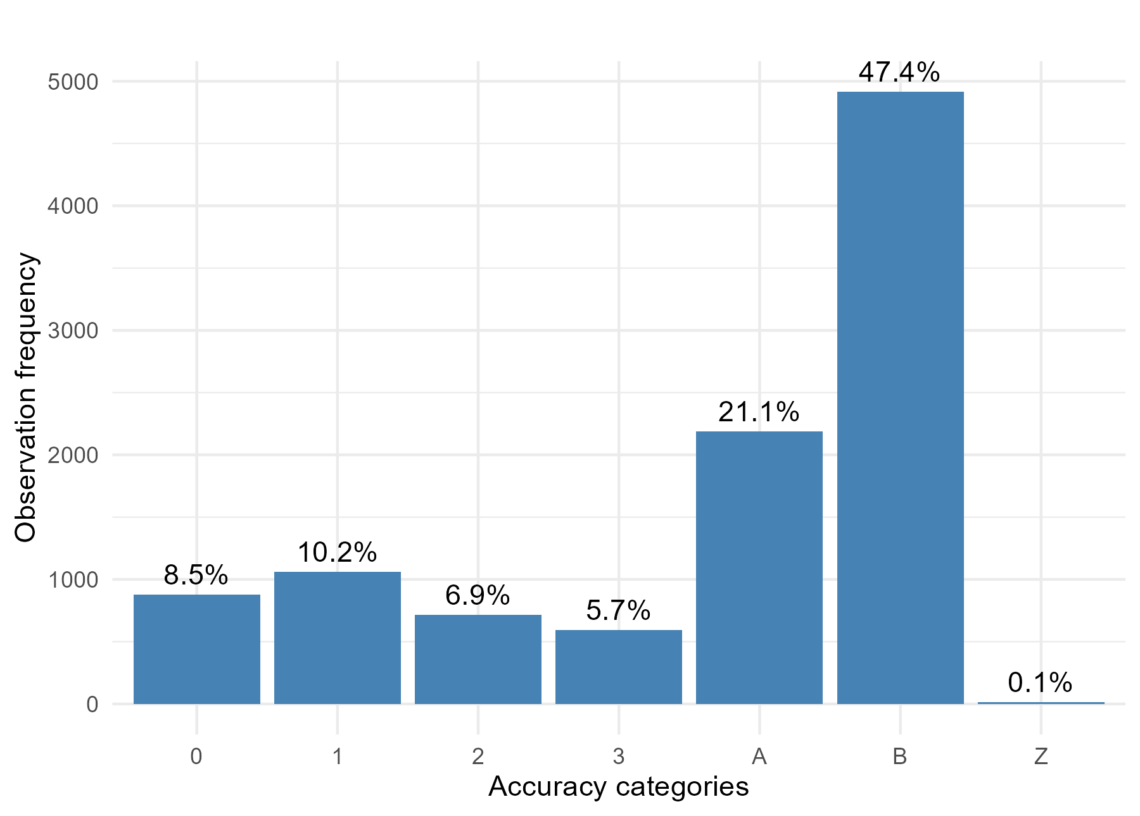
Fig. S1 Accuracy of ARGOS satellite data points. Numeric categories indicate the locations from 3 – highest accuracy (< 250 m) to 0 – no accuracy (> 1500 m or more). Locations with no accuracy estimates are denoted by A and B while invalid locations are categorized as Z (these were removed).

Fig. S2 Expectation-maximization binary clustering (EMbC) of ARGOS and GPS-GSM data using speed and turning angle information from the movement data to categorize bird behavior into four movement categories. Categories LL (Low speed – low turning angle) and LH (Low speed – high turning) angle were retained as locations ‘on the ground’.

Fold | Accuracy
0 | 0.910657307
1 | 0.9158993247
2 | 0.9064254523
3 | 0.9017718371
4 | 0.9039513678
5 | 0.9114518148
6 | 0.9006479482
7 | 0.9033861448
8 | 0.9103975535
9 | 0.9142947502
Table S1 Ten-fold cross validation of training and validation data by using one of the folds as a validation set, and training the model on the remaining nine folds. The accuracy metric for each validation step is averaged by repeating this process to estimate model performance.

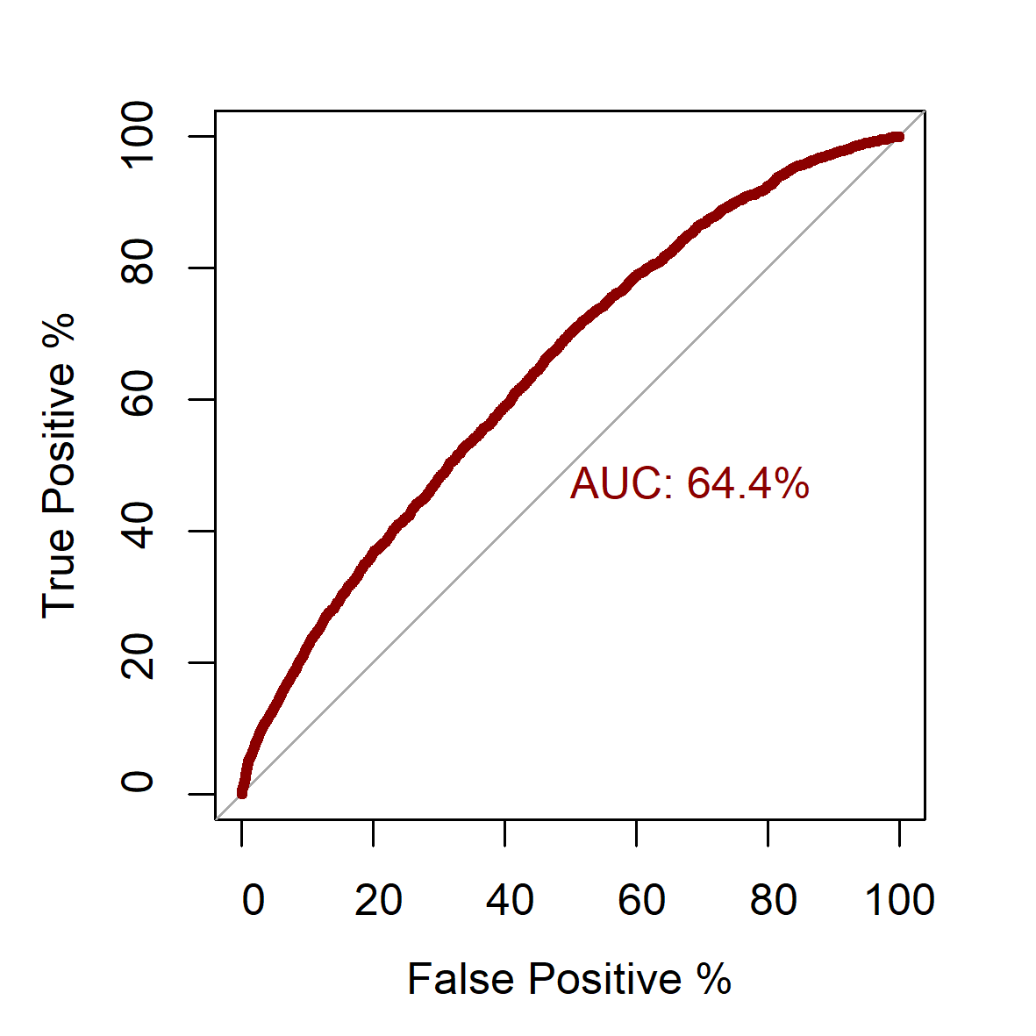

Fig. S3 Area under the ROC curve indicating the ability of random forest model to rightly predict actual presence (true positives). Higher values (greater area under the curve) represent a better model fit.

Fig. S4 Influence of individual predictor variables on habitat suitability predictions through the annual cycle. Tasseled-Cap Wetness indicating presence of water (coastlines or irrigation) and soil moisture, and topography (Roughness) were some of the important predictors.

