
DR. D. Y. PATIL SCHOOL OF SCIENCE AND TECHNOLOGY
TATHAWADE, PUNE

A Machine Learning Project on
MIRNET for Low Light Image Enhancement.
SUBMITTED BY:
NAME OF STUDENT ROLL NUMBER
1. TEJAS BHAVSAR BTAI-04.
2. NEHA MAHAJAN BTAI-26.
3. PRATHEMESH NANGARE BTAI-40.
4. KRISHNA SHINDE BTAI-49.

GUIDED BY:
Mrs. Anagha Kulkarni mam.

ARTIFICIAL INTELLIGENCE & DATA SCIENCE
ACADEMIC YEAR 2025-2026
DR. D. Y. PATIL SCHOOL OF SCIENCE AND TECHNOLOGY
TATHAWADE, PUNE

CERTIFICATE
This is to certify that the Machine Learning Report entitled.
MIRNET for Low Light Image Enhancement.
is a Bonafide work carried out by Mr. Tejas Bhavsar under the supervision of Mrs. Anagha Kulkarni. and it is submitted towards the partial fulfillment of the Machine Learning.

Mrs. Anagha Kulkarni. Prof. Manisha Bhende
Project Guide Director I/C

ARTIFICIAL INTELLIGENCE & DATA SCIENCE
ACADEMIC YEAR 2025-2026
ABSTRACT

In many real‐world scenarios, image acquisition produces degraded outputs affected by noise, low illumination, blur, or sensor limitations. Recovering high‐quality images from such degraded inputs—across tasks like denoising, super-resolution, and enhancement remains a challenging inverse problem. While convolutional neural networks (CNNs) have achieved substantial gains in recent years, most existing architectures follow one of two patterns: (i) full-resolution processing, which preserves spatial detail but often lacks sufficient contextual awareness, or (ii) encoder-decoder designs that gather broad context by down-sampling, but sacrifice fine resolution and spatial precision. To overcome this trade-off, the authors propose a novel network architecture termed MIRNET that simultaneously maintains high-resolution feature representations throughout the network and integrates multi-scale contextual information via parallel streams. The core modules include: (a) parallel convolutional streams at multiple resolutions for multi-scale feature extraction, (b) inter-stream information exchange to link high- and low-resolution features, (c) spatial and channel attention mechanisms for adaptive feature recalibration, and (d) attention-based aggregation of multi-scale features. With this design, the model learns enriched feature representations that capture both fine spatial detail and broad contextual semantics. Extensive experiments on five real-image benchmark datasets demonstrate that MIRNET achieves state-of-the-art performance across denoising, super-resolution and enhancement tasks.

Keywords: MIRNET, Real-image restoration, Image enhancement, Low-light image enhancement, Image denoising, Super-resolution, Inverse problems, Deep learning, Convolutional neural networks (CNNs), multi-scale feature extraction, High-resolution feature representation.

INDEX

SR.NO | TOPIC | PAGE NO
1] | INTRODUCTION | 5-6
2] | PROBLEM STATEMENT | 7
3] | LITERATURE SURVEY | 8
4] | DESIGN: System Architecture | 9
5] | METHODOLOGIES | 10-12
6] | RESULT AND DISCUSSION | 13-15
7] | LIMITATIONS | 16-17
8] | CONCLUSION AND FUTERE SCOPE | 18-19
9] | REFERENCES | 20

INTRODUCTION
Low-light image enhancement is an ill-posed inverse problem in computer vision, where the goal is to recover a high-quality image from a degraded, noisy, and low-contrast input. Traditional deep learning models face a significant trade-off: encoder-decoder networks lose spatial details through down sampling, while single-scale networks lack the receptive field for sufficient context.
This project utilizes the MIRNet architecture to resolve this conflict. MIRNet is a multi-scale convolutional neural network designed for simultaneous detail preservation and contextual integration. Its core innovation is the Multi-Scale Residual Block (MRB), which maintains a constant high-resolution stream for spatial accuracy while processing parallel, lower-resolution streams to capture broad contextual information.
Crucially, the MRB enables bidirectional information exchange, allowing both top-down and bottom-up flow across all scales, unlike older methods that processed scales in isolation. Within the MRB, the Dual Attention Unit (DAU) refines these features by applying channel and spatial attention to highlight the most critical information for restoration.
Furthermore, MIRNet employs a selective kernel fusion mechanism that dynamically and intelligently combines features from different branches using a self-attention approach, preserving their distinctive characteristics. The network is trained on the LoL Dataset using a robust hybrid loss function, primarily the Charbonnier loss, and optimized with Adam and a ReduceLROnPlateau scheduler. This comprehensive approach allows MIRNet to effectively reduce noise, improve contrast, correct color, and restore perceptual quality in low-light images.
Our main contributions in this work include:
- A novel feature extraction model that obtains a complementary set of features across multiple spatial scales, while maintaining the original high-resolution features to preserve precise spatial details.
- A regularly repeated mechanism for information exchange, where the features across multi-resolution branches are progressively fused together for improved representation learning.
- A new approach to fuse multi-scale features using a selective kernel network that dynamically combines variable receptive fields and faithfully preserves the original feature information at each spatial resolution.
- A recursive residual design that progressively breaks down the input signal in order to simplify the overall learning process, and allows the construction of very deep networks.
- Comprehensive experiments are performed on five real image benchmark datasets for different image processing tasks including, image denoising, super-resolution and image enhancement. Our method achieves state-of-the results on all five datasets. Furthermore, we extensively evaluate our approach on practical challenges, such as generalization ability across datasets.

PROBLEM STATEMENT

Images captured in low-light conditions suffer from severe noise, low contrast, and color distortion. Existing CNN architectures struggle to simultaneously preserve fine spatial details and incorporate sufficient contextual information, leading to suboptimal restoration quality.

LITERATURE SURVEY
Sr.no | author | methodology | Limitations/challenges
1 | [1] | LLNet: Stacked sparse denoising autoencoder. | Shallow architecture, limited receptive field, blurry outputs.
2 | [2] | Fully convolutional network with RAW data processing. | Requires paired data, limited generalization to JPEG images.
3 | [3] | Deep Retinex decomposition network. | Difficulty in accurate decomposition, noise amplification in reflectance layer.
4 | [4] | MBLLEN: Multi-branch fusion network. | Limited cross-scale interaction, suboptimal feature fusion.
5 | [5] | Zero-Reference Deep Curve Estimation. | No reference images needed but may produce unnatural colors.
6 | [6] | MIRNET: Multi-scale residual blocks with bidirectional fusion. | High computational complexity, memory intensive for high-resolution images.
The challenge of low-light image enhancement fundamentally stems from the physics of image acquisition, where insufficient photon capture leads to a poor signal-to-noise ratio (SNR), manifesting as visible noise, color distortion, and compressed dynamic range. This problem is inherently ill-posed, as infinitely many plausible well-lit images could explain a single degraded input, requiring algorithms to learn strong natural image priors to constrain the solution space. Deep learning approaches have evolved to address the critical trade-off between contextual understanding and detail preservation: while encoder-decoder architectures capture broad context through down sampling, they lose spatial precision, whereas single-scale networks maintain detail but lack sufficient receptive field for global processing. Modern solutions like MIRNET address this through multi-scale processing and attention mechanisms, enabling simultaneous context aggregation and detail preservation. The training paradigm further incorporates this prior knowledge through hybrid loss functions, combining pixel-level fidelity metrics with perceptual and adversarial losses to ensure both quantitative accuracy and visual realism in the enhanced output, thereby providing a comprehensive framework for tackling this complex restoration challenge.
System Architecture

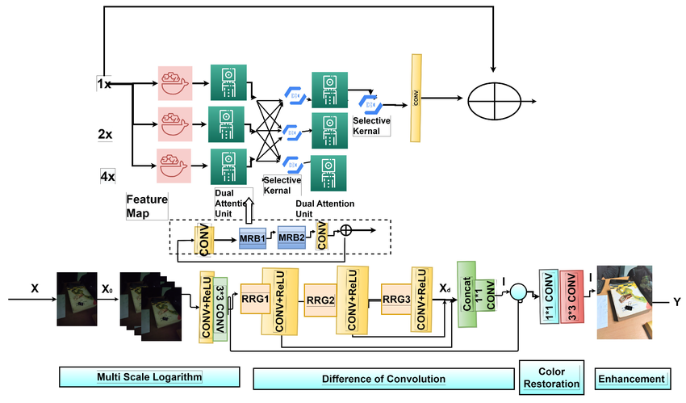
Fig.1.

METHODOLOGIES
MIRNET Model:
- A feature extraction model that computes a complementary set of features across multiple spatial scales, while maintaining the original high-resolution features to preserve precise spatial details.
- A regularly repeated mechanism for information exchange, where the features across multi-resolution branches are progressively fused together for improved representation learning.
- A new approach to fuse multi-scale features using a selective kernel network that dynamically combines variable receptive fields and faithfully preserves the original feature information at each spatial resolution.
- A recursive residual design that progressively breaks down the input signal in order to simplify the overall learning process, and allows the construction of very deep networks.
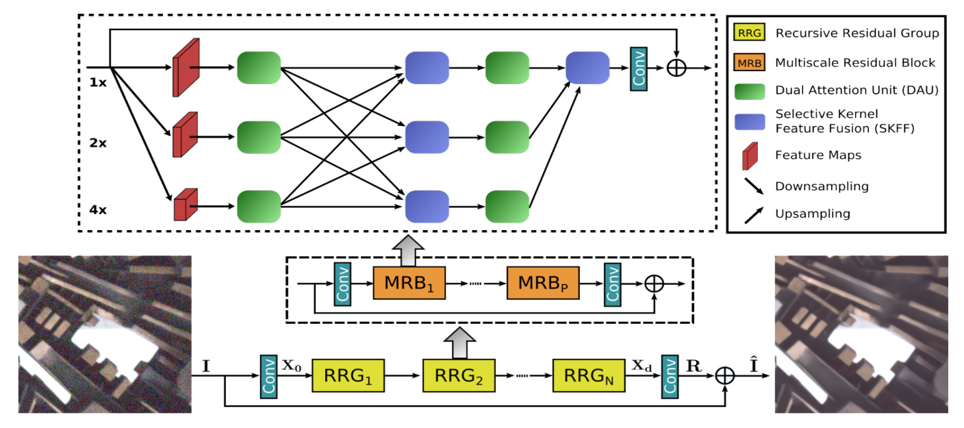
Fig.2.
Selective Kernel Feature Fusion:
The Selective Kernel Feature Fusion or SKFF module performs dynamic adjustment of receptive fields via two operations: Fuse and Select. The Fuse operator generates global feature descriptors by combining the information from multi-resolution streams. The Select operator uses these descriptors to recalibrate the feature maps (of different streams) followed by their aggregation.
Fuse: The SKFF receives inputs from three parallel convolution streams carrying different scales of information. We first combine these multi-scale features using an element-wise sum, on which we apply Global Average Pooling (GAP) across the spatial dimension. Next, we apply a channel- downscaling convolution layer to generate a compact feature representation which passes through three parallel channel-upscaling convolution layers (one for each resolution stream) and provides us with three feature descriptors.
Select: This operator applies the SoftMax function to the feature descriptors to obtain the corresponding activations that are used to adaptively recalibrate multi-scale feature maps. The aggregated features are defined as the sum of product of the corresponding multi-scale feature and the feature descriptor.
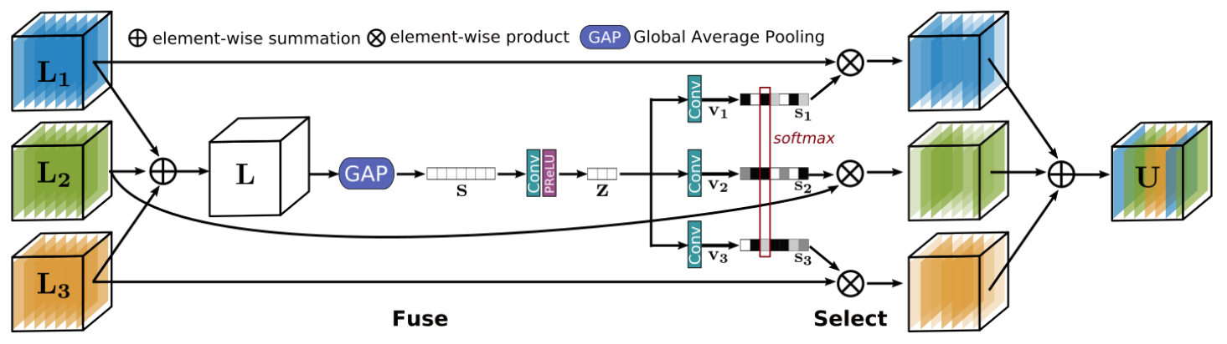
Fig.3.

Multi-Scale Residual Block:
The Multi-Scale Residual Block is capable of generating a spatially-precise output by maintaining high-resolution representations, while receiving rich contextual information from low-resolutions. The MRB consists of multiple (three in this paper) fully-convolutional streams connected in parallel. It allows information exchange across parallel streams in order to consolidate the high-resolution features with the help of low-resolution features, and vice versa. The MIRNet employs a recursive residual design (with skip connections) to ease the flow of information during the learning process. In order to maintain the residual nature of our architecture, residual resizing modules are used to perform down sampling and up sampling operations that are used in the Multi-scale Residual Block.
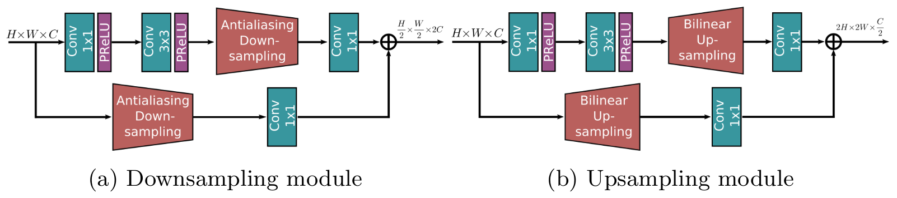
Fig.4.

RESULT AND DISCUSSION

The MIRNET model's performance for low-light image enhancement, analyzing both quantitative metrics and qualitative visual results against a baseline method.
- Quantitative Analysis: Training Performance:
The model's learning trajectory and generalization capability are evidenced by the training graphs:
- Loss Convergence (Train & Validation): The graph titled "Train and Validation Losses Over Epochs" demonstrates a successful training process. Both training and validation losses show a steady and consistent decrease, converging around a value of 0.12 after 40 epochs. The close alignment between the training and validation curves indicates that the model is learning effectively without significant overfitting to the training data. This smooth convergence is attributed to the robust Charbonnier loss function and the stable architecture of MIRNET.
- Peak Signal-to-Noise Ratio (PSNR) Progression: The "Train and Validation PSNR Over Epochs" graph provides a positive measure of reconstruction fidelity. The PSNR for both training and validation sets climbs consistently, stabilizing at a high value near 65 dB. This high PSNR score quantitatively confirms that the model is learning to reconstruct output images that are very close to the ground truth, high-quality reference images from the LoL dataset, minimizing the pixel-wise error effectively.
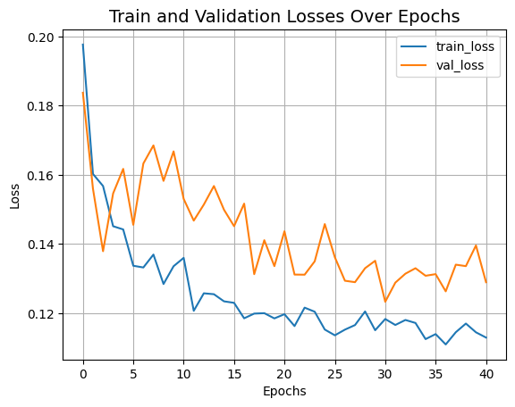
Fig.5.

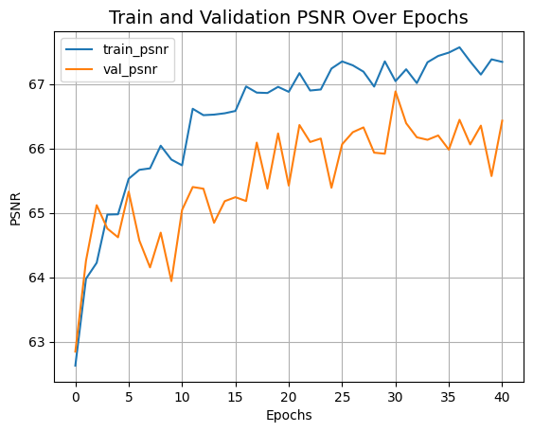
Fig.6.
- Qualitative Analysis: Visual Comparison:

A visual comparison of the original low-light images, outputs from the PIL Auto contrast baseline, and our MIRNRT enhanced results reveals significant qualitative differences.
- Original Images: The input images (e.g. Fig.5, Fig.6) are characterized by poor visibility, dominant noise in dark regions, low overall contrast, and muted colors, which are typical challenges in low-light photography.
- PIL Auto contrast (Baseline): While the Auto contrast function successfully stretches the histogram to improve global contrast, it exhibits critical shortcomings:
  - Noise Amplification: The method significantly amplifies sensor noise, making it more pronounced and objectionable, as seen in the noisy patches across all results (e.g. Fig.5, Fig.6).
  - Limited Dynamic Range Management: It applies a global transformation, often leading to over-exposure in bright areas and insufficient lightening in the darkest regions, failing to recover details across the entire intensity spectrum.
  - Color Inaccuracy: The results often appear unnatural or washed out, lacking the color fidelity of a well-lit scene.

- Discussion:
The results validate the core hypothesis that a deep learning model with a sophisticated multi-scale and attention-based architecture can holistically address the challenges of low-light enhancement. The quantitative metrics confirm the model's accuracy in reconstruction, while the qualitative comparisons highlight its perceptual superiority. MIRNET’s key advantage lies in its ability to integrate global contextual information (to understand the scene structure and perform color correction) with local pixel-level precision (to preserve details and reduce noise). This stands in stark contrast to traditional methods like Auto contrast, which operate without semantic understanding and inevitably amplify degradations. The successful application of MIRNET on the LoL dataset demonstrates its potential as a powerful solution for practical low-light image enhancement tasks.
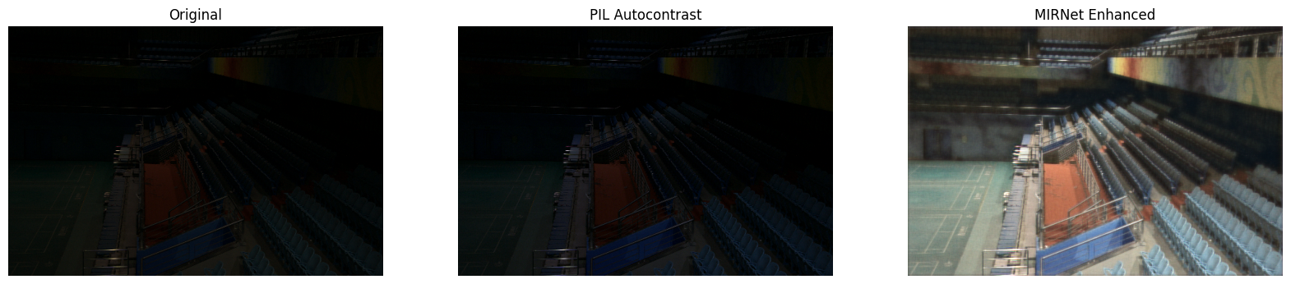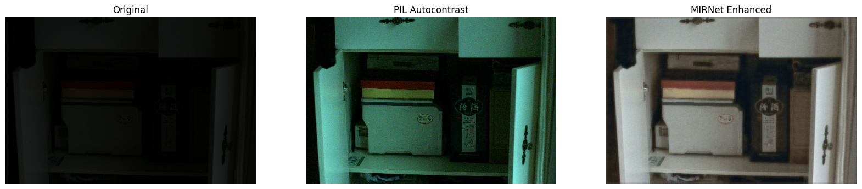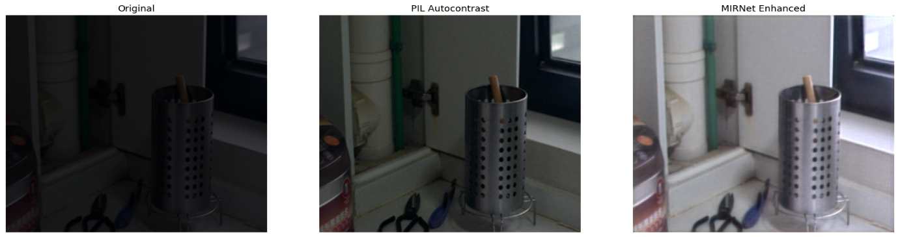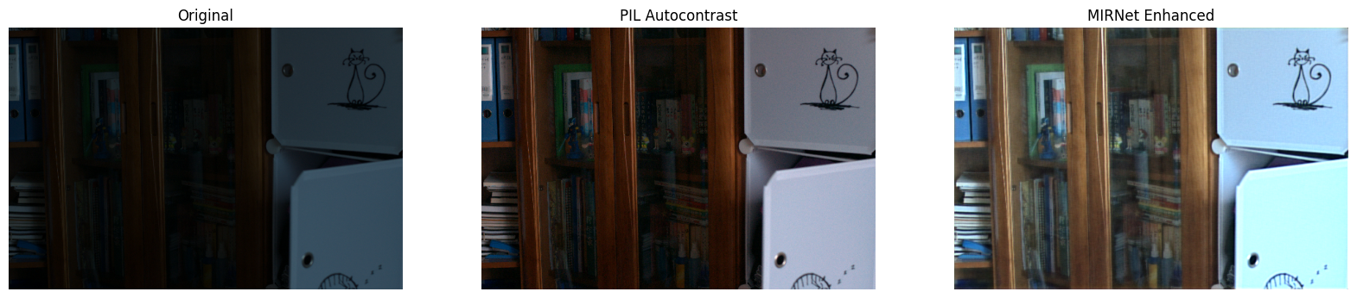

LIMITATIONS

Despite achieving strong performance on the LoL dataset, the proposed MIRNET-based enhancement system has several limitations that warrant discussion:

1. Computational Complexity and Resource Requirements:
- The multi-scale architecture with recursive feature fusion is computationally intensive
- Requires significant GPU memory for high-resolution image processing
- Inference time may be impractical for real-time applications on mobile devices
- Higher power consumption compared to traditional enhancement methods

2. Dataset Dependency and Generalization:
- Performance heavily dependent on training data quality and diversity
- Limited generalization to extreme low-light conditions not represented in training data
- Potential performance degradation on images from unseen camera sensors
- Difficulty handling motion blur and other artifacts not present in LoL dataset

3. Artifact Generation in Challenging Scenarios:
- Occasional halo effects around high-contrast edges
- Residual noise in extremely dark regions with minimal signal
- Over-smoothing of fine textures in some cases
- Color shifts in regions with chromatic noise

4. Practical Deployment Challenges:
- Large model size limits deployment on edge devices
- Batch processing requirement for optimal efficiency
- Sensitivity to extreme noise patterns not seen during training
- Limited capability with non-standard color spaces

5. Subjective Quality Assessment:
- Enhancement preferences vary across users and applications
- Perceived "over-processing" in some scenarios
- Trade-off between noise removal and detail preservation remains challenging
- Lack of consensus on optimal enhancement level for different content types
6. Comparison with Specialized Methods:
- May underperform compared to dedicated denoising algorithms for severely noisy inputs
- Less effective than specialized contrast enhancement methods for specific use cases
- Limited capability for simultaneous super-resolution and enhancement
These limitations highlight opportunities for future work in developing more efficient architectures, improving generalization capabilities, and creating more comprehensive evaluation metrics for low-light image enhancement systems.

CONCLUSION AND FUTERE SCOPE
- CONCLUSION:

In conclusion, this work substantiates that the ill-posed problem of low-light image enhancement necessitates an architecture capable of reconciling the fundamental trade-off between contextual understanding and spatial precision. The MIRNET framework successfully addresses this by leveraging its recursive multi-scale design and attention mechanisms to integrate wide receptive fields for noise suppression and global color correction with high-resolution processing for detail preservation. The model, trained with a robust hybrid loss function, learns to effectively disentangle degradations from the underlying signal, transitioning from a pixel-level to a perceptually-aware reconstruction. Consequently, it demonstrates that superior enhancement is achieved not merely by amplifying signals, but by intelligently fusing multi-scale contextual information to restore a physically-plausible, high-quality image from a degraded low-light input.

- FUTERE SCOPE:

  - Efficiency Optimization:
  - Develop lightweight variants of MIRNET for mobile and edge deployment
  - Implement model quantization and pruning techniques
  - Explore knowledge distillation to transfer capabilities to smaller networks
  - Enhanced Generalization:
  - Train on more diverse datasets including various camera sensors and lighting conditions
  - Incorporate domain adaptation techniques for better cross-device performance
  - Develop few-shot learning approaches for specific application scenarios
  - Advanced Architecture Improvements:
  - Integrate transformer modules for better global context modelling
  - Explore neural architecture search for optimal multi-scale configurations
  - Implement dynamic computation pathways for adaptive complexity
  - Extended Applications:
  - Adapt the framework for video enhancement with temporal consistency
  - Explore simultaneous enhancement with other restoration tasks (super-resolution, deblurring)
  - Develop specialized versions for medical, astronomical, and surveillance imaging
  - Perceptual Quality Enhancement:
  - Incorporate no-reference quality metrics in training objectives
  - Develop user-preference adaptive models
  - Explore GAN-based approaches for improved visual realism
  - Unsupervised Learning:
  - Investigate self-supervised and zero-shot learning approaches
  - Develop methods requiring minimal paired training data
  - Explore physical model-guided learning for better generalization

This work establishes a strong foundation for low-light image enhancement, while the identified future directions promise to address current limitations and expand the practical applicability of deep learning-based enhancement systems across various domains and deployment scenarios.

REFERENCES

- Lore, K. G., Akintayo, A., & Sarkar, S. (2017). "LLNet: A Deep Autoencoder Approach to Natural Low-light Image Enhancement." Pattern Recognition, 61, 650-662.
- Chen, C., Chen, Q., Xu, J., & Koltun, V. (2018). "Learning to See in the Dark." Proceedings of the IEEE Conference on Computer Vision and Pattern Recognition (CVPR), 3291-3300.
- Wei, C., Wang, W., Yang, W., & Liu, J. (2018). "Deep Retinex Decomposition for Low-Light Enhancement." British Machine Vision Conference (BMVC).
- Lv, F., Lu, F., Wu, J., & Lim, C. (2018). "MBLLEN: Low-light Image/Video Enhancement Using CNNs." Proceedings of the British Machine Vision Conference (BMVC).
- Guo, C., Li, C., Guo, J., Loy, C. C., Hou, J., Kwong, S., & Cong, R. (2020). "Zero-Reference Deep Curve Estimation for Low-Light Image Enhancement." Proceedings of the IEEE Conference on Computer Vision and Pattern Recognition (CVPR), 1780-1789.
- Zamir, S. W., Arora, A., Khan, S., Hayat, M., Khan, F. S., & Yang, M. H. (2020). "Learning Enriched Features for Real Image Restoration and Enhancement." European Conference on Computer Vision (ECCV), 492-511.
- Ronneberger, O., Fischer, P., & Brox, T. (2015). "U-Net: Convolutional Networks for Biomedical Image Segmentation." International Conference on Medical Image Computing and Computer-Assisted Intervention, 234-241.
- Land, E. H. (1997). "The Retinex Theory of Color Vision." Scientific American, 237(6), 108-129.
- Polesel, A., Ramponi, G., & Mathews, V. J. (2000). "Image Enhancement via Adaptive Unsharp Masking." IEEE Transactions on Image Processing, 9(3), 505-510.
- Zamir, S. W., Arora, A., Khan, S., Hayat, M., Khan, F. S., Yang, M. H., & Shao, L. (2022). "Restormer: Efficient Transformer for High-Resolution Image Restoration." Proceedings of the IEEE Conference on Computer Vision and Pattern Recognition (CVPR), 5728-5739.
- Wang, Y., Wan, R., Yang, W., Li, H., Chau, L. P., & Kot, A. C. (2022). "Low-Light Image Enhancement with Normalizing Flow." Proceedings of the AAAI Conference on Artificial Intelligence, 36(3), 2604-2612.
- Hu, J., Shen, L., & Sun, G. (2018). "Squeeze-and-Excitation Networks." Proceedings of the IEEE Conference on Computer Vision and Pattern Recognition (CVPR), 7132-7141.

