SHAREPIC
Technical Design & Deployment Specification | v3.0 | 29 October 2026
Status: demo-ready implementation snapshot. Verified facts are separated from known gaps.
Revision 3.0 adds embedded application workflow, deployment architecture and JWT request-flow diagrams, plus an explicit manual deployment sequence. Existing implementation caveats remain in force.

1. Executive summary
SharePic is a social photo-sharing application with an Angular frontend and three Java/Spring Boot REST microservices. The UI is served by Nginx, which routes API calls to internal Kubernetes Services. Workloads run on GKE Autopilot; Cloud SQL for PostgreSQL stores relational data and Google Cloud Storage stores image objects.
Release 20261028162646 was built with Cloud Build, published to Artifact Registry, deployed to all four GKE deployments, and each rollout completed with one ready replica. A public HTTP request to http://136.82.121.18/ returned 200. These checks verify rollout and frontend response, not full end-to-end regression.

2. Verified deployment inventory
Item | Value
Project | project-7724e29a-0202-4802-903
Region | us-east1
Cluster | sharepic-cluster (GKE Autopilot)
App URL | http://136.82.121.18
Artifact Registry | us-east1-docker.pkg.dev/project-7724e29a-0202-4802-903/sharepic-repo
Release tag | 20261028162646
Cloud SQL | project-7724e29a-0202-4802-903:us-east1:sharepic-1
GCS bucket | sharepic-profile-pictures-1; post-images/ prefix for post images
Ingress | sharepic-ingress; HTTP port 80; HTTPS/TLS not configured/verified
Deployments | user-service, post-service, feed-service, sharepic-ui; 1 ready replica each at last check

3. Architecture and service boundaries
Browser → GKE Ingress (HTTP :80) → sharepic-ui Service → Nginx → internal Kubernetes Services.
Component | Port | Responsibility
sharepic-ui | 80 | Angular production build served by Nginx; reverse proxy
User Service | 8081 | Registration, login, profile read/update; issues JWT access tokens
Post Service | 8080 | Create/read/update/delete posts; stores post metadata and image URL
Feed Service | 8082 | Feed retrieval and likes; calls Post Service and forwards Authorization header
Cloud SQL | 5432 via proxy sidecar | Managed PostgreSQL database
Cloud Storage | Managed | Profile and post image objects
Nginx routes /api/v1/users and /api/v1/auth/ to user-service:8081; /api/v1/feed and the post-like route to feed-service:8082; /api/v1/posts routes to post-service:8080. Backend pods use a Cloud SQL Auth Proxy sidecar (2.18.2), service account sharepic-ksa and Kubernetes Secret sharepic-runtime-secrets.
Deployment architecture. The public ingress routes browser traffic to the UI Service only; Nginx reverse-proxies API paths to internal Services. Backend pods use a Cloud SQL Auth Proxy sidecar to connect to Cloud SQL. The dashed build/release path is manually initiated by the operator; it is not a GitHub-triggered CI pipeline. Dashed GCS connections indicate application image operations described by the current design and should be confirmed against runtime IAM and code before production claims.
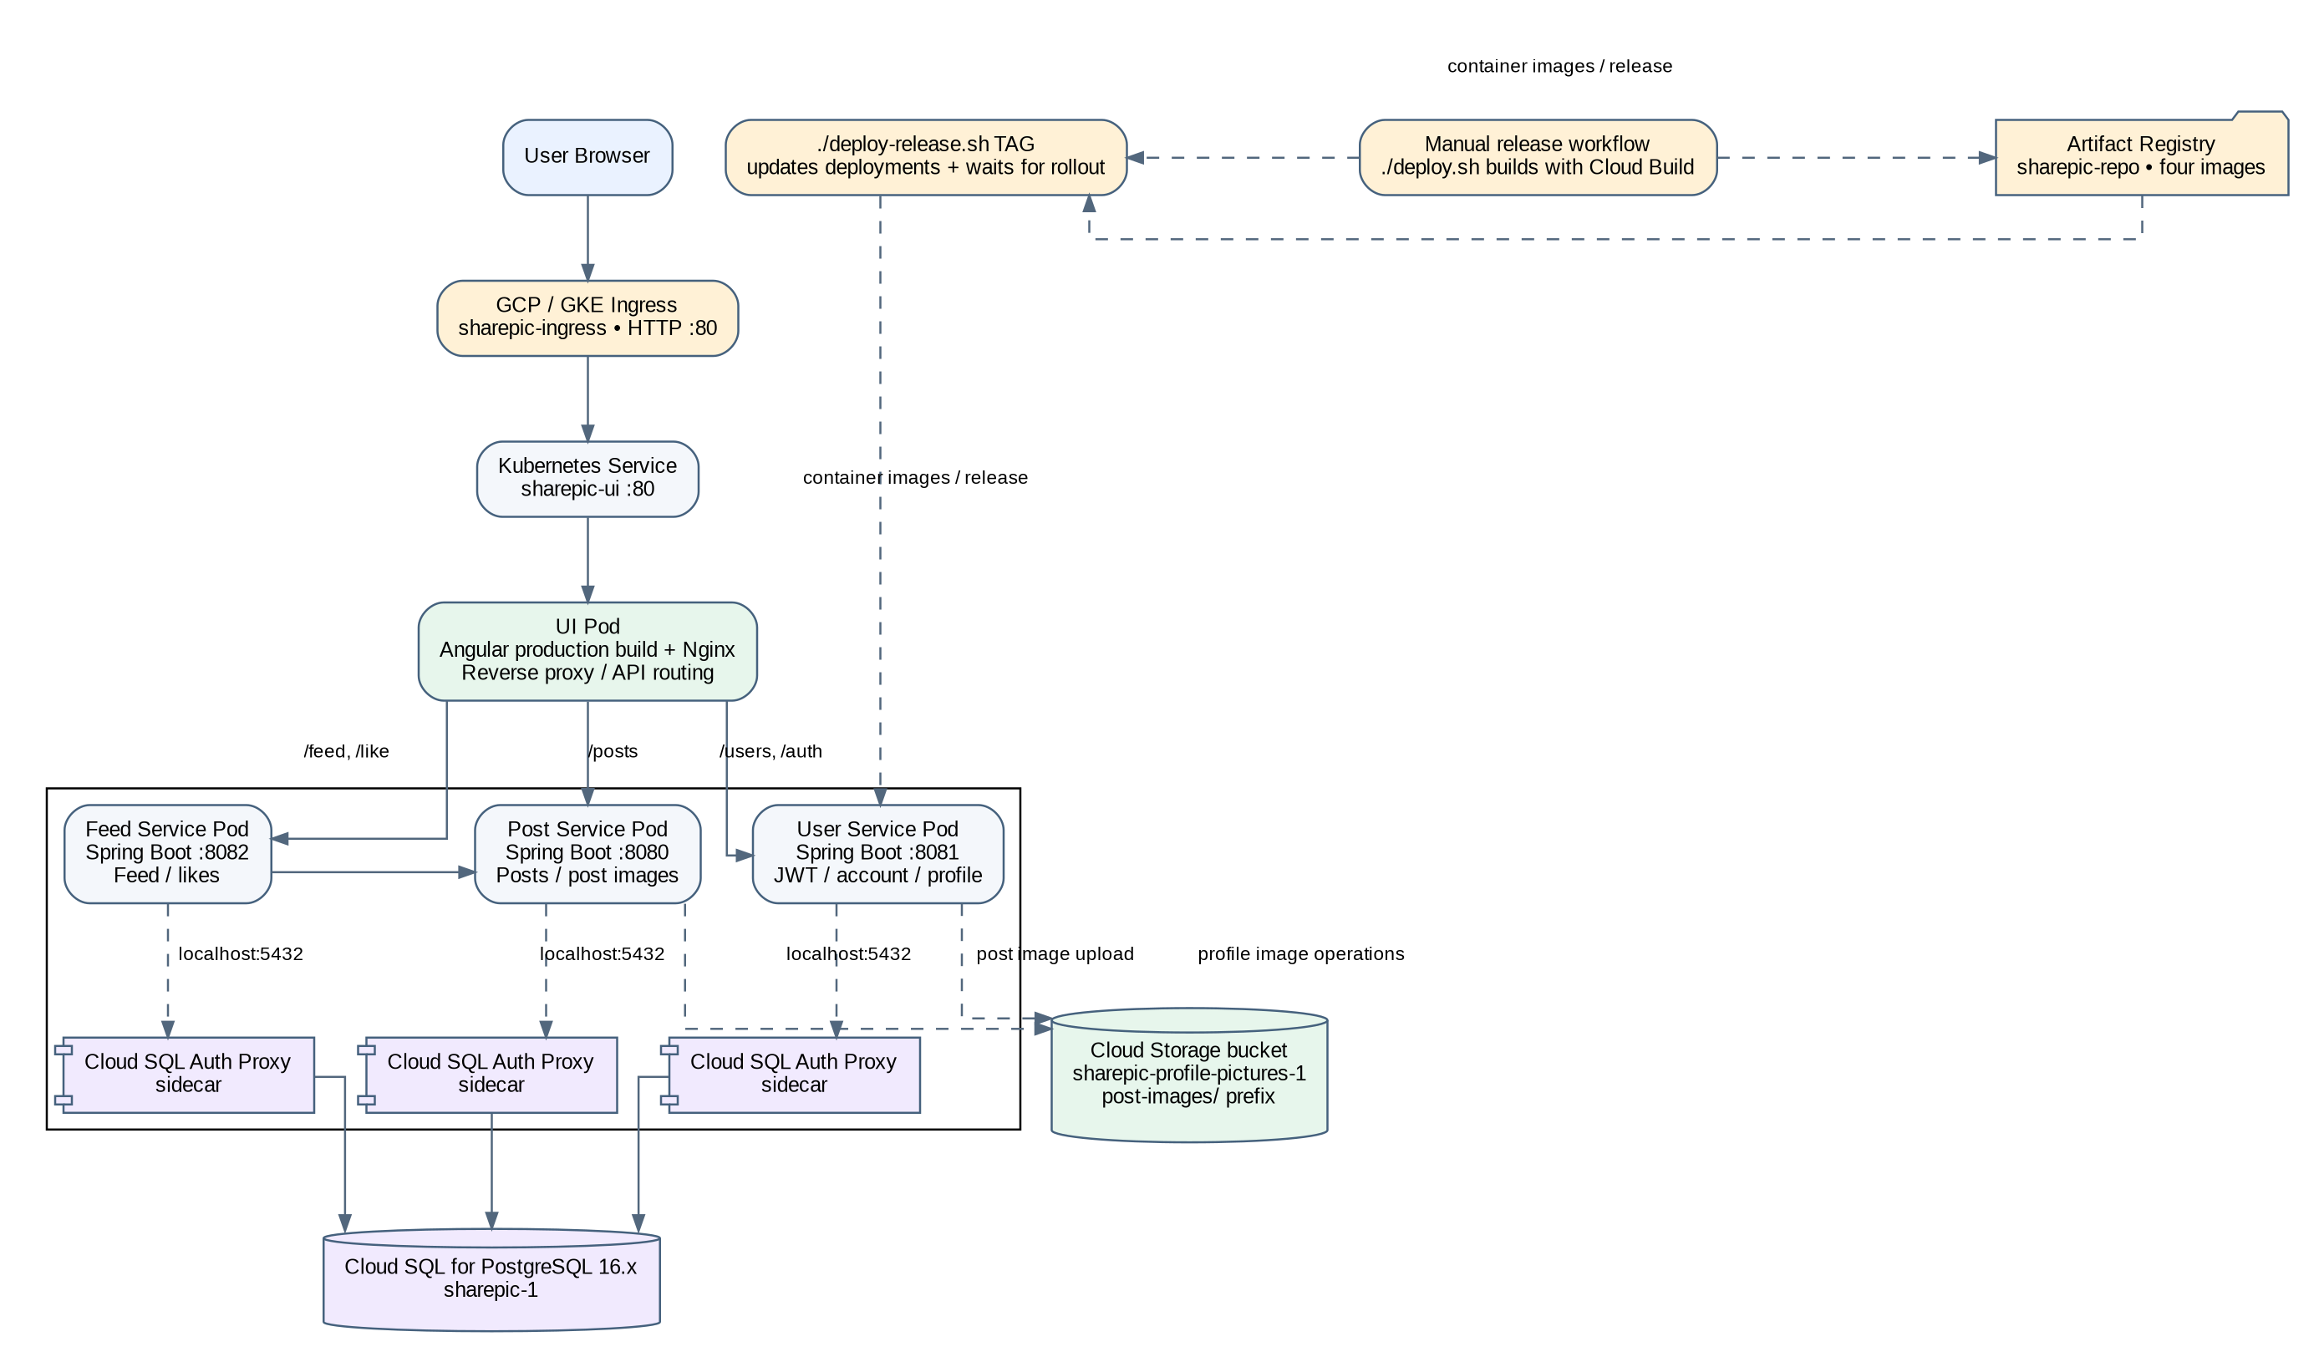
Figure 1. SharePic deployment architecture (verified demo environment; HTTP ingress, single replica per deployment).

4. Application flows

4.1 Login and feed
1. UI sends POST /api/v1/auth/login to User Service.
2. User Service validates credentials and returns user data plus a JWT access token.
3. UI sends Authorization: Bearer <accessToken> to protected APIs.
4. GET /api/v1/feed reaches Feed Service, which calls Post Service and forwards the Authorization header.
5. Post metadata and image URLs are returned to the UI. Image access depends on GCS URL and IAM configuration.

4.2 Create a post
1. UI sends multipart/form-data to POST /api/v1/posts with caption and optional image.
2. Post Service persists metadata and, when supplied, uploads the image object to GCS.
3. PostgreSQL stores the image URL/reference; the feed later returns the post metadata.

4.3 Like a post
1. UI sends POST /api/v1/posts/{postId}/like with a bearer token.
2. Feed Service validates the post through Post Service.
3. A like is recorded with composite key (post_id, user_id). Self-like returns 400; duplicate like returns 409 per API contract.
The following workflow summarizes the main request paths. The diagram is a logical application flow; actual image URL accessibility depends on the configured GCS access policy.
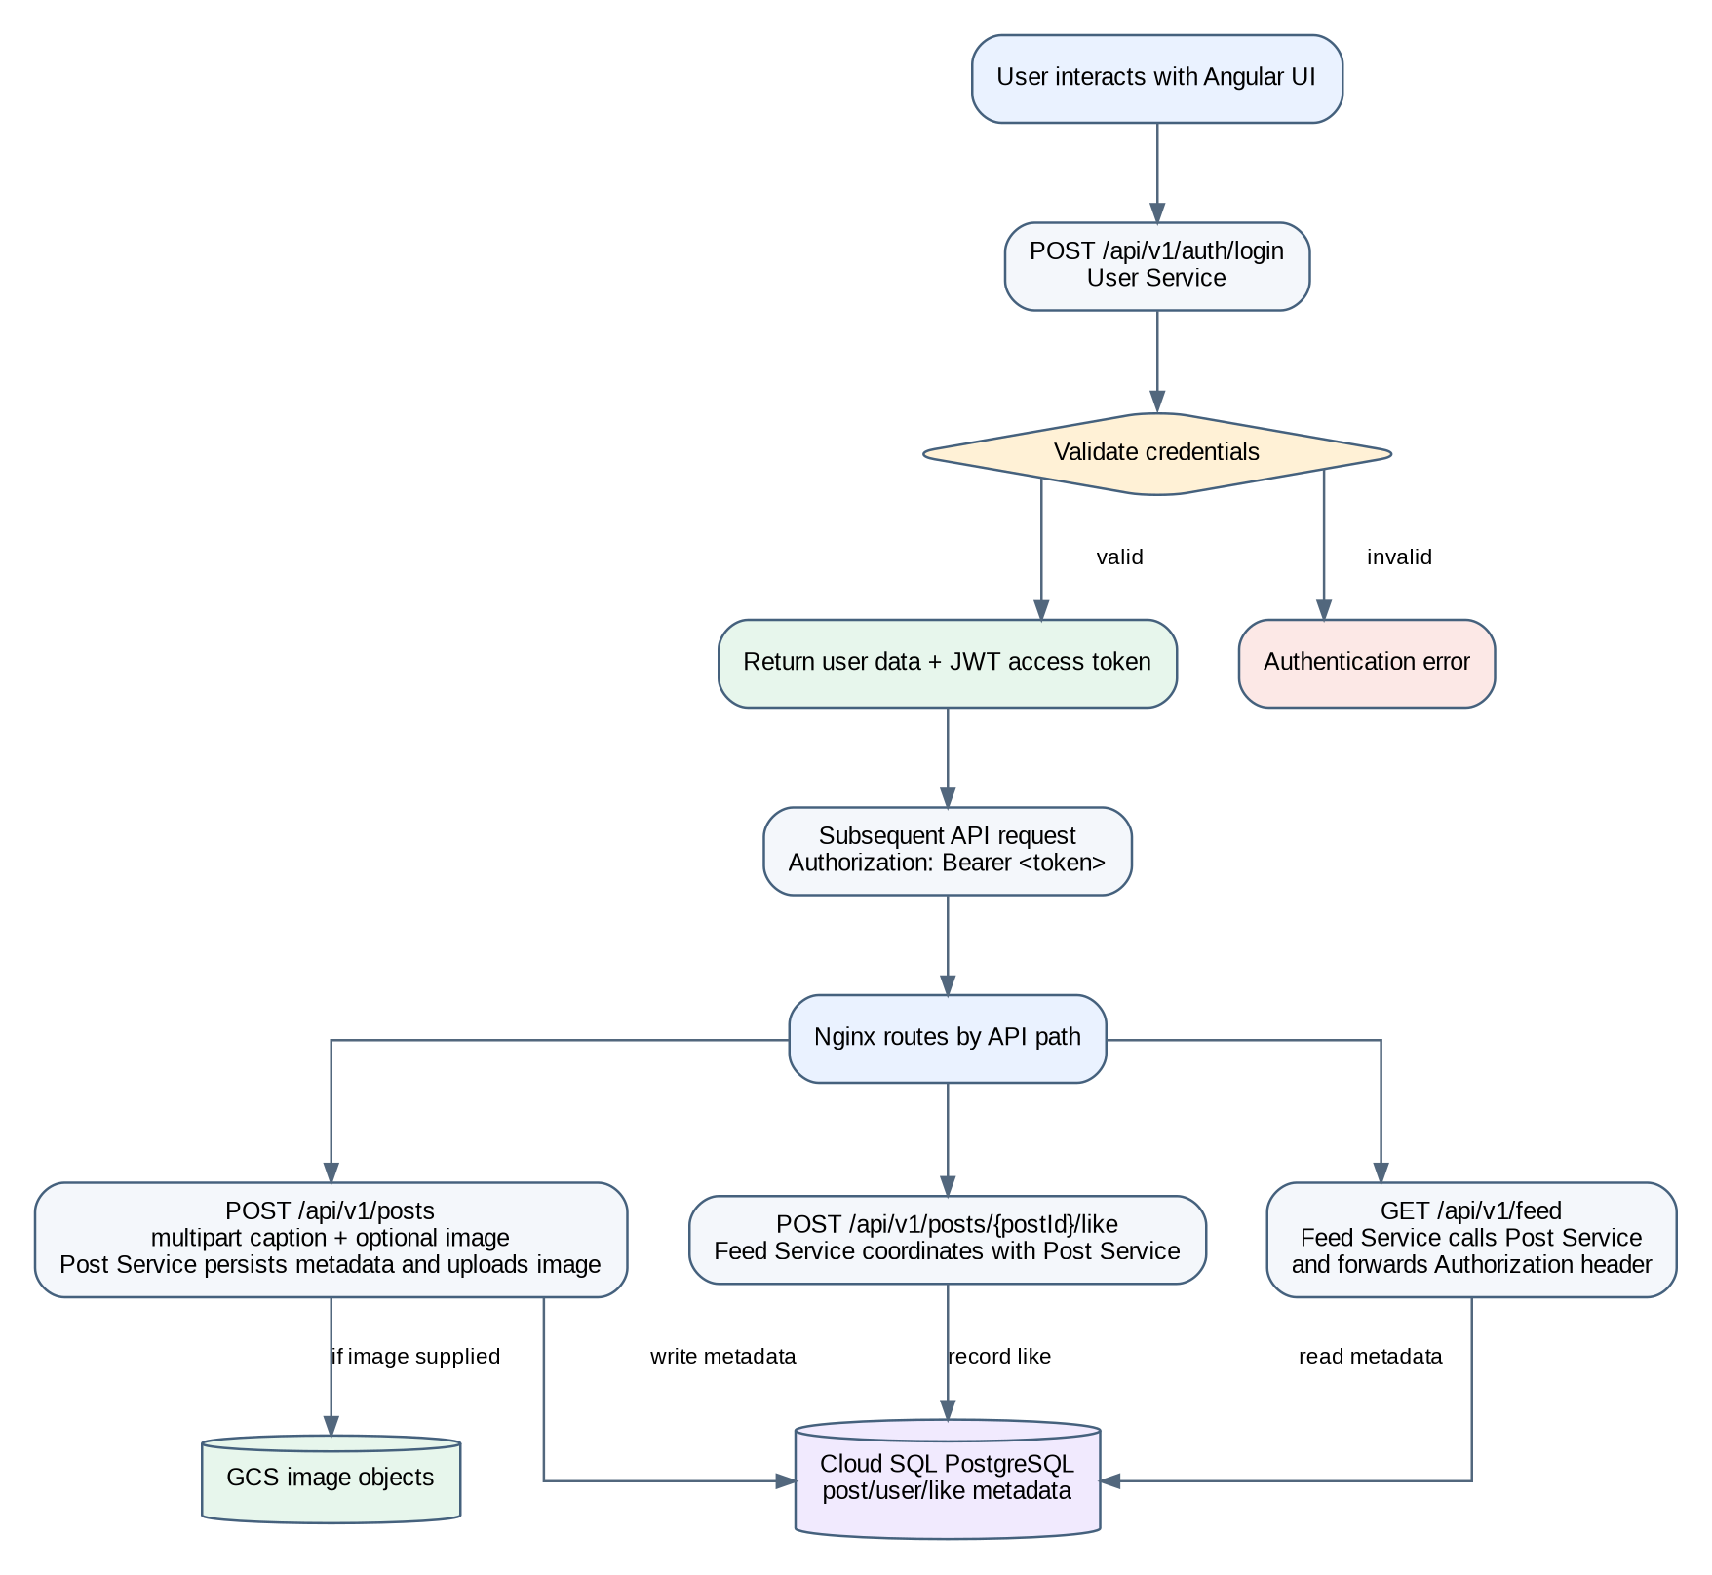
Figure 2. Application workflow: authentication, feed retrieval, post creation and likes.

5. Technology stack
Layer | Technology
Frontend | Angular production build; Nginx
Backend | Java 21; Spring Boot; Maven; Spring Data JPA/Hibernate
Authentication | Username/email + password; JWT bearer tokens; role-based authorities
Database | PostgreSQL 16.x on Cloud SQL
Object storage | Google Cloud Storage
Build/registry | Google Cloud Build; Artifact Registry
Runtime | GKE Autopilot
Ingress | GKE Ingress, HTTP port 80

6. Data model
Table | Key fields | Purpose
users | id UUID PK; user_name; email; password_hash; role; bio; profile_pic_url; timestamps | Account and profile. Username/email unique; password stored as hash.
posts | id UUID PK; user_id; caption; image_url; timestamps | Post metadata. image_url may be null for text-only posts at model level.
post_likes | (post_id UUID, user_id UUID) composite PK; created_at | Like relationship; composite key prevents duplicate user/post rows.
Logical relationships: one user can author many posts; users and posts have a many-to-many like relationship represented by post_likes. Verify deployed foreign keys and exact schema from migrations/live database before making stronger claims.

7. API inventory
Service | Method and path | Purpose | Auth
User | POST /api/v1/users | Register | Public
User | POST /api/v1/auth/login | Login/token | Public
User | GET /api/v1/users/me | Current profile | JWT
User | PUT /api/v1/users/me | Update bio/profilepic multipart | JWT
Post | POST /api/v1/posts | Create post, optional image | JWT
Post | GET /api/v1/posts/{postId} | Get post | JWT
Post | PUT /api/v1/posts/{postId} | Update owned post | JWT
Post | DELETE /api/v1/posts/{postId} | Delete owned post | JWT
Post | GET /api/v1/posts/posts | List newest first | JWT
Feed | GET /api/v1/feed | Feed | JWT
Feed | POST /api/v1/posts/{postId}/like | Like post | JWT
Keep /api/v1/posts/posts as-is unless intentionally changing both clients and service mappings.

8. Security: implemented and caveats
- Current implementation uses JWT bearer-token authentication. JWT is a token format; do not claim a complete OAuth2 flow unless an authorization-server/delegated authorization flow is verified.
- Protected requests use Authorization: Bearer <accessToken>. Post update/delete enforce ownership; like rules reject self-likes and duplicate likes.
- Runtime secret configuration is supplied through Kubernetes Secret sharepic-runtime-secrets. Do not put secret values, passwords, signing keys, bearer tokens or service-account keys in source control.
- HTTPS/TLS is not configured/verified; public ingress is HTTP port 80. Verify password hashing, token expiry/rotation, CORS, secret access and GCS IAM before production use.
JWT request flow (conceptual). Confirm the actual signature algorithm, expiry validation, signing-key source and password hashing implementation in code before presenting those details as verified. JWT is signed, not inherently encrypted. CORS controls browser cross-origin behavior; it is not an authentication or authorization mechanism.
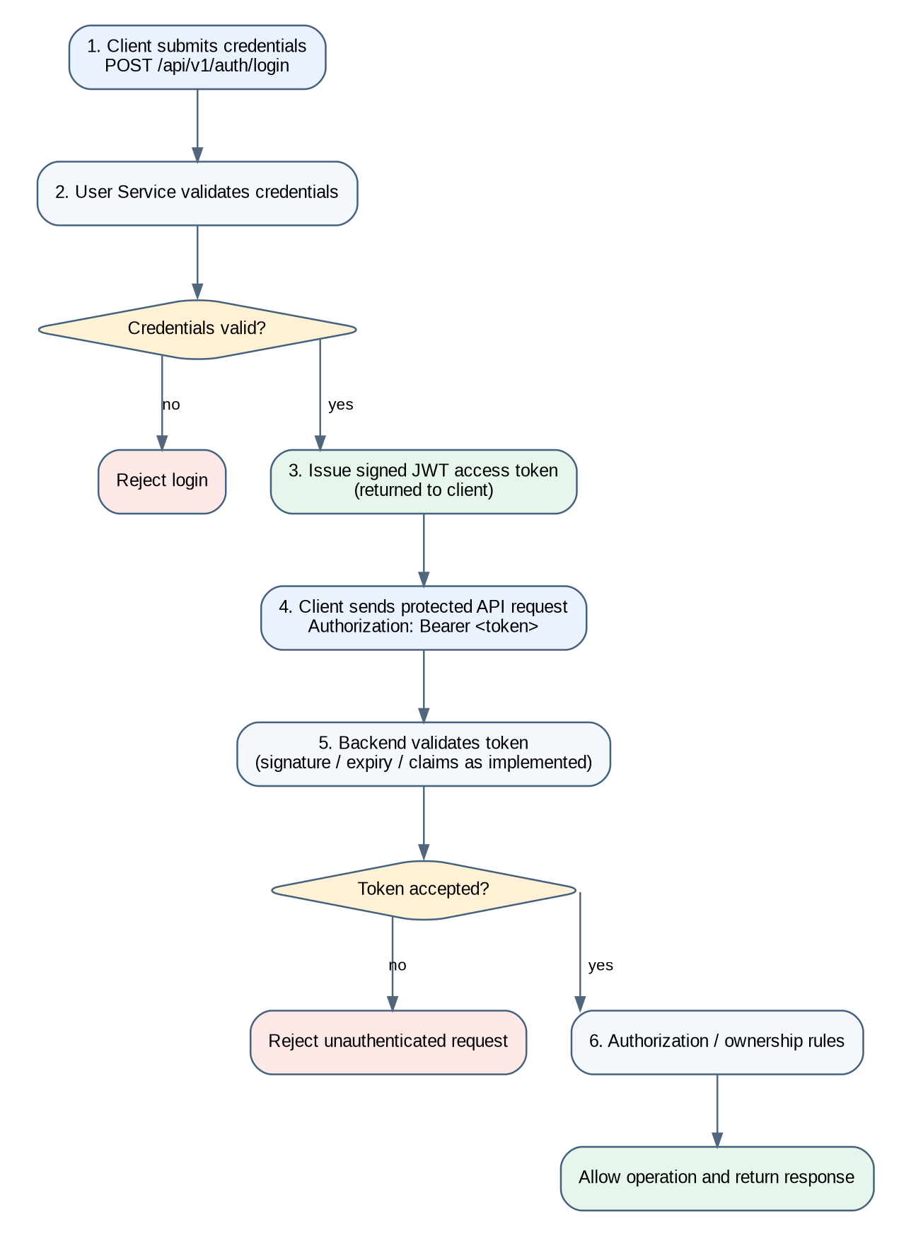
Figure 3. JWT login and protected-request flow. Token checks are shown conceptually and must match the implemented filter/configuration.

9. Deployment automation
Script | What it does | Safety
deploy.sh | Builds four images with Cloud Build and timestamp tag; pushes to Artifact Registry. | Default mode is build-only; does not update GKE.
deploy-release.sh TAG | Checks four image references, prompts for DEPLOY, updates existing deployments with kubectl set image, waits for rollouts. | Deploys a chosen existing release; does not rebuild it.
Release 20261028162646 is verified: four images published, all four rollouts completed, one ready replica per deployment, public frontend HTTP check returned 200. This is manually triggered deployment automation, not full CI/CD. GitHub-triggered builds, automated integration tests and functional-test-based rollback are not verified.
Deployment sequence: (1) operator runs ./deploy.sh to build the four container images with Cloud Build and publish them to Artifact Registry; (2) operator selects the intended existing image tag and runs ./deploy-release.sh TAG; (3) script checks image references, requests explicit DEPLOY confirmation, updates the existing GKE deployments and waits for each rollout; (4) operator verifies deployments/pods and performs browser-level smoke tests. The scripts are manually invoked; successful rollout and HTTP 200 do not establish end-to-end correctness.

10. Availability and operational gaps
Area | Current evidence | Not yet verified / next step
Replicas | 1 ready replica per deployment | Multiple replicas, PDB, topology and failure testing
Autoscaling | No HPA verified | Define metrics and test HPA
Ingress | HTTP :80 | Configure HTTPS/TLS if required
Cloud SQL | Auth Proxy sidecar configured | Verify HA, backups, PITR and restore test
GCS | Bucket used by app | Verify least privilege, retention/versioning and recovery
Monitoring | Full application monitoring not verified | Review logs, alerts, uptime checks and dashboard
Functional tests | Rollout + frontend HTTP 200 checked | Browser test login/feed/post/image/like/logout; text-only post and profile UI

11. Open items
- Complete the browser smoke test including text-only post and profile-edit UI.
- Verify deployed database schema/foreign keys.
- Clarify OAuth2 requirement; describe JWT implementation accurately.
- Configure HTTPS/TLS before non-demo exposure.
- Verify token expiry, password hashing, CORS, GCS IAM and secret access.
- Verify Cloud SQL HA/backups/restore and GCS retention.
- Consider HPA/multiple replicas and GitHub-triggered CI/CD after the demo.

JWT Authentication Flow
The following flow illustrates how a user obtains a JWT during login and how the token is supplied to protected SharePic APIs. It reflects the documented login endpoint and bearer-token usage; service-level validation details should be confirmed against the implementation.
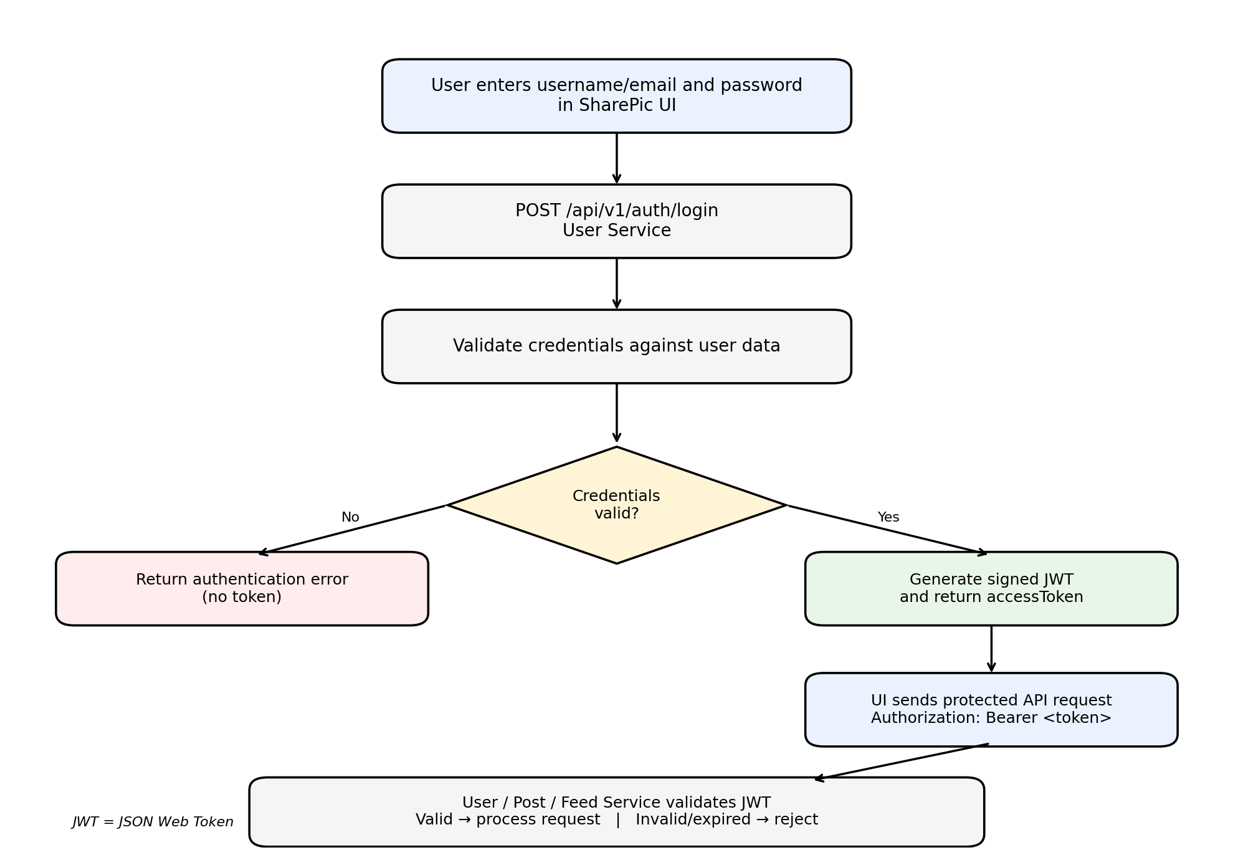
Figure: SharePic JWT authentication and protected API request flow

Flow summary
- The user submits login credentials through the SharePic UI to POST /api/v1/auth/login on the User Service.
- The User Service validates the credentials. Invalid credentials result in an authentication error and no access token.
- For valid credentials, the service returns an accessToken containing a signed JWT.
- The UI includes the token in the Authorization: Bearer <access-token> header when calling protected endpoints.
- The relevant User, Post, or Feed Service validates the token before processing the request; invalid or expired tokens should be rejected.

