RV FITNESS – GYM MANAGEMENT SYSTEM
Comprehensive Technical Architecture & Operations Guide
Gym Location: Narsobawadi, Maharashtra, India | Version: 1.0 (Production-Ready)
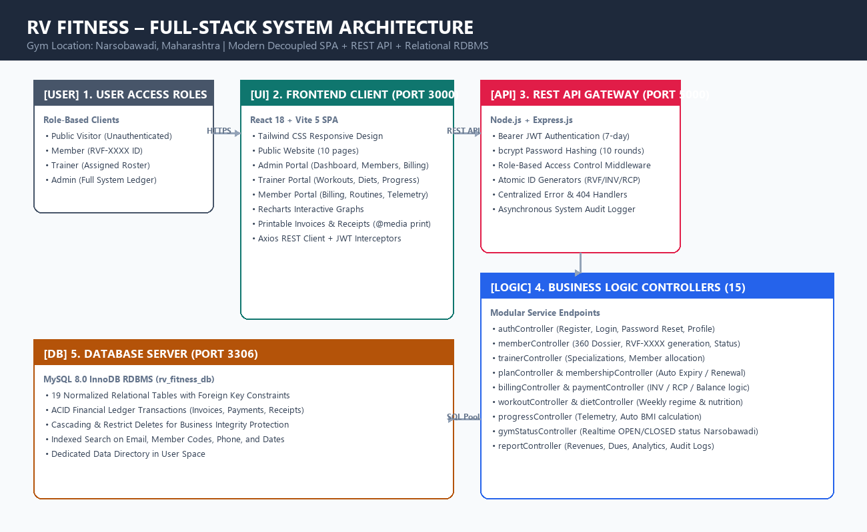
Figure 1: Full-Stack System Architecture of RV Fitness Narsobawadi

1. Executive Summary & Technology Stack
RV Fitness is a comprehensive full-stack gym management platform engineered for commercial gym operations in Narsobawadi. The system is not a UI prototype; every feature is linked to a live MySQL 8.0 relational database with atomic billing transactions, JWT role-based security, member management, trainer assignment, custom workout and diet plans, biometric telemetry tracking, and an operational gym status CMS.
Architecture Layer | Technology Chosen | Core Responsibility
Frontend Framework | React 18 + Vite 5 | Component SPA, Hot Module Replacement, Client Routing
Styling & Icons | Tailwind CSS + Lucide React | Responsive utility classes, fitness branding, mobile navigation
Data Visualization | Recharts 2.13 | Interactive charts for weight progress and business KPIs
HTTP Client | Axios 1.7 | Centralized REST client, JWT injection, 401 session recovery
Backend Runtime | Node.js 20 LTS + Express.js | Modular REST API, asynchronous I/O, error handling middleware
Database Server | MySQL 8.0 (InnoDB) | 19 normalized tables, foreign keys, ACID financial ledgers
Authentication | JWT + bcryptjs | Stateless 256-bit token signing and 10-round salted password hashes
Print Engine | Native CSS @media print | Pixel-perfect official invoices and payment receipts

2. Relational Database Design (19 Normalized Tables)
The relational database schema is stored under rv_fitness_db and strictly enforces foreign key referential integrity using MySQL 8.0 InnoDB engine with utf8mb4 collation.
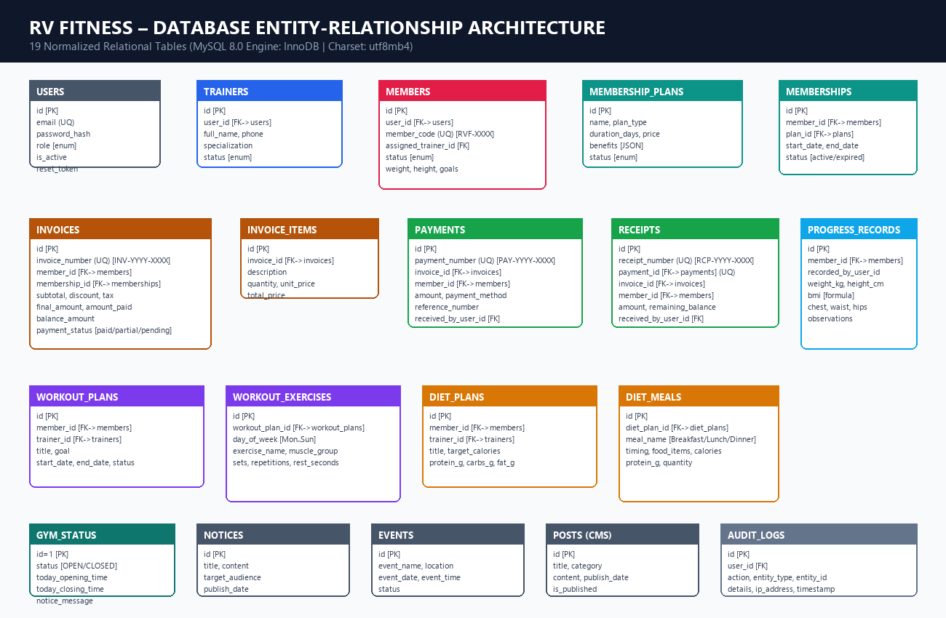
Figure 2: Entity-Relationship Diagram of the 19 Normalized Relational Tables
Table Name | Primary Keys & FKs | Description & Critical Columns
users | id (PK) | System authentication: email (unique), password_hash, role (admin/trainer/member), is_active
trainers | id (PK), user_id (FK->users) | Trainer roster: full_name, phone, specialization, experience_years, bio, status
members | id (PK), user_id (FK), assigned_trainer_id (FK) | Member directory: member_code (RVF-XXXX, UQ), full_name, phone, height, weight, goals
membership_plans | id (PK) | Plan tiers: name, plan_type (Monthly/Quarterly/Annual), duration_days, price, benefits (JSON)
memberships | id (PK), member_id (FK), plan_id (FK) | Active subscriptions: start_date, end_date, status (active, expiring_soon, expired)
invoices | id (PK), member_id (FK), membership_id (FK) | Billing documents: invoice_number (INV-YYYY-XXXX), final_amount, amount_paid, balance, status
invoice_items | id (PK), invoice_id (FK->invoices) | Line item charges: description, quantity, unit_price, total_price
payments | id (PK), invoice_id (FK), member_id (FK) | Cash/UPI transactions: payment_number (PAY-YYYY-XXXX), amount, method, reference
receipts | id (PK), payment_id (FK, UQ), invoice_id (FK) | Official receipts: receipt_number (RCP-YYYY-XXXX), amount, remaining_balance, cashier
workout_plans | id (PK), member_id (FK), trainer_id (FK) | Personalized routine headers: title, goal, start_date, end_date, status
workout_exercises | id (PK), workout_plan_id (FK) | Daily exercises: day_of_week (Mon..Sun), exercise_name, muscle_group, sets, reps, rest
diet_plans | id (PK), member_id (FK), trainer_id (FK) | Macronutrient diet charts: title, target_calories, protein_g, carbs_g, fat_g
diet_meals | id (PK), diet_plan_id (FK) | Scheduled meals: meal_name (Breakfast..Dinner), timing, food_items, calories, quantity
progress_records | id (PK), member_id (FK), recorded_by (FK) | Biometric telemetry: weight_kg, height_cm, bmi (calculated), chest, waist, hips, arms, observations
notices | id (PK), created_by_user_id (FK) | Internal and public notices: title, content, target_audience (all/members/trainers)
events | id (PK) | Competitions and workshops: event_name, event_date, event_time, location (Narsobawadi)
posts | id (PK) | CMS articles: title, category (tip/achievement/update/offer), content, is_published
gym_status | id=1 (Singleton PK) | Realtime operational status: status (OPEN/CLOSED/HOLIDAY), opening_time, closing_time, notice
audit_logs | id (PK), user_id (FK) | Security audit trail: action, entity_type, entity_id, details, ip_address, timestamp

3. Authentication & Role-Based Access Control (RBAC)
The security architecture employs stateless 256-bit JSON Web Tokens (JWT) coupled with 10-round salted bcrypt password hashes. Plain text passwords are never stored.
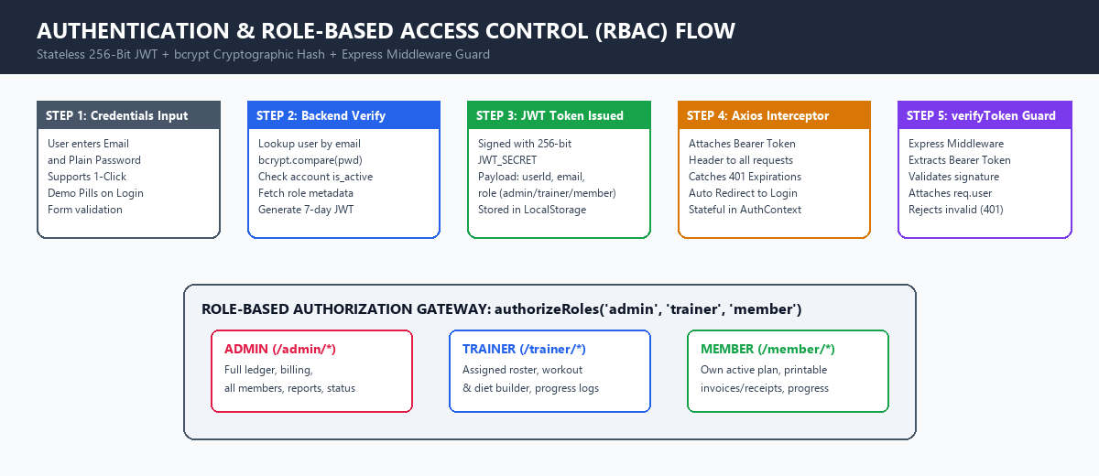
Figure 3: Authentication Lifecycle and Role-Based Route Guards

Core Security Components
1. verifyToken Middleware: Validates incoming HTTP requests containing the Authorization: Bearer <token> header. Verifies the token against process.env.JWT_SECRET, confirms the user exists and is_active in MySQL, and populates req.user.
2. authorizeRoles Middleware: Restricts route access based on user role. Accepts allowed roles (e.g. authorizeRoles('admin')) and returns HTTP 403 Forbidden if the user lacks adequate permissions.
3. ProtectedRoute Component: Guards client-side React routes. Verifies authentication state from AuthContext, validates role permissions, and redirects unauthorized visitors to /login or role dashboards.

4. Billing, Invoices & Payment Ledger
The financial module guarantees strict consistency. All payments atomically adjust invoice amounts, prevent overpayments, and issue sequential receipts.
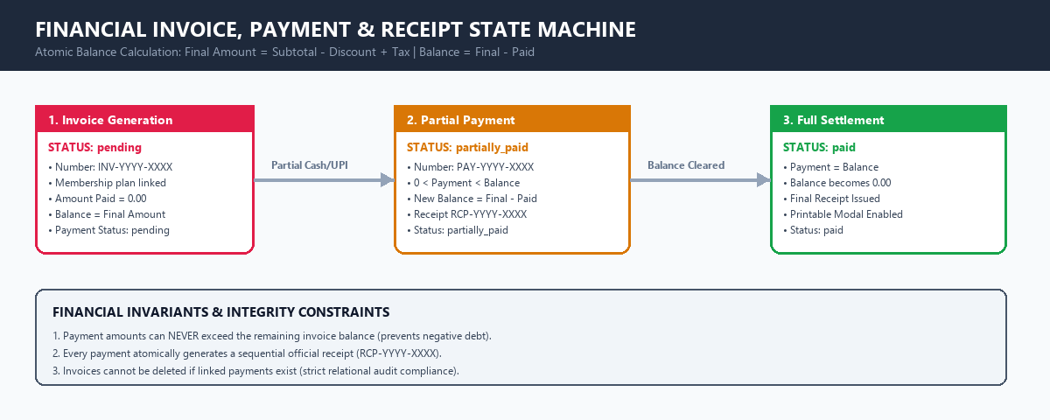
Figure 4: Financial Invoice and Payment State Machine

Mathematical Ledger Rules
• Final Amount Formula: Final Amount = Subtotal - Discount + Tax Amount
• Balance Formula: Remaining Balance = Final Amount - Total Amount Paid
• Payment Validation: A payment is valid if and only if: 0 < Payment Amount <= Remaining Balance. Payments exceeding balance are blocked.
• Status Transitions: Invoices transition from 'pending' (0 paid) to 'partially_paid' (partial balance remaining) to 'paid' (balance = 0.00).

5. Member Lifecycle & Coaching Telemetry
Members experience a structured lifecycle from initial onboarding to trainer allocation, customized weekly routines, dietary guidance, and biometric progress tracking.
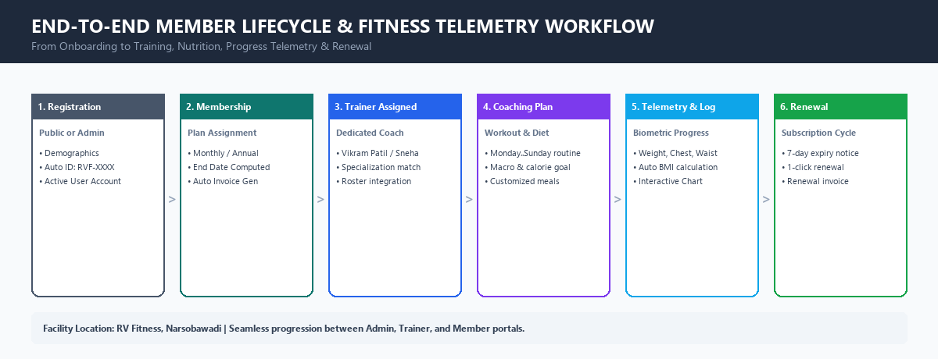
Figure 5: End-to-End Member Progression & Telemetry Workflow

Biometric Telemetry & BMI Calculation
• Automated Telemetry: Whenever a trainer records a progress check-in, the system automatically computes the member's Body Mass Index (BMI): BMI = weight_kg / (height_m ^ 2). Measurements for chest, waist, hips, arms, and thighs are preserved chronologically and visualized via Recharts.

6. Complete Backend Function Reference (15 Controllers)
Below is the exhaustive catalog of all functions across the 15 backend controller modules:
Controller Module | Exported Functions | Key Logic & DB Operations
authController.js | register, login, getMe, forgotPassword, resetPassword, updateProfile, generateToken | User registration with RVF-XXXX allocation, password comparison, JWT signing, profile updates
memberController.js | getMembers, getMemberById, createMember, updateMember, toggleMemberStatus, deleteMember | Full-text search, 360-degree member dossier aggregation, status toggles, referential integrity check
trainerController.js | getTrainers, getTrainerById, createTrainer, updateTrainer, toggleTrainerStatus | Trainer hiring, client count subqueries, specialization updates, member roster
planController.js | getPlans, createPlan, updatePlan, togglePlanStatus | Membership plan tiers, JSON benefits parsing, price management
membershipController.js | getMemberships, assignMembership, renewMembership, cancelMembership | Auto date calculation (end_date = start_date + duration), automatic renewal invoice creation
billingController.js | getInvoices, getInvoiceById, createInvoice, cancelInvoice | Sequential INV-YYYY-XXXX generation, line items insertion, payment status monitoring
paymentController.js | getPayments, recordPayment, getReceipts, getReceiptById | Atomic payment recording, balance recalculation, RCP-YYYY-XXXX receipt generation
workoutController.js | getWorkoutByMemberId, createWorkoutPlan, deleteWorkoutPlan | Weekly schedule authoring (Mon..Sun), exercise grouping, sets and reps assignment
dietController.js | getDietByMemberId, createDietPlan, deleteDietPlan | Nutrition chart builder, daily calorie goals, scheduled meals breakdown
progressController.js | getProgressByMemberId, recordProgress, deleteProgress | Telemetry logging, automated BMI calculation, chronological ordering for charts
noticeController.js | getNotices, createNotice, deleteNotice | Gym announcements targeted to all, members, or trainers
eventController.js | getEvents, createEvent, deleteEvent | Community bootcamps, workshops, competitions in Narsobawadi
postController.js | getPosts, createPost, deletePost | CMS updates, transformation achievements, workout tips, offers
gymStatusController.js | getGymStatus, updateGymStatus | Realtime operational status (OPEN/CLOSED/HOLIDAY), operating hours
reportController.js | getAdminDashboard, getTrainerDashboard, getMemberDashboard, getReports, getAuditLogs | Analytical reports (revenue, dues, rosters), live KPI summaries, audit trail

7. Frontend Page Catalog (25 Distinct Views)
The frontend is structured into 4 role-based view portals:
1. Public Website (10 Views): Home, About, Facilities, Membership Plans, Trainers, Photo Gallery, Announcements, Gym Status, Contact (Narsobawadi), and Public Navigation/Footer.
2. Authentication Portal (3 Views): Login (with 1-Click Quick Demo Login Pills), Register (Public Member Onboarding), and Forgot Password.
3. Admin Portal (10 Views): Executive Dashboard (Recharts KPIs), Member Directory, Member 360 Detail, Trainer Management, Plan Editor, Invoice Ledger, Payment Processing, Analytics & Reports, Content CMS, and Security Audit Logs.
4. Trainer Portal (5 Views): Trainer Dashboard, Assigned Client Roster, Weekly Workout Manager, Diet & Nutrition Manager, and Biometric Progress Logger.
5. Member Portal (7 Views): Member Home Dashboard, Personal Profile, Invoices & Payment Receipts, Assigned Workout Schedule, Diet Chart, Weight Progress Chart, and Gym Bulletins.
6. Printable Document Modals: PrintInvoiceModal (official tax invoice) and PrintReceiptModal (official fee receipt) with @media print stylesheets.

8. Operational Batch Launchers & Demo Credentials
To ensure continuous operation without dependency on terminal sessions, three standalone batch files are provided:
• START_RV_FITNESS.bat: Double-click to start MySQL (Port 3306), Node Backend (Port 5000), and Vite Frontend (Port 3000), automatically opening the browser to http://127.0.0.1:3000.
• STOP_RV_FITNESS.bat: Cleanly stops all background services with one double-click.
• PUSH_TO_GITHUB.bat: Synchronizes and pushes repository commits to GitHub (https://github.com/tejasbuwa/RV-Fitness-Gym-Management-System.git).
Role | Name | Email | Password
Admin | Super Admin | admin@rvfitness.com | Admin@123
Trainer | Vikram Patil | vikram@rvfitness.com | Trainer@123
Trainer | Sneha Kulkarni | sneha@rvfitness.com | Trainer@123
Member | Rohit Deshmukh (RVF-0001) | rohit@gmail.com | Member@123
Member | Ananya Joshi (RVF-0002) | ananya@gmail.com | Member@123
Member | Sachin More (RVF-0003) | sachin@gmail.com | Member@123

