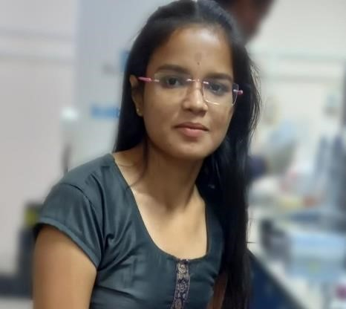 Kshitija Kadam

Software Developer

# My Contact

* kshitijakadam@gmail.com o 7517052003
* Wakad, Pune
* [https://www.linkedin.com/in/kshitij](https://www.linkedin.com/in/kshitijakadamswd)

[akadamswd](https://www.linkedin.com/in/kshitijakadamswd)

# Technical Skill

* SQL(RDBMS)
* Java

# Soft Skill

* Leadership
* Collaboration
* Adaptability
* Communication
* Creative
* Problem solving

# Education Background

* BTech Biotechnology - 83%(2022)
* Maharashtra Vidyalaya (2018)

# Personal Details

o DOB: 15/04/2000 o Hobbies: Sketching, Painting, Learning languages o Permanent Address: 805 Kasba Peth, Barshi

# Objectives

A dedicated and result-oriented IT professional possessing a passion for programming and seeking for career to make the most of my coding skills and knowledge possessed for goals and ambitions of the organization.

# Achivements

* Class Representative in college
* State level Boxing player
* Many awards in Sketching
* Research works- 1.Genetic Diversity in pomegranate

2.Image J software

3.Invitro propagation on Bhagwa