Solar Radiation Prediction Results - CatBoost Classifier

# Distribution of UNIXTime

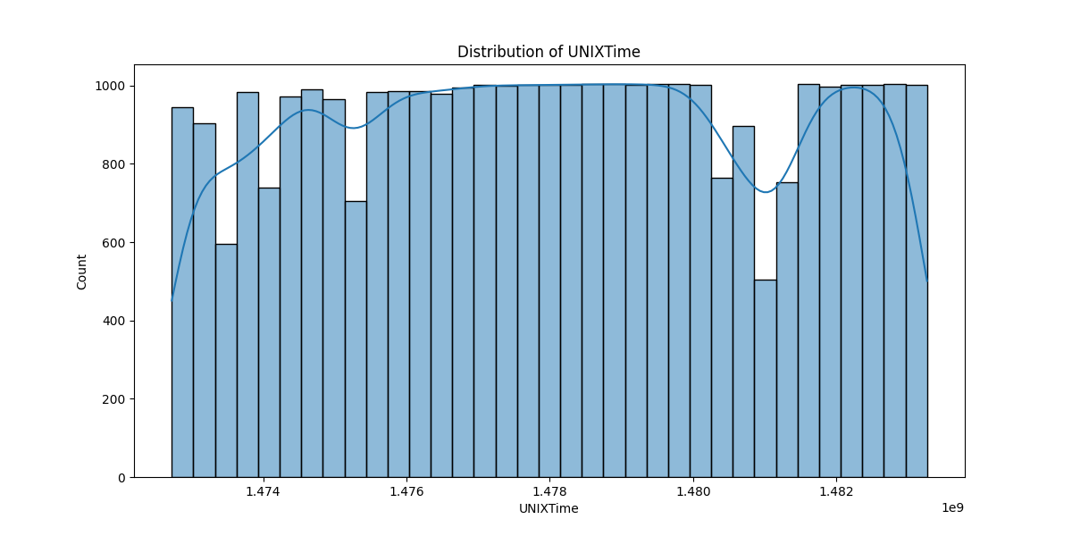

# Correlation Heatmap

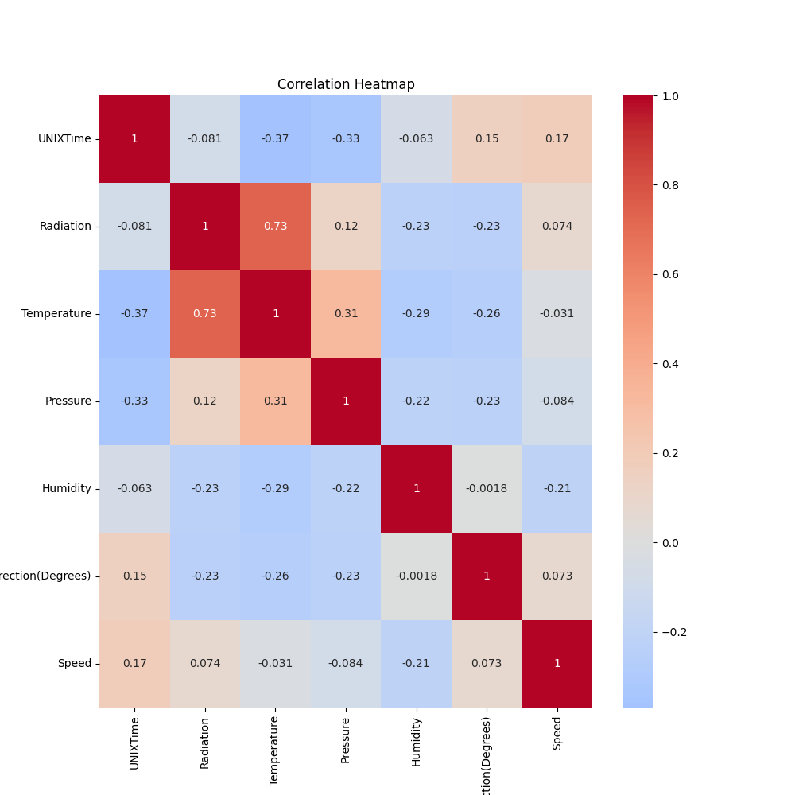

# Classification Metrics

Accuracy: 0.9230063226595961

Precision: 0.9664742451154529

Recall: 0.8781521081299173

F1 Score: 0.9201987104957192

# Cross-Validation Results

Cross-Validation Accuracy Scores: [0.87090853 0.69103701 0.53716733 0.54083818 0.65279902 0.56255736  
 0.65728274 0.60954712 0.75734394 0.5869033 ]

Mean CV Accuracy Score: 0.6466384544849

Standard Deviation of CV Accuracy Scores: 0.09993326328267033

# True vs Predicted Radiation Classes

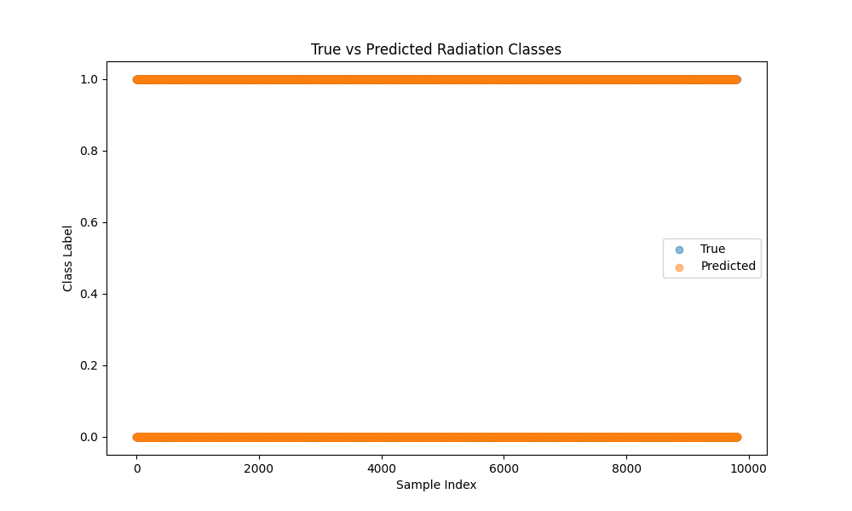

# Distribution of Residuals

