Solar Radiation Prediction Results - Gradient Boosting Classifier

# Distribution of UNIXTime

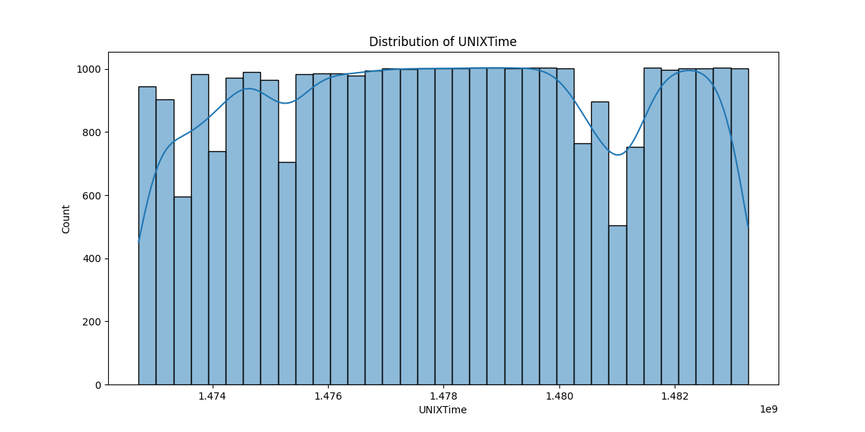

# Correlation Heatmap

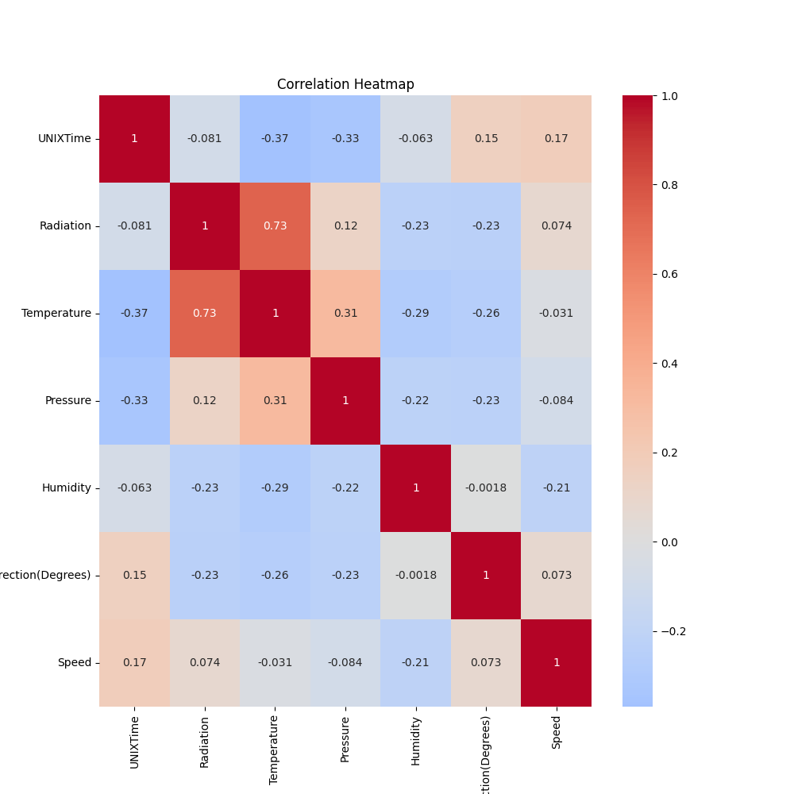

# Classification Metrics

Accuracy: 0.8634509483989394

Precision: 0.9290796963946869

Recall: 0.7901956828727053

F1 Score: 0.8540281260220212

# Cross-Validation Results

Cross-Validation Accuracy Scores: [0.89660447 0.61853778 0.48455185 0.75007648 0.84704803 0.69531967  
 0.78365973 0.61077111 0.750612 0.64749082]

Mean CV Accuracy Score: 0.7084671928314388

Standard Deviation of CV Accuracy Scores: 0.11637121418029059

# True vs Predicted Radiation Classes

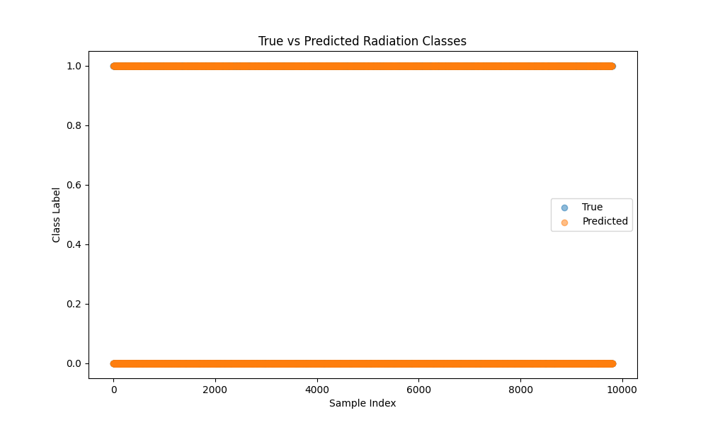

# Distribution of Residuals

