Solar Radiation Prediction Results - NGBoost Classifier

# Distribution of UNIXTime

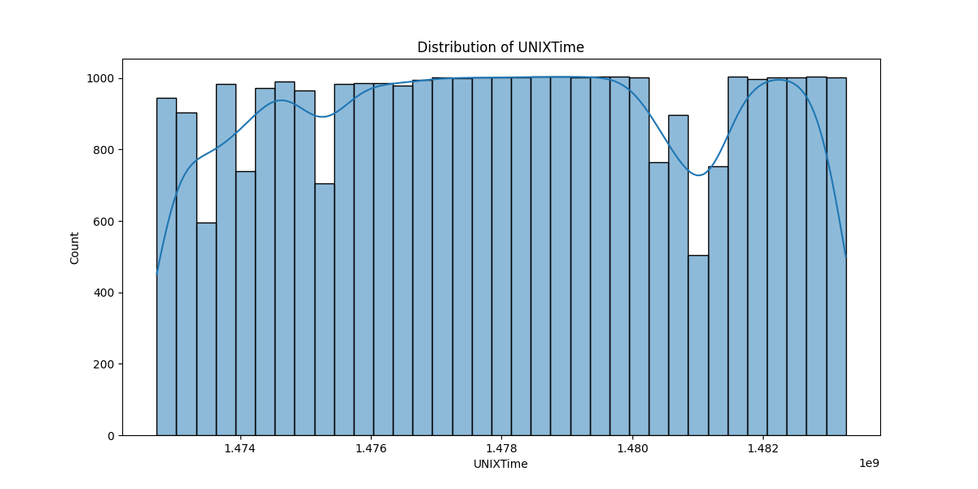

# Correlation Heatmap

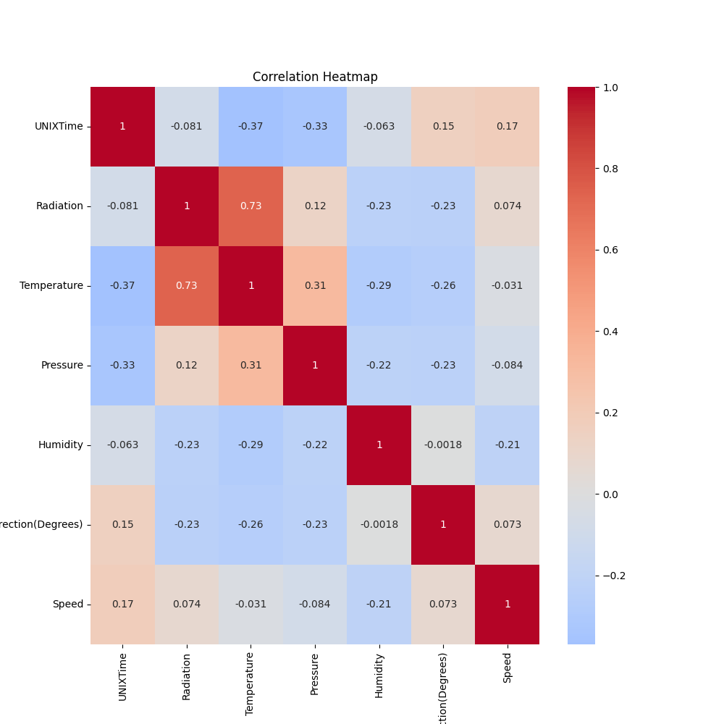

# Classification Metrics

Accuracy: 0.8345910666938609

Precision: 0.9068065381800439

Recall: 0.749848698809764

F1 Score: 0.8208922261484098

# Cross-Validation Results

Cross-Validation Accuracy Scores: [0.8990517 0.78464362 0.78403181 0.83878862 0.84765983 0.79320893  
 0.8623011 0.86474908 0.83476132 0.67044064]

Mean CV Accuracy Score: 0.8179636663243188

Standard Deviation of CV Accuracy Scores: 0.06079892404196497

# True vs Predicted Radiation Classes

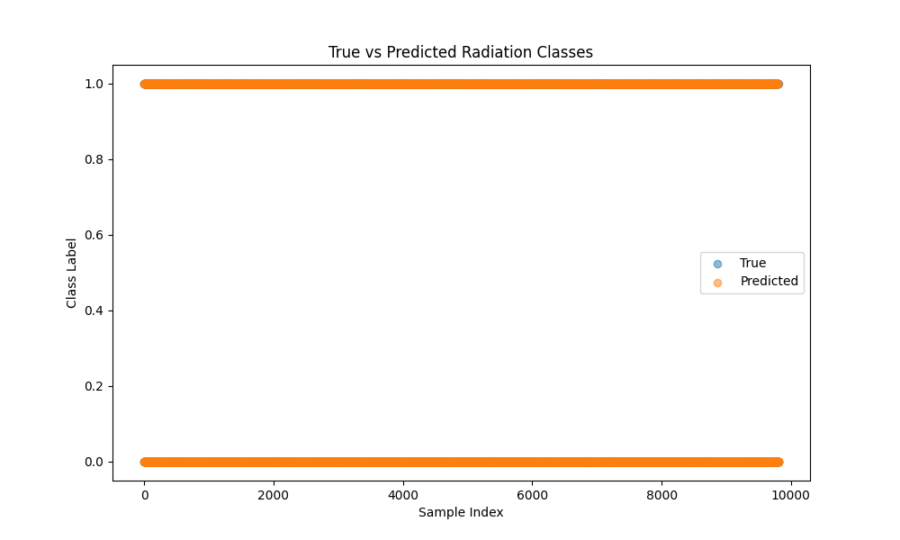

# Distribution of Residuals

