Solar Radiation Prediction Results - NGBoost Regressor

# Distribution of UNIXTime

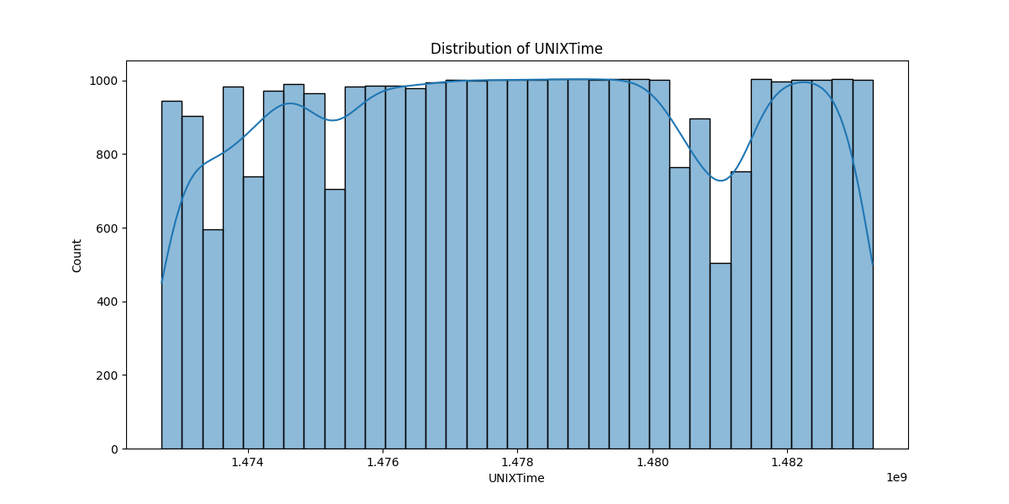

# Correlation Heatmap

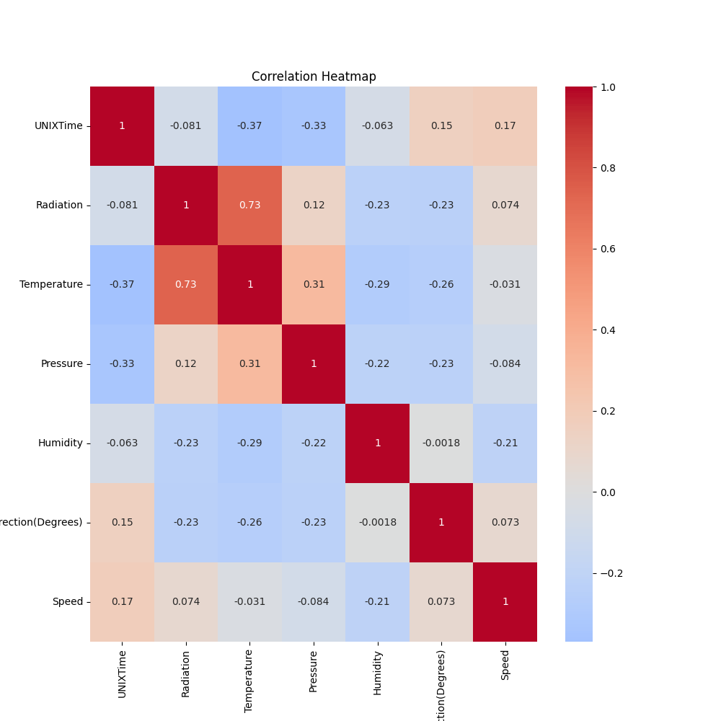

# Regression Metrics

R2 Score: 0.7333727998119616

Mean Squared Error (MSE): 26925.539381892875

Root Mean Squared Error (RMSE): 164.09003437714574

Mean Absolute Error (MAE): 103.20612624457887

# Cross-Validation Results

Cross-Validation MSE Scores: [33642.13239809 35353.02883696 32958.89420405 63162.91516247  
 35586.11527421 43714.46477245 35466.55974538 25204.50840552  
 25232.98870776 28862.89133232]

Mean CV MSE Score: 35918.44988392145

Standard Deviation of CV MSE Scores: 10470.73162940581

# True vs Predicted Radiation Values

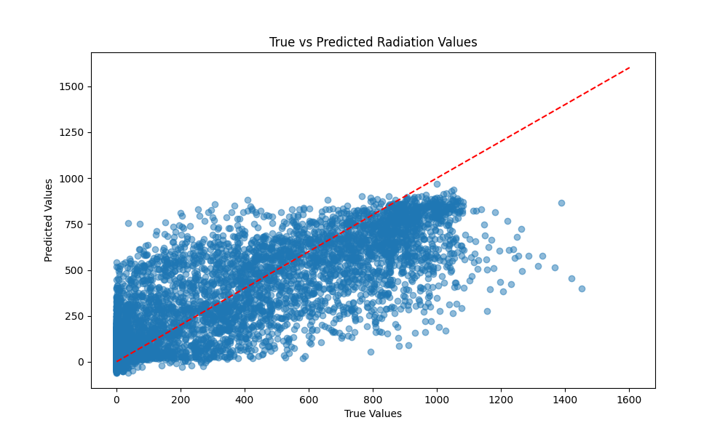

# Distribution of Residuals

