Solar Radiation Prediction Results - Random Forest Classifier

# Distribution of UNIXTime

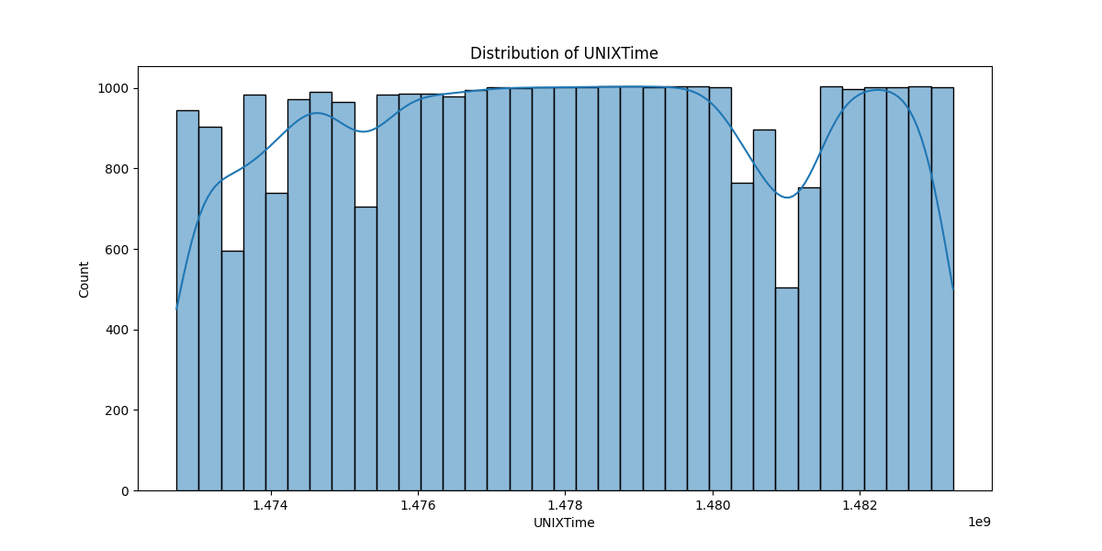

# Correlation Heatmap

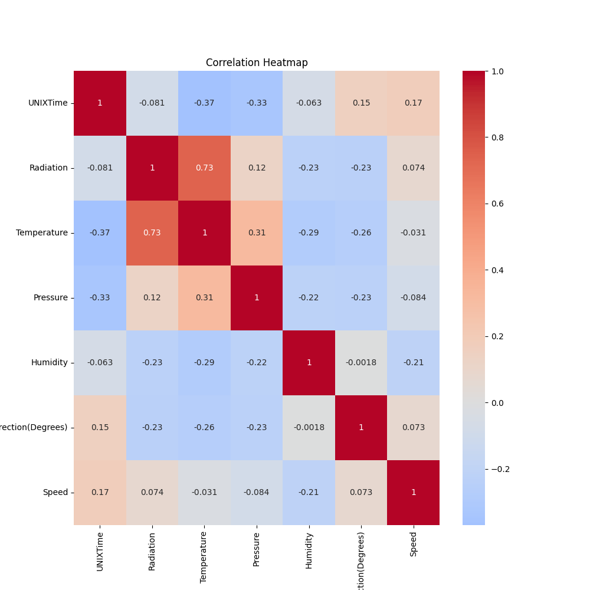

# Classification Metrics

Accuracy: 0.9464613501937589

Precision: 0.965546218487395

Recall: 0.9271736937663909

F1 Score: 0.9459709786971288

# Cross-Validation Results

Cross-Validation Accuracy Scores: [0.81706944 0.59620679 0.45029061 0.51361273 0.69654329 0.62251453  
 0.59608323 0.61168911 0.71787026 0.5997552 ]

Mean CV Accuracy Score: 0.6221635178279846

Standard Deviation of CV Accuracy Scores: 0.09796423930594024

# True vs Predicted Radiation Classes

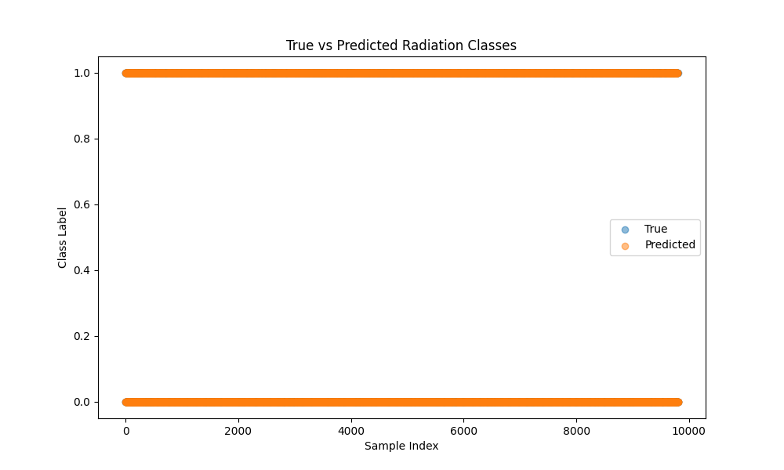

# Distribution of Residuals

