Solar Radiation Prediction Results - SGD Regressor

# Distribution of UNIXTime

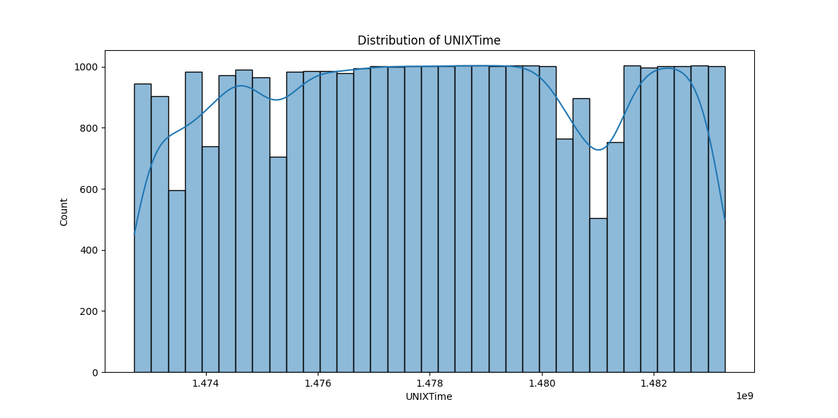

# Correlation Heatmap

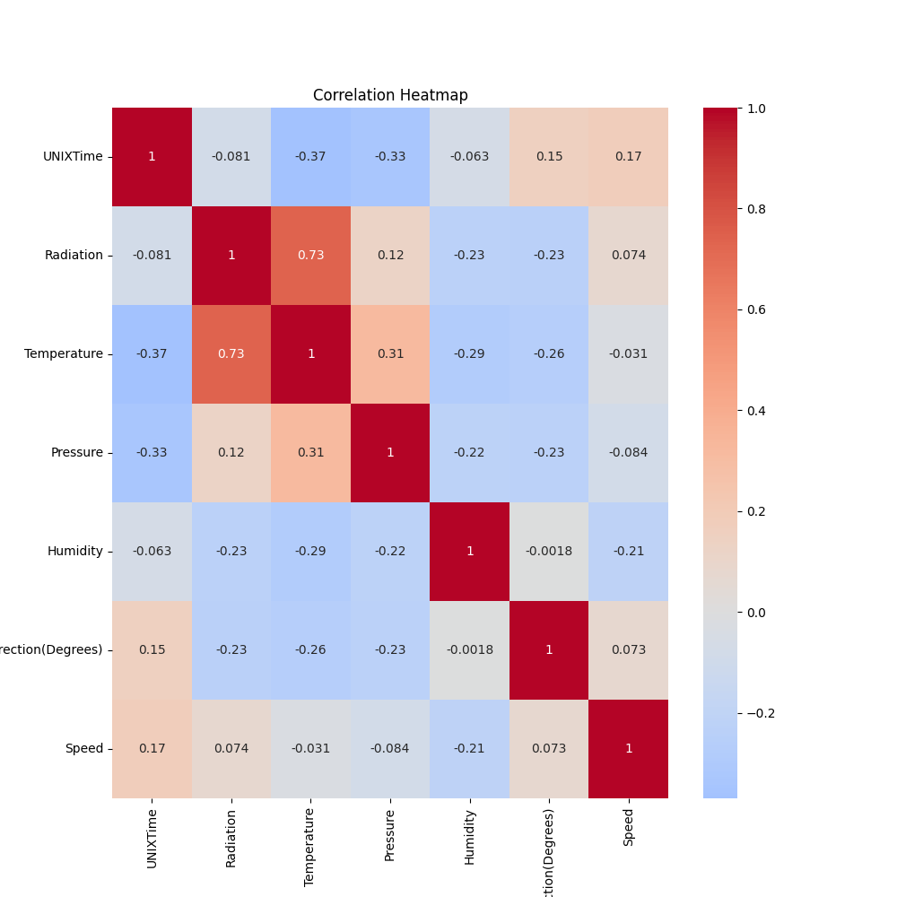

# Regression Metrics

R2 Score: 0.5984895734412697

Mean Squared Error (MSE): 40546.81891016123

Root Mean Squared Error (RMSE): 201.36240689404076

Mean Absolute Error (MAE): 151.42723438252105

# Cross-Validation Results

Cross-Validation MSE Scores: [45657.02979604 49836.72321118 37020.35373584 61878.63224048  
 43077.20211607 45938.82543188 39307.47381654 28341.18554893  
 37342.92357511 30723.06458996]

Mean CV MSE Score: 41912.34140620291

Standard Deviation of CV MSE Scores: 9241.284579019386

# True vs Predicted Radiation Values

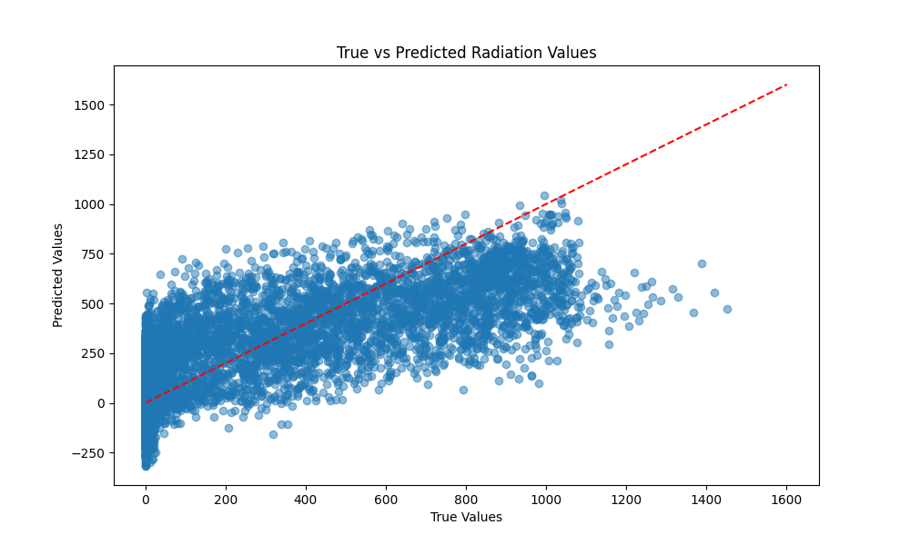

# Distribution of Residuals

