Solar Radiation Prediction Results

# Correlation Heatmap

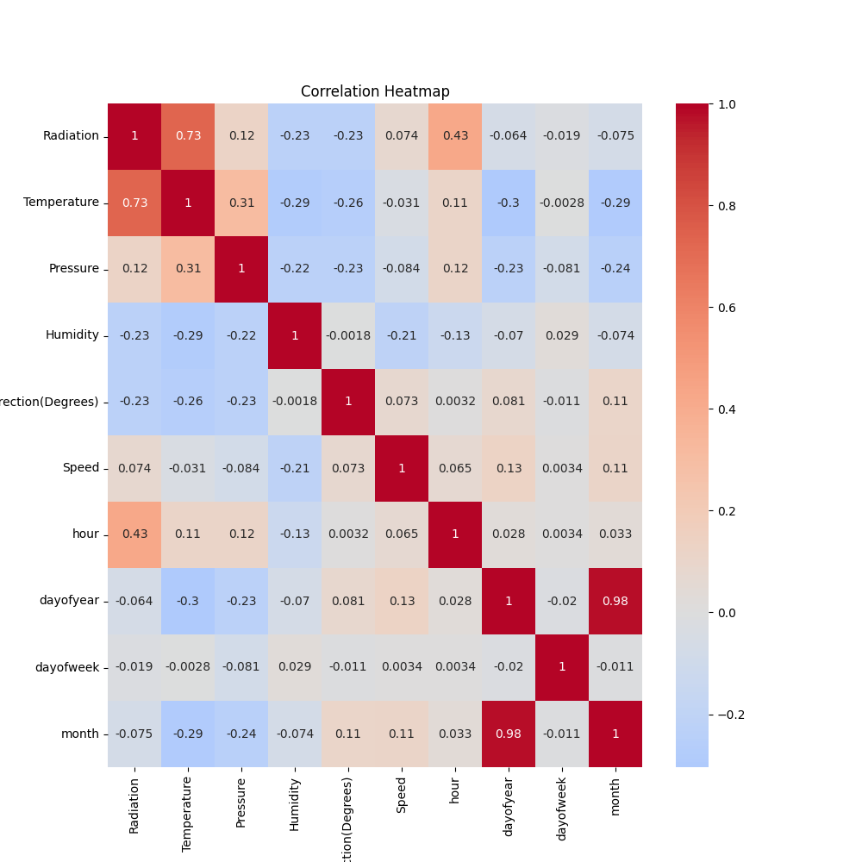

# Regression Metrics

R2 Score: 0.8125858445627372

Mean Squared Error (MSE): 18926.153143382846

Root Mean Squared Error (RMSE): 137.57235602904694

Mean Absolute Error (MAE): 104.4146244559905

# Cross-Validation Results

Cross-Validation R2 Scores: [ 0.80693135 0.64979974 0.83214171 0.83879794 0.71559213 0.87266265  
 0.87256998 0.85831463 0.78733903 -0.20278827]

Mean CV R2 Score: 0.703136089729349

Standard Deviation of CV R2 Scores: 0.30953780356292576

# True vs Predicted Radiation Values

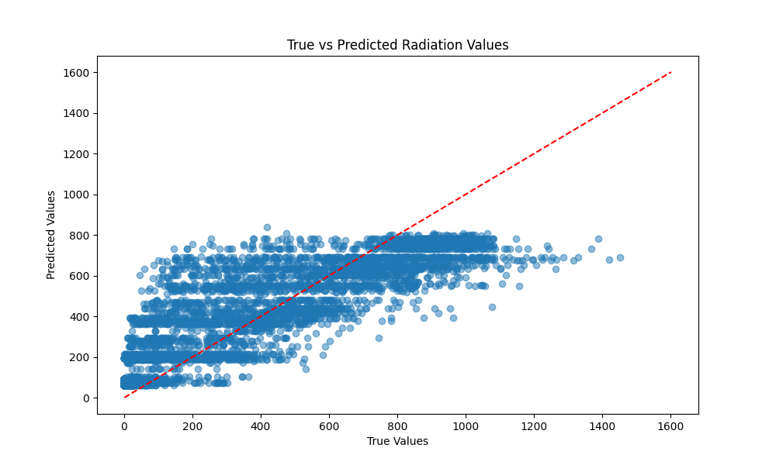

# Distribution of Residuals

