Solar Radiation Prediction Results - AdaBoost Classifier

# Distribution of UNIXTime

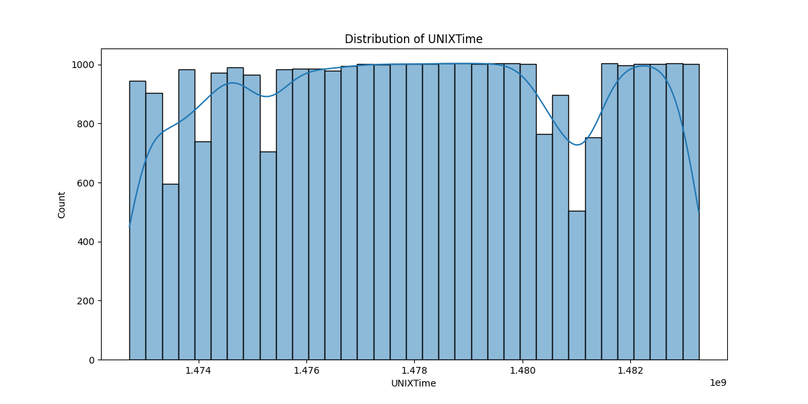

# Correlation Heatmap

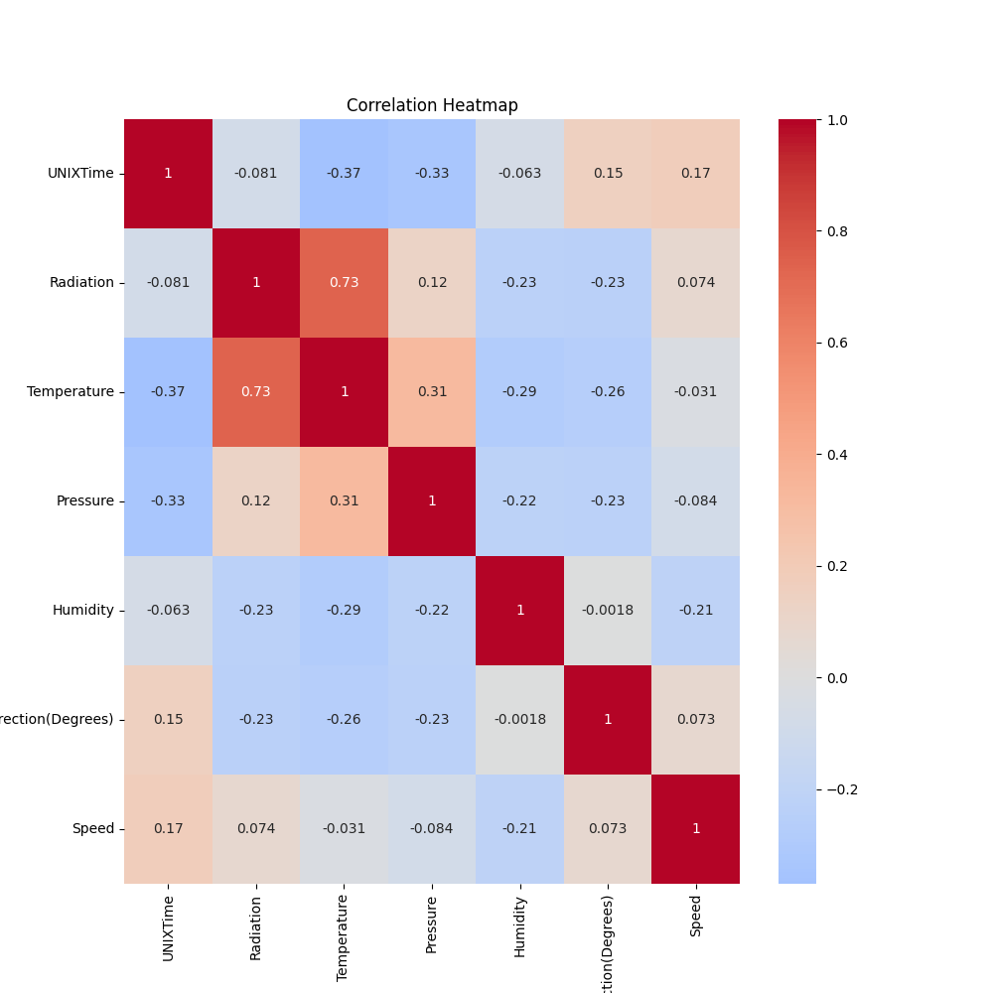

# Classification Metrics

Accuracy: 0.8229655313073628

Precision: 0.8725422160536664

Recall: 0.7609441194270729

F1 Score: 0.8129310344827586

# Cross-Validation Results

Cross-Validation Accuracy Scores: [0.85683695 0.65769348 0.78464362 0.77179566 0.88283879 0.76261854  
 0.8619951 0.84883721 0.81701346 0.65238678]

Mean CV Accuracy Score: 0.7896659600048375

Standard Deviation of CV Accuracy Scores: 0.07746753395334154

# True vs Predicted Radiation Classes

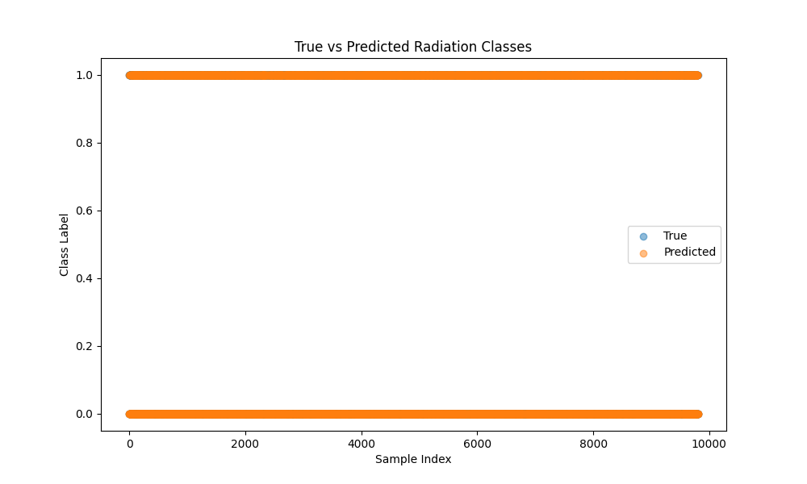

# Distribution of Residuals

