Solar Radiation Prediction Results - CatBoost Regressor

# Distribution of UNIXTime

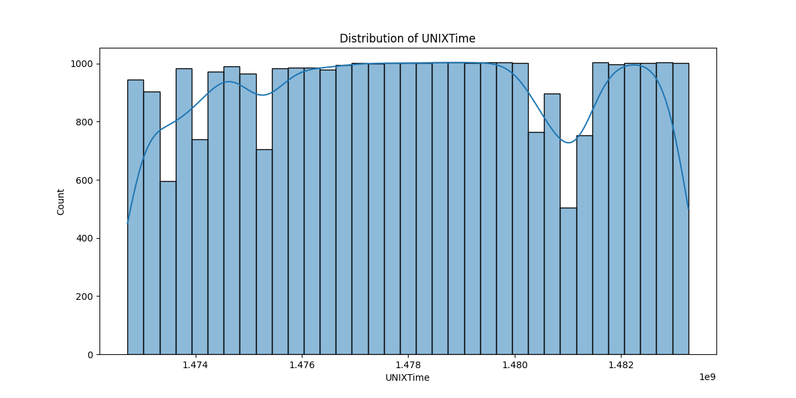

# Correlation Heatmap

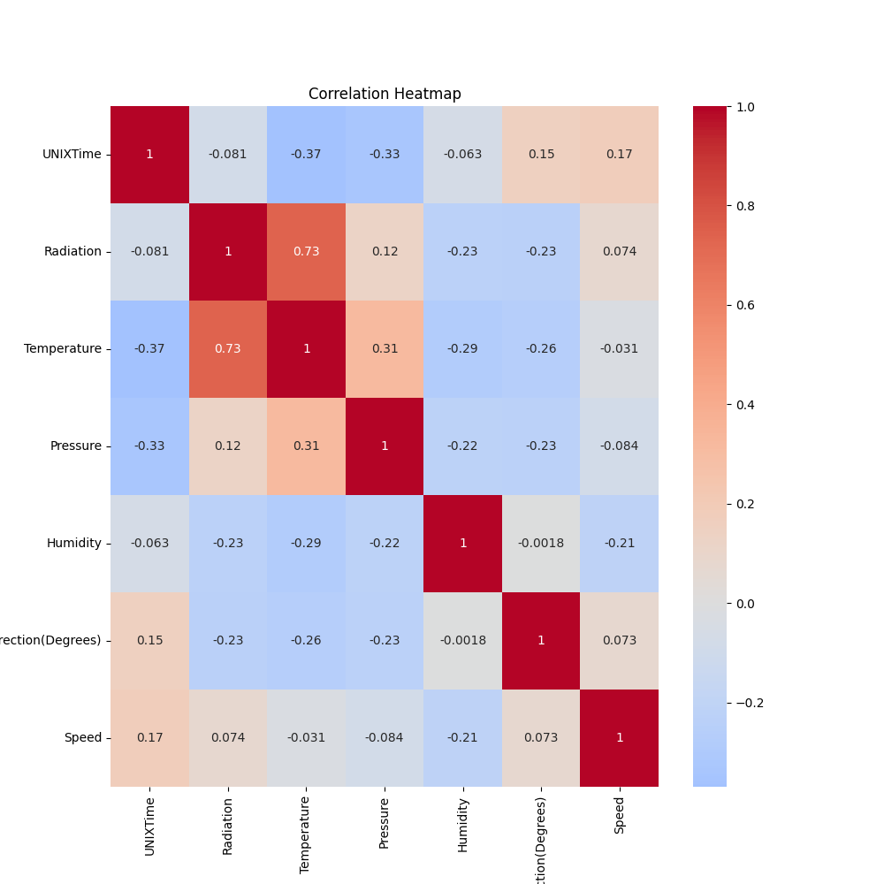

# Regression Metrics

R2 Score: 0.8889283344427216

Mean Squared Error (MSE): 11216.651950985392

Root Mean Squared Error (RMSE): 105.90869629537222

Mean Absolute Error (MAE): 59.60777924657756

# Cross-Validation Results

Cross-Validation MSE Scores: [45908.37413261 39987.32755076 59354.63566538 73738.60838356  
 28789.62782709 41862.45048989 31110.02475079 21788.90286862  
 33890.67269196 40268.49888151]

Mean CV MSE Score: 41669.9123242154

Standard Deviation of CV MSE Scores: 14481.47591830203

# True vs Predicted Radiation Values

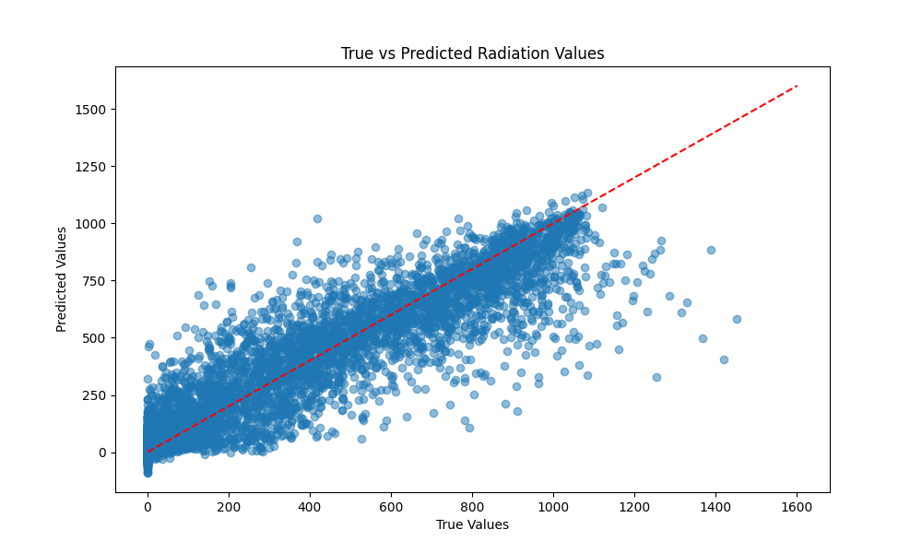

# Distribution of Residuals

