Solar Radiation Prediction Results - Gradient Boosting Regressor

# Distribution of UNIXTime

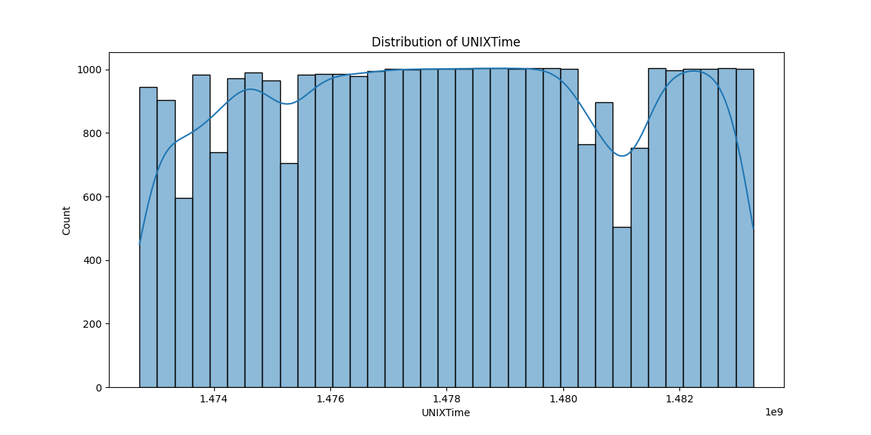

# Correlation Heatmap

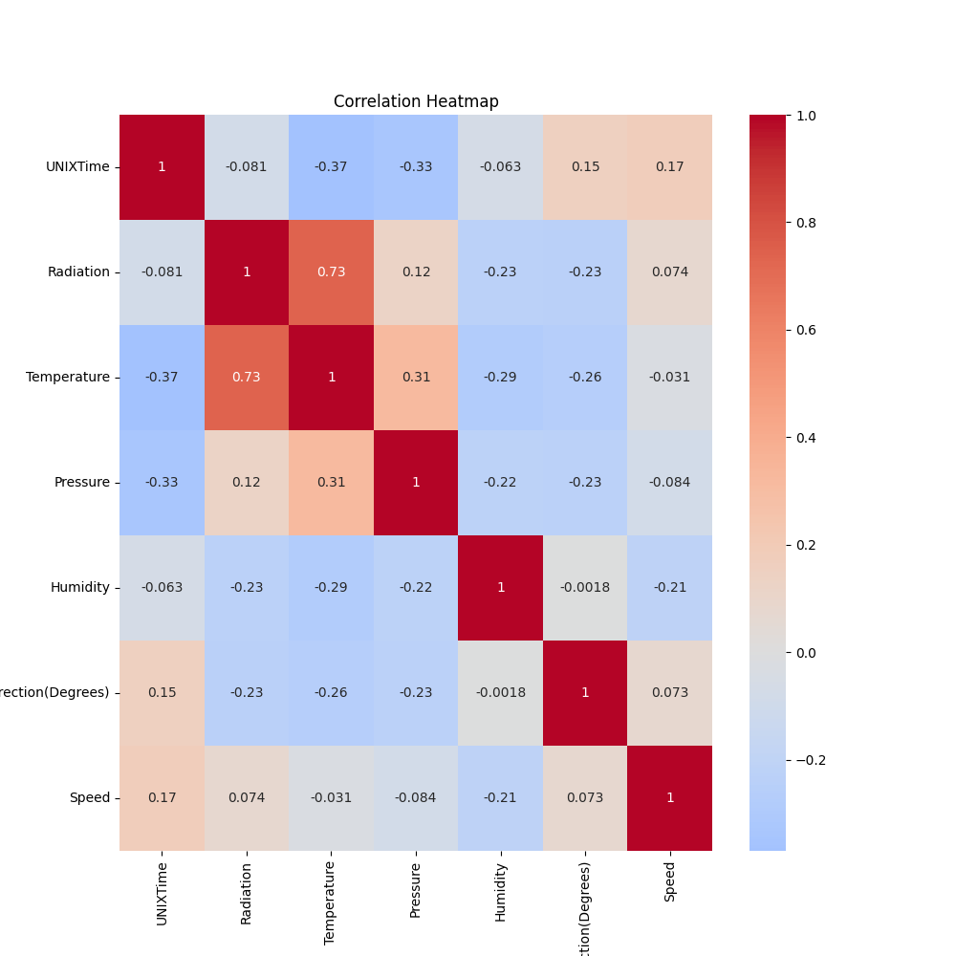

# Regression Metrics

R2 Score: 0.7568425176700299

Mean Squared Error (MSE): 24555.43306106867

Root Mean Squared Error (RMSE): 156.70173279536084

Mean Absolute Error (MAE): 98.64864775238583

# Cross-Validation Results

Cross-Validation MSE Scores: [33965.36303083 35995.53952931 32373.01444376 65046.26274581  
 35082.65023037 42340.32932905 35922.2400005 25049.86719756  
 26644.21986876 30278.10770842]

Mean CV MSE Score: 36269.759408437494

Standard Deviation of CV MSE Scores: 10683.987573472974

# True vs Predicted Radiation Values

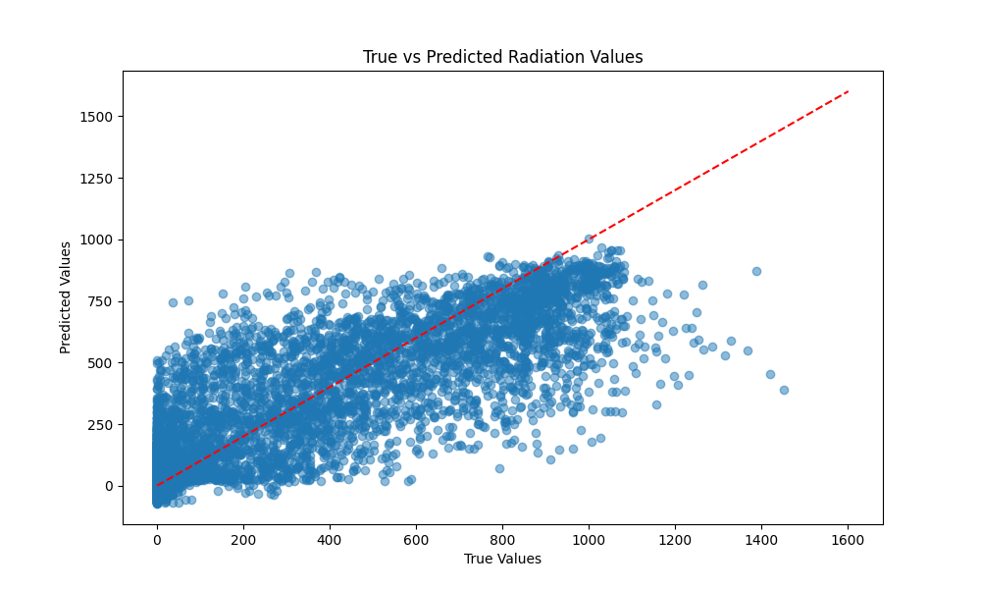

# Distribution of Residuals

