Solar Radiation Prediction Results - LGBM Regressor

# Distribution of UNIXTime

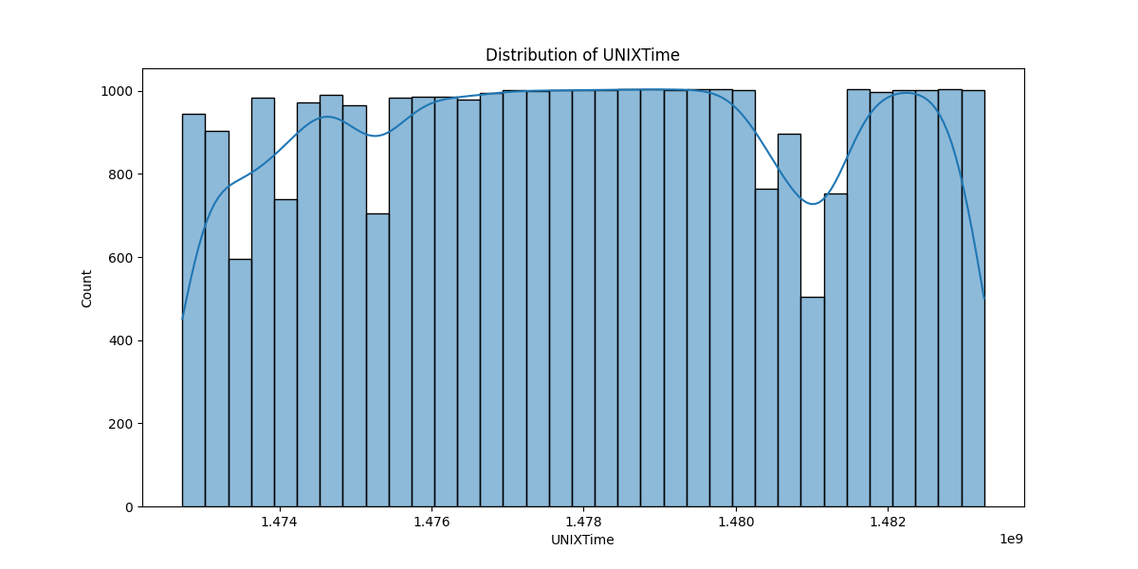

# Correlation Heatmap

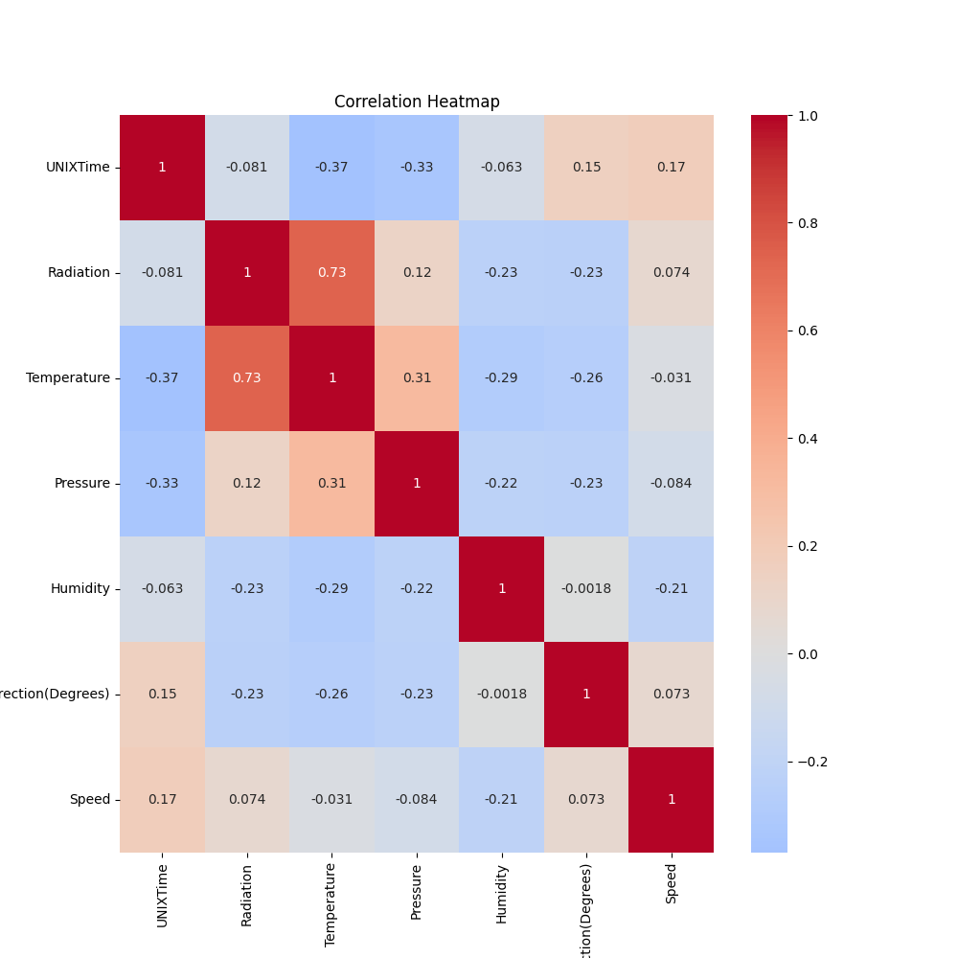

# Regression Metrics

R2 Score: 0.8643558215984637

Mean Squared Error (MSE): 13698.124815845107

Root Mean Squared Error (RMSE): 117.03898844336065

Mean Absolute Error (MAE): 65.69038321886335

# Cross-Validation Results

Cross-Validation MSE Scores: [35900.40626629 38587.96777443 47471.2311382 73002.33735243  
 35248.89881098 38889.31789128 37405.94512668 24759.9938257  
 27391.81060635 41091.54057492]

Mean CV MSE Score: 39974.944936728185

Standard Deviation of CV MSE Scores: 12596.504191304457

# True vs Predicted Radiation Values

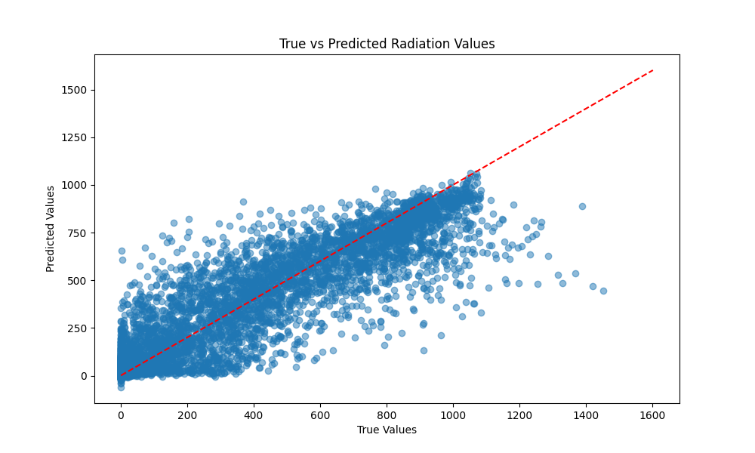

# Distribution of Residuals

