Solar Radiation Prediction Results - Random Forest Regressor

# Distribution of UNIXTime

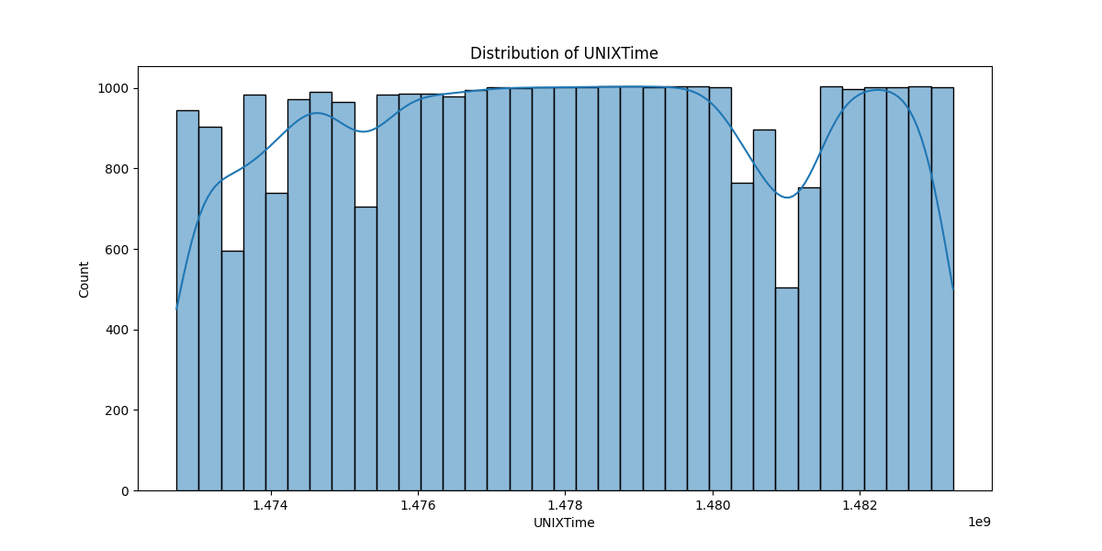

# Correlation Heatmap

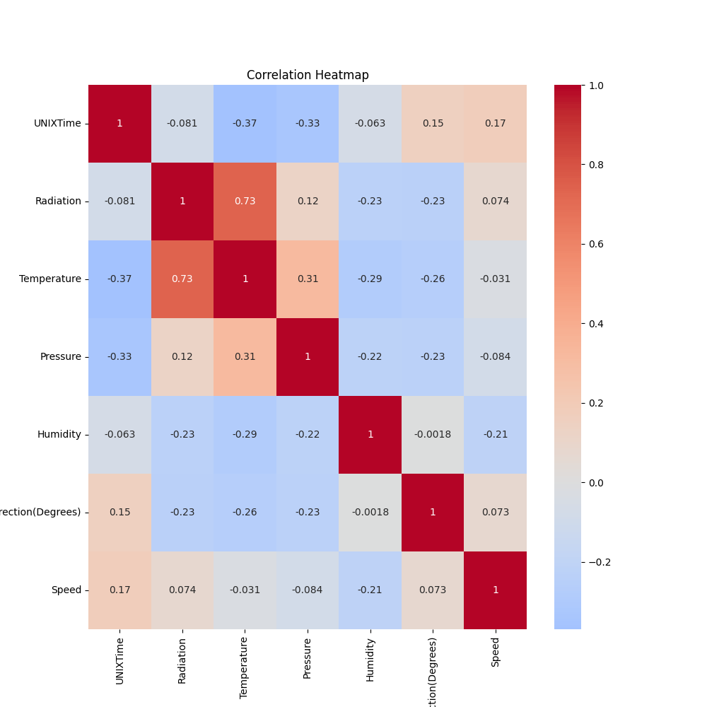

# Regression Metrics

R2 Score: 0.8954658868809143

Mean Squared Error (MSE): 10556.4525208012

Root Mean Squared Error (RMSE): 102.74459849939169

Mean Absolute Error (MAE): 49.238099102590255

# Cross-Validation Results

Cross-Validation MSE Scores: [53880.5775296 41690.63450913 45205.2018221 75339.25672714  
 39908.60263223 48833.98324638 41850.14523864 24566.86500227  
 27134.15757176 38820.15777491]

Mean CV MSE Score: 43722.95820541706

Standard Deviation of CV MSE Scores: 13488.720945458386

# True vs Predicted Radiation Values

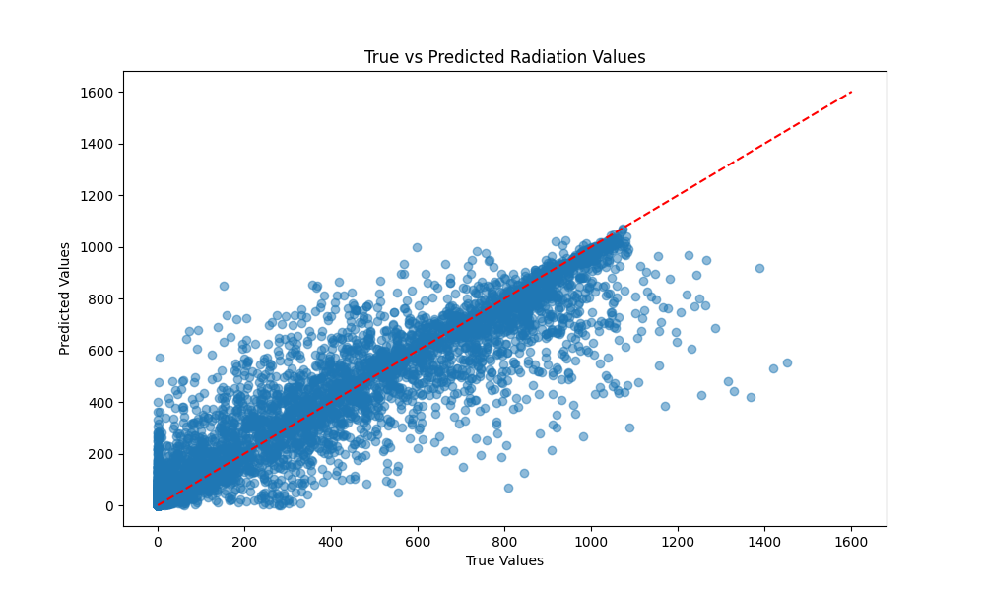

# Distribution of Residuals

