Solar Radiation Prediction Results

# Distribution of UNIXTime

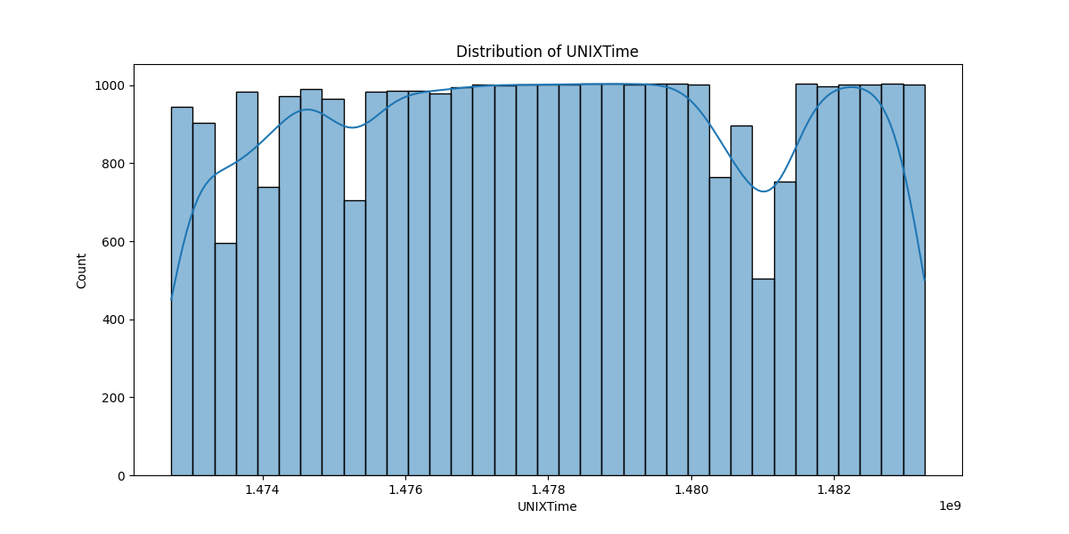

# Correlation Heatmap

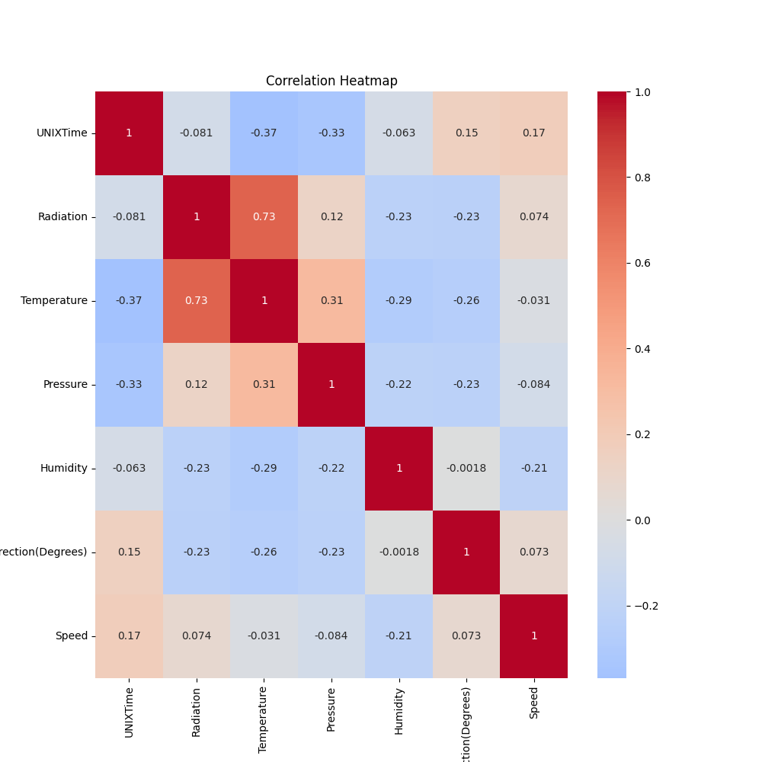

# Pairplot of DataFrame

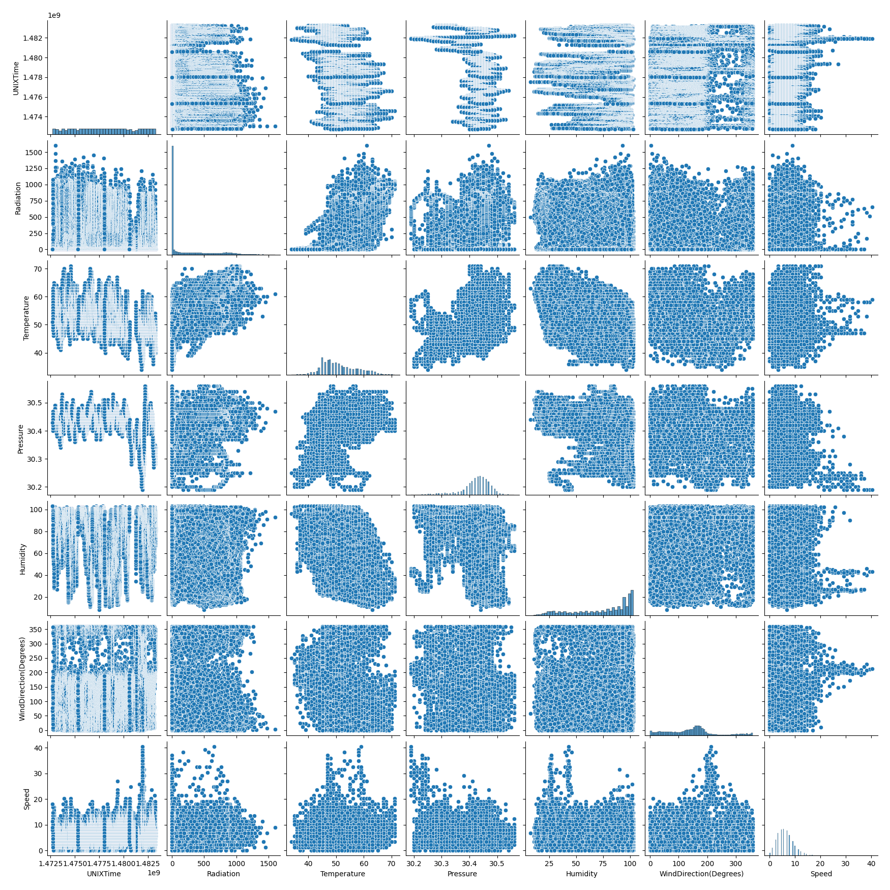

# Classification Metrics

Accuracy: 0.9198449928615133

Precision: 0.9641664811929669

Recall: 0.8739156748033085

F1 Score: 0.9168253968253969

# Cross-Validation Results

Cross-Validation RMSE Scores: 0 0.428831  
1 0.384964  
2 0.358990  
3 0.343618  
4 0.333545  
5 0.325314  
6 0.319893  
7 0.316413  
8 0.312589  
9 0.310017  
10 0.307075  
11 0.305173  
12 0.303105  
13 0.301181  
14 0.298917  
15 0.297044  
16 0.295616  
17 0.293501  
18 0.291525  
19 0.289846  
20 0.287460  
21 0.285633  
22 0.284049  
23 0.281568  
24 0.280201  
25 0.279017  
26 0.276547  
27 0.275094  
28 0.273668  
29 0.272446  
30 0.270787  
31 0.269225  
32 0.267314  
33 0.266067  
34 0.264798  
35 0.263925  
36 0.263047  
37 0.261928  
38 0.260591  
39 0.259331  
40 0.258496  
41 0.257277  
42 0.256074  
43 0.254742  
44 0.253881  
45 0.252464  
46 0.250775  
47 0.249312  
48 0.248106  
49 0.246805  
Name: test-rmse-mean, dtype: float64

Mean CV RMSE Score: 0.2877556661693642

Standard Deviation of CV RMSE Scores: 0.0057975317350199606

# True vs Predicted Radiation Values

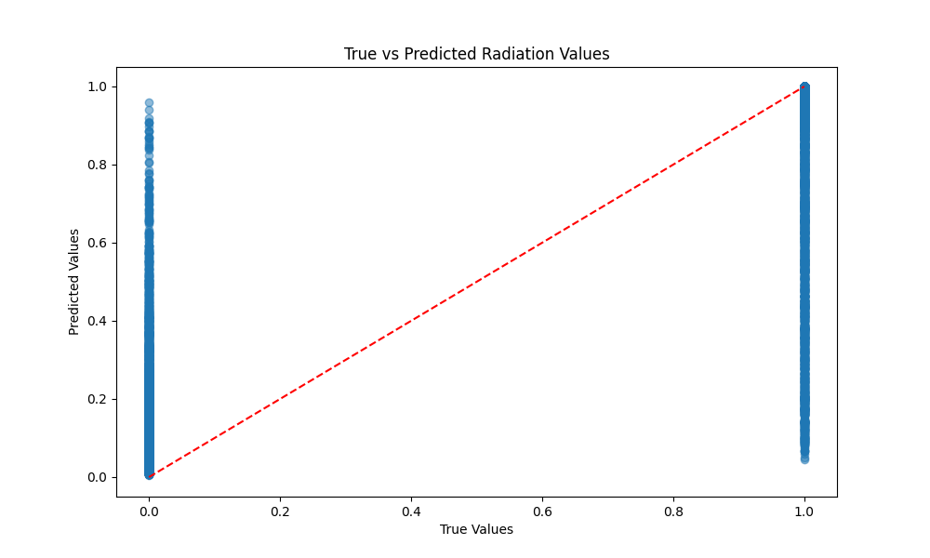

# Distribution of Residuals

