Solar Radiation Prediction Results - XGBoost Regressor

# Distribution of UNIXTime

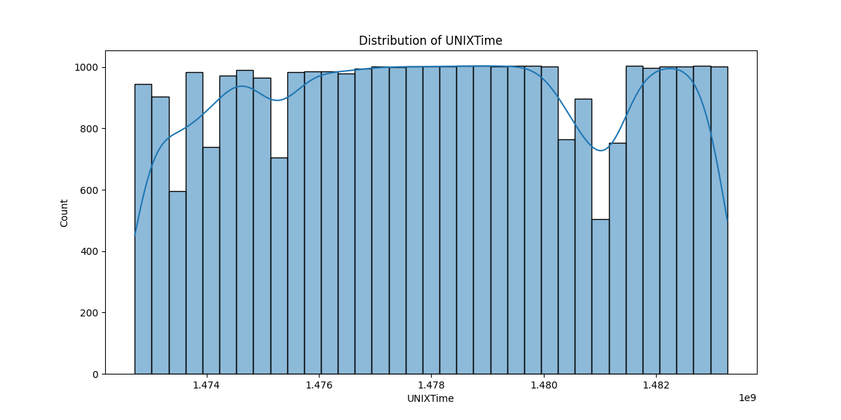

# Correlation Heatmap

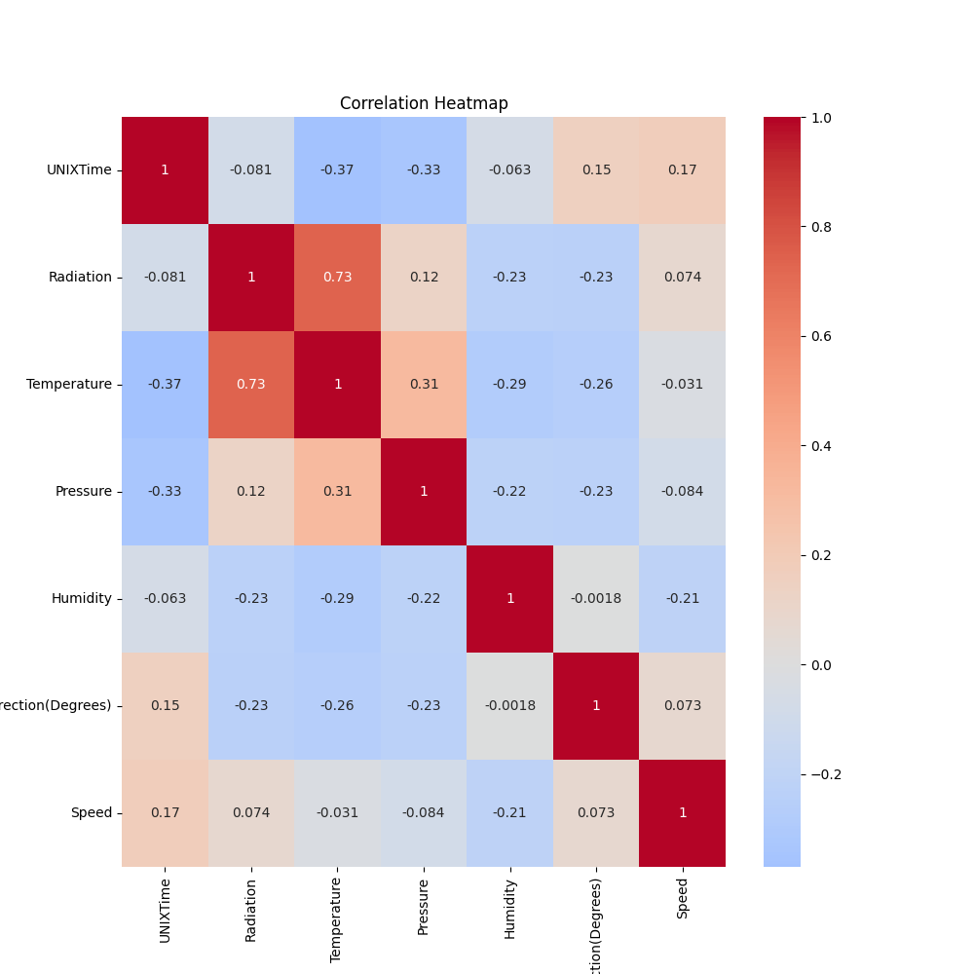

# Regression Metrics

R2 Score: 0.8844980530898243

Mean Squared Error (MSE): 11664.047096552591

Root Mean Squared Error (RMSE): 108.00021803937523

Mean Absolute Error (MAE): 59.15116431536943

# Cross-Validation Results

Cross-Validation MSE Scores: [48809.1222926 42246.35204017 56565.08721813 72151.39884469  
 31714.06504193 42867.39580755 36373.94745492 28324.27310992  
 32806.86621943 38639.02123539]

Mean CV MSE Score: 43049.75292647341

Standard Deviation of CV MSE Scores: 12560.630299649849

# True vs Predicted Radiation Values

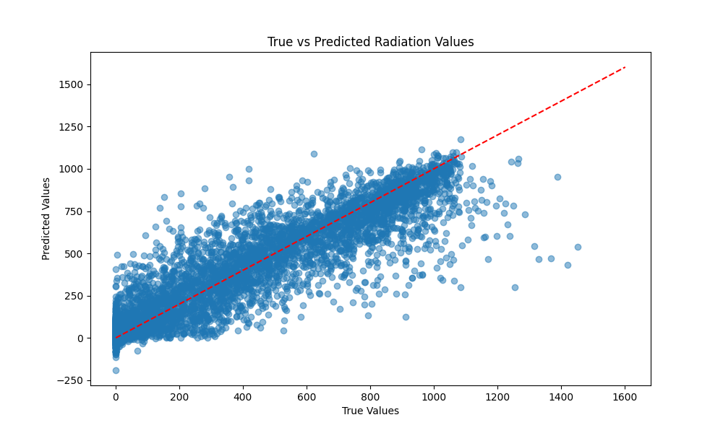

# Distribution of Residuals

