Psychotherapy Exam Notes: Units I to IV
MPhil Clinical Psychology, Year II

UNIT I: INTRODUCTION TO PSYCHOTHERAPY

1. Definitions of psychotherapy
- Wolberg (1954): a form of treatment for problems of an emotional nature in which a trained person deliberately establishes a professional relationship with the patient, in order to (1) remove, modify or retard existing symptoms, (2) mediate disturbed patterns of behaviour, and (3) promote positive personality growth and development.
- Jerome Frank (1961, Persuasion and Healing): a planned, emotionally charged, confiding interaction between a trained, socially sanctioned healer and a sufferer; it aims to produce changes in the sufferer’s feelings, attitudes and behaviour.
- Norcross (1990): the informed and intentional application of clinical methods and interpersonal stances derived from established psychological principles, for the purpose of assisting people to modify their behaviours, cognitions, emotions and/or other personal characteristics in directions that the participants deem desirable.
- Strupp: a learning process in which a trained person uses the relationship to help the patient overcome distress and develop more adaptive functioning.
- Key elements common to all definitions: (1) a trained, professional therapist; (2) a help-seeking client; (3) a psychological (non-medical) method; (4) a planned, systematic, theory-based process; (5) a confiding, therapeutic relationship; (6) the aim of change (symptom relief, behaviour change, growth).
- Psychotherapy vs counselling: counselling usually deals with normal developmental, situational and adjustment problems, is more present- and problem-focused, and is shorter; psychotherapy deals with deeper, more enduring or pathological problems and personality reconstruction, and is usually longer. The overlap is large and the distinction is mostly one of degree.
- Psychotherapy vs medical treatment: psychotherapy works through communication, relationship and learning rather than drugs; both are often combined (for example for depression or psychosis).

2. Objectives (goals) of psychotherapy
- Relieve symptoms and distress (anxiety, depression, obsessions, etc.).
- Modify maladaptive behaviour, thoughts and emotions (change).
- Gain insight into the origin and meaning of problems (especially in psychodynamic work).
- Improve interpersonal relationships and social functioning.
- Strengthen coping, problem solving and adaptive defences; improve self-esteem and self-efficacy.
- Resolve inner conflicts and past trauma; foster emotional expression and regulation.
- Promote personal growth, self-actualisation and a sense of meaning.
- Prevent relapse and improve quality of life; in severe illness, maintain functioning and prevent hospitalisation.

3. The process of psychotherapy at a glance
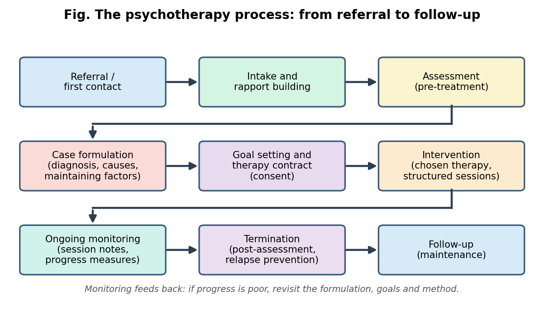
Flow of the therapy process

4. Issues related to the training of professional therapists
- Who may practise (India): the Rehabilitation Council of India (RCI) Act, 1992 (amended 2000) regulates training and registration of clinical psychologists. The RCI-recognised M.Phil in Clinical Psychology (two years, with supervised clinical practice) is the entry qualification; practitioners must hold a Central Rehabilitation Register (CRR) number. The Mental Healthcare Act (MHCA), 2017 recognises the clinical psychologist as a mental health professional.
- Components of training: (1) theoretical knowledge (psychopathology, theories of therapy, assessment); (2) supervised clinical practice under qualified supervisors (direct observation, audio/video review, case conferences); (3) personal therapy or self-awareness work (to manage countertransference and blind spots); (4) learning ethics and law; (5) research literacy and evidence-based practice; (6) cultural competence; (7) lifelong learning and continuing education.
- Competencies expected: relationship (alliance) skills, assessment and case formulation, intervention skills in at least one major model, ethical decision making, record keeping, working with diversity, use of supervision, reflective practice.
- Issues and challenges:
  - Wide variation in the quality, duration and supervision of training; shortage of trained supervisors.
  - Over-reliance on Western models with limited cultural adaptation; need for training in indigenous and culturally sensitive approaches.
  - Whether personal therapy for trainees should be mandatory.
  - Gate-keeping: judging suitability of trainees (personal qualities such as empathy, maturity, integrity) and remediating or dismissing unfit trainees.
  - Training vs licensing gap: unregulated practice by untrained persons (“quacks”); need to protect the public.
  - Therapist stress, burnout, vicarious traumatisation and compassion fatigue; importance of self-care and peer support.
  - Boundaries and dual relationships arising from trainee-supervisor and small-community settings.
  - Training in the use of technology (tele-therapy) and its ethics.
  - Practising within the limits of one’s competence; knowing when to refer.

5. Ethical issues in therapy work
Core ethical principles (APA Ethical Principles; also reflected in the RCI Code of Conduct)
- Beneficence and non-maleficence: do good; avoid harm.
- Fidelity and responsibility: trust, professional and scientific responsibility, accountability.
- Integrity: honesty, accuracy, truthfulness; no deception or exaggerated claims.
- Justice: fairness, equal access to quality services; no discrimination.
- Respect for people’s rights and dignity: privacy, confidentiality, autonomy, self-determination.
Major ethical issues
- Competence: practise only within the limits of training; refer when needed; keep updated.
- Informed consent: must be obtained before assessment and treatment (see section 7).
- Confidentiality and its limits: private information is shared only with consent; exceptions (see below).
- Dual (multiple) relationships and boundaries: avoid social, business, financial or sexual relationships with clients. Sexual intimacy with a client (or former client, at least for a specified period) is unethical and prohibited. Avoid exploitation and misuse of power; manage gifts, self-disclosure, touch and social media contact carefully.
- Fees and contracts: be clear and honest about fees, missed sessions and payment; do not exploit.
- Record keeping and data security.
- Termination and referral: do not abandon clients; terminate when the client no longer needs or benefits; provide referrals and handover.
- Cultural sensitivity and respect for diversity: avoid bias based on gender, caste, religion, sexuality, disability, socio-economic status.
- Supervision and consultation: use regularly; seek help in ethical dilemmas.
- Advertising and claims: avoid false or unsubstantiated claims about outcomes.
- Research ethics: consent, no harm, confidentiality, ethics committee approval.
- Ethical decision-making steps: identify the problem and the people affected; consult codes and law; consult supervisor/colleagues; consider options and consequences; decide and act; document; evaluate.
Limits of confidentiality
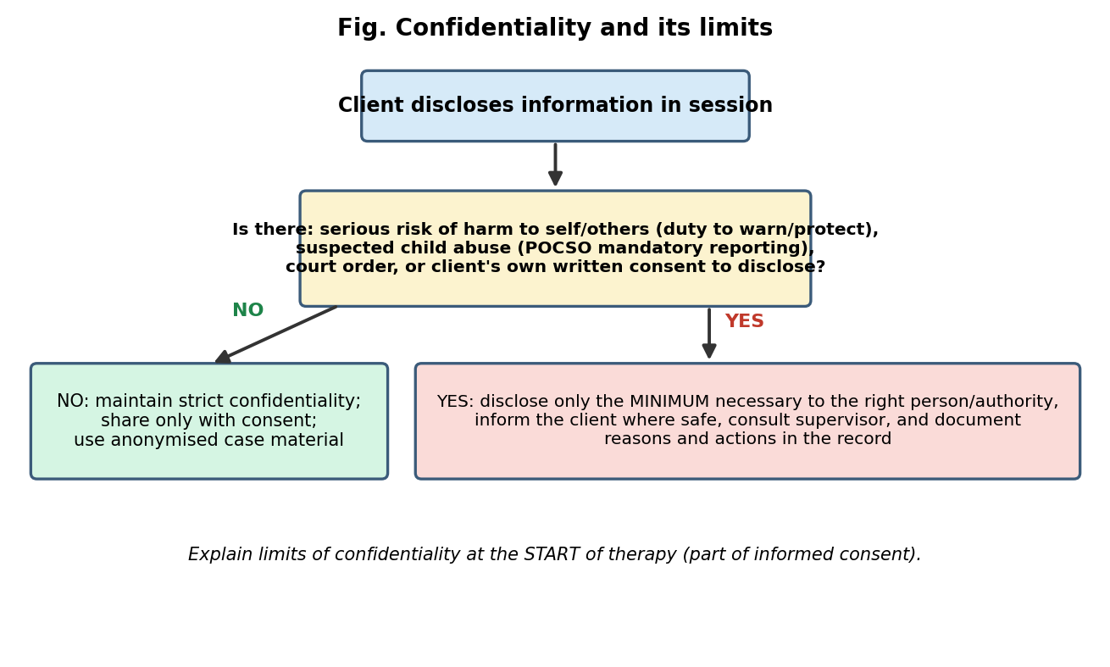
Confidentiality decision flow
- The Tarasoff v. Regents of the University of California (1976) decision established a duty to warn and protect identifiable third parties from serious threats of violence by a client.
- In India, the MHCA 2017 protects the confidentiality of information about a person’s mental illness and treatment (disclosure allowed with consent, for the treatment, for safety, or by court order), and the POCSO Act, 2012 makes reporting of known or suspected child sexual abuse mandatory. The Right to Privacy was recognised as a fundamental right by the Supreme Court in Puttaswamy (2017).

6. Legal issues in therapy work (India)
- Rehabilitation Council of India Act, 1992: regulates training, registration and conduct of rehabilitation professionals including clinical psychologists; practising without registration is an offence.
- Mental Healthcare Act, 2017: rights-based law. Key points:
  - Rights of persons with mental illness: right to access mental healthcare (affordable, quality, available), right to community living, right to protection from cruel, inhuman or degrading treatment, right to equality and non-discrimination, right to information, right to confidentiality, right to access medical records, right to personal contacts and communication, right to legal aid, and right to make complaints about deficiencies in services.
  - Advance directive (a person can state how they wish to be treated and who their nominated representative will be).
  - Capacity to make treatment decisions is presumed unless shown otherwise.
  - Suicide attempt is presumed to be under severe stress and is not punishable (Section 115); the government must provide care and rehabilitation.
  - Restrictions on electro-convulsive therapy (no ECT without anaesthesia and muscle relaxant; not for minors), prohibition of sterilisation as treatment, restraints used only in a limited way.
- Rights of Persons with Disabilities Act, 2016 (includes mental illness and intellectual disability).
- POCSO Act, 2012 (mandatory reporting) and the Juvenile Justice Act (care of children).
- Consumer Protection Act and civil/criminal law on negligence (professional malpractice); courts may seek records or testimony.
- Tele-mental health: the Telemedicine Practice Guidelines (2020) and guidelines on tele-psychiatry apply.
- Therapist’s legal duties: valid consent, confidentiality, competent practice, accurate records, reporting obligations, no exploitation, referral when needed. Legal vs ethical: law sets the minimum enforceable standard; ethics sets the higher aspirational standard of conduct.

7. Rights and responsibilities in psychotherapy
Client rights | Client responsibilities
Informed consent; know the therapist’s training, approach and fees | Attend sessions regularly and on time; give notice of cancellation
Confidentiality (with known limits) | Be honest and open about problems, history and progress
Be treated with respect, dignity, free from discrimination | Actively participate and complete agreed homework
Know the nature, expected duration and alternatives of treatment | Pay agreed fees; follow the agreed contract
Refuse or withdraw from therapy at any time | Respect the therapist’s boundaries
Access to own records; a second opinion; make complaints | Inform the therapist about other treatments, medicines, risks

Therapist responsibilities
Competence; keep within limits of training; refer when appropriate
Obtain informed consent; maintain confidentiality
Maintain boundaries; avoid dual and exploitative relationships
Keep accurate records; protect them; follow reporting laws
Respect diversity; use culturally appropriate methods
Continue supervision and learning; practise self-care
Terminate appropriately; ensure continuity of care

8. Consent and assent (including minors)
Informed consent is the client’s voluntary agreement to assessment or therapy after receiving and understanding adequate information. Its elements:
- Capacity (competence) to decide: the ability to understand, appreciate, reason and express a choice.
- Disclosure of information: purpose and nature of therapy, methods, expected benefits, possible risks and discomfort, alternatives (including no treatment), duration, fees, confidentiality and its limits, recording or observation, supervision, the therapist’s qualifications, and the right to withdraw without penalty.
- Comprehension: language that is simple and understandable; check understanding.
- Voluntariness: free from coercion or undue pressure.
- Documentation: written (or recorded) consent, revisited when the plan changes. Consent is a process, not a one-time signature.
Special issues
- Minors (<18 years in India): the legal consent comes from the parent or legal guardian. The child’s assent (the child’s affirmative, informed agreement to the extent of the child’s developing capacity) is sought as well. Assent respects the child’s autonomy, increases cooperation and strengthens the alliance. Guidelines (for example ICMR 2017) generally require assent for children roughly between 7 and 18 years, with simpler language for younger children and more weight to the wishes of older, mature adolescents. If a child refuses, the therapist explores concerns and, unless safety requires otherwise, respects it.
- Adults lacking capacity: involve the nominated representative or legal guardian under the MHCA 2017; still seek the person’s views and use the least restrictive approach.
- Consent for recording (audio or video), observation, supervision, research or publication is separate and specific. Case material is anonymised.
- Emergency (immediate risk to life) can justify action without full consent, with documentation.
- Cultural context: in collectivist settings, family involvement is common; the therapist must still ensure the client’s own consent and confidentiality where appropriate.
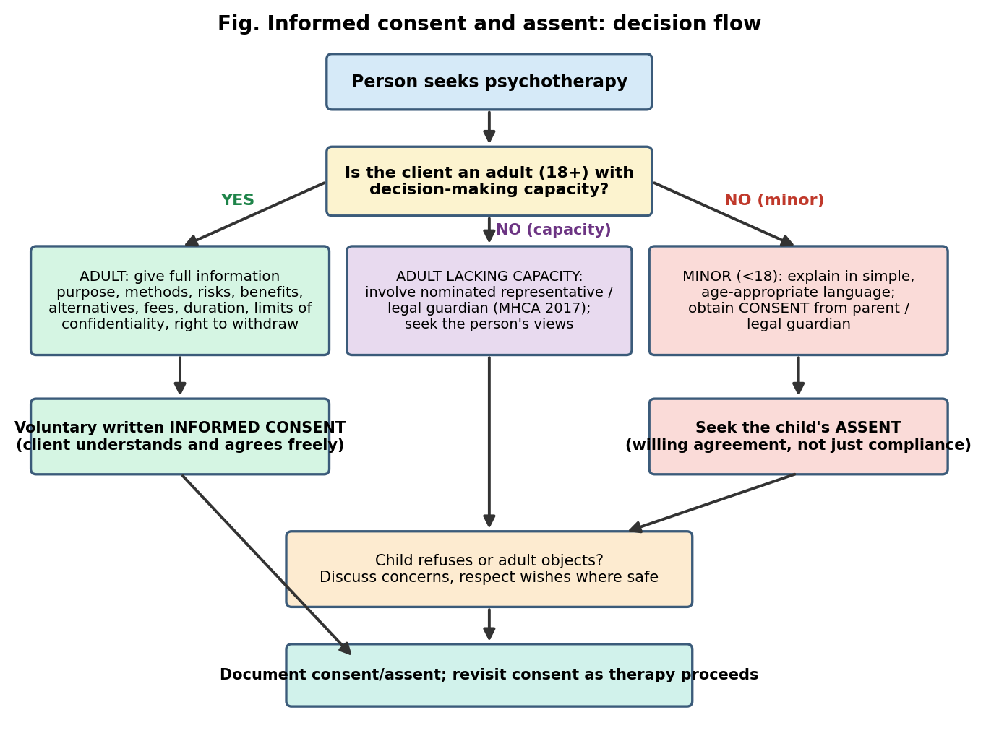
Consent and assent decision flow

9. Planning and recording of therapy sessions
Planning
- Intake and assessment: presenting complaints, history, risk assessment, mental status, test results, diagnosis.
- Case formulation: an integrated hypothesis explaining the problem: predisposing, precipitating, perpetuating and protective factors (the “4 Ps”); guides the treatment plan.
- Treatment plan: goals, chosen therapy, frequency (usually once a week), session length (usually 45 to 50 minutes), expected duration, measures of progress, plan for emergencies, and criteria for termination.
- Therapeutic frame: time, place, fee, boundaries, cancellation policy, contact between sessions.
- Session planning: prepare using previous notes; plan the aims for each session, but be responsive to the client’s needs.
Structure of a typical session (for example in CBT)
- Brief check-in and mood check.
- Bridge from the previous session.
- Agenda setting (collaboratively).
- Review of homework.
- Work on agenda items (the main therapeutic work).
- Summaries (capsule summaries during the session).
- Assign new homework.
- Feedback from the client on the session.
Recording
- Types of records: intake/case history form; assessment reports and test data; treatment plan; consent forms; progress notes for each session; process notes (the therapist’s private reflections, usually kept separate); risk assessments; referral and termination summaries; correspondence.
- Formats of progress notes: SOAP (Subjective, Objective, Assessment, Plan), DAP (Data, Assessment, Plan), BIRP (Behaviour, Intervention, Response, Plan).
- Good records are: timely, accurate, objective, factual, brief but complete, free of judgemental language, signed and dated.
- Purposes: continuity of care, monitoring progress, supervision, communication with other professionals, evidence in legal or ethical review, research and quality improvement.
- Security and confidentiality: secure storage (locked cabinets, password-protected files), restricted access, coded identifiers; retention for the period required by law or institutional policy; safe disposal.
- Audio/video recording needs explicit written consent; recordings are used only for the agreed purpose (such as supervision) and destroyed as agreed.

10. Structuring therapy and setting goals
- Structure gives therapy direction, safety and efficiency: a clear frame (contract), a clear agenda each session, phases (beginning, middle, end), regular review of progress.
- Phases of therapy: (1) Beginning: engagement, assessment, formulation, contracting, goal setting. (2) Middle: active intervention and working through. (3) End: consolidation, relapse prevention, termination, follow-up.
- Goal setting: goals should be collaborative (jointly negotiated), derived from the case formulation, and expressed in the client’s own words.
- Characteristics of good goals (SMART): Specific, Measurable, Achievable, Realistic/Relevant, Time-bound; also stated positively (what the client will do or have, not only what to stop), under the client’s control, and ordered by priority.
- Types of goals: ultimate vs intermediate vs immediate (session) goals; outcome goals (symptom relief, behaviour change) vs process goals (insight, alliance, skills); short-term vs long-term.
- Goal Attainment Scaling (Kiresuk and Sherman, 1968): each goal is scaled from -2 (much worse) to +2 (much better than expected), allowing individualised measurement.
- Why it matters: goal consensus is a component of the therapeutic alliance (Bordin) and predicts outcome; clear goals increase motivation and let both parties know when therapy is complete.
- Revisiting goals: goals are revised as new information emerges or progress occurs.

11. Pre- and post-assessment
- Purpose: the pre-assessment (baseline) provides diagnosis, severity, risk, strengths, and a benchmark; the post-assessment evaluates change after therapy; follow-up assessment checks maintenance. Ongoing session-by-session monitoring (for example OQ-45, CORE-OM, Outcome Rating Scale/Session Rating Scale) provides feedback so that therapy can be adjusted (feedback-informed treatment). Tracking progress reduces deterioration, especially in clients who are “not on track”.
- Methods: structured and unstructured interviews, behavioural observation, self-report scales, clinician-rated scales, projective or other tests when relevant, collateral information, physiological measures, client diaries/self-monitoring.
- Commonly used measures: BDI-II, PHQ-9, HAM-D (depression); BAI, GAD-7, HAM-A (anxiety); Y-BOCS (OCD); PCL-5/CAPS-5 (PTSD); SCL-90-R and GHQ (general distress); WHO-5, WHOQOL-BREF (well-being and quality of life); GAF/WHODAS 2.0 (functioning); CGI (clinical global impression); target-complaint ratings; therapeutic alliance measures (WAI).
- Evaluating change:
  - Statistical significance (group level) vs clinical significance (individual level).
  - Reliable Change Index (RCI; Jacobson and Truax, 1991): the change must exceed measurement error (RCI > 1.96).
  - Clinically significant change: the client crosses a cutoff between the dysfunctional and functional populations (for example moves from within the clinical range to within the normal range).
  - Effect size (Cohen’s d) and percentage improvement.
  - Single-case designs (AB, ABAB, multiple baseline) for individual evaluation.
- Good practice: use reliable and valid measures suitable for the client’s language, culture and literacy; use the same measures before and after; interpret with caution (placebo, regression to the mean, practice effects, response bias); share results with the client and use them to plan further care.

12. Evidence-based practice (EBP) of therapies
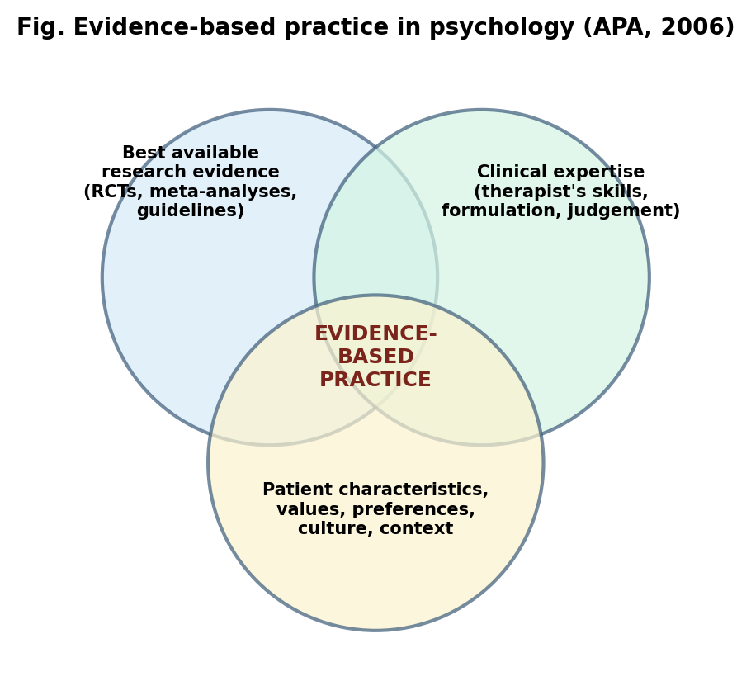
Evidence-based practice
- Definition (APA Presidential Task Force, 2006): the integration of the best available research with clinical expertise in the context of patient characteristics, culture and preferences. The concept came from evidence-based medicine (Sackett).
- Empirically supported treatments (ESTs): Division 12 (Society of Clinical Psychology) of the APA, Chambless and Hollon (1998) criteria: well-established (at least two good between-group design studies by independent researchers, or a large series of single-case studies, showing superiority to placebo or another treatment, with treatment manuals and clear samples) and probably efficacious.
- Hierarchy of evidence: systematic reviews/meta-analyses of RCTs; randomised controlled trials; controlled trials without randomisation; cohort and case-control; single-case studies; expert opinion.
- Efficacy vs effectiveness vs clinical utility: efficacy = works under controlled research conditions; effectiveness = works in real-world practice; clinical utility = feasible, acceptable and cost-effective in practice.
- Examples of well-supported treatments: CBT for depression, panic, social anxiety, GAD; exposure and response prevention (ERP) for OCD; prolonged exposure, cognitive processing therapy and EMDR for PTSD; behavioural activation and IPT for depression; DBT for borderline personality disorder; family-based treatment for adolescent anorexia; parent management training for child conduct problems; CBT for insomnia; social skills training, family psychoeducation and cognitive remediation for schizophrenia.
- Guidelines: NICE (UK), APA, and WHO mhGAP recommend specific treatments. In India, culturally adapted low-intensity interventions delivered by lay counsellors (for example the Healthy Activity Programme in the PREMIUM trials in Goa, and the Thinking Healthy Programme) show that evidence-based care can be scaled up.
- Steps of EBP in the clinic: ask a clear clinical question; search for the best evidence; appraise it; integrate it with clinical expertise and the client’s values; apply; evaluate the outcome.
- History of the evidence debate: Eysenck (1952) claimed psychotherapy was no more effective than spontaneous remission; Smith and Glass (1977) meta-analysed 375 studies and found a mean effect size of about 0.68 (the average treated person was better off than about 75% of untreated persons). The “Dodo bird verdict” (Rosenzweig; Luborsky) suggests that all bona fide therapies work about equally, pointing to common factors.
Common factors vs specific factors
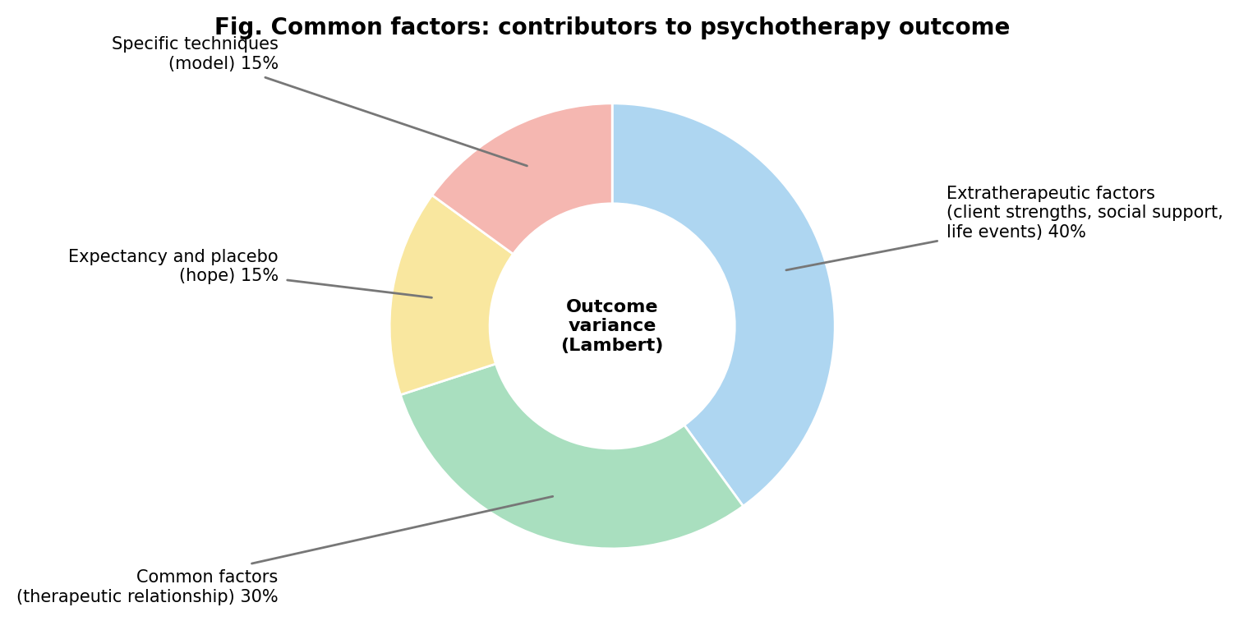
Common factors (Lambert)
- Common factors: therapeutic relationship (alliance, empathy), client expectations and hope (placebo), a healing setting and rationale, a credible ritual, new learning experiences, mastery. Wampold’s contextual model argues that these factors, rather than specific techniques, explain most of the benefit of therapy.
- Lambert (1992) estimated the contributions: extratherapeutic/client factors 40%, relationship 30%, expectancy 15%, technique 15% (approximate and debated).
- Balance: both specific (model-based) and common (relationship) factors matter; treatment works best when evidence-based techniques are delivered within a strong relationship.
Criticisms and challenges of EBP
- RCT samples are often unrepresentative (strict exclusion, no comorbidity); limited generalisability to diverse and Indian populations.
- Manuals can reduce flexibility; researcher allegiance effects; publication bias.
- Under-emphasis of common factors and the therapist’s contribution; weak evidence for some established therapies (for example long-term psychodynamic) is partly due to fewer trials, not necessarily lack of effect.
- Outcome focus on symptom measures rather than broader well-being or meaning.
- Practice-based evidence and routine outcome monitoring are suggested to complement RCTs. Cultural adaptation and task shifting are important in India.

UNIT II: THERAPEUTIC RELATIONSHIP

1. Meaning and importance
- The therapeutic relationship (alliance) is the collaborative, emotional bond and working partnership between client and therapist. It is the “vehicle” through which techniques are delivered, and a curative factor in itself.
- Research evidence: meta-analyses (Horvath and Symonds, 1991; Horvath et al., 2011; Flückiger et al., 2018) show a moderate and consistent association between alliance and outcome (about r = .28), across therapies, diagnoses and formats; the alliance explains more outcome variance than the specific technique. The early alliance (by sessions 3 to 5) predicts outcome, and the alliance is partly an effect of early improvement, partly a cause. Norcross and Lambert’s task force classified alliance, empathy, goal consensus, cohesion (in groups) and collecting client feedback as “demonstrably effective” relationship elements.
- Rogers (1957) argued that the relationship conditions are necessary and sufficient; others (for example behaviour therapists) consider them necessary but not sufficient.

2. Components and models of the relationship
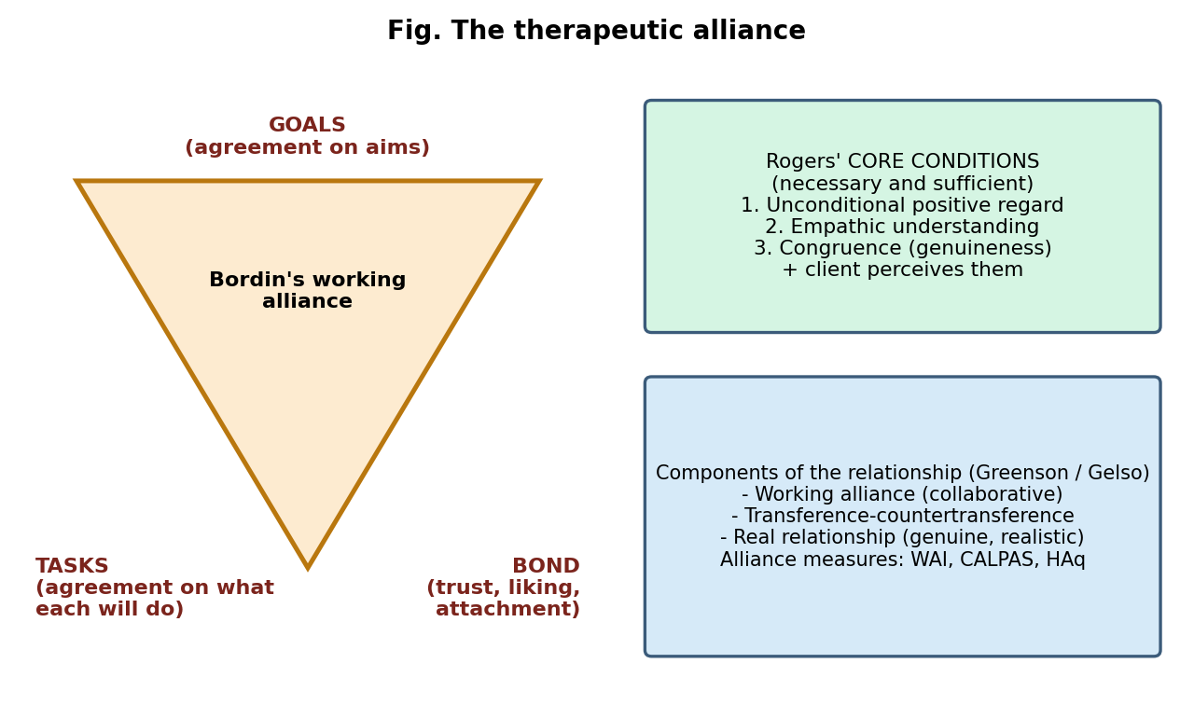
The therapeutic alliance
- Bordin (1979), the working alliance (pantheoretical model): three parts: (1) agreement on goals, (2) agreement on tasks, and (3) the emotional bond (trust, liking, caring).
- Rogers’ core conditions (person-centred): empathy, unconditional positive regard (warmth), congruence (genuineness), perceived by the client.
- Greenson (1967) and Gelso: the relationship consists of the working alliance, transference-countertransference configuration and the real relationship (genuine, realistic perceptions of each other).
- Zetzel: therapeutic alliance as a basis for analysis; Luborsky: “helping alliance” (type 1: therapist as supportive; type 2: shared work).
- Attachment perspective (Bowlby): the therapist acts as a secure base; the client’s attachment style shapes the relationship.
- Transference: the client’s displacement of feelings and expectations from past relationships onto the therapist (positive or negative). Countertransference: the therapist’s emotional reactions to the client (rooted in the therapist’s own history or evoked by the client); managed through self-awareness and supervision; can be used as information. Resistance: the client’s conscious or unconscious opposition to the process of therapy (silence, lateness, avoidance, intellectualisation).
- Stages of the relationship: (1) engagement/formation, (2) deepening and working, (3) termination (ending is itself therapeutic; may revive loss and separation issues).
- Measures: Working Alliance Inventory (WAI) (Horvath and Greenberg), California Psychotherapy Alliance Scales (CALPAS), Helping Alliance Questionnaire (HAq), Session Rating Scale.
Alliance ruptures and repair
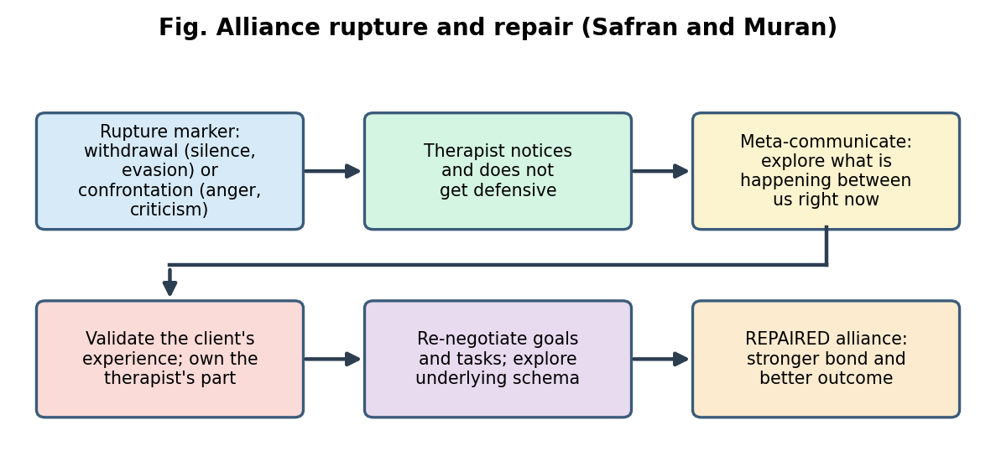
Rupture and repair
- Ruptures are tensions or breakdowns in the alliance. Withdrawal ruptures (client becomes silent, compliant, changes the topic) and confrontation ruptures (client criticises, expresses anger, demands change) (Safran and Muran).
- Repair (meta-communication, empathic validation, flexibility with tasks or goals) is associated with better outcome; repaired ruptures can strengthen the alliance (rupture-repair cycle).

3. Client characteristics
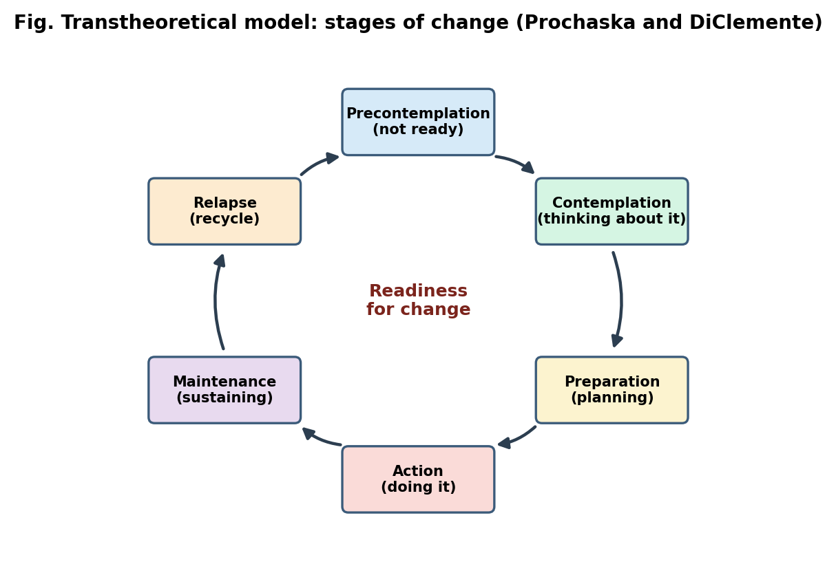
Stages of change
- Motivation and readiness for change (Prochaska and DiClemente: precontemplation, contemplation, preparation, action, maintenance, relapse). Interventions should match the stage; confrontation of a precontemplative client leads to resistance (motivational interviewing is suitable).
- Expectations and hope (a major common factor); role expectations (what the client thinks therapy is).
- Attachment style: secure attachment predicts a quicker alliance; avoidant clients may keep emotional distance; anxious-ambivalent clients may be over-dependent; disorganised clients may show frequent ruptures.
- Personality and coping style: externalising vs internalising coping (Beutler); reactance (high-reactance clients do better with non-directive approaches).
- Psychological mindedness and openness, verbal ability, insight, intelligence (important in insight-oriented therapy). The old YAVIS client stereotype (young, attractive, verbal, intelligent, successful) vs HOUND (homely, old, unintelligent, non-verbal, disadvantaged) shows the bias in the field.
- Demographics and culture: age, gender, language, caste, religion, socio-economic status, cultural beliefs about illness (for example spiritual or somatic explanations, stigma), family expectations; culturally mismatched therapy leads to early dropout.
- Severity, distress and functioning: severe impairment, interpersonal difficulties and chronic problems make alliance-building harder.
- Previous therapy experience, referral source (voluntary vs mandated or family-pushed), social support, life circumstances.

4. Therapist characteristics
- Personal qualities: empathy, warmth, genuineness, respect, trustworthiness, patience, flexibility, emotional stability, humour, hope-inspiring attitude, self-awareness, tolerance of ambiguity.
- Professional factors: training, competence, experience, supervision, adherence to ethical standards, cultural competence (knowledge, awareness, skills), capacity to formulate and adapt the treatment.
- Therapist effects: therapists differ in effectiveness (some consistently get better results); differences are larger than the differences between treatments.
- Therapeutic stance and style: directive vs non-directive, level of activity, self-disclosure (when it serves the client), use of humour, theoretical orientation, and allegiance to the model.
- Countertransference and personal issues: unresolved conflicts, over-identification, need to rescue, anger, boredom, attraction; burnout.
- Demographic match (gender, ethnicity, language): some clients prefer a match; matching is less important than the therapist’s attitude and cultural responsiveness.
- Therapist expectations and belief in the treatment; positive regard for the client.
- Therapist qualities that harm: coldness, rigidity, authoritarianism, over-involvement, criticism, lack of respect for boundaries.

5. Illness factors
- Type of disorder: relationships are easiest to form with mild-moderate anxiety and adjustment problems, and harder with personality disorders (especially borderline, paranoid, antisocial), psychosis (suspicion, poor insight), severe depression (withdrawal, hopelessness), substance use (denial), eating disorders (ambivalence).
- Severity and chronicity: more severe or chronic conditions lengthen the time to build a bond; repeated failed treatments reduce hope.
- Insight and motivation: poor insight (psychosis, mania) reduces collaboration.
- Comorbidity (for example depression with anxiety or substance use).
- Suicidality and risk require a more active, structured stance and may strain boundaries.
- Trauma and abuse history make trust difficult; need for safety and gradual pacing.
- Cognitive impairment (organic disorders, intellectual disability) requires simplified communication and family involvement.
- Medication and physical illness (sedation, side effects, pain) influence engagement.

6. Technique factors
- Match between technique and client/problem (Beutler’s prescriptive matching: for example directive techniques for low-reactance clients, non-directive for high-reactance; symptom-focused for externalisers, insight-focused for internalisers).
- Structure and clarity of the rationale; a credible rationale and explanation raise expectation and alliance.
- Timing and accuracy of interventions (for example well-timed, accurate interpretations strengthen alliance; premature or inaccurate interpretation produces defensiveness).
- Directive vs non-directive style: too directive can cause reactance; too passive can cause confusion or frustration.
- Use of confrontation, exposure or challenging techniques early on can strain the alliance, so the bond should be built first.
- Flexibility vs strict manual adherence: responsive flexibility and ability to adjust to the client improve alliance; rigid adherence in the face of ruptures worsens it.
- Homework and between-session tasks shape the task agreement.
- Format: individual, group, family; in-person vs online (the alliance in video therapy is comparable but affected by technical problems and loss of non-verbal cues).

7. Other factors influencing the relationship
- Therapy setting and frame: privacy, comfort, location, accessibility, waiting time, fees, session length and frequency, cancellation policy.
- Duration: longer treatment allows deeper bond; abrupt endings strain it.
- Social and cultural context: family support or opposition, stigma, language barriers, gender norms, religion, power distance (clients may defer to the “doctor” in Indian settings, so may not disagree openly).
- Life events and external stress during therapy.
- Third parties: referral source, parents, insurers, courts (mandated therapy).
- Technology: mobile, video and text-based therapy.
- Therapist-client “fit” and chemistry (very difficult to assess but important); the importance of early feedback and being willing to refer elsewhere if the fit is poor.
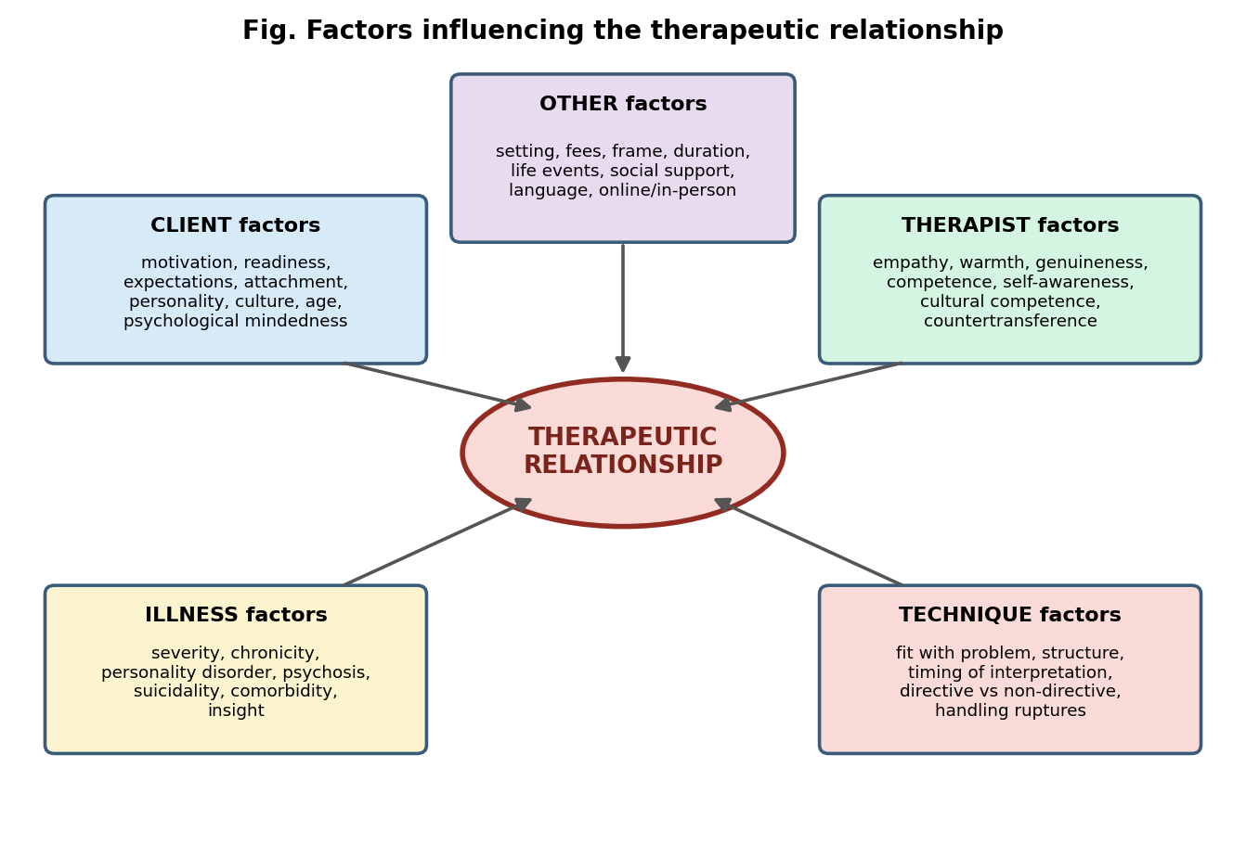
Factors influencing the therapeutic relationship

8. Building and maintaining a good relationship (practical points)
- Start with warmth, courtesy, a clear explanation of the process and confidentiality.
- Use active listening, accurate empathy and non-judgemental acceptance.
- Be reliable and consistent: punctuality, boundaries, honesty.
- Collaboratively set goals and tasks; invite feedback regularly (“How is this working for you?”).
- Notice and discuss ruptures early; take responsibility for the therapist’s contribution.
- Respect culture, values and pace; avoid imposing the therapist’s values.
- Use supervision to manage countertransference.
- Plan and discuss termination openly.

UNIT III: INTERVIEWING

1. Meaning and objectives of the interview
- An interview is a purposeful, planned, goal-directed conversation between an interviewer and an interviewee, in which the interviewer collects information, assesses and/or helps. It differs from ordinary conversation by having a purpose, structure, asymmetrical roles and professional ethics.
- Objectives:
  - Establish rapport and a working relationship.
  - Collect information on the presenting complaints, history (personal, family, medical, psychiatric, social), and current functioning.
  - Make a diagnosis and assess risk (suicide, violence).
  - Understand the client’s perception, feelings, beliefs and expectations.
  - Mental status examination (MSE) and assess insight and judgement.
  - Plan treatment, choose the intervention, and give information.
  - Evaluate progress and outcome; provide support; motivate.
  - Obtain data for research or legal/forensic purposes.

2. Types of interviews
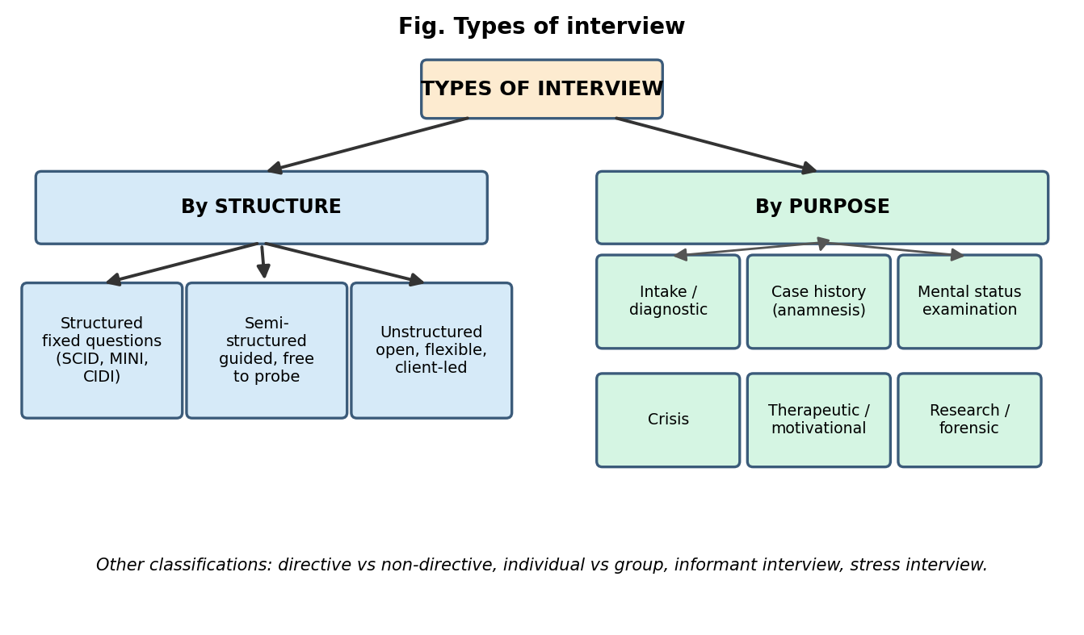
Types of interview
By purpose
- Intake (initial) interview: first contact; reason for referral, presenting problem, expectations, screening, risk.
- Diagnostic interview: to arrive at a diagnosis (for example DSM/ICD criteria).
- Case history (anamnesis) interview: detailed developmental, family, educational, occupational, medical and social history; often includes informants.
- Mental status examination (MSE): appearance and behaviour, speech, mood and affect, thought (form, content), perception, cognition (orientation, attention, memory), insight, judgement.
- Crisis interview: brief, focused, directive; assess safety, stabilise, link to resources.
- Therapeutic interview: the interview itself is a means of change (counselling, motivational interviewing).
- Research interview, forensic, employment/selection, informant interviews (parents, spouse), stress interviews, group interviews.
By structure
- Structured, semi-structured and unstructured interviews (see below).
- Directive vs non-directive: in directive interviews the interviewer controls topic and direction; in non-directive interviews the client leads.

3. Characteristics of structured and unstructured interviews
Feature | Structured | Semi-structured | Unstructured
Questions | Fixed wording and order | Core questions; interviewer may probe and rephrase | Open; general topics, determined by the interviewee
Flexibility | Very low | Moderate | Very high
Reliability | High (standardised, scored) | Good with trained interviewers | Low; depends on the interviewer
Validity | Good for diagnosis, may miss depth | Good balance | Rich, deep, but susceptible to bias
Rapport | Lower; mechanical feel | Good | High
Training needed | Little (lay interviewers possible for fully structured) | Clinical skill needed | Considerable skill
Time | Predictable | Variable | Variable, long
Examples | DIS, CIDI, MINI (fully/highly structured) | SCID-5, SCAN, K-SADS, ADIS-5, SADS, CAPS-5 | Clinical intake, therapeutic interview
Use | Research, epidemiology, standardised diagnosis | Clinical diagnosis, research | Exploration, therapy, case-history
- Advantages of structured interviews: reliability, comparability, completeness, reduced interviewer bias, use of decision rules; limitations: rigid, less rapport, may miss unique concerns, need cultural adaptation.
- Advantages of unstructured interviews: flexibility, depth, rapport, discovery of unexpected issues; limitations: poor reliability, interviewer bias (halo effect, first impression, confirmation bias, anchoring), difficulty in comparison, may miss symptoms.
- Semi-structured interviews combine the strengths and are widely preferred for clinical research.

4. Stages of an interview
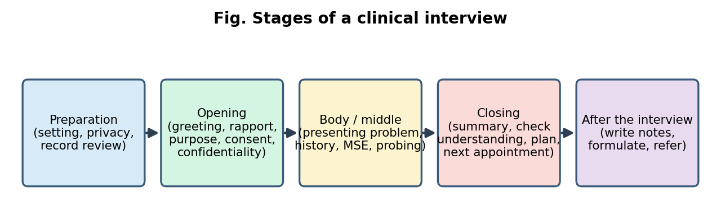
Stages of an interview
- Preparation: review referral and records; arrange privacy, seating (comfortable, at an angle, not behind a desk), time, absence of interruptions; clarify own aims.
- Opening: greet by name, introduce yourself and role, explain purpose, time, confidentiality and its limits, obtain consent; begin with an open invitation (“What brings you here?”); put the client at ease.
- Body (middle): explore the presenting problem (onset, course, severity, precipitants, impact), then relevant history; use funnelling (open to specific), probe, clarify, reflect, summarise; conduct the MSE; assess risk.
- Closing: summarise, check accuracy, invite additions (“Is there anything I haven’t asked?”), give feedback or information, plan next steps, fix the next appointment, end on time and on a supportive note.
- After the interview: record notes promptly, formulate, plan, refer, reflect on own reactions.

5. Interviewing techniques and skills (micro skills)
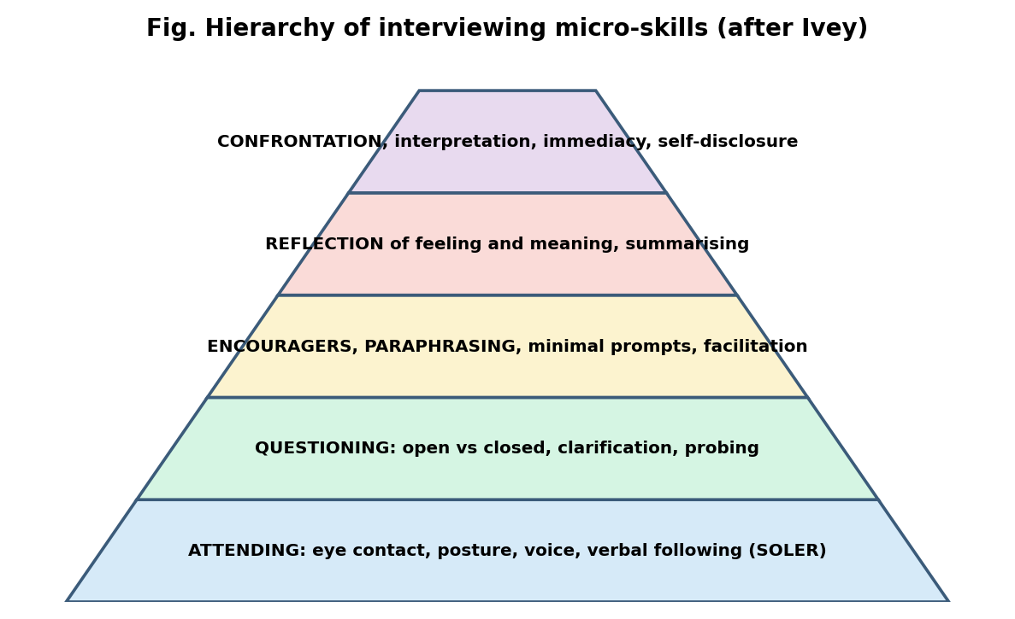
Hierarchy of micro-skills
Micro skills (Ivey) are small, specific communication skills that, together, make up effective interviewing.
A. Attending behaviour (Egan’s SOLER)
- Squarely face the client; Open posture; Lean slightly toward; maintain appropriate Eye contact; stay Relaxed and natural.
- Verbal following: keep to the client’s topic, do not interrupt or jump topics.
B. Questioning
- Open-ended questions begin with what, how, could, tell me about… and invite elaboration: “How have things been for you since the accident?” They encourage exploration, give control to the client and build rapport.
- Closed questions can be answered “yes/no” or with a short fact; useful for specific details, diagnosis and risk (for example “Have you thought of ending your life?”). Too many create an interrogation.
- Probing questions explore further (“Can you give an example?”).
- Avoid: leading (“You don’t drink, do you?”), double-barrelled (two questions in one), multiple stacked questions, “why” questions (sound judgemental; elicit defensiveness or intellectualisation), and judgemental or loaded questions.
- Funnel technique: begin broad, then narrow; inverted funnel is used in sensitive topics.
C. Clarification
- Seeking to make unclear or vague statements specific: “Do you mean that you felt angry or hurt?” “When you say always, can you tell me about a typical week?” It checks the interviewer’s understanding.
D. Paraphrasing (restating) and reflection
- Paraphrase: restating the content in the interviewer’s own words, briefly (“So your boss criticised your report in front of everyone.”)
- Reflection of feeling: identifying and verbalising the emotion beneath the content (“You felt humiliated and angry.”) Shows empathy and helps the client label emotion. Also reflection of meaning (values, beliefs).
- Summarisation: pulls together themes and checks understanding, used at transitions and at the end.
E. Facilitation (encouragers)
- Minimal verbal and non-verbal prompts that keep the client talking: “Mm-hmm”, “Go on”, “And then…?”, nodding, repeating key words (echoing), a gesture of interest, waiting.
F. Confrontation
- Pointing out discrepancies, inconsistencies or avoided issues between words and actions, feelings and behaviour, or two statements: “You say you are not angry, but your fists are clenched.” It is not an attack; it is a caring, tentative, specific, gentle challenge, used after rapport, with an invitation to explore. Poorly timed confrontation causes defensiveness.
G. Silence (and its use)
- Types: thoughtful/reflective (the client is thinking, working), emotional (overwhelmed, crying), resistant (unwilling to speak, hostile), anxious/awkward, confused (does not know what to say), and the interviewer’s strategic silence.
- Management: allow a pause of about 5 to 10 seconds; observe non-verbal signals; use encouragers, gentle reflection (“It seems hard to say”) or an open invitation; do not rush in with questions; respect cultural differences about silence.
- Benefits: gives time to think, signals acceptance, helps deeper disclosure; risks: if prolonged and unaddressed, it may be experienced as rejection.
H. Other skills: interpretation (linking patterns or meaning, cautiously), self-disclosure (brief and relevant), immediacy (discussing what is happening between client and interviewer now), empathic responding, reassurance, giving information/advice, goal setting, focusing, structuring, summarising, managing the time and ending.

6. Verbal and non-verbal components of interviewing
Verbal components
- Content (what is said: facts, themes, beliefs), language (vocabulary and simple clear words, avoiding jargon; using the client’s language and metaphors), speech characteristics (rate, tone, pitch, volume, fluency), paralanguage/paraverbal cues (sighs, pauses, laughter, tremor in voice), and style of questions and responses.
Non-verbal components
- Kinesics: facial expression, eye contact, gestures, posture, head nods; fidgeting, tension, psychomotor retardation or agitation.
- Proxemics (Hall): personal space (intimate 0 to 18 inches, personal 1.5 to 4 feet which suits interviews, social, public); cultural variation.
- Haptics: touch (use cautiously and with consent).
- Appearance and grooming (client and interviewer), environment (seating, lighting, clock, privacy).
- Chronemics: punctuality, pace, use of time.
- Congruence/incongruence: non-verbal behaviour often reveals feelings that words conceal (for example smiling while describing a tragedy); interpret patterns, not isolated cues, and avoid over-reading; consider culture (eye contact may be disrespectful in some contexts; head wobble, nodding, gender distance in India).

7. Common errors in interviewing
- Leading or loaded questions; too many closed questions; double-barrelled questions.
- Interrupting, talking too much, or filling silences.
- Giving premature advice or reassurance; moralising or judging.
- Not listening (planning the next question), poor note-taking that breaks eye contact.
- Interviewer biases: halo effect, stereotyping, confirmation bias, first-impression error.
- Ignoring non-verbal cues, culture and language needs; failing to explain confidentiality.
- Not ending on time; not summarising; not assessing risk.

8. Mental status examination (outline)
General appearance and behaviour; speech; mood (subjective) and affect (objective); thought: form (flow) and content (delusions, obsessions, preoccupations); perception (hallucinations, illusions); cognition (orientation, attention and concentration, memory, general knowledge, abstraction); insight; judgement. Risk assessment (suicide, harm to others) is part of every interview.

UNIT IV: AFFECTIVE PSYCHOTHERAPIES
How to answer questions in this unit (framework for every therapy): origin, basis (theory), formulation (how problems are understood), goals, procedures and techniques, stages and process, therapist’s role, outcome, indications and contraindications, research and current status, and a critical evaluation. The notes follow this order.

1. Psychodynamic psychotherapy
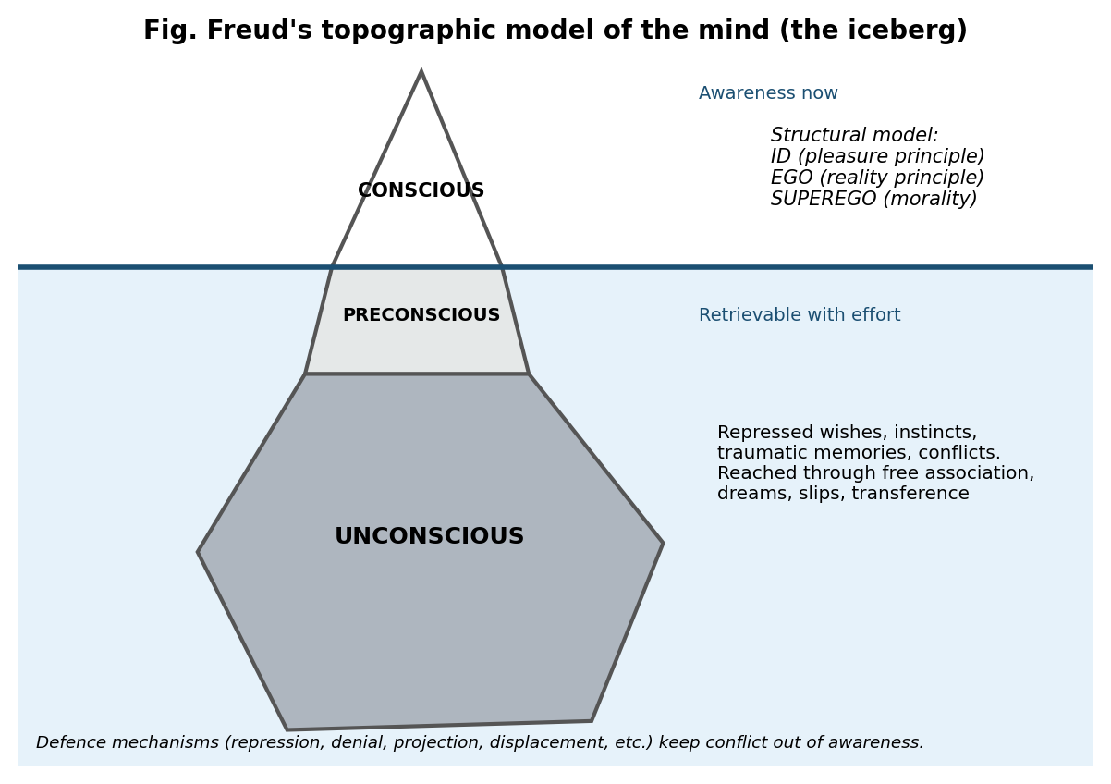
The Freudian iceberg
Origin
- Begins with Sigmund Freud (1856 to 1939) and Josef Breuer (the case of Anna O., “the talking cure”; Studies on Hysteria, 1895). Freud developed psychoanalysis from hypnosis and catharsis to free association and interpretation (The Interpretation of Dreams, 1900).
- Later developments: Jung (analytical psychology), Adler, Anna Freud and Hartmann (ego psychology), Klein, Fairbairn, Winnicott (object relations), Kohut (self psychology), Bowlby (attachment), and modern relational and short-term psychodynamic therapies. Psychodynamic psychotherapy is the modern, briefer form of psychoanalysis (face-to-face, one to two sessions per week).
Basis (key concepts)
- Psychic determinism: behaviour and symptoms have meaning and causes.
- Unconscious: most mental processes are outside awareness; topographic model (conscious, preconscious, unconscious) and structural model (id = pleasure principle, ego = reality principle, superego = conscience and ideals).
- Psychosexual stages: oral, anal, phallic (Oedipus/Electra complex), latency, genital; fixation and regression in response to excess frustration or indulgence.
- Anxiety (reality, neurotic, moral) and defence mechanisms (repression, denial, projection, displacement, reaction formation, regression, rationalisation, sublimation, intellectualisation, etc.).
- Early childhood experiences and unresolved conflicts shape personality; transference and countertransference; resistance.
Formulation of problems
- Symptoms are compromise formations between an unacceptable repressed wish (id), the demands of reality and the superego; they symbolise the underlying conflict and give “secondary gain”. Treatment aims to make the unconscious conscious: “Where id was, there ego shall be.”
Goals
- Insight into unconscious conflicts and patterns, resolution of conflict, strengthening the ego, more mature defences, and lasting personality change; symptom relief follows.
Procedures and techniques
- Therapist stance: neutrality, abstinence, anonymity (“blank screen”), evenly hovering (suspended) attention; a warm but professional attitude. The client often lies on a couch (classical analysis, 3 to 5 sessions per week for years); in psychodynamic therapy sessions are 1 to 2 per week, face-to-face.
- Free association: the fundamental rule: say everything that comes to mind without censoring.
- Dream analysis: dreams are the “royal road to the unconscious”. Manifest content (what is remembered) vs latent content (hidden meaning); the dream work includes condensation, displacement, symbolisation, secondary revision.
- Interpretation: the therapist explains the unconscious meaning of the client’s associations, dreams, symptoms and behaviour; timing and tact are key. Types: clarification, confrontation, interpretation (Bibring); mutative interpretation (Strachey).
- Analysis of resistance: noting and exploring lateness, silence, forgetting, intellectualising.
- Analysis of transference: the client repeats old relationship patterns with the therapist; transference neurosis develops in classical analysis; analysed in the here-and-now and linked to the past (“the transference is the main tool”).
- Parapraxes (Freudian slips), free-floating associations, working through (repeated exploration and elaboration of insights until lasting change).
- Contemporary techniques: focus on the current relationship, mentalisation (Fonagy), supportive and expressive techniques, formulation of the core conflictual relationship theme (CCRT; Luborsky).
Stages and process
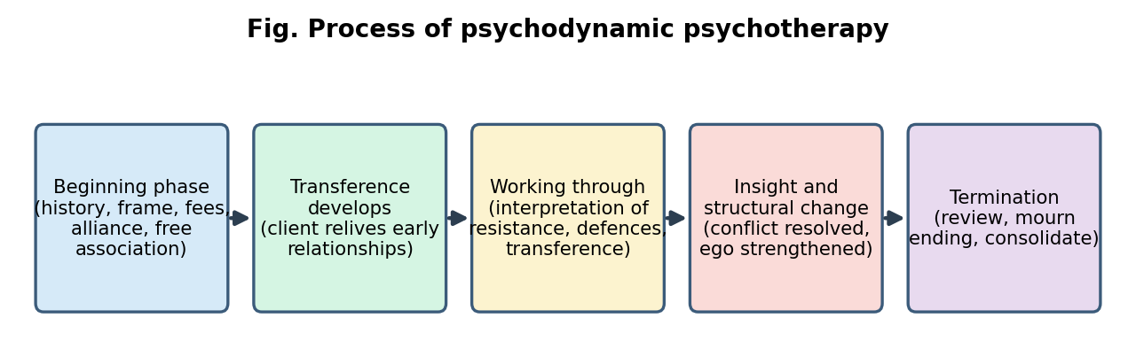
Psychodynamic process
- Initial (opening) phase: assessment, history, therapeutic contract and frame (fees, times), establishing the alliance, explaining free association.
- Development of transference: the client’s feelings toward the therapist emerge and become intense.
- Working-through phase: interpretation of resistance, defences and transference; insights and corrective emotional experience.
- Termination: the ending is planned, with review, resolution of the transference, mourning the end, and consolidation.
Outcome
- Reduced symptoms, greater insight, more flexible and mature defences, healthier relationships, better self-esteem; gains often continue after treatment ends (“sleeper effect”).
Indications
- Neurotic disorders (anxiety, depression, obsessions, phobias), personality problems, interpersonal difficulties, adjustment problems, trauma-related conflicts, clients with good ego strength, psychological-mindedness, motivation, capacity to form relationships and tolerate frustration. Contraindications: acute psychosis, severe impulsivity or suicidality, poor reality testing, low motivation or intelligence, crisis situations (supportive therapy preferred).
Research and current status
- Meta-analyses (for example Shedler, 2010; Leichsenring and Rabung) show large pre-post effects and efficacy comparable to other bona fide treatments for many conditions; evidence for short-term psychodynamic therapy (STPP) is good for depression, anxiety, somatic disorders and personality disorders; mentalisation-based treatment (MBT) and transference-focused psychotherapy (TFP) are effective in borderline personality disorder. Evidence for classical long-term analysis is more limited (few RCTs, difficult to study).
- Criticisms: non-falsifiable concepts (Popper), long and expensive, evidence from case studies, over-emphasis on early sexuality, limited for severe disorders. Today the approach is widely taught, influencing CBT, attachment and relational therapies.

2. Brief psychotherapy
Origin
- Early foundations: Ferenczi and Rank (1920s: active technique, set time limits), Alexander and French (1946: “corrective emotional experience”, flexible frequency). Models: Malan (Tavistock brief focal psychotherapy), Sifneos (short-term anxiety-provoking psychotherapy, STAPP), Mann (time-limited psychotherapy, 12 sessions), Davanloo (intensive short-term dynamic psychotherapy, ISTDP), Strupp and Binder (time-limited dynamic psychotherapy), Luborsky (supportive-expressive), Klerman and Weissman (interpersonal psychotherapy, IPT), de Shazer and Berg (solution-focused brief therapy, SFBT), MRI group (strategic brief therapy), crisis intervention (Lindemann, Caplan), Beck’s CBT (time-limited). Growth was driven by cost, demand, and evidence that most improvement occurs early (Howard: about 50% improved by 8 sessions and about 75% by 26 sessions).
Basis
- Time limit is therapeutic: the end date mobilises motivation and prevents regression and dependency.
- Focus on a specific, circumscribed problem or theme (focus); therapist is active, directive and selective.
- Emphasis on the here-and-now, the client’s strengths and resources; assumption that small changes lead to larger changes.
- Psychodynamic brief therapies emphasise conflict and transference; cognitive-behavioural and solution-focused ones emphasise skills and solutions.
Formulation
- A focal formulation (for example a recurring interpersonal pattern, a current loss, or an unresolved conflict linked to the present problem); in IPT, one of four problem areas: grief, interpersonal role disputes, role transitions, interpersonal deficits.
Goals
- Resolve the focal problem, relieve symptoms, restore previous functioning, and teach skills that the client can use later; not complete personality reconstruction.
Procedures and techniques
- Patient selection (Sifneos’ criteria): a circumscribed chief complaint, at least one meaningful past relationship, ability to interact flexibly with the evaluator, psychological-mindedness, motivation to change, and ability to tolerate anxiety.
- Contract: 6 to 20 sessions (often 12 to 16), fixed end date, weekly sessions.
- Techniques: focused interpretation, selective attention and inattention, challenging defences, use of positive transference, homework, problem solving, role play, communication analysis (IPT), and in SFBT: the miracle question, scaling questions, exception finding, coping questions, compliments, and a formula first-session task.
Stages and process
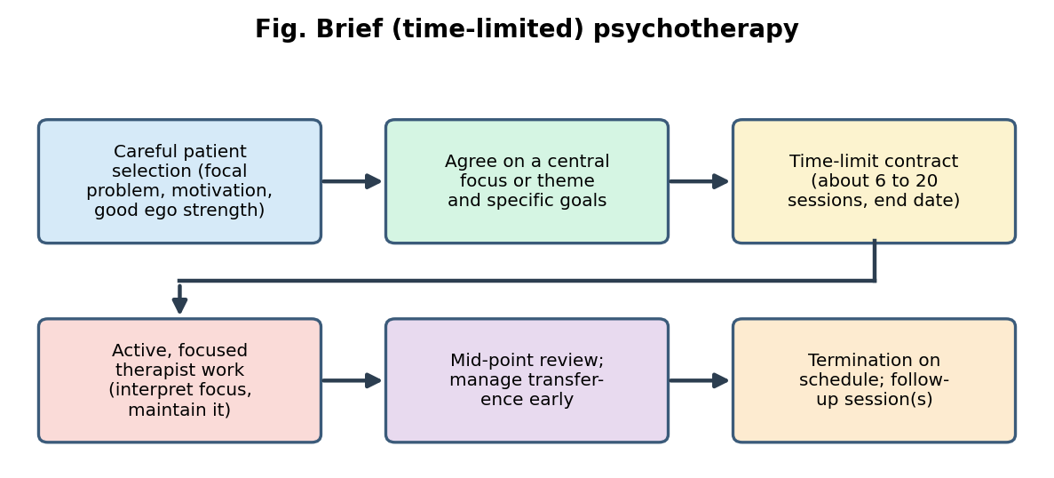
Brief therapy process
- Assessment and selection (sessions 1 to 3): history, focus, goals, contract.
- Middle phase: active work on the focus; interpret or practise skills; maintain the focus; mid-point review.
- Termination: discuss the ending explicitly; consolidate gains; plan for the future; arrange booster/follow-up sessions.
Outcome
- Symptom relief and improved functioning; many studies show brief therapy comparable to long-term therapy for common disorders (depression, anxiety, adjustment).
Indications
- Acute, focal problems, adjustment disorders, mild to moderate depression and anxiety, grief, crises, motivated clients with good ego strength. Contraindications: severe personality disorders, chronic multi-problem conditions, severe psychosis, severe depression with high risk (needs longer-term or combined care), poor motivation.
Research and current status
- Strong evidence for IPT (depression, eating disorders), brief CBT and SFBT (moderate evidence); STPP supported; dose-effect research supports early gains. Widely used in managed care, primary care, college counselling and telehealth. Critics note that brief therapy may be inadequate for chronic disorders and that “brief” is sometimes driven by cost.

3. Humanistic psychotherapy
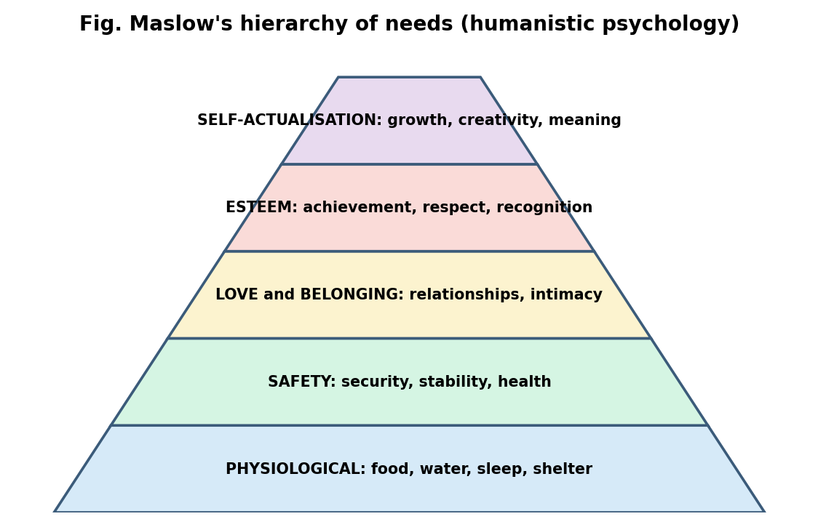
Maslow’s hierarchy
Origin
- Emerged in the 1950s and 1960s as the “third force” in psychology, a reaction against the determinism of psychoanalysis and the mechanistic view of behaviourism. Key figures: Abraham Maslow (hierarchy of needs; self-actualisation), Carl Rogers (person-centred), Rollo May and Viktor Frankl (existential), Fritz Perls (Gestalt). The Association for Humanistic Psychology (1961) was founded by Maslow and others. Philosophical roots: phenomenology, existentialism, Rousseau.
Basis
- Human beings are inherently good, growth-oriented and capable of self-direction (actualising tendency).
- Emphasis on subjective experience, free will, choice, responsibility, the here-and-now, and the whole person.
- Maslow: hierarchy of needs (physiological, safety, love/belonging, esteem, self-actualisation); psychopathology arises when growth needs are blocked.
- The therapeutic relationship is the main agent of change (not technique).
Formulation, goals and techniques
- Distress arises when natural growth is blocked by environmental conditions, conditions of worth, loss of awareness, or disconnection from experience.
- Goals: self-awareness, self-acceptance, authenticity, personal growth and self-actualisation, responsibility.
- Techniques: empathic listening, reflection, unconditional acceptance, experiential techniques (for example focusing, chair work), emphasis on genuine presence; non-directive and client-led.
Outcome, indications, research
- Increased self-esteem, congruence, emotional awareness and relationship satisfaction.
- Indicated for mild to moderate distress, identity and relationship problems, growth seeking, depression, anxiety; not as first line for severe psychosis or when structured skills training is required.
- Research: the Elliott et al. meta-analyses show that humanistic-experiential therapies produce large pre-post gains, stable at follow-up, and are equivalent to CBT in many comparisons. Modern forms: emotion-focused therapy (EFT; Greenberg), process-experiential therapy, motivational interviewing. Critique: vague concepts, difficult to test, over-optimism about human nature, limited for severe disorders.

4. Existential psychotherapy
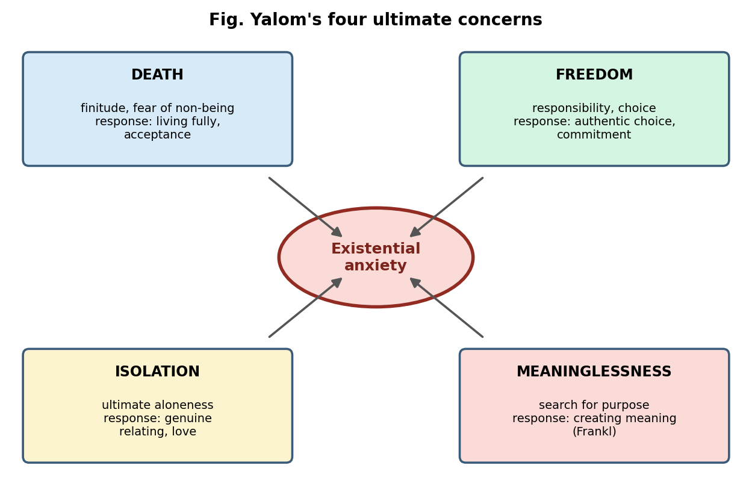
Four ultimate concerns
Origin
- Philosophical roots: Kierkegaard, Nietzsche, Heidegger, Sartre, Buber. Clinical: Binswanger and Boss (Daseinsanalysis), Viktor Frankl (logotherapy, from the 1930s; Man’s Search for Meaning, 1946, formed in the concentration camps), Rollo May (Existence, 1958), Irvin Yalom (Existential Psychotherapy, 1980), Emmy van Deurzen (British school).
Basis
- Human existence involves unavoidable “ultimate concerns” (Yalom): death, freedom (responsibility), isolation and meaninglessness. Confronting them produces existential anxiety; avoidance leads to symptoms.
- Existence precedes essence: we create ourselves through our choices; authenticity (living in accordance with our values) versus bad faith/inauthenticity.
- Being-in-the-world (Heidegger); the three modes (Umwelt, Mitwelt, Eigenwelt: physical, social and personal worlds); will to meaning (Frankl), freedom of will, and meaning of life; existential guilt (unlived life).
Formulation
- Psychopathology reflects inauthentic living, avoidance of freedom and responsibility, loss of meaning, or failure to cope with death and isolation. Frankl described noogenic neurosis (the existential vacuum): boredom, emptiness, depression due to loss of meaning.
Goals
- Help clients face life’s givens honestly; increase awareness, responsibility, authenticity, freedom of choice and meaning; commitment to action in the face of anxiety.
Procedures and techniques
- Phenomenological exploration of the client’s worldview (bracketing therapist’s assumptions); Socratic dialogue; dealing with ultimate concerns; examining values, choices and avoidances; “I” statements that increase responsibility; here-and-now relationship as a laboratory.
- Logotherapy techniques: paradoxical intention (the client deliberately attempts the feared behaviour or wish, reducing anticipatory anxiety, for example in phobias, insomnia), dereflection (shifting attention away from the problem or self to meaningful activities and others), attitudinal modification (finding meaning in unavoidable suffering), Socratic dialogue, and discovering meaning through creative, experiential and attitudinal values.
- Existential group therapy (Yalom’s curative factors: universality, altruism, imparting hope, etc.).
Stages and process

  - Establish a genuine relationship and explore the client’s worldview and values. 2. Identify concerns, patterns of avoidance and inauthenticity. 3. Challenge and deepen awareness, explore meanings, freedom, responsibility. 4. Commit to chosen action and new ways of living; end with consolidation.
Outcome and indications
- Greater meaning, purpose, authenticity and ability to tolerate anxiety. Suited to existential crises (life transitions, midlife, bereavement), terminal or chronic illness (for example meaning-centred psychotherapy, Breitbart), depression with emptiness, addictions, trauma, and clients seeking meaning. Less suitable for acute psychosis or those wanting quick symptom control.
Research and status
- Evidence is moderate: meta-analysis of meaning-centred interventions (Vos and colleagues) show benefit for meaning, depression, quality of life, especially in people with cancer. Logotherapy has small studies of benefit. Criticisms: abstract, hard to operationalise and standardise, and requires verbal/philosophical ability. It strongly influences palliative care, ACT and humanistic therapies.

5. Gestalt therapy
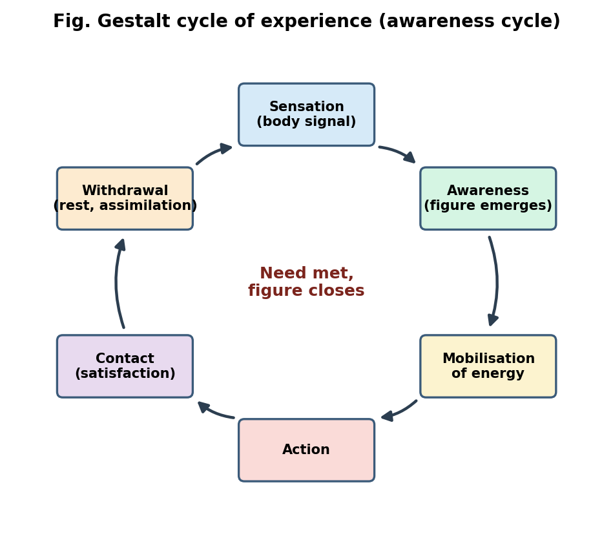
Gestalt cycle of experience
Origin
- Developed by Frederick (Fritz) Perls, Laura Perls and Paul Goodman in the 1940s to 1950s (Gestalt Therapy, 1951), from psychoanalysis, Gestalt psychology (Wertheimer, Köhler), Reich, Lewin’s field theory, Moreno and existential-phenomenological philosophy; made popular in the 1960s at the Esalen Institute.
Basis
- Holism and field theory (the person and environment form one field); the here-and-now (“what” and “how”, not “why”); awareness is curative; figure and ground (the dominant need becomes the figure); organismic self-regulation; contact with the environment at the boundary; responsibility (“response-ability”); unfinished business (unexpressed feelings that demand attention and interfere with the present).
- Paradoxical theory of change (Beisser): change occurs when a person becomes what he or she is, not when trying to become what he or she is not.
Formulation
- Disturbance arises from interruption of the cycle of experience and boundary (contact) disturbances:
  - Introjection (swallowing others’ views without examination),
  - Projection (disowning one’s own feelings and attributing them to others),
  - Retroflection (turning onto oneself what one would do to others, or doing to self what one wants from others),
  - Deflection (avoiding contact by distraction, humour, vagueness),
  - Confluence (loss of boundary between self and other).
- Perls’ layers of neurosis: phony, phobic, impasse, implosive, explosive.
- Top-dog vs underdog (the inner conflict between “should” and “want”).
Goals
- Increase awareness (of self, environment, choices), take responsibility, integrate split-off parts, complete unfinished business, achieve contact and self-support (shift from environmental support to self-support), and enhance spontaneity.
Procedures and techniques (therapist makes “experiments”, not interpretations)
- Empty chair (two-chair) technique: dialogue with an imagined person or part of self to express unfinished business or resolve conflict (top-dog/underdog).
- Exaggeration of gesture or posture to heighten awareness; reversal (act out the opposite); rehearsal; making the rounds in groups.
- “I” language (“I won’t” instead of “I can’t”; “I” instead of “it/you”); “what/how” instead of “why”; staying with the feeling; present tense language.
- Dream work: every part of a dream is a projected aspect of the dreamer, who “plays” each part.
- Body awareness (focusing on bodily sensation, breathing, tension), confrontation (supportive), fantasy and guided imagery, dialogue with symptoms or body parts, and use of the therapist’s presence and feedback.
Stages and process

  - Contact and relationship building (the “I-Thou” relationship; dialogue, presence, inclusion). 2. Awareness work to identify the figure, needs and avoidances. 3. Experiments to heighten awareness and contact (empty chair etc.); work through impasse. 4. Integration and completion, with new choices and closure.
- Therapist: authentic, present, non-interpretative; phenomenological, dialogic and experimental.
Outcome and indications
- Greater awareness, responsibility, emotional expression, integration, vitality, better interpersonal functioning. Used for anxiety, depression, interpersonal and personality problems, psychosomatic complaints, trauma-related unfinished business, groups, couples. Cautions: very confrontational techniques may overwhelm fragile clients; unsuitable for acute psychosis, weak impulse control, or those unable to tolerate intense emotion.
Research and status
- Research is limited but growing: a meta-analysis (Strümpfer, 2006) found positive effects; emotion-focused therapy (EFT) research (empty-chair work for unfinished business; Greenberg, Paivio) shows efficacy. Current forms: relational Gestalt, dialogic, EFT, and Gestalt in organisations. Criticism: early Perls style was authoritarian and anti-intellectual; limited empirical base; techniques can be misused as “tricks”.

6. Person-centred (client-centred) therapy
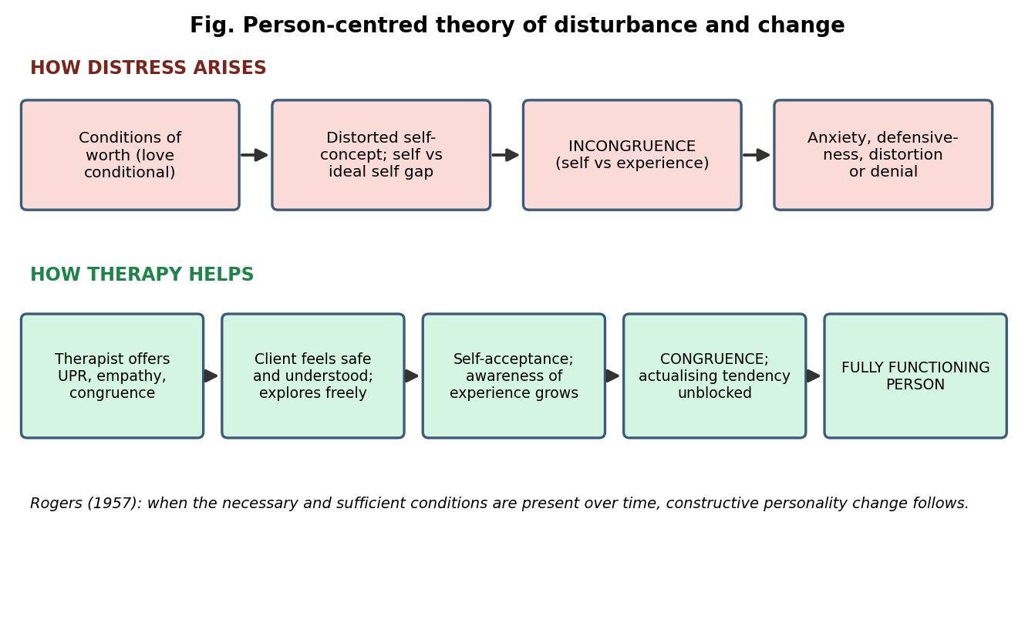
Person-centred theory
Origin
- Carl R. Rogers (1902 to 1987). Counseling and Psychotherapy (1942) introduced non-directive counselling; Client-Centered Therapy (1951); later the person-centred approach (1970s onward) applied to education, groups, conflict resolution (encounter groups) and peace work. The Wisconsin project (schizophrenia) and research recording of therapy sessions began an empirical tradition.
Basis (theory)
- Actualising tendency: the single motivating force of every organism toward growth and fulfilment.
- Self-concept (organised perceptions of self) and ideal self; organismic valuing process (trust in one’s own experiencing).
- Conditions of worth: when love and approval are conditional, the child introjects others’ standards and distorts or denies experiences inconsistent with them.
- Incongruence: gap between self-concept and experience (and between real and ideal self) leads to anxiety, defensiveness and maladjustment; congruence leads to psychological health. Fully functioning person: open to experience, living existentially, trusting one’s organism, creative, free.
- Phenomenological stance: the client’s subjective reality is the key; the client is the expert on himself/herself.
Formulation
- Psychological problems stem from incongruence caused by conditions of worth, and treatment is aimed at providing the conditions in which the actualising tendency can resume.
Rogers’ six necessary and sufficient conditions (1957)
- Two persons are in psychological contact.
- The client is in a state of incongruence (vulnerable or anxious).
- The therapist is congruent (genuine, integrated) in the relationship.
- The therapist experiences unconditional positive regard (UPR) for the client.
- The therapist experiences an empathic understanding of the client’s internal frame of reference and communicates it.
- The client perceives (at least to a minimal degree) the therapist’s UPR and empathy.
Techniques and procedures
- Non-directive: the therapist does not interpret, diagnose, advise, probe, or reassure.
- Active (reflective) listening: reflection of feelings, paraphrase, clarification, summarising, accepting silences, responding to the client’s internal frame of reference, genuineness in the relationship, warmth; also focusing (Gendlin).
- Therapist as a facilitator, an equal partner who “walks beside” the client; the relationship is the technique.
Stages and process
- Rogers’ seven stages of process: from stage 1 (rigid, unaware, remote from feelings, unwilling to communicate about self) through stages 2 to 4 (loosening; describing feelings as past, then present but distanced; more freely expressed) to stages 5 to 7 (feelings experienced in the immediate moment, acceptance of oneself as a process, fluid, trusting of experiencing). Therapy progresses as the client moves along this continuum, with freer expression, greater congruence and self-acceptance.
- In practice: the client talks; the therapist reflects; as the client feels understood and accepted, defences lower, self-exploration deepens, new self-understanding emerges, and the client makes self-directed changes. Length: flexible.
Outcome
- Increased self-acceptance and congruence, an internal locus of evaluation, greater openness to experience, trust of self, reduced anxiety and defensiveness, and improved relationships and self-direction.
Indications and contraindications
- Wide applicability: mild to moderate emotional problems, adjustment, identity, relationship problems, grief, counselling settings, adolescents, students, couples and groups, children (child-centred play therapy), and as a base of all therapies’ relationship skills. Limitations: clients who want direct advice or structured skills; acute psychosis, severe disorders (modified use), crises requiring active intervention, those with limited verbal ability.
Research and status
- Research of Rogers and colleagues was a pioneer in therapy research (recording and rating of sessions; Truax and Carkhuff). Meta-analyses show that empathy, positive regard and congruence correlate with outcome in the range of about r = .2 to .3 (Elliott et al., 2018; Orlinsky). Person-centred therapy is as effective as other bona fide therapies in many studies. Criticisms: the “necessary and sufficient” claim is not supported (many clients benefit from specific techniques); no explicit techniques; may be less effective for severe disorders; middle-class, verbal bias; slow. Current: person-centred and experiential therapies, counselling psychology, EFT, UK counselling training (for example in NHS).

7. Adlerian therapy (Individual Psychology)
Origin
- Alfred Adler (1870 to 1937), a Viennese physician who was an early member of Freud’s circle and broke away in 1911 to found Individual Psychology. Developed by Rudolf Dreikurs (children, families, the “democratic” classroom), Heinz Ansbacher, Harold Mosak, Don Dinkmeyer. Adler established the first child-guidance clinics (Vienna, 1920s).
Basis (key concepts)
- Holism and teleology: the person is indivisible; behaviour is goal-directed (fictional finalism, the guiding fiction).
- Inferiority feelings, compensation and striving for superiority/significance (perfection or completion); inferiority complex and superiority complex.
- Social interest (Gemeinschaftsgefühl): innate capacity to cooperate and contribute; the measure of mental health.
- Lifestyle: the unique pattern of beliefs, goals and behaviours formed in early childhood (by about age 5) from the family constellation and birth order (oldest, second, middle, youngest, only child).
- Private logic (idiosyncratic, mistaken beliefs) vs common sense; basic mistakes (overgeneralisation, false goals, denial of worth, faulty values).
- Life tasks: work, love (intimacy), community (friendship, society); later self and spirituality.
- Creative self: people actively create their lifestyle; encouragement/discouragement; safeguarding tendencies (excuses, aggression, withdrawal). Children’s four mistaken goals: attention, power, revenge, display of inadequacy (Dreikurs).
Formulation
- Psychological problems arise from discouragement, mistaken lifestyle beliefs, exaggerated feelings of inferiority and low social interest. Problems are viewed as problems of living, not illness (“the patient has a way of life that doesn’t work”).
Goals
- Increase social interest and belonging, correct mistaken beliefs and lifestyle, encourage courage and self-worth, replace inferiority/superiority striving with contribution.
Procedures and techniques
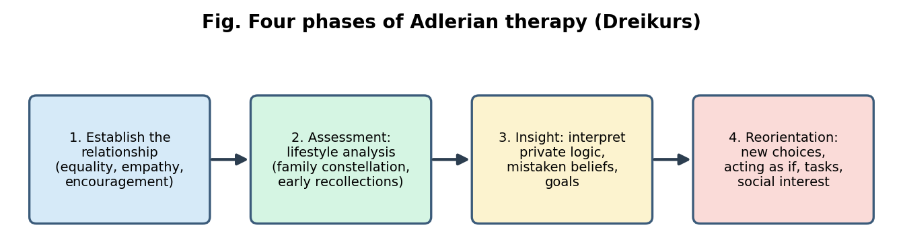
Adlerian phases
- Four phases (Dreikurs): (1) establish the relationship (equality, empathy, mutual respect, collaboration); (2) assessment (analysis) of the lifestyle, using the family constellation (birth order, family atmosphere, parental style) and early recollections (the earliest memories as projective clues), dreams, and the Question (“What would be different if you were well?”); (3) insight (disclosing and interpreting mistaken beliefs, private logic, goals); (4) reorientation (action: new choices and behaviours).
- Techniques: encouragement (the central technique), “acting as if”, “spitting in the client’s soup” (making the payoff of the behaviour unattractive), “catching oneself”, push-button technique (choosing feelings by recalling pleasant and unpleasant memories), task setting and homework, paradoxical intention, immediate confrontation, avoiding the “tar baby”, creating images, natural and logical consequences (parenting), family council and parent education.
- Therapist’s role: equal, collaborative, optimistic, encouraging teacher or “coach”; therapy is considered an educational and re-educational process.
Outcome
- Reduced inferiority and discouragement, increased courage, greater social interest, more adaptive lifestyle and relationships.
Indications
- Children and adolescents, parent education and family therapy, school counselling, couples, group counselling, career counselling, personality and adjustment issues, and groups from varied cultures (collectivist values fit). Less suited to severe psychopathology (needs adaptation).
Research and status
- Research is limited; studies show positive effects of Adlerian parent education (STEP) and Adlerian play therapy, and Adlerian counselling; meta-analyses of Adlerian approaches show moderate benefits. Adler’s ideas anticipated cognitive therapy (Ellis, Beck), humanistic and family systems therapies. Criticism: concepts are difficult to test and imprecise (for example “social interest”), and overemphasis on birth order lacks support.

8. Transactional Analysis (TA)
Origin
- Eric Berne (1910 to 1970): Transactional Analysis in Psychotherapy (1961); Games People Play (1964); later Thomas Harris (I’m OK - You’re OK, 1967), Claude Steiner (scripts), Stephen Karpman (drama triangle, 1968), Robert and Mary Goulding (redecision therapy), Taibi Kahler (drivers), and Franklin Ernst (OK Corral).
Basis
- Ego states (observable states of mind and behaviour): Parent (taught: Critical/Controlling and Nurturing), Adult (thought: objective, data-processing), Child (felt: Free/Natural, Adapted, Rebellious). Structural analysis examines the content of ego states; contamination (Parent or Child intrudes upon Adult) and exclusion (rigid exclusion of an ego state) are disturbances.
- Transactions: the unit of social interaction: complementary (expected response, communication continues), crossed (unexpected response, communication breaks down), ulterior (two levels: social and psychological hidden message).
- Strokes (units of recognition; positive/negative, conditional/unconditional); recognition hunger, stimulus hunger, structure hunger; time structuring: withdrawal, rituals, pastimes, activities, games, intimacy.
- Games and rackets: repetitive transactional sequences with a hidden payoff and a predictable bad ending (“Why don’t you - Yes, but”; “Kick me”); racket feelings.
- Life script: an unconscious life plan formed in childhood from parental messages, injunctions (don’t be, don’t think, don’t feel, don’t be close…), counter-injunctions or drivers (Be perfect, Please others, Try hard, Be strong, Hurry up) and early decisions.
- Life positions (OK Corral): I’m OK-You’re OK (healthy); I’m OK-You’re not OK (blaming/paranoid); I’m not OK-You’re OK (depressive/ withdrawn); I’m not OK-You’re not OK (hopeless).
- Autonomy (awareness, spontaneity, intimacy) is the goal.
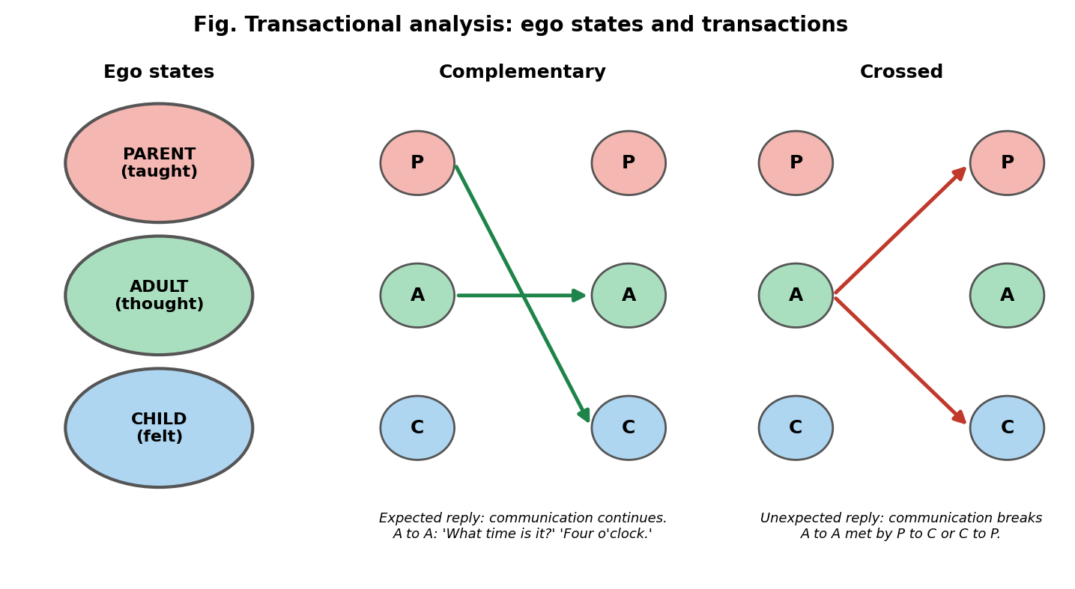
Ego states and transactions
Formulation
- Psychological problems arise from contaminated or excluded ego states, destructive games, negative scripts, and unhealthy life positions.
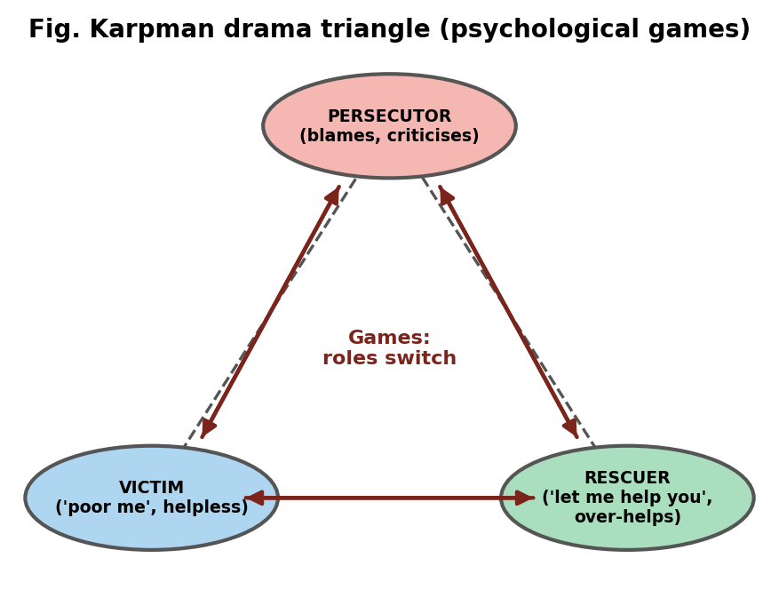
Karpman drama triangle
- Karpman drama triangle: the roles of Persecutor, Victim and Rescuer are played in games and shift quickly; the healthier alternatives are assertiveness, vulnerability and caring (empowerment dynamic).
Goals
- Autonomy, free Adult functioning, game-free intimacy, revising the script (“script cure”), social control, symptomatic relief.
Procedures and techniques
- Contract: a mutual, clear, specific agreement on goals and responsibilities (central feature, it gives TA its collaborative, “OK-OK” stance).
- Four types of analysis: structural (ego states), transactional (what people say and do to each other), game analysis (identify games and the payoff; formula G), script analysis (life plan).
- Berne’s therapeutic operations: interrogation, specification, confrontation, explanation, illustration, confirmation, interpretation, crystallisation.
- Other techniques: egogram, permissions and protection (Crossman), redecision (re-experiencing and changing early decisions, using chair work), stroke work, analysis of the drama triangle, role play, homework, group treatment (TA groups are the usual format).
Stages and process
- Contracting and assessment; 2. Strengthening and decontaminating the Adult; 3. Deconfusion of the Child (release of old feelings, redecision); 4. Relearning, practice of new behaviours; 5. Autonomy and termination.
Outcome and indications
- Increased autonomy, better communication, ending of games, improved self-esteem. Indications: neurotic problems, relationship and communication problems, personality issues, couples and families, group therapy, education, organisations (management training), counselling. Contraindications: acute psychosis (adapted forms exist).
Research and status
- Evidence is modest: reviews (for example Novey, 2002) report positive outcomes, but there are few rigorous trials. It remains widely taught, with accreditation by ITAA/EATA, and its language is simple and accessible to clients. Criticisms: simplistic jargon, limited empirical validation, overlap with psychodynamic and cognitive concepts.

9. Reality therapy (and choice theory)
Origin
- William Glasser (1925 to 2013), an American psychiatrist, dissatisfied with Freudian therapy; developed reality therapy in work at the Ventura School for Girls and a veterans’ hospital (Reality Therapy, 1965). Later formulated control theory (1980s), renamed choice theory (Choice Theory, 1998). Robert Wubbolding developed the WDEP system and the “cycle of counselling”. The William Glasser Institute promotes it.
Basis
- All behaviour is chosen (we can only directly control our own actions and thinking). Total behaviour consists of acting, thinking, feeling and physiology (like the four wheels of a car; the front wheels, acting and thinking, can be chosen directly and steer the others).
- Five basic needs (genetic): survival, love and belonging, power (achievement/worth), freedom, fun. The quality world (the “picture album” of people, things and beliefs one most wants); we compare the perceived world to it; frustration produces behaviour.
- Most psychological problems are relationship problems; unsatisfying relationships are the root. Seven deadly habits (criticising, blaming, complaining, nagging, threatening, punishing, bribing) destroy relationships, and seven caring habits (supporting, encouraging, listening, accepting, trusting, respecting, negotiating differences) build them.
- Responsibility (meeting one’s needs without preventing others from doing so); focus on the present and future; no excuses, no blame, no punishment and never giving up. Mental illness labels are rejected; symptoms are chosen behaviours (“depressing” instead of “depression”).
Formulation
- The client has an unsatisfied need (usually love/belonging) and is choosing ineffective behaviours (for example withdrawing, depressing, blaming) to satisfy it. The “failure identity” vs “success identity.”
Goals
- Help clients take responsibility, make effective choices, improve relationships, and meet needs responsibly, realistically and rightly (Glasser’s “3 Rs”: responsibility, reality, right and wrong).
Procedures and techniques
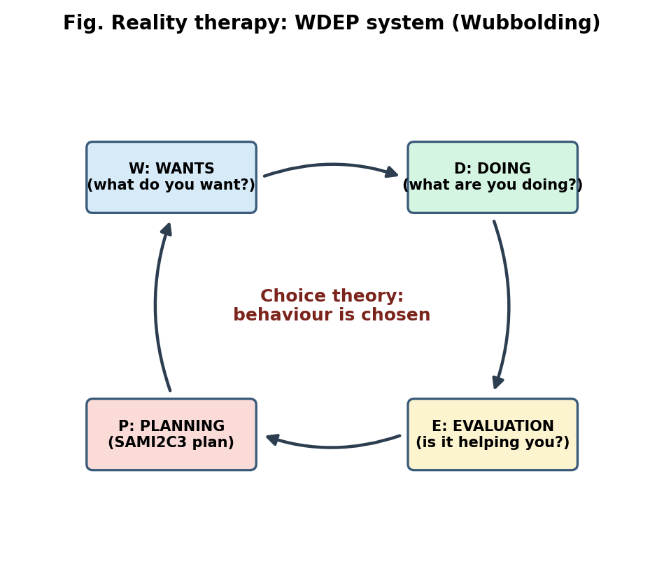
WDEP system
- Cycle of counselling (Wubbolding): (A) the environment (build a trusting, friendly relationship; involvement; use of humour, listening, avoiding arguing and criticising) and (B) the procedures that lead to change, the WDEP system:
  - W: Wants: explore wants, needs, perceptions (“What do you want?”).
  - D: Doing and direction: current total behaviour (“What are you doing? Where are you headed?”).
  - E: Evaluation: the self-evaluation of the behaviour (“Is what you are doing helping you get what you want?” “Is it realistic?”).
  - P: Planning and commitment: make a SAMI2C3 plan: Simple, Attainable, Measurable, Immediate, Involves the client, Controlled by the client, Committed to, Consistent.
- Techniques: skilful questioning, metaphors and humour, paradoxical techniques, role play, contracts, self-disclosure, “confrontation” in the form of “Is it helping?”, and not accepting excuses; avoid discussing past and symptoms unless relevant.
Stages
- Build the environment; establish what the client wants; explore current behaviour; guide evaluation; develop and commit to plan; follow up (accountability; plans revised if unsuccessful).
Outcome and indications
- Improved responsibility, internal locus of control, relationships, self-esteem, and more satisfying behaviour. Indications: schools (Quality School), adolescents and delinquents, corrections, addictions, relationship and marital counselling, group counselling, workplace, brief counselling, institutions. Cautions: not suitable alone for severe mental illness or trauma needing exploration; may be perceived as blaming.
Research and status
- Studies (for example in schools, correctional and cross-cultural settings, including Korea) show benefits for self-esteem, locus of control, responsibility and relationships; evidence base is moderate and often quasi-experimental. Used worldwide as a short, practical approach. Criticisms: rejection of diagnosis and the biological basis of mental illness, limited attention to unconscious and past, and simplistic view of choice.

10. Supportive psychotherapy
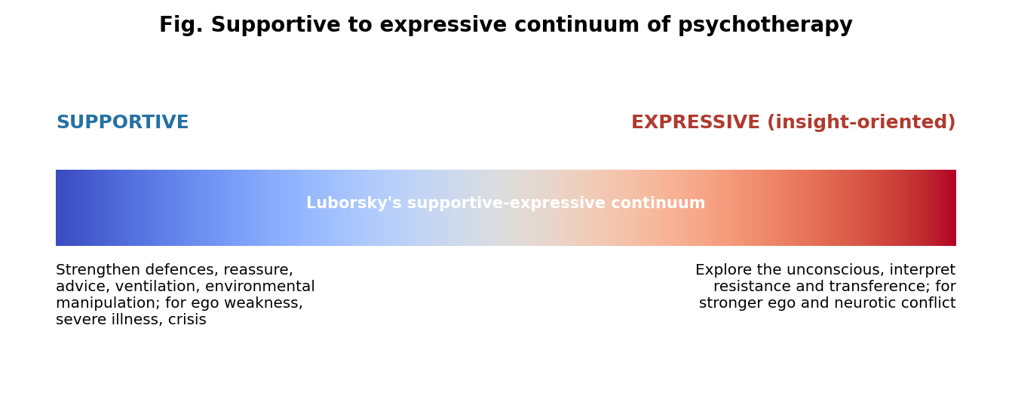
Supportive to expressive continuum
Origin
- Arises from the earliest practice of psychiatry (reassurance, advice, moral treatment) and from psychodynamic therapy at the supportive end of the supportive-expressive continuum (Luborsky). Described by Wallerstein (Menninger project), Rockland (1989), Winston, Pinsker and McCullough, and Werman for patients with limited ego strength.
Basis
- Aim is to maintain, restore or improve ego functions and self-esteem and to strengthen existing defences and coping, rather than uncover the unconscious. The therapeutic relationship is the main agent of change (the therapist as a trusted, caring support or “auxiliary ego”).
Formulation
- Symptoms occur when stress overwhelms the person’s coping resources (an overwhelmed ego or a fragile personality); treatment strengthens the person’s functioning and adaptation.
Goals
- Symptom relief, stabilisation, improved adaptation and coping, support during crisis or illness, prevention of relapse and rehospitalisation, enhanced self-esteem.
Procedures and techniques
- Therapist is active, warm, flexible and often directive; sessions are mainly in the here-and-now.
- Techniques: reassurance, encouragement and praise; empathic listening and ventilation (catharsis); advice and guidance; education (psychoeducation); explanation and clarification; anticipatory guidance (preparing for stressful events); problem solving and reality testing; reframing; environmental modification/manipulation (for example involving family, changing work, arranging services); modelling; limit-setting; strengthening adaptive defences; building self-esteem; interventions at times of crisis. Avoid deep interpretation and transference exploration; positive transference is not interpreted but used.
- Frequency and duration: flexible (weekly to monthly), time-limited or long-term maintenance.
Stages and process

  - Assessment of strengths and ego capacities; 2. Building the alliance; 3. Defining problems and goals; 4. Selecting appropriate supportive techniques and applying them; 5. Monitoring and gradual reduction or maintenance; 6. Open-ended or flexible ending.
Outcome and indications
- Better coping and daily functioning, reduced distress, fewer relapses. Indications: schizophrenia and other severe mental illness, bipolar disorder, personality disorders (low ego strength), crises and bereavement, chronic or terminal medical illness, adjustment disorders, the elderly, those with cognitive limits or low insight, clients unsuitable or not ready for insight-oriented therapy.
Research and status
- The Menninger study (Wallerstein) found that supportive therapy produced more lasting change than expected; studies show effectiveness comparable to other therapies in depression, personality disorders and in severe mental illness (for example Winston et al., 1994); it is the most widely used therapy in practice but is under-researched and often used as a “control” in trials. Criticism: may foster dependency, lacks a distinct theory, and may be undervalued.

11. Clinical hypnotherapy
Origin
- Franz Anton Mesmer (animal magnetism, 1770s); Marquis de Puységur (artificial somnambulism); James Braid (1843 coined “hypnosis” and “neurypnology”); Liébeault and Bernheim (Nancy school: hypnosis as suggestion); Charcot (Salpêtrière; hysteria); Janet; Breuer and Freud (catharsis under hypnosis; Freud later abandoned it); Milton H. Erickson (permissive, indirect, utilisation approach); Hilgard (neodissociation theory and the Stanford Hypnotic Susceptibility Scales); Barber, Sarbin, Spanos, Kirsch (socio-cognitive, expectancy theories).
- Definition (APA Division 30): a state of consciousness involving focused attention and reduced peripheral awareness, characterised by an enhanced capacity for response to suggestion.
Basis
- State theories (altered state, dissociation: Hilgard) vs non-state/socio-cognitive theories (role-taking, expectancy, imagination). Key features: absorption, focused attention, suggestibility, reduced critical analysis, and responsiveness to suggestion. It is not sleep (EEG shows wakefulness) nor loss of control. Neuroimaging indicates changes in the anterior cingulate, prefrontal and default-mode networks.
- Hypnotisability is a stable trait, varies in the population (about 10% highly responsive, 10 to 15% low responsiveness), and is measured by the Stanford Hypnotic Susceptibility Scale, Harvard Group Scale, Hypnotic Induction Profile (eye-roll sign).
Formulation
- Problems (symptoms, habits, pain, anxiety) are maintained by automatic, learned responses, and by negative or distorted beliefs and imagery; hypnosis lets the client use imagination and focused attention to modify perception, emotion and behaviour (and to access unconscious resources, in Ericksonian terms).
Goals
- Symptom control (pain, anxiety), habit change, relaxation, increased self-efficacy and ego-strength, exploration of unconscious material (hypnoanalysis), and training in self-hypnosis for self-management.
Procedures and techniques
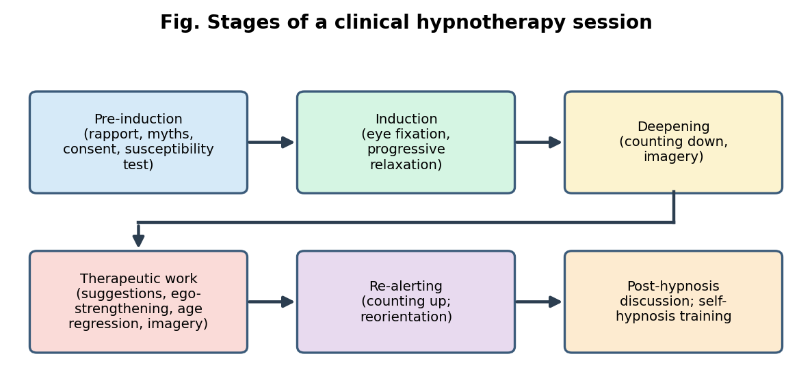
Stages of a hypnotherapy session
- Pre-induction: consent, history, explain hypnosis and dispel myths (loss of control, sleep, revealing secrets), build expectancy and rapport; test suggestibility.
- Induction: eye fixation, progressive muscle relaxation, breathing, imagery, arm levitation, rapid inductions (Elman, Spiegel), Ericksonian indirect inductions (confusion, storytelling, pacing and leading).
- Deepening: counting down, staircase imagery, fractionation, depth tests.
- Therapeutic phase: direct suggestions (for example for symptom removal), indirect and permissive suggestions and metaphors (Erickson), ego-strengthening (Hartland), imagery and rehearsal, hypnotic analgesia/anaesthesia (glove anaesthesia), age regression and hypnoanalysis (uncovering and abreaction; used with caution), post-hypnotic suggestions and anchoring, desensitisation under hypnosis, parts therapy.
- Termination: counting up and re-alerting (dehypnosis), reorientation, discussion; teach self-hypnosis for practice.
Indications
- Pain (chronic, procedural, labour, dental), anxiety and phobias, irritable bowel syndrome, insomnia, habit disorders (smoking, nail biting, obesity as an adjunct), psychosomatic problems (asthma, skin disorders, warts), nausea in chemotherapy, preparation for surgery, performance anxiety, adjunct to CBT, PTSD, dissociative conditions (by specialists).
- Contraindications and cautions: psychosis, severe personality disorder, paranoid states, some organic brain conditions and epilepsy (relative), poor motivation; risk of false memory when used to recover memories (not recommended for forensic memory retrieval); must be practised by trained clinicians within their competence; avoid stage hypnosis.
Research and status
- Meta-analyses (for example Kirsch, Montgomery and Sapirstein, 1995; Montgomery et al.) found that adding hypnosis to CBT produces greater improvement; evidence is strong for pain control, IBS and procedural distress, moderate for anxiety and phobias, and weaker or inconclusive for smoking cessation and weight loss. It is widely accepted as an adjunct, with continuing neuroscience research. Criticisms: myths and public misconceptions, risk of suggestion and false memories, variable training standards.

12. Play therapy
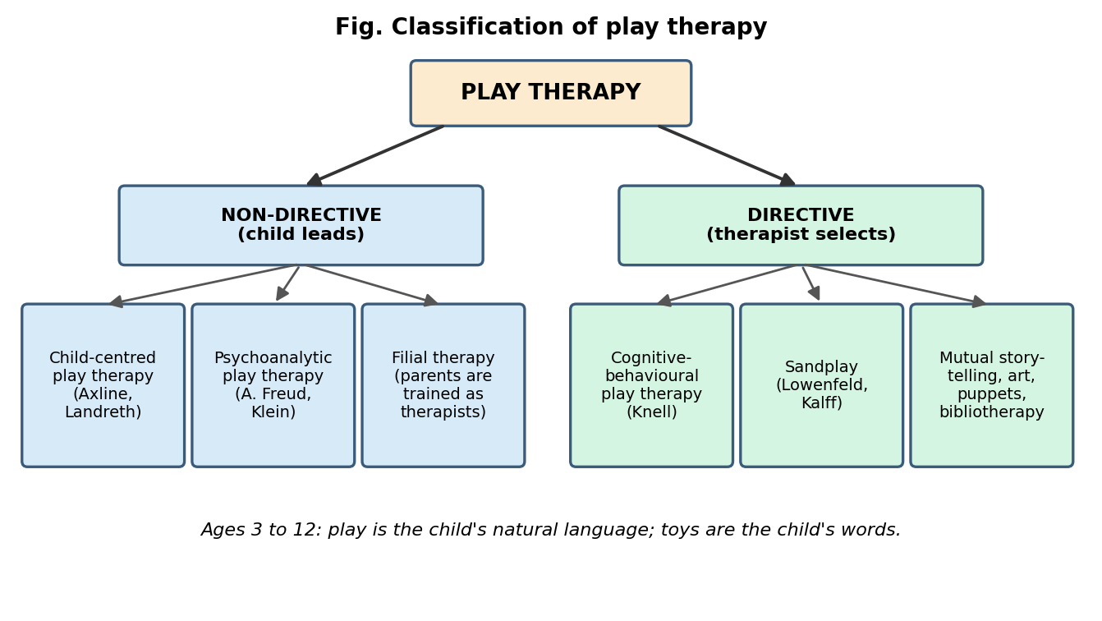
Classification of play therapy
Origin
- Freud (the case of Little Hans, 1909); Hermine Hug-Hellmuth (1919, first to use play with children); Anna Freud (play to build alliance) and Melanie Klein (play as free association: play analysis); Margaret Lowenfeld (“World technique”, 1929, forerunner of sandplay); David Levy (release therapy, 1938); Virginia Axline (non-directive play therapy, 1947; Dibs: In Search of Self, 1964); Clark Moustakas; Bernard and Louise Guerney (filial therapy, 1960s); Garry Landreth (child-centred play therapy, CCPT); Susan Knell (cognitive-behavioural play therapy); Violet Oaklander (Gestalt play), Charles Schaefer (Association for Play Therapy, 1982), Gardner (mutual storytelling), Jernberg (Theraplay).
Basis
- Play is the child’s natural language and medium of self-expression, communication and learning; toys are the child’s “words”, play is the child’s “speech”. Children cannot verbalise abstract thoughts and feelings, so they express them through symbolic play.
- Therapeutic powers of play (Schaefer and Drewes): facilitating communication, fostering emotional wellness (catharsis, abreaction, counter-conditioning), enhancing social relationships (attachment, empathy), and increasing personal strengths (resilience, self-esteem, creative problem solving).
- Theoretical bases: psychoanalytic (symbolism, catharsis), humanistic/child-centred (self-direction), attachment, cognitive-behavioural (modelling, skills), developmental theories (Piaget, Erikson).
Axline’s eight principles of non-directive play therapy: (1) develop a warm, friendly relationship; (2) accept the child exactly as he or she is; (3) establish a feeling of permissiveness; (4) recognise and reflect the child’s feelings; (5) respect the child’s ability to solve his or her own problems; (6) do not direct the child’s actions or conversation; (7) do not hurry the therapy; (8) establish only those limitations necessary to anchor the therapy to the world and make the child aware of responsibility.
Formulation
- Children’s problems reflect blocked emotions, trauma, insecure attachment, developmental difficulties and unmet needs; play lets them express and master experiences safely at a symbolic distance.
Goals
- Emotional expression, improved self-concept and self-esteem, emotional regulation, social skills, coping, resolution of trauma or conflict, behaviour change, strengthened parent-child attachment.
Procedures and techniques
- Play room and toys: real-life toys (doll house, family, kitchen), acting-out and aggressive toys (soldiers, puppets, bop bag), and creative-expressive media (sand, water, clay, paint, art).
- Techniques: tracking (“You’re putting the baby in the bed”), reflecting feelings, returning responsibility (“You can decide”), encouragement, limit-setting (ACT: Acknowledge the feeling, Communicate the limit, Target alternatives), and structured techniques: puppets, sandplay and sand tray, drawing and art, storytelling (Gardner’s mutual storytelling), bibliotherapy, role play, therapeutic games, CBT-based play (modelling, exposure through play, skills), and parents’ involvement: filial therapy and child-parent relationship therapy (CPRT) train parents to hold play sessions at home; Theraplay (structure, engagement, nurture, challenge).
Stages and process

  - Assessment, parent consultation and consent/assent. 2. Relationship building: the child explores the room, tests the therapist. 3. Exploration and expression (themes begin to appear in the play). 4. Working through: aggression, regression, testing of limits, dramatic play, and mastery; growth. 5. Termination (children are prepared early; transition and review). Usually 30 to 45 minute weekly sessions for about 12 to 20 sessions.
Outcome and indications
- Better emotional expression, behaviour, self-esteem, social skills, parent-child relationships. Indications: ages about 3 to 12 years; anxiety, fears, trauma and abuse, bereavement, parental divorce, adjustment problems, behavioural problems, selective mutism, aggression, hospitalisation, autism (adapted), developmental difficulties. Not suitable alone when immediate safety or family issues dominate (needs family work); adolescents may need other media (talk, art, drama).
Research and status
- Bratton et al. (2005): a meta-analysis of 93 studies showed a large mean effect size (about 0.80), larger when parents were involved; Leblanc and Ritchie (2001) found 0.66; CCPT meta-analyses (Lin and Bratton, 2015) show moderate to large effects. Play therapy is widely used in clinics, schools and hospitals; registered play therapists (APT). Criticisms: methodological weaknesses, varied approaches, need for rigorous trials with specific disorders.

13. Psychodrama
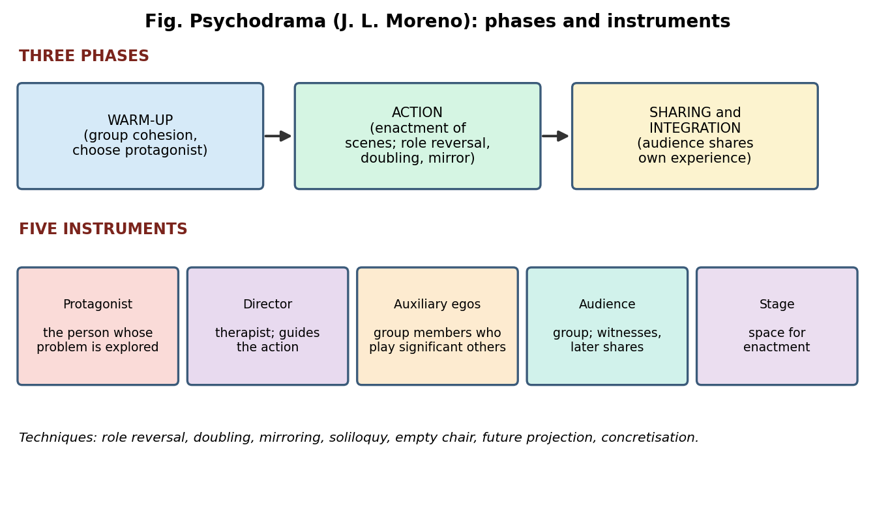
Psychodrama phases and instruments
Origin
- Jacob L. Moreno (1889 to 1974), Vienna: Theatre of Spontaneity (1921); moved to the USA in 1925 and set up the Beacon sanatorium (1936). He coined group psychotherapy, developed sociometry (measuring social relationships) and sociodrama. Zerka Moreno (his wife) was a key developer. Influenced Gestalt, drama therapy, role play and CBT behavioural rehearsal.
Basis (theory)
- Spontaneity and creativity are the foundations of mental health; pathology = loss of spontaneity, rigid role patterns and unfinished action.
- Role theory: role-taking, role-playing, role-creating; role conflict and role rigidity.
- Tele: two-way empathic feeling and mutual understanding between people.
- Catharsis (of integration, not simply abreaction), encounter, surplus reality (enactment of what has not happened, or what is feared/wished), the here-and-now (the “moment”), warm-up, and action (acting out rather than only talking).
- Social atom (the person’s network of significant relationships).
Formulation
- Distress arises when a person’s role repertoire is limited or conflicts, spontaneity is blocked, and significant relationships and events remain unresolved. Enactment brings these into the open, so that they can be experienced and changed.
Goals
- Catharsis and release, insight, new role repertoire, spontaneity, interpersonal skills, resolution of unfinished business, behaviour rehearsal for the future, and group cohesion and support.
Five instruments: (1) Protagonist (the client whose issue is explored), (2) Director (the therapist who guides), (3) Auxiliary egos (group members/trained assistants who play significant others or parts of the protagonist), (4) Audience (the group, witnesses and supports), (5) Stage (the space for enactment).
Techniques
- Role reversal (the protagonist plays the other person to understand their perspective; the most powerful technique), doubling (an auxiliary expresses the protagonist’s unspoken feelings), mirroring (the protagonist watches an auxiliary portray him or her), soliloquy, empty chair, future projection (rehearsal of a future scene), concretisation (making abstract feelings concrete), sculpting, social atom, magic shop, sociodrama (focus on group or social issues).
Phases and process
- Warm-up: the director builds trust and group cohesion; a protagonist emerges (the issue is chosen).
- Action: the scene is set (often moving from the present to the past); enactment with auxiliary egos; role reversal, doubling, mirroring; peak emotion (catharsis) and new solutions; closure of the scene with rehearsal of new responses.
- Sharing and integration: the audience shares their own similar experiences (not analysis or advice), reducing isolation and supporting the protagonist; sometimes processing and role de-roling.
Outcome and indications
- Emotional release, insight, improved relationships and role flexibility, group support. Indications: group settings for trauma, grief, addictions, family and relationship issues, adolescents, social skills training, personality disorders, psychiatric inpatients, anger, training in professional skills, and community or school sociodrama. Cautions: acute psychosis or severely fragile clients, if there is inadequate containment; needs a skilled director, careful screening and aftercare.
Research and status
- Kipper and Ritchie (2003): a meta-analysis of 25 studies reported a large effect (about 0.95), with role reversal and doubling the most effective techniques; integrative reviews (Orkibi and Feniger-Schaal, 2019) show positive effects (moderate evidence). It remains an influential action-based group therapy, used in India too. Criticisms: few rigorous RCTs, variable training, risk of emotional flooding.

14. Oriental approaches
These approaches come from Asian philosophical and healing traditions, and many focus on mind-body regulation, attention and relaxation. Many have been adapted as evidence-based interventions; some (energy healing) lack scientific support. When answering, give: origin, basis/philosophy, practice, mechanism, indications, research evidence, and cautions.

14.1 Yoga
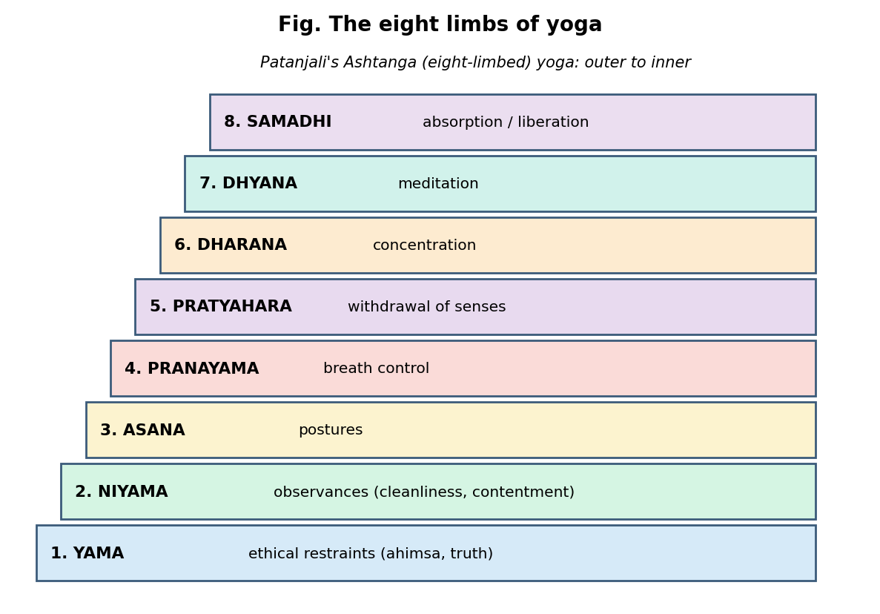
Eight limbs of yoga
- Origin: ancient India (Indus Valley and Vedic traditions); systematised by Patanjali in the Yoga Sutras (about 200 BCE to 400 CE) as Ashtanga (eight-limbed) yoga; Hatha yoga (Hatha Yoga Pradipika, 15th century). Types: Raja, Hatha, Karma, Bhakti, Jnana yoga.
- Basis: yoga means “union” (of body, mind and spirit). Patanjali defines yoga as “cessation of the fluctuations of the mind (chitta vritti nirodha)”. Distress arises from ignorance (avidya) and attachment; the eight limbs are yama (ethical restraints), niyama (observances), asana (postures), pranayama (breath control), pratyahara (withdrawal of the senses), dharana (concentration), dhyana (meditation), samadhi (absorption).
- Practices (in therapy): gentle asanas, pranayama (nadi shodhana, bhramari, ujjayi, kapalabhati), relaxation, meditation, Sudarshan Kriya, and the Common Yoga Protocol (AYUSH).
- Mechanisms: increases parasympathetic/vagal tone and heart rate variability, lowers cortisol and sympathetic arousal, increases GABA activity (Streeter et al.), improves attention and emotion regulation, and reduces inflammation.
- Indications and evidence: depression, anxiety, stress, PTSD, insomnia, chronic pain, substance use, schizophrenia (adjunct), hypertension. NIMHANS studies (for example Janakiramaiah et al., 2000, on Sudarshan Kriya in melancholic depression; trials in schizophrenia) and meta-analyses (Cramer et al., 2013) found benefit as an adjunct or alternative for mild to moderate depression and anxiety. Cautions: injury risk; vigorous breathing exercises can trigger anxiety or mania in vulnerable people; unsupervised intense practice is not recommended in psychosis; need for a qualified instructor.

14.2 Meditation
- Origin: Hindu, Buddhist and Taoist contemplative traditions (Vipassana, Samatha, Zen, Transcendental Meditation by Maharishi Mahesh Yogi, 1950s). Clinical adaptation: Mindfulness-Based Stress Reduction (MBSR; Jon Kabat-Zinn, 1979) and Mindfulness-Based Cognitive Therapy (MBCT; Segal, Williams and Teasdale, 2002); mindfulness is also a part of DBT and ACT.
- Types: focused attention (breath or mantra), open monitoring (mindfulness: non-judgemental awareness of the present moment), loving-kindness/compassion meditation, body scan.
- Basis and mechanism: training attention and decentring (observing thoughts as mental events, not facts); reduces rumination and worry, increases acceptance and emotion regulation. Neurobiologically: increased activity and thickness in the prefrontal cortex, insula and hippocampus; decreased amygdala reactivity and default-mode activity.
- Procedure: posture, breath awareness, body scan, noticing and gently returning attention; 8-week group programme with daily home practice (MBSR/MBCT).
- Indications and evidence: prevention of relapse in recurrent depression (MBCT; recommended in NICE guidelines), anxiety, stress, chronic pain, insomnia, substance use (mindfulness-based relapse prevention), cancer patients’ distress. A major meta-analysis (Goyal et al., 2014) found moderate evidence for improving anxiety, depression and pain. Cautions: adverse effects occasionally (anxiety, dissociation, intrusive memories) especially with intensive retreats in vulnerable people (trauma, psychosis).

14.3 Shavasana (and Yoga Nidra)
- Origin and meaning: Shavasana (“corpse pose”) is the final relaxation posture of a yoga session; Yoga Nidra (“yogic sleep”) is a guided deep relaxation (popularised by Swami Satyananda Saraswati).
- Practice: lying supine on the back, arms and legs relaxed, eyes closed, systematic relaxation of body parts (rotation of consciousness), breath awareness, imagery, and sometimes a resolve (sankalpa); duration 10 to 30 minutes.
- Mechanism: a relaxation response (Benson): decreases sympathetic arousal, heart rate, blood pressure, muscle tension and cortisol; increases parasympathetic activity; it resembles progressive muscle relaxation (Jacobson).
- Indications and evidence: stress, anxiety, insomnia, hypertension, PTSD and chronic pain as adjunct; small trials of yoga nidra show reductions in anxiety and stress and improved sleep. Cautions: pregnant women should lie on the left side; those with trauma may find lying still and eyes closed distressing.

14.4 Pranic healing
- Origin: developed by Master Choa Kok Sui (1987, Miracles through Pranic Healing), drawing on ancient Indian and Chinese ideas of prana/qi (life energy).
- Basis: the body has an energy (bioplasmic) body or aura with chakras (energy centres); disease results from depleted or congested prana. Healing is done by scanning (sensing the energy field with the hands), cleansing (sweeping away “diseased energy”), energising (projecting prana), and stabilising, usually without touch. “Pranic psychotherapy” includes emotional cleansing and forgiveness.
- Evidence: very limited; a few small, poorly controlled studies. No credible evidence for an energy field that practitioners can detect (see the study by Rosa et al., 1998, JAMA, on therapeutic touch); benefits are probably due to relaxation, attention, suggestion and expectancy. It is considered complementary and alternative and should not replace evidence-based treatment; ethical practice requires informed consent about the limited evidence.

14.5 Reiki
- Origin: Mikao Usui (Japan, 1922); transmitted by Hayashi and Hawayo Takata to the West. “Rei” = universal, “ki” = life energy.
- Basis: a practitioner channels universal life energy through the hands (light touch or hovering) to the client, restoring the flow of energy; disease results from blocked energy. Practitioners train in three degrees and receive attunements. Sessions last 20 to 90 minutes with set hand positions; the client lies clothed.
- Evidence: studies are small and have a high risk of bias; reviews (for example Cochrane review of Reiki for anxiety and depression) found insufficient evidence; any benefit may result from relaxation, therapeutic touch, attention and placebo/expectancy. Used as a complementary comfort measure (for example in hospitals, cancer care). Cautions: it should not delay medical or psychological treatment.

14.6 Tai chi
- Origin: China (Chen village, 17th century; later Yang, Wu, Sun styles) from Taoist philosophy and martial arts; related to qigong.
- Basis: yin-yang balance and qi flow; “meditation in motion”. Practice: slow, flowing, coordinated movements (forms), weight shifting, diaphragmatic breathing and focused attention.
- Mechanisms: gentle aerobic exercise, balance and strength training, mindfulness, stress reduction, reduced inflammatory markers, improved heart rate variability.
- Indications and evidence: depression and anxiety (meta-analyses show reduced stress, anxiety, depression; Lavretsky et al., 2011, found benefit as an adjunct in late-life depression), fall prevention in older adults, chronic pain and fibromyalgia, cardiac rehabilitation, cognitive health, schizophrenia (adjunct), stress, sleep.
- Cautions: adapt for physical limitation; generally safe.

14.7 Other oriental and indigenous approaches (also asked as “etc.”)
- Morita therapy (Japan, Shoma Morita, 1919) for shinkeishitsu (anxious, obsessional): principle “accept your feelings and do what needs to be done”; stages: isolated bed rest (4 to 7 days), light work, heavy work, and social reintegration; useful for anxiety, OCD, social anxiety.
- Naikan therapy (Japan, Ishin Yoshimoto): structured introspection about what one received from others, what one returned, and the trouble one caused, building gratitude and responsibility.
- Qigong, acupuncture, Ayurveda, Siddha and Unani systems; Sudarshan Kriya; mantra and chanting; bhakti and devotional practices, spiritual counselling.
- Common evaluation of oriental approaches: good fit with Indian and Asian clients’ cultural beliefs; low cost, minimal side effects; promote self-regulation and acceptance; strengths: improved well-being, adjunct role in CBT (mindfulness), culturally acceptable; limitations: variable quality of evidence, risk of replacing medical care, danger of unqualified practitioners, spiritual claims untestable (energy healing).

15. Comparison of the affective psychotherapies (quick revision)
Therapy | Founder(s) | Core idea | Key techniques | Therapist role
Psychodynamic | Freud | Unconscious conflict, early experience | Free association, dream analysis, interpretation, transference | Neutral, interpreting expert
Brief | Malan, Sifneos, Mann, Klerman | Time-limited focus on a specific theme | Focal interpretation, contract, IPT, solution-focused questions | Active, directive
Humanistic | Maslow, Rogers, May | Growth, self-actualisation | Empathic listening, experiential work | Facilitator, equal
Existential | Frankl, May, Yalom | Ultimate concerns, meaning | Dialogue, paradoxical intention, dereflection | Fellow traveller, authentic
Gestalt | Perls | Awareness, contact, unfinished business | Empty chair, exaggeration, “I” statements | Present, experimental
Person-centred | Rogers | Actualising tendency, incongruence | Reflection, core conditions | Non-directive facilitator
Adlerian | Adler, Dreikurs | Social interest, lifestyle, inferiority | Early recollections, encouragement, acting as if | Collaborative teacher
TA | Berne | Ego states, games, scripts | Structural/transactional analysis, contract, redecision | Contract-based teacher
Reality | Glasser, Wubbolding | Choice theory, basic needs | WDEP, SAMI2C3 plan | Active, challenging coach
Supportive | Wallerstein, Rockland | Strengthen coping and defences | Reassurance, advice, ventilation | Active, warm, directive
Hypnotherapy | Braid, Erickson | Focused attention, suggestibility | Induction, suggestion, imagery | Guide
Play | Axline, Klein, A. Freud | Play as child’s language | Tracking, limit setting, sandplay, storytelling | Accepting, facilitating
Psychodrama | Moreno | Spontaneity, role theory | Role reversal, doubling, mirroring | Director
Oriental | Patanjali, Usui, etc. | Mind-body regulation | Yoga, meditation, relaxation | Teacher or practitioner

16. How to write a 20-mark answer
- Structure: a brief introduction (origin and definition, 2 to 3 lines) → theory/basis → formulation → goals → techniques and process (use a flowchart) → indications/contraindications → research evidence and current status → critical evaluation and conclusion.
- Always add a labelled flowchart or diagram (stages, cycle, triangle); include names, years and technical terms (for example Rogers 1957, six conditions, Dreikurs four phases, WDEP, Kipper and Ritchie 2003).
- Likely essay questions: ethical and legal issues in psychotherapy (India: MHCA 2017, RCI Act, POCSO); consent and assent in minors; planning, recording and goal setting; pre/post assessment; evidence-based practice and common factors; the therapeutic relationship and factors influencing it; alliance ruptures; interview types and micro-skills (with examples); verbal and non-verbal communication; structured vs unstructured interviews; any one affective therapy in full (psychodynamic, person-centred, Gestalt, Adlerian, TA, reality, hypnotherapy, play therapy, psychodrama, brief); oriental approaches (yoga, meditation, tai chi, reiki, pranic healing) with evidence.
- Memory aids: SOLER (attending); SMART (goals); WDEP and SAMI2C3 (reality therapy); Bordin’s G-T-B (Goals, Tasks, Bond); Dreikurs’s R-A-I-R (Relationship, Assessment, Insight, Reorientation); Gestalt boundary disturbances I-P-R-D-C (Introjection, Projection, Retroflection, Deflection, Confluence); Yalom’s D-F-I-M (Death, Freedom, Isolation, Meaninglessness); Karpman P-V-R; TA P-A-C.

