TEJAS GUND

FLOWCHART

E-Commerce Website

**Flowchart 1:**

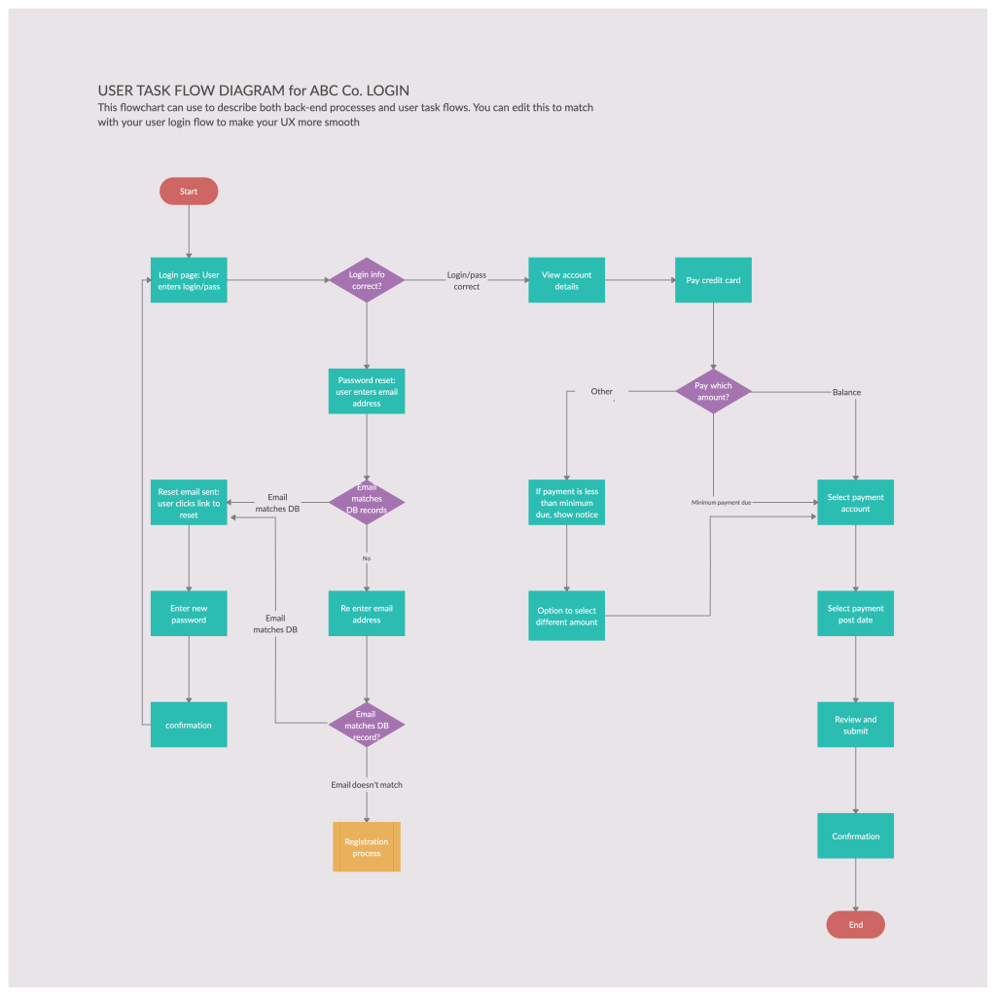

**Flowchart 2:**

