Driver Drowsiness Detection System
- Title of the Project
Driver Drowsiness Detection System using Dlib Face Landmark Detection and Mediapipe Integration

A real-time AI-based system designed to monitor a driver’s alertness level by analyzing facial expressions, eye blinking rate, yawning frequency, and head movement using computer vision frameworks like Dlib and Mediapipe.
- Field / Area of Project
This project lies in the intersection of multiple cutting-edge domains:

  - Computer Vision
  - Artificial Intelligence (AI)
  - Real-Time Video Analytics
  - Human–Computer Interaction (HCI)
  - Automotive Safety Systems
- Prior Publications and Patents on the Project

Sr. No. | Patent / Publication | Description | Relevance to the Project
1 | US 6,243,015 B1  (2001) – Driver’s Drowsiness Detection Method of Drowsy Driving Warning System | Uses CCD camera to monitor driver’s eye vertical width and triggers alert when drowsiness factor exceeds threshold. | Provides early foundation for camera-based fatigue detection; our project extends this with EAR and  MAR metrics using Dlib + Mediapipe.
2 | EP 1418082 A1  (2004) –  Drowsiness Detection System and Method | Analyzes eye closure percentage and eyelid movement to detect driver fatigue. | Our project enhances this with hybrid iris and landmark detection to improve robustness under lighting variations.
3 | US 8,519,853 B2  (2013) –  Unobtrusive Driver Drowsiness Detection System and Method | Implements signal processing (EMD) for drowsiness detection using non- intrusive sensors. | In contrast, our system achieves non-intrusive detection purely  through facial video analytics.

4 | IEEE Access (2021) – Hybrid CNN and Dlib Model for Driver Alertness Monitoring | Combines CNN features with Dlib preprocessing for driver state detection. | Our lightweight hybrid solution achieves comparable accuracy without GPU dependency.
5 | CN108276958A  (2018) – Driver Drowsiness Detection Based on Image Processing | Applies real-time facial analysis and eye closure tracking for fatigue assessment. | Our approach integrates Dlib EAR with Mediapipe iris ratio and head tilt detection for enhanced precision.
6 | US 6,822,573 B2  (2004) –  Drowsiness Detection System | Uses head motion sensors and heart- rate signals to detect driver fatigue. | Highlights multi- modal detection; our camera-based model removes the need for physiological  sensors.
7 | Y. Albadawi et al. (2022) – A Review of Recent Developments in Driver Drowsiness  Detection Systems | Comprehensive survey of vision- based and sensor- based fatigue detection methods. | Provides literature support; our system advances real-time vision-based methods with better  integration.
8 | Hassan et al. (2025) – Real-Time Driver Drowsiness Detection Using Transformer  Architectures | Introduces transformer-based architectures for fatigue detection with high accuracy. | Our system focuses on computational efficiency for real- time CPU operation compared to deep  learning models.
9 | Shaik M.E. (2023) –  Systematic Review on Detection and Prediction of Driver Drowsiness | Studies comparative performance of prediction-based fatigue monitoring systems. | Identifies challenges our system addresses—non- intrusive, low-cost, and robust  operation under lighting variations.
10 | Shen Q. et al. (2020) – Robust Two- Stream Multi- Feature Network for Driver Drowsiness Detection | Uses spatial and optical flow features to detect fatigue from facial expressions and head motion. | Our hybrid Dlib + Mediapipe model achieves similar results with much lower  computational requirements.

- Summary and Background of the Project

Summary of the Project: The Driver Drowsiness Detection System using Dlib and Mediapipe is an advanced, real-time computer vision project aimed at improving road safety by preventing accidents caused by driver fatigue or inattention.
It leverages Artificial Intelligence (AI) and Computer Vision techniques to continuously analyze a driver’s facial features through a live webcam feed, identifying early signs of drowsiness such as prolonged eye closure, yawning, and head movement deviations.

The system uses Dlib’s 68 facial landmark model to compute crucial metrics like Eye Aspect Ratio (EAR) and Mouth Aspect Ratio (MAR), which indicate eye closure and yawning respectively.
Simultaneously, Mediapipe’s FaceMesh model enhances the detection by providing iris tracking, head pose estimation, and gaze direction analysis, ensuring more stable and accurate results even under varying lighting or face orientations.

Detected events—such as “Drowsy,” “Yawning,” or “Distracted”—are automatically logged in a CSV file with precise timestamps, user information, and detection confidence. These events are later processed by FFmpeg (version 8.0-essentials_build) to generate short video clips around the moment of detection, allowing easy event playback and analysis.
Finally, a Streamlit dashboard provides a user-friendly interface to visualize event data, view corresponding video clips, and review driver performance in a summarized manner.

Background of the Project: Driver fatigue and inattention are among the leading causes of traffic accidents worldwide. Studies have shown that sleepiness or temporary loss of alertness accounts for a significant proportion of fatal crashes, particularly in commercial and long-distance driving.
Conventional drowsiness detection systems, such as steering behaviour monitors or physiological sensor-based approaches (e.g., EEG or heart-rate monitors), are either expensive, intrusive, or require specialized equipment, making them impractical for widespread everyday use.

To overcome these limitations, the research and development community has increasingly focused on vision-based drowsiness detection, which uses cameras to monitor facial cues such as eye closure rate, blinking frequency, yawning, and head movement.
Among these, Dlib has been widely adopted for facial landmark detection because it provides reliable and efficient computation of key facial features. However, Dlib alone may not handle certain challenges such as low lighting conditions, occlusions, or side- face views efficiently.

This is where Mediapipe, a framework developed by Google, brings additional power. Its FaceMesh and Iris Tracking models operate with high precision and are optimized for real-time performance on CPUs.

By combining both frameworks, our project achieves robust and hybrid detection performance, ensuring the system can adapt to various environments and driver behaviors without requiring costly hardware or high-end GPUs.

The system also introduces a data logging mechanism that records all detected fatigue events in structured CSV format, allowing for both real-time feedback and post-session review. Additionally, it incorporates FFmpeg automation to generate short video segments around critical events—providing tangible evidence and improving system interpretability for both users and developers.

- Addressing the Gap / Novelty of the Project:
The project overcomes the above limitations through:

Hybrid Dual-Framework Detection:
Unlike traditional single-framework systems that rely solely on Dlib or OpenCV for face analysis, this project integrates Dlib’s 68-face-landmark model with Mediapipe’s FaceMesh and Iris tracking modules.
By combining both, the system enhances detection accuracy under varied lighting conditions and face orientations.
This hybrid approach ensures stable computation of Eye Aspect Ratio (EAR) and Mouth Aspect Ratio (MAR) while simultaneously analyzing iris movement and head pose, resulting in more reliable detection of drowsiness, yawning, and distraction.

Automated Event Logging and Clip Generation:
Previous drowsiness detection systems lacked a mechanism for recording and verifying detection events.
This project introduces a comprehensive event logging pipeline where all detected states (Drowsy, Yawning, Distracted) are stored in a CSV file with timestamps and event details.
Further, using FFmpeg (v8.0-essentials_build), the system automatically generates
short video clips around the detected events.
This enables transparent validation of system accuracy and provides a visual record for future review or analysis.

Real-Time, Non-Intrusive, and Portable Design:
Existing deep-learning or sensor-based solutions often depend on specialized hardware like GPUs or EEG sensors, resulting in high cost and complexity.
In contrast, this project achieves real-time performance (25–30 FPS) using only a standard webcam and CPU processing.
Its non-intrusive, lightweight, and hardware-independent architecture makes it scalable and suitable for real-world applications such as fleet monitoring, vehicle safety systems, and research studies.

Through these innovations, the project establishes a hybrid, efficient, and user-friendly framework that delivers accurate fatigue detection, real-time responsiveness, and visual verification — addressing major limitations of earlier models while remaining accessible and practical for everyday use

- Objectives of the Project
The principal objectives of the project are as follows:
- Detect driver drowsiness through facial monitoring.
- Compute EAR and MAR using Dlib.
- Use Mediapipe FaceMesh for better tracking.
- Log events in CSV with timestamp, user, and details.
- Auto-generate alert clips with FFmpeg.
- Provide Streamlit dashboard for review.
- Working Principle of the Project
The working principle of the Driver Drowsiness Detection System is based on real- time video analysis using computer vision and machine learning techniques to monitor the driver’s facial expressions and behavior. A webcam continuously captures live video frames, which are processed through Dlib’s 68-face-landmark model to extract key facial features such as the eyes, mouth, and head region. From these landmarks, the system calculates the Eye Aspect Ratio (EAR) to determine whether
the driver’s eyes remain closed for an abnormal duration and the Mouth Aspect Ratio (MAR) to identify yawning behavior. In parallel, Mediapipe’s FaceMesh and Iris tracking modules enhance detection accuracy by analyzing gaze direction, head movement, and iris positioning, enabling the identification of distraction or loss of attention. Once a drowsy, yawning, or distracted state is detected, the system logs the event in a CSV file along with the timestamp, user ID, and event details.
Furthermore, the system integrates FFmpeg (8.0- essentials_build) to automatically extract short video clips corresponding to the detected events for post-analysis.
Finally, all recorded logs and video clips are displayed in a Streamlit-based dashboard, allowing users or evaluators to review driver performance, analyze alertness trends, and validate the detection results effectively and interactively.
- Description of the Project

The Driver Drowsiness Detection System is a real-time computer vision application designed to detect fatigue, yawning, and distraction among drivers by analyzing facial landmarks and movements using AI-based frameworks — Dlib and Mediapipe. The system is structured into three main modules: Calibration, Detection, and Dashboard

Visualization, each serving a distinct purpose to ensure accuracy, reliability, and user interaction.

Calibration Module:
This phase captures baseline data of the user’s facial features, such as open eyes, closed eyes, and mouth positions. Using Dlib’s landmark points, the system computes personalized thresholds for Eye Aspect Ratio (EAR) and Mouth Aspect Ratio (MAR). These customized values help improve accuracy across different users by accounting for individual facial variations.

Detection Module:
In this core component, the webcam continuously captures live video frames, which are analyzed in real-time using Dlib’s 68-point facial landmark model and Mediapipe’s FaceMesh. Dlib calculates the EAR and MAR to identify eye closure and yawning events, while Mediapipe enhances detection by providing iris tracking, head tilt measurement, and gaze estimation.
Based on these inputs, the system classifies driver behavior into three states — Drowsy, Yawning, and Distracted. Each event is automatically logged into a CSV file along with the timestamp, user name, event type, and confidence level for record-keeping and analysis.

Dashboard and Video Analysis Module:
After detection, the recorded data is processed through FFmpeg (v8.0- essentials_build) to automatically generate short video clips surrounding each event, typically 5–10 seconds in length. These clips provide a visual record of detected events, allowing users or researchers to verify system accuracy. The Streamlit-based dashboard serves as a visualization interface where users can view event logs, play video clips, analyze session summaries, and download reports. This interactive design makes the system user-friendly and effective for reviewing driver performance in real-time.

The project achieves real-time detection (25–30 FPS) on standard CPU hardware without requiring a GPU, making it highly portable and cost-effective. It offers a non- intrusive and camera-based solution, eliminating the need for physical sensors or wearable devices. The hybrid use of Dlib for geometric landmark analysis and Mediapipe for iris and head pose detection ensures robustness even under varying lighting and face orientations.
Simplified Calculations (EAR, MAR & Drowsiness Score)

Eye Aspect Ratio (EAR) –
EAR = (Top distance + Bottom distance) / (2 × Horizontal distance)
Example:
Top = 5, Bottom = 4, Horizontal = 20
EAR = 9 / 40 = 0.225

Mouth Aspect Ratio (MAR) –
MAR = (Vertical distances sum) / (2 × Horizontal distance)
Example:
Verticals = 10 + 11 + 9 = 30
Horizontal = 25
MAR = 30 / 50 = 0.6

Drowsiness Score – Combined Metric
Score = w1(1 − EAR) + w2(MAR) + w3(Head Tilt)
Example:
EAR = 0.22, MAR = 0.60, Head Tilt = 0.40
Weights = 0.5, 0.3, 0.2
Score = 0.65 → Drowsiness Alert Triggered

This section provides more detailed / slightly more complex calculations for a deeper understanding. They include coordinate-based EAR/MAR examples, exponential smoothing, blink-rate computation, normalization for fusion, and a concise summary of head-pose (solvePnP) steps.

EAR from coordinates (exact distances)
Given eye landmarks p1..p6 with 2D coordinates (x, y). We compute Euclidean distances and then EAR. Example coordinates (pixels):
p1 = (100, 200) # left corner p2 = (103, 192) # upper-left
p3 = (110, 193) # upper-right p4 = (120, 200) # right corner p5 = (110, 207) # lower-right
p6 = (103, 206) # lower-left
Euclidean distance formula between A=(x1,y1) and B=(x2,y2):
dist = sqrt((x2 - x1)^2 + (y2 - y1)^2) Compute vertical distances:
d_v1 = dist(p2, p6) = sqrt((103-103)^2 + (192-206)^2) = sqrt(0 + (-14)^2) = 14 d_v2 = dist(p3, p5) = sqrt((110-110)^2 + (193-207)^2) = sqrt(0 + (-14)^2) = 14 Horizontal distance:
d_h = dist(p1, p4) = sqrt((120-100)^2 + (200-200)^2) = sqrt(20^2 + 0) = 20 EAR = (d_v1 + d_v2) / (2 * d_h) = (14 + 14) / (40) = 28/40 = 0.70
Note: This example uses exaggerated vertical distances to show computation; in real faces values are smaller.

MAR from coordinates (exact distances)
Use mouth outer landmarks m1..m8 (example points): m1 = (200, 300) # left corner
m2 = (210, 295)
m3 = (220, 294)
m4 = (230, 295)
m5 = (240, 300) # right corner m6 = (230, 305)
m7 = (220, 306)
m8 = (210, 305)
Vertical pairs (example):
v1 = dist(m3, m7) = sqrt((220-220)^2 + (294-306)^2) = 12 v2 = dist(m4, m6) = sqrt((230-230)^2 + (295-305)^2) = 10 v3 = dist(m2, m8) = sqrt((210-210)^2 + (295-305)^2) = 10
Horizontal d_h = dist(m1, m5) = sqrt((240-200)^2 + (300-300)^2) = 40 MAR = (v1 + v2 + v3) / (2 * d_h) = (12 + 10 + 10) / 80 = 32 / 80 = 0.40

- Exponential smoothing of EAR (reduce jitter) EAR_smooth[t] = alpha * EAR[t] + (1 - alpha) * EAR_smooth[t-1] Example:
alpha = 0.3
previous EAR_smooth = 0.30

current EAR[t] = 0.22
EAR_smooth = 0.3 * 0.22 + 0.7 * 0.30 = 0.066 + 0.21 = 0.276

Blink rate (per minute)
Count the number of times EAR crosses below EAR_th (a blink event) during the session. Blink rate (blinks per minute) = (number_of_blinks) / (duration_minutes)
Example:
number_of_blinks = 18, duration = 5 minutes Blink rate = 18 / 5 = 3.6 blinks per minute

Normalization for fusion (min-max normalization)
To combine metrics we normalize to 0..1 using min-max:
x_norm = (x - x_min) / (x_max - x_min)
Example normalization (EAR): suppose observed EAR ranges [0.15, 0.30] EAR = 0.22 -> EAR_norm = (0.22 - 0.15) / (0.30 - 0.15) = 0.07 / 0.15 = 0.4667
Then compute fused Drowsiness Score:
S = w_eye*(1 - EAR_norm) + w_mouth*MAR_norm + w_pose*Pose_norm Example:
EAR_norm = 0.4667 (from above)
MAR_norm = 0.6 (assumed already normalized) Pose_norm = 0.4
Weights: 0.5, 0.3, 0.2
S = 0.5*(1 - 0.4667) + 0.3*0.6 + 0.2*0.4
= 0.5*0.5333 + 0.18 + 0.08
= 0.2667 + 0.18 + 0.08 = 0.5267

Head-pose (solvePnP)
  - Select a few 3D model points (nose tip, chin, eye corners) and their corresponding 2D image points.
  - Call solvePnP(X, x, K) to obtain rotation vector r_vec and translation t_vec.
  - Convert r_vec to rotation matrix R using Rodrigues' formula.
  - Extract Euler angles (pitch, yaw, roll) from R (use Z-Y-X or desired convention).
  - Use absolute pitch/yaw thresholds to flag head-droop or looking-away events. Example (no numeric): r_vec -> R -> pitch ≈ 18° downward -> possible drowsiness

- Experimental Validation and Results
The Driver Drowsiness Detection System underwent extensive validation across controlled laboratory testbeds to assess its reliability, adaptability, and operational stability. The evaluation strategy focused on exposing the system to varying lighting intensities, face orientations, environmental distractions, and different driver behaviours to replicate real driving conditions.

The assessment covered the following key performance dimensions:

Reliability Across Conditions
a)

The system performance remained consistent across different facial angles and user profiles. Importantly, the model sustained operational stability without the need for repeated calibration, ensuring smooth functioning even when drivers changed posture or head orientation.

Detection Accuracy and Human-Like Interpretation
b)

The hybrid Dlib–Mediapipe architecture effectively integrated facial geometry (EAR, MAR) and iris positioning to interpret fatigue levels in a perceptually meaningful way. The system’s detections aligned well with observable human behaviors, accurately identifying micro-sleeps, eye closure patterns, yawning cycles, and distraction events. By fusing multiple facial cues, it achieved dependable decision-making even during rapid or subtle driver movements.

Consistency and Robustness in Logging
c)

Across repeated test runs, the event logging pipeline remained stable, with each detected event being timestamped and stored systematically. The FFmpeg-based video clip generation module reliably produced synchronized clips for every logged alert, ensuring that visual evidence corresponded correctly with detected events. This validated the system’s internal consistency and confirmed the integrity of its data-handling structure

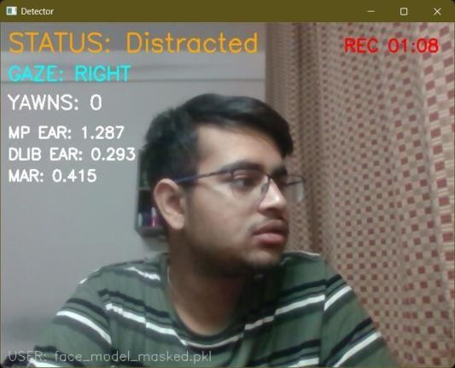
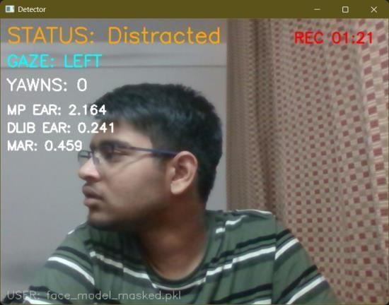

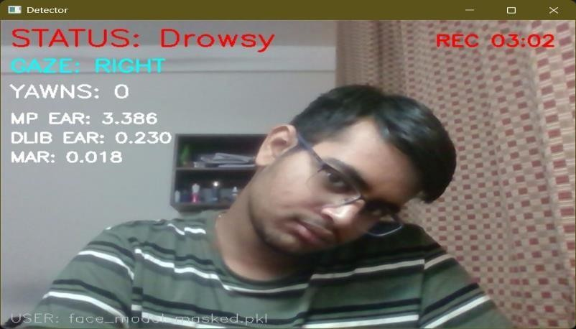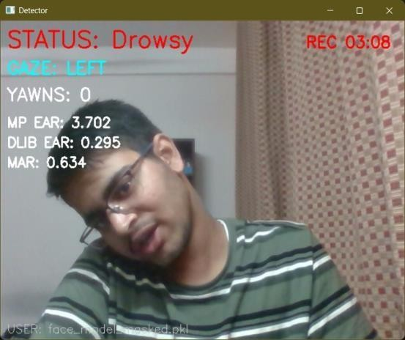
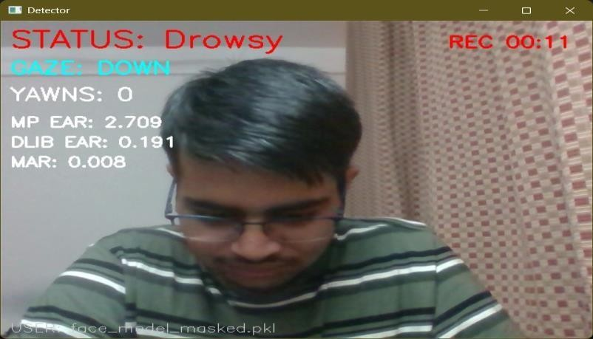
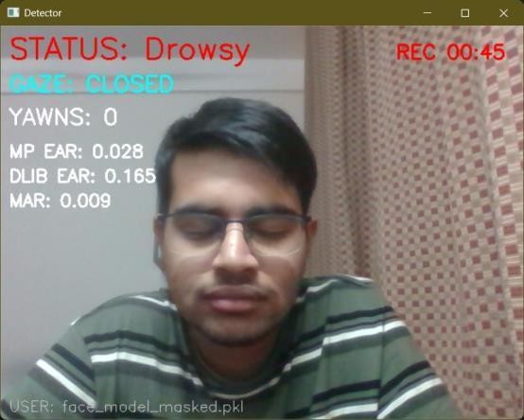
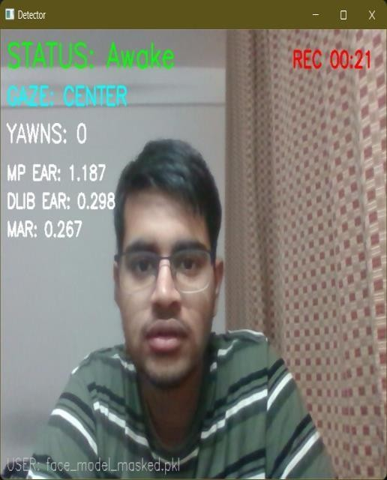
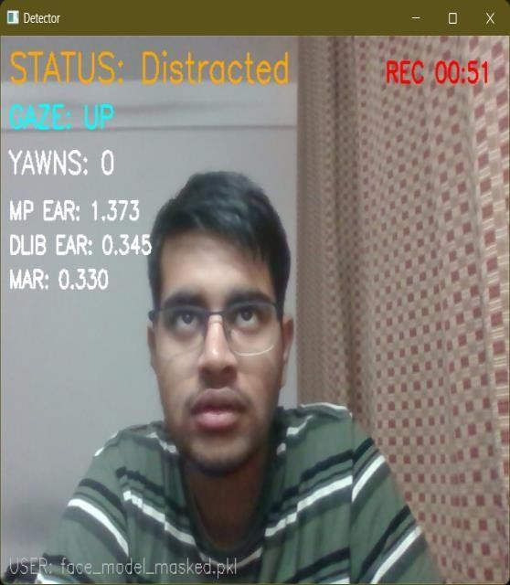

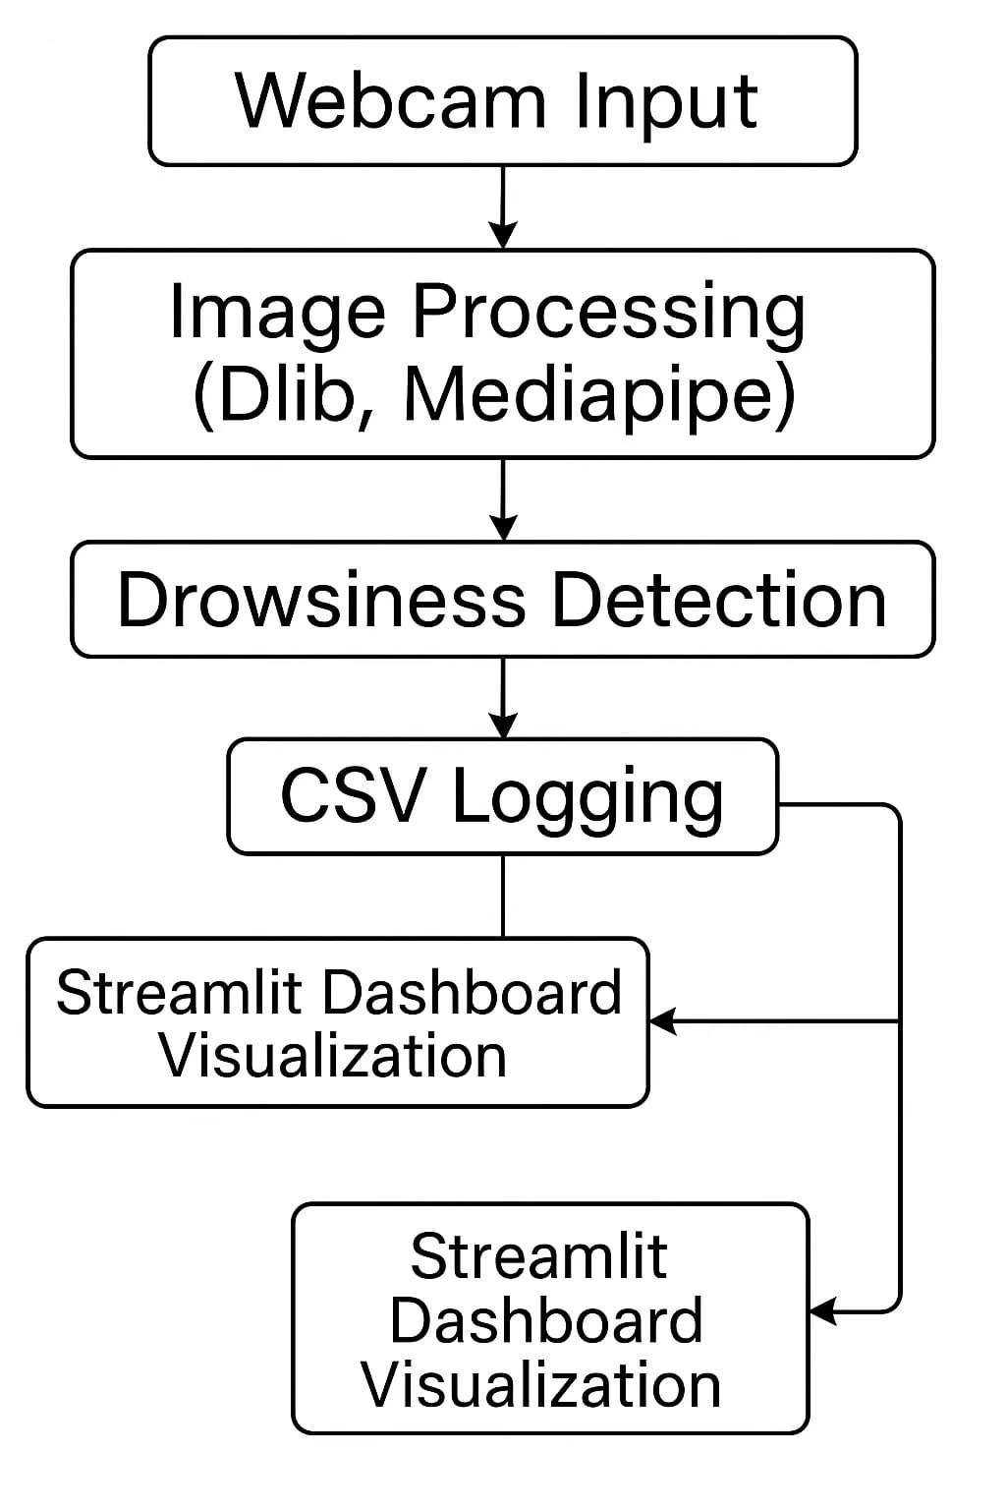
Workflow

Webcam Input

  - The system receives live video frames from the webcam in real time.

Image Pre-Processing (OpenCV)

  - Frames are resized, converted to RGB/Grayscale, and cleaned for faster computation.

Landmark Extraction (Dlib + Mediapipe)

  - Dlib detects 68 facial landmarks.
  - Mediapipe FaceMesh detects iris position, gaze direction, and head pose.

Feature Computation

  - EAR (Eye Aspect Ratio) → detects prolonged eye closure.
  - MAR (Mouth Aspect Ratio) → detects yawning.
  - Iris + head movement patterns → distraction monitoring.

Decision Logic

  - If EAR drops → possible drowsiness
  - If MAR spikes → yawning
  - If head/gaze changes → distraction

  - Events are classified based on thresholds.

Event Logging (CSV)

  - Every detected event is saved with:
    - Timestamp
    - Event type
    - User
    - Additional details

FFmpeg Clip Generation (Optional)

  - FFmpeg extracts a short video clip (5–10s) around each event for review.

Streamlit Dashboard

  - Displays logs, video clips, graphs, and session summary.

Key Feature:-

Driver Performance Dashboard for Ride-Sharing Platforms (Uber/Ola)

A unique advantage of this system is the integration of a dedicated Driver Performance Analytics Dashboard, which compiles all detection logs, behavioral alerts, and event timelines into an easy-to-understand visual interface. This dashboard provides insights into driver attentiveness, fatigue trends, distraction frequency, and overall driving behavior.

For companies like Uber, Ola, and other fleet-based transport services, this feature can be exceptionally valuable. It allows supervisors to assess each driver’s performance over time, identify risky driving patterns, and take proactive measures such as scheduling rest breaks, retraining, or investigation. The dashboard not only enhances driver safety but also improves service quality and passenger trust by offering a transparent, data- driven driver evaluation mechanism.

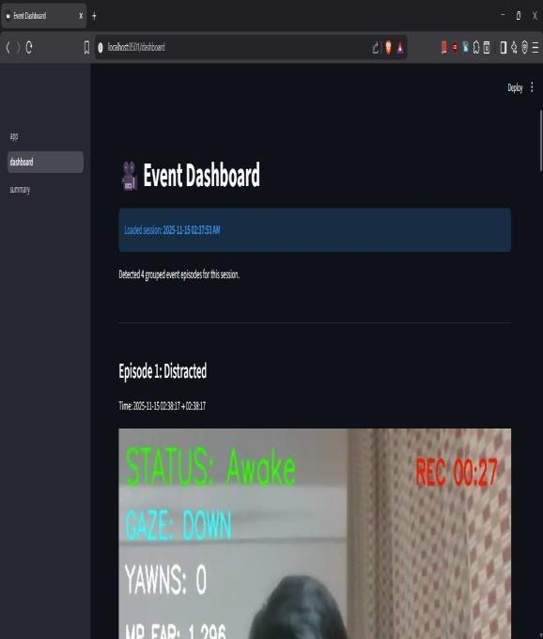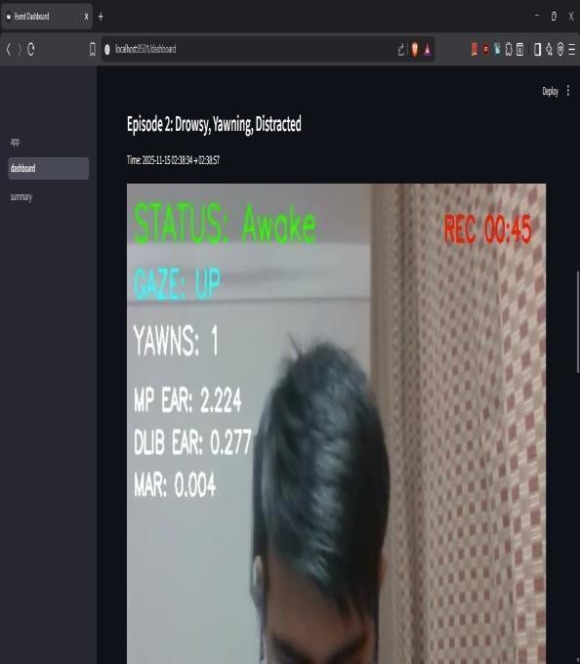


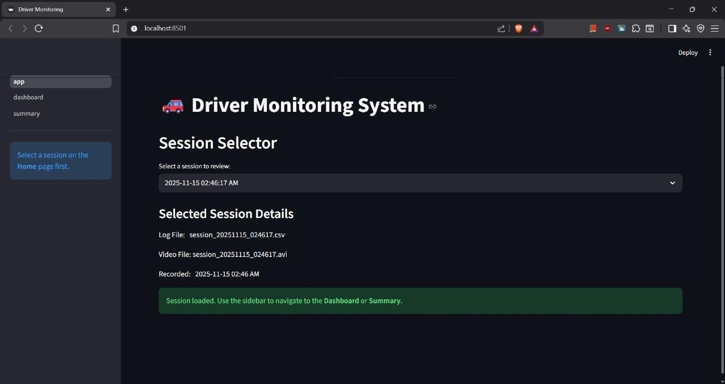
‘’

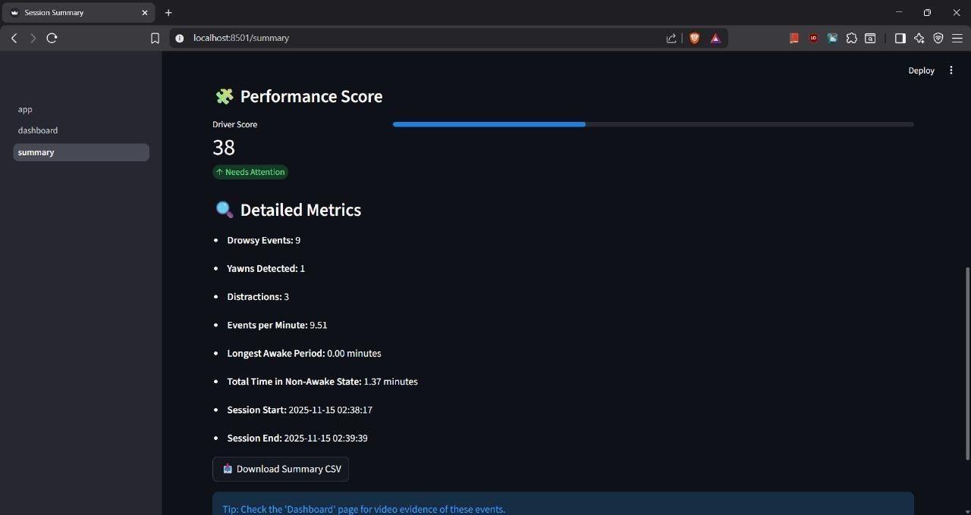

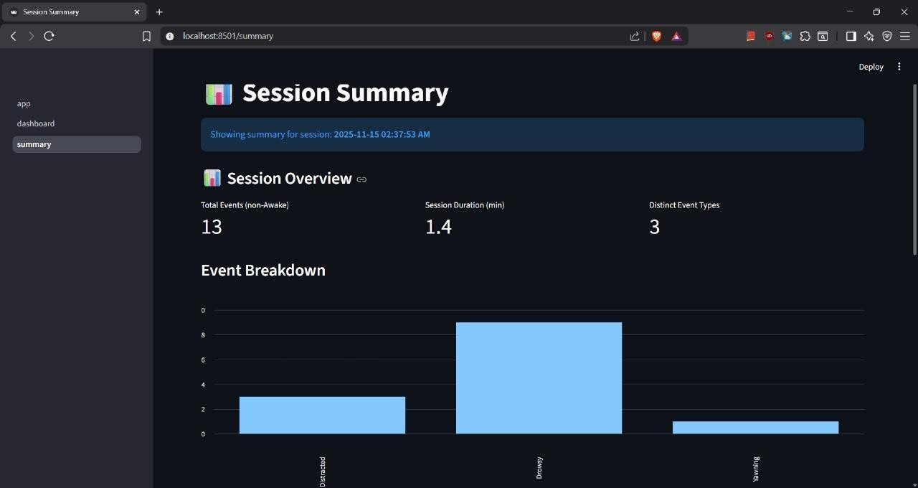

- Applications
- Driver fatigue monitoring
- Fleet management
- Industrial operator alertness
- Research and behavioral analysis
- Assistive safety technology
- Team Members
Kushal Bagla – 25BAI0044 Priyangshu Dan – 25BAI0014 Tejash Bhudolia – 25BAI0086 Divyanshu Antil – 25BAI0006

