Experiment 8
Develop a program using malloc(), calloc(), realloc(), and free(). Monitor memory allocation behavior and identify memory leaks using Valgrind. Code:
#include <stdio.h>
#include <stdlib.h>

int main() {
int i;

// 1. malloc() int *a = (int *)malloc(3 * sizeof(int));

if (a == NULL) { printf("malloc failed\n"); return 1;
}

printf("Memory allocated using malloc()\n");

for (i = 0; i < 3; i++) { a[i] = (i + 1) * 10; printf("a[%d] = %d\n", i, a[i]);
}

// 2. calloc() int *b = (int *)calloc(3, sizeof(int)); if (b == NULL) { printf("calloc failed\n"); free(a); return 1;
}

printf("\nMemory allocated using calloc()\n");

for (i = 0; i < 3; i++) { printf("b[%d] = %d\n", i, b[i]);
}

// 3. realloc() a = (int *)realloc(a, 5 * sizeof(int));

if (a == NULL) { printf("realloc failed\n"); free(b); return 1;
}

printf("\nMemory resized using realloc()\n");

a[3] = 40; a[4] = 50; for (i = 0; i < 5; i++) { printf("a[%d] = %d\n", i, a[i]);
}

// 4. free() free(a);
printf("\nMemory allocated by malloc/realloc has been freed.\n");

free(b); printf("Memory allocated by calloc has been freed.\n");

return 0;
}
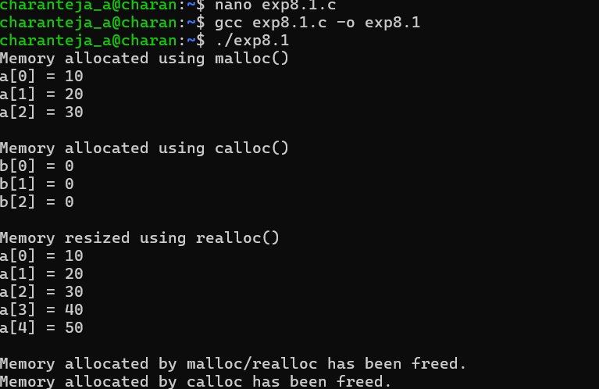
Develop a program that demonstrates Copy-on-Write behavior after a fork(). Analyze memory usage before and after modifying data in the child process.

#include <stdio.h>
#include <stdlib.h>
#include <unistd.h>
#include <sys/wait.h>

#define SIZE (10 * 1024 * 1024) // 10 MB

int main() {
char *data = malloc(SIZE);

if (data == NULL) { printf("Memory allocation failed\n"); return 1;
}

// Fill memory so that it is actually allocated for (int i = 0; i < SIZE; i++) { data[i] = 'A';
}

printf("Parent: 10 MB memory allocated.\n"); printf("Parent PID: %d\n", getpid());

pid_t pid = fork();

if (pid < 0) { printf("fork() failed\n"); free(data); return 1;
}

if (pid == 0) { // Child process printf("\nChild PID: %d\n", getpid()); printf("Child: Memory is initially shared using Copy-on-Write.\n");

sleep(2);

// Modify the memory printf("Child: Modifying 10 MB of memory...\n");

for (int i = 0; i < SIZE; i++) { data[i] = 'B';
}

printf("Child: Memory modification completed.\n");

sleep(5);

free(data); exit(0);
} else {
// Parent process
printf("\nParent: Child created using fork().\n"); printf("Parent: Both processes initially share the same memory pages.\n");

sleep(8);

wait(NULL);

printf("\nParent: Child process completed.\n");

free(data);
}

return 0;
}

