DSN Fabric MCP Server
Solution overview, technical handover and deployment guide
Document control
Item | Detail
Document | DSN Fabric MCP Server: solution overview, technical handover and deployment guide
Version | 1.0 (first issue)
Date | 9 October 2026
Prepared by | JMAN Group
Status | Draft for review
Code baseline | Repository dsn-fabric-mcp_server, branch main, commit 4105bad
Business rule version | DSN_FABRIC_2026-08-10_V1 (see business_rules.py)
Audience | Engineers who will maintain or extend the server  Platform / infrastructure teams who will deploy it  Analytics leads who own the DSN reconciliation rules

Table 1: Revision history
Version | Date | Change
1.0 | 09 Oct 2026 | First issue, written from a full review of the code at commit 4105bad.

Contents
Right-click and choose Update Field to build the table of contents.

Overview

Purpose of this document
This document hands over the DSN Fabric MCP server. It covers what the solution does and why it exists, how the code is organised, how to install and configure it, how to run and support it, and what to watch out for. Section 7 is a dedicated guide for teams moving the server from analysts' laptops to a shared, centrally hosted server.
Everything in this document was checked against the code. Where a statement is a recommendation or a proposed change rather than current behaviour, it is labelled as such.

What the solution does
The DSN Fabric MCP server is a Python service that lets Claude answer DSN business questions directly from the Microsoft Fabric data warehouse. It uses the Model Context Protocol (MCP), the open standard Claude uses to call external tools. An analyst asks a question in plain English, for example "core title transactions for Morgan Auto Group in June 2026 by agency". Claude picks the matching approved report, and the server runs reconciliation-grade SQL against Fabric. It returns a short preview to Claude and keeps the full result on disk so it can be paged through or exported to Excel.
Table 2: Solution capabilities
Capability | What it gives the business
Approved reports (dsn_query) | Seven standard DSN workflows (core transactions, parent-customer detail, dealer-service summary, aggregate summary, reference summary, EOMV retail and MVD), always calculated the same way.
Targeted discovery (dsn_catalog) | Look up exact agency codes, stored parent-customer names, tables, columns and methodology without loading the whole schema into Claude's context.
Large-result handling (dsn_result) | Results of up to 250,000 rows are cached locally. Claude sees a bounded preview, and users can page through the rest or export everything to Excel.
Excel with provenance | Each export includes a _pull_info sheet listing the report, scope, methodology, business rule version, warnings, row counts and query hashes.
Bounded ad-hoc SQL | A single read-only SELECT, used as a last resort when no approved report fits. The number of rows returned is capped.
Health check | Confirms the configuration, the Service Principal sign-in and the warehouse connection. It never returns secrets.

Why it exists
The original proof of concept gave Claude two generic tools: get_schema() and an unrestricted execute_sql(sql). That proved the connection to Fabric worked, but it left Claude to work out DSN reconciliation rules from the schema every time. Two runs of the same question could produce different numbers. The main causes were:
- Fan-out. The Fabric fact table can repeat one business transaction across several service rows, so counting fact rows overstates transaction counts and summing revenue across dimension joins overstates revenue.
- Business definitions. A core transaction means all EFS transactions plus non-EFS transactions with one of four title sub-services. A model will not infer that from column names.
- Date semantics. Every reconciled number uses an inclusive start date and an exclusive end date. Writing BETWEEN or an end-of-month date by hand causes small but real differences.
- Scope rules. Reference and aggregate summaries rely on agreed source keep-lists and entity exclusion lists.
This build applies one rule throughout: Claude decides WHAT analysis is needed, and the MCP server decides HOW it is calculated. The business rules and SQL live in version-controlled server code. Each result records the BUSINESS_RULE_VERSION that produced it, so a number shown in a meeting can be traced back to the exact rules and SQL behind it.

Architecture
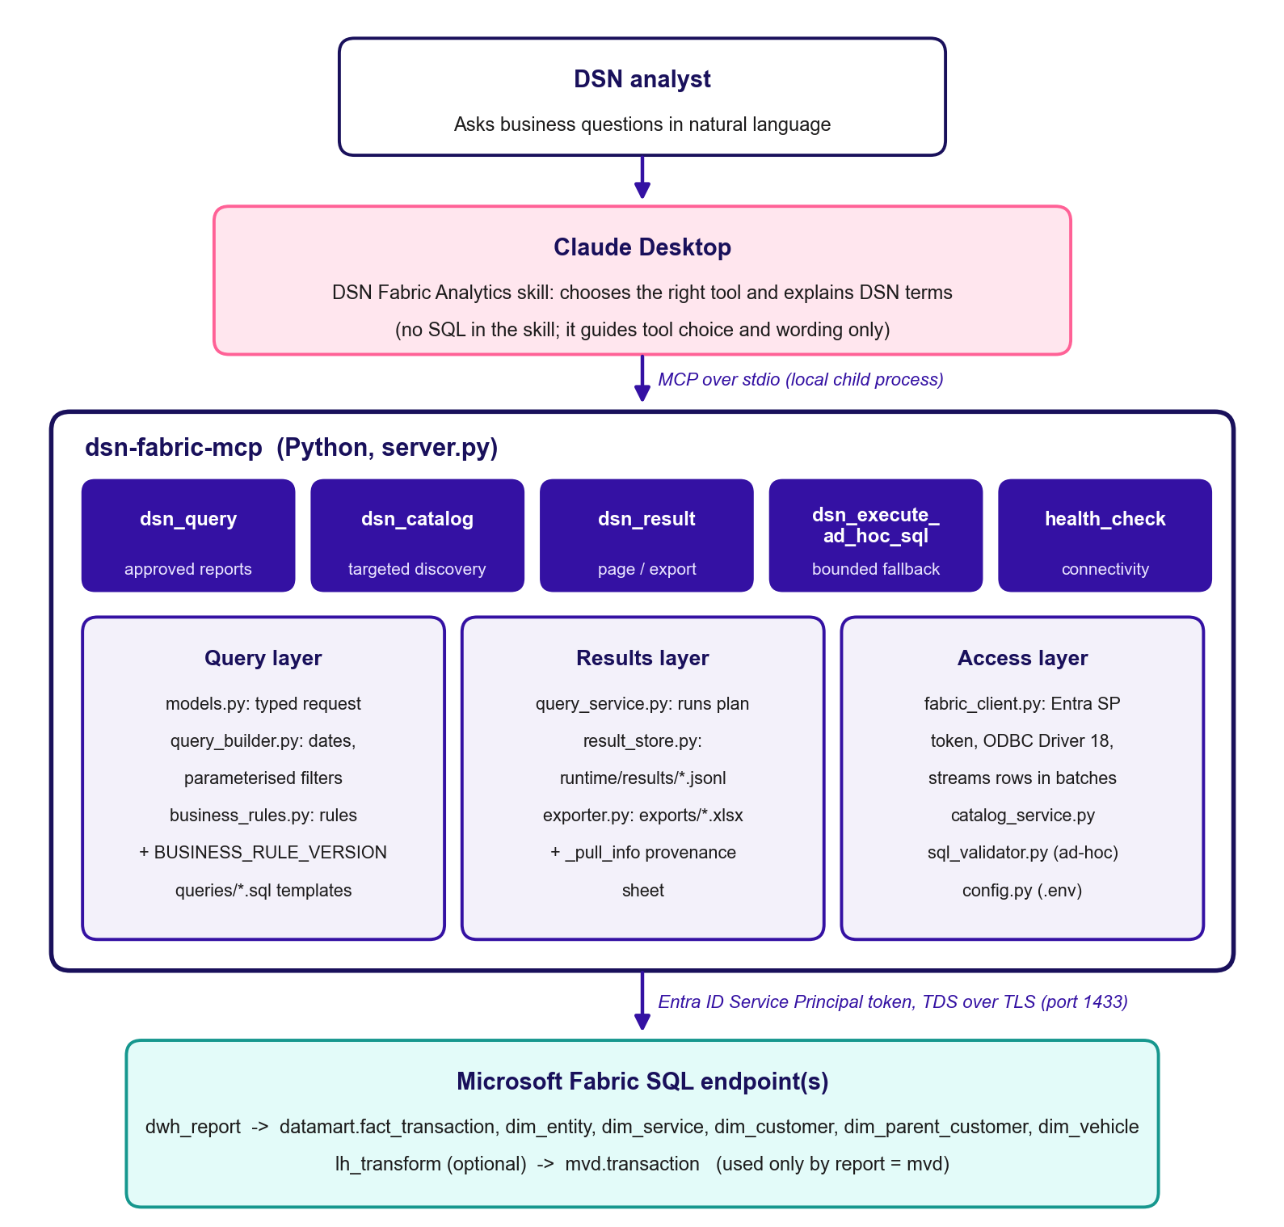
Figure 1: Current architecture (local, per-user deployment over stdio)
Today the server runs as a local child process of Claude Desktop on each analyst's machine and talks to Claude over stdio. Each layer has a single job:
Table 3: Architecture layers
Layer | Modules | Responsibility
MCP interface | server.py, models.py | Registers five tools, validates typed inputs with Pydantic, and converts internal errors into tool errors Claude can read.
Query planning | query_builder.py, business_rules.py, queries/*.sql | Works out the date window, checks report options, builds parameterised SQL from server-owned templates, and attaches the methodology text and rule version.
Execution and results | query_service.py, result_store.py, exporter.py | Runs each dataset, streams rows into a JSONL cache on disk, builds the preview, and writes XLSX exports with provenance.
Data access | fabric_client.py, config.py | Gets and caches an Entra ID token, connects through ODBC Driver 18 with token authentication, and streams results in batches.
Discovery and guardrails | catalog_service.py, sql_validator.py | Runs targeted catalog look-ups and checks ad-hoc SQL as an extra safeguard.
Guidance (optional) | skill/dsn-fabric-analytics/ | A Claude skill that tells Claude which tool to use and how to read DSN terms. It contains no SQL.

Key design decisions
- The server owns the methodology. SQL lives in queries/*.sql and rule lists live in business_rules.py. The skill only explains them.
- Every user value is a bound parameter. Template tokens such as {{FILTERS}} are filled only with server-generated SQL fragments. Agency codes, dates and names are always passed as ? parameters.
- Claude cannot choose the target. Endpoints, databases and credentials come only from server configuration and are never tool parameters.
- The preview is separate from the full result. Claude receives at most 500 preview rows, while the complete result (up to FABRIC_MAX_RESULT_ROWS) is cached locally for paging and export.
- Fabric permissions are the real security boundary. The SQL validator is an extra safeguard only. The Service Principal should have read-only access to the schemas the server needs.
- Failed runs leave nothing behind. If any dataset fails, the partial cache for that query is deleted.

Data sources
Table 4: Fabric objects read by the server
Fabric item | Object | Used by
dwh_report (warehouse) | datamart.fact_transaction | All reports except MVD
 | datamart.dim_entity (agency_code, entity_name, parent_entity_name) | All warehouse reports; list_agencies
 | datamart.dim_service (service_name, sub_service_name) | core, parent detail, dealer-service, EOMV
 | datamart.dim_customer (customer_name, licence number, parent_customer_name) | core, parent detail, dealer-service
 | datamart.dim_parent_customer | core, parent detail; list_parent_customers
 | datamart.dim_vehicle | parent detail
lh_transform (lakehouse SQL endpoint, optional) | mvd.transaction | mvd report only

Codebase

Repository structure
The repository is flat and small: about 1,900 lines of Python, nine SQL templates and five test modules.
Table 5: Repository contents
Path | Purpose
server.py | Entry point. Creates the MCPServer, registers the five tools and starts the stdio transport. Services are created lazily on the first tool call.
config.py | Loads .env from the project folder and validates required and optional settings. Error messages name a missing variable but never show its value.
fabric_client.py | Entra ID Service Principal token (refreshed 120 s before expiry), ODBC Driver 18 connection, batched streaming with an accurate truncation check, and health_check.
models.py | Pydantic request and response models and enums. Cross-field date checks live here.
business_rules.py | BUSINESS_RULE_VERSION, the core sub-service list, reference keep and exclude lists, aggregate exclusions, the report catalogue and methodology text.
query_builder.py | Pure functions that turn a QueryRequest into a QueryPlan of parameterised datasets with SHA-256 query hashes.
query_service.py | Runs a plan, streams rows into the cache, builds the preview, adds warnings and optionally exports.
catalog_service.py | The seven catalog actions (reports, methodology, agencies, parent customers, tables, describe table, search columns).
result_store.py | Disk cache under runtime/results/<query_id>/ holding meta.json and one JSONL file per dataset, with TTL clean-up.
exporter.py | Writes a cached result to .xlsx: one sheet per dataset plus the _pull_info sheet.
sql_validator.py | Read-only checks for ad-hoc SQL: a single statement, SELECT/CTE only, forbidden keywords, and a schema allow-list.
queries/*.sql | Nine server-owned SQL templates (see Table 9).
tests/ | Unit tests for config, query builder, result store and validator, plus a manual Fabric integration test.
skill/dsn-fabric-analytics/ | Claude skill (SKILL.md plus references/methodology.md). A packaged .zip sits next to it.
.env.example, claude_desktop_config.example.json | Configuration templates. The real .env is git-ignored.

MCP tools
Table 6: MCP tools exposed to Claude
Tool | Purpose | Key inputs | Returns
dsn_query | Main tool. Runs an approved report. | report, year/month/months or from_date/to_date  agency_codes, parent_customer, grain, include_all  result_mode (preview | export), preview_rows (1-500) | query_id, scope, methodology, rule version, dataset previews, warnings, optional export path
dsn_catalog | Targeted discovery | action, search, report, schema_name, table_name, limit (max 500) | Columns, rows and a truncation flag
dsn_result | Page, inspect or export a cached result | action (page | metadata | export), query_id, dataset, offset, limit (max 500) | Rows plus has_more, metadata, or an export path/URI
dsn_execute_ad_hoc_sql | Fallback read-only SELECT | sql, limit (1 to FABRIC_MAX_ADHOC_ROWS) | Rows plus a warning that the methodology is not enforced
health_check | Connectivity check | none | Status, warehouse, connection, whether MVD is configured, error detail

All tools except dsn_result are annotated as read-only and idempotent. dsn_result is marked non-read-only because its export action writes a file.

Approved reports
Table 7: Approved reports available through dsn_query
Report | What it answers | Filters | Datasets | Target
core_transactions | Reconciliation-grade EFS, non-EFS, core and all-transaction counts plus revenue, at one of five grains | agency, parent, grain | 1 | dwh_report
parent_customer_detail | Transaction-level rows for one exact parent customer | parent (required), agency | 1 | dwh_report
dealer_service_summary | Distinct transactions by dealer, service and month | parent, agency | 1 | dwh_report
aggregate_summary | Authoritative entity transaction counts plus revenue by source | include_all only | 2 | dwh_report
reference_summary | Same shape as the reference workbook, using the legacy keep and exclude scope | agency | 2 | dwh_report
eomv_retail | EOMV retail detail (Express Lane for DMV) | date only | 1 | dwh_report
mvd | MVD transaction detail | agency | 1 | lh_transform

Core transaction grains
core_transactions accepts a grain that controls the GROUP BY. The default is the most detailed grain:
- month: one row per year-month (ym).
- month_agency: adds agency_code and entity_name.
- month_parent_customer: adds dealer_group (parent customer).
- month_agency_parent_customer: agency plus dealer group.
- month_agency_parent_customer_dealer (default): adds dealer_name and dealer_license.

Key workflows

dsn_query request lifecycle
- Claude sends a QueryRequest. Pydantic checks it: from_date and to_date must be given together, to_date must be later than from_date, month and months cannot both be set, months must be contiguous, and year is required unless explicit dates are given. Agency codes are upper-cased and trimmed.
- build_query_plan checks options for the chosen report. For example, aggregate_summary rejects agency and parent filters, and include_all is only allowed on aggregate_summary. It then works out the window [start, end). A single month becomes the first of that month to the first of the next, with December rolling into the next year.
- The matching plan function renders the SQL template with server-built fragments and collects the parameters in the order their placeholders appear. Unit tests check that the number of ? placeholders matches the number of parameters for every report.
- QueryService.run creates a query_id (a 32-character hex UUID) and writes meta.json with the report, rule version, scope, methodology and warnings.
- For each dataset, FabricClient.execute_stream fetches rows in batches of FABRIC_FETCH_SIZE, converts them to JSON-safe values (Decimal becomes float, dates become ISO strings), appends them to the dataset's JSONL file and fills the preview. When the row cap is reached it fetches one extra row to tell whether the result is really truncated.
- Warnings are added (truncation, or zero rows from a parent-customer match) and saved before any export, so the Excel provenance matches what Claude was told.
- If result_mode=export, the XLSX is written straight away. The response returns the query_id, previews and the export path.

Paging and export
After a query, Claude calls dsn_result with the query_id instead of running the query against Fabric again. page reads rows offset to offset+limit from the JSONL cache. If a query produced several datasets, dataset must be named. export writes exports/<timestamp>-<report>-<id8>.xlsx with frozen headers, auto-filters, number formats for revenue and count columns, and the _pull_info sheet. Cached results expire after FABRIC_RESULT_CACHE_TTL_HOURS (default 24); after that the user must run dsn_query again.

Catalog discovery
When a parent-customer name or agency code is uncertain, Claude should call dsn_catalog (list_parent_customers or list_agencies with a search substring) rather than guess. Parent-customer matching is exact, so a zero-row parent_customer_detail result comes back with a warning that points to this look-up.

Ad-hoc SQL fallback
dsn_execute_ad_hoc_sql checks the statement first. It must be a single statement starting with SELECT or WITH and must not contain forbidden keywords such as INSERT, UPDATE, DELETE, DROP, EXEC, INTO, OPENROWSET or BULK. Comments and string literals are removed before checking. It also rejects three- and four-part names and two-part names outside FABRIC_ADHOC_ALLOWED_SCHEMAS (default datamart). The query then runs against dwh_report only, with a row cap.

Business rules summary
Table 8: Business rules enforced by the server (rule version DSN_FABRIC_2026-08-10_V1)
Rule | Definition (as implemented)
Transaction count | COUNT(DISTINCT transaction_id), never a count of fact rows.
Date window | transaction_date >= from_date AND transaction_date < to_date (exclusive upper bound).
Core transaction | source = 'efs', OR UPPER(sub_service_name) is one of ORIG NEW TITLE, TRANSFER TITLE, ORIG USED TITLE, ORIGINAL USED TITLE. all_txns is returned alongside as a control.
Agency mapping | Always dim_entity.agency_code, never inferred from entity_name.
Aggregate summary | Entity dataset: fact joined to dim_entity, excluding entities Auto Title Service Group, Express OMV and Dealer Services Network of North Texas, and source atares.  Source revenue dataset: fact table only, with the source exclusion only.  include_all=true turns both exclusions off for a comparison run. Both lists are marked provisional.
Reference summary | Keeps the sources add123, bc, efs, eltmanager, eltv1, inovah, quickview and square, and excludes 15 named DSN/Express OMV/tag-agency entities. Both comparisons are case- and whitespace-normalised.
EOMV retail | parent_entity_name = 'EOMV' AND service_name = 'Express Lane for DMV'. No agency filter, because agency_code is NULL for these rows.
MVD | lh_transform.mvd.transaction with no joins, ordered by system and date.
Revenue authority | Use aggregate_summary for authoritative revenue totals. Detail extracts can double-count revenue through join fan-out.

SQL templates
Table 9: Server-owned SQL templates
Template | Tokens | Notes
core_transactions.sql | DIM_SELECT, CORE_SUBSERVICE_PLACEHOLDERS (x2), FILTERS, DIM_GROUP, ORDER_BY | LEFT JOINs to service, customer and parent customer; INNER JOIN to entity
parent_customer_detail.sql | FILTERS | INNER JOIN to parent customer; LEFT JOINs to service, vehicle and customer
dealer_service_summary.sql | FILTERS | INNER JOINs; dealer name taken from dim_customer.parent_customer_name
aggregate_entity.sql / aggregate_source.sql | FILTERS | Monthly buckets via DATEFROMPARTS
reference_entity.sql / reference_source.sql | FILTERS | Share one filter block and parameter list
eomv_retail.sql | none | Filters hard-coded in the template
mvd.sql | FILTERS | Runs against the transform target

_render raises an error if any {{TOKEN}} is left unfilled, so a template change that adds a token without matching builder code fails straight away rather than sending broken SQL.

Dependencies
Table 10: Runtime dependencies
Dependency | Version | Why it is needed
Python | 3.10+ (developed on 3.13) | Uses X | None type syntax evaluated by Pydantic and match in the SDK
mcp | >=2.0,<3.0 (2.3.0 installed) | MCP Python SDK v2 (mcp.server.mcpserver.MCPServer)
pydantic | >=2.7,<3.0 | Typed tool schemas and validation
pyodbc | >=5.0 | ODBC connectivity to the Fabric SQL endpoint
azure-identity | >=1.15 | ClientSecretCredential for Entra ID tokens
python-dotenv | >=1.0 | Loads .env
openpyxl | >=3.1 | XLSX export
Microsoft ODBC Driver 18 for SQL Server | 18.x | System driver loaded by pyodbc. Without it, every connection fails.
Claude Desktop | Current | MCP host for the local stdio deployment
Microsoft Fabric + Entra ID | n/a | Data platform and identity provider

Note: requirements.txt sets version ranges, not exact versions. Before any production deployment, generate a pinned lock file (for example with pip-compile or uv pip compile) so builds can be repeated.

Testing
The unit suite has 18 tests and needs no Fabric access. All 18 passed on 9 October 2026 in the project virtual environment. It covers:
- test_config.py: minimum configuration, and a missing secret is named in the error without its value being shown.
- test_query_builder.py: exclusive month windows, December rollover, rejection of non-contiguous months, parameter order for core transactions, placeholder and parameter parity for every report, and option checks.
- test_result_store.py: writing, paging and metadata.
- test_sql_validator.py: SELECT and CTE accepted; writes, cross-database names and disallowed schemas rejected; keywords inside string literals ignored.
tests/integration_test.py is a manual test against real Fabric. It runs health_check and a five-row June 2026 core-transactions query, and prints "NOT RUN" if no configuration is present.
python -m unittest discover -s tests -p "test_*.py" -v
python tests\integration_test.py
There are no tests yet for exporter.py, catalog_service.py, the tool wiring in server.py, or the business numbers themselves (golden reconciliation values). See Section 6.

Setup

Prerequisites
- Windows 10/11 workstation (or macOS/Linux; the code itself works on any OS) with Python 3.10 or later.
- Microsoft ODBC Driver 18 for SQL Server installed.
- Claude Desktop installed and signed in.
- A Microsoft Entra ID app registration (Service Principal) with a client secret.
- The SQL connection string or endpoint of the dwh_report warehouse (and of lh_transform if MVD is needed).
- Network access from the workstation to login.microsoftonline.com and to the Fabric SQL endpoint on TCP 1433.

Service Principal and Fabric access
- Register an app in Entra ID (for example sp-dsn-fabric-mcp-<env>) and create a client secret. Record the tenant ID, client ID and secret in a password vault, not in email or chat.
- Ask a Fabric administrator to enable the tenant setting that lets service principals use Fabric APIs (Admin portal > Tenant settings > Developer settings), limited to a security group that contains this app.
- Grant the app read-only access to the dwh_report warehouse, either through the Viewer workspace role or by sharing the item with permission to read data using SQL. Do the same for lh_transform if the MVD report is needed.
- Where possible, narrow access further with T-SQL, for example GRANT SELECT ON SCHEMA::datamart (and SCHEMA::mvd on lh_transform). Never grant write, DDL or admin permissions.
- Copy the SQL connection string host from the warehouse settings in Fabric (it ends in .datawarehouse.fabric.microsoft.com).
Security: The Service Principal's permissions are the real security boundary. The ad-hoc SQL validator is only an extra safeguard and must not be relied on to stop data access.

Configuration reference
Settings are read from a .env file in the project folder (copy .env.example). Values already set in the process environment take precedence (override=False).
Table 11: Environment variables
Variable | Req. | Default | Purpose
FABRIC_TENANT_ID | Yes | none | Entra tenant ID
FABRIC_CLIENT_ID | Yes | none | Service Principal application (client) ID
FABRIC_CLIENT_SECRET | Yes | none | Service Principal secret. Never commit or share it.
FABRIC_SQL_ENDPOINT | Yes | none | Fabric SQL endpoint host for dwh_report
FABRIC_DATABASE | Yes | none | Warehouse name, normally dwh_report
FABRIC_TRANSFORM_DATABASE | MVD | none | Set to lh_transform to enable the mvd report
FABRIC_TRANSFORM_SQL_ENDPOINT | No | = SQL endpoint | Only needed if lh_transform is on a different endpoint
FABRIC_ADHOC_ALLOWED_SCHEMAS | No | datamart | Comma-separated schema allow-list for ad-hoc SQL
FABRIC_EXPORT_DIR | No | ./exports | Folder for XLSX exports
FABRIC_RESULT_CACHE_DIR | No | ./runtime/results | Folder for the result cache
FABRIC_RESULT_CACHE_TTL_HOURS | No | 24 | How long cached results are kept
FABRIC_CONNECTION_TIMEOUT_SECONDS | No | 30 | ODBC connection timeout
FABRIC_QUERY_TIMEOUT_SECONDS | No | 180 | Cursor query timeout (if the driver supports it)
FABRIC_FETCH_SIZE | No | 1000 | Rows per fetch batch
FABRIC_MAX_RESULT_ROWS | No | 250000 | Maximum rows cached per dataset. Results beyond this are marked truncated.
FABRIC_MAX_ADHOC_ROWS | No | 2000 | Maximum limit for ad-hoc SQL
FABRIC_MAX_PREVIEW_ROWS | No | 500 | Upper limit on preview rows (can only lower the 500 built into the code)
FABRIC_DEFAULT_PREVIEW_ROWS | No | 100 | Read by the code but not currently used (see KI-06)
FABRIC_WORKSPACE_ID / FABRIC_WAREHOUSE_ID | No | none | Metadata only. Not currently used.

Local installation (Windows)
- Clone or copy the repository to a local, non-synced folder (not OneDrive or SharePoint), for example C:\dsn-fabric-mcp.
- Create a virtual environment and install the dependencies:
cd C:\dsn-fabric-mcp
python -m venv .venv
.venv\Scripts\activate
python -m pip install --upgrade pip
pip install -r requirements.txt
- Copy .env.example to .env and fill in the values from Section 3.2. Restrict the file so only the analyst can read it.
- Run the unit tests, then the integration test:
python -m unittest discover -s tests -p "test_*.py" -v
python tests\integration_test.py
A healthy integration run prints health: {'status': 'ok', ...} followed by a short core-transactions preview.

Connecting Claude Desktop
Edit Claude Desktop's configuration file (Settings > Developer > Edit Config, which opens claude_desktop_config.json). Add the server using absolute paths to the virtual environment's Python and to server.py:
{
"mcpServers": {
"dsn-fabric-mcp": {
"command": "C:\\dsn-fabric-mcp\\.venv\\Scripts\\python.exe",
"args": ["C:\\dsn-fabric-mcp\\server.py"]
}
}
}
Quit Claude Desktop completely (including the system tray icon) and reopen it. The tools should appear under the dsn-fabric-mcp server.

Installing the skill
Upload skill/dsn-fabric-analytics.zip in the Skills area of Claude's settings. On Team and Enterprise plans, an owner can provision it for the whole organisation. The skill teaches Claude to use dsn_query first, to look up names with dsn_catalog, and to report variances rather than change filters to force a match. If you edit SKILL.md or references/methodology.md, rebuild the zip so the two copies stay the same.

Verification
Table 12: Post-installation smoke test
Step | Ask Claude to… | Expected result
1 | Run the DSN health check | status=ok, connection=successful; transform_configured=true if MVD is set up
2 | List the approved DSN reports | Seven reports with their purposes
3 | Show core transactions for June 2026 by agency | Preview with efs_txns, non_efs_txns, core_txns, all_txns; scope 2026-06-01 to 2026-07-01
4 | Export that result to Excel | An .xlsx in exports/ with a data sheet and a _pull_info sheet
5 | Compare a known month against the legacy reconciled figure | Numbers match, or the variance is explained and recorded

Operations

Routine maintenance
Table 13: Maintenance schedule
Activity | Frequency | Details
Rotate the Service Principal secret | Before expiry (at least every 6-12 months) | Create a new secret, update every .env (or Key Vault on a server), confirm with health_check, then delete the old secret.
Purge exports | Weekly, or set by policy | exports/ is never cleaned automatically (KI-01). Delete old XLSX files in line with DSN data-retention rules.
Check cache size | Monthly | runtime/results/ is pruned only when a new query runs. Check disk use on busy machines.
Update dependencies | Quarterly | Update the Python packages and ODBC driver in a branch, run the unit and integration tests, then roll out.
Review business rules | Quarterly, or when DSN changes | Confirm the exclusion and keep lists are still right, especially the provisional aggregate exclusions.
Check for schema drift | After each Fabric model release | Run every report for a recent month. Column renames show up as query errors.
Keep the skill in sync | Whenever the skill or report list changes | Rebuild and re-upload the skill zip.

Changing a business rule
- Agree the change with the DSN data owner and record the decision and its reason.
- Edit business_rules.py (lists and methodology text), the relevant queries/*.sql, and/or query_builder.py.
- Change BUSINESS_RULE_VERSION, for example DSN_FABRIC_2026-11-01_V2. Every result and export records this value, which is how users can tell old numbers from new ones.
- Add or update unit tests, including placeholder and parameter parity, and run the integration test.
- Run the affected report for a reconciled month and compare it with the expected figures.
- Update skill/.../methodology.md if the explanation has changed, rebuild the zip, and redeploy.

Adding a new report
- Add a value to ReportType in models.py.
- Add a REPORT_CATALOG entry and a methodology_for branch in business_rules.py.
- Create queries/<report>.sql using ? parameters and {{FILTERS}}-style tokens only.
- Add an option check in _validate_report_options and a _<report>_plan function, and dispatch it in build_query_plan.
- Add the report to test_all_plans_have_matching_parameters, plus targeted tests.
- Add the mapping to the skill's Typical mappings list.

Logging and monitoring
The server logs to stderr at INFO level, and Azure SDK logging is reduced to WARNING. Each dsn_query call logs the report and query_id. Claude Desktop saves MCP server output to log files. On Windows these are in %APPDATA%\Claude\logs\ (look for files whose names start with mcp). Secrets and tokens are never logged.
The local deployment has no central monitoring: each analyst's logs stay on their own machine. A central audit trail is one of the main reasons to move to a server (Section 7).

Troubleshooting
Table 14: Troubleshooting guide
Symptom / message | Likely cause | Resolution
Missing required configuration: FABRIC_... | .env missing, in the wrong folder, or incomplete | .env must sit next to config.py. Fill in all five required variables.
Could not load 'ODBC Driver 18 for SQL Server' | Driver not installed, or 32/64-bit mismatch | Install the 64-bit ODBC Driver 18 and match it to the Python architecture.
Service Principal authentication failed | Wrong tenant/client/secret, or secret expired | Check the values in Entra. Rotate the secret if it has expired.
Could not connect to configured Fabric target | Wrong endpoint, missing workspace access, tenant setting off, or firewall | Check the endpoint host, the SP's warehouse access and the tenant setting, and test TCP 1433.
The MVD/lh_transform target is not configured | FABRIC_TRANSFORM_DATABASE not set | Set it (and the endpoint if it is different).
Query failed: ... timeout | Wide window at a detailed grain, or Fabric capacity under pressure | Narrow the window or grain, or increase FABRIC_QUERY_TIMEOUT_SECONDS. Check Fabric capacity metrics.
Result not found or expired | TTL passed or cache cleared | Run dsn_query again.
This query has multiple datasets | Paging aggregate or reference results without naming dataset | Pass dataset exactly as shown, for example Revenue by Source.
parent_customer_detail returns 0 rows | Exact-match spelling or case differs | Use dsn_catalog list_parent_customers with a search term, then use the stored name.
Truncation warning | Dataset exceeded FABRIC_MAX_RESULT_ROWS | Narrow the scope. Raise the cap only after checking disk space and Excel limits.
Could not write '...xlsx' | File open in Excel, or no write permission | Close the file and retry.
Ad-hoc disallowed keyword / Schema ... not allowed | Validator rule (possibly a false positive on an identifier) | Use an approved report. If ad-hoc SQL is truly needed, rename the column with an alias or use an allowed schema.
Tools missing in Claude Desktop | Bad JSON, relative paths, or the app was not restarted | Validate the JSON, use absolute paths, quit fully from the system tray, and check the MCP logs.
Numbers do not reconcile | Different scope, data vintage, rule version, or a revenue fan-out comparison | Compare _pull_info (scope, rule version, query hash). Check all_txns against core_txns. Use aggregate_summary for revenue. Do not change filters to force a match.

Support model
Table 15: Support tiers (names to be confirmed at handover)
Tier | Who | Handles
L1 | Analyst / power user | Runs health_check, re-runs expired queries, looks up names in the catalog, closes files that block exports
L2 | Solution engineer (owner of this repository) | Config and secrets, log review, query errors, validator issues, dependency updates, rule-version changes
L3 | Fabric / data platform team | Capacity, permissions, tenant settings, schema changes, data quality in datamart
Business owner | DSN analytics lead | Approves methodology changes and exclusion lists; signs off reconciliations

When escalating, include the query_id, the report and scope, the business_rule_version, the _pull_info sheet (if exported), the exact error text and the time. Never include .env contents.

Known issues, limitations and assumptions

Known issues
These were found during the code review for this document. None of them stops the current local deployment, but several must be fixed before a shared server deployment (marked S).
Table 16: Known issues (S = must fix before server deployment)
ID | Issue | Impact | Recommendation
KI-01 | exports/ is never cleaned up; TTL clean-up only covers runtime/results/. | Sensitive XLSX files pile up on disk indefinitely. | Add an export TTL or purge job. S
KI-02 | dealer_service_summary takes the parent name from dim_customer.parent_customer_name and uses INNER JOINs, while core_transactions and parent detail use dim_parent_customer through parent_customer_key with LEFT JOINs. | The same parent_customer filter can give different populations and totals in different reports. | Confirm the intended source with the business and align the joins.
KI-03 | core_transactions revenue is a SUM across dimension joins. | Revenue can be overstated by fan-out (documented and warned in the response). | Keep the warning. Consider removing revenue from this report.
KI-04 | t.source = 'efs', the aggregate exclusions and the EOMV filters are exact, case-sensitive matches. Fabric Warehouse's default collation is case-sensitive. | If casing or whitespace changes upstream, rows are silently misclassified. | Normalise as the reference report does (LOWER(LTRIM(RTRIM(...)))), or add data-quality checks.
KI-05 | The ad-hoc validator lets one-part table names through (they resolve to the default schema), rejects keywords inside bracketed identifiers, and catalog LIKE searches do not escape % or _. | The schema allow-list can be bypassed, and some valid queries are wrongly rejected. | Rely on Fabric permissions. Consider a proper SQL parser such as sqlglot, or disable ad-hoc SQL in production. S
KI-06 | FABRIC_DEFAULT_PREVIEW_ROWS is not used, and the 500 preview limit is built into the code. FABRIC_WORKSPACE_ID/WAREHOUSE_ID are not used. | The configuration suggests settings that have no effect. | Wire them up or remove them.
KI-07 | health_check tests dwh_report only. | A broken MVD/lh_transform connection only shows up when someone runs a query. | Add an optional check of the transform target.
KI-08 | get_page reads the JSONL file from the beginning every time. | Pages deep into a 250,000-row result are slow. | Store byte offsets, or switch to a columnar or SQLite cache.
KI-09 | Export builds the whole workbook in memory and applies number formats cell by cell after loading. | Large exports are slow and use a lot of memory. | Use openpyxl write_only mode and set formats while writing rows. S
KI-10 | meta.json is read, changed and rewritten without locks, and service set-up is not thread-safe. The SDK runs tool calls in worker threads. | Concurrent calls, or several worker processes, can race and corrupt metadata. | Add locking or move metadata to a transactional store. S
KI-11 | Raw ODBC error text is passed back to Claude (Query failed: ...). | May reveal internal object names to the user. | Log the full error on the server and return a sanitised message plus a correlation ID. S
KI-12 | If the driver does not support cursor.timeout, the error is silently ignored. | The query timeout may not be enforced. | Log when the timeout cannot be set, and use Fabric query limits as a backstop.
KI-13 | The skill exists both as a folder and as a zip in the repository. | The two copies can drift apart. | Build the zip in CI and stop committing it.

Limitations
- Local, single-user only. The server uses stdio, so it runs as a child process of one Claude Desktop install. There is no remote access, shared cache or central audit log.
- One identity for all users. Every query runs as the same Service Principal, so Fabric row-level security cannot be applied per user and Fabric audit logs show the SP, not the analyst.
- Exports are local files. export_path and export_uri are file:// paths on the machine running the server.
- Fixed set of reports. Only seven workflows are approved. Anything else needs the ad-hoc fallback (where the methodology is not enforced) or a code change.
- Date windows. months must be contiguous within one year. Windows that cross a year boundary need from_date and to_date. Comparing non-contiguous periods means running separate queries.
- Size limits. Each dataset is capped at FABRIC_MAX_RESULT_ROWS (250,000 by default). Excel's limit of 1,048,576 rows per sheet sets the practical ceiling if the cap is raised.
- No result reuse. Running the same query twice queries Fabric twice. The cache is for paging and export only.
- No CI pipeline. Tests are run by hand.

Assumptions
- The Fabric schema is stable: datamart.fact_transaction and the dim_* tables, and mvd.transaction, keep the column names used in the templates.
- transaction_id is the business transaction key. Fact rows can repeat it because of service-level fan-out.
- Source codes are stored in lower case (efs, atares) and sub-service names match the approved list once upper-cased.
- dim_entity.agency_code is the authoritative agency mapping, and agency_code is NULL for EOMV retail rows.
- The aggregate exclusion lists are provisional and still need formal business sign-off. The reference lists copy the legacy reference workbook.
- DSNL behaviour is a cube or service-line effect, not missing data (as stated in the skill).
- The Service Principal is read-only and limited to the schemas the server needs.
- Analyst workstations are managed, encrypted and not synced to uncontrolled storage, because cached results and exports contain business-sensitive data.

Recommended next steps and enhancements
Table 17: Prioritised roadmap (effort: S < 1 week, M 1-3 weeks, L > 3 weeks)
Priority | Recommendation | Why | Effort
High | Get business sign-off on the provisional aggregate exclusions and on the parent-customer source (KI-02) | These directly affect reported numbers | S
High | Build golden-number regression tests from reconciled months for each report | Catches changes in methodology or schema before users do | M
High | Set up CI (for example GitHub Actions or Azure DevOps): unit tests, linting, a pinned lock file and a skill zip build | Repeatable, reviewable releases | S
High | Fix KI-01, KI-04 and KI-06 | Data retention, correctness and configuration clarity | S
High | Move to a central server deployment (Section 7) | One install, central audit, no secrets on laptops, shared exports | L
Medium | Use managed identity or Key Vault instead of client secrets | Removes long-lived secrets | S-M
Medium | Write exports in streaming mode and add an indexed cache (KI-08, KI-09) | Faster large exports and paging | M
Medium | Structured audit log (user, tool, report, scope, rows, duration, query hash) | Governance and usage insight | S
Medium | Reuse results when the same query hash runs within the TTL | Lower Fabric load and faster answers | S
Medium | Add a transform-target check to health_check (KI-07) | Finds MVD problems earlier | S
Low | New approved reports, for example period-over-period comparison or agency trend | Removes common ad-hoc requests | M
Low | A Claude tool-selection evaluation set (questions mapped to expected report and parameters) | Catches regressions when the skill or tool descriptions change | M
Low | Move rule lists from Python to a version-controlled YAML file with schema validation | Lets analysts propose changes through pull requests | M

Deploying the MCP server on a shared server
This section is for the team that will host the MCP server centrally instead of on each analyst's laptop. It explains what changes, which code changes are required first, and gives a step-by-step runbook and go-live checklist.
Important: The current code is built for local stdio use. Copying the repository to a server and running python server.py will not give you a usable shared service. Complete the mandatory changes in Section 7.3 first.

What changes when it runs on a server
Table 18: Local vs. server deployment
Concern | Today (local stdio) | On a shared server
Transport | stdio child process of Claude Desktop | Streamable HTTP over HTTPS at a stable URL (for example https://dsn-mcp.<domain>/mcp)
Who can call it | Only the local user | Anyone who can reach the URL, so OAuth authentication is mandatory
Fabric credentials | SP secret in .env on every laptop | One managed identity or Key Vault secret, never on laptops
Result cache | Private to one user | Shared, so it must be isolated per user
Exports | file:// path the user can open | Must be delivered as a secure, time-limited download link
Concurrency | One user at a time | Many simultaneous calls, so locking and Fabric capacity matter
Logs | Scattered across laptops | Central audit and monitoring

Target architecture
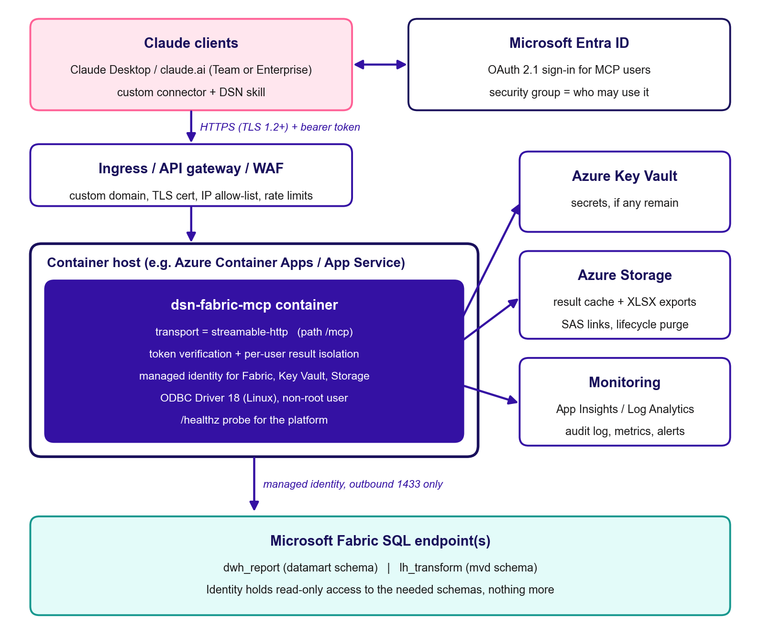
Figure 2: Recommended server deployment on Azure
Azure is recommended because Fabric, Entra ID and Key Vault are already in the client's Microsoft estate. Any container platform that offers HTTPS ingress, managed identity and persistent storage will work.
Networking: Remote MCP connectors in claude.ai (and connectors added through Claude's connector settings) are called from Anthropic's cloud, not from the user's laptop. An endpoint that is only reachable on a private network will not work for them. Plan for public HTTPS ingress, restricted to Anthropic's published outbound IP ranges and protected by OAuth. Check the current Anthropic connector documentation before finalising the network design.

Mandatory code changes before deployment
- Switch to the Streamable HTTP transport. MCP SDK 2.x supports this natively. Make the transport configurable so the local stdio mode keeps working:
import os
if __name__ == "__main__":
if os.environ.get("MCP_TRANSPORT", "stdio") == "streamable-http":
mcp.run(
transport="streamable-http",
host=os.environ.get("MCP_HOST", "0.0.0.0"),
port=int(os.environ.get("MCP_PORT", "8000")),
streamable_http_path="/mcp",
)
else:
mcp.run(transport="stdio")
Also set transport_security (allowed hosts and origins) for the public hostname, and decide whether to use stateless_http=True. Stateless mode makes it easier to run more than one replica.
- Authenticate every request. Pass the SDK's token_verifier and auth=AuthSettings(...) to MCPServer. The server must check Entra ID access tokens (issuer, audience, expiry, signature via JWKS, and the required scope or app role) and allow only a dedicated security group.
- Entra ID does not support OAuth Dynamic Client Registration. Check against current Claude connector documentation whether a pre-registered client ID can be configured, or put an OAuth broker or gateway in front of the server.
- Never expose the endpoint without authentication, even on an internal network.
- Remove the client secret from the host. Make FABRIC_CLIENT_SECRET optional in config.py and use ManagedIdentityCredential or DefaultAzureCredential in fabric_client.py. Grant Fabric read access to the managed identity. If a secret is still needed, load it from Key Vault as a platform secret reference.
- Isolate results per user. Record the caller's identity (the token's oid or upn claim) in meta.json when a query is created, and refuse dsn_result page, metadata or export requests from anyone else. Today, anyone who has a query_id can read the result.
- Deliver exports remotely. Upload each XLSX to Azure Blob Storage (or SharePoint) and return a short-lived, user-scoped download link instead of a file:// path. Apply a lifecycle rule that deletes exports after the agreed retention period (fixes KI-01).
- Make the result store safe for concurrent use (KI-10). Add file locking, or move metadata to a transactional store such as Azure Table Storage, SQLite on a single replica, or Redis. Initialise services once at start-up, for example with a lifespan hook.
- Add audit logging and sanitise errors (KI-11). For each tool call, record the user, tool, report, scope, query_id, row counts, duration and outcome to Application Insights or Log Analytics. Return sanitised errors with a correlation ID.
- Decide the ad-hoc SQL policy (KI-05). Either disable dsn_execute_ad_hoc_sql in production with a configuration flag, or limit it to an approved app role.
- Add a `/healthz` HTTP route that the platform can probe without MCP authentication, and keep the MCP health_check tool for users.

Sample container image
Linux containers need Microsoft ODBC Driver 18 installed from Microsoft's package repository. A starting point (pin the base image digest and package versions in your pipeline):
FROM python:3.12-slim-bookworm
RUN apt-get update && apt-get install -y --no-install-recommends curl gnupg2 unixodbc \
&& curl -fsSL https://packages.microsoft.com/keys/microsoft.asc \
| gpg --dearmor -o /usr/share/keyrings/microsoft-prod.gpg \
&& curl -fsSL https://packages.microsoft.com/config/debian/12/prod.list \
> /etc/apt/sources.list.d/mssql-release.list \
&& apt-get update && ACCEPT_EULA=Y apt-get install -y --no-install-recommends msodbcsql18 \
&& rm -rf /var/lib/apt/lists/*
WORKDIR /app
COPY requirements.txt .
RUN pip install --no-cache-dir -r requirements.txt
COPY . .
RUN useradd --create-home mcp && mkdir -p /data && chown mcp /data
USER mcp
ENV MCP_TRANSPORT=streamable-http MCP_PORT=8000 \
FABRIC_RESULT_CACHE_DIR=/data/results FABRIC_EXPORT_DIR=/data/exports
EXPOSE 8000
CMD ["python", "server.py"]
Add a .dockerignore that excludes .env, .venv/, runtime/, exports/, __pycache__/ and .git/, so secrets and cached data never end up in the image. Mount /data on encrypted persistent storage, for example an Azure Files share, or replace it with Blob storage as described in Section 7.3.

Infrastructure and security checklist
Table 19: Infrastructure and security checklist
Area | What to do
Hosting | Azure Container Apps or App Service for Containers, in the same tenant and region as the Fabric capacity. Start with one replica until the result store is shared and lock-safe.
Environments | Separate dev, test and prod, each with its own identity, configuration, storage and URL. Never point dev at prod data without approval.
Identity to Fabric | Use a dedicated managed identity (or SP) per environment with Viewer or read-data access to dwh_report (and lh_transform), narrowed with GRANT SELECT ON SCHEMA. No write or admin rights.
User access | Entra app registration for the MCP API, with an app role or scope assigned to a security group of approved DSN analysts. Review membership quarterly.
Secrets | Key Vault with RBAC. No .env file in the image or repository. Set rotation reminders.
Network in | HTTPS only (TLS 1.2+), custom domain and managed certificate. Gateway or WAF with rate limits. Allow-list Anthropic's published egress IPs if claude.ai connectors are used.
Network out | Allow only login.microsoftonline.com (443), the Fabric SQL endpoint (1433) and Azure Storage, Key Vault and monitoring endpoints.
Data at rest | Encrypted storage for the cache and exports, with lifecycle deletion (for example cache 24 h, exports 7-30 days according to DSN policy). No public blob access.
Monitoring | Application Insights or Log Analytics, with alerts on authentication failures, query error rate, p95 latency, storage growth and container restarts.
Capacity | Load-test realistic concurrent use. Watch Fabric capacity unit (CU) consumption, because detailed core queries over long windows are expensive.
CI/CD | Pipeline: lint, unit tests, dependency and image vulnerability scan, build, push, deploy to test, smoke test, approval gate, deploy to prod.
Data protection | Confirm data classification and approval to process DSN data through Claude with the client's information-security team before go-live.

Step-by-step deployment runbook
- Agree scope and owners. Name the service owner, platform owner and business owner, the target Claude plan (Team or Enterprise), and data-handling approval.
- Make the code changes in Section 7.3 on a feature branch. Get them peer-reviewed and run all unit tests, plus new tests for authentication, per-user isolation and export upload.
- Provision Azure resources (preferably with Bicep or Terraform): resource group, container registry, Container Apps environment, Key Vault, storage account (cache and exports containers with lifecycle rules), and Log Analytics with Application Insights.
- Create identities. Create a user-assigned managed identity for the container and grant it Fabric read access, Key Vault Secrets User and Storage Blob Data Contributor. Create the Entra app registration that protects the MCP API and assign the analyst security group.
- Check Fabric access from Azure. Run tests/integration_test.py as a one-off job inside the environment to prove the identity can sign in and query.
- Build and push the image through CI, tagged with the git commit SHA and the business rule version.
- Configure the container app. Use the same FABRIC_* variables as Table 11, plus the new settings:
- MCP_TRANSPORT=streamable-http, MCP_HOST=0.0.0.0, MCP_PORT=8000
- FABRIC_RESULT_CACHE_DIR and FABRIC_EXPORT_DIR on mounted storage (or the new Blob settings)
- Authentication settings (issuer, audience, required scope or role) and the ad-hoc SQL on/off flag
- Secrets only as Key Vault references
- Deploy to test. Turn on HTTPS ingress with the custom domain, health probes on /healthz, and the gateway or WAF rules.
- Smoke-test with the MCP Inspector (npx @modelcontextprotocol/inspector). Connect to https://<host>/mcp, sign in, and call health_check, dsn_catalog list_reports, a one-month core_transactions and an export. Confirm that a second user cannot read the first user's query_id.
- Register the connector in Claude. An organisation owner adds a custom connector with the server URL and OAuth details, and makes it available to the analyst group. Provision the DSN Fabric Analytics skill organisation-wide.
- Pilot. Run a 1-2 week pilot with a few analysts. Reconcile at least one month for every report against legacy outputs and record the sign-off.
- Go live and decommission local installs. Remove the local mcpServers entry and .env files from analyst laptops, delete their cached runtime/ and exports/ folders, and rotate the old SP secret that was distributed to laptops.
- Hypercare. For two weeks, review logs and alerts daily, track feedback and adjust capacity.

Go-live checklist
Table 20: Go-live checklist
# | Check | Owner | Done
1 | Data-handling approval and classification confirmed | Business owner / InfoSec | ☐
2 | Streamable HTTP transport, OAuth token checks and per-user isolation implemented and tested | Engineering | ☐
3 | No secrets in the image or repository; managed identity or Key Vault in use | Engineering | ☐
4 | Fabric identity is read-only and limited to the required schemas | Fabric admin | ☐
5 | HTTPS, custom domain, WAF or gateway, and IP allow-list configured | Platform | ☐
6 | Export delivery through expiring links; lifecycle deletion for cache and exports | Engineering | ☐
7 | Audit logging and alerts live; dashboards shared with the service owner | Platform | ☐
8 | Ad-hoc SQL policy decided and enforced | Business owner | ☐
9 | Golden-number reconciliation passed for all seven reports | Analytics lead | ☐
10 | Connector and skill provisioned to the analyst group in Claude | Claude org owner | ☐
11 | Support tiers, on-call and escalation contacts published | Service owner | ☐
12 | Rollback plan tested (previous image tag and local stdio fallback) | Platform | ☐
13 | Old laptop secrets rotated and local caches deleted | Engineering | ☐

Rollback and day-2 operations
- Rollback: redeploy the previous image tag, which is tied to its git SHA and rule version. In an emergency, analysts can temporarily go back to the local stdio set-up (Section 3) with a short-lived, separately issued secret.
- Releases: every change goes through CI, then the test environment, then approval. Changes to business rules must change BUSINESS_RULE_VERSION and be announced to users.
- Secrets and identities: if any secret remains, rotate it on a schedule. Review security-group membership quarterly.
- Capacity: review Fabric CU usage and query latency monthly. Lower FABRIC_MAX_RESULT_ROWS or add result reuse if load grows.
- Patching: rebuild the image monthly to pick up base-image and ODBC driver security fixes.
- Data retention: check that lifecycle rules are deleting cache and exports as configured.

Appendix

Glossary
Table 21: Glossary
Term | Meaning
MCP | Model Context Protocol: the open protocol Claude uses to call external tools and services.
Skill | A packaged set of instructions that guides how Claude uses tools. Here it contains guidance only, no SQL.
Service Principal (SP) | An Entra ID application identity the server uses to sign in to Fabric.
DSN | Dealer Services Network, the business whose transaction data this server reports on.
EFS | A transaction source. All EFS transactions count as core.
Core transaction | An EFS transaction, or a non-EFS transaction with an approved title sub-service.
Parent customer / dealer group | The group-level customer (dim_parent_customer.parent_customer_name).
Agency code | dim_entity.agency_code, the agency identifier used for all agency filtering.
EOMV | Express OMV retail. Identified by parent_entity_name = 'EOMV'.
MVD | Motor vehicle division transactions held in lh_transform.mvd.transaction.
Fan-out | One business transaction appearing on several fact or join rows, which inflates naive counts and sums.
Rule version | BUSINESS_RULE_VERSION, stamped on every result and export for traceability.

Example requests
Core transactions for one dealer group in June 2026, by agency:
{ "report": "core_transactions", "year": 2026, "month": 6,
"parent_customer": "Morgan Auto Group", "grain": "month_agency",
"result_mode": "preview", "preview_rows": 100 }
Authoritative aggregate summary for the first half of 2026, exported to Excel:
{ "report": "aggregate_summary", "from_date": "2026-01-01", "to_date": "2026-07-01",
"include_all": false, "result_mode": "export" }
Next page of a cached multi-dataset result:
{ "action": "page", "query_id": "<32-hex id>", "dataset": "Revenue by Source",
"offset": 100, "limit": 100 }

