Step 1: Install Apache Spark
- Download Apache Spark: Go to the Apache Spark website (https://spark.apache.org/downloads.html) and download the latest version of Apache Spark.
- Extract Spark: After downloading, extract the contents of the downloaded file to a directory of your choice. (Create DSBDAL folder in home directory and extract the contents)
- Set up Environment Variables: Add Spark's bin directory to your PATH environment variable. You can do this by modifying your shell profile file (e.g., .bashrc, .bash_profile, .zshrc, etc.) (Our is bash)
  - Open your Terminal: Launch your terminal application. This process may differ slightly depending on your operating system (e.g., Terminal on macOS, Command Prompt or PowerShell on Windows, Terminal on Linux).
  - Determine your Shell: Before proceeding, determine which shell you're using. Common shells include Bash, Zsh, and Fish. You can typically find out your current shell by running the following command:
echo $SHELL
  - Edit the Shell Profile File: Based on your shell, you'll edit the corresponding profile file:
    - For Bash (~/.bashrc):
nano ~/.bashrc
  - Add Spark's bin Directory to PATH: Inside the opened file, add the following line at the end:
export PATH="/home/student/DSBDAL/spark-3.5.1-bin-hadoop3/bin:$PATH"
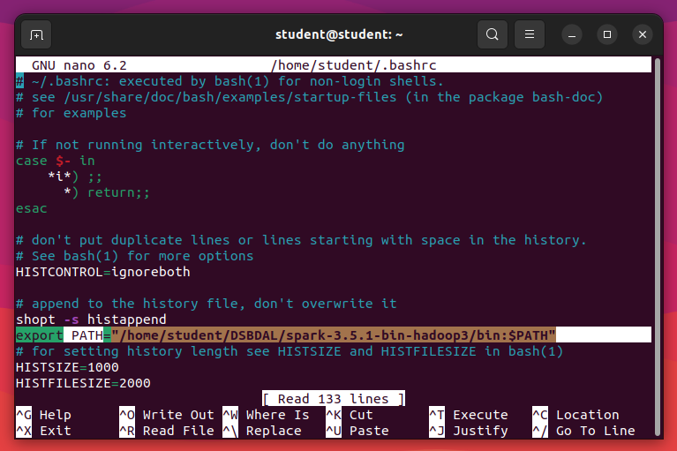

  - Save and Exit: After adding the line, save the file and exit the editor. In Nano, you can do this by pressing Ctrl + O to write the file and Ctrl + X to exit.
  - Apply Changes: To apply the changes to your current terminal session, either close and reopen the terminal or run:
source ~/.bashrc
  - Verify: You can verify that Spark's bin directory has been added to your PATH by running:
echo $PATH
You should see the path to Spark's bin directory listed in the output.
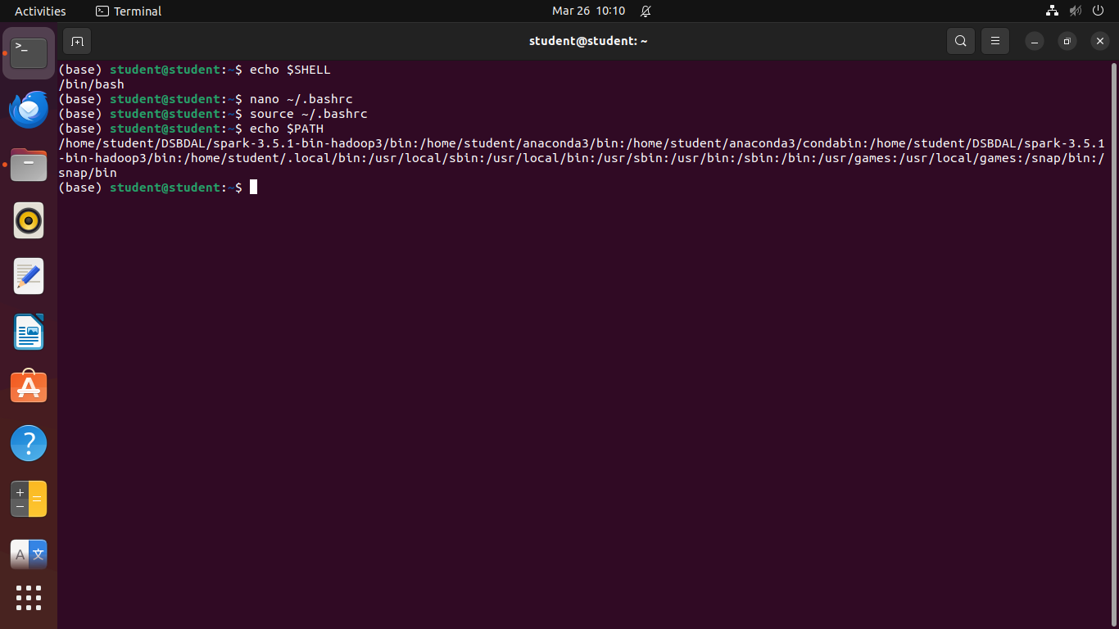
- Verify Installation: Open a new terminal window and type spark-shell. If Spark has been installed correctly, you should see the Spark shell prompt.
spark-shell
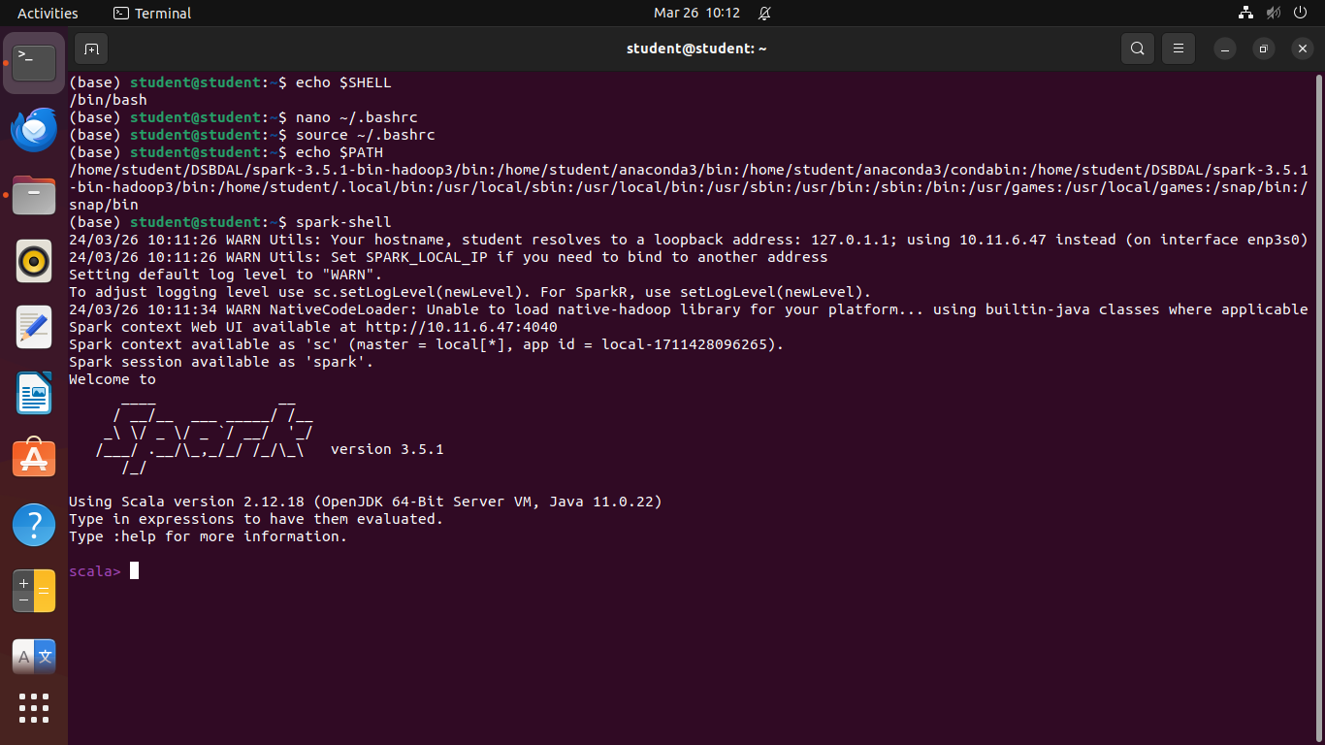

Step 2:
Use following link to execute word count scala program on apache spark

https://www.tutorialspoint.com/apache_spark/apache_spark_introduction.htm
Create wordcount_input.txt file in DSBDAL folder and pest any paragraph into it
Option 1: one by one statement execution on Scala Terminal
val inputfile = sc.textFile("/home/student/DSBDAL/input.txt")
val counts = inputfile.flatMap(line => line.split(" ")).map(word => (word, 1)).reduceByKey(_+_);
counts.toDebugString
counts.cache()
counts.saveAsTextFile("output")
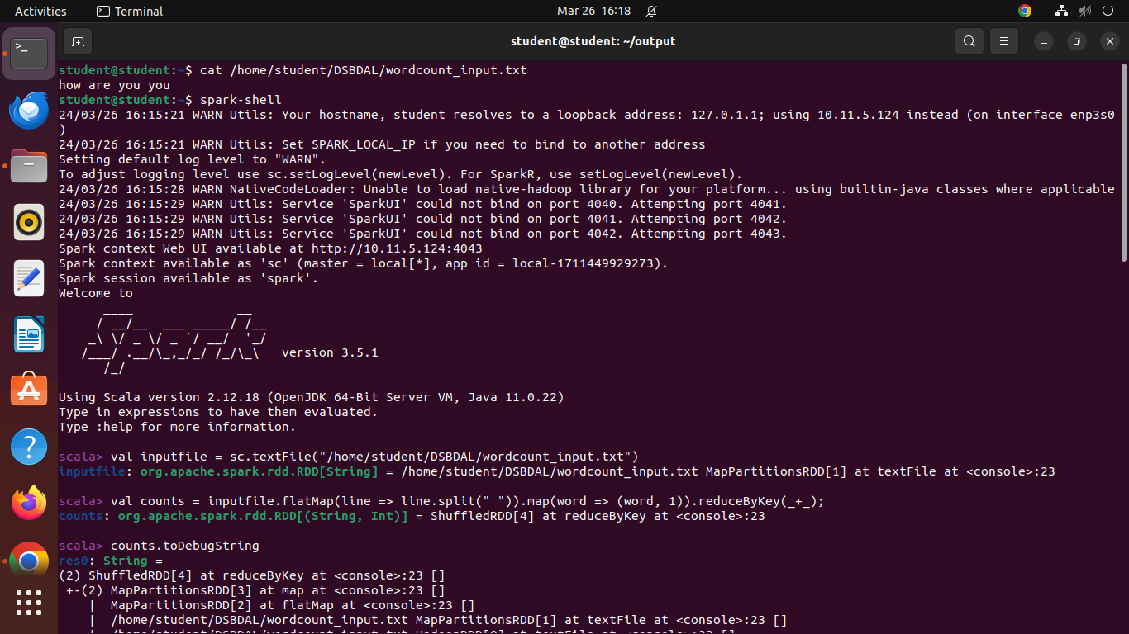
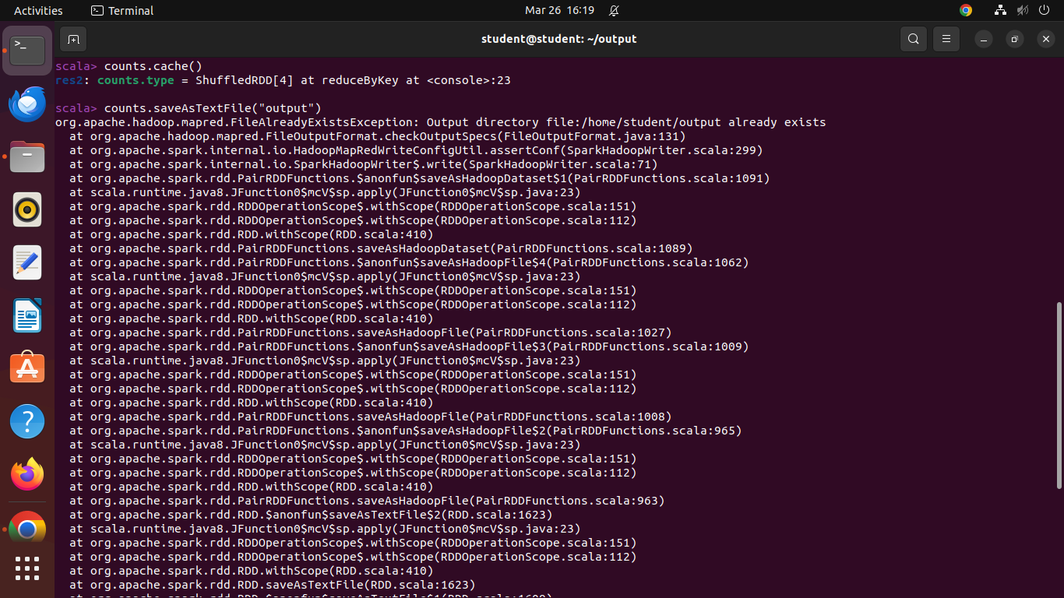
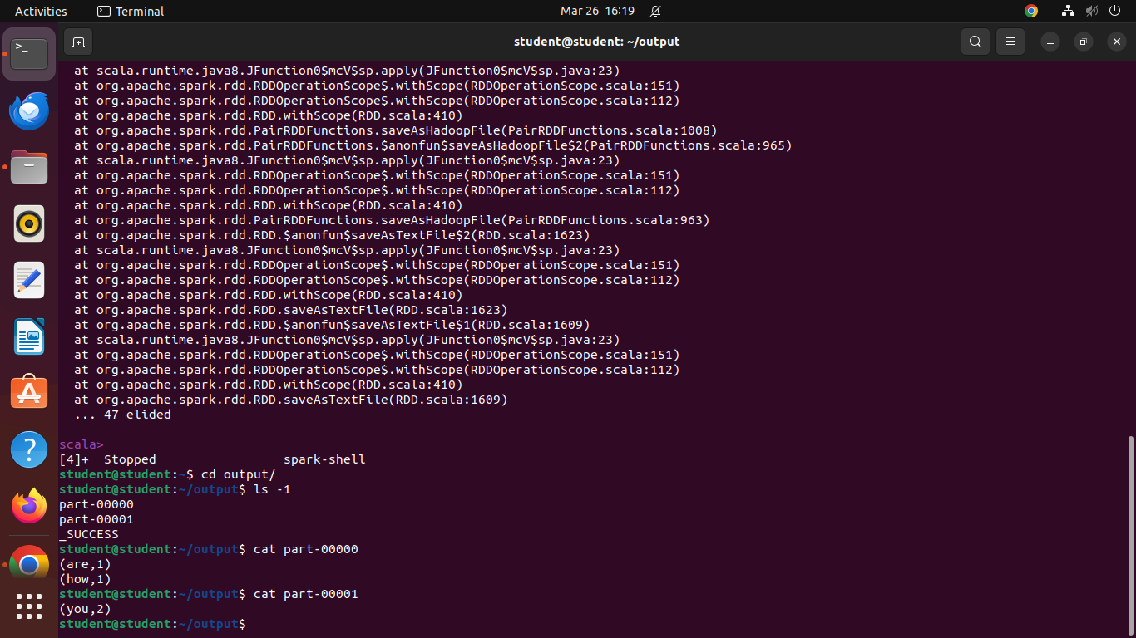

Option 2: Using scala program file
Create file named wordcount.scala with following code
val inputfile = sc.textFile("/home/student/DSBDAL/wordcount_input.txt")
val counts = inputfile.flatMap(line => line.split(" ")).map(word => (word, 1)).reduceByKey(_+_);
counts.toDebugString
counts.cache()
counts.saveAsTextFile("output")
Use following command to execute the code
spark-shell< wordcount.scala

