A Phase II, Randomized, Double‑Blind, Placebo‑Controlled Study

Protocol Number: PROTO‑001
National Clinical Trial (NCT) Identified Number: NCT12345678
Principal Investigator: Dr. Ananya R. Mehta, MD, PhD
IND/IDE Sponsor: BioAdvance Therapeutics Pvt. Ltd.
Funded by: National Institutes of Health (NIH)
Version Number: v1.0
Date: 2026-02-22

Table of Contents
Right-click to update Table of Contents

STATEMENT OF COMPLIANCE
The trial will be carried out in accordance with International Conference on Harmonisation Good Clinical Practice (ICH GCP) and the following:
• United States (US) Code of Federal Regulations (CFR) applicable to clinical studies (45 CFR Part 46, 21 CFR Part 50, 21 CFR Part 56, 21 CFR Part 312, and/or 21 CFR Part 812)
• National Institutes of Health (NIH)-funded investigators and clinical trial site staff who are responsible for the conduct, management, or oversight of NIH-funded clinical trials have completed Human Subjects Protection and ICH GCP Training.
• The protocol, informed consent form(s), recruitment materials, and all participant materials will be submitted to the Institutional Review Board (IRB) for review and approval. Approval of both the protocol and the consent form must be obtained before any participant is enrolled. Any amendment to the protocol will require review and approval by the IRB before the changes are implemented to the study. In addition, all changes to the consent form will be IRB-approved; a determination will be made regarding whether a new consent needs to be obtained from participants who provided consent, using a previously approved consent form.

PROTOCOL APPROVAL & AGREEMENT
Protocol Name: | A Phase II, Randomized, Double‑Blind Study
Protocol Number: | PROTO‑001
IMP: | XYZ‑101 (Inhalation Suspension)
Indication: | Moderate-to-Severe Asthma
Clinical Phase: | phase-II
Investigators: | Dr. Ananya R. Mehta, MD, PhD – Principal Investigator
Coordinating Investigator: | Dr. Ananya R. Mehta, MD, PhD
Expert Committee: | Dr. N. Raghavan, Clinical Pharmacology Expert Dr. Latha Venugopal, Pulmonology Specialist

GCP Statement
This clinical trial will be conducted in full compliance with the principles outlined in the International Council for Harmonisation (ICH) Guideline for Good Clinical Practice (E6 R2/R3), the Declaration of Helsinki, and applicable local regulatory requirements. All investigators agree to adhere to these guidelines to ensure the rights, safety, and well‑being of trial participants.

Approval Statement
By signing this document, the undersigned acknowledge approval of this clinical trial protocol and agree to conduct the study in accordance with its provisions, the Sponsor’s standard operating procedures (SOPs), applicable regulatory requirements, and ICH‑GCP guidelines. No deviations or modifications to the protocol may be implemented without written approval from the Sponsor and Ethics Committee, except where necessary to eliminate immediate hazards to participants.

Sponsor Representatives
Name: Mr. R. Sandeep Kumar
Title: Director, Clinical Development
Organization:
Date: 22/2/2026
Signature: ____________________
--------------------
Name: Dr. Latha Venugopal
Title: Pulmonology Specialist
Organization:
Date: 22/2/2026
Signature: ____________________
--------------------

Investigator Agreement
I, the undersigned Investigator, confirm that I have read and understood this clinical trial protocol (Version 1.0 dated 22‑02‑2026). I agree to conduct this study in accordance with the protocol, ICH‑GCP guidelines, applicable ethical and regulatory requirements, and to ensure the protection, safety, and confidentiality of all study participants.
<b>Investigator Name:</b> Dr. Ananya R. Mehta
<b>Title:</b> Principal Investigator, Pulmonary Medicine
<b>Facility:</b> Chennai Clinical Research Institute
<b>Date:</b> 22-02-2026

1 PROTOCOL SUMMARY

1.1 Synopsis
<b>Title:</b> A Phase II, Randomized, Double‑Blind, Placebo‑Controlled Study
<b>Coordinating Investigator:</b> Dr. Ananya R. Mehta, MD, PhD
<b>Planned duration:</b> March 2026 – February 2027

Primary Objectives
To evaluate the efficacy of XYZ‑101 in reducing the frequency of asthma exacerbations.
Especially in adults with moderate‑to‑severe asthma.

Primary Endpoints
Change from baseline in annualized rate of asthma exacerbations at Week 24.
<b>Number of Patients:</b> 160

1.2 Schema
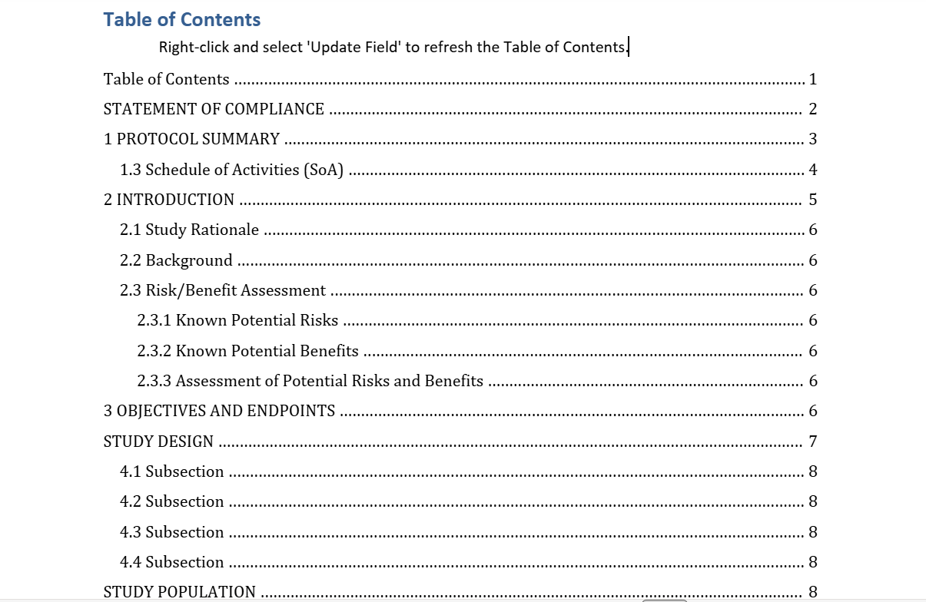
Table of contents
Detailed overview of the study management
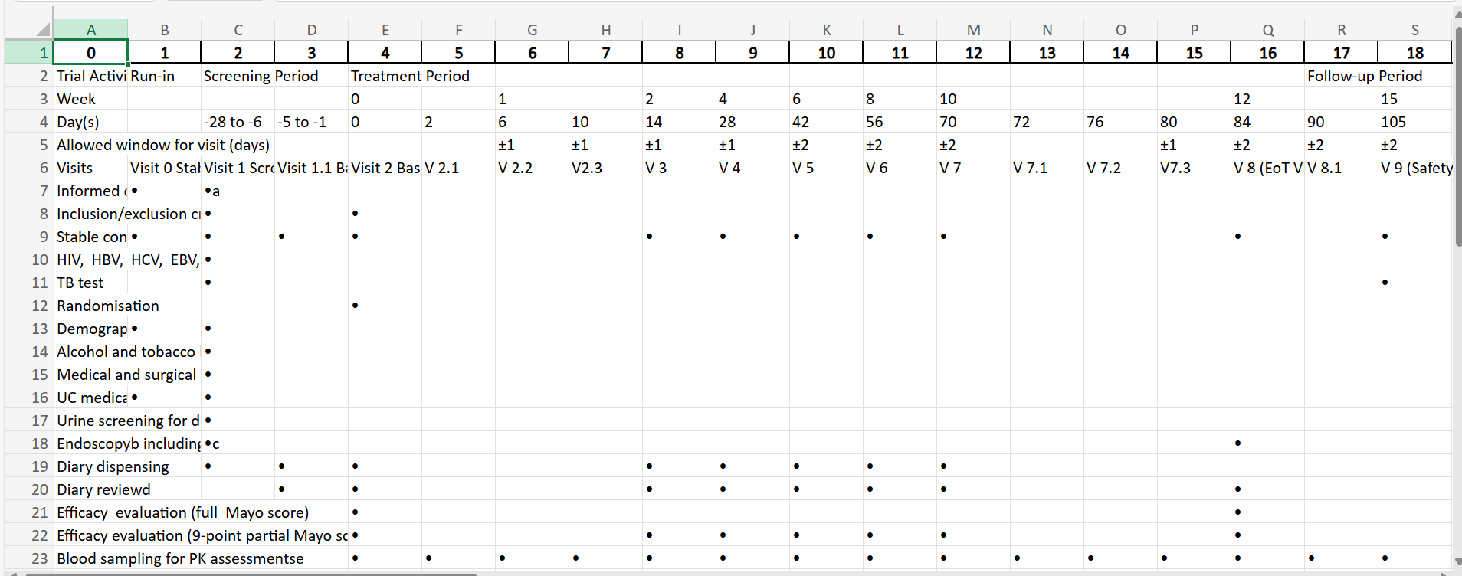
Trial activity
Patients visit window

1.3 Schedule of Activities (SoA)
Procedures | Screening | Enrollment/Baseline | Visit 1 | Visit 2 | Visit 3 | Visit 4 | Visit 5 | Visit 6 | Visit 7 | Visit 8 | Visit 9 | Visit 10 | Visit 11 | Visit 12 | Final Visit
Informed consent | X | X | X
Demographics |  |  |  |  |  | X |  |  | X |  | X |  | X |  | X
Medical history |  |  | X |  | X |  | X |  |  | X |  |  |  | X | X
Randomization |  | X |  |  | X |  | X | X | X |  | X |  | X |  | X
Administer study intervention |  | X |  |  |  |  |  |  |  |  |  |  | X |  | X
Concomitant medication review | X |  | X |  | X |  | X | X |  | X |  |  | X
Physical exam |  | X |  |  |  |  |  |  |  | X | X |  | X | X
Vital signs |  |  |  |  |  |  |  |  |  |  |  | X |  | X
Height |  |  | X |  |  | X |  |  | X |  | X |  | X |  | X
Weight |  |  |  |  |  |  |  |  |  |  |  |  |  |  | X
Performance status |  |  |  |  |  |  |  |  |  |  | X |  | X
Hematology | X |  | X |  |  |  | X |  | X |  | X |  | X
Serum chemistry
Pregnancy test |  | X | X |  | X |  | X | X |  | X |  |  | X |  | X
EKG |  |  |  |  |  |  |  |  |  |  |  |  |  |  | X
Adverse event review |  |  |  |  |  |  | X |  |  | X
Radiologic/Imaging | X |  | X |  |  | X |  |  |  |  |  | X
Other assessments |  |  |  |  |  |  |  |  |  | X |  |  | X |  | X
Complete CRFs |  | X |  |  | X |  |  |  |  |  | X

2 INTRODUCTION

2.1 Study Rationale
Although the sample size was calculated considering only Cw6
haplotype, it will also be adequate for a regression model assessing
differences from baseline of clinically relevant variables such as BMI,
metabolic syndrome, smoking and TNFα-308 polymorphism, which,
among the six existing polymorphisms, is the one most greatly affecting
response to treatment with anti-TNFα drugs.

2.2 Background
The purpose of this amendment is to provide continued treatment of patients on secukinumab
for an additional 48 weeks (overall up to 72 weeks), and thus allow for safety, tolerability, and
efficacy data to be collected from the participating patients over a longer period of time.

2.3 Risk/Benefit Assessment

2.3.1 Known Potential Risks
Furthermore, as a consequence of the European Medicines Agency’s (EMA) approval in
February 2015 of secukinumab “for the treatment of moderate severe plaque psoriasis in adults who are candidates for systemic therapy,” inclusion criterion number 5 has been changed in order to guarantee treatment to the population of systemically naïve patients, as per label. The study extension can be terminated by Novartis for any reason after a period of at least 12 weeks. Termination may occur only in selected regions where the drug is commercially available; this decision will be made on a region-by-region basis, as for some regions the study will continue as planned even though secukinumab may have become commercially available.

2.3.2 Known Potential Benefits
Title: “A 24-week, multicenter, proSpective stUdy to evaluate the PASI 90 clinical response rate and the safety PRofile of sEcukinuMab 300 mg in Cw6negativE and Cw6-positive patients with moderate to severe chronic plaque-type psoriasis (SUPREME) – amended with an extension treatment period of up to 48 weeks”

2.3.3 Assessment of Potential Risks and Benefits
Although the sample size was calculated considering only Cw6
haplotype, it will also be adequate for a regression model assessing
differences from baseline of clinically relevant variables such as BMI,
metabolic syndrome, smoking and TNFα-308 polymorphism, which,
among the six existing polymorphisms, is the one most greatly affecting
response to treatment with anti-TNFα drugs.

3 OBJECTIVES AND ENDPOINTS
This section outlines the primary, secondary, and exploratory objectives of the study along with their corresponding endpoints. The objectives are designed to evaluate the efficacy, safety, and mechanistic effects of XYZ‑101 in adults with moderate‑to‑severe asthma. Endpoints have been selected based on regulatory expectations, clinical relevance, and established asthma outcome measures to ensure meaningful interpretation of therapeutic benefit.
The primary objective focuses on assessing the effect of XYZ‑101 on reducing asthma exacerbations, which represents a clinically significant outcome in this population. Secondary objectives evaluate lung function, symptom control, and safety. Exploratory objectives examine biomarkers, pharmacokinetic parameters, and patient‑reported outcomes to support mechanistic understanding and further clinical development.
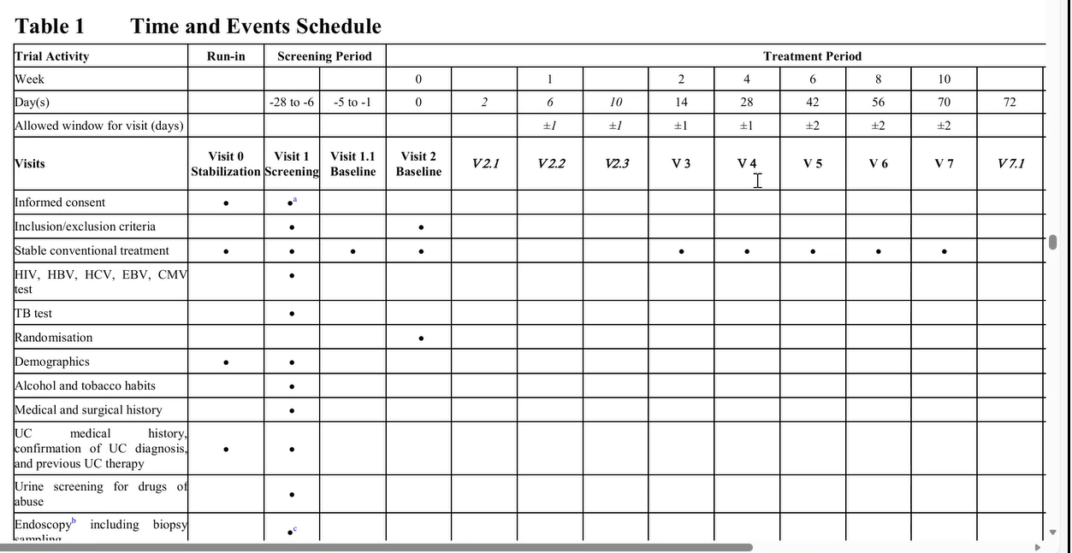
Figure: Overview of Study Objectives and Endpoint Hierarchy
This diagram illustrates the structured relationship among the primary, secondary, and exploratory objectives, along with their corresponding endpoints. The hierarchy highlights how each level of objectives aligns with key clinical outcomes—including exacerbation rates, lung function improvements, safety assessments, biomarker changes, and patient-reported quality-of-life metrics.
Type | Objectives | Endpoints
Primary | Evaluate the efficacy of XYZ‑101 in reducing the rate of asthma exacerbations compared with placebo at Week 24. | Change from baseline in annualized exacerbation rate at Week 24.
Secondary | Assess improvement in lung function following administration of XYZ‑101. | Mean change from baseline in FEV₁ at Week 24.
Secondary | Evaluate changes in asthma symptom control. | Change from baseline in ACQ‑7 score at Week 24.

4 STUDY DESIGN
If a prohibited treatment listed in Table 5-1 is used during the study, the patient must discontinue use of the prohibited treatment if he/she wishes to continue in the study. At the discretion of the investigator, if the patient’s use of a prohibited treatment presents undue safety risk for the patient, he/she should be discontinued from study treatment as per Section 5.5.9.

4.1 Overall Design
Topical treatment that is likely to impact signs
and symptoms of psoriasis (e.g. vitamin D
analogues,
- 2 weeks
- 2 weeks
- pimecrolimus,
- retinoids,
- salicylvaseline, salicylic acid, lactic acid,
tacrolimus, tar, urea alpha-hydroxy or fruit
acids)

4.2 Scientific Rationale for Study Design
Patients may voluntarily withdraw from the study for any reason at any time. They may be considered withdrawn if they state an intention to withdraw, fail to return for visits, or become lost to follow-up for any other reason.
Patients may voluntarily withdraw from the study for any reason at any time. They may be considered withdrawn if they state an intention to withdraw, fail to return for visits, or become lost to follow-up for any other reason.
If premature withdrawal occurs for any reason, the investigator must make every effort to determine the primary reason for a patient’s premature withdrawal from the study and record this information.

4.3 Justification for Dose
The investigational treatment must be discontinued under the following circumstances:
1. Withdrawal of informed consent
2. Severe adverse events that, in the opinion of the Investigator, warrant discontinuation
3. Pregnancy
4. Use of prohibited treatment as per Table 5-1
Any other protocol deviation that results in a significant risk to the patient’s safety

4.4 End of Study Definition
Patients that do not achieve PASI 50 at week 16 will terminate treatment. For patients who are lost to follow-up (i.e. those patients whose status is unclear because they fail to appear for study visits without stating an intention to withdraw), the investigator should show "due diligence" by documenting the steps taken to contact the patient, e.g. dates of telephone calls, registered letters in the source, etc. Patients who are prematurely withdrawn from the study will not be replaced by an equal number of newly enrolled patients.

5 STUDY POPULATION
The core study will have a duration of 24 weeks. Following the evaluation of psoriasis severity at week 16, patients achieving PASI 50 response will be eligible to continue on the study treatment for an additional 8 weeks. Willing patients reaching at least a PASI 75 response during the core study will be eligible to enter an extension treatment period of an additional 48 weeks. The investigator must provide follow-up medical care for all patients who are prematurely withdrawn from the study, or must refer them for appropriate ongoing care.

5.1 Inclusion Criteria
The study can be terminated at any time for any reason by Novartis. Should this be necessary, the patient should be seen as soon as possible and treated as a prematurely withdrawn patient. The investigator may be informed of additional procedures to be followed in order to ensure that adequate consideration is given to protect the patient’s interests. The investigator will be responsible for informing Ethics Committees (ECs) of the early termination of the trial.
The study extension can be terminated by Novartis for any reason after a period of at least 12 weeks. Termination may occur only in selected regions where the drug is commercially available; this decision will be made on a region-by-region basis, as for some regions the study will continue as planned even though secukinumab may have become commercially available.

5.2 Exclusion Criteria
Investigational treatment must be received by a designated person at the study site, handled and stored safely and properly, and kept in a secured location to which only the investigator and designees have access. Upon receipt, all investigational treatment should be stored according to the instructions specified on the labels. Clinical supplies are to be dispensed only in accordance with the protocol.

5.3 Lifestyle Considerations
Medication labels will be in the local language and comply with the legal requirements of each country. The investigator must maintain an accurate record of the shipment and dispensing of investigational treatment in a drug accountability log. Monitoring of drug accountability will be performed by the field monitor during site visits and at the completion of the trial.

5.4 Screen Failures
At the conclusion of the study, and as appropriate during the course of the study, the investigator will return all unused investigational treatment, packaging, drug labels, and a copy of the completed drug accountability log to the Novartis monitor or to the Novartis address provided in the investigator folder at each site. Handling of other study treatment: not applicable.

5.5 Strategies for Recruitment and Retention
At the conclusion of the study, and as appropriate during the course of the study, the investigator will return all unused investigational treatment, packaging, drug labels, and a copy of the completed drug accountability log to the Novartis monitor or to the Novartis address provided in the investigator folder at each site. Handling of other study treatment: not applicable.

6 STUDY INTERVENTION
All patients will receive Secukinumab 300 mg subcutaneously using the Phase III regimen: 300 mg (two 150 mg injections) a week for the first five weeks (visits 3-7), and once every 4 weeks thereafter (visits 8-12). Patients proceeding to the extension period will self-administer
treatment (two 150 mg injections) once every 4 weeks for an additional 48 weeks. The study treatment solution must be injected subcutaneously in non-affected areas of the skin. Following the evaluation of psoriasis severity at 16 weeks, patients achieving a PASI 50 response will be eligible to continue on the study treatment for another 8 weeks.
Their PASI score will be evaluated at 24 weeks. Willing patients reaching at least a PASI 75 response at the end of the 24-week core study will enter an extension treatment period of an additional 48 weeks. All dates of injections given to the subject during the study must be recorded on the Dosage
Administration Record e-CRF.

6.1 Study Intervention(s) Administration
The investigator may prescribe any medications and/or supportive care during the study based on clinical needs. Use of rescue medication must be recorded on the Concomitant medications/Significant non-drug therapies/Dose Administration Record in the Electronic Case Report Form (eCRF).

6.2 Study Intervention Description
Investigational treatment must be received by a designated person at the study site, handled and stored safely and properly, and kept in a secured location to which only the investigator and designees have access. Upon receipt, all investigational treatment should be stored according to the instructions specified on the labels. Clinical supplies are to be dispensed only in accordance with the protocol.

6.3 Dosing and Administration
The investigator should instruct the patient to notify the study site about any new medications he/she takes after being enrolled into the study. All medications, procedures and significant non-drug therapies (including physical therapy and blood transfusions) administered after the patient was enrolled into the study must be recorded.

6.4 Preparation/Handling/Storage/Accountability
Patients may voluntarily withdraw from the study for any reason at any time. They may be considered withdrawn if they state an intention to withdraw, fail to return for visits, or become lost to follow-up for any other reason. If premature withdrawal occurs for any reason, the investigator must make every effort to determine the primary reason for a patient’s premature withdrawal from the study and record this information.

6.5 Acquisition and accountability
The investigator should discontinue the investigational treatment for a given patient and/or withdraw the patient from the study if, on balance, he/she believes that continuation would be detrimental to the patient’s well-being.

6.6 Formulation, Appearance, Packaging, and Labeling
The investigational treatment must be discontinued under the following circumstances:
1) Withdrawal of informed consent
2) Severe adverse events that, in the opinion of the Investigator, warrant discontinuation
3) Pregnancy

6.7 Product Storage and Stability
Patients that do not achieve PASI 50 at week 16 will terminate treatment. For patients who are lost to follow-up (i.e. those patients whose status is unclear because they fail to appear for study visits without stating an intention to withdraw), the investigator should show "due diligence" by documenting the steps taken to contact the patient, e.g. dates of telephone calls, registered letters in the source, etc. Patients who are prematurely withdrawn from the study will not be replaced by an equal number of newly enrolled patients.

6.8 Preparation
The study can be terminated at any time for any reason by Novartis. Should this be necessary, the patient should be seen as soon as possible and treated as a prematurely withdrawn patient. The investigator may be informed of additional procedures to be followed in order to ensure that adequate consideration is given to protect the patient’s interests. The investigator will be responsible for informing Ethics Committees (ECs) of the early termination of the trial.

6.9 Measures to Minimize Bias: Randomization and Blinding
The study extension can be terminated by Novartis for any reason after a period of at least 12 weeks. Termination may occur only in selected regions where the drug is commercially available; this decision will be made on a region-by-region basis, as for some regions the study will continue as planned even though secukinumab may have become commercially available.

6.10 Study Intervention Compliance
HLA-Cw6 determination will be performed at screening for patients who have provided written informed consent. A central laboratory will be used to determine Cw6. Patients will thereafter be stratified into the two cohorts. TNFα-308 polymorphism will be centrally determined at the same time.

6.11 Concomitant Therapy
The study can be terminated at any time for any reason by Novartis. Should this be necessary, the patient should be seen as soon as possible and treated as a prematurely withdrawn patient. The investigator may be informed of additional procedures to be followed in order to ensure that adequate consideration is given to protect the patient’s interests. The investigator will be responsible for informing Ethics Committees (ECs) of the early termination of the trial.
The study extension can be terminated by Novartis for any reason after a period of at least 12 weeks. Termination may occur only in selected regions where the drug is commercially available; this decision will be made on a region-by-region basis, as for some regions the study will continue as planned even though secukinumab may have become commercially available.

6.12 Rescue Medicine
The investigator will be responsible for informing Ethics Committees (ECs) of the early termination of the trial.
The study extension can be terminated by Novartis for any reason after a period of at least 12 weeks. Termination may occur only in selected regions where the drug is commercially available; this decision will be made on a region-by-region basis, as for some regions the study will continue as planned even though secukinumab may have become commercially available.

7 STUDY INTERVENTION DISCONTINUATION AND PARTICIPANT DISCONTINUATION/WITHDRAWAL

7.1 Discontinuation of Study Intervention

7.2 Participant Discontinuation/Withdrawal from the Study

7.3 Lost to Follow-Up

8 STUDY ASSESSMENTS AND PROCEDURES

8.1 Efficacy Assessments

8.2 Safety and Other Assessments

8.3 Adverse Events and Serious Adverse Events

8.4 Definition of Adverse Events (AE)

8.5 Definition of Serious Adverse Events (SAE)

8.6 Classification of an Adverse Event

8.7 Time Period and Frequency for Event Assessment and Follow-Up

8.8 Adverse Event Reporting

8.9 Serious Adverse Event Reporting

8.10 Reporting Events to Participants

8.11 Events of Special Interest

8.12 Reporting of Pregnancy

8.13 Unanticipated Problems

8.14 Definition of Unanticipated Problems (UP)

8.15 Unanticipated Problem Reporting

8.16 Reporting Unanticipated Problems to Participants

9 STATISTICAL CONSIDERATIONS

9.1 Statistical Hypotheses

9.2 Sample Size Determination

9.3 Populations for Analyses

9.4 Statistical Analyses

9.5 General Approach

9.6 Analysis of the Primary Efficacy Endpoint(s)

9.7 Analysis of the Secondary Endpoint(s)

9.8 Safety Analyses

9.9 Baseline Descriptive Statistics

9.10 Planned Interim Analyses

9.11 Sub-Group Analyses

9.12 Tabulation of Individual participant Data

9.13 Exploratory Analyses

10 SUPPORTING DOCUMENTATION AND OPERATIONAL CONSIDERATIONS

10.1 Regulatory, Ethical, and Study Oversight Considerations

10.2 Informed Consent Process

10.3 Study Discontinuation and Closure

10.4 Confidentiality and Privacy

10.5 Future Use of Stored Specimens and Data

10.6 Key Roles and Study Governance

10.7 Safety Oversight

10.8 Clinical Monitoring

10.9 Quality Assurance and Quality Control

10.10 Data Handling and Record Keeping

10.11 Protocol Deviations

10.12 Publication and Data Sharing Policy

10.13 Conflict of Interest Policy

10.14 Additional Considerations

10.15 Abbreviations

10.16 Protocol Amendment History

11 REFERENCES

10.3 Abbreviations

10.4 Protocol Amendment History

11 REFERENCES

