Name:- Tejashree Appa Khade
Roll No:-2601099

Que. 1.

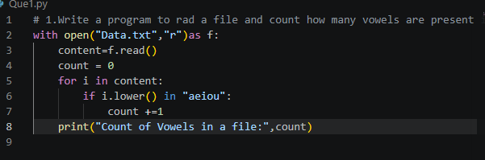

Output-



Que. 2.

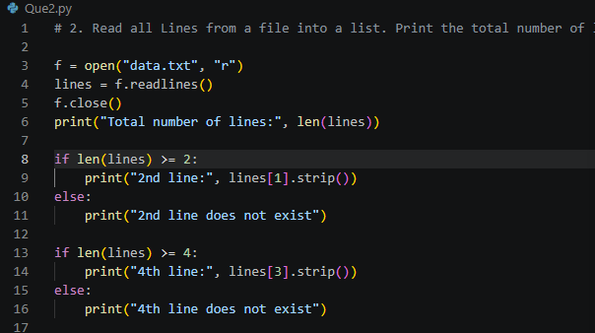

Output-

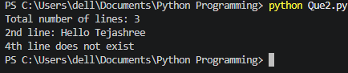

Que. 3

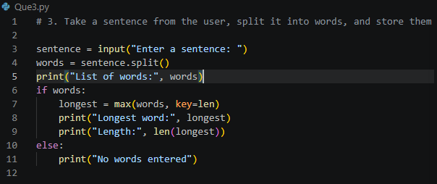.
Output-

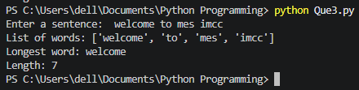

Que. 4.

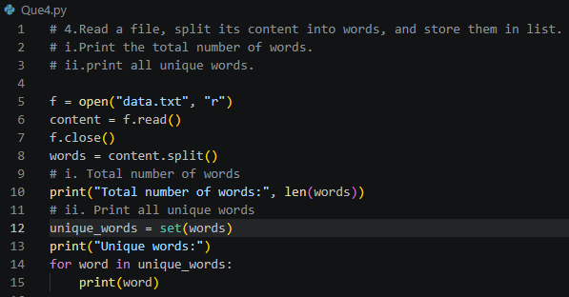

Output-

