The University of Texas at Dallas

MKT 6301-Marketing Management   
Instructor: Prof. Norris Bruce

Authored by:

Arun Menon

Sagar Bhatia

Akshay Lodha

Nitin Dhamale

Tejashree Pandit

Anant Shri Panthri

Table of Contents

Introduction 2

Problem Definition 3

Market Demographics- Survey (Potential market) 4

Competition Analysis 5

SWOT Analysis 6

Market Segmentation 7

Targeting 8

Positioning and Position Statement 8

Marketing Plan- Food Asia 9

Breakeven Analysis 15

Limitations to success of FoodAsia 16

Time frame, national or regional rollout 17

Conclusion 17

References 18

Table of Figure

Figure 1: Data of Students enrolled in University of Texas at Dallas 2

Figure 2: Data indicating diversity of student at UT-Dallas 2

Figure 3: Analysis of survey results 4

Figure 4: Survey results for meal preference 5

Figure 5: Tagline and Logo 9

Figure 6: Menu for Initial food truck 10

Figure 7: Packing and take-away box template 11

Table of Tables

Table 1: Enrollment Statistic- International student 3

Table 2: Menu cost and pricing list 13

Table 3: Initial fixed cost 14

Table 4: Recurring Expenses 15

Table 5: Breakeven analysis calculation 16

# Introduction

The below data Figure 1: Data of Students enrolled in University of Texas at Dallas shows the growth rate of enrolled students in The University of Texas at Dallas

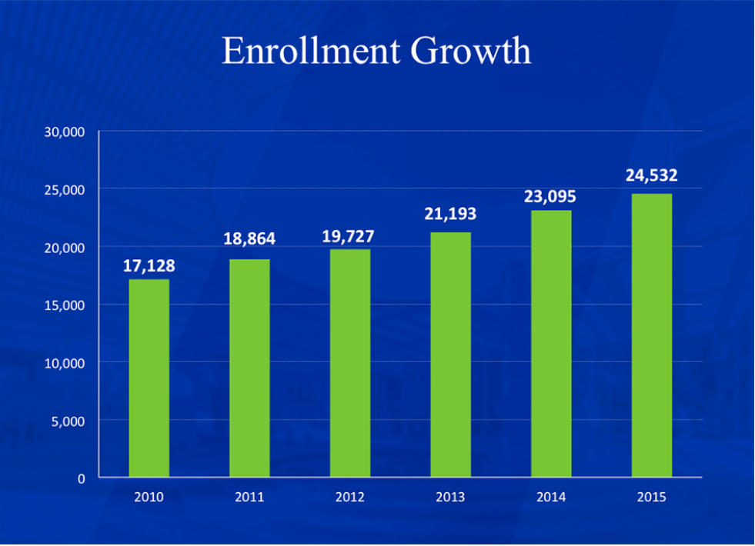

Figure :Data of Students enrolled in University of Texas at Dallas [1]

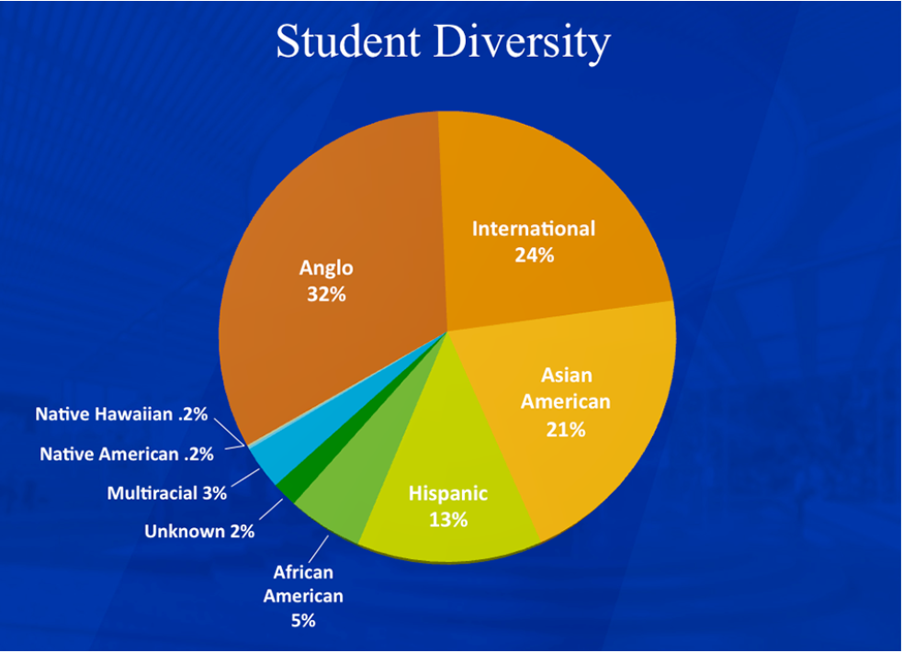

Figure : Data indicating diversity of student at UT-Dallas [2]

In the year 2016, the fall intake of international students was close to 7000. The above graph shows the percent of international student in the university.

# Problem Definition

As food and shelter are the basic needs of any student. With numerous options for shelter and limited options for food, most of the international students coming to UTD miss their ethnic food. Adjusting to a new culture takes time and in student life, sometimes food gets compromised, this can take a toll on student’s health. Data summarized, below, in Table 1: Enrollment Statistic- International student, can be used as a tool to conclude that most international students coming to the United States are Indians and Chinese.

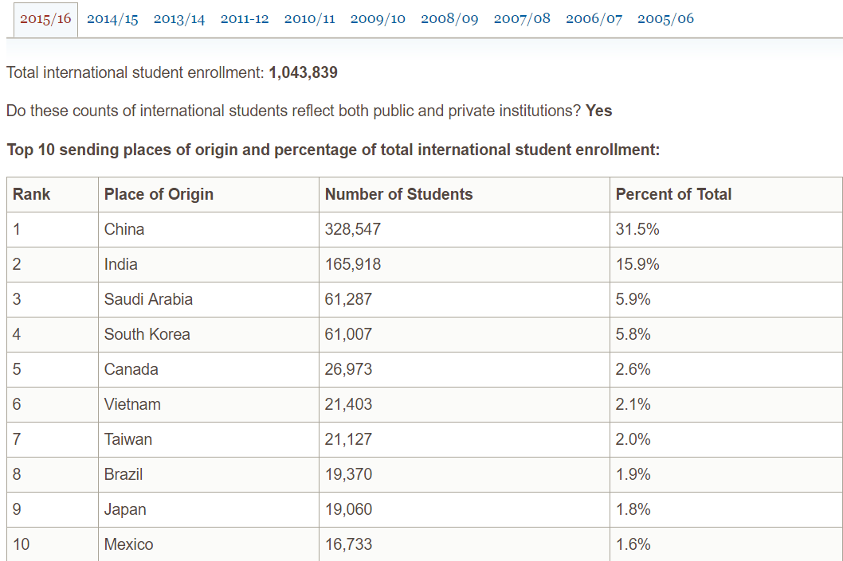

Table : Enrollment Statistic- International student [3]

Based on research and market survey, it is seen that there is a lack of availability of Asian cuisine/ fast food on the university campus. There are thirteen on-campus food outlets and 10 trucks that serve American continental. There is a need to segment the student population so that students’ demand can be effectively catered. Through surveys and a regular one on one interviews the idea of launching a start-up, food truck called ‘FoodAsia’, that can solve this problem came into existence.

# Market Demographics- Survey (Potential market)

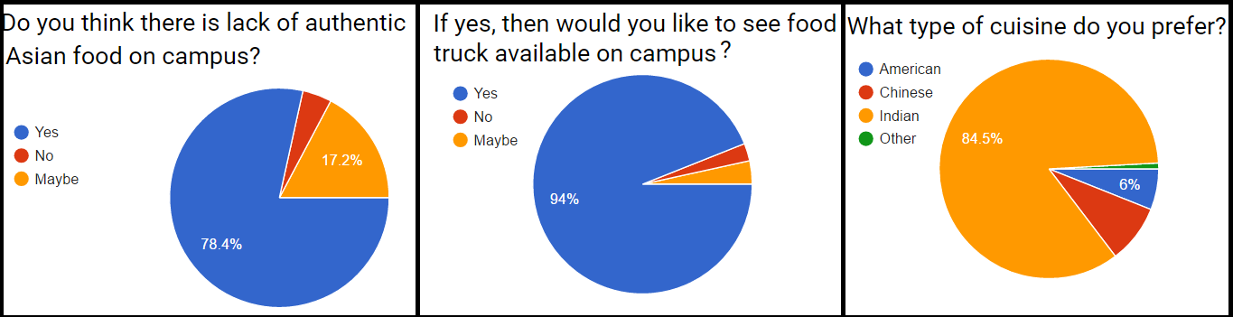The team rolled out a survey to gauge the feedback and option of the prospective customers to understand the customer demographics and target the product based on the data collected. The data collected from this survey is presented below.

Figure : Analysis of survey results

Nearly 79% of international students think that there is a lack of authentic Asian food with nearly 17% undecided.

84% of the people who took the survey prefer Indian Cuisine and nearly 94% of the students want to see a food truck that caters their need of ethnic cuisines.

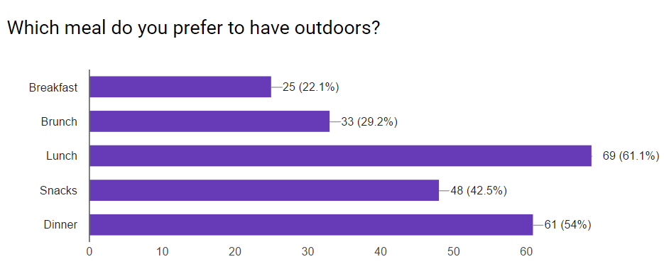

Figure :Survey results for meal preference

As per the survey most students prefer Lunch and Dinner followed by snacks.

# Competition Analysis

Currently there are 13 food trucks servicing on campus. None of them provide Asian food.

Other available options on UTD campus are:

1. IHOP
2. Panda Express
3. The Pub
4. Chick-fil-A
5. Jason’s Deli
6. Papa John’s

Here only Panda express is a major competitor as it carries Asian food.

# SWOT Analysis

Based on the competition landscape and the core competency of the team, following is the result of SWOT analysis.

**STRENGTH**

The following is a list of strengths of product Food Asia: -

1. One of its kind- First mover advantage
2. Can operate at different time of the day
3. Food truck can serve different locations on campus
4. Can provide authentic Asian food on campus at affordable prices

**WEAKNESS**

The following is a list of weaknesses associated with FoodAsia: -

1. Initial Cost and breakeven point is after longer duration.
2. Difficult to acquire initial customer to create a buzz- High Acquisition cost.
3. Lack of seating arrangement can be a turn-off for few customers.

**OPPORTUNITY**

The opportunities the team Food Asia plans to exploit are: -

1. There is no competition in the near foreseeable future.
2. The demand of Asian food is high on campus.
3. The margin in food industry is comparatively high; this can be leveraged for the promotional cost.

**THREATS**

The following are threats associated to the plan-

1. Any change in Government Regulations can affect the plan adversely.
2. The unpredictable weather of the city is a major turn off to the customers of the food truck.
3. The licensing policy for food truck on campus if changed in any way may toss the structure of the business severely.

# Market Segmentation

It involves finding out what kinds of consumers with different needs exist. After analysing the market, Team is planning to divide the market into 3 different market segments:

1. Asian Students
2. American Citizen of Asian Origin
3. Others

As a part of market segmentation for product market, Team is also considering following four important aspects:

1. What - Product Type (Asian Food)
2. To Meet – Customer Needs (To satisfy customer hunger)
3. Who - Customer Segments (Student/Staff)
4. Where - Geographic Region (International Students), Demographic Region (Budgeted Income)

Since team is planning to provide authentic Asian food to consumers, main target customers will be students of Indian, Chinese and other Asian origin. As customer needs and type of food changes geographically in India, the food truck would aim to cover food items from all different parts of country like West region of India is famous for *Vada Pav, Pani-puri, Dhokala* etc., South region is famous for *Idli/Wada sambhar and Rice*.

# Targeting

After analysing each market segment, team is planning to select one target segment – Asian students, based on its buying power, size, growth of the market, competitiveness etc.

As mentioned above, Team has segmented the market based on geographic and demographic conditions which are distinguishable, measurable, accessible, and growing. As per survey and analysis, team found that, at The University of Texas at Dallas (UTD) majority of international students are from India and China. Hence, team should target those international students and because of ‘FoodAsia’, these students will not miss their homeland food and the food truck marketing team would be able to target its intended customer segment impeccably.

# Positioning and Position Statement

The position statement of ‘FoodAsia’ is “For students and staff members at UTD who prefer eating Asian food, FoodAsia, is a food-truck that unlike Panda Express, provides mobile food services by reaching out to customers at an affordable price.”

Team will be offering an exclusive product, promoting it as the first authentic food truck to offer reasonable, budgeted Asian food. Moreover, the variety of food items and quality of product which team is planning to provide will satisfy the needs of the targeted customer.

# Marketing Plan- Food Asia

The marketing plan for introduction of Food Asia is based on following parameters.

* Product: brand name, package, etc.
* Promotion: Message, targeted to whom, media (TV, Radio, Print).
* Distribution
* Price: Include discounts, incentives, etc.
* Time frame, national or regional rollout
* Limitations or potential threats to success. What if a big company copies the new product?

**Product**

Brand Name: FoodAsia

Tagline & Logo:

Figure : Tagline and Logo

Menu for the food truck at the time of launch is indicated

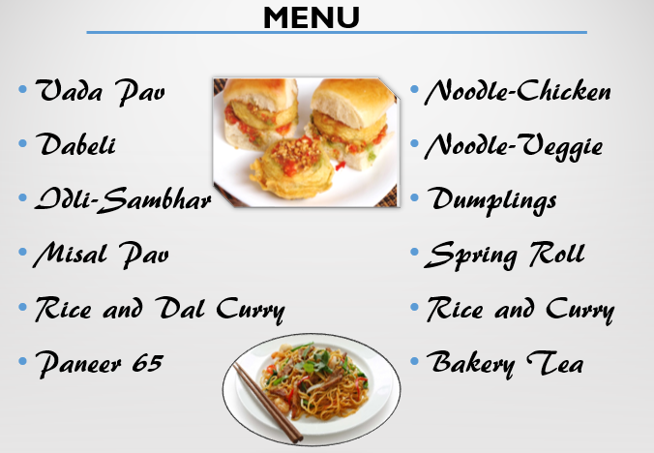

Figure : Menu for Initial food truck

**Indian Cuisine**

Vada Pav- A deep fried potato patty mixed with coriander and spice

Dal Rice- Rice with a cooked yellow lentil (dal).

Vada/Idly- South Indian dishes made from rice flour.

Dabeli- It is a spicy snack made by mixing boiled potatoes with a Dabeli masala, and stuffed into burger bun

Misal Pav- It consists of Misal (a spicy curry usually made of sprouted moth beans) and served with Indian Bread

Paneer 65- Paneer 65 is an excellent dish eaten as a starter or as an accompaniment. Paneer is a homemade Indian cottage cheese.

**Chinese Cuisine**

Chicken Noodles/Rice- Rice or noodles fried stirred in chicken curry.

Beef Noodles/Rice- Rice or noodles stirred fry in beef curry.

Spring Roll- Variety of filled, rolled appetizers or dim sum

Dumplings- Small pieces of dough wrapped around a filling

**Packaging and Labelling**

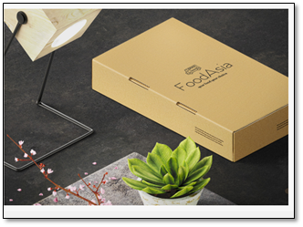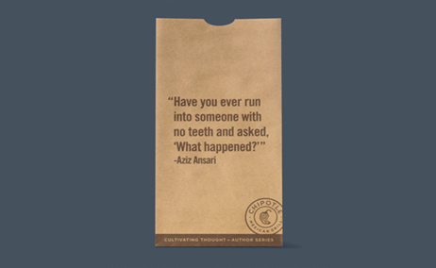When someone eats meals alone or probably with someone boring they tend to wander their eyes in search of reading something interesting. Here we are using similar concept that chipotle used where their foods are packed in paper bags filled with short stories. Also, there would be standard packing/ take-away options.

Figure : Packing and take-away box template

**Promotion**

Creating brand awareness by distributing flyers over the campus to spread awareness about our brand.

The team intends to collaborate with the most frequently used application on campus called Unibees to give updates about the offers and deals provided by our food truck. This application can also be used to give latest schedule and location of the food truck to the users.

Social Media (like Facebook, Twitter, Instagram) can be used as a powerful technique to attract consumers. Website was developed to promote information about the brand - https://foodasiablog.wordpress.com/

**Place**

The distribution channel of food truck can be associated with Direct Channel as the truck is both the manufacturer as well as the retailer.

Place is an important factor in attracting the crowd, place is always about distribution. The food truck’s target market may move from one place to another based on the hot spot.

Hot Spot here refers to the events that takes place on campus and that could lead to potential customers. Latest study shows that most of the customers found the food truck by just being around them. So indeed, location plays a vital role in distribution strategy.

|  |  |  |  |  |
| --- | --- | --- | --- | --- |
| **Sr. No.** | **Menu List** | **Cost Price $** | **Sell price $** | **Profit $** |
|  | Vada Pav | 1.5 | 2.5 | 1 |
|  | Dabeli | 1.5 | 2.5 | 1 |
|  | Idli Sambhar | 3 | 4.5 | 1.5 |
|  | Misal Pav | 2.5 | 3.5 | 1 |
|  | Rice & Curry | 5 | 6 | 1 |
|  | Paneer 65 | 4 | 5.5 | 1.5 |
|  | Noodle-Chicken | 3.5 | 5 | 1.5 |
|  | Noodle-Veggie | 4 | 5 | 1 |
|  | Dumplings | 4 | 5 | 1 |
|  | Spring Roll | 4 | 5 | 1 |

Table : Menu cost and pricing list

**Prices**:

The below table shows the **Start Up/initial setup** cost involved:

|  |  |
| --- | --- |
| **Equipment** | **Estimated Cost $** |
| Truck | 30,000 |
| Truck servicing | 3600 |
| Power Backup | 1,000 |
| Fire Extinguisher | 300 |
| Food Utensils | 1500 |
| Plates/Napkins | 3600 |
| Uniform | 500 |
| Licensing | 500 |
| Miscellaneous | 3000 |
| Fuel | 6000 |
| Commissary | 4800 |
| Repairs/Servicing | 6000 |
| Labor cost | 72000 |
| **Total** | **132,800** |

Table : Initial fixed cost

The monthly expenses are as follows:

|  |  |
| --- | --- |
| **Monthly Maintenance Cost** | **Estimated Cost $** |
| Fuel | 500 |
| Plates/ Napkins | 300 |
| Commissary | 1000 |
| Repairs | 1000 |
| Labour cost | 7000 |
| Cost of preparing Food | Demand x Cost of preparing 1 food item |

Table : Recurring Expenses

# Breakeven Analysis

Based on the survey it can be concluded that most of the customers would go for Indian food. Taking the student population of UTD into consideration, there are around 27k students who would be interested to buy food, here we assume the demand for the food to be among 5% of the student population that keeps on increasing with the subsequent quarters. The expected breakeven point is reached after a year i.e. 13th month.

Breakeven analysis was done and number of break-even units for one year was achieved.

The following table demonstrates the calculations

|  |  |  |  |  |
| --- | --- | --- | --- | --- |
| **Fixed Costs** | **Average Price** | **Variable Costs** | **Contribution Margin** | **Break-Even Units** |
| $132,800.00 | $4.60 | $3.40 | $1.20 | 110,666.67 |
|  |  |  |  |  |
| **Fixed Costs** | **Amount** |  | **Variable Costs** | **Per Unit Amount** |
| Truck | 30,000 |  | Raw material | 3 |
| Truck servicing | 3600 |  | Packaging | 0.4 |
| Power Backup | 1,000 |  |  |  |
| Fire Extinguisher | 300 |  |  |  |
| Food Utensils | 1500 |  |  |  |
| Plates/Napkins | 3600 |  |  |  |
| Uniform | 500 |  |  |  |
| Licensing | 500 |  |  |  |
| Miscellaneous | 3000 |  |  |  |
| Fuel | 6000 |  |  |  |
| Commissary | 4800 |  |  |  |
| Repairs/Servicing | 6000 |  |  |  |
| Labour cost | 72000 |  |  |  |
| **Total** | **132,800** |  | **Total** | **3.4** |

Table :Breakeven analysis calculation

From the above table, we can infer that 110,666 units need to be sold in a year to achieve breakeven.

# Limitations to success of FoodAsia

1. Any change in Government Regulations can affect the plan adversely.
2. The unpredictable weather of the city is a major turn off to the customers of food truck.
3. The licensing policy for food truck on campus if changed in any way may toss the structure of the business severely.

# Time frame, national or regional rollout

The first aim is to achieve our target at The University of Texas at Dallas and once the target is achieved plan to expand the ventures at other universities in Texas and thereby penetrate more markets.

# Conclusion

The team plans to target students who are missing their home cuisine and provide them with healthier yet pocket friendly option.  The aim is to give them a better option than fast food. As the targeted segment of customers comprises mostly of students; the plan is to give food in relatively affordable pocket friendly meal, which will make sure that students do not have to worry much about the cost they are spending on the food and at the same time getting good quality home food.

Further, the team is planning to expand the business depending on the response from the customers by adding more trucks to provide better service to the customers. In future of off days, the team plans to have food truck outside the campus selling on weekends so that students who are studying at home can also enjoy home cooked food and they do not have to go far away or spend time in cooking during exams.

The team also plans to integrate the business with comet cards so as to make the process easier and beneficial for the students by giving them discounts depending on their number of visits. The future expansion plan also includes discounts on special days like festivals, birthdays and provide special regional foods.

# References

[1]http://www.utdallas.edu/news/2015/11/18-31793_Enrollment-Growth-Stays-on-Pace-to-Exceed-Strategi_story-wide.html *(Retrieved on 4th April, 2017)*

[2]<http://www.utdallas.edu/news/2015/11/18-31793_Enrollment-Growth-Stays-on-Pace-to-Exceed-Strategi_story-wide.html> *(Retrieved on 4th April, 2017)*

[3]<http://www.iie.org/Services/Project-Atlas/United-States/International-Students-In> US#.WNl7p2jyvb0*(Retrieved on 4th April, 2017)*