**High Performance Analytics**

Assignment 2- QlikView Project

By:

Tejashree Pandit

Project Deliverables:

* Script:

SET ThousandSep=',';

SET DecimalSep='.';

SET MoneyThousandSep=',';

SET MoneyDecimalSep='.';

SET MoneyFormat='$#,##0.00;($#,##0.00)';

SET TimeFormat='h:mm:ss TT';

SET DateFormat='M/D/YYYY';

SET TimestampFormat='M/D/YYYY h:mm:ss[.fff] TT';

SET MonthNames='Jan;Feb;Mar;Apr;May;Jun;Jul;Aug;Sep;Oct;Nov;Dec';

SET DayNames='Mon;Tue;Wed;Thu;Fri;Sat;Sun';

SET LongMonthNames='January;February;March;April;May;June;July;August;September;October;November;December';

SET LongDayNames='Monday;Tuesday;Wednesday;Thursday;Friday;Saturday;Sunday';

SET FirstWeekDay=6;

SET BrokenWeeks=1;

SET ReferenceDay=0;

SET FirstMonthOfYear=1;

SET CollationLocale='en-US';

//ODBC CONNECT TO [SQLite3 Datasource;Database=I:\Fall-2017\HPA\Assignments\Assignment 2\HowPplDie.sqlite;];

ODBC CONNECT TO [SQLite3 Datasource];

ActivityCode:

LOAD Code as ActivityCode,

Description as ActCode_desc;

SQL SELECT *

FROM ActivityCode;

AgeRecode12:

LOAD Code as AgeRecode12,

Description as AgeRec12_Desc;

SQL SELECT *

FROM AgeRecode12;

DeathRecords:

LOAD Id as DeathRecordId,

ResidentStatus,

Education1989Revision,

Education2003Revision,

EducationReportingFlag,

MonthOfDeath,

Sex,

AgeType,

Age,

AgeSubstitutionFlag,

AgeRecode52,

AgeRecode27,

AgeRecode12,

InfantAgeRecode22,

PlaceOfDeathAndDecedentsStatus,

MaritalStatus,

DayOfWeekOfDeath,

CurrentDataYear,

InjuryAtWork,

MannerOfDeath,

MethodOfDisposition,

Autopsy,

ActivityCode,

PlaceOfInjury,

Icd10Code,

CauseRecode358,

CauseRecode113,

InfantCauseRecode130,

CauseRecode39,

NumberOfEntityAxisConditions,

NumberOfRecordAxisConditions,

Race,

BridgedRaceFlag,

RaceImputationFlag,

RaceRecode3,

RaceRecode5,

HispanicOrigin,

HispanicOriginRaceRecode;

SQL SELECT *

FROM DeathRecords;

EntityAxisConditions:

LOAD Id as EAC_Id,

DeathRecordId,

Part as EAC_Part,

Line as EAC_Line,

Sequence as EAC_Sequence,

Icd10Code as EAC_Icd10Code;

SQL SELECT *

FROM EntityAxisConditions;

AgeRecode27:

LOAD Code as AgeRecode27,

Description as AgeRec27_desc;

SQL SELECT *

FROM AgeRecode27;

AgeRecode52:

LOAD Code as AgeRecode52,

Description as AgeRec52_desc;

SQL SELECT *

FROM AgeRecode52;

AgeType:

LOAD Code as AgeType,

Description as AgeType_Desc;

SQL SELECT *

FROM AgeType;

BridgedRaceFlag:

LOAD Code as BridgedRaceFlag,

Description as BRF_Desc;

SQL SELECT *

FROM BridgedRaceFlag;

DayOfWeekOfDeath:

LOAD Code as DayOfWeekOfDeath,

Description as DWD_Desc;

SQL SELECT *

FROM DayOfWeekOfDeath;

Education1989Revision:

LOAD Code as Education1989Revision,

Description as Edu1989Rev_Desc;

SQL SELECT *

FROM Education1989Revision;

Education2003Revision:

LOAD Code as Education2003Revision,

Description as Edu2003Rev_Desc;

SQL SELECT *

FROM Education2003Revision;

EducationReportingFlag:

LOAD Code as EducationReportingFlag,

Description as EduRepFlag_Desc;

SQL SELECT *

FROM EducationReportingFlag;

HispanicOrigin:

LOAD Code as HispanicOrigin,

Description as HO_Desc;

SQL SELECT *

FROM HispanicOrigin;

HispanicOriginRaceRecode:

LOAD Code as HispanicOriginRaceRecode,

Description as HORR_Desc;

SQL SELECT *

FROM HispanicOriginRaceRecode;

Icd10Code:

LOAD Code as Icd10Code,

Description as Icd10Code_Desc;

SQL SELECT *

FROM Icd10Code;

InfantAgeRecode22:

LOAD Code as InfantAgeRecode22,

Description as IAR22_Desc;

SQL SELECT *

FROM InfantAgeRecode22;

MannerOfDeath:

LOAD Code as MannerOfDeath,

Description as MOD_Desc;

SQL SELECT *

FROM MannerOfDeath;

MaritalStatus:

LOAD Code as MaritalStatus,

Description as MS_Desc;

SQL SELECT *

FROM MaritalStatus;

MethodOfDisposition:

LOAD Code as MethodOfDisposition,

Description as MethOfDis_Desc;

SQL SELECT *

FROM MethodOfDisposition;

PlaceOfDeathAndDecedentsStatus:

LOAD Code as PlaceOfDeathAndDecedentsStatus,

Description as PODD_Desc;

SQL SELECT *

FROM PlaceOfDeathAndDecedentsStatus;

PlaceOfInjury:

LOAD Code as PlaceOfInjury,

Description as POJ_Desc;

SQL SELECT *

FROM PlaceOfInjury;

Race:

LOAD Code as Race,

Description as Race_Desc;

SQL SELECT *

FROM Race;

RaceImputationFlag:

LOAD Code as RaceImputationFlag,

Description as RIF_Desc;

SQL SELECT *

FROM RaceImputationFlag;

RaceRecode3:

LOAD Code as RaceRecode3,

Description as RR3_Desc;

SQL SELECT *

FROM RaceRecode3;

RaceRecode5:

LOAD Code as RaceRecode5,

Description as RR5_desc;

SQL SELECT *

FROM RaceRecode5;

RecordAxisConditions:

LOAD Id as RAC_Id,

DeathRecordId,

Icd10Code as RAC_Icd10Code;

SQL SELECT *

FROM RecordAxisConditions;

ResidentStatus:

LOAD Code as ResidentStatus,

Description as RS_Desc;

SQL SELECT *

FROM ResidentStatus;

* Screenshots:

1. Qlikview Model

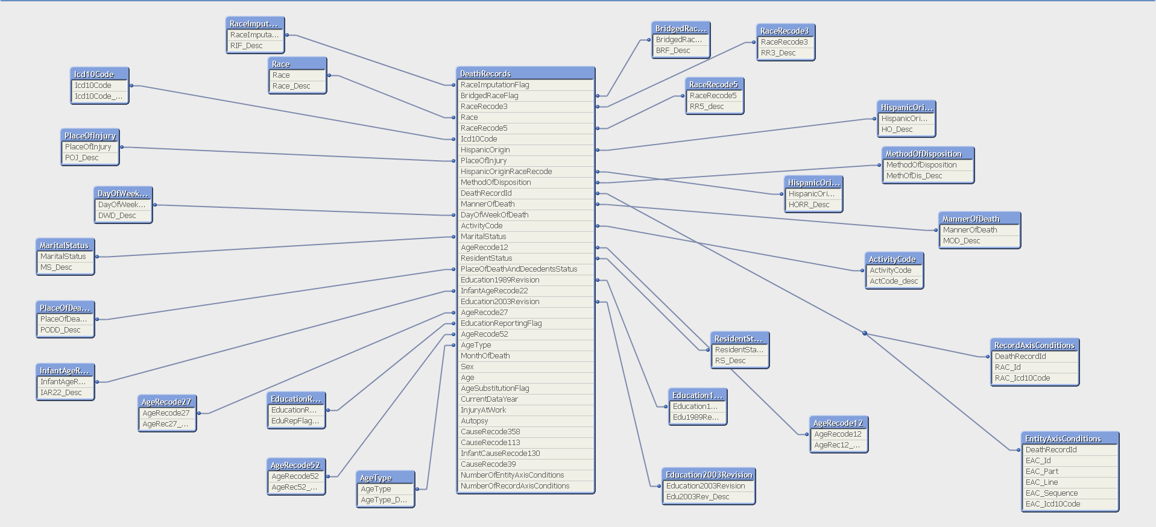

2. Visualizations:

i) Introduction Tab

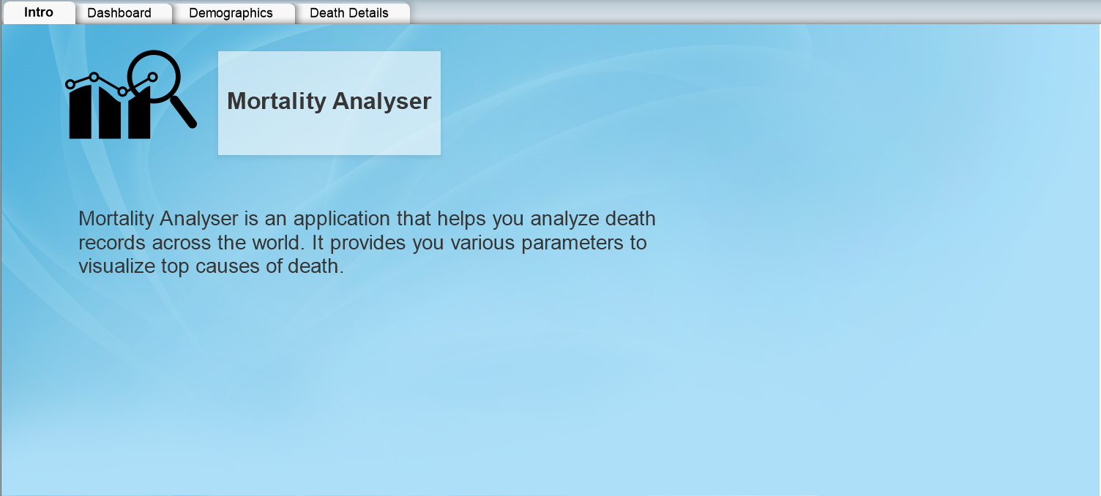

ii) Dashboard

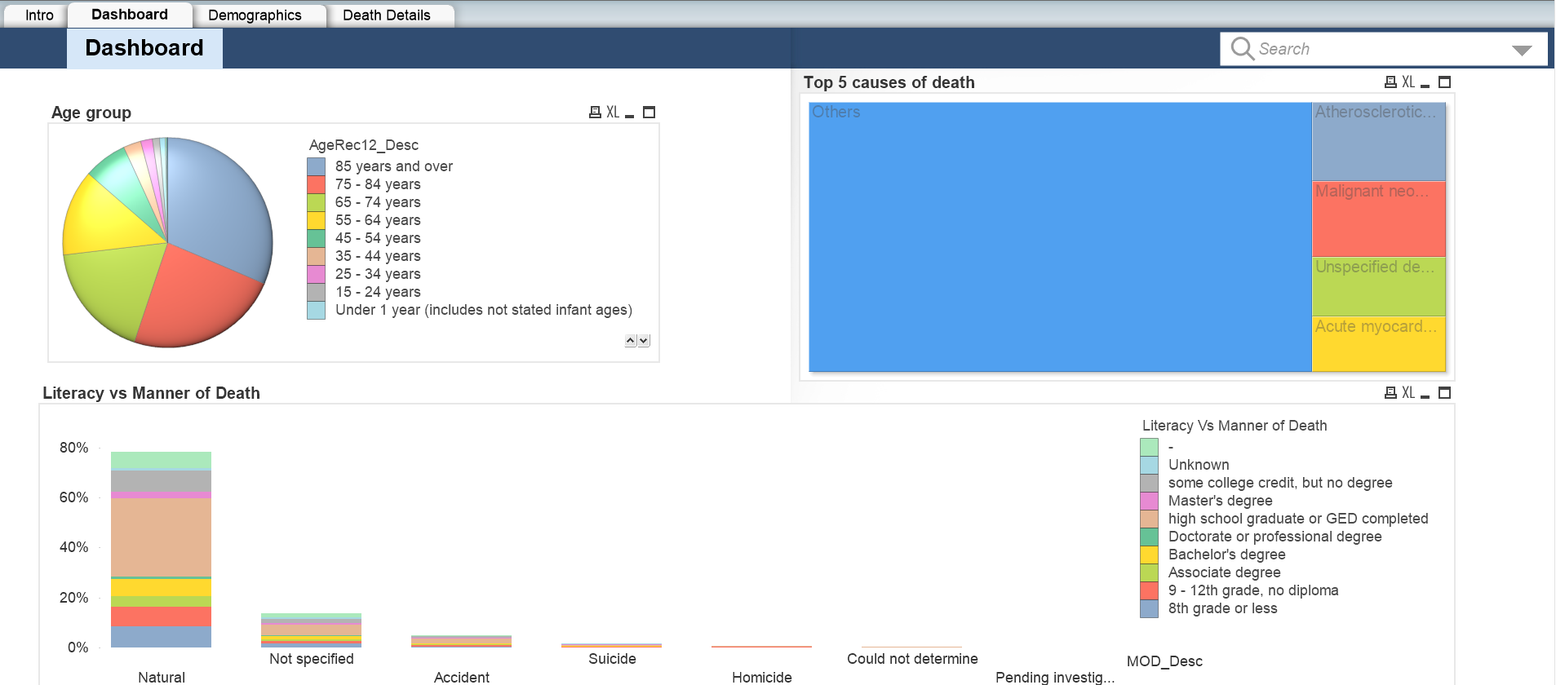

iii) Demographics:

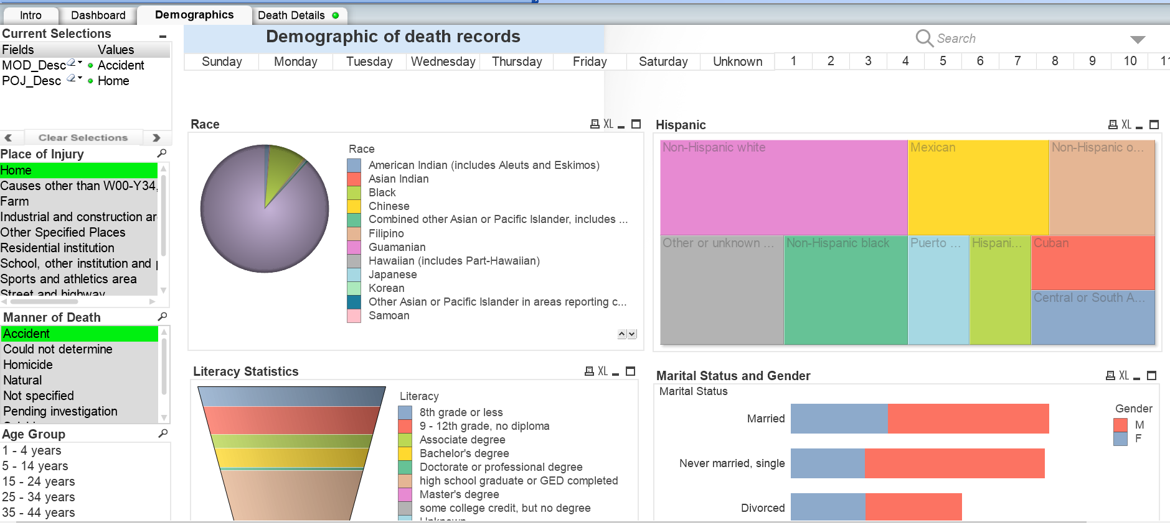

iv) Death Details

