KAPTURE FINANCE
Collections Voicebot — “Maya”
High-Level Design (HLD)
Outbound EMI-Collections Voice Agent — Architecture, Conversation Design & Compliance
AI Delivery Intern — Take-Home Assignment, Task 1
Prepared for: Kapture CX | Target build platform: Vapi
Version 1.0

0. Scenario & Design Intent
Kapture Finance needs an outbound voice agent (“Maya”) that calls customers with an overdue personal-loan EMI, verifies identity, discloses the overdue amount, negotiates a resolution, and hands off to a human only when the conversation genuinely requires judgement — all inside RBI-aligned fair-collection practice (no threats, no disclosure to third parties, permitted calling hours, honoring do-not-call requests).
Design principle that shapes every section below: authentication and disclosure are enforced by code, not by prompt instruction. The LLM proposes what to say; a deterministic state-machine layer decides what it is allowed to say. This is the single most important control in the system — it is what stops a model from being “talked past” verification under conversational pressure.
Reference case used throughout this document: Rahul Sharma, personal loan, overdue EMI ₹8,499, 12 days past due.

1. Architecture & Pipeline
The pipeline is a standard real-time voice stack (telephony → STT → orchestrator/LLM → TTS) with a tools layer for account, payment, and compliance systems, and an observability layer that taps every stage.
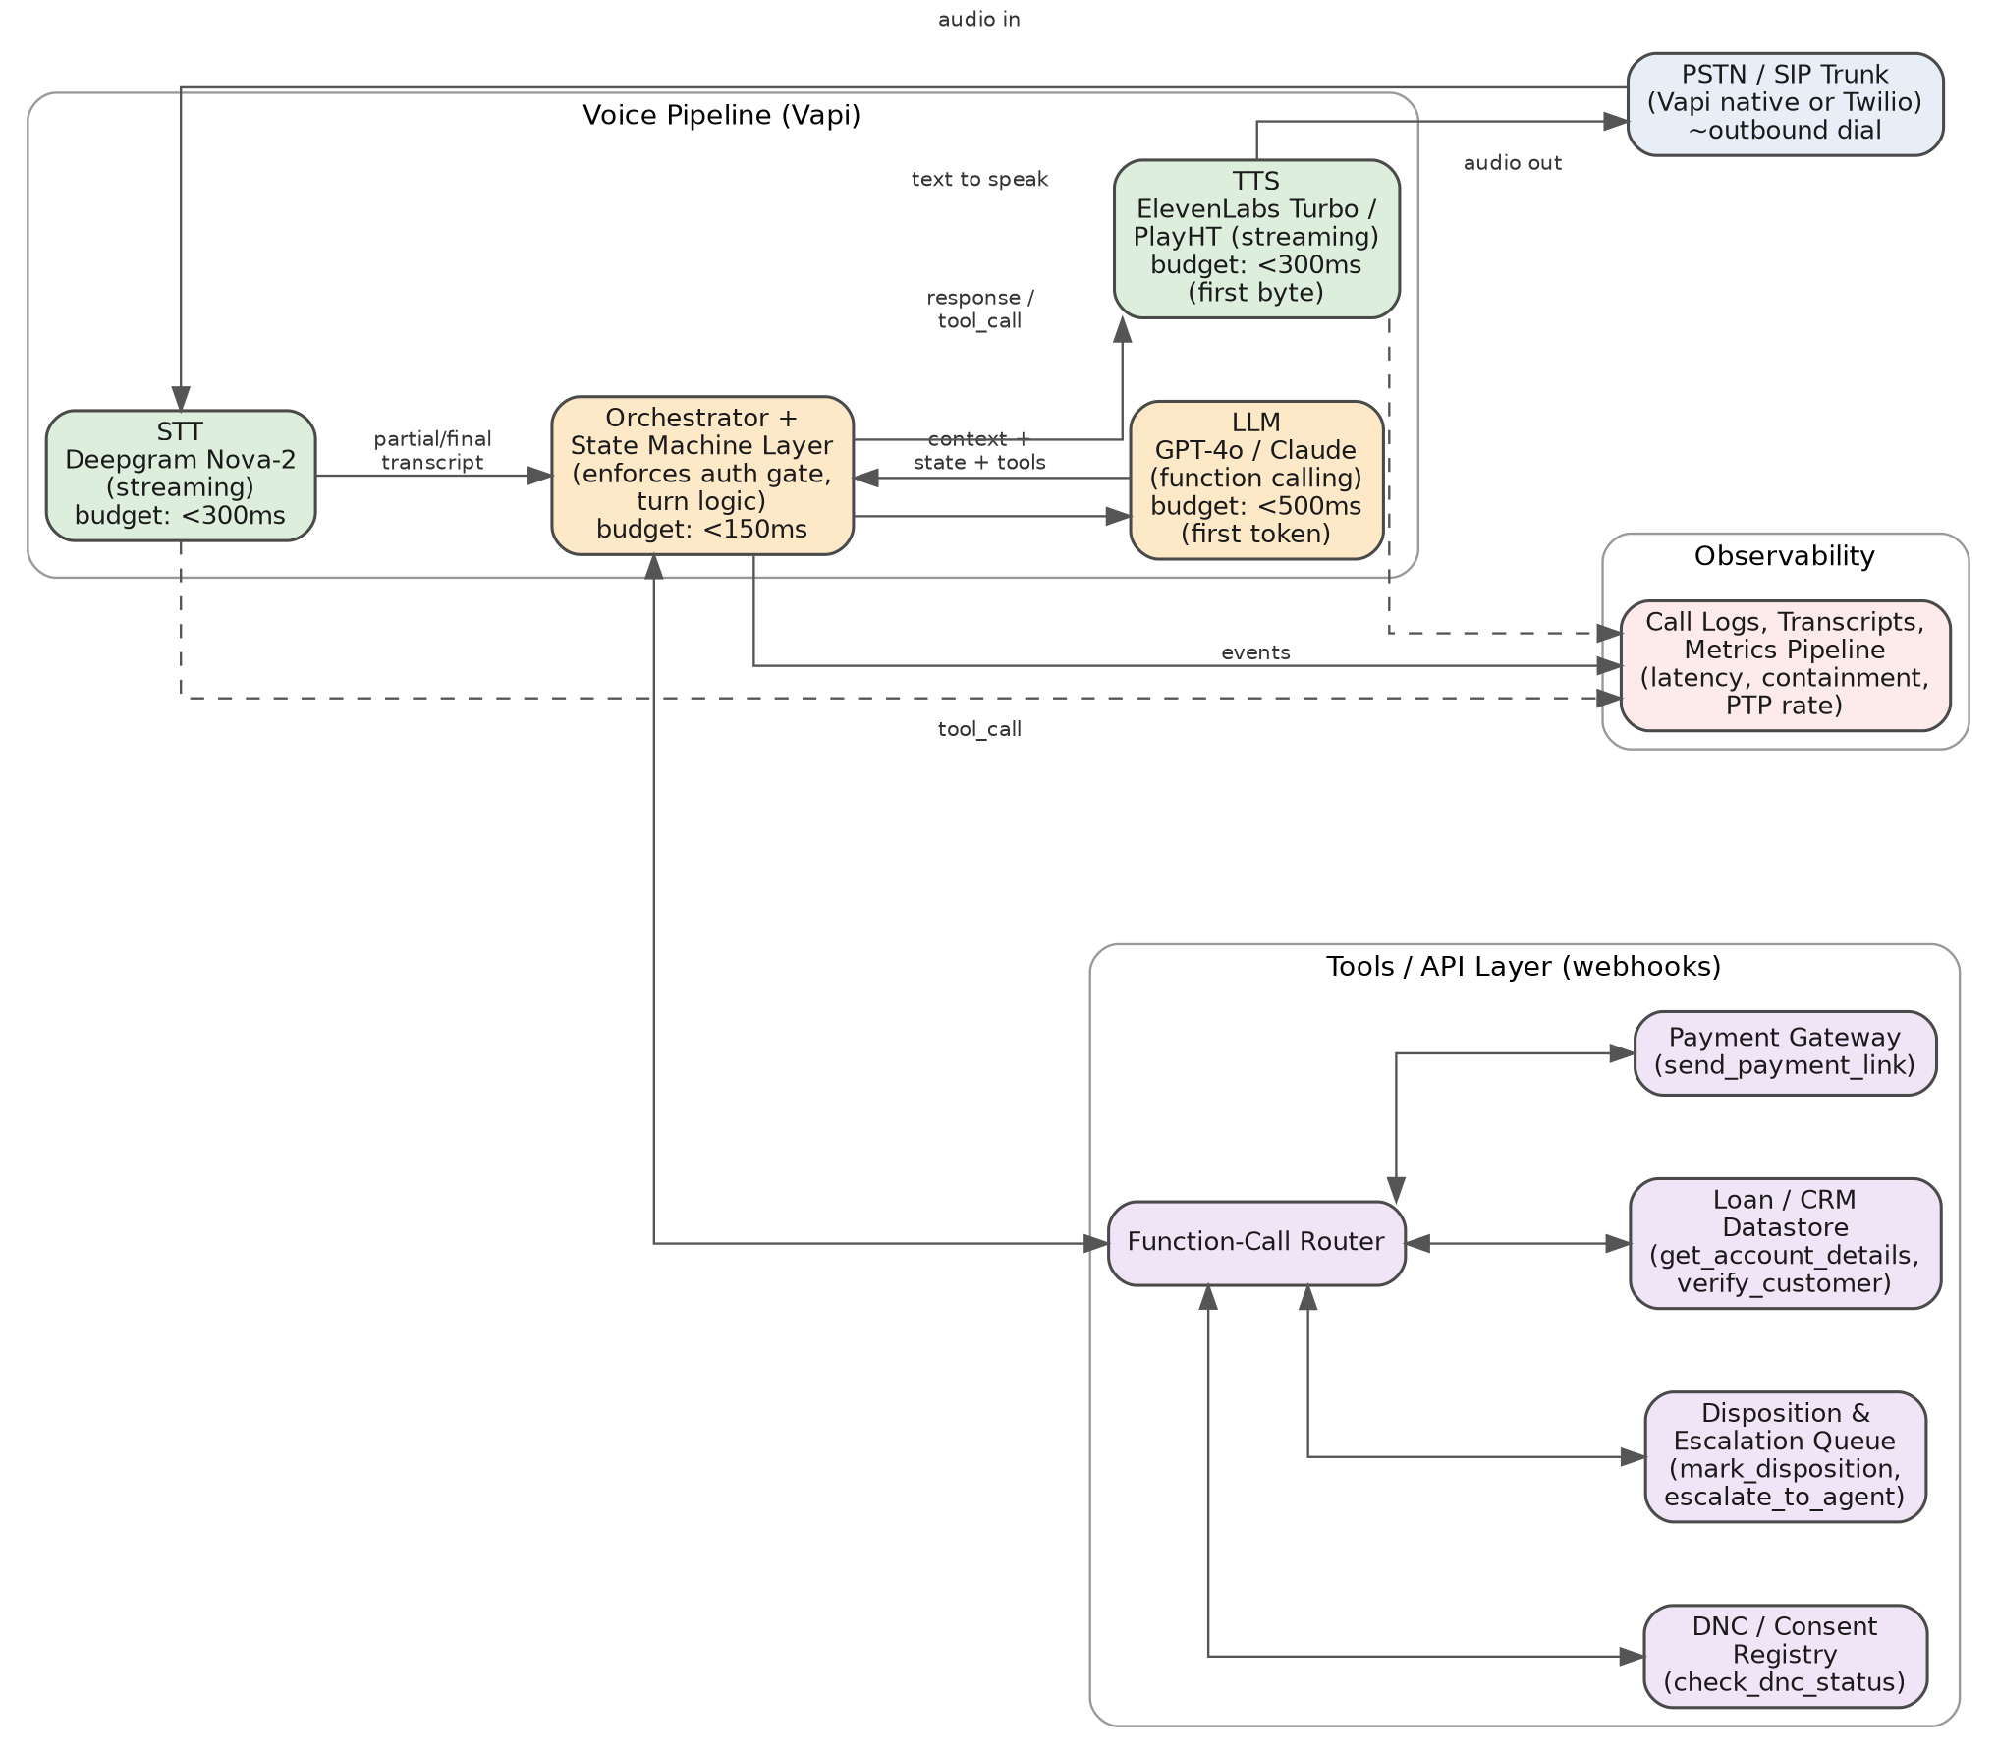
Figure 1. End-to-end pipeline: telephony, voice pipeline, tools/API layer, and observability.

1.1 Latency budget per hop
Target: under ~1.2s perceived turn latency (end of caller speech to start of bot audio), with barge-in enabled so the caller can interrupt at any time.
Hop | Component | Budget | Notes
1 | STT (streaming) | < 300 ms | Deepgram Nova-2 (or Vapi built-in), partial transcripts streamed continuously; endpointing tuned to Hindi/English code-switch pauses.
2 | Orchestrator / state check | < 150 ms | Deterministic layer: resolves current state, injects only the context/tools valid for that state before calling the LLM.
3 | LLM first token | < 500 ms | GPT-4o / Claude with function calling; small, state-scoped system prompt (not the full flow) keeps prompt processing fast.
4 | Tool call round-trip (when triggered) | < 400 ms | Mocked webhooks return synchronously; orchestrator plays a filler (“one moment”) if a call exceeds ~600 ms.
5 | TTS first byte (streaming) | < 300 ms | ElevenLabs Turbo / PlayHT streaming synthesis, sentence-chunked so audio starts before the full reply is generated.
6 | Telephony egress | < 100 ms | Vapi-managed SIP/PSTN leg.

2. Conversation Flow / State Machine
The flow is modelled as an explicit finite-state machine that lives outside the LLM. Each state defines: what tools/context are exposed to the model, what the model is allowed to say, and which transitions are legal. Authentication (S2) is the hard gate: no state past S3 is reachable unless the orchestrator’s own boolean auth_verified flag — set only by a successful verify_customer() tool result — is true. The LLM cannot set this flag itself; it can only trigger the tool call that may set it.
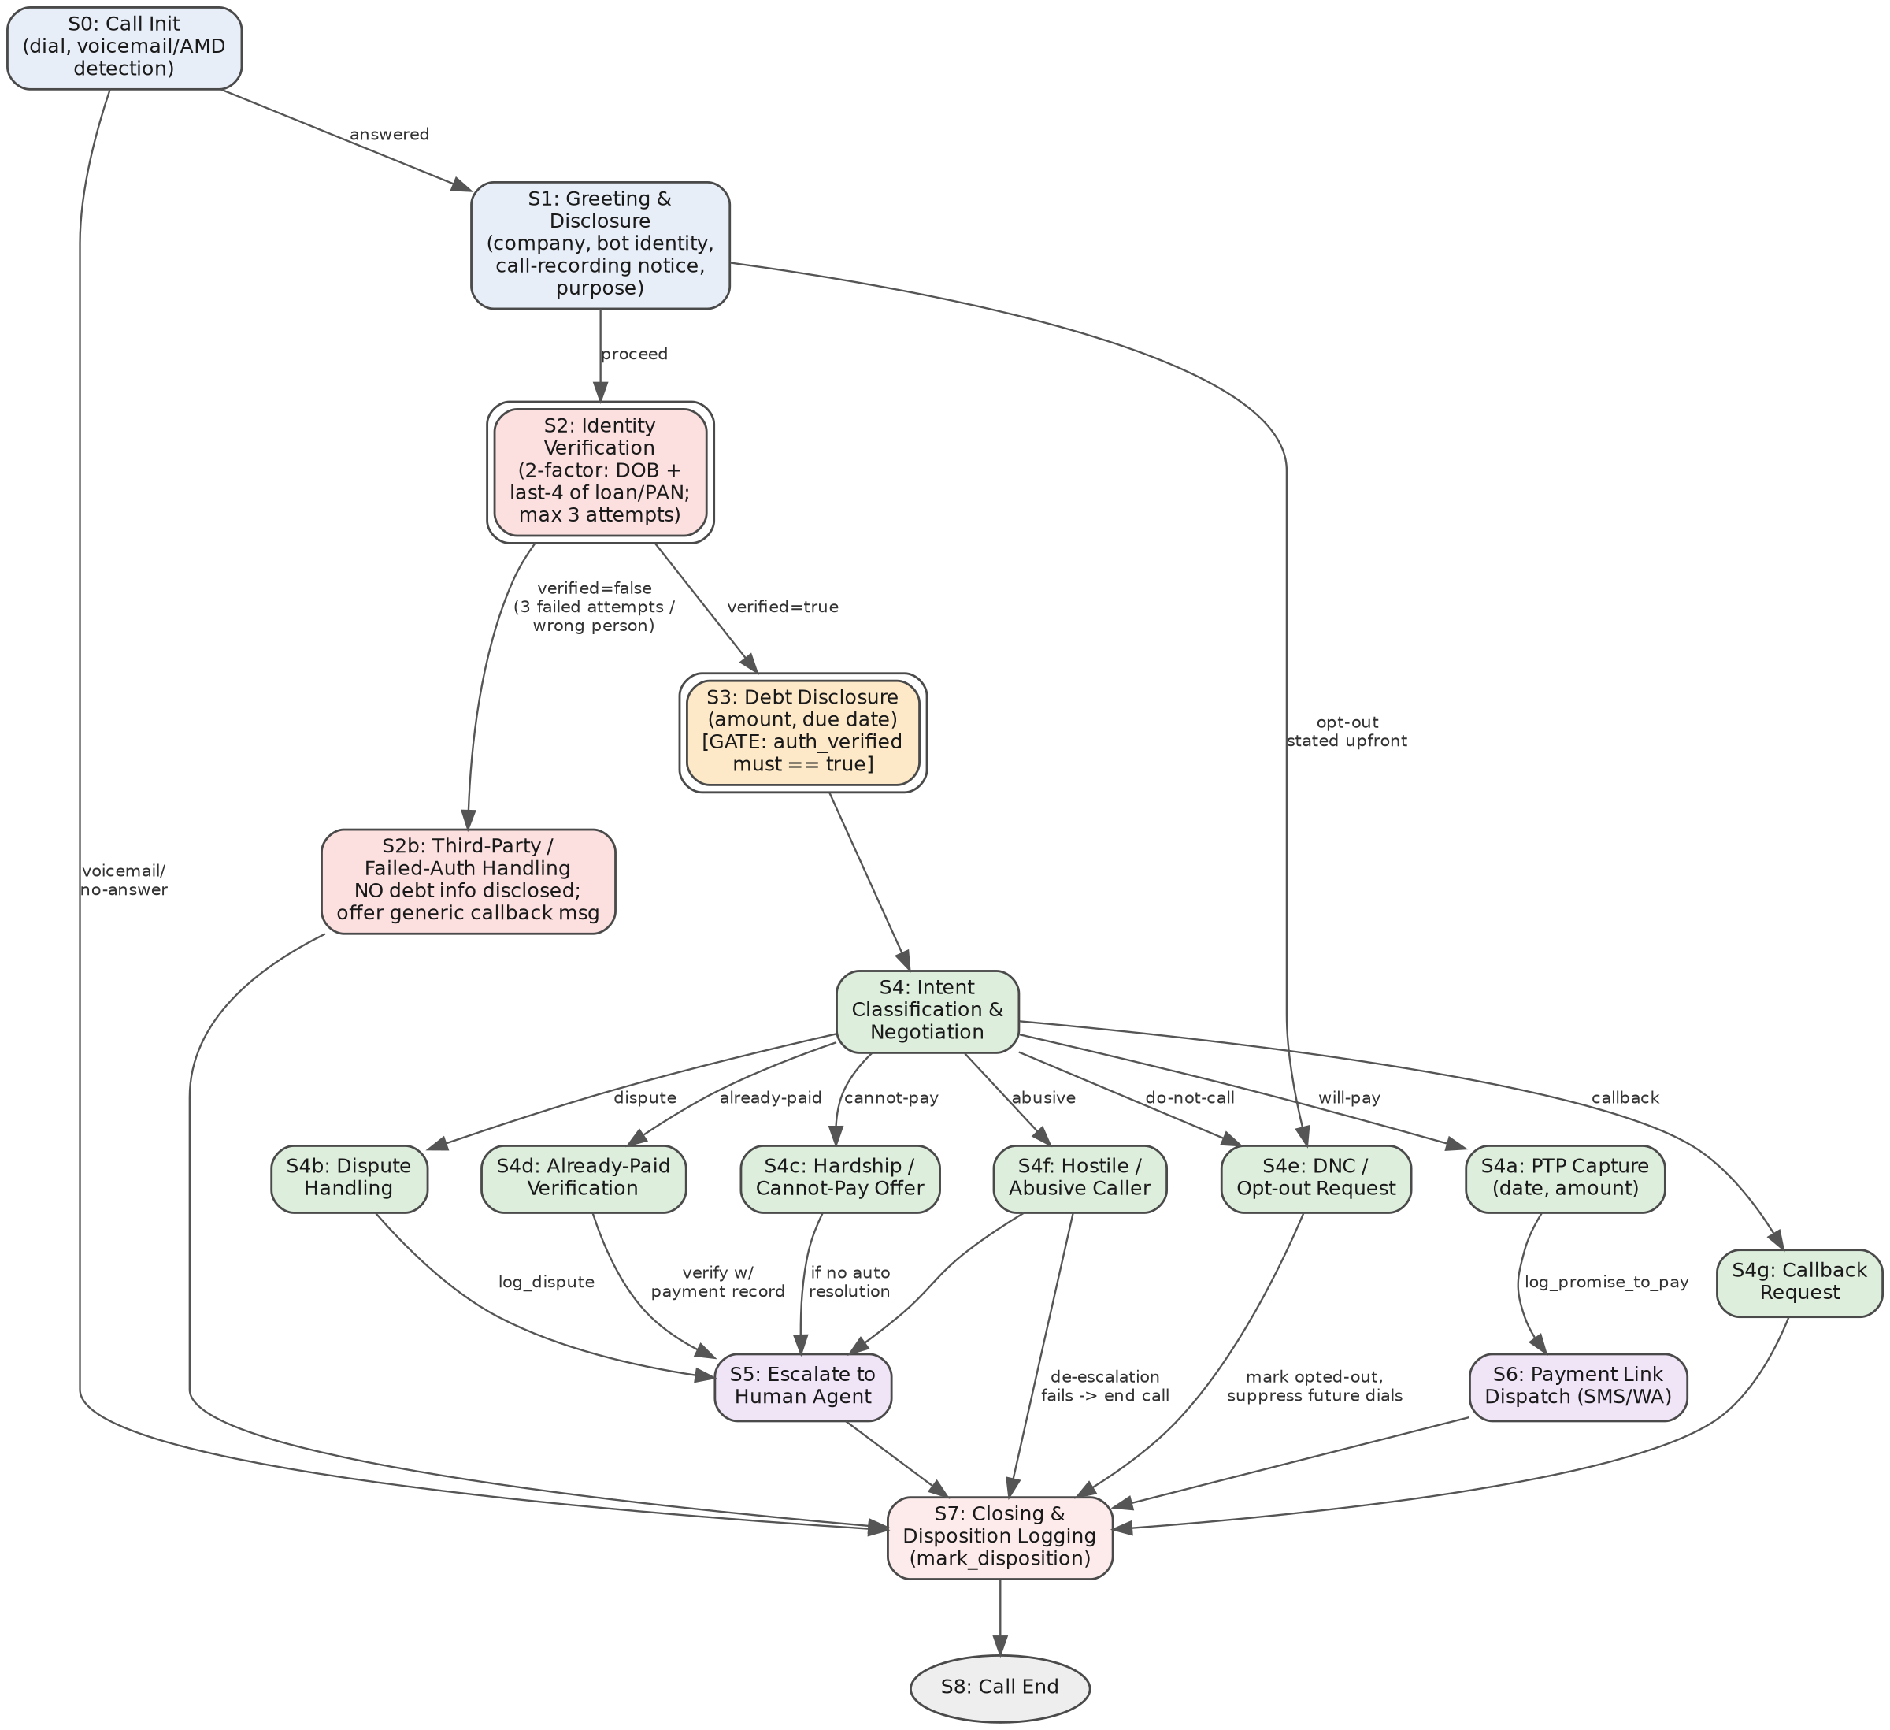
Figure 2. Full state machine. Double-bordered states are code-enforced gates.

2.1 State reference
State | What locks it / gate | Exit transitions
S0 Call Init | AMD (answering-machine detection) result | Answered → S1 · Voicemail/no-answer → S7 (leave compliant voicemail disclosure only, no amount)
S1 Greeting & Disclosure | Scripted, must complete before any question is asked | → S2, or → S4e if caller opts out immediately
S2 Identity Verification | 2-factor match (last-4 of loan a/c or PAN) scored server-side by verify_customer; 3-attempt cap enforced by orchestrator counter, not by the model | verified=true → S3 · verified=false after 3 tries or explicit “wrong person” → S2b
S2b Third-Party / Failed Auth | Code-level block: response filter strips any account/amount tokens from LLM output in this state | → S7 (disposition: no_disclosure_unverified)
S3 Debt Disclosure | GATE: only reachable with auth_verified == true | → S4
S4 Intent Classification | Runs an intent-tagging pass on each user turn | Routes to S4a–S4g based on tagged intent
S4a–g sub-states | See §3 Intents & Entities | Each resolves to S5 (escalate), S6 (payment link), or directly to S7
S5 Escalate to Human | Triggered on dispute, unresolved hardship, repeated hostility, or model uncertainty above a confidence threshold | → S7
S6 Payment Link Dispatch | Only after explicit verbal PTP with date + amount captured | → S7
S7 Closing & Disposition | Every path must pass through here — no silent call termination | → S8
S8 Call End | Terminal | —

3. Intents & Entities

3.1 Intents
Intent | Description | Example utterance | Routes to
will_pay | Customer agrees to pay and commits to a date/amount | “I’ll pay by Friday.” | S4a PTP Capture
cannot_pay / hardship | Customer states inability to pay — job loss, medical, income shock | “I lost my job, I can’t pay right now.” | S4c Hardship Offer
dispute | Customer disputes the amount, EMI count, or that a loan exists | “This isn’t my loan / the amount is wrong.” | S4b Dispute Handling
already_paid | Customer claims payment already made | “I paid this on the 3rd.” | S4d Already-Paid Verification
wrong_person | Person answering is not the customer | “There’s no Rahul here.” | S2b (pre-auth) or S7 (post-auth mis-route)
callback_request | Customer wants to be called at a different time | “Call me after 6pm.” | S4g Callback Request
hostile / abusive | Aggressive, abusive, or threatening language toward the bot | Raised voice, insults, refusal to engage | S4f Hostile Handling
do_not_call | Explicit opt-out / do-not-call request | “Stop calling this number.” | S4e DNC / Opt-out
language_switch | Mid-call switch between English and Hindi | Code-mixed or full switch | Handled in place — not a state change
out_of_scope | Unrelated question or off-topic request | “Can you help me apply for a new loan?” | Redirect once, then escalate if repeated

3.2 Entities extracted
Entity | Type | Extraction notes
auth_dob / auth_id_last4 | string/date | Captured only inside S2; never logged in plaintext transcript — masked as ‘••••’ in logs, raw value passed directly to verify_customer over the tool channel.
ptp_date | date | Normalized to ISO-8601; relative expressions (“next Friday”, “mahine ke end tak”) resolved against call timestamp + IST.
ptp_amount | currency (INR) | Defaults to full overdue amount if unspecified; partial-payment amounts captured explicitly and flagged for review if < 50% of due.
dispute_reason | enum + free text | Tagged to a coarse category (amount_mismatch / not_my_loan / already_settled / other) for routing, full utterance kept for the human agent.
preferred_language | enum (en/hi) | Set on first detection of Hindi tokens; persists for the remainder of the call unless the caller switches again.
callback_window | datetime range | Validated against permitted calling hours before being accepted.

4. Tools / API Calls
All tools are exposed to the LLM as function-calling schemas but gated by state: the orchestrator only advertises the subset of tools legal in the current state, so the model cannot, for example, call send_payment_link before a PTP exists or check_dnc_status mid-negotiation for no reason.
Tool | Called from | Inputs | Outputs
verify_customer | S2 | phone, dob, id_last4 | verified (bool), attempts_left (int), account_id (string, only if verified)
get_account_details | S3 | account_id | customer_name, loan_type, emi_amount, due_date, days_past_due
check_dnc_status | S1 (pre-check) | phone | is_dnc (bool), consent_channel (enum)
log_promise_to_pay | S4a | account_id, ptp_date, ptp_amount, channel | confirmation_id, status
send_payment_link | S6 | account_id, channel (sms/whatsapp), amount | status, link_id, delivered (bool)
log_dispute | S4b | account_id, dispute_reason, notes | ticket_id
escalate_to_agent | S5 | account_id, reason, transcript_summary, priority | ticket_id, queue
mark_disposition | S7 | call_id, disposition_code, notes, ptp_ref (optional) | status (ack)
Sample schema (send_payment_link), illustrating the pattern used for all eight tools:
{
"name": "send_payment_link",
"parameters": {
"account_id": "string, required",
"channel": "enum[sms, whatsapp], required",
"amount": "number, required, INR"
},
"returns": {
"status": "enum[sent, failed]",
"link_id": "string",
"delivered": "boolean"
}
}

5. Auth & Data Safety

5.1 Verifying identity before disclosure
- Two independent factors required before any account fact is spoken: date of birth and the last 4 digits of the loan account (or PAN), matched server-side by verify_customer — never compared by the LLM.
- Maximum 3 attempts, tracked by an orchestrator-side counter (not something the model can be argued into extending).
- The auth_verified flag is set only by a successful tool result and lives in orchestrator state, not in the prompt — it cannot be altered by anything the caller says.
- For this Vapi demo, debt facts are never placed in the pre-auth model context and the webhook blocks every account-data or payment tool until auth_verified is set by verify_customer. A production deployment additionally requires an output-policy filter before TTS to block any pre-auth debt disclosure attempt.

5.2 Protecting against third-party disclosure
- If verification fails or the person states they are not the customer, the bot never confirms whether the number belongs to a loan customer at all — it uses a neutral script (“I may have the wrong person — could you ask [name] to call us back?”) and logs wrong_person, ending the call without any financial content.
- No voicemail message includes the amount or the word “overdue” — only “this is Maya calling from Kapture Finance; please return our call using the official contact details”.
- For this demo, DOB plus ID-last-four is the mocked verification control. Production use requires the lender's compliance-approved identity-verification method (for example, an OTP or a stronger customer-authentication control); knowledge of these details alone must not be treated as third-party authorization.

5.3 Data handling
- PII (DOB, ID digits) is passed on a separate tool-call channel and masked in transcripts/logs; only the verified boolean and account_id persist in the conversation log.
- Call recordings and transcripts retained per the client’s data-retention policy; access scoped to collections and QA roles only.

6. Guardrails & Compliance

6.1 Mandatory disclosures
- Opening line always states: bot identity (“this is Maya, an automated assistant from Kapture Finance”), the fact that the call may be recorded, and the neutral purpose (“calling regarding a confidential customer-service matter”) — before any question is asked.

6.2 Calling hours & consent
- Outbound dials only scheduled within RBI-permitted collection-call hours (08:00–19:00 local time); the orchestrator, not the LLM, enforces this at dial time.
- A do_not_call intent at any point immediately routes to S4e: the bot confirms the opt-out verbally, calls mark_disposition with a DNC code, and the number is suppressed from future dial lists — no further negotiation attempted on that call.

6.3 Tone & conduct
- System prompt hard-constrains tone: no threats, no repetition/pressure tactics, no implying legal action the client hasn’t authorized, no contacting or disclosing to third parties, no raised urgency language beyond stating the actual due date.
- On hostile/abusive input, the bot de-escalates once (“I understand this is frustrating — I’m only here to help resolve your account”); a second instance of abuse ends the call politely rather than continuing to absorb it.

6.4 Hallucination & off-topic guardrails
- The model may only state figures returned by get_account_details — it is instructed never to compute, estimate, or infer an amount, and the response filter (§5.1) backstops this.
- Off-topic requests (new loans, unrelated complaints) get one polite redirect to the call’s purpose; a second attempt routes to escalate_to_agent rather than letting the model improvise an answer outside its remit.

7. Edge Cases
Case | Detection | Handling
Already paid | already_paid intent | Acknowledge, do not argue; call escalate_to_agent with reason=payment_verification so a human reconciles against the ledger; disposition already_paid_claimed.
Disputes the amount | dispute intent | Do not re-assert the figure repeatedly; log_dispute, offer to send a statement, escalate for review.
Requests do-not-call | do_not_call intent | Immediate opt-out flow (§6.2); no further negotiation.
Wrong number | wrong_person intent, pre- or post-auth | No financial disclosure (§5.2); mark wrong_number, remove from this customer’s dial attempt.
Voicemail / no input timeout | AMD at S0, or silence > 6s twice in a row mid-call | Voicemail: compliant callback message only. Mid-call silence: one gentle re-prompt, then a second timeout ends the call with disposition no_response.
Abusive caller | hostile intent, repeated | One de-escalation attempt, then graceful call end (§6.3).
Mid-call language switch (EN/HI) | language token detection each turn | STT/LLM/TTS all support both; preferred_language updates immediately and the bot continues in the new language without restarting the flow.
Tool/API failure or timeout | webhook error or > 600 ms with no response | Bot plays a natural filler, retries once; on repeated failure it apologizes, logs a technical_failure disposition, and offers a human callback rather than guessing at account data.

8. Escalation & Disposition

8.1 When the bot hands off to a human
- Disputes of amount/ownership, hardship cases beyond a scripted standard offer, an already-paid claim, repeated hostility after one de-escalation attempt, low intent-classification confidence for two consecutive turns, and any explicit “talk to a person” request.

8.2 Every call ends with a logged disposition
S7 is the single mandatory exit for every call path (see Figure 2) — there is no route that reaches S8 without first calling mark_disposition. Disposition codes:
Code | Meaning
ptp_captured | Promise-to-pay logged, payment link sent
already_paid_claimed | Customer claims payment made — escalated for reconciliation
dispute_logged | Amount/ownership disputed — escalated
hardship_escalated | Cannot-pay / hardship — escalated for restructuring options
dnc_opt_out | Customer opted out of future calls
wrong_number | Not the customer — no disclosure made
no_disclosure_unverified | Auth failed 3x — call ended without disclosure
no_response | Silence/no input after re-prompt
voicemail_left | Compliant voicemail message left
technical_failure | Tool/API failure prevented completion

9. Observability

9.1 What is logged per call
- Full transcript (PII-masked per §5.3), state-transition trace with timestamps, every tool call + its latency and result, final disposition code, and per-hop latency (STT/LLM/TTS) for the whole call.

9.2 Metrics tracked
Metric | Why it matters
Containment rate | % of calls resolved without human escalation — the core efficiency metric for the bot.
PTP rate | % of authenticated calls ending in a logged promise-to-pay — the core business outcome.
PTP kept rate (downstream) | % of PTPs actually paid by the promised date — validates whether the negotiation is producing real commitments, not just agreeable ones.
Auth success / failure rate | Tracks whether verification questions are well-calibrated — too many failures may mean genuine customers are getting locked out.
Avg. turn latency (p50/p95) | Directly affects perceived call quality and containment.
Drop / hang-up rate by state | Flags exactly where in the flow customers abandon the call — the most actionable debugging signal.
Escalation rate by reason | Shows which intents the bot cannot yet resolve, prioritizing prompt/flow improvements.
DNC compliance latency | Time between an opt-out request and suppression in the dialer — a compliance-critical SLA.

10. Assumptions & Out of Scope
- Payment gateway, SMS/WhatsApp, and CRM/loan-ledger integrations are mocked webhooks for this exercise, matching real response shapes but not connected to live systems.
- DOB plus last-4-ID is a mock-only exercise control. Production must use a lender-approved authentication method; this build does not authorize third parties based on knowledge of these details.
- Calling-hours enforcement and DNC-list suppression are described as orchestrator-level controls; the actual dialer/scheduling system sits outside this bot and is assumed to exist at Kapture Finance.
- Language support is scoped to English and Hindi per the brief; other regional languages are out of scope.
- Legal/regulatory language (e.g. exact RBI Fair Practices Code wording) should be reviewed by Kapture’s compliance team before production use — this HLD implements the spirit of those norms, not a legal sign-off.

