NOSQL-CFDB-HBase-PART-II

Use the table you created in the part-1 exercise.

* Tablename:<your-namespace>:driver_dangerous_event
* Columnfamilyname:events

1. [INSERT]Writeandrunninecodestoinsertanewrowintothetable.
   1. Rowkey:4
   2. Columns: values
      1. driverId:<your-loginorUISNetID>
      2. driverName:<yourname>
      3. eventTime:<currenttime>e.g.2030-01-0103:25:03.567
      4. eventType:Normal
      5. latitudeColumn:37.484938
      6. longitudeColumn:-119.966284
      7. routeId:845
      8. routeName:UIStoGoogle
      9. truckId:637

Answer:

Thecommandusedforthisisasfollows:

put'tdend2:driver_dangerous_event','4','events:driverId,events:driverName, events:eventTime,

events:eventType, events:latitudeColumn, events:longitudeColumn, events:routeId,events:routeName,events:truckId','tdend2,TejashriDendi, 2030-01-01 03:25:03.567,

Normal,37.484938,-119.966284,845,UIStoGoogle,637'

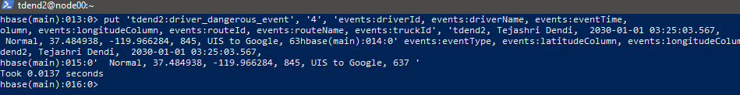

1. [RETRIEVE]Writeandrunacodetoretrievetherowyouinsertedin1 ONLY.a. Note: The row only, not the other rows.

b.Youmaywanttocheckthehelppage‘help<command>’

Answer: We can use ‘get’ to retrieve the specific row as it provides the parameterstoexplicitlyspecifytherowkey.Heretherowkeyis4andsothe the command is :



Result:

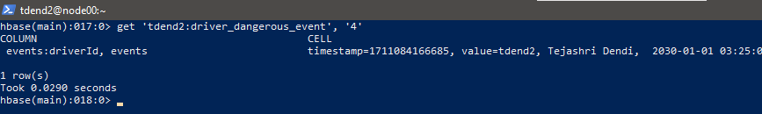

1. [UPDATE]Writeandrunacodetoupdatethevalueoftherowyouinserted in 1.
   1. Columnname(qualifier):
      1. routeName
   2. TheNEW valueofthecolumn
      1. UIStoMicrosoft
   3. Also,runtheabovecode(Assignment2.2)tocheckthechanges.
      1. Expectedchanges:‘UIStoGoogle’➔‘UIStoMicrosoft’

Answer:

Itcanbeupdatedusing‘put’commandasfollows:

put'tdend2:driver_dangerous_event','events:routeName','UIStoMicrosoft'



Verificationofaboveupdation:

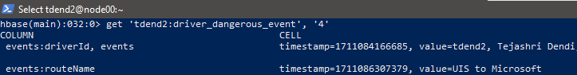

1. [RETRIEVE2]Writeandrunacodetoretrievethetwocolumnsoftherow you inserted

in1

* 1. Columnswewanttosee:
     1. driverName
     2. routeName
  2. Note:Twocolumns(qualifiers)only
  3. Youmaywanttocheckthehelppage‘help<command>’

Answer:

get'tdend2:driver_dangerous_event',‘4’,'events:driverName','events:routeName'

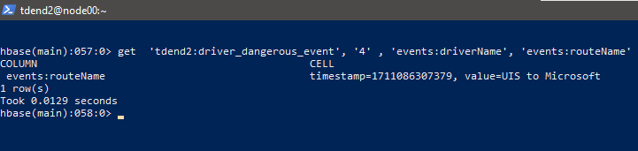

1. Writeandrunacode(script)toretrievemeta-dataofyourtableoutsideof the HBase

shell.

* 1. UseLinuxcommandsandHBaseshellcommands.
     1. Hint
        1. Linuxcommand:echo
        2. HBaseshellcommand:describe Answer:

Step-1:Created.shfileasfollows:

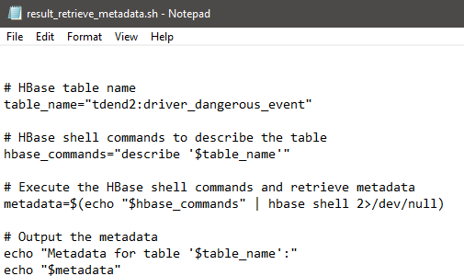

Step-2:

Copied.shfilefromlocalexistencetoclustersothatitcanbeexecuted.Itisas follows.

ScpC:\Users\Swathi\Documents/result_retrieve_metadata.sh

[tdend2@cscluster.uis.edu](mailto:tdend2@cscluster.uis.edu):.

Step-3:Loggedintocsclustertogivepermissionsasrequiredtoexecutethe file as follows

chmod+xC:\Users\Swathi\Documents/result_retrieve_metadata.sh Step-4: Removal of carriage returns as follows.

sed -i 's/\r//' /home/tdend2/result_retrieve_metadata.sh Step-5: Final execution

./result_retrieve_metadata.sh

Theresultoftheabovestepsisasfollows:

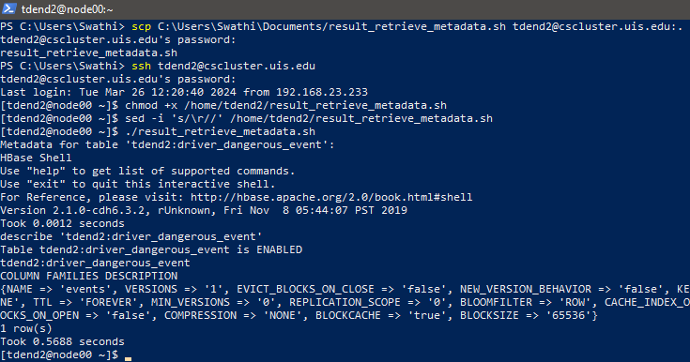

Hence table description is obtained successfully and displayed using echo.

++++++++++++++++++++++++++++THEEND+++++++++++++++++++++++++++