SQL Queries

Assignment#1

Insert a venue (UIS Performing Arts Center) to venues table (created in Ex1-1) and 10upcoming events you chooseto watch from theUIS Center to theevents table(created in this exercise)

* Addvenueintothetable:venuename:UISPerformingArtsCenter(https://uispac.com/)

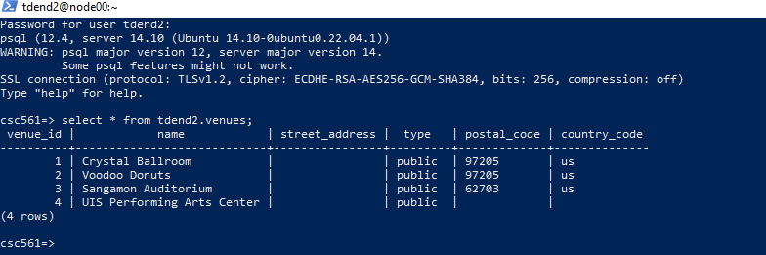

* UpcomingeventsatUISPerformingArtsCenter

ohttps://uispac.com/events/upcoming-events

oChoose10eventsthatyouwanttoliketowatch

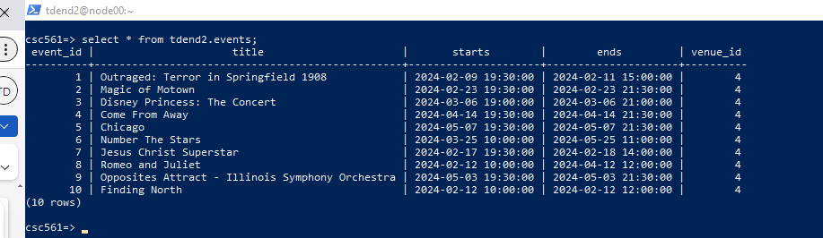

* ShowtheallvenuesincludingvenuesyouaddedinEx1-1



* Shows the allevents including previous (added in Ex1-1) and upcoming events in the table: you must show venue name, not venue_id
* Ifyoucannotfindanyinfo,e.g.,endstime,assume2hourevents.
* Ref:Section3and3.1Addingtheeventstotheeventstable

EventsaddedinEx-1:

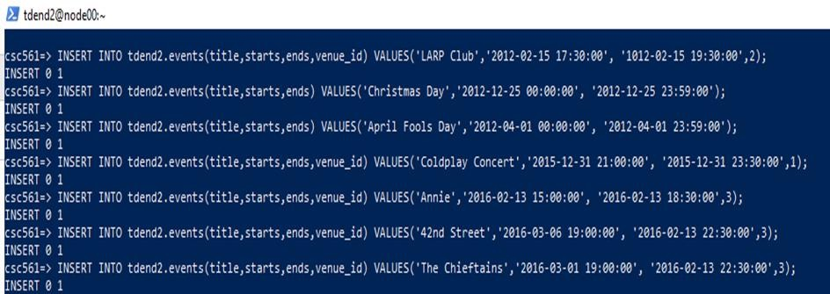

COMMAND: SELECT

events.event_id, events.title, events.starts, events.ends, venues. name

FROM

tdend2.events JOIN

tdend2.venues ON events.venue_id = venues.venue_id ORDERBY

events.starts;

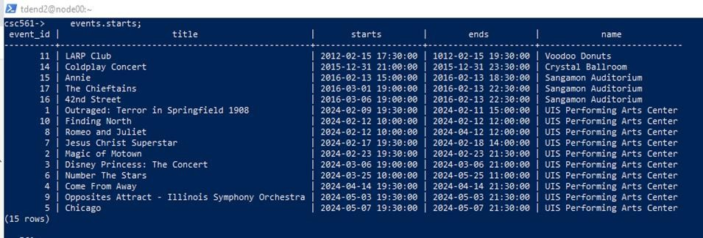

=================================================================================

Assignment#2(20pts)

Writeandrunaquerytoretrievethetotalnumbersofnon-nullrows:

* Columns:survived,age,andcabin
* Outputcolumns:total_nn_survived,total_nn_age,total_nn_cabin
* Showyourqueryandresults
* Note:Aquery,notmultiplequeries,e.g,UNION
* Ref:Section5Aggregationquerieswitharealdataset.(Assignment#2–#4)

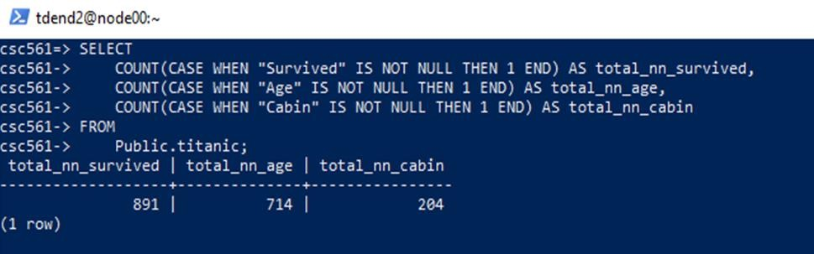

==================================================================================

Assignment#3(20pts)

Writeandrunaquerytoretrievethetotalnumbersofuniquerowsorgroups(cardinality)

* Columns:survived,age,andcabin
* Outputcolumns:cardinality_survived,cardinality_age,cardinality_cabin
* Showyourqueryandresults
* Note:Aquery,notmultiplequeries,e.g,UNION

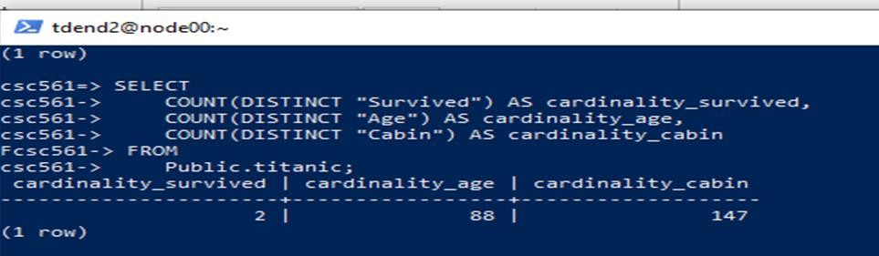

===================================================================================

Assignment#4(30pts)

Write and run a query to retrieve data showing which gender (male or female) has a greater survivalrate.

16/16

* Showyourqueryandresults
* Note:Aquery,notmultiplequeries

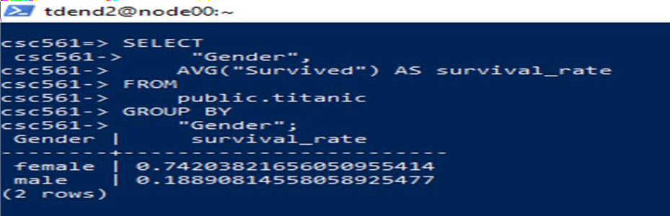

================================END======================END========================