**SQL Exercise Solutions**

**Write SQL queries to finish the following tasks, show data in tables, and outputs**

* 1. **1)Create** a new table named **users** SERIAL PRIMARY KEY integer id
  2. first_name
  3. last_name
  4. email (not null)
  5. password (not null)
  6. created_at (of type timestamp)
  7. updated_at (of type timestamp)
  8. **CREATEDUSERS** RELATION (ALTERED THE DATATYPE OF FIRST NAMAND LAST NAME AS I GAVECHARACTER DATA TYPE INITIALLY):
  9. 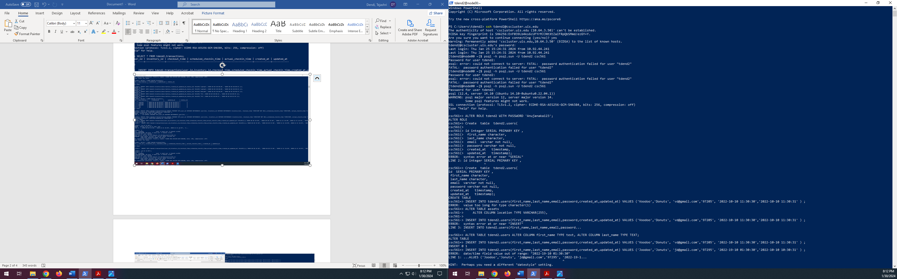

ALTERED USERS AND INSERTED ROWS:

* 1. 
  2. ============================================================================================
  3. 2)It should have the following columns:
  4. **Create** a new table named **status** SERIAL PRIMARY KEY integer id
  5. Description (not null)
  6. created_at (of type timestamp)
  7. updated_at (of type timestamp)
  8. RESULT AFTER CREATION OF TABLE:
  9. 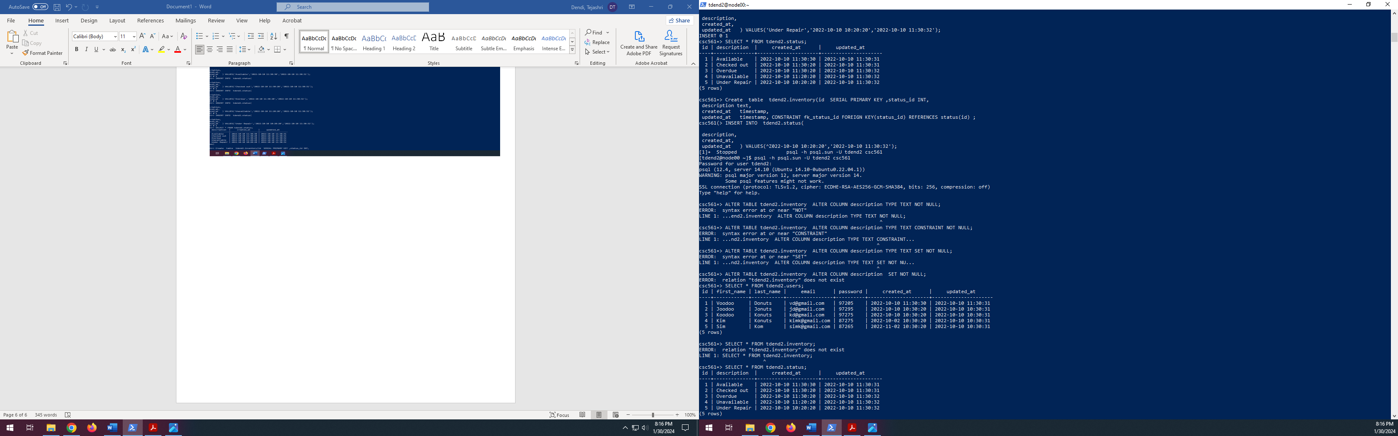

============================================================================================

3)It should have the following columns:

* 1. **Create** a new table named **inventory** SERIAL PRIMARY KEY integer id
  2. status_id (foreign key constraint by referencing the status table) ,description (not null). It should have the following columns: / 12 1 2
  + created_at (of type timestamp)
  + updated_at (of type timestamp)

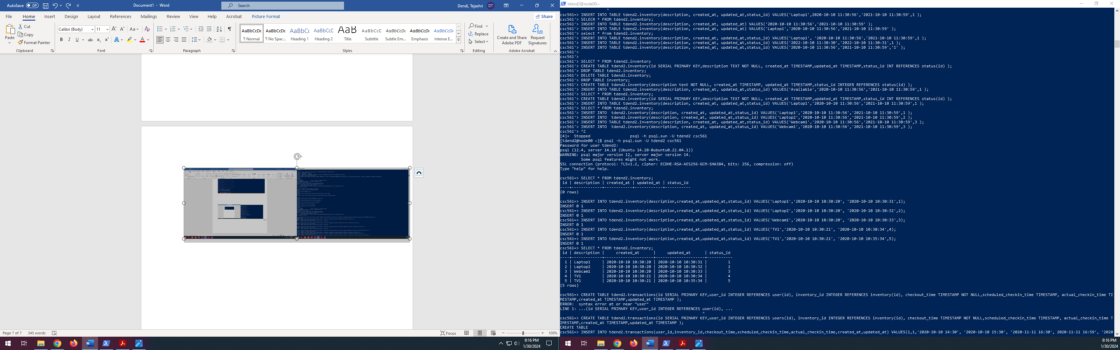

============================================================================================

* 1. **4)Create** a new table named **transactions** SERIAL PRIMARY KEY id
  2. user_id (foreign key constraint by referencing the user table)
  3. inventory_id (foreign key constraint by referencing the inventory table)
  4. checkout_time (of type timestamp) | (not null)
  5. scheduled_checkin_time (of type timestamp)
  6. actual_checkin_time (of type timestamp)
  7. created_at (of type timestamp)
  8. updated_at (of type timestamp)
  9. 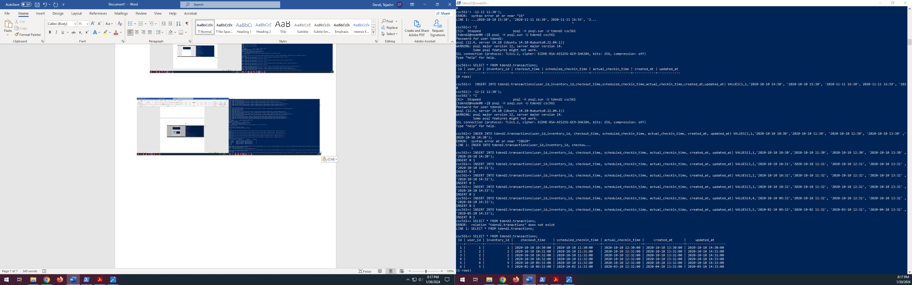

============================================================================================

5)It should have the following columns:

**Note: timestamps** are a string like 2019-08-26 17:30

1. **Insert** 5 users into the **users** table. The fields are self-explanatory.

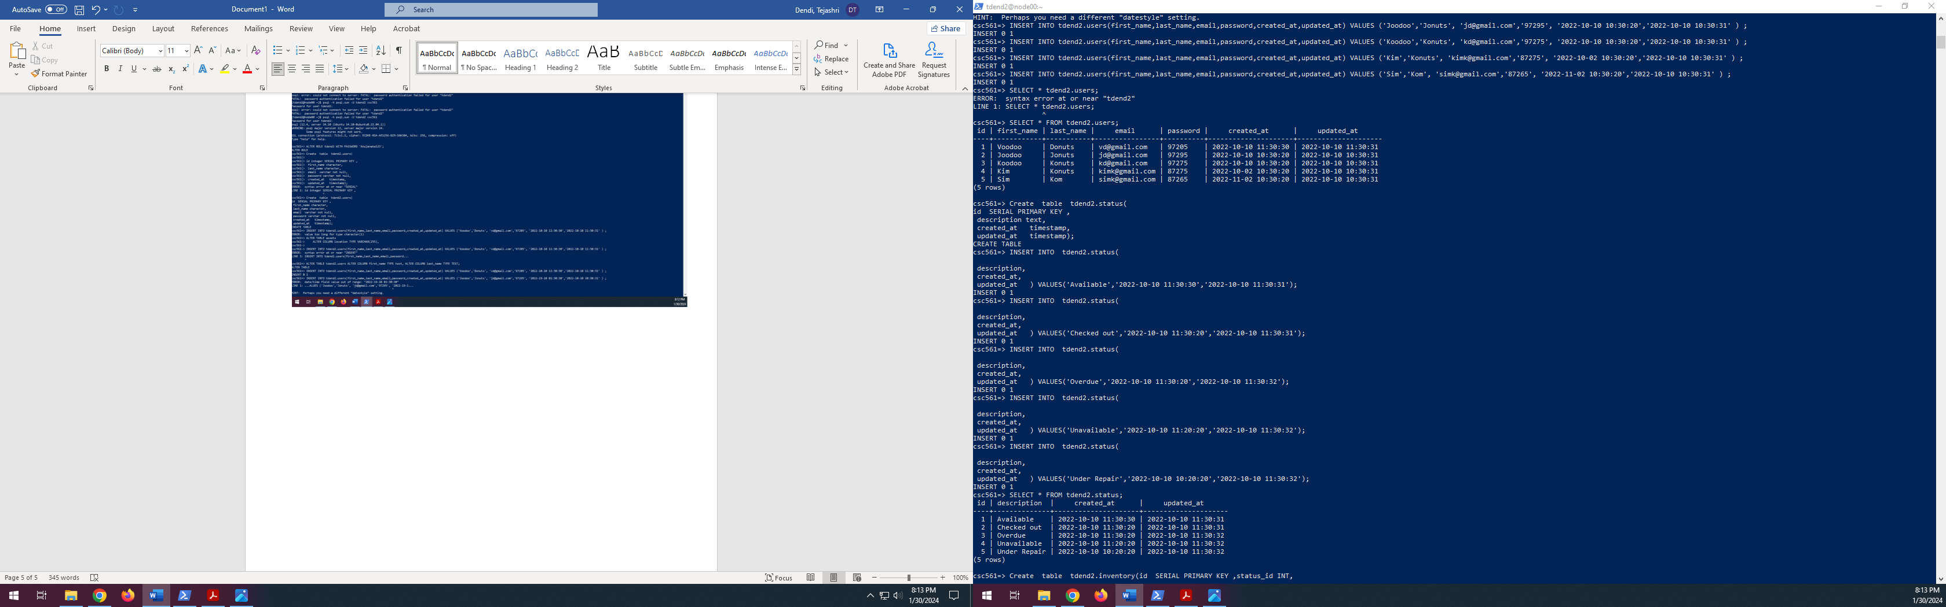



============================================================================================

6)Insert 5 records into the status table. The description field should be Available, Checked out, Overdue, Unavailable, and Under Repair. The other fields are self-explanatory.



==========================================================================================

7)Insert 5 records into the inventory table. The description field should be Laptop1, Laptop2, Webcam1, TV1, Microphone1. The other fields are self-explanatory.

AND **INSERT**ED 5 ROWS IN **INVENTORY** :



AFTER **INSERTION** OF RECORDS IN **INVENTORY**:



=========================================================================================

8)**Insert** 3 records into the **transactions** table.Two of the transactions should be for the user in the users table with id = 1. Two of the transactions should have a scheduled_checkin_time after September 3, 2019.

INSERTED ROWS SATISFYING THE ABOVE CONDITIONS.

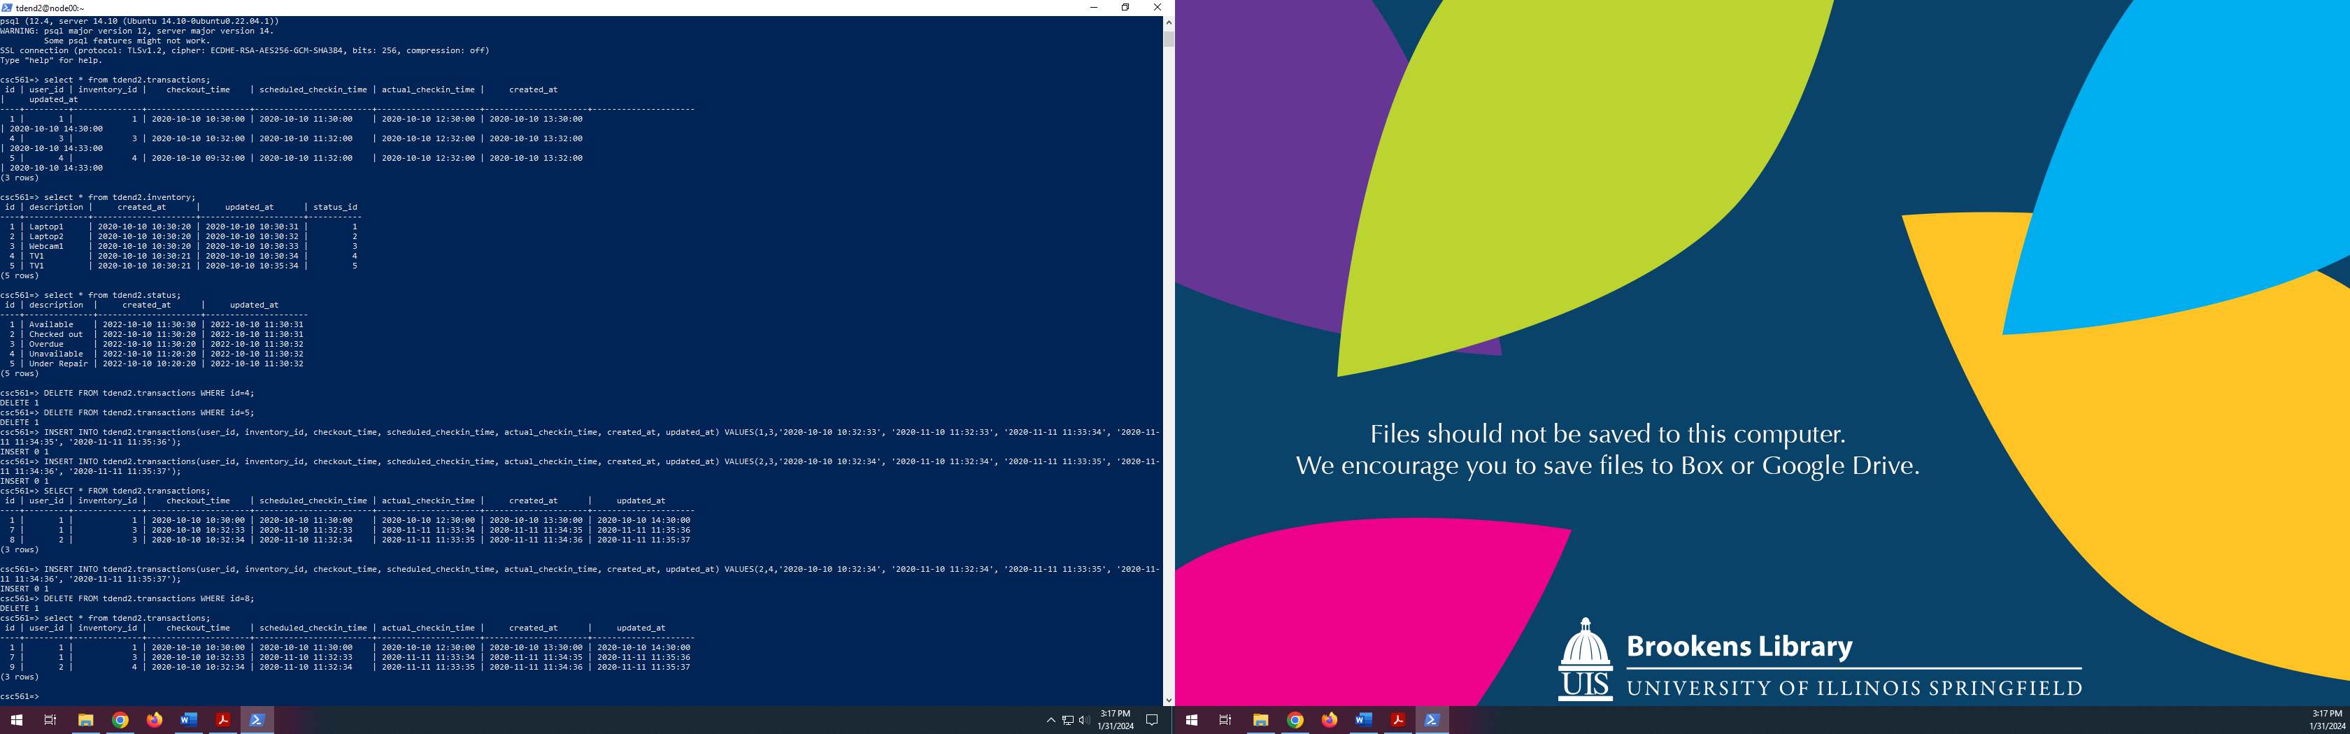

-----------------------------------------------------------------------------------------------------------------------------------------------------

Then update the status of these three inventory items in the inventory table to Checked out. The fields are self-explanatory, keeping in mind the foreign key constraints.

NOW UPDATING THEM AS CONDITIONED:

**Updated** as:

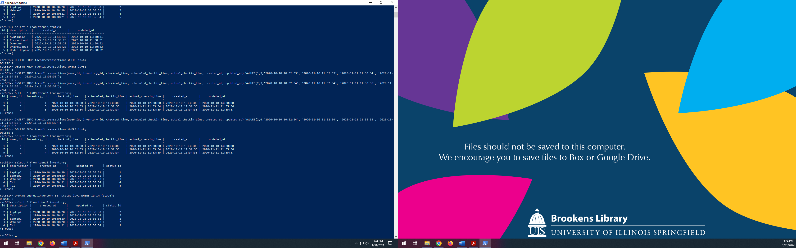

**Before updating**, the inventory table is as follows:



**After updating**, the inventory relation is as:



============================================================================================

9)**Alter** the users table to add a column for **signed**_**agreement** (**Boolean** column that **defaults**to**false**).

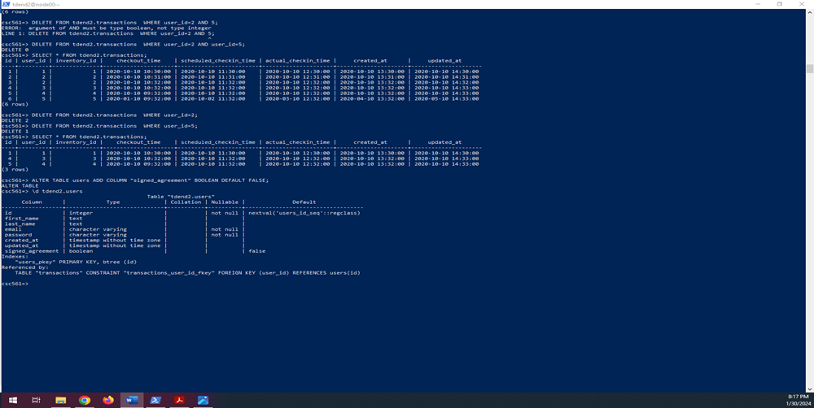



========================================================================================

10)Write a query that returns a count of the number of items with a status of Checked out by user_id 1

Checked out iItems by user id -1 are 2:

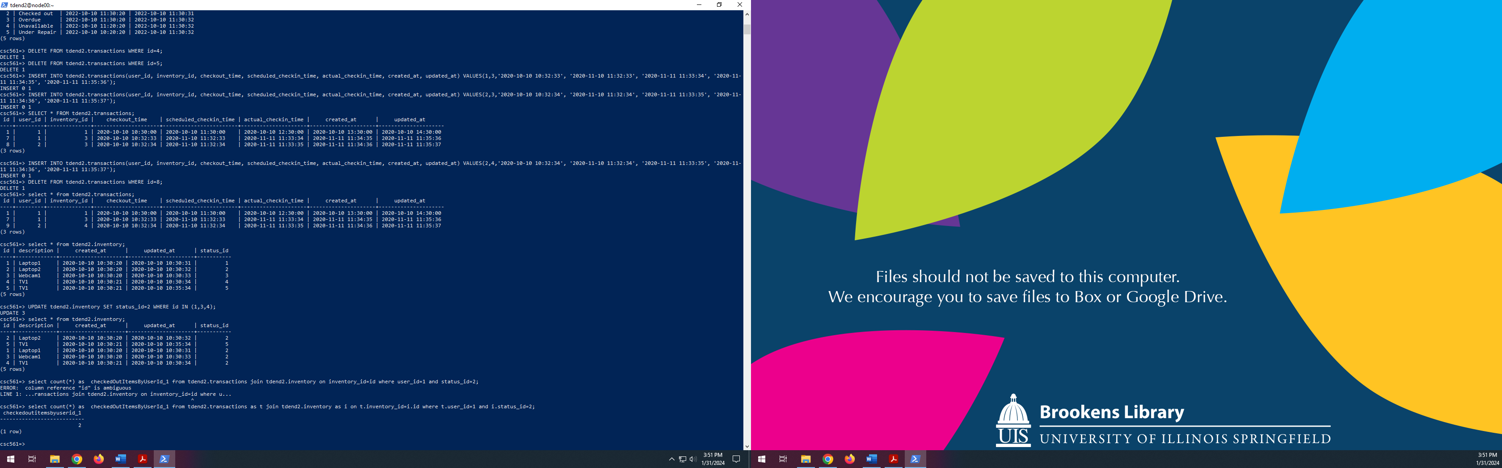



======================================END===================================================