#step1

import warnings

warnings.filterwarnings('ignore')

import pandas as pd

import numpy as np

from matplotlib import pyplot as plt

import seaborn as sns

from sklearn.model_selection import train_test_split

from sklearn.linear_model import LogisticRegression

from sklearn.metrics import confusion_matrix, classification_report

from sklearn.preprocessing import StandardScaler, MinMaxScaler

from sklearn.metrics import accuracy_score, classification_report, confusion_matrix

from sklearn.ensemble import RandomForestClassifier

#step2

#importing dataset

df = pd.read_csv("D:\\diabetes_prediction_dataset.csv")

df.head(9)

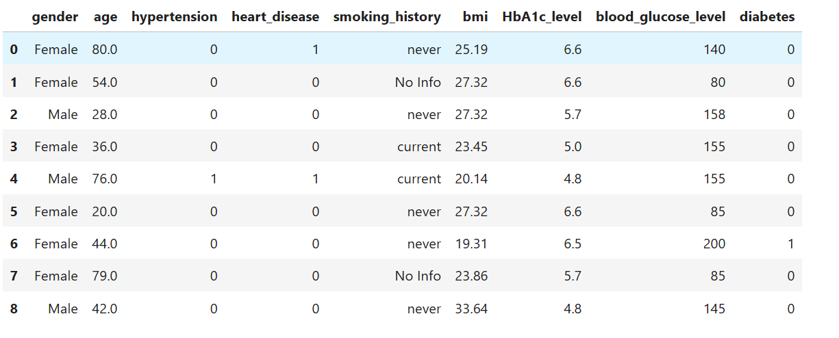

#step3

#getting info about all the columns

df.info()

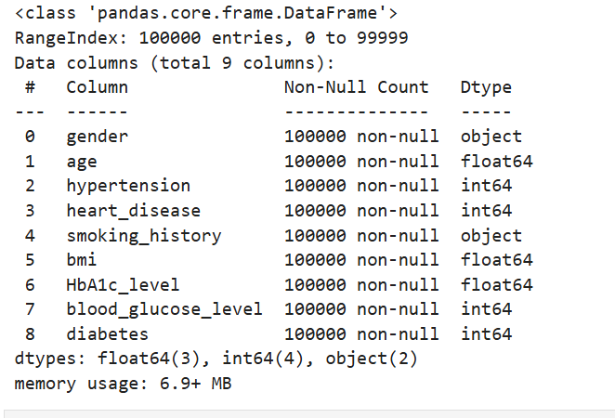  
#step4

#getting statiscal data about each numerical columns

df.describe()

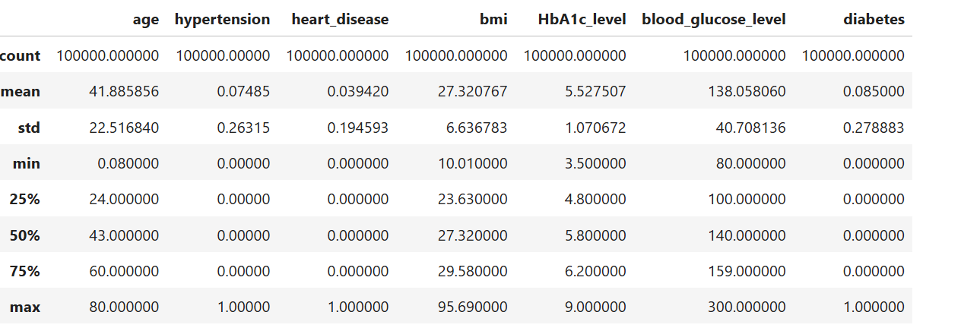

#Step5

#checking if dataset contains any null values

df.isna().sum()

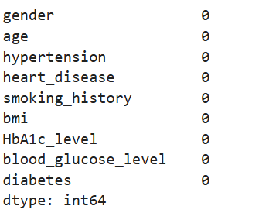

#step6

#checking number of unique values in a column

df['gender'].value_counts()

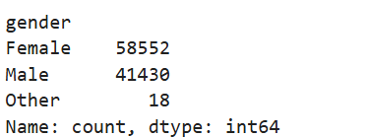

#step7

#Age Distribution

sns.histplot(df['age'], bins=30, color='orange')

plt.title("Age Distribution")

plt.show()

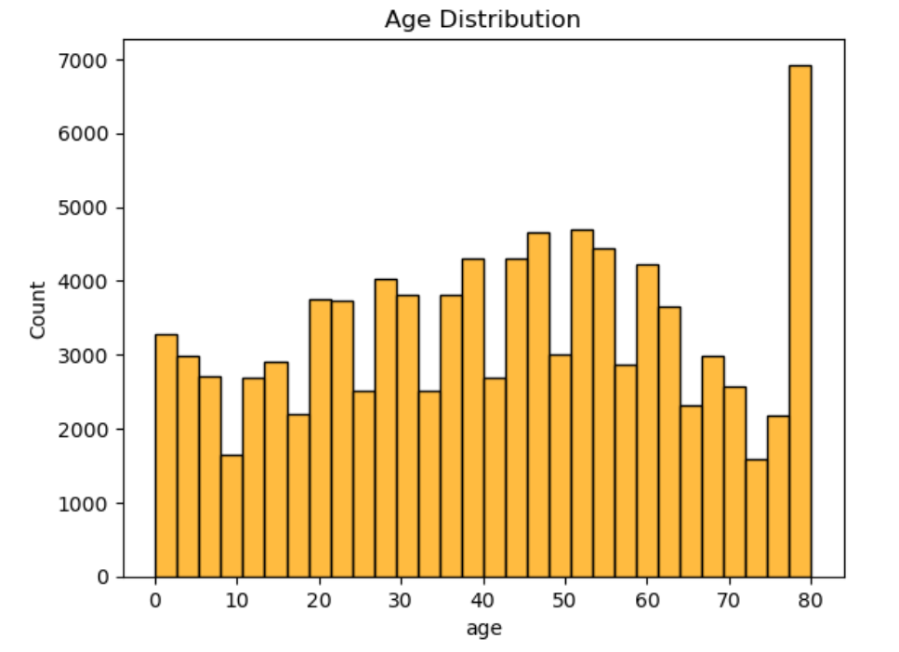

#step8

#Hypertension & Heart Disease Prevalence

sns.barplot(x=['No', 'Yes'], y=df['hypertension'].value_counts(normalize=True))

plt.title("Hypertension Prevalence")

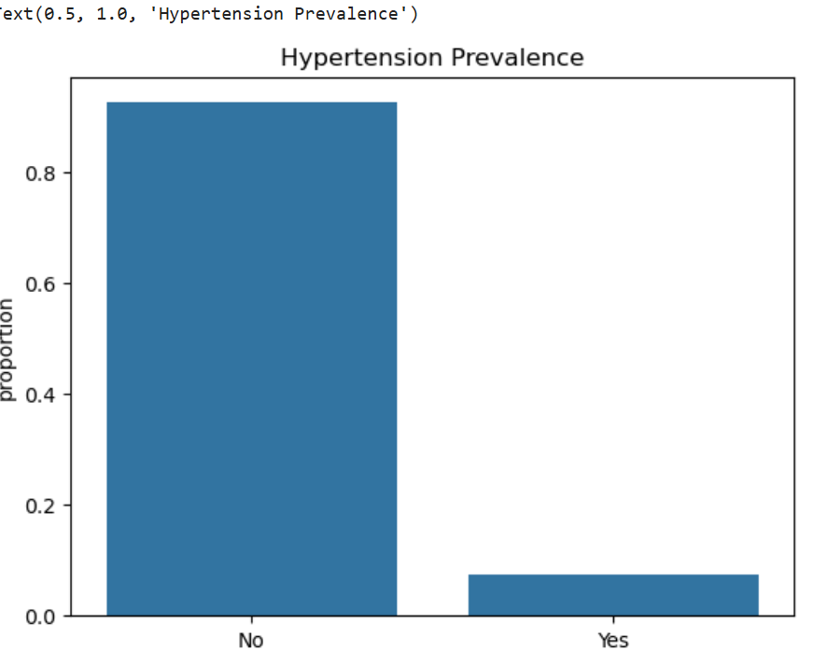

#step9

#BMI Distribution ans Outliers

sns.boxplot(x=df['bmi'])

plt.title("BMI Distribution")

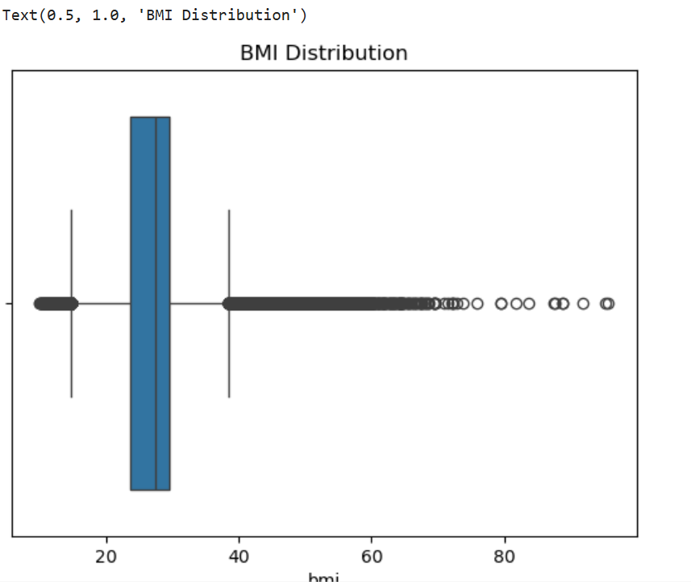

#step10

df['bmi'].value_counts()

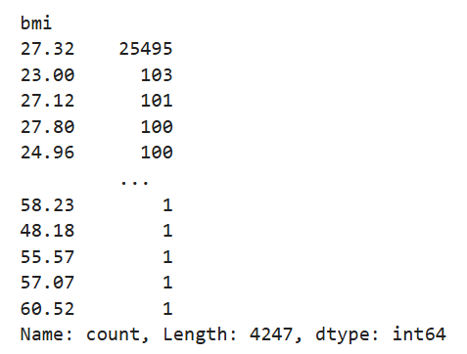

#step11

#Performing outlier treatment on BMI

Q1 = df['bmi'].quantile(0.25)

Q3 = df['bmi'].quantile(0.75)

IQR = Q3 - Q1

lower_bound = Q1 - 1.5 * IQR

upper_bound = Q3 + 1.5 * IQR

# Finding outliers

outliers = df[(df['bmi'] < lower_bound) | (df['bmi'] > upper_bound)]

print(f'Number of outliers in BMI column: {len(outliers)}')



#step12

#New df with no outliers in BMI column

df = df[(df['bmi'] >= lower_bound) & (df['bmi'] <= upper_bound)]

df

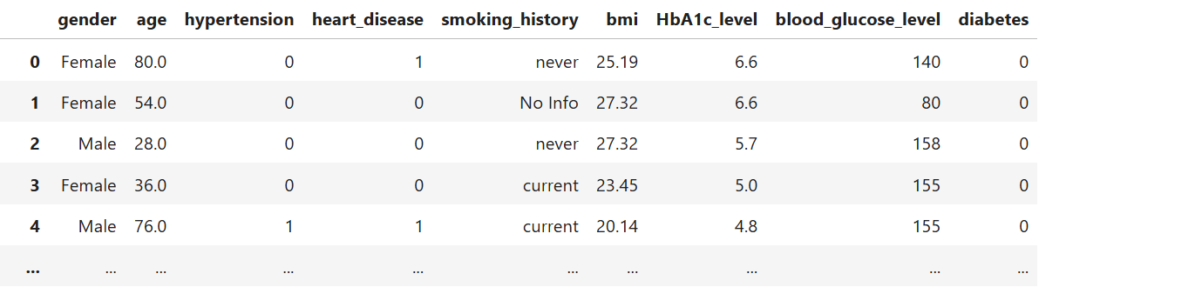

#step13

sns.boxplot(x=df['bmi'])

plt.title("BMI Distribution")

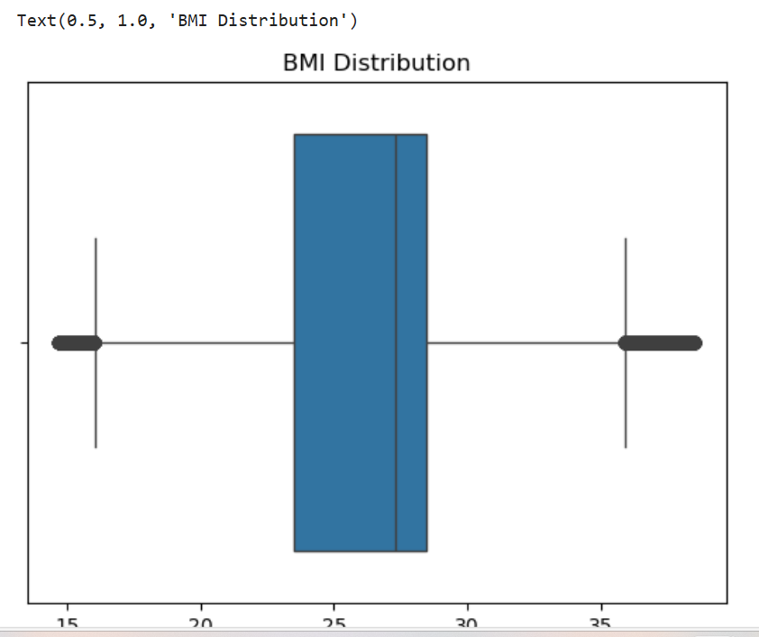

#step14

df.smoking_history.value_counts()

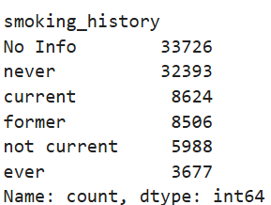

#step15

#Based on smoking , mapping to a value

smoking_history_map = {

'never': 0, # Non-Smoker

'not current': 0, # Non-Smoker

'former': 1, # Former Smoker

'current': 2, # Smoker

'ever': 2, # Smoker (considered similar to 'current')

'No Info': -1 # Unknown

}

df['smoking_history'] = df['smoking_history'].map(smoking_history_map)

df

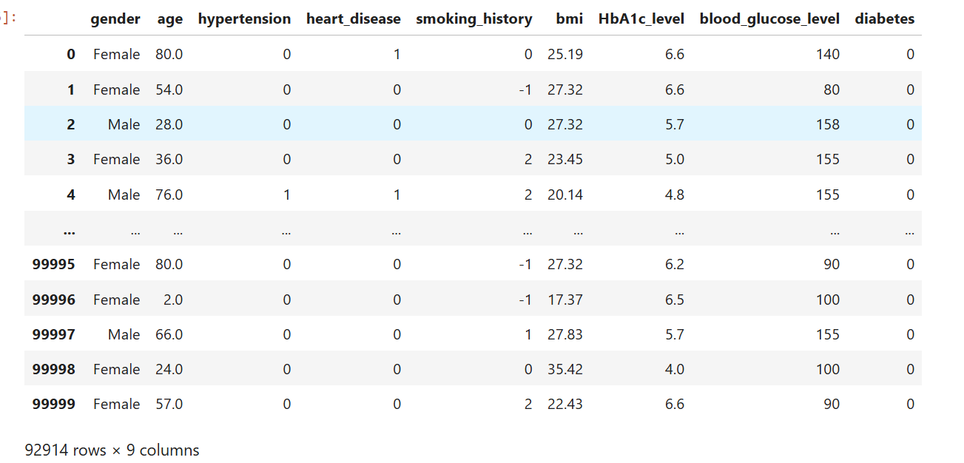

#step16

df['gender'].value_counts()

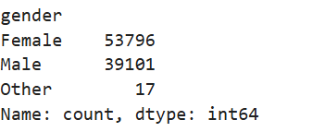   
#step17

# Remove rows where gender is "Other"

df = df[df['gender'] != 'Other']

df

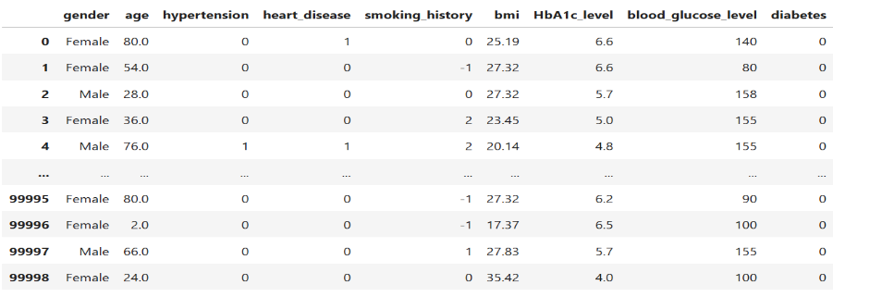

#step18

df['gender'].value_counts()

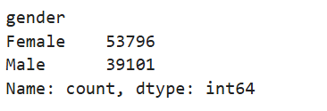

#step19

# Mapping dictionary for gender (Female: 0, Male: 1)

gender_map = {

'Female': 0,

'Male': 1

}

# Apply the mapping to the 'gender' column

df['gender'] = df['gender'].map(gender_map)

df

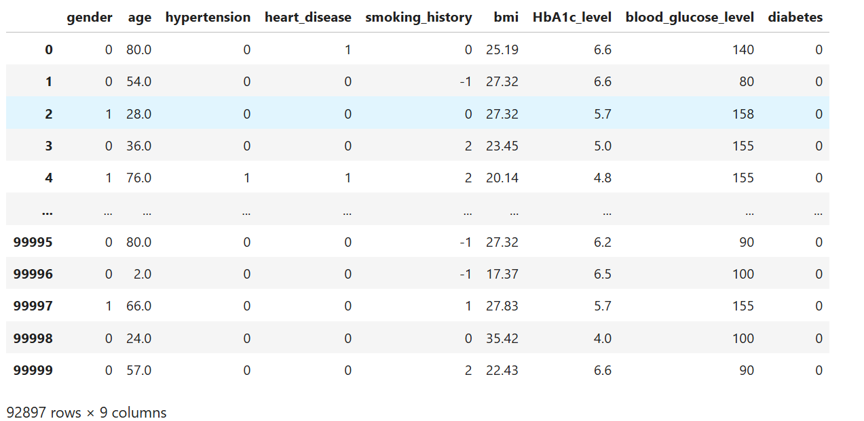

#Step20  
#scaling data to bring all values to a Range [0,1]

scaler = MinMaxScaler()

# Apply scaling to the columns (exclude categorical ones)

df[['age','smoking_history','bmi','HbA1c_level', 'blood_glucose_level']] = scaler.fit_transform(df[['age','smoking_history','bmi','HbA1c_level', 'blood_glucose_level']])

df

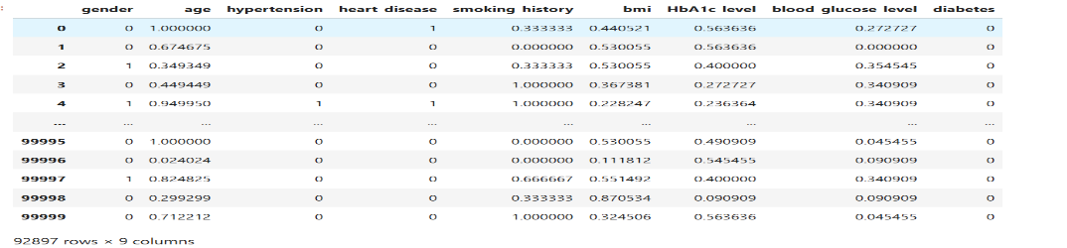

#step21

X = df.drop('diabetes', axis=1)

y = df['diabetes']

# Train-test split

X_train, X_test, y_train, y_test = train_test_split(X, y, test_size=0.3, random_state=42)

#step22

# Initialize the Logistic Regression Model

model_logistic = LogisticRegression(class_weight='balanced', random_state=42)

# Train the model

model_logistic.fit(X_train, y_train)

# Make predictions

y_pred = model_logistic.predict(X_test)

# Evaluate the model

print("Accuracy:", accuracy_score(y_test, y_pred))

print("Classification Report:\n", classification_report(y_test, y_pred))

print("Confusion Matrix:\n", confusion_matrix(y_test, y_pred))

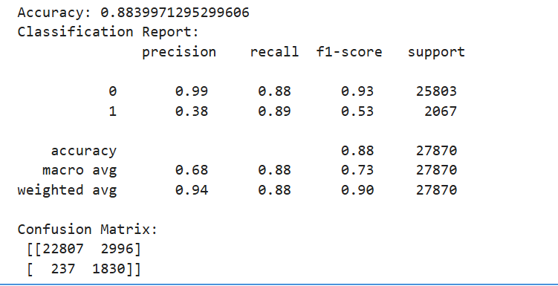

#step23

# Initialize the Random Forest Classifier model

model_rfc = RandomForestClassifier(class_weight='balanced', random_state=42)

# Train the model

model_rfc.fit(X_train, y_train)

# Make predictions

y_pred = model_rfc.predict(X_test)

# Evaluate the model

print("Accuracy:", accuracy_score(y_test, y_pred))

print("Classification Report:\n", classification_report(y_test, y_pred))

print("Confusion Matrix:\n", confusion_matrix(y_test, y_pred))

