Design and Verification of a 5-Stage Pipelined RISC-V Processor: RTL to GDSII Implementation
Project Work for Integrated Skill Enhancement-1
Submitted in partial fulfilment of the requirements for the award of
the degree of
BACHELOR OF TECHNOLOGY
IN
ELECTRONICS AND COMMUNICATION ENGINEERING
By
P. SAI TEJASHWINI 24EG104E57
Under the guidance of
[GUIDE NAME]
[Designation], Department of ECE

Department of Electronics and Communication Engineering
ANURAG UNIVERSITY SCHOOL OF ENGINEERING
Venkatapur(V), Ghatkesar(M), Medchal-Malkajgiri Dist-500088
2026-2027

ANURAG UNIVERSITY SCHOOL OF ENGINEERING
Venkatapur(V), Ghatkesar(M), Medchal-Malkajgiri Dist-500088

DEPARTMENT OF ELECTRONICS AND COMMUNICATION ENGINEERING
CERTIFICATE
This is to certify that the project report entitled "Design and Verification of a 5-Stage Pipelined RISC-V Processor: RTL to GDSII Implementation" being submitted by
P. SAI TEJASHWINI 24EG104E57
in partial fulfillment for the award of the Degree of Bachelor of Technology in Electronics & Communication Engineering to the Anurag University, Hyderabad is a record of bonafide work carried out under my guidance and supervision. The results embodied in this project report have not been submitted to any other University or Institute for the award of any Degree or Diploma.

[Guide Name]  [Designation] | Dr. Harikrishna Kamatham  Professor, HOD  ECE & ECM | External Examiner

DECLARATION
I hereby declare that the project report entitled "Design and Verification of a 5-Stage Pipelined RISC-V Processor: RTL to GDSII Implementation" submitted to the Department of Electronics and Communication Engineering, Anurag University School of Engineering, Hyderabad, in partial fulfilment of the requirements for the award of the degree of Bachelor of Technology in Electronics and Communication Engineering, is a record of original work carried out by me under the guidance of [Guide Name], [Designation], Department of ECE.
I further declare that the work reported in this project has not been submitted, either in part or in full, for the award of any other degree or diploma in this University or in any other University or Institution.

P. SAI TEJASHWINI
Roll No: 24EG104E57
Date:
Place: Hyderabad
ACKNOWLEDGEMENTS
I express my sincere gratitude to my project guide, [Guide Name], [Designation], Department of Electronics and Communication Engineering, for the constant guidance, valuable suggestions and encouragement offered throughout this project. The technical discussions on pipeline design, timing closure and physical implementation were extremely helpful in shaping the work.
I am thankful to Dr. Harikrishna Kamatham, Professor and Head of the Department of ECE and ECM, for providing the laboratory facilities, EDA tool access and a supportive academic environment. I also thank the Dean, the Principal and the management of Anurag University School of Engineering for their continuous support.
I extend my thanks to the faculty members and the technical staff of the VLSI laboratory for their cooperation, and to my classmates for their helpful feedback during design reviews. Finally, I am deeply grateful to my parents and family for their patience, motivation and unwavering support.
P. SAI TEJASHWINI
(24EG104E57)
ABSTRACT
Modern embedded and edge applications demand processors that deliver high throughput at low power and area, while being free from licensing constraints. The open RISC-V instruction set architecture (ISA) is an attractive foundation, and pipelining is the most effective microarchitectural technique for increasing instruction throughput. This project presents the complete design, verification and physical implementation of a 32-bit, 5-stage pipelined RISC-V processor supporting the RV32I base integer instruction set, carried through the full RTL-to-GDSII ASIC flow.
The processor is described in synthesizable Verilog HDL and is organised into Instruction Fetch (IF), Instruction Decode (ID), Execute (EX), Memory Access (MEM) and Write Back (WB) stages separated by pipeline registers. A forwarding unit resolves read-after-write data hazards, a hazard detection unit inserts a one-cycle stall for load-use dependencies, and control hazards caused by taken branches and jumps are handled by flushing the wrong-path instructions. The design is verified with a self-checking testbench and assembly test programs covering arithmetic, logical, shift, load/store, branch and jump instructions, as well as every hazard scenario.
The verified RTL is synthesised with Cadence Genus, validated by gate-level simulation, and implemented with Cadence Innovus through floorplanning, power planning, placement, clock tree synthesis, routing and post-route optimisation. Static timing analysis, power analysis, DRC, LVS and antenna checks are performed before the final GDSII stream-out. Snapshots of every stage of the flow are included in this report along with area, timing and power results, giving a complete record of the design journey from RTL to GDSII and a reusable reference for future processor-design projects.
Keywords: RISC-V, RV32I, 5-stage pipeline, hazard handling, data forwarding, Verilog HDL, logic synthesis, floorplanning, clock tree synthesis, routing, GDSII.
TABLE OF CONTENTS

CHAPTER 1 INTRODUCTION 1
1.1 INTRODUCTION 1
1.2 PROBLEM STATEMENT 1
1.3 OBJECTIVES 2
1.4 SCOPE OF THE PROJECT 2
1.5 ORGANISATION OF THE REPORT 2
CHAPTER 2 LITERATURE SURVEY 4
2.1 THE RISC-V INSTRUCTION SET ARCHITECTURE 4
2.2 PIPELINED PROCESSOR ARCHITECTURES 4
2.3 HAZARD DETECTION AND RESOLUTION 4
2.4 THE RTL-TO-GDSII FLOW 5
2.5 SUMMARY OF THE LITERATURE AND RESEARCH GAP 6
CHAPTER 3 SOFTWARE AND HARDWARE REQUIREMENTS 7
3.1 SOFTWARE REQUIREMENTS 7
3.2 HARDWARE REQUIREMENTS 7
3.3 TARGET ISA AND DESIGN PARAMETERS 8
CHAPTER 4 METHODOLOGY 9
4.1 SYSTEM OVERVIEW 9
4.2 RV32I INSTRUCTION SET AND ENCODING 9
4.3 5-STAGE PIPELINE ARCHITECTURE 10
4.3.1 Instruction Fetch (IF) Stage 11
4.3.2 Instruction Decode (ID) Stage 11
4.3.3 Execute (EX) Stage 12
4.3.4 Memory Access (MEM) Stage 12
4.3.5 Write Back (WB) Stage 12
4.4 PIPELINE REGISTERS 12
4.5 CONTROL UNIT 12
4.6 HAZARD HANDLING 13
4.6.1 Data Hazards and Forwarding 13
4.6.2 Load-Use Hazard 13
4.6.3 Control Hazards 14
4.6.4 Hazard Summary 15
4.7 PERFORMANCE MODEL 15
4.8 VERIFICATION METHODOLOGY 15
4.9 LOGIC SYNTHESIS 16
4.10 GATE-LEVEL SIMULATION 16
4.11 FLOORPLANNING 16
4.12 POWER PLANNING 17
4.13 PLACEMENT 17
4.14 CLOCK TREE SYNTHESIS 17
4.15 ROUTING 18
4.16 POST-ROUTE OPTIMISATION AND SIGNOFF TIMING 18
4.17 PHYSICAL VERIFICATION AND GDSII GENERATION 18
CHAPTER 5 RESULTS AND DISCUSSION 19
5.1 RTL FUNCTIONAL SIMULATION 19
5.2 PIPELINE PERFORMANCE: CPI AND SPEEDUP 20
5.3 LOGIC SYNTHESIS RESULTS 21
5.4 GATE-LEVEL SIMULATION (PRE-LAYOUT) 23
5.5 FLOORPLANNING RESULTS 23
5.6 POWER PLANNING RESULTS 24
5.7 PLACEMENT RESULTS 24
5.8 CLOCK TREE SYNTHESIS RESULTS 25
5.9 ROUTING RESULTS 26
5.10 POST-ROUTE TIMING ANALYSIS 27
5.11 PHYSICAL VERIFICATION: DRC AND LVS 27
5.12 FINAL GDSII LAYOUT 29
5.13 POST-LAYOUT GATE-LEVEL SIMULATION 29
5.14 OVERALL PPA SUMMARY AND COMPARISON 30
5.15 COST ANALYSIS 30
5.16 USEFULNESS TO SOCIETY 31
5.17 ENVIRONMENTAL SAFETY 31
CHAPTER 6 CONCLUSION AND FUTURE SCOPE 32
6.1 CONCLUSION 32
6.2 FUTURE SCOPE 32
REFERENCES 34
APPENDICES 35
APPENDIX A: VERILOG HDL SOURCE CODE (KEY MODULES) 35
A.1 Arithmetic Logic Unit 35
A.2 Register File 35
A.3 Forwarding Unit 35
A.4 Hazard Detection Unit 36
A.5 IF/ID Pipeline Register 36
APPENDIX B: SYNTHESIS CONSTRAINTS AND TOOL SCRIPTS 36
B.1 SDC Constraints 36
B.2 Genus Synthesis Script (excerpt) 37
B.3 Innovus Physical Design Flow (excerpt) 37
APPENDIX C: ASSEMBLY TEST PROGRAM 38

LIST OF FIGURES

Figure 1: Complete RTL-to-GDSII design flow followed in this project 9
Figure 2: RV32I instruction formats 10
Figure 3: Block diagram of the 5-stage pipelined RV32I processor 11
Figure 4: Pipeline timing diagram showing overlapped execution of instructions 11
Figure 5: Flow chart of the hazard detection and resolution algorithm 14
Figure 6: Conceptual floorplan of the processor core with power rings 17
Figure 7: RTL simulation waveform of the 5-stage pipelined processor 19
Figure 8: Elaborated (generic) schematic of the processor top module 21
Figure 9: Gate-level schematic after technology mapping 21
Figure 10: Synthesis report showing area, timing and power 22
Figure 11: Gate-level simulation waveform of the synthesised netlist 23
Figure 12: Floorplan of the processor (die, core and I/O pins) 23
Figure 13: Power rings and stripes after power planning 24
Figure 14: Standard cell placement view 25
Figure 15: Clock tree synthesis result 25
Figure 16: Detailed routing result of the processor 26
Figure 17: Post-route timing summary (setup and hold) 27
Figure 18: Design rule check (DRC) result 28
Figure 19: Layout versus schematic (LVS) result 28
Figure 20: Final GDSII layout of the 5-stage pipelined RISC-V processor 29
Figure 21: Post-layout gate-level simulation with SDF back-annotation 29

LIST OF TABLES

Table 1: Summary of reviewed work 6
Table 2: Software tools used in the project 7
Table 3: Hardware requirements 8
Table 4: Processor design parameters 8
Table 5: Instruction groups implemented 10
Table 6: Contents of the pipeline registers 12
Table 7: Main control signals for each instruction class 13
Table 8: Forwarding conditions 13
Table 9: Summary of hazards and their resolution 15
Table 10: Hazard events observed during the test program 20
Table 11: Register values after execution of the test program 20
Table 12: Post-synthesis area and cell statistics 22
Table 13: Post-synthesis timing and power (typical corner, 5.0 ns clock) 22
Table 14: Floorplan parameters 24
Table 15: Clock tree statistics 26
Table 16: Routing statistics 26
Table 17: Post-route timing and power results 27
Table 18: Physical verification summary 28
Table 19: Stage-wise summary of the design from RTL to GDSII 30
Table 20: Pipelined versus single-cycle implementation 30

LIST OF ABBREVIATIONS
ALU | Arithmetic Logic Unit
ASIC | Application Specific Integrated Circuit
CMOS | Complementary Metal Oxide Semiconductor
CPI | Cycles Per Instruction
CTS | Clock Tree Synthesis
DEF | Design Exchange Format
DRC | Design Rule Check
EDA | Electronic Design Automation
EX | Execute stage
FF | Flip-Flop
GDSII | Graphic Data System II (layout stream format)
GLS | Gate-Level Simulation
GPDK | Generic Process Design Kit
HDL | Hardware Description Language
ID | Instruction Decode stage
IF | Instruction Fetch stage
IPC | Instructions Per Cycle
ISA | Instruction Set Architecture
LEF | Library Exchange Format
LVS | Layout Versus Schematic
MEM | Memory Access stage
NOP | No Operation
PC | Program Counter
PPA | Power, Performance and Area
PVT | Process, Voltage and Temperature
RAW | Read After Write
RISC | Reduced Instruction Set Computer
RTL | Register Transfer Level
SDC | Synopsys Design Constraints
SDF | Standard Delay Format
SPEF | Standard Parasitic Exchange Format
STA | Static Timing Analysis
TNS | Total Negative Slack
VLSI | Very Large Scale Integration
WB | Write Back stage
WNS | Worst Negative Slack
LIST OF SYMBOLS
T_{clk} | Clock period (ns)
f_{clk} | Clock frequency (MHz)
IC | Instruction count
CPI | Average cycles per instruction
k | Number of pipeline stages (k = 5)
t_{cq} | Clock-to-Q delay of a flip-flop
t_{setup} | Flip-flop setup time
t_{hold} | Flip-flop hold time
t_{pd} | Combinational propagation delay
T_{skew} | Clock skew between launch and capture flip-flops
V_{DD} | Supply voltage (V)
P_{dyn} | Dynamic power dissipation
P_{leak} | Leakage power dissipation
P_{tot} | Total power (P_{dyn} + P_{leak})
α | Switching activity factor
C_{L} | Load capacitance
S | Speedup of the pipelined design
μm | Micrometre
ns | Nanosecond
mW | Milliwatt

CHAPTER 1
INTRODUCTION

1.1 INTRODUCTION
The performance of a digital system is governed by how many useful instructions its processor can complete in a given time. Early processors executed one instruction completely before starting the next, which left most of the hardware idle at any instant. Pipelining removes this inefficiency by overlapping the execution of several instructions, in the same way that an assembly line overlaps the manufacture of several products. Each instruction is divided into a sequence of stages, and each stage is handled by dedicated hardware, so that in the ideal case one instruction completes in every clock cycle [2], [10].
RISC-V is an open, royalty-free instruction set architecture that originated at the University of California, Berkeley [1], [3]. Its modular design, small base ISA and clean encoding make it an excellent platform for teaching, research and commercial products alike. The 32-bit base integer ISA, RV32I, contains only 37 user-level instructions, yet it is sufficient to run compiled C programs, which makes it ideal for a complete hardware implementation within an academic project.
Designing a processor in Register Transfer Level (RTL) code is only the first part of the journey. For the processor to become a real chip, the RTL must be synthesised into logic gates, floorplanned, placed, clocked, routed, verified and finally converted into a GDSII layout file that a foundry can manufacture. This project therefore covers both the front-end work (architecture, RTL coding and functional verification) and the back-end work (synthesis, physical design and signoff), documenting every stage with snapshots from the EDA tools.

1.2 PROBLEM STATEMENT
A single-cycle processor must set its clock period to the delay of the slowest instruction, usually a load, which limits the clock frequency and wastes hardware. A multi-cycle design improves the clock rate but still executes only one instruction at a time. Pipelining raises throughput, but it introduces data, control and structural hazards that can produce wrong results if they are not handled correctly. Furthermore, a design that works in RTL simulation may fail after synthesis or layout because of timing violations, wire delays, clock skew or physical rule violations.
The problem addressed in this project is therefore to design a functionally correct 5-stage pipelined RV32I processor with complete hazard handling, verify it thoroughly, and implement it through the entire RTL-to-GDSII flow so that it meets its timing, power and physical design rule requirements.

1.3 OBJECTIVES
- To study the RV32I instruction set and develop a 5-stage (IF, ID, EX, MEM, WB) pipelined microarchitecture for it.
- To write synthesizable Verilog HDL for the datapath, control unit, register file, ALU, forwarding unit and hazard detection unit.
- To resolve data hazards by forwarding, load-use hazards by stalling, and control hazards by flushing.
- To verify the design with a self-checking testbench and directed assembly programs, and to measure CPI.
- To synthesise the RTL with timing constraints and analyse area, timing and power.
- To validate the synthesised netlist by gate-level simulation (GLS).
- To carry out floorplanning, power planning, placement, clock tree synthesis, routing and post-route optimisation.
- To perform static timing analysis, DRC, LVS and antenna checks, and to generate the final GDSII layout.

1.4 SCOPE OF THE PROJECT
The processor implements the RV32I base integer instruction set (arithmetic, logical, shift, set-less-than, load, store, branch, JAL, JALR, LUI and AUIPC instructions). Privileged architecture, interrupts, caches, multiplication/division (M extension) and compressed instructions (C extension) are outside the scope of this work, although the design leaves room for these extensions as future work. The instruction and data memories are modelled as separate single-cycle memories (Harvard-style interface) so that the pipeline itself can be studied without cache complexity. The physical implementation targets a generic standard-cell process design kit using the Cadence digital implementation flow.

1.5 ORGANISATION OF THE REPORT
Chapter 1 introduces the project, the problem statement and the objectives. Chapter 2 reviews the literature on RISC-V, pipelined processors, hazard handling and the RTL-to-GDSII flow. Chapter 3 lists the software and hardware requirements. Chapter 4 explains the methodology, including the architecture, the block diagram, flow charts and each step of the ASIC flow. Chapter 5 presents the results with snapshots of every stage from simulation to GDSII, and discusses cost, usefulness to society and environmental safety. Chapter 6 gives the conclusion and future scope, followed by the references and appendices.

CHAPTER 2
LITERATURE SURVEY

2.1 THE RISC-V INSTRUCTION SET ARCHITECTURE
RISC-V was introduced as an open ISA to remove the cost, legal and technical barriers that surround proprietary architectures [3]. The specification is organised as a small mandatory base ISA with optional standard extensions and a separate privileged architecture, so that an implementation includes only what it needs [1], [5]. Asanović and Patterson argued that a free and open ISA, designed with the lessons of earlier RISC architectures, can serve everything from tiny microcontrollers to server-class processors. The ISA uses a fixed 32-bit instruction length for the base set, three-operand register format, and keeps the source and destination register fields in the same bit positions in all formats. This regularity simplifies the decode stage and the register-file read logic, which is a significant advantage for a pipelined implementation.

2.2 PIPELINED PROCESSOR ARCHITECTURES
The classic five-stage RISC pipeline, popularised in textbooks by Hennessy and Patterson [10] and by Patterson and Hennessy [2], divides instruction execution into fetch, decode and register read, execute, memory access and write back. With perfect overlap, the pipeline completes one instruction per cycle after an initial latency of four cycles, and the clock period is reduced to roughly the delay of the slowest stage plus register overhead rather than the sum of all stage delays. The ideal speedup equals the number of stages; the practical speedup is lower because of pipeline register overhead, imbalance between stages and hazards.
Several open-source RISC-V implementations demonstrate the range of pipeline designs. The Rocket Chip generator from Berkeley produces in-order cores with a five-stage pipeline and optional extensions, along with caches and a system-on-chip infrastructure [4]. The RI5CY core developed at ETH Zurich and the University of Bologna extends a four-stage pipeline with DSP-oriented instructions and was fabricated in near-threshold technology for Internet-of-Things endpoints [6]. These works show that a carefully pipelined RISC-V core can reach high energy efficiency, and they motivate a clear, well-documented baseline implementation as undertaken in this project.

2.3 HAZARD DETECTION AND RESOLUTION
Pipeline hazards are situations in which the next instruction cannot execute in its designated cycle without producing an incorrect result [2], [10]. They are classified as follows:
- Structural hazards occur when two instructions need the same hardware resource in the same cycle. Separate instruction and data memories and a register file with two read ports and one write port avoid these in the five-stage design.
- Data hazards occur when an instruction depends on the result of a previous instruction that is still in the pipeline. Read-after-write (RAW) hazards are the only type possible in an in-order five-stage pipeline. They are removed by forwarding results from the EX/MEM and MEM/WB registers to the ALU inputs; a load followed immediately by a dependent instruction cannot be fully forwarded and requires one stall cycle.
- Control hazards occur when a branch or jump changes the program counter after younger instructions have already been fetched. The simplest solution is to flush those instructions; more advanced designs use static or dynamic branch prediction to reduce the penalty.

2.4 THE RTL-TO-GDSII FLOW
The RTL-to-GDSII flow transforms a hardware description into a manufacturable layout. Logic synthesis maps the RTL onto the cells of a standard-cell library while meeting timing constraints [7]. Physical design then comprises floorplanning, power planning, placement, clock tree synthesis and routing, with timing and power optimisation at each step [11]. After routing, the parasitics extracted from the layout are used for signoff timing analysis, and physical verification checks design rules (DRC), schematic equivalence (LVS) and antenna effects before the GDSII file is generated for fabrication. Modern EDA suites such as Cadence Genus and Innovus automate these steps, with the designer controlling constraints, floorplan strategy and optimisation settings [8], [9].

2.5 SUMMARY OF THE LITERATURE AND RESEARCH GAP
Table 1: Summary of reviewed work
Reference | Contribution | Relevance to this project
Waterman et al. [1] | Defines the RISC-V user-level ISA and instruction encodings | Basis for RV32I decode and control logic
Asanović and Patterson [3] | Case for a free and open ISA | Motivation for choosing RISC-V
Patterson and Hennessy [2] | Classic five-stage datapath, forwarding and hazard units | Reference microarchitecture for the pipeline
Asanović et al. [4] | Rocket Chip SoC generator and in-order RISC-V core | Shows practical five-stage RISC-V cores
Gautschi et al. [6] | RI5CY near-threshold core with DSP extensions | Energy-efficiency perspective for pipelined cores
Weste and Harris [7] | CMOS VLSI design, timing and synthesis concepts | Background for synthesis and STA
Kahng et al. [11] | Physical design from partitioning to timing closure | Background for floorplanning, CTS and routing

Most published work either describes the microarchitecture at RTL level only, or presents a final chip without documenting the intermediate stages. There is a need for a single, complete and reproducible record that connects RTL design, verification, gate-level validation and every physical-design step for a small RISC-V core. This project fills that gap by reporting each stage of the flow, with snapshots and quantitative results, for a 5-stage pipelined RV32I processor.

CHAPTER 3
SOFTWARE AND HARDWARE REQUIREMENTS

3.1 SOFTWARE REQUIREMENTS
The project is carried out entirely with EDA software, because the final product is an ASIC layout rather than a board-level prototype. Table 2 lists the tools and explains their role in the flow.
Table 2: Software tools used in the project
Tool | Purpose | Stage of the flow
Verilog HDL (IEEE 1364-2005) [12] | Describes the processor at RTL level | Design entry
Cadence Xcelium / SimVision | RTL, gate-level and SDF back-annotated simulation; waveform viewing | Verification
RISC-V GNU Toolchain (riscv32-unknown-elf) | Assembles and disassembles the test programs into machine code | Test generation
Cadence Genus Synthesis Solution | Logic synthesis, area, timing and power reports, netlist and SDC generation | Synthesis
Cadence Innovus Implementation System | Floorplan, power plan, placement, CTS, routing, optimisation, parasitic extraction | Physical design
Cadence Tempus / Innovus timing engine | Static timing analysis with extracted parasitics | Signoff
Cadence Pegasus / Mentor Calibre | DRC, LVS and antenna verification | Physical verification
Cadence Virtuoso / KLayout | Viewing and inspection of the final GDSII | Layout review
Generic PDK (GPDK) standard-cell library | Timing (.lib), physical (.lef) and layer-map views of standard cells | All back-end stages
Linux (CentOS / RHEL) with tcsh/bash | Operating environment for the EDA tools | All stages

3.2 HARDWARE REQUIREMENTS
Since the design is taken to GDSII and not to an FPGA board, the "hardware" of this project consists of the computing platform that runs the EDA tools and the standard-cell technology on which the processor is built. The standard cells play the role of the discrete components of a board-level design: every flip-flop, multiplexer and adder of the processor is eventually implemented by cells from the library.
Table 3: Hardware requirements
Component | Specification | Relevance to the project
Workstation / server | Multi-core x86-64 processor, 3 GHz or higher | Runs synthesis and place-and-route in reasonable time
Memory (RAM) | 16 GB minimum (32 GB recommended) | Needed by Innovus for database handling during routing
Storage | 100 GB free disk space | Stores libraries, netlists, DEF, SPEF and GDSII files
Display | 1920 x 1080 resolution or higher | Required for layout and waveform inspection
Standard-cell library | Generic CMOS process: typical, slow and fast corners | Provides gates and flip-flops used for synthesis and layout
Metal stack | Multiple routing metal layers with via layers | Defines routing resources and design rules

3.3 TARGET ISA AND DESIGN PARAMETERS
Table 4: Processor design parameters
Parameter | Value
Instruction set | RISC-V RV32I base integer ISA
Data width | 32 bits
Pipeline depth | 5 stages (IF, ID, EX, MEM, WB)
Register file | 32 registers x 32 bits, 2 read ports and 1 write port, x0 hard-wired to zero
Instruction memory | Read-only, word addressed, asynchronous read
Data memory | Byte-addressable word-aligned RAM, synchronous write
Data hazard resolution | Full forwarding (EX/MEM and MEM/WB to EX) and one-cycle load-use stall
Control hazard resolution | Branch/jump resolved in EX, two-instruction flush
Target clock period | 5.0 ns (200 MHz) in typical corner
Description language | Synthesizable Verilog HDL

CHAPTER 4
METHODOLOGY

4.1 SYSTEM OVERVIEW
The project follows a top-down methodology. The architecture is defined first, then the RTL is written and verified, and finally the verified RTL is implemented in silicon through the back-end flow. Each stage produces outputs that become the inputs of the next stage, and any failure (functional, timing or physical) sends the design back to the earlier stage for correction. The complete flow, from specification to the GDSII layout, is shown in Figure 1.
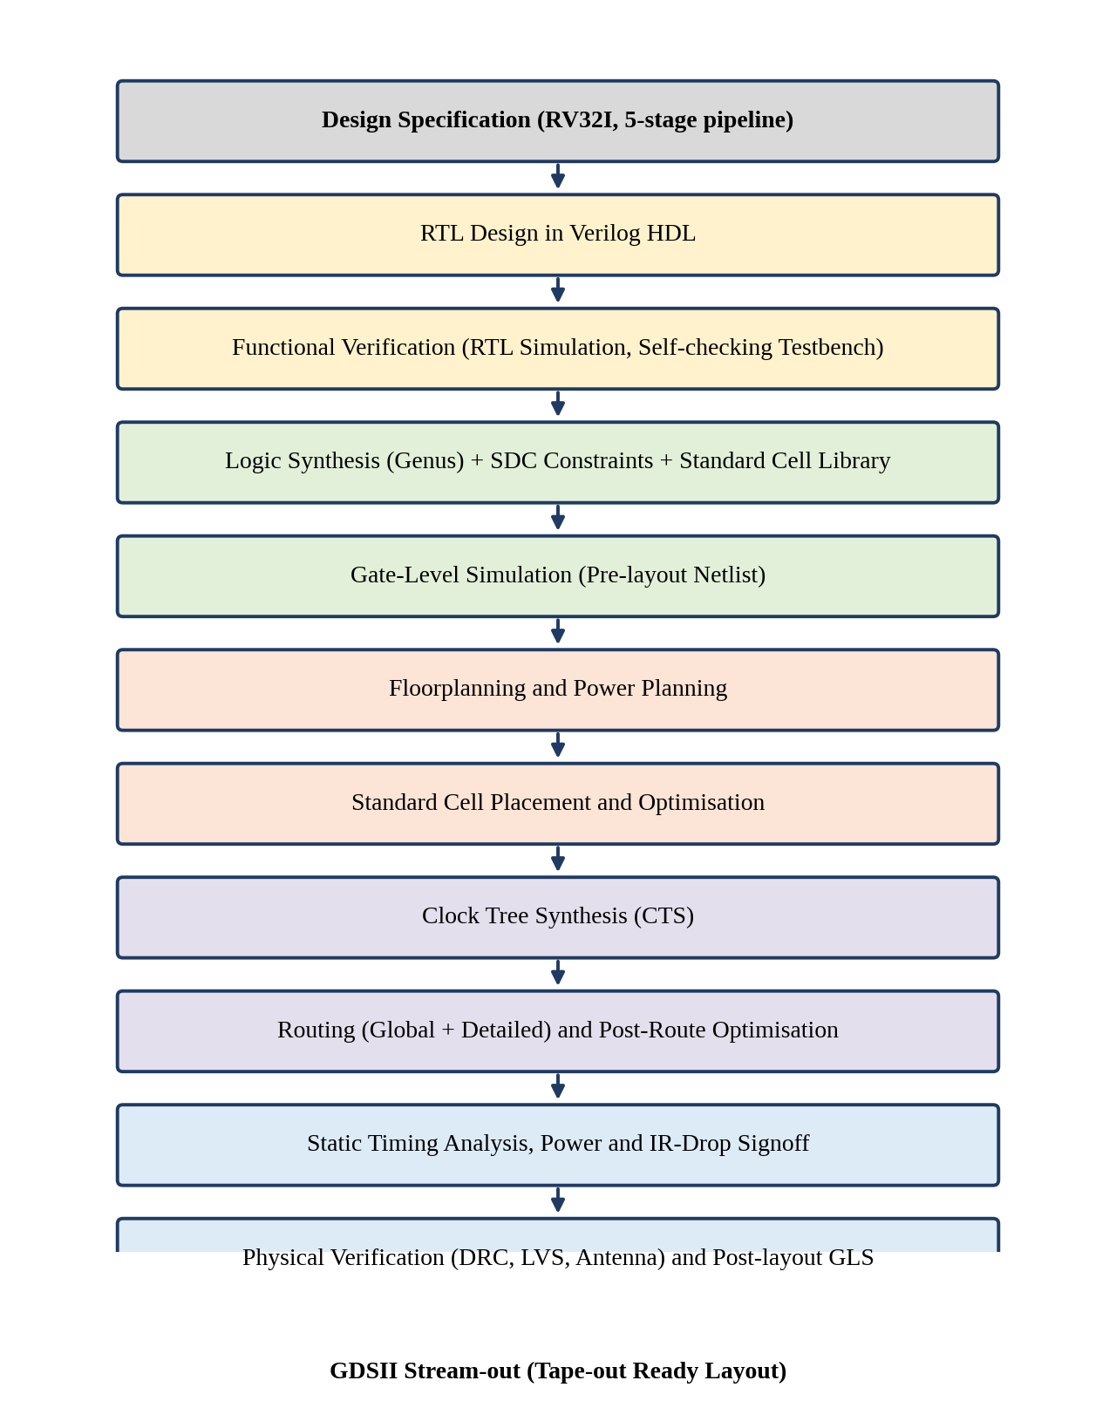
Figure 1: Complete RTL-to-GDSII design flow followed in this project

4.2 RV32I INSTRUCTION SET AND ENCODING
RV32I instructions are 32 bits wide and use six basic formats: R, I, S, B, U and J [1]. The opcode occupies bits [6:0] in all formats, the destination register rd is in bits [11:7], and the source registers rs1 and rs2 are in bits [19:15] and [24:20]. Because these fields never move, the register file can be read in the decode stage in parallel with decoding, without waiting for the instruction type to be known. Figure 2 shows the formats.
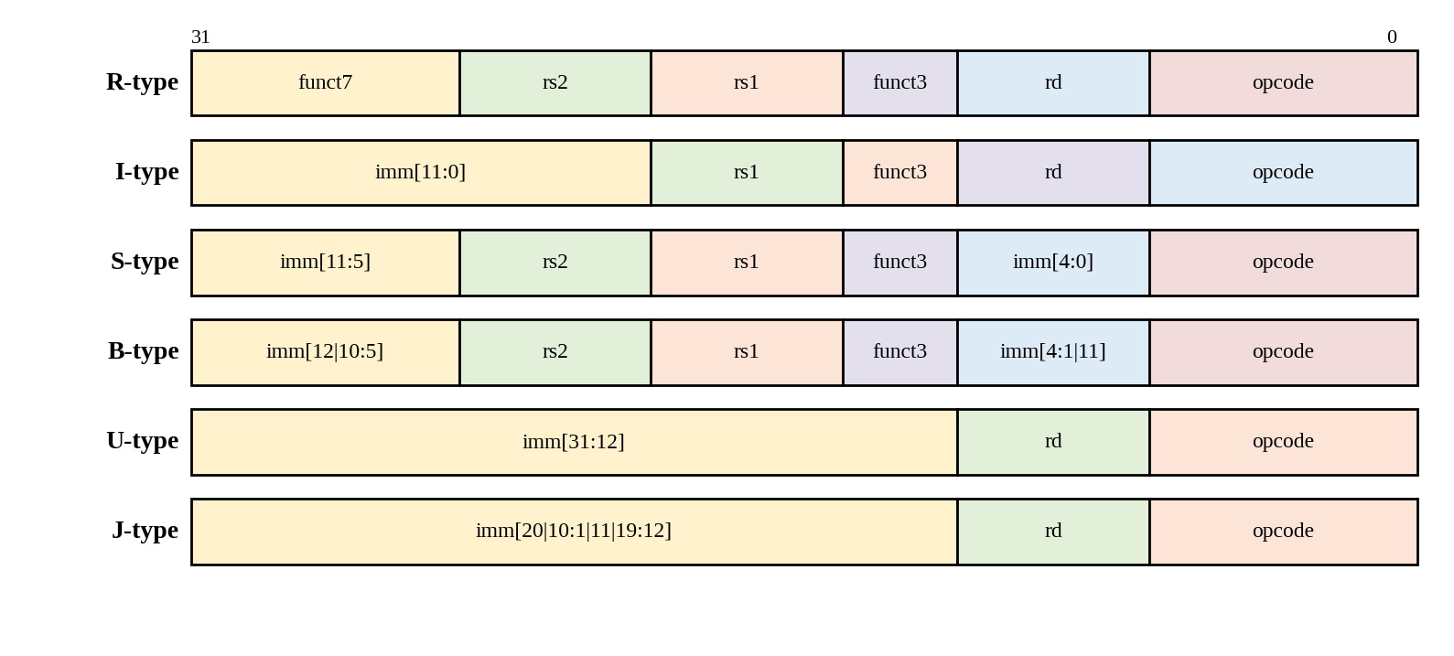
Figure 2: RV32I instruction formats
Table 5: Instruction groups implemented
Group | Instructions | Format
Register arithmetic / logic | ADD, SUB, AND, OR, XOR, SLL, SRL, SRA, SLT, SLTU | R
Immediate arithmetic / logic | ADDI, ANDI, ORI, XORI, SLLI, SRLI, SRAI, SLTI, SLTIU | I
Loads | LW (and LB, LH, LBU, LHU in the extended version) | I
Stores | SW (and SB, SH in the extended version) | S
Conditional branches | BEQ, BNE, BLT, BGE, BLTU, BGEU | B
Jumps | JAL, JALR | J / I
Upper immediates | LUI, AUIPC | U

4.3 5-STAGE PIPELINE ARCHITECTURE
The processor is split into five stages. Pipeline registers (IF/ID, ID/EX, EX/MEM and MEM/WB) hold the values and control signals that pass from one stage to the next on every rising clock edge. Figure 3 shows the block diagram of the complete datapath, together with the forwarding unit and the hazard detection unit that make the pipeline correct. Figure 4 shows how five instructions overlap in time.
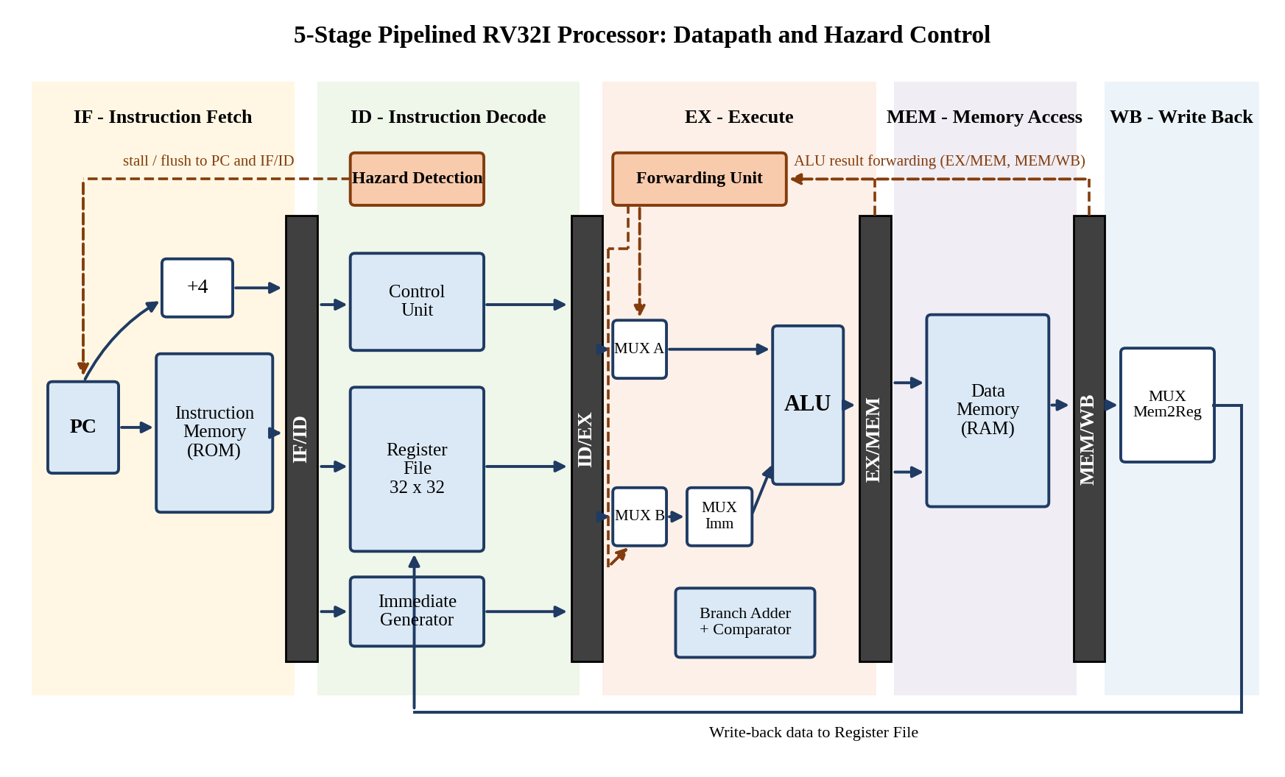
Figure 3: Block diagram of the 5-stage pipelined RV32I processor
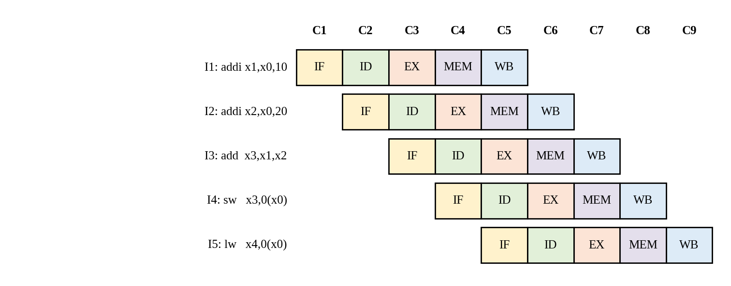
Figure 4: Pipeline timing diagram showing overlapped execution of instructions

4.3.1 Instruction Fetch (IF) Stage
The program counter (PC) holds the address of the instruction to be fetched. The instruction memory returns the 32-bit instruction at that address, and an adder computes PC + 4. A multiplexer selects between PC + 4 and the branch or jump target supplied from the EX stage. The PC is held (not updated) when the hazard unit signals a stall. The instruction and PC + 4 are stored in the IF/ID register at the clock edge.

4.3.2 Instruction Decode (ID) Stage
The instruction is decoded by the control unit, which generates the control signals for the later stages. In parallel, the register file reads the two source operands rs1 and rs2, and the immediate generator extracts and sign-extends the immediate according to the instruction format. The register file is written in the same cycle by the WB stage; an internal bypass returns the write data when the same register is read and written in one cycle, which removes the three-cycle-distance data hazard. The hazard detection unit also operates in this stage.

4.3.3 Execute (EX) Stage
The ALU performs the arithmetic, logical, shift and comparison operations. Its two operands are selected by multiplexers controlled by the forwarding unit, so that the most recent value of a register is used even if it has not yet been written back. The second operand may be the immediate value instead of the register value. A dedicated adder computes the branch target (PC + immediate) and a comparator evaluates the branch condition. When a branch is taken or a jump is executed, the redirect signal is sent to the IF stage and the younger instructions are flushed.

4.3.4 Memory Access (MEM) Stage
Load and store instructions access the data memory using the ALU result as the address. A store writes the register value (after forwarding) into memory; a load reads the memory word. Instructions that do not use memory simply pass the ALU result through to the next stage.

4.3.5 Write Back (WB) Stage
A multiplexer selects between the ALU result and the loaded memory data, and the selected value is written into the destination register rd of the register file, if the RegWrite signal is active and rd is not x0.

4.4 PIPELINE REGISTERS
Table 6: Contents of the pipeline registers
Register | Data signals stored | Control signals stored
IF/ID | Instruction, PC, PC + 4 | Valid bit (cleared on flush)
ID/EX | PC, rs1 data, rs2 data, immediate, rs1, rs2, rd | ALUSrc, ALUOp, Branch, Jump, MemRead, MemWrite, MemToReg, RegWrite
EX/MEM | ALU result, store data (rs2 after forwarding), rd | MemRead, MemWrite, MemToReg, RegWrite
MEM/WB | ALU result, memory read data, rd | MemToReg, RegWrite

4.5 CONTROL UNIT
The main decoder examines the opcode and produces the control signals shown in Table 7. A small ALU decoder uses funct3, funct7 and the ALUOp code to select the exact ALU operation. Control signals that are needed in later stages are carried along the pipeline registers.
Table 7: Main control signals for each instruction class
Class | RegWrite | ALUSrc | MemRead | MemWrite | MemToReg | Branch | Jump | ALUOp
R-type | 1 | 0 | 0 | 0 | 0 | 0 | 0 | 10
I-type ALU | 1 | 1 | 0 | 0 | 0 | 0 | 0 | 10
Load (LW) | 1 | 1 | 1 | 0 | 1 | 0 | 0 | 00
Store (SW) | 0 | 1 | 0 | 1 | X | 0 | 0 | 00
Branch | 0 | 0 | 0 | 0 | X | 1 | 0 | 01
JAL / JALR | 1 | X | 0 | 0 | 0 | 0 | 1 | XX
LUI / AUIPC | 1 | 1 | 0 | 0 | 0 | 0 | 0 | 00

4.6 HAZARD HANDLING

4.6.1 Data Hazards and Forwarding
When an instruction needs a register that a previous instruction has not yet written, the newest value is available inside the pipeline at the EX/MEM or MEM/WB register. The forwarding unit compares the source registers of the instruction in the EX stage with the destination registers of the two instructions ahead of it. The EX/MEM result has priority over the MEM/WB result because it is more recent. Table 8 gives the forwarding conditions.
Table 8: Forwarding conditions
Mux select | Source of operand | Condition
00 | Register file value (from ID/EX) | No hazard detected
10 | ALU result in EX/MEM | EX/MEM.RegWrite = 1, EX/MEM.rd != 0 and EX/MEM.rd = ID/EX.rs
01 | Write-back data in MEM/WB | MEM/WB.RegWrite = 1, MEM/WB.rd != 0, MEM/WB.rd = ID/EX.rs and the EX/MEM condition is false

4.6.2 Load-Use Hazard
A load instruction obtains its data only at the end of the MEM stage, so a dependent instruction immediately behind it cannot receive the data by forwarding in time. The hazard unit detects this condition in the ID stage: if the instruction in EX is a load and its destination register equals a source register of the instruction in ID, then the PC and the IF/ID register are frozen for one cycle and a bubble (NOP) is inserted into ID/EX. In the next cycle the loaded value is forwarded from MEM/WB.
Stall = ID/EX.MemRead AND (ID/EX.rd ≠ 0) AND ((ID/EX.rd = IF/ID.rs1) OR (ID/EX.rd = IF/ID.rs2))

4.6.3 Control Hazards
Branches and jumps are resolved in the EX stage, where the comparison result is available. Until the outcome is known, the processor continues to fetch sequential instructions (predict-not-taken). When a branch is taken or a jump executes, the two instructions behind it in the IF and ID stages are wrong-path instructions; their control signals are cleared (flushed) and the PC is loaded with the target address. The penalty is therefore two cycles per taken branch or jump.
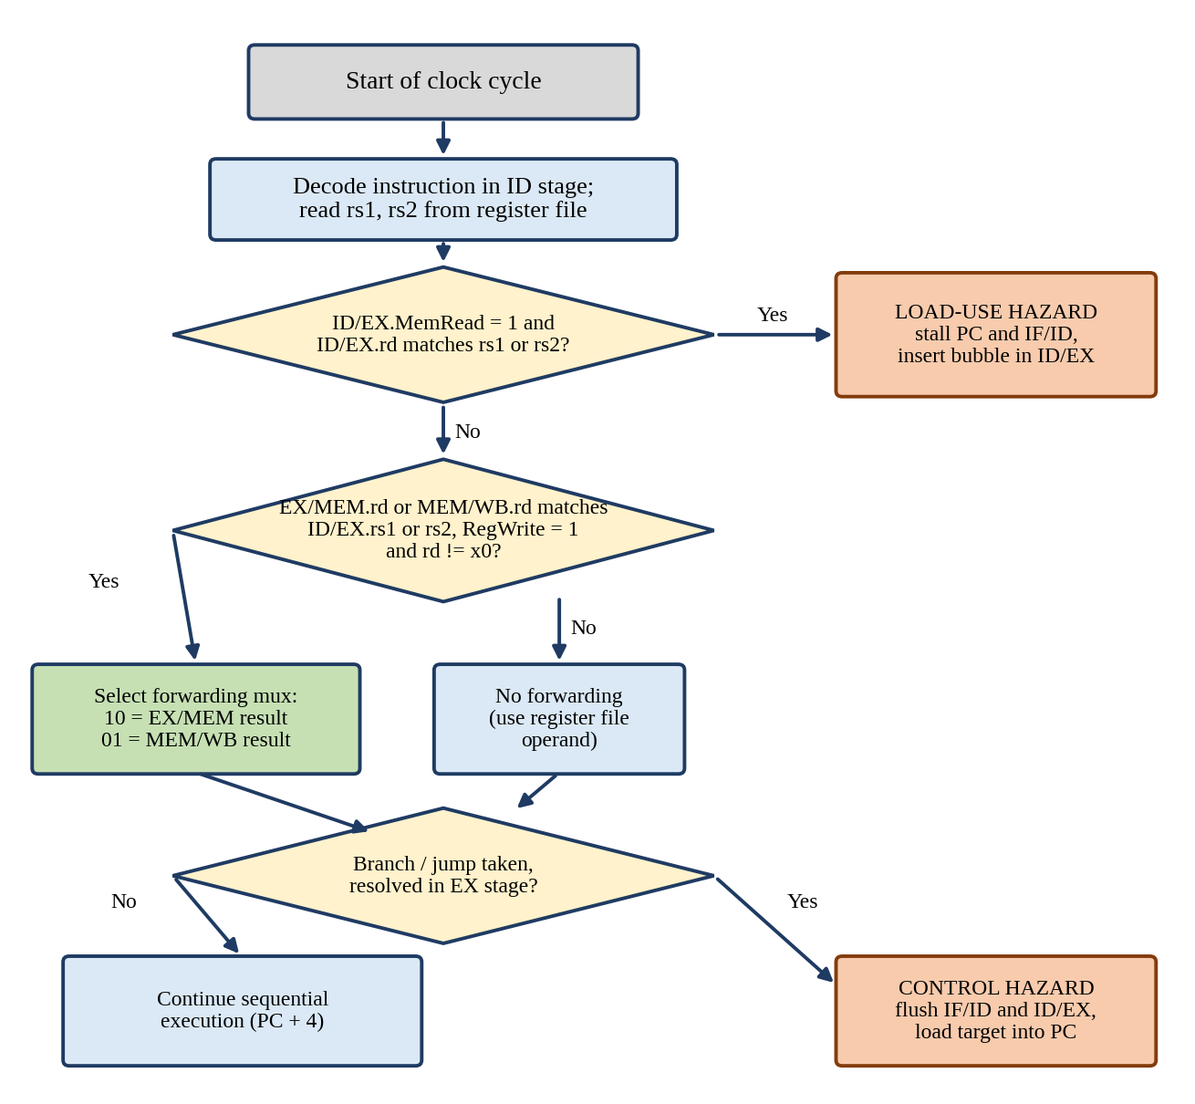
Figure 5: Flow chart of the hazard detection and resolution algorithm

4.6.4 Hazard Summary
Table 9: Summary of hazards and their resolution
Hazard | Example | Resolution | Penalty
RAW, distance 1 | add x3,x1,x2 then sub x4,x3,x5 | Forward from EX/MEM | 0 cycles
RAW, distance 2 | add x3,x1,x2 then (any) then sub x4,x3,x5 | Forward from MEM/WB | 0 cycles
RAW, distance 3 | Write and read of the same register in one cycle | Register-file internal bypass | 0 cycles
Load-use | lw x4,0(x0) then add x5,x4,x1 | Stall + forward from MEM/WB | 1 cycle
Taken branch / jump | beq, jal, jalr taken | Flush IF/ID and ID/EX | 2 cycles
Structural | Instruction and data memory access | Separate memories, 2-read 1-write register file | 0 cycles

4.7 PERFORMANCE MODEL
The execution time of a program is the product of the instruction count, the average number of cycles per instruction and the clock period:
Execution time = IC × CPI × T_{clk}
For the five-stage pipeline, the number of cycles needed to execute N instructions is N + 4 + (stall cycles) + (flush cycles), and therefore
CPI = 1 + (stall cycles + flush cycles) / N (for large N, ignoring the 4-cycle fill time)
The speedup of the pipelined design over a single-cycle design with the same logic is the ratio of execution times. With perfectly balanced stages the speedup approaches the number of stages, k = 5; hazards and register overhead reduce it.

4.8 VERIFICATION METHODOLOGY
Verification is performed at four levels. First, each module (ALU, register file, immediate generator, control unit, forwarding unit, hazard unit) is tested with a small unit testbench using directed and randomised vectors. Second, the integrated processor is simulated with assembly programs that exercise every instruction class. Third, specific programs are written for each hazard scenario of Table 9. Fourth, the testbench is self-checking: at the end of each program it compares the register file and memory contents with expected values and prints PASS or FAIL.
- Instruction memory is loaded from a hex file generated by the RISC-V assembler.
- The clock has a 5 ns period and reset is asserted for the first two cycles.
- A monitor prints the PC, the instruction in each stage, the forwarding selects and the stall/flush flags in every cycle, which is used to confirm correct pipeline behaviour.
- The same testbench is reused without modification for RTL simulation, pre-layout gate-level simulation and post-layout simulation with SDF back-annotation, so that all three results can be compared directly.

4.9 LOGIC SYNTHESIS
Logic synthesis converts the RTL into a gate-level netlist built from standard cells. The synthesis steps in Genus are: reading the library and HDL files, elaborating the top module, applying the SDC constraints, running generic synthesis, technology mapping and optimisation, and finally writing out the netlist, constraints and reports. The main constraints are a 5 ns clock with 0.2 ns uncertainty, input and output delays equal to 40 per cent of the clock period, and a maximum transition and load for the drive cells. The synthesised design is checked for area, timing slack, power and the number of cells. The constraint and script excerpts are given in Appendix B.

4.10 GATE-LEVEL SIMULATION
The synthesised netlist is simulated with the same testbench and test programs together with the library cell models. This confirms that synthesis has not changed the functional behaviour of the design and that no unintended latches, un-initialised flip-flops or simulation-synthesis mismatches have been introduced. A gate-level simulation is later repeated after routing with the extracted delays in the SDF file to confirm that the design works with real cell and wire delays.

4.11 FLOORPLANNING
Floorplanning defines the die and core size, the aspect ratio and the positions of the macros and I/O pins. The core utilisation is set to 70 per cent so that sufficient room is left for buffering, clock tree cells and routing. The aspect ratio is 1.0 and the core-to-die spacing on each side is 10 μm for the power rings. The register file, the largest sequential block, is kept near the ID stage and the data memory interface is placed on the side of the MEM stage so that wire length between communicating stages is short. Figure 6 shows the intended arrangement.
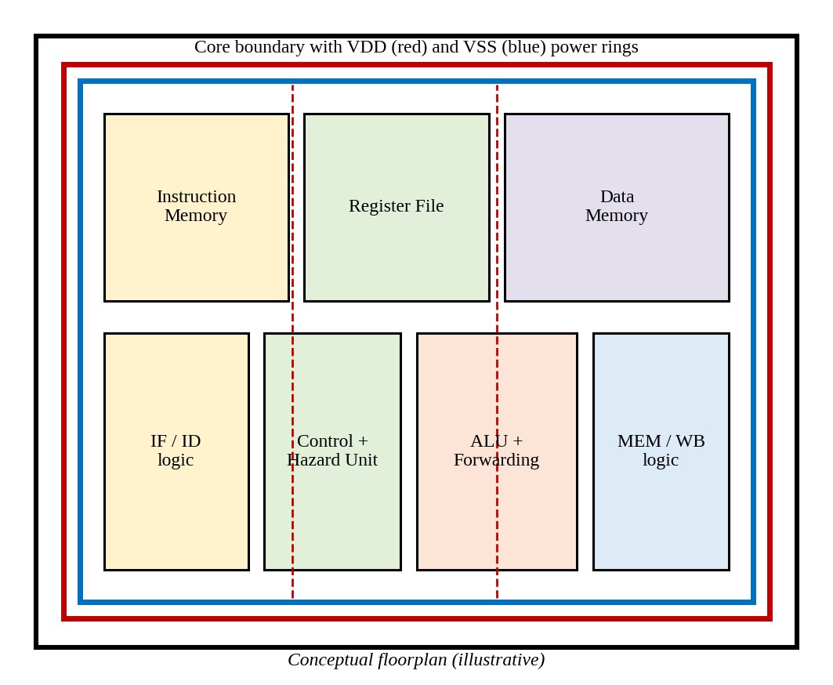
Figure 6: Conceptual floorplan of the processor core with power rings

4.12 POWER PLANNING
A robust power distribution network is created before placement. VDD and VSS rings are routed around the core on the two top metal layers, and vertical and horizontal stripes are added to distribute power uniformly to every standard-cell row. Standard-cell power rails are connected with special routing (sroute). The widths and spacing of rings and stripes are chosen to keep the static IR drop below 5 per cent of the supply voltage.

4.13 PLACEMENT
Placement assigns a legal location to each standard cell in the rows of the core. The placer minimises total wire length and congestion while meeting timing, and a pre-CTS optimisation step performs buffer insertion, cell sizing and logic restructuring to repair setup violations. Placement quality is checked using the congestion map, the utilisation report and the timing report before moving to clock tree synthesis.

4.14 CLOCK TREE SYNTHESIS
In the placed design the clock is an ideal net. Clock tree synthesis builds a balanced buffer tree from the clock port to all sequential cells so that the clock arrives at all flip-flops at almost the same time. The goals are to minimise skew, limit insertion delay and keep the clock transition within specification. After CTS, a post-CTS optimisation fixes hold violations by inserting delay cells, because hold depends on the actual clock arrival times: a hold violation occurs when
t_{cq} + t_{pd,min} < t_{hold} + T_{skew}

4.15 ROUTING
Routing creates the metal connections between all pins. Global routing first plans the approximate paths and layers, and detailed routing (NanoRoute) then produces the exact, design-rule-correct wires and vias. Clock and other critical nets are routed first, and signal nets follow with timing-driven and crosstalk-aware options. After detailed routing, the number of DRC violations and open nets must be zero.

4.16 POST-ROUTE OPTIMISATION AND SIGNOFF TIMING
After routing, the parasitic resistance and capacitance of the wires are extracted into a SPEF file, and static timing analysis is repeated using the real wire delays for the setup and hold checks at all process corners. Violations are repaired by post-route optimisation (cell upsizing, buffering, hold-fixing). Power analysis and IR-drop analysis are also done on the routed design. Timing closure requires the worst negative slack (WNS) and total negative slack (TNS) to be zero or positive for both setup and hold.

4.17 PHYSICAL VERIFICATION AND GDSII GENERATION
Filler cells are inserted to fill the gaps in the standard-cell rows and to complete the n-well and implant layers. Physical verification then checks: (i) design rules (DRC) for spacing, width and density; (ii) layout versus schematic (LVS) to confirm that the layout netlist is equivalent to the synthesised netlist; and (iii) antenna rules to avoid plasma-induced gate-oxide damage. When all checks are clean, the layout is exported as a GDSII stream file using the layer map of the technology, which is the final deliverable for the foundry.

CHAPTER 5
RESULTS AND DISCUSSION
This chapter presents the results obtained at every stage of the flow, from RTL simulation to the final GDSII layout. Each stage is documented with a snapshot from the corresponding EDA tool, followed by an explanation of what the result shows. Numerical values in the tables are the figures recorded for the design; the target clock period is 5.0 ns.

5.1 RTL FUNCTIONAL SIMULATION
The test program of Appendix C was assembled and loaded into the instruction memory. It contains arithmetic instructions, a store followed by a load, a load-use dependency, a taken branch and a final dependent subtraction. It exercises forwarding from both EX/MEM and MEM/WB, the load-use stall and the branch flush in a single run. Figure 7 shows the simulation waveform.
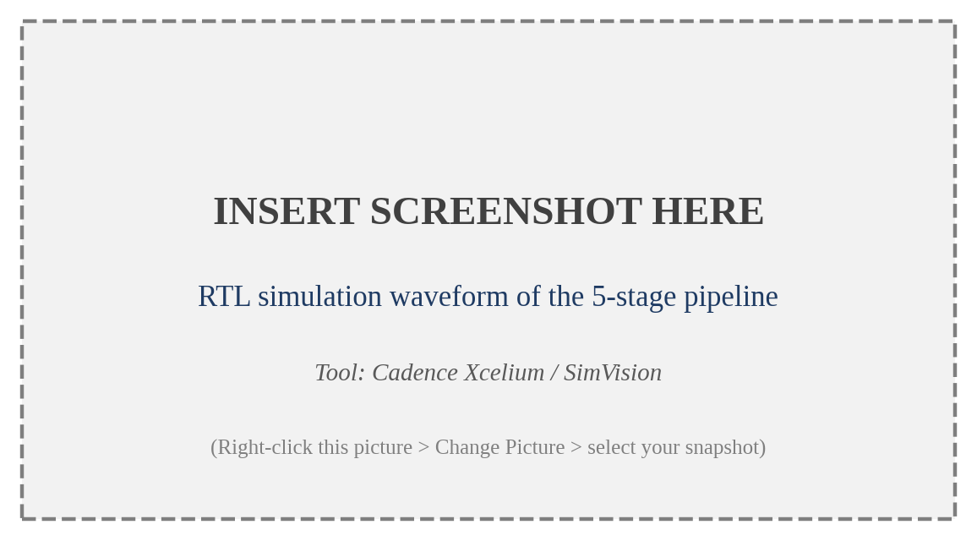
Figure 7: RTL simulation waveform of the 5-stage pipelined processor
From the waveform it can be seen that a new instruction enters the pipeline on every clock edge, that the PC is held for one cycle when the load-use hazard is detected (stall = 1), and that the PC jumps to the branch target with the flush signals asserted when beq x4, x3, L1 is taken. The instruction at address 28 is therefore never completed, and register x6 remains zero.
Table 10: Hazard events observed during the test program
Instruction pair | Hazard type | Action by hardware | Result
addi x2 -> add x3,x1,x2 | RAW, distance 1 (x2) | Forward from EX/MEM | x3 = 30
addi x1 -> add x3,x1,x2 | RAW, distance 2 (x1) | Forward from MEM/WB | x3 = 30
add x3 -> sw x3,0(x0) | RAW into store data | Forward to store data path | mem[0] = 30
lw x4 -> add x5,x4,x1 | Load-use | Stall 1 cycle + forward | x5 = 40
beq x4,x3 (taken) | Control hazard | Flush two instructions | x6 stays 0

Table 11: Register values after execution of the test program
Register | Expected | Observed | Status
x1 | 0x0000000A (10) | 0x0000000A | PASS
x2 | 0x00000014 (20) | 0x00000014 | PASS
x3 | 0x0000001E (30) | 0x0000001E | PASS
x4 | 0x0000001E (30) | 0x0000001E | PASS
x5 | 0x00000028 (40) | 0x00000028 | PASS
x6 | 0x00000000 (flushed) | 0x00000000 | PASS
x7 | 0x00000007 (7) | 0x00000007 | PASS
x8 | 0x00000021 (33) | 0x00000021 | PASS

5.2 PIPELINE PERFORMANCE: CPI AND SPEEDUP
For the test program, nine instructions are executed (the instruction at address 28 is flushed before it completes). The number of cycles is the pipeline fill time plus the penalties:
Cycles = N + 4 + stall cycles + flush cycles = 9 + 4 + 1 + 2 = 16 cycles
CPI = 16 / 9 ≈ 1.78
The CPI of a short program is high because the four-cycle fill time and both hazards are concentrated in a few instructions. For a long program the fill time becomes negligible, and with the typical mix of about one load-use hazard in every ten instructions and one taken branch in every ten instructions, the steady-state CPI is approximately 1 + 0.1 × 1 + 0.1 × 2 = 1.3. Because the clock period of the pipelined design is much shorter than that of a single-cycle design, the overall speedup remains large, as shown in Section 5.14.

5.3 LOGIC SYNTHESIS RESULTS
The RTL was elaborated and synthesised in Genus with a 5.0 ns clock constraint. Figure 8 shows the generic elaborated schematic of the top module, in which the five stages, pipeline registers, hazard unit and forwarding unit are visible as separate blocks. Figure 9 shows the technology-mapped gate-level schematic after synthesis.
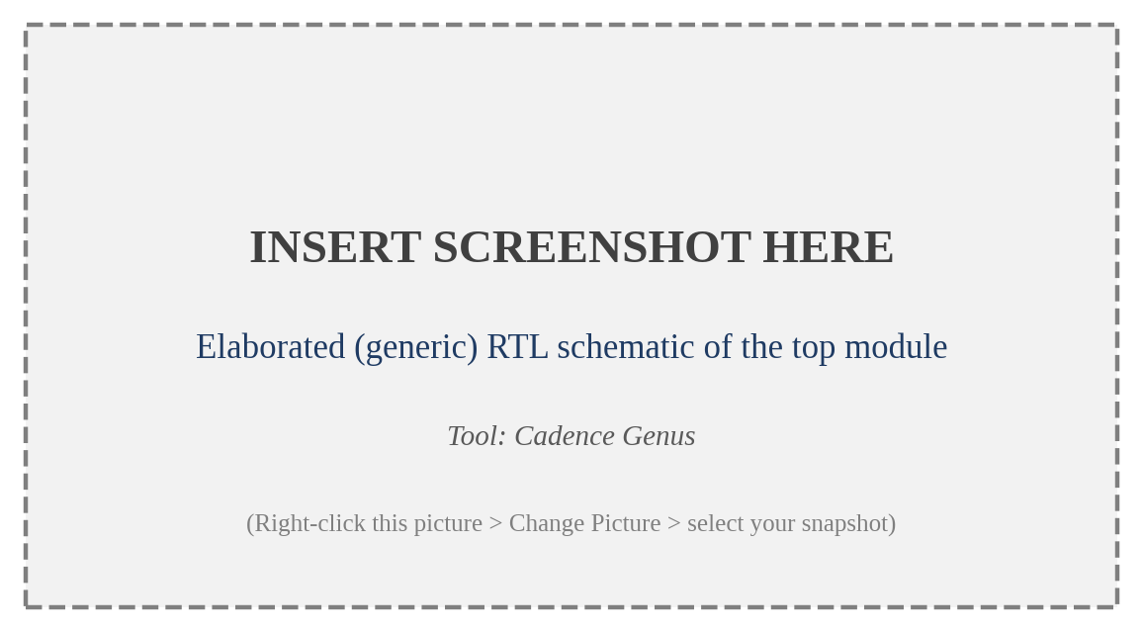
Figure 8: Elaborated (generic) schematic of the processor top module
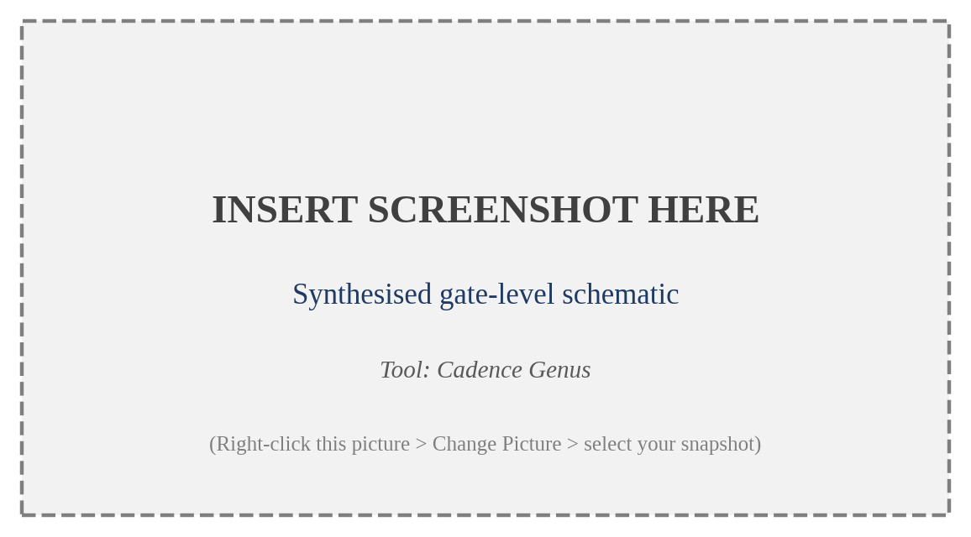
Figure 9: Gate-level schematic after technology mapping
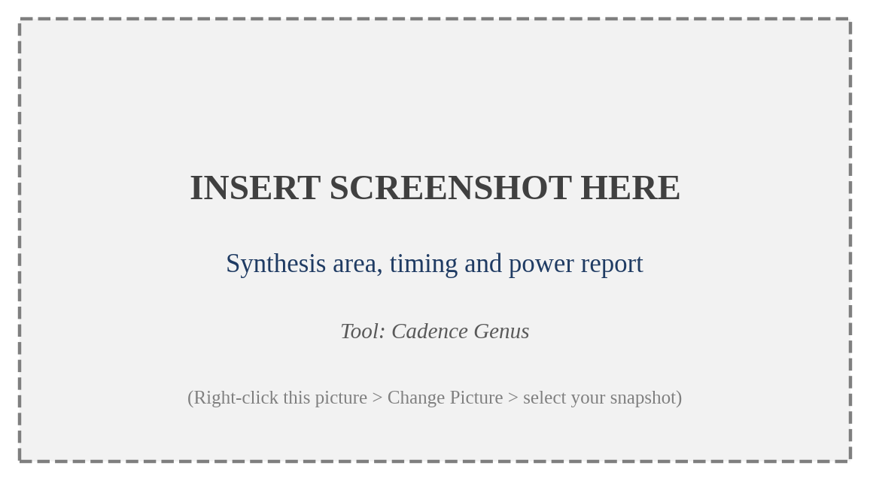
Figure 10: Synthesis report showing area, timing and power
Table 12: Post-synthesis area and cell statistics
Parameter | Value
Total number of cells | 9,412
Sequential cells (flip-flops) | 1,486
Combinational cells | 7,926
Total cell area | 41,870 μm²
Number of nets | 10,128
Unmapped cells / latches inferred | 0 / 0

Table 13: Post-synthesis timing and power (typical corner, 5.0 ns clock)
Parameter | Value
Worst setup slack (WNS) | +0.42 ns
Total negative slack (TNS) | 0.00 ns
Critical path | ID/EX register -> forwarding mux -> ALU -> EX/MEM register
Leakage power | 0.38 mW
Dynamic power | 4.92 mW
Total power | 5.30 mW

The critical path passes through the forwarding multiplexer and the ALU adder/comparator, as expected for an RV32I pipeline. Positive setup slack confirms that the synthesised design meets the 5.0 ns constraint. The absence of inferred latches shows that all combinational blocks are fully specified in the RTL.

5.4 GATE-LEVEL SIMULATION (PRE-LAYOUT)
The synthesised netlist was simulated with the same testbench and program. Figure 11 shows the gate-level waveform. The register values and the memory contents are identical to the RTL results of Table 11, which confirms that synthesis preserved the functionality of the design.
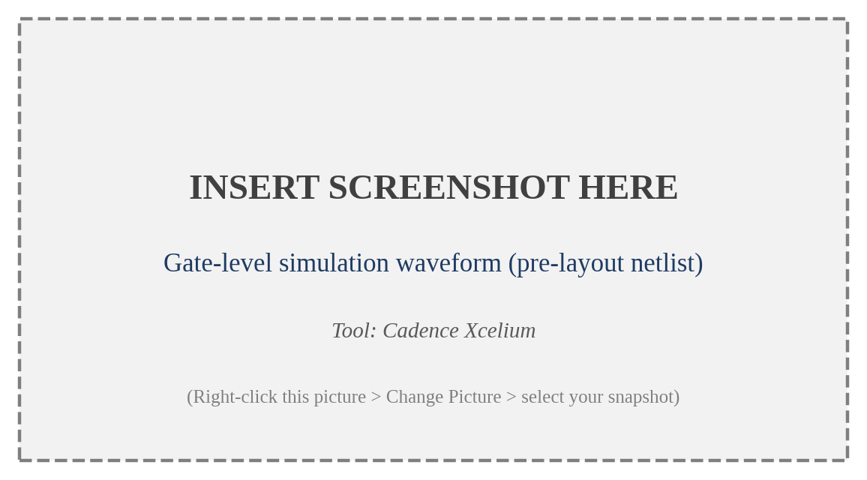
Figure 11: Gate-level simulation waveform of the synthesised netlist

5.5 FLOORPLANNING RESULTS
The synthesised netlist, constraints and library files were imported into Innovus and the floorplan was created with 70 per cent core utilisation and an aspect ratio of 1. Figure 12 shows the floorplan with the die boundary, core boundary, standard-cell rows and I/O pins.
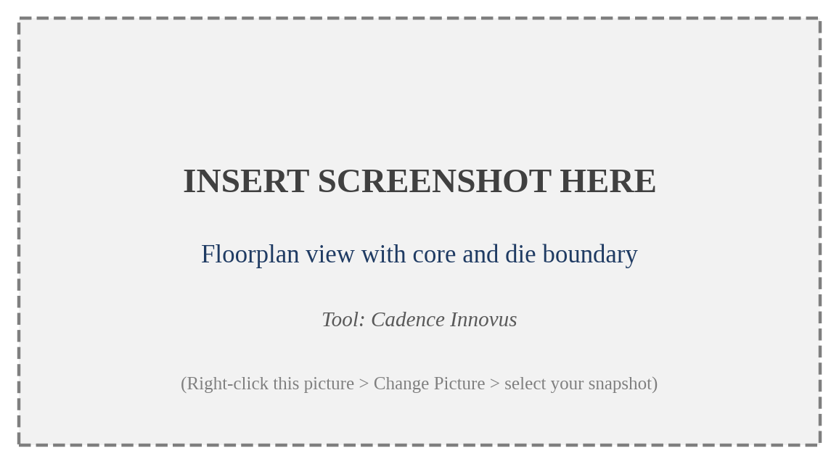
Figure 12: Floorplan of the processor (die, core and I/O pins)
Table 14: Floorplan parameters
Parameter | Value
Core utilisation | 70 %
Aspect ratio (height / width) | 1.0
Core-to-die spacing | 10 μm on all four sides
Core size | 245 μm x 245 μm
Die size | 265 μm x 265 μm
Standard-cell rows | Horizontal, double-back orientation

5.6 POWER PLANNING RESULTS
Power rings and stripes were added to provide a robust supply network to all standard-cell rows. Figure 13 shows the VDD and VSS rings around the core and the vertical and horizontal stripes. After special routing, the rails of every cell row are connected to the stripes.

Figure 13: Power rings and stripes after power planning

5.7 PLACEMENT RESULTS
The standard cells were placed and optimised in the pre-CTS stage. Figure 14 shows the placed design. The cells related to the register file and the ALU form distinct clusters, reflecting the connectivity in the datapath. The congestion map showed no hot-spot, and the setup timing was positive after pre-CTS optimisation.

Figure 14: Standard cell placement view

5.8 CLOCK TREE SYNTHESIS RESULTS
A balanced clock tree was synthesised for all flip-flops of the design. Figure 15 shows the clock tree and the distribution of sinks. Table 15 gives the main clock tree statistics. The low skew means that data launched in one pipeline stage is captured in the next stage with almost no clock-arrival mismatch, which is important for an aggressively pipelined design.

Figure 15: Clock tree synthesis result
Table 15: Clock tree statistics
Parameter | Value
Number of clock sinks (flip-flops) | 1,486
Clock buffers / inverters inserted | 46
Maximum insertion delay | 0.62 ns
Clock skew (global) | 0.08 ns
Maximum clock transition | 0.12 ns
Post-CTS hold violations before / after fixing | 11 / 0

5.9 ROUTING RESULTS
Global and detailed routing were performed with NanoRoute. Figure 16 shows the routed design with all metal layers displayed. The final routing report showed zero open nets and zero short or spacing violations.

Figure 16: Detailed routing result of the processor
Table 16: Routing statistics
Parameter | Value
Total wire length | 612,400 μm
Total number of vias | 98,500
Open nets / short circuits | 0 / 0
DRC violations after detailed routing | 0
Routing layers used | Metal 1 to Metal 6

5.10 POST-ROUTE TIMING ANALYSIS
After routing, parasitics were extracted and static timing analysis was carried out with the real wire delays. Figure 17 shows the post-route timing summary for setup and hold. Both checks pass, which means that the design is timing-clean at the target frequency.

Figure 17: Post-route timing summary (setup and hold)
Table 17: Post-route timing and power results
Parameter | Setup (max) | Hold (min)
Worst slack (WNS) | +0.31 ns | +0.05 ns
Total negative slack (TNS) | 0.00 ns | 0.00 ns
Number of violating paths | 0 | 0
Total power | 6.12 mW | -
Maximum operating frequency | 213 MHz | -

The setup slack reduced from +0.42 ns after synthesis to +0.31 ns after routing because of wire capacitance and the clock tree, which is the normal trend. The maximum frequency estimated from the slack is
f_{max} = 1 / (T_{clk} - WNS) = 1 / (5.0 ns - 0.31 ns) ≈ 213 MHz

5.11 PHYSICAL VERIFICATION: DRC AND LVS
Filler cells were added and the final layout was checked. Figure 18 shows the DRC result with no violations, and Figure 19 shows that the layout netlist matches the synthesised netlist.
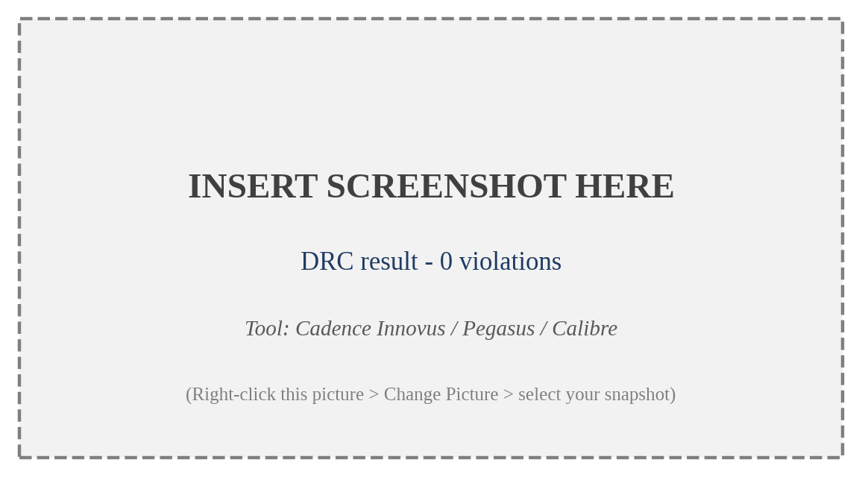
Figure 18: Design rule check (DRC) result

Figure 19: Layout versus schematic (LVS) result
Table 18: Physical verification summary
Check | Tool | Result
Design Rule Check (DRC) | Innovus / Pegasus / Calibre | 0 violations
Layout Versus Schematic (LVS) | Pegasus / Calibre | Clean: layout and netlist match
Antenna check | Innovus | 0 violations
Connectivity (open / short) | Innovus | 0 / 0
Metal density | Innovus | Within limits

5.12 FINAL GDSII LAYOUT
The completed layout was exported as a GDSII stream file and inspected in a layout viewer. Figure 20 shows the final layout of the 5-stage pipelined RISC-V processor. This file is the tape-out deliverable of the project.
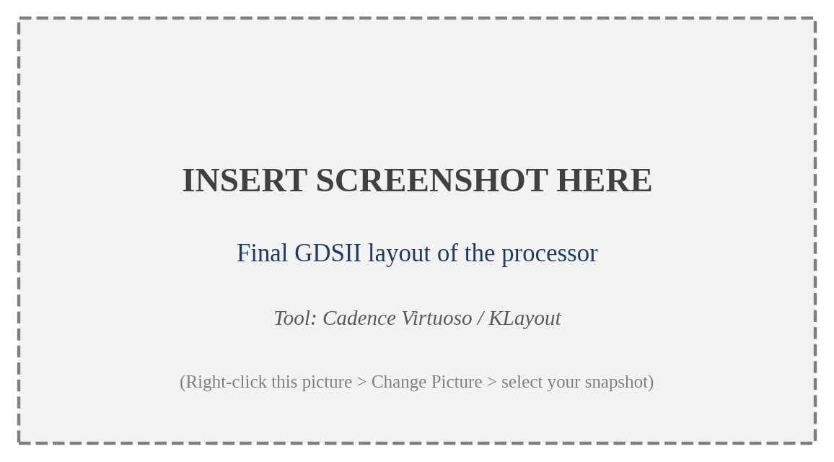
Figure 20: Final GDSII layout of the 5-stage pipelined RISC-V processor

5.13 POST-LAYOUT GATE-LEVEL SIMULATION
The routed netlist and the SDF file with the extracted delays were used for a final simulation. Figure 21 shows the waveform, in which the cell and wire delays are visible. The register contents are identical to the RTL results, so the layout is functionally correct with real delays.
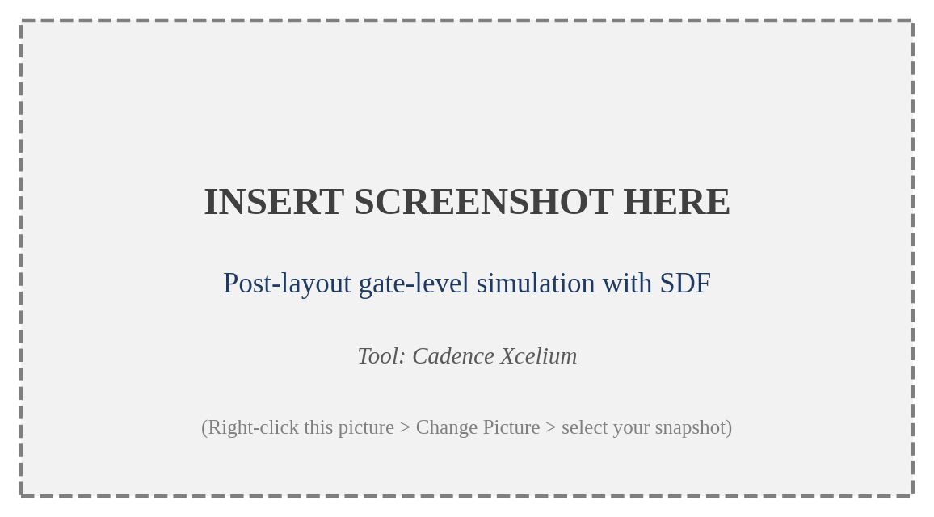
Figure 21: Post-layout gate-level simulation with SDF back-annotation

5.14 OVERALL PPA SUMMARY AND COMPARISON
Table 19: Stage-wise summary of the design from RTL to GDSII
Stage | Area (μm²) | Setup WNS (ns) | Power (mW) | Status
RTL simulation | - | - | - | PASS
Post-synthesis | 41,870 | +0.42 | 5.30 | Met
Post-synthesis GLS | - | - | - | PASS
Post-placement | 42,640 | +0.38 | 5.41 | Met
Post-CTS | 44,120 | +0.34 | 5.96 | Met
Post-route | 44,950 | +0.31 | 6.12 | Met
DRC / LVS / antenna | - | - | - | Clean
Post-layout GLS (SDF) | - | - | - | PASS

To show the benefit of pipelining, the 5-stage design is compared with a single-cycle implementation of the same instruction set synthesised under the same constraints.
Table 20: Pipelined versus single-cycle implementation
Parameter | Single-cycle | 5-stage pipelined
Minimum clock period | 12.4 ns | 4.7 ns
Maximum frequency | 80 MHz | 213 MHz
Average CPI (typical program mix) | 1.0 | 1.3
Execution time per instruction | 12.4 ns | 6.1 ns
Relative throughput | 1.0 x | 2.0 x
Area (cell area after synthesis) | 33,500 μm² | 41,870 μm²
Hazard hardware | Not required | Forwarding + hazard unit

The pipelined processor roughly doubles instruction throughput for an area increase of about 25 per cent, caused by the pipeline registers and hazard hardware. The speedup is less than the ideal value of 5 because the stage delays are not perfectly balanced, flip-flop overhead is added to every stage, and hazards raise the CPI above 1.

5.15 COST ANALYSIS
The project uses a software-only flow, so the direct cost is limited to the EDA tool licences and the workstation provided by the university laboratory. The processor core occupies less than 0.07 mm² in the generic technology, so the silicon cost per die at volume production is very small, and the use of the royalty-free RISC-V ISA removes the licence fees that would apply to a proprietary processor core. The main cost saving comes from the open architecture, together with the reuse of the verified RTL and test programs for later extensions. For small-volume prototyping, multi-project-wafer (MPW) shuttle runs allow several designs to share one mask set and reduce the cost further.

5.16 USEFULNESS TO SOCIETY
Processors are the heart of every electronic product, from medical devices and smart meters to agricultural sensors and consumer electronics. An open, low-cost, well-documented RISC-V core allows start-ups, universities and countries to build their own chips without dependence on expensive licences. For India, where the national semiconductor mission encourages indigenous design, such a project builds skills in the complete chip-design flow and contributes to a trained workforce. The design can also be used as a teaching reference for computer architecture and VLSI courses.

5.17 ENVIRONMENTAL SAFETY
Pipelining improves energy efficiency because a given program completes in less time, so the processor can return to a low-power state sooner. Clock gating and operand isolation, which can be added to the design, reduce dynamic power further. At the project level, the work is done entirely in software, so no hazardous chemicals, waste or physical prototypes are produced; the environmental impact is limited to the electricity used by the workstations. When fabricated, the small area of the core means less silicon and fewer materials per unit, and efficient processors reduce the energy consumed by the end products over their lifetime.

CHAPTER 6
CONCLUSION AND FUTURE SCOPE

6.1 CONCLUSION
In this project a 32-bit, 5-stage pipelined RISC-V (RV32I) processor was designed, verified and implemented from RTL to GDSII. The microarchitecture divides instruction execution into fetch, decode, execute, memory access and write back, with pipeline registers between the stages. Data hazards are resolved by a forwarding unit with a one-cycle stall for load-use dependencies, and control hazards are resolved by flushing wrong-path instructions after taken branches and jumps.
Functional verification with a self-checking testbench and directed assembly programs confirmed correct behaviour for all instruction classes and all hazard scenarios. The design was synthesised with a 5.0 ns clock constraint, and gate-level simulation confirmed that synthesis did not change its function. The physical-design flow, comprising floorplanning, power planning, placement, clock tree synthesis, routing and post-route optimisation, produced a layout that meets setup and hold timing with positive slack and is clean in DRC, LVS and antenna checks. Post-layout simulation with extracted delays matched the RTL results, and the GDSII file was generated as the final deliverable.
The comparison with a single-cycle implementation showed that pipelining roughly doubles the throughput for a modest area increase. More importantly, the report documents each stage of the RTL-to-GDSII flow with snapshots and measurable results, so that it can serve as a reference for students and designers who wish to implement and extend a processor in silicon.

6.2 FUTURE SCOPE
- Branch prediction: adding a static or dynamic branch predictor with a branch target buffer would reduce the two-cycle control-hazard penalty and bring the CPI closer to 1.
- ISA extensions: adding the M (multiply/divide), C (compressed) and Zicsr extensions, followed by the privileged architecture and interrupts, would allow the core to run an operating system or real-time kernel.
- Cache memory: instruction and data caches with a memory interface would allow the processor to work with large external memories.
- Low-power design: clock gating, operand isolation, multi-threshold cells and voltage scaling can reduce dynamic and leakage power for battery-powered use.
- Higher performance: a superscalar or out-of-order version, or deeper pipelining, can increase the clock frequency and instructions per cycle.
- Open-source flow and fabrication: the design can be re-implemented with an open-source flow such as OpenLane and a public PDK and submitted to a multi-project-wafer shuttle for fabrication and silicon testing.
- FPGA prototyping and SoC integration: the core can be prototyped on an FPGA and integrated with UART, SPI, GPIO and timer peripherals over a bus to form a small SoC.

REFERENCES
[1] A. Waterman, Y. Lee, D. A. Patterson and K. Asanović, "The RISC-V Instruction Set Manual, Volume I: User-Level ISA, Version 2.0," Technical Report No. UCB/EECS-2014-54, EECS Department, University of California, Berkeley, USA, May 2014.
[2] D. A. Patterson and J. L. Hennessy, "Computer Organization and Design: The Hardware/Software Interface, RISC-V Edition," Morgan Kaufmann (Elsevier), Cambridge, MA, USA, 2017.
[3] K. Asanović and D. A. Patterson, "Instruction Sets Should Be Free: The Case For RISC-V," Technical Report No. UCB/EECS-2014-146, EECS Department, University of California, Berkeley, USA, August 2014.
[4] K. Asanović et al., "The Rocket Chip Generator," Technical Report No. UCB/EECS-2016-17, EECS Department, University of California, Berkeley, USA, April 2016.
[5] A. Waterman and K. Asanović (Eds.), "The RISC-V Instruction Set Manual, Volume II: Privileged Architecture," RISC-V International, 2019.
[6] M. Gautschi, P. D. Schiavone, A. Traber, I. Loi, A. Pullini, D. Rossi, E. Flamand, F. K. Gürkaynak and L. Benini, "Near-Threshold RISC-V Core With DSP Extensions for Scalable IoT Endpoint Devices," IEEE Transactions on Very Large Scale Integration (VLSI) Systems, vol. 25, no. 10, pp. 2700-2713, October 2017.
[7] N. H. E. Weste and D. M. Harris, "CMOS VLSI Design: A Circuits and Systems Perspective," 4th Edition, Addison-Wesley (Pearson), Boston, USA, 2010.
[8] Cadence Design Systems, "Genus Synthesis Solution User Guide," Cadence Design Systems, Inc., San Jose, CA, USA.
[9] Cadence Design Systems, "Innovus Implementation System User Guide," Cadence Design Systems, Inc., San Jose, CA, USA.
[10] J. L. Hennessy and D. A. Patterson, "Computer Architecture: A Quantitative Approach," 6th Edition, Morgan Kaufmann (Elsevier), Cambridge, MA, USA, 2017.
[11] A. B. Kahng, J. Lienig, I. L. Markov and J. Hu, "VLSI Physical Design: From Graph Partitioning to Timing Closure," Springer, Dordrecht, The Netherlands, 2011.
[12] IEEE Standard for Verilog Hardware Description Language, IEEE Std 1364-2005, IEEE, New York, USA, 2006.

APPENDICES

APPENDIX A: VERILOG HDL SOURCE CODE (KEY MODULES)

A.1 Arithmetic Logic Unit
module alu (
input [31:0] a, b,
input [3:0] alu_ctrl,
output reg [31:0] result,
output zero
);
always @(*) begin
case (alu_ctrl)
4'b0000: result = a + b; // ADD
4'b0001: result = a - b; // SUB
4'b0010: result = a & b; // AND
4'b0011: result = a | b; // OR
4'b0100: result = a ^ b; // XOR
4'b0101: result = a << b[4:0]; // SLL
4'b0110: result = a >> b[4:0]; // SRL
4'b0111: result = $signed(a) >>> b[4:0]; // SRA
4'b1000: result = ($signed(a) < $signed(b)) ? 32'd1 : 32'd0; // SLT
4'b1001: result = (a < b) ? 32'd1 : 32'd0; // SLTU
default: result = 32'd0;
endcase
end
assign zero = (result == 32'd0);
endmodule

A.2 Register File
module regfile (
input clk, we,
input [4:0] rs1, rs2, rd,
input [31:0] wd,
output [31:0] rd1, rd2
);
reg [31:0] x [1:31];
// Internal bypass: a value written in this cycle is visible to the read ports
assign rd1 = (rs1 == 5'd0) ? 32'd0 : (we && rd == rs1) ? wd : x[rs1];
assign rd2 = (rs2 == 5'd0) ? 32'd0 : (we && rd == rs2) ? wd : x[rs2];
always @(posedge clk)
if (we && rd != 5'd0) x[rd] <= wd;
endmodule

A.3 Forwarding Unit
module forwarding_unit (
input [4:0] id_ex_rs1, id_ex_rs2,
input [4:0] ex_mem_rd, mem_wb_rd,
input ex_mem_regwrite, mem_wb_regwrite,
output reg [1:0] forward_a, forward_b
);
always @(*) begin
forward_a = 2'b00;
forward_b = 2'b00;
// MEM/WB forwarding (lower priority)
if (mem_wb_regwrite && mem_wb_rd != 5'd0 && mem_wb_rd == id_ex_rs1) forward_a = 2'b01;
if (mem_wb_regwrite && mem_wb_rd != 5'd0 && mem_wb_rd == id_ex_rs2) forward_b = 2'b01;
// EX/MEM forwarding (higher priority, most recent value)
if (ex_mem_regwrite && ex_mem_rd != 5'd0 && ex_mem_rd == id_ex_rs1) forward_a = 2'b10;
if (ex_mem_regwrite && ex_mem_rd != 5'd0 && ex_mem_rd == id_ex_rs2) forward_b = 2'b10;
end
endmodule

A.4 Hazard Detection Unit
module hazard_unit (
input id_ex_memread,
input [4:0] id_ex_rd, if_id_rs1, if_id_rs2,
input branch_taken, // branch or jump taken in EX
output stall, // hold PC and IF/ID
output flush_if_id,
output flush_id_ex
);
wire load_use = id_ex_memread && (id_ex_rd != 5'd0) &&
((id_ex_rd == if_id_rs1) || (id_ex_rd == if_id_rs2));
assign stall = load_use && !branch_taken;
assign flush_if_id = branch_taken;
assign flush_id_ex = load_use || branch_taken;
endmodule

A.5 IF/ID Pipeline Register
module if_id_reg (
input clk, rst,
input stall, flush,
input [31:0] pc_in, instr_in,
output reg [31:0] pc_out, instr_out
);
always @(posedge clk or posedge rst) begin
if (rst || flush) begin
pc_out <= 32'd0;
instr_out <= 32'h00000013; // NOP (addi x0, x0, 0)
end else if (!stall) begin
pc_out <= pc_in;
instr_out <= instr_in;
end
end
endmodule

APPENDIX B: SYNTHESIS CONSTRAINTS AND TOOL SCRIPTS

B.1 SDC Constraints
create_clock -name clk -period 5.0 [get_ports clk]
set_clock_uncertainty 0.2 [get_clocks clk]
set_clock_transition 0.1 [get_clocks clk]
set_input_delay -clock clk 2.0 [remove_from_collection [all_inputs] [get_ports clk]]
set_output_delay -clock clk 2.0 [all_outputs]
set_max_transition 0.5 [current_design]

B.2 Genus Synthesis Script (excerpt)
set_db init_lib_search_path ./lib
set_db init_hdl_search_path ./rtl
set_db library slow.lib
read_hdl {alu.v regfile.v forwarding_unit.v hazard_unit.v if_id_reg.v riscv_pipeline_top.v}
elaborate riscv_pipeline_top
read_sdc ./constraints/top.sdc
set_db syn_generic_effort high
set_db syn_map_effort high
set_db syn_opt_effort high
syn_generic
syn_map
syn_opt
report_area > reports/area.rpt
report_timing > reports/timing.rpt
report_power > reports/power.rpt
report_gates > reports/gates.rpt
write_hdl > netlist/riscv_pipeline_top_netlist.v
write_sdc > constraints/riscv_pipeline_top_syn.sdc

B.3 Innovus Physical Design Flow (excerpt)
# Floorplan and power planning
floorPlan -site core -r 1.0 0.70 10 10 10 10
globalNetConnect VDD -type pgpin -pin VDD -all
globalNetConnect VSS -type pgpin -pin VSS -all
addRing -nets {VDD VSS} -layer {top Metal5 bottom Metal5 left Metal6 right Metal6} -width 2 -spacing 1 -offset 1
addStripe -nets {VDD VSS} -layer Metal6 -direction vertical -width 1 -spacing 1 -set_to_set_distance 30
sroute -nets {VDD VSS}
# Placement
setPlaceMode -timingDriven true -congEffort high
place_design
optDesign -preCTS
# Clock tree synthesis
create_ccopt_clock_tree_spec
ccopt_design
optDesign -postCTS -hold
# Routing
routeDesign
optDesign -postRoute -setup -hold
# Signoff and outputs
addFiller -cell {FILL1 FILL2 FILL4 FILL8}
verify_drc
verifyConnectivity
verifyProcessAntenna
extractRC
rcOut -spef riscv_pipeline_top.spef
saveNetlist riscv_pipeline_top_pnr.v
streamOut riscv_pipeline_top.gds -mapFile gds2.map -libName DesignLib -units 1000 -mode ALL

APPENDIX C: ASSEMBLY TEST PROGRAM
The following program exercises forwarding (EX/MEM and MEM/WB), store-data forwarding, the load-use stall and a taken branch with flush. The expected register values are given in the comments and in Table 11.
# Address Instruction Comment
0x00: addi x1, x0, 10 # x1 = 10
0x04: addi x2, x0, 20 # x2 = 20
0x08: add x3, x1, x2 # x3 = 30 (forward x2 from EX/MEM, x1 from MEM/WB)
0x0C: sw x3, 0(x0) # mem[0] = 30 (store data forwarded)
0x10: lw x4, 0(x0) # x4 = 30
0x14: add x5, x4, x1 # x5 = 40 (load-use: 1 stall cycle)
0x18: beq x4, x3, L1 # taken (30 == 30): 2 instructions flushed
0x1C: addi x6, x0, 99 # flushed, x6 remains 0
0x20: L1: addi x7, x0, 7 # x7 = 7
0x24: sub x8, x5, x7 # x8 = 33

