Software Engineering
Digital Assignment - 2
Software Design Document
By
Tejas Jaiswal (24BAI1264)
Dhananjay Shankar (24BAI1298)
Submitted to
Dr. Alok Chauhan
Project Title:
Scrollhalla: E-Reader RSS Feed
GitHub Repository:
https://github.com/tejasjaiswal2024-art/Scrollhalla

1. Design Principles Applied
Digital Assignment 1 established what Scrollhalla should do. This document explains how the codebase is organised so that it can keep doing it as the system grows. Four principles drove the structure, and each one is visible in the source rather than only in the diagram.

1.1 Abstraction
Syndication formats differ in structure but not in purpose: every feed ultimately yields a list of articles. Scrollhalla captures that in BaseParser, an abstract class that fixes the contract and deliberately refuses to say how it is met, and in IFeedItem, the single normalised shape every parser must return.
export interface IFeedItem {
id: string; title: string; link: string; content: string;
pubDate: string; feedType: 'RSS' | 'ATOM'; sourceTitle: string;
}

export abstract class BaseParser {
protected parserName: string;
constructor(parserName: string) { this.parserName = parserName; }

/** Implemented by the RSS and Atom subclasses. */
public abstract parse(feedUrl: string): Promise<IFeedItem[]>;
}
Listing 1 — backend/src/parsers/BaseParser.ts
The payoff is that everything downstream — the cron worker, the cache, the API, the React client — is written against IFeedItem alone. None of them contains a single line of RSS- or Atom-specific logic, so none of them has to change when a format is added.

1.2 Modularity
The backend is divided into five layers whose dependencies point in one direction only: routing calls controllers, controllers call domain services, services operate on the domain model, and only the outermost layer talks to Redis, PostgreSQL or the network. Because the arrows never turn back, the domain model can be loaded and tested with no server running.
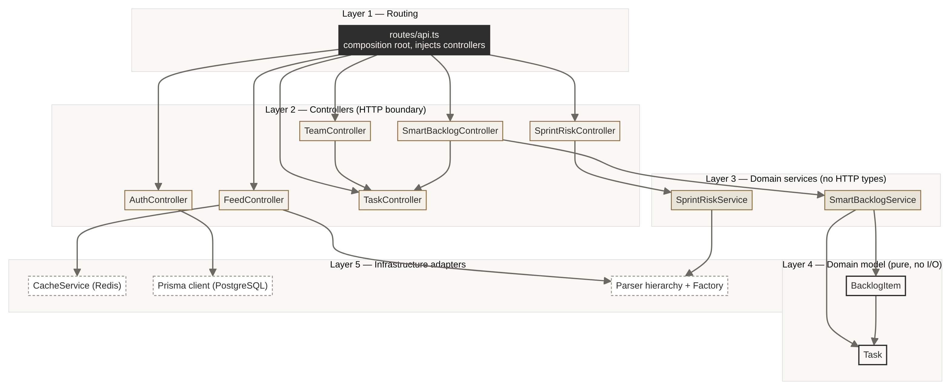
Figure 1 — Module dependency layers; every arrow points downward.
Adding a feed format is the clearest demonstration. FeedParserFactory is the only place in the system that knows which concrete parser exists, so extension is additive rather than invasive.
export class FeedParserFactory {
public static createParser(formatOrUrl: string = 'AUTO'): BaseParser {
const formatUpper = formatOrUrl.toUpperCase();
if (formatUpper === 'ATOM' || formatOrUrl.includes('/atom'))
return new AtomParser();
if (formatUpper === 'RSS' || formatOrUrl.includes('/rss'))
return new RssParser();
return new RssParser(); // generic XML default
}
}
Listing 2 — backend/src/parsers/FeedParserFactory.ts

1.3 Cohesion
Each unit was given one reason to exist. SmartBacklogService computes priority and does nothing else — it performs no I/O, touches no HTTP types, and holds its tuning constants as injected configuration rather than magic numbers scattered through the method.
export class SmartBacklogService {
constructor(config?: Partial<ISmartBacklogConfig>) {
this.config = {
weightViews: config?.weightViews ?? 1.5,
weightComments: config?.weightComments ?? 4.0,
weightBacklogAge: config?.weightBacklogAge ?? 2.5,
weightStoryPoints: config?.weightStoryPoints ?? 1.2
};
}

public calculatePriorityScore(item: BacklogItem): number {
const viewScore = item.views * this.config.weightViews;
const commentScore = item.commentCount * this.config.weightComments;
// log damping keeps a stale item from dominating on age alone
const ageScore = Math.log(item.daysInBacklog + 1) * 10
* this.config.weightBacklogAge;
const complexity = item.storyPoints * this.config.weightStoryPoints;
const base = viewScore + commentScore + ageScore + complexity;
item.priorityScore = Math.max(0, base * item.moscowWeight);
return item.priorityScore;
}
}
Listing 3 — backend/src/services/SmartBacklogService.ts
Responsibility is split rather than pooled: Task owns behaviour over its own state (incrementViews, addComment, getDaysInBacklog), BacklogItem derives the scoring metrics from a Task, and the service combines them. Because the weights are constructor arguments, re-tuning the algorithm never means editing the formula.

1.4 Low Coupling
Controllers receive their collaborators instead of constructing them. routes/api.ts acts as the single composition root, which is what allows a controller to be exercised with a substitute dependency and what keeps the wiring visible in one file rather than hidden across six.
const taskController = new TaskController();
const smartBacklogController = new SmartBacklogController(taskController);
const teamController = new TeamController(taskController);
const sprintRiskController = new SprintRiskController();
Listing 4 — backend/src/routes/api.ts (composition root)
Coupling is also limited across the network boundary. Nginx reverse-proxies /api/ to the backend container, so the browser only ever sees one origin; the React client holds no hostname or port for the API, and the deployment topology can change without touching client code.

2. High-Level Architecture
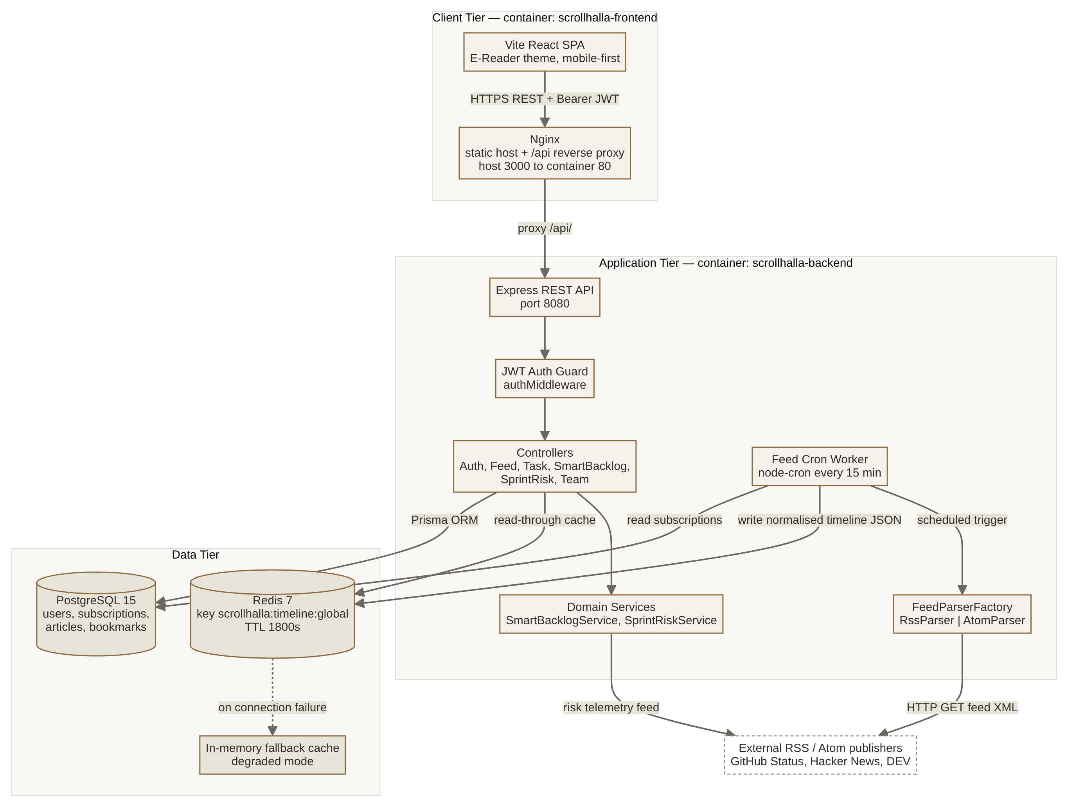
Figure 2 — Updated architecture and deployment view.

2.1 Which style, and why
The system is a layered (n-tier) architecture deployed as four containers orchestrated by Docker Compose, with one deliberate refinement: the read path is inverted, so that reads are served from precomputed state rather than computed on demand.
A layered style was chosen over a microservice decomposition because the deciding constraint is team size, not scale. Two developers on a semester project pay the full coordination cost of independent services — separate deployments, network failure modes, distributed debugging — while gaining nothing, since there is no independent scaling requirement and no second team to decouple from. Layering delivers the property actually needed, which is that business rules stay independent of delivery mechanism, at a fraction of the operational cost.
The inversion is the part worth defending. Parsing several external feeds takes seconds and depends on servers we do not control, so doing it inside a request would make latency hostage to third parties. Instead a node-cron worker harvests on a schedule and writes a normalised timeline to Redis; GET /api/feed then degenerates to a single key read. Freshness is traded for latency and isolation — a deliberate exchange, bounded by the 15-minute schedule and a 30-minute TTL.
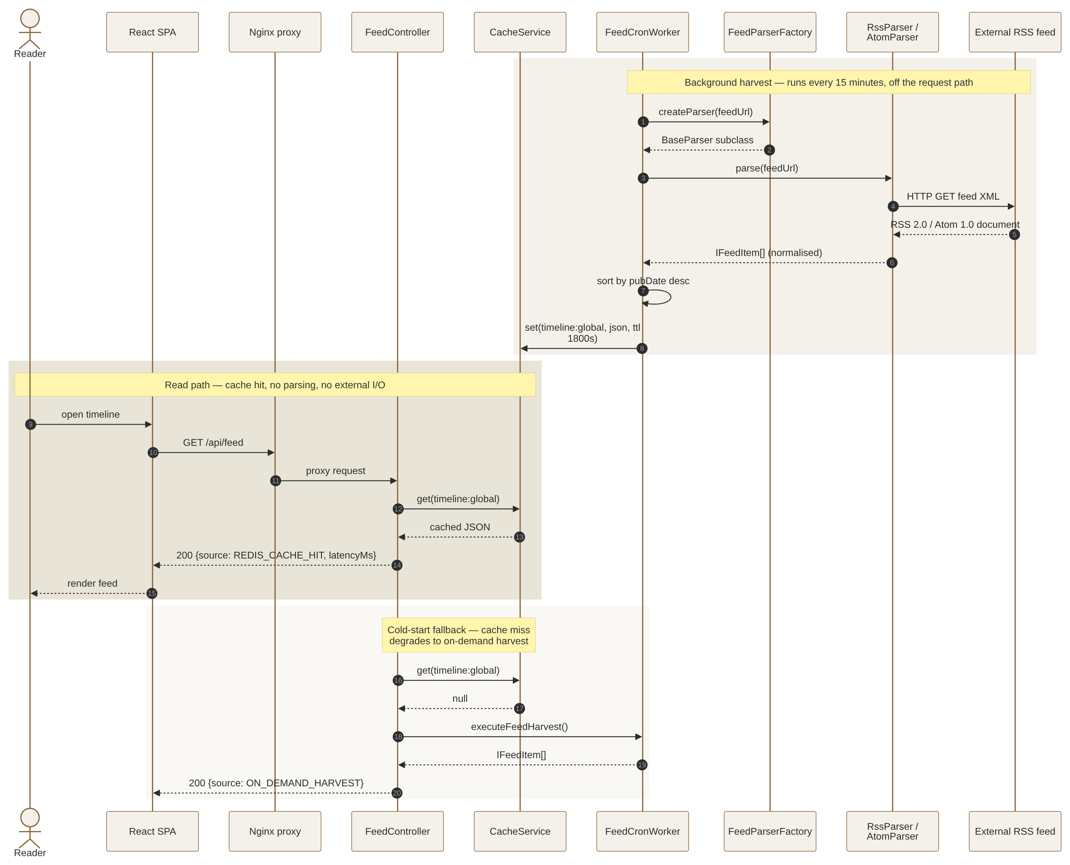
Figure 3 — Harvest, cached read, and cold-start fallback.

2.2 The object model
The class diagram shows where the patterns actually sit: inheritance under BaseParser, creation isolated in FeedParserFactory, and behaviour kept next to the data it acts on in Task and BacklogItem.
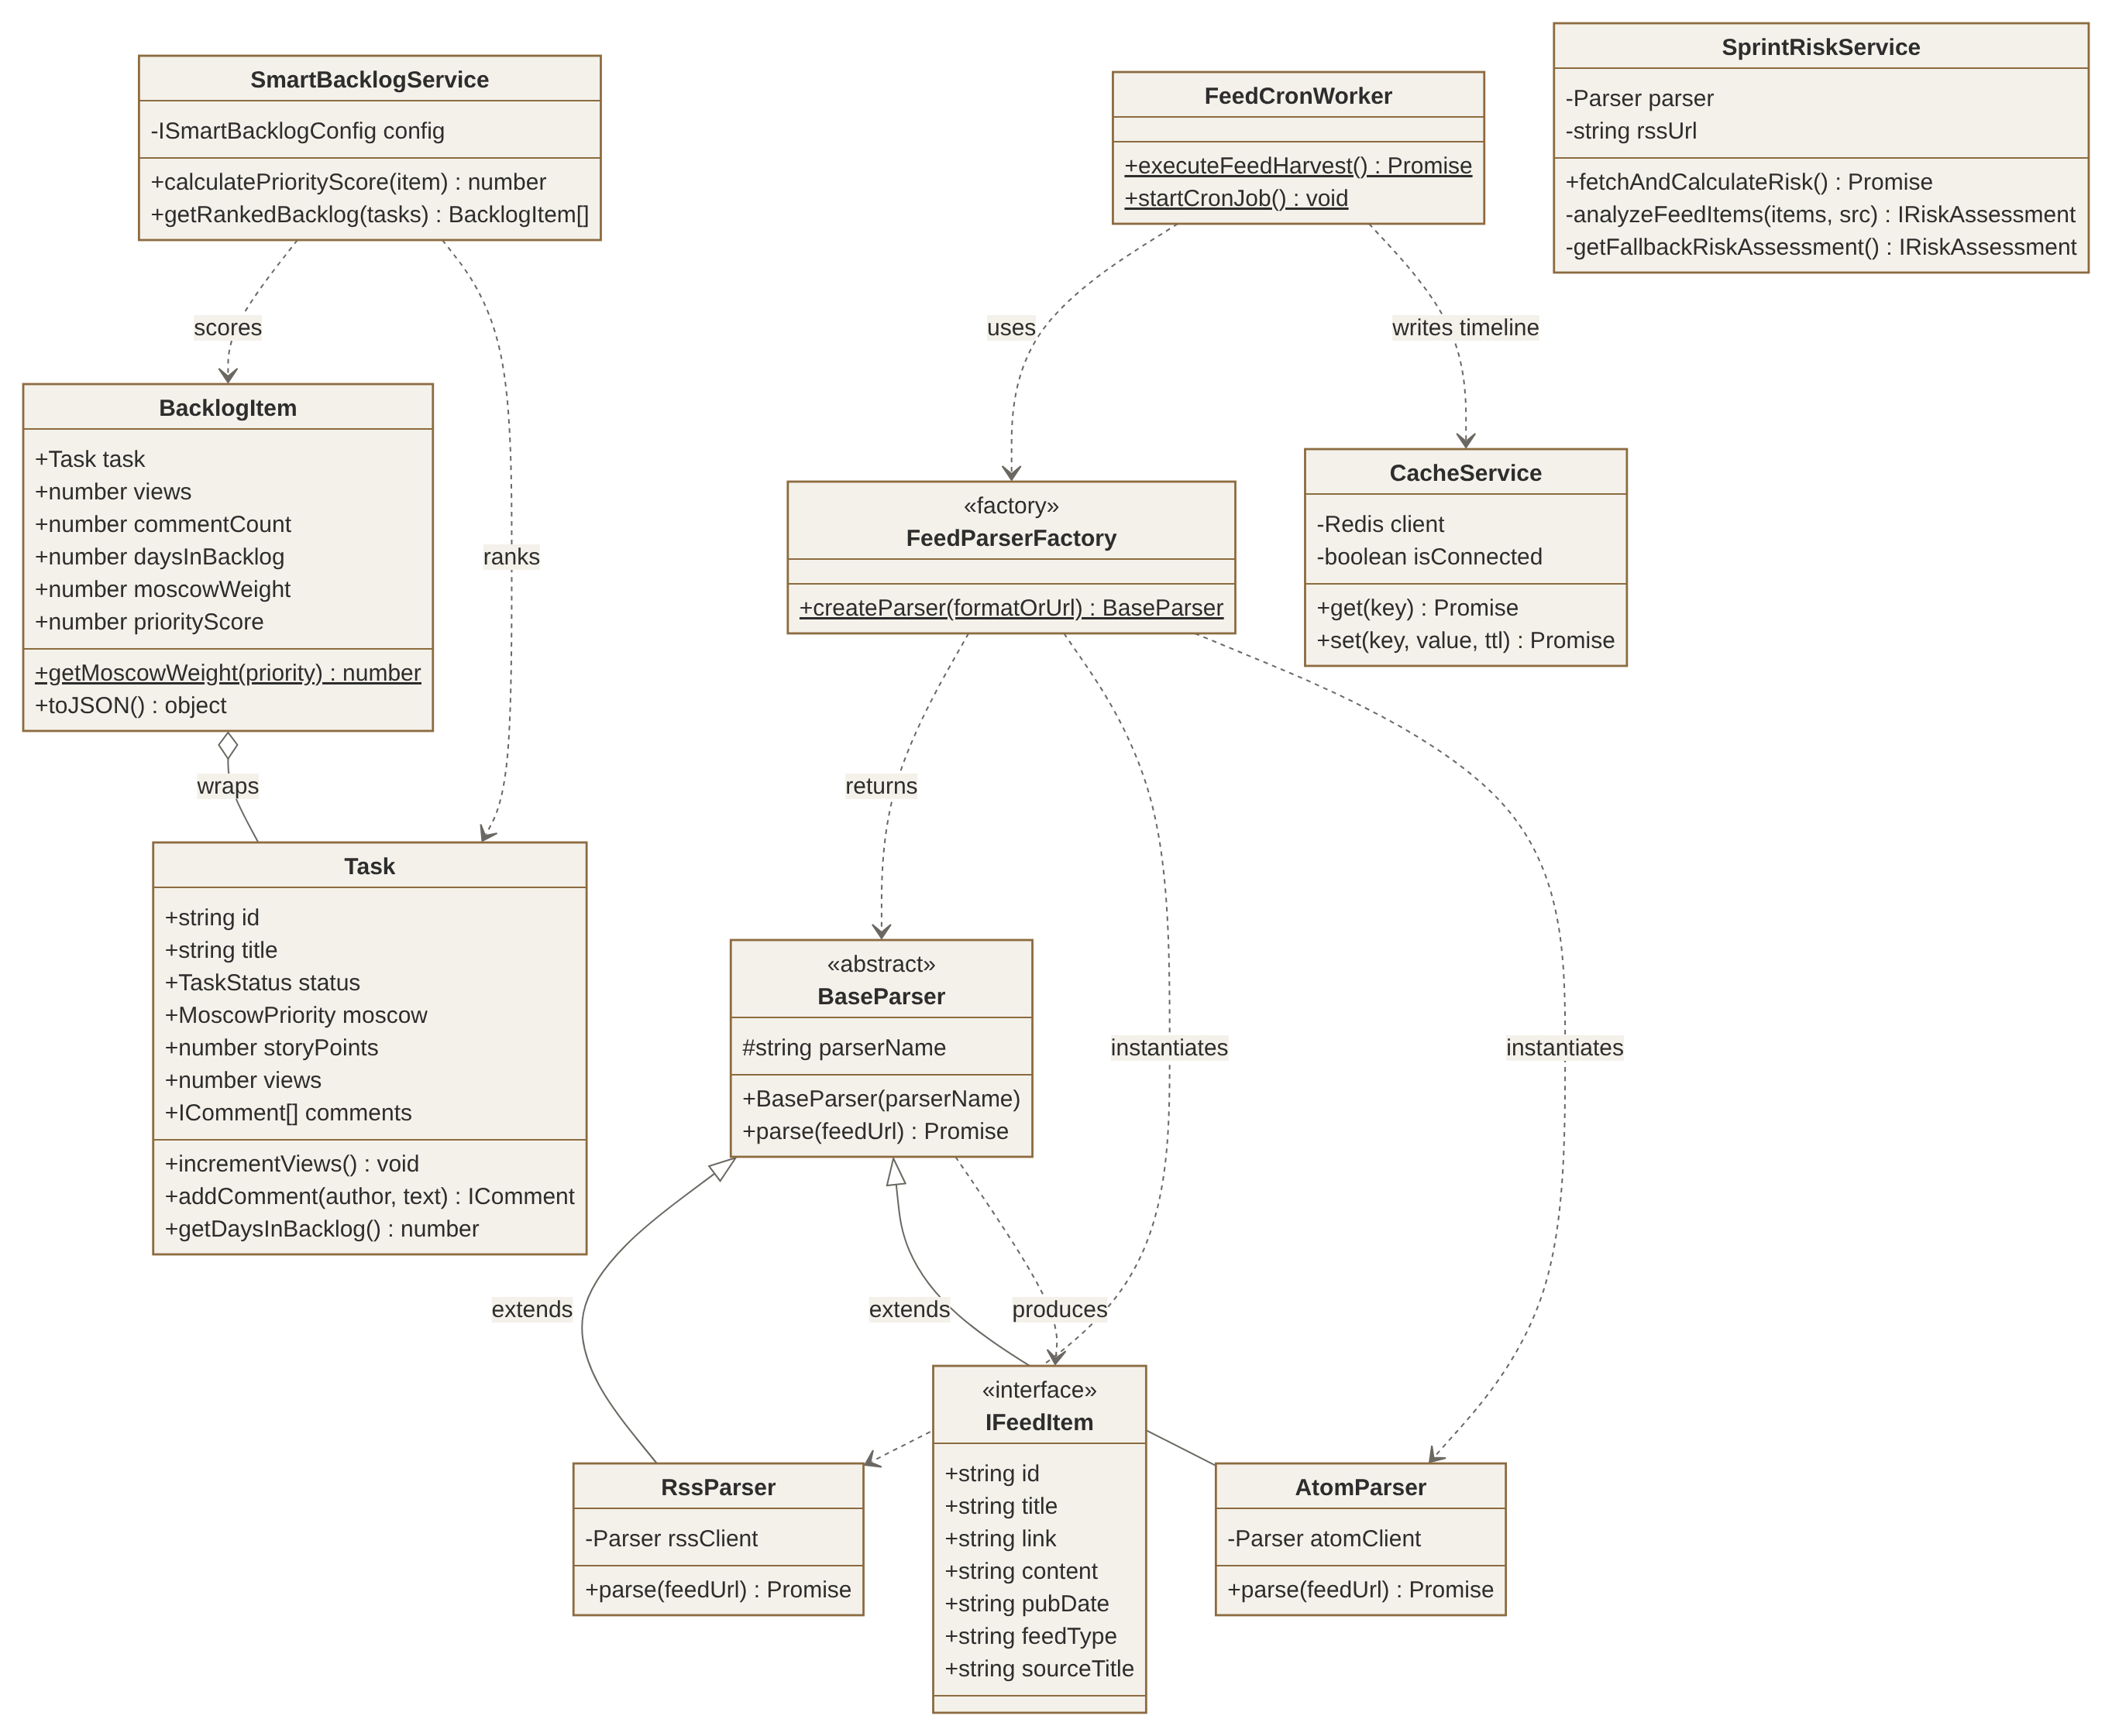
Figure 4 — OOAD class model of the backend domain.

3. User Interface Design
The interface is generated from a small, fixed token set rather than styled screen by screen. Four colours and three type roles are defined once and reused everywhere, which is why six screens built separately still read as one product — abstraction applied to the visual layer exactly as it is applied to the parsers.
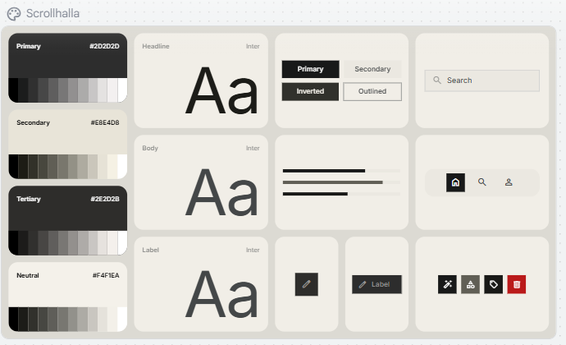
Figure 5 — Design system: colour ramps, type scale, and component states.
How the interface is made user-friendly. Every decision below removes work from the reader rather than adding capability:
- Reduced eye strain. A warm paper ground (#F4F1EA) with soft charcoal text (#2D2D2D) avoids the pure-white/pure-black contrast that tires the eye during long reading sessions.
- One primary action per screen. Onboarding ends in a single Build My Feed button; the reader ends in Next Article. Nothing competes for the tap.
- Controls recede, content leads. Actions are monochrome outlines placed at the edges, so the article is always the brightest and largest element in view.
- Familiar navigation. A fixed four-item bottom bar (Library, Explore, Feed, Settings) keeps every destination one thumb-reach away and never changes position.
- Reader control over presentation. Text size, serif/sans face, and warm/dark theme are user settings, not fixed choices — accessibility handled as a preference rather than an afterthought.
- Honest empty and cost states. Read-time estimates appear on every card, and saved-article counts are shown in the header, so the reader always knows what they are committing to.

3.1 The six screens
 | 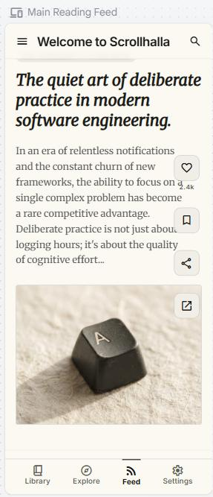 | 
1. Onboarding | 2. Reading Feed | 3. Explore

Onboarding bootstraps the feed from interest tags so the first session is never empty. The reading feed presents one article per card in a vertical stream. Explore offers curated sources plus a manual RSS URL field for readers who already know what they want.

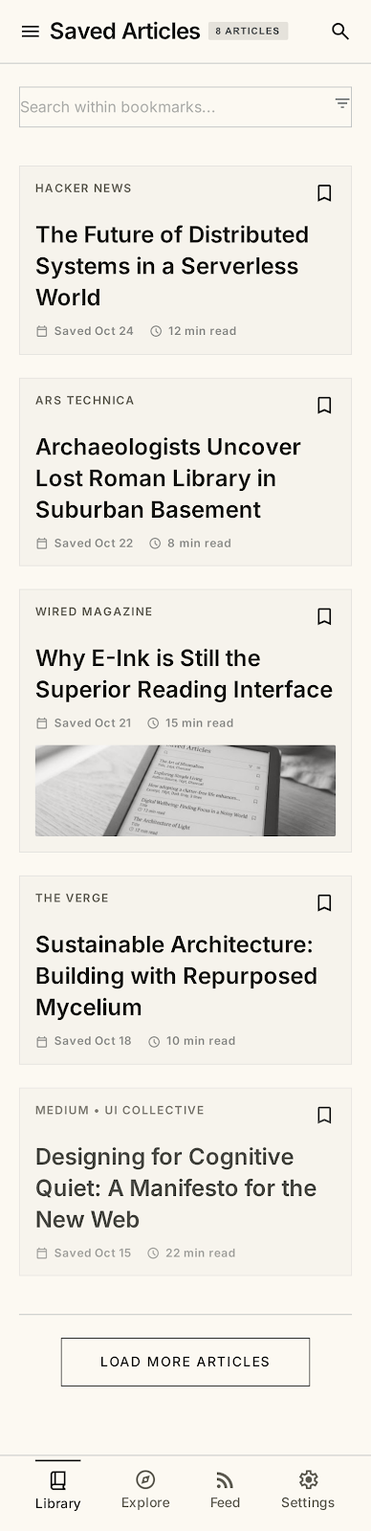 |  | 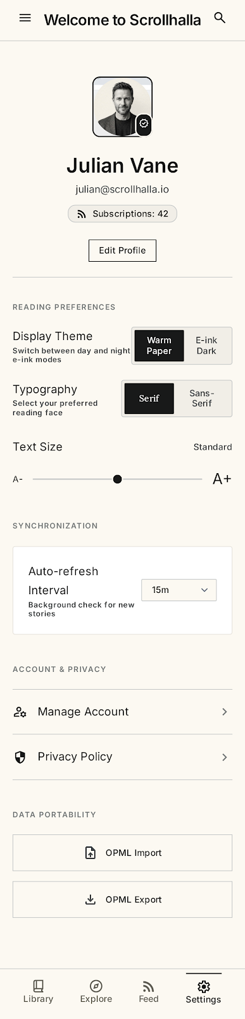
4. Saved Articles | 5. Article Reader | 6. Settings & Profile

Saved articles is a plain reverse-chronological library with search. The reader view removes every control except font size and bookmark. Settings groups reading preferences, synchronisation, account and OPML portability into four labelled blocks so the list never has to be scanned linearly.

4. Design Decisions and Why
Decision | Why it was chosen | What it costs
Abstract parser behind a factory | Adding a syndication format becomes one new subclass plus one line in the factory. No caller changes, so the worker and API stay closed to modification. | One extra indirection for a system that today supports only two formats.
Invert the read path: cron harvest into Redis | Moves seconds of third-party network latency off the request path entirely; a feed read becomes a single cache lookup. | Content can be up to 15 minutes stale; correctness now depends on the worker running.
Cache with in-memory fallback | The app still serves when Redis is unreachable, so a missing container degrades performance instead of breaking the product. | Fallback state is per-process and lost on restart; masks a real outage unless monitored.
Rich domain classes over plain records | Behaviour lives with the data it concerns (getDaysInBacklog, getMoscowWeight), so the scoring rule cannot drift from the fields it reads. | Objects must be rehydrated rather than used straight from JSON.
Nginx reverse proxy for /api/ | One origin in the browser: no CORS configuration in production and no API hostname compiled into the client bundle. | Local development without containers needs a matching Vite proxy rule.

5. Maintainability and Future Changes
A design document that lists only strengths is not much use for planning. The seams below are known, deliberately left for the next iteration, and recorded here with the intervention each one needs.
Seam | Why it matters | Planned intervention
Task persistence is an in-memory array in TaskController, and the Prisma schema has no Task model. | A controller is doing repository work, so the Agile data is lost on restart and cannot be queried. | Extract ITaskRepository; supply InMemoryTaskRepository now and PrismaTaskRepository later. The controller depends on the interface, so nothing else changes.
Seven React views target a superseded CSS contract (glass-panel, --border-color) that index.css no longer defines. | The design system was replaced by the paper theme without a compile-time contract, so the drift is silent. | Promote the tokens in Figure 5 into typed CSS custom properties and route every view through them, so a removed token breaks the build.
Sample article and task fixtures exist in both the backend and the frontend. | Two copies of the same fixture drift apart and produce demos that disagree. | Collapse to one fixture module consumed by both sides.
The frontend build runs vite build with no type-check step. | Type errors and unreachable modules can reach main unnoticed — which is how the drift above went unseen. | Add tsc --noEmit ahead of vite build in the build script and in CI.

6. Requirements Traceability
Each design element exists to serve stories carried over from Digital Assignment 1, tracked as GitHub Issues in the project repository.
Story | Requirement | Design element that satisfies it
#1, #2, #19 | Account creation, secure login, logout | AuthController with bcrypt hashing and JWT issue; authMiddleware bearer guard
#3 | Interest-tag onboarding | Onboarding screen (Figure 5, screen 1); tag selection seeds initial subscriptions
#4, #12 | Vertical article stream and focus view | Reading Feed and Article Reader screens; ReaderViewModal component
#13, #14 | Hourly refresh; RSS 2.0 and Atom support | FeedCronWorker schedule plus BaseParser / FeedParserFactory hierarchy
#15 | Cache parsed feeds for instant load | CacheService over Redis, key scrollhalla:timeline:global, TTL 1800s
#5, #6, #17 | Paper background, serif body, font sizing | Design-system tokens; Settings typography and text-size controls
#9, #24 | Saved list and empty state | Saved Articles screen with count in header and search field
#22, #23 | External database config; one-command deploy | Environment-driven DATABASE_URL; four-service docker-compose.yml

Conclusion
Scrollhalla's design holds together because the same idea is applied at three different scales: name the contract, then depend on the contract rather than the implementation. IFeedItem does this for syndication formats, the five-layer dependency rule does it for the backend, and the token set does it for the interface. The result is a system where the expected changes — a new feed format, a different cache, a re-tuned scoring weight, a restyled screen — are each confined to one place.
The seams recorded in Section 5 are the honest counterpart to that claim. They are named, scoped, and each has a defined intervention, which is the difference between technical debt that is managed and technical debt that is merely accumulated.

Repository: https://github.com/tejasjaiswal2024-art/Scrollhalla
Design sources: /design/mermaid (editable), /design/png (exports), /design/screens (UI)

