Scrollhalla DA3 Report

Software Engineering
Digital Assignment – 3 / Review – 3
Project Title: Scrollhalla: E-Reader RSS Feed
Testing · Version Management · System Building · Final Project Report
By Tejas Jaiswal (24BAI1264) &
Dhananjay Shankar (24BAI1298)
Submitted to Dr. Alok Chauhan
GitHub: https://github.com/tejasjaiswal2024-art/Scrollhalla

Contents
Part A — Review 3 submission
- Integration, Regression and Mutation Testing
- Version Management and System Building
- Screenshots of Developed Functionalities
- Tools and Technologies Used
- Project Demo Video
Part B — Project Report
- Problem Statement
- User Stories
- System Architecture and System Design
- Design of Tests
Appendix
- Software Requirements Specification (SRS)
- Data Flow Diagrams (Level 0 and Level 1)
- Entity Relationship Diagram
- UML Diagrams
- Code Listing and GitHub Link

1. Integration, Regression and Mutation Testing
Until this review the repository had no automated tests. For DA3 a four-level test suite was built around the backend's existing layered structure (routes → controllers → services → domain models → infrastructure adapters), plus a frontend unit suite. All suites run with one command per level and in CI on every push.
116 | 92.3% | 86.2% → 96.5% | 10
automated tests (111 backend + 5 frontend) | backend line coverage (87.1% branch) | mutation score (Stryker, 489 mutants) | regression snapshots (API contract + golden master)

Level | Tool | What it exercises | Tests | Command
Unit | Jest + ts-jest | Task, BacklogItem, SmartBacklogService, SprintRiskService, RssParser, AtomParser, FeedParserFactory, CacheService fallback, JWT middleware — each in isolation, network stubbed. | 74 | npm run test:unit
Integration | Jest + supertest | The real Express app end-to-end through router, controllers, services and models. Only Layer-5 adapters (Prisma, Redis, outbound HTTP) are replaced by in-memory fakes. | 23 | npm run test:integration
Regression | Jest snapshots | Status code + response shape of every endpoint, the ranking of the seed backlog (golden master), and previously-identified edge cases. | 14 | npm run test:regression
Mutation | Stryker Mutator | Injects 489 small faults into models, services, parsers, middleware and controllers and checks that the suite above detects each one. | 489 mutants | npm run test:mutation
Frontend unit | Vitest | OPML 2.0 export: envelope, one outline per feed, category default, XML escaping of all five special characters. | 5 | npm test (frontend)

1.1 Unit testing
Unit tests pin the business rules that the rest of the system depends on: the default values of a Task, the MoSCoW weight table, the exact Smart Backlog scoring formula, the severity classification and risk thresholds of the Sprint Risk service, and the normalisation each parser performs. The RSS client is replaced by a shared stub so no test touches the network.
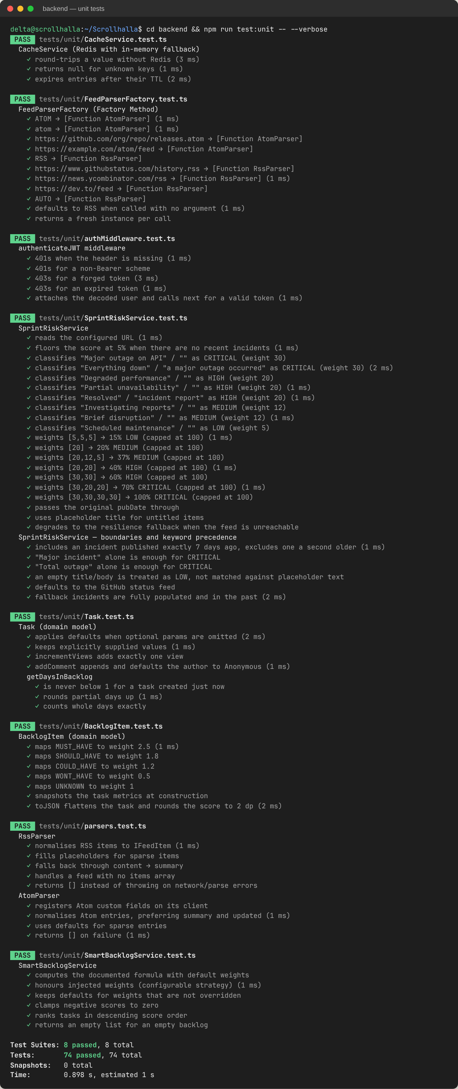
Figure 1 — Unit suite: 74 tests across 8 suites, all passing.

1.2 Integration testing
The integration suite drives the real application over HTTP with supertest. The composition root in routes/api.ts is left untouched, so the test also verifies that dependency injection wires the controllers correctly — for instance, that a task created through /api/tasks is visible to the Smart Backlog and Team controllers, which share the same TaskController instance. Five integration scenarios are covered:
- Task CRUD flow — create, read (view counter increments), update, comment, delete, and 404 on every verb afterwards.
- Cross-controller — a high-engagement task rises to the top of /api/smart-backlog; reassignment changes team workload.
- Feed pipeline — cold cache triggers on-demand harvest through Factory → Parser → Cache; the second request is a REDIS_CACHE_HIT; one failing publisher does not break the timeline.
- Sprint risk — the endpoint degrades to the resilience fallback when the status feed is offline.
- Auth flow — register → duplicate refused → login → protected profile with bcrypt and JWT; identical 401 for wrong password and unknown user.
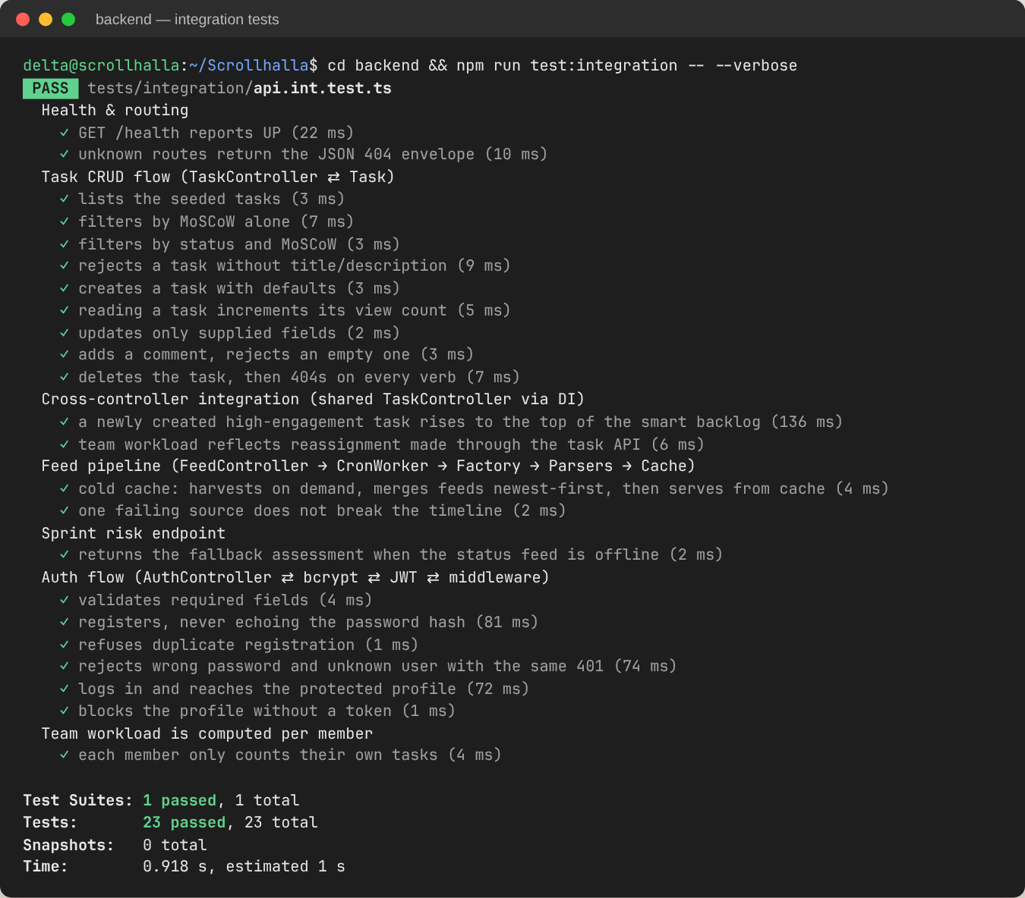
Figure 2 — Integration suite: 23 tests across the full request path.
Listing 1 — Integration tests replace only the infrastructure adapters (backend/tests/integration/api.int.test.ts)
// Integration: real Express app → router → controllers → services → models.
// Only Layer-5 adapters (Prisma, Redis, outbound HTTP) are replaced.
jest.mock('../../src/config/prisma', () => require('../helpers/mockInfra').prismaModuleMock());
jest.mock('../../src/config/redis', () => require('../helpers/mockInfra').cacheModuleMock());
jest.mock('rss-parser', () => require('../helpers/rssParserMock').rssParserModuleMock());
it('cold cache: harvests on demand, merges feeds newest-first, then serves from cache', async () => {
const first = await request(app).get('/api/feed');
expect(first.body).toMatchObject({ success: true, source: 'ON_DEMAND_HARVEST', count: 3 });
const second = await request(app).get('/api/feed');
expect(second.body.source).toBe('REDIS_CACHE_HIT');
expect(parseURL).toHaveBeenCalledTimes(3); // no second harvest
});

1.3 Regression testing
The regression pack protects behaviour that users and the frontend already rely on. REG-01 snapshots the status code and the shape of every endpoint's response — volatile values such as IDs and timestamps are reduced to their type so the snapshot only changes when the contract changes. REG-02 is a golden master of the seeded backlog ranking. REG-03 pins edge cases: the documented storyPoints: 0 → 3 coercion, the 100% cap on team utilisation, non-enumerating login errors, and malformed JSON being handled by the global error handler.
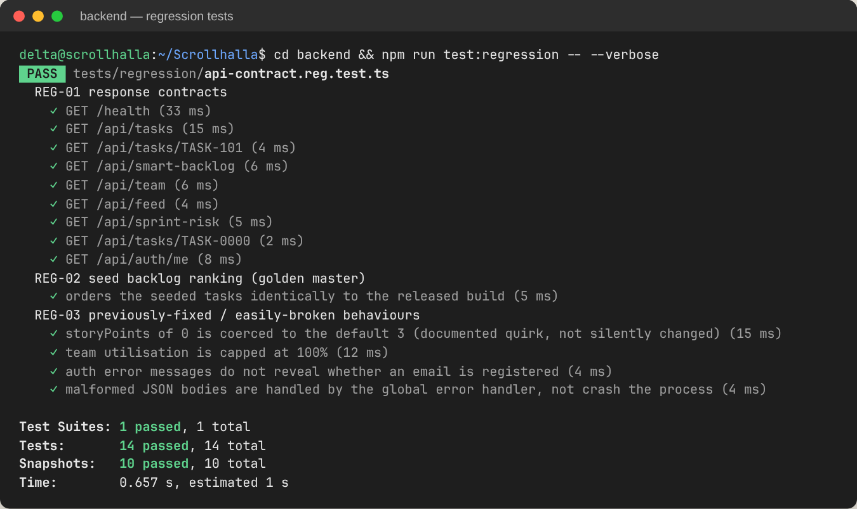
Figure 3 — Regression pack: 14 tests, 10 snapshots matched.
Listing 2 — Contract snapshot that ignores volatile values (backend/tests/regression/api-contract.reg.test.ts)
/** Replace volatile values (ids, timestamps, latencies) with their type so snapshots are stable. */
const shape = (v: any): any => {
if (Array.isArray(v)) return v.length ? [shape(v[0])] : [];
if (v && typeof v === 'object') return Object.fromEntries(Object.keys(v).sort().map(k => [k, shape(v[k])]));
return typeof v;
};
it.each([['GET', '/health'], ['GET', '/api/tasks'], ['GET', '/api/smart-backlog'], /* … 9 endpoints */])('%s %s', async (_m, url) => {
const r = await request(app).get(url);
expect({ status: r.status, body: shape(r.body) }).toMatchSnapshot();
});

1.4 Coverage
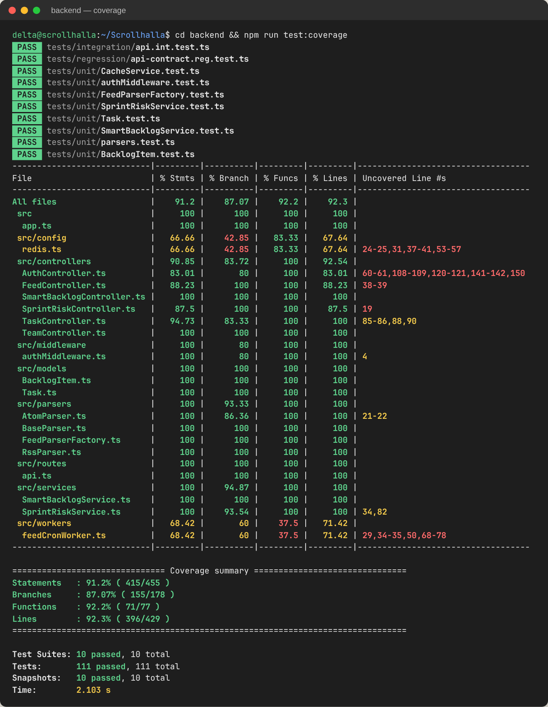
Figure 4 — Istanbul coverage across all backend source files.
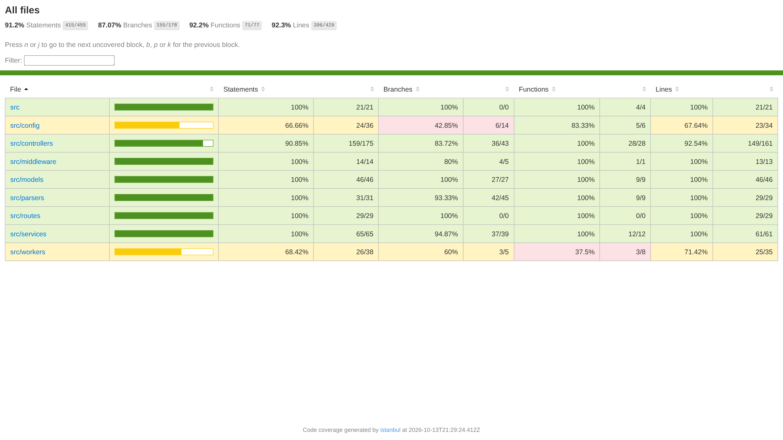
Figure 5 — HTML coverage report (uploaded as a CI artifact on every run).

1.5 Mutation testing
Line coverage only shows that code ran; it does not show that a test would fail if the code were wrong. Stryker answers that question by generating mutants — >= turned into >, || into &&, a string emptied, a branch forced to true — and re-running the suite against each one. A mutant that no test notices survives and marks a weak spot.
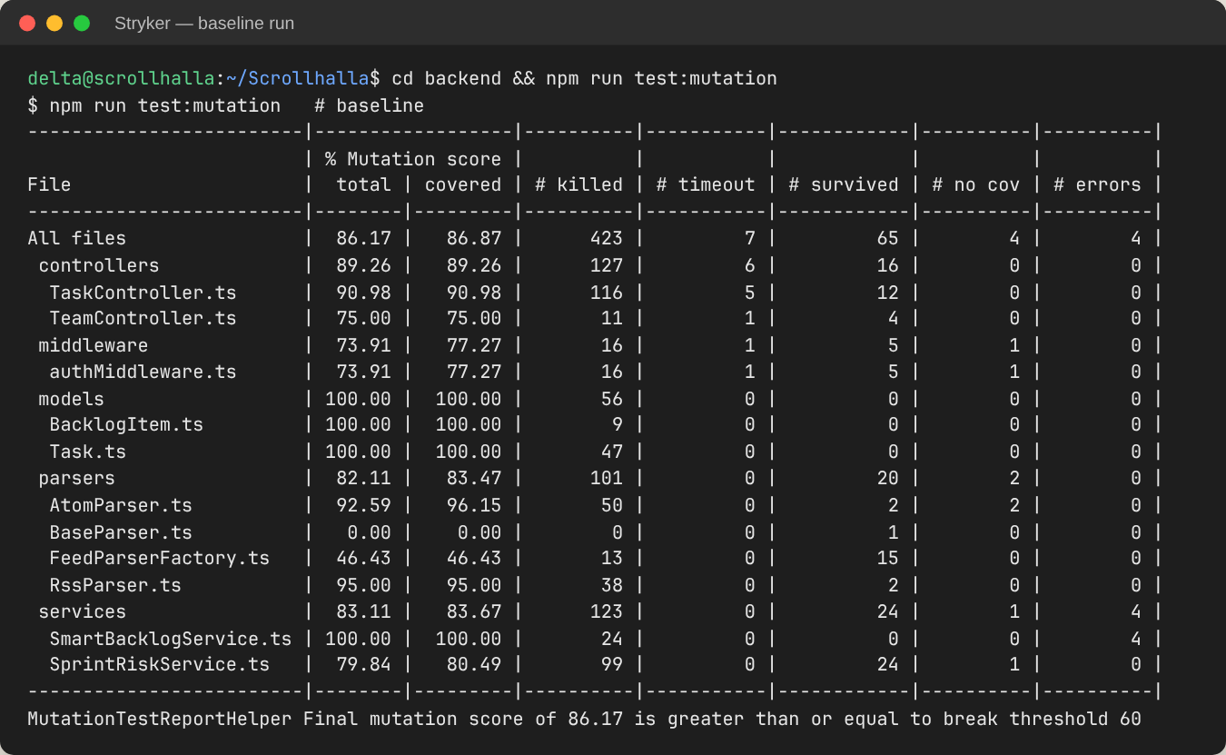
Figure 6 — Baseline run: 86.17% mutation score, 65 surviving mutants.
The baseline run surfaced four real problems, each fixed in a separate commit:
Surviving mutants | What they revealed | Action
15 in FeedParserFactory RSS condition | Every mutation of the RSS branch survived because the branch was unreachable: whatever it matched already fell through to the RSS default. | Refactored the factory to a single Atom check (commit 46bd884).
4 in TaskController moscow filter | The only filter test combined status and MoSCoW; every IN_PROGRESS seed task is MUST_HAVE, so the MoSCoW filter was never actually tested. | Added a MoSCoW-only filter test.
5 in authMiddleware | Tests checked status codes but never the response body, so emptying the error message went unnoticed. | Assert full 401 and 403 bodies.
~20 in SprintRiskService | The 7-day boundary (<= vs <), keyword precedence (“major” alone), and fallback incident fields were unasserted. | Boundary test with fake timers; keyword and fallback assertions.
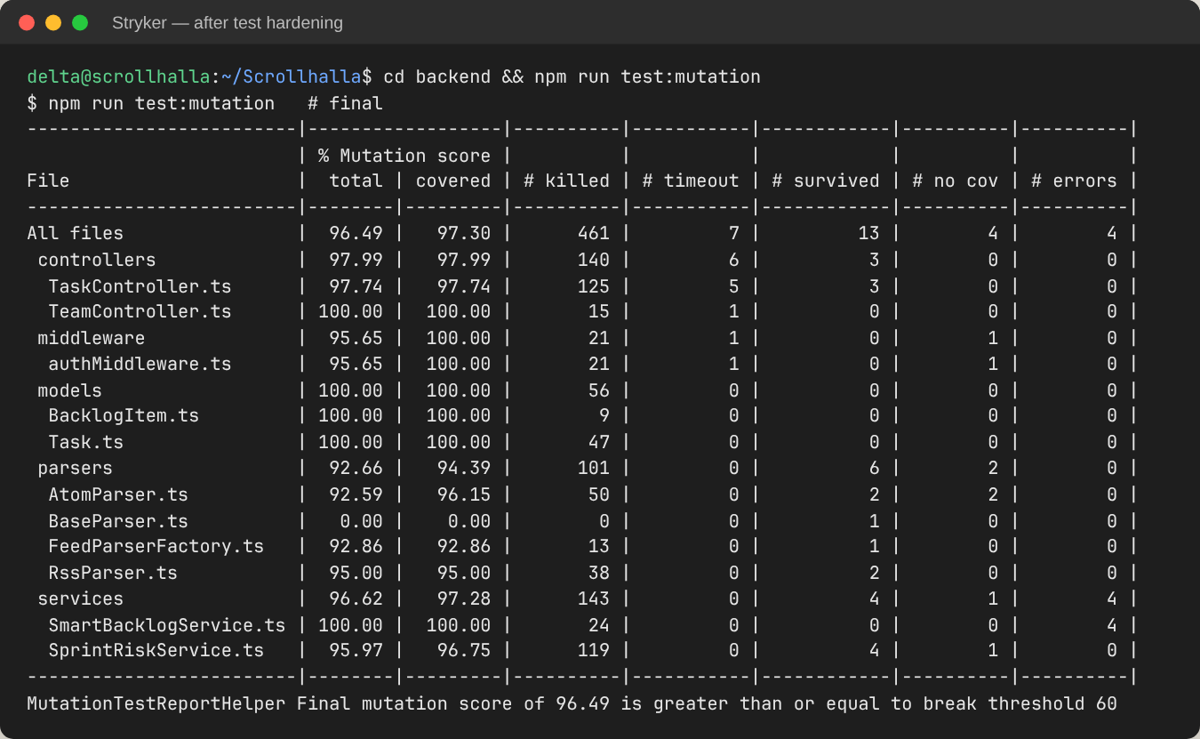
Figure 7 — After hardening: 96.49% mutation score (461 killed, 7 timeout, 13 survived).
Remaining survivors are equivalent mutants, meaning changes that cannot alter observable behaviour, so no test can kill them. Examples: status || TaskStatus.TO_DO in the controller (the Task constructor applies the same default); item.pubDate || new Date() (items without a date are already filtered out above); the unused parserName field; and log-message strings. They are documented here rather than suppressed.
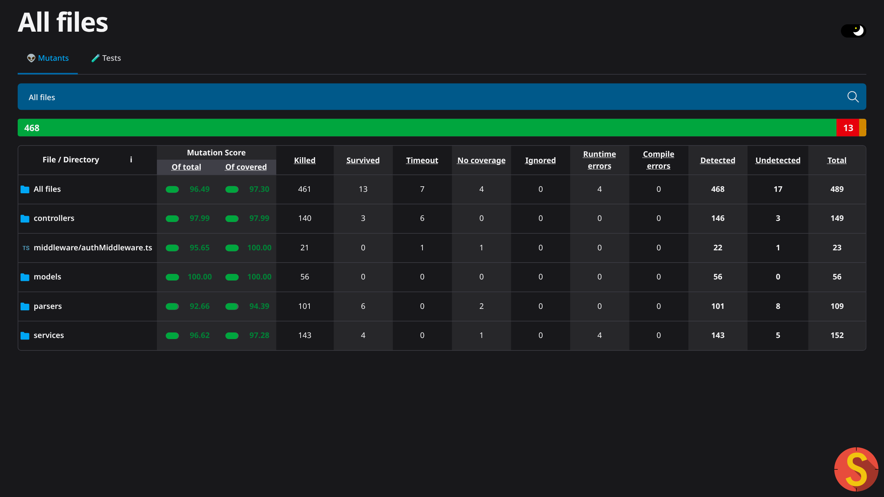
Figure 8 — Stryker HTML report (CI artifact).

1.6 Frontend tests
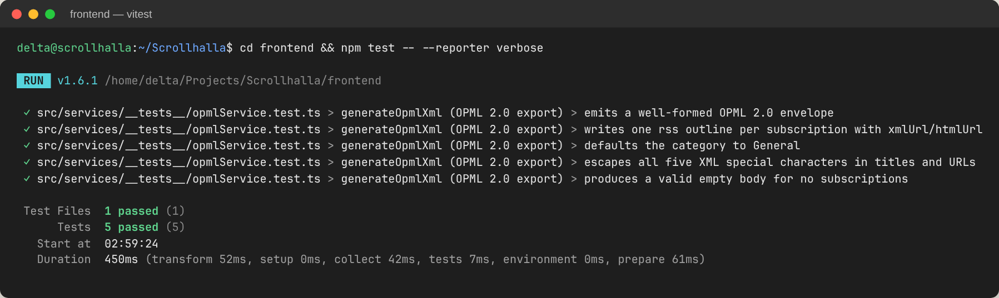
Figure 9 — Vitest suite for the OPML 2.0 export service.

2. Version Management and System Building

2.1 Branching strategy
The project follows GitHub Flow, as set up in DA1: main holds the stable, deployable version and every unit of work lives on a feature/* branch merged through a pull request. Each review has its own branch (feature/da2-design, feature/da3-testing) next to the functional branches (feature/onboarding-rss-enhancements, feature/opml-feed-exporter). Commits use the Conventional Commits prefixes feat, fix, test, refactor, docs and ci, so the history reads as a changelog. Releases are marked with semantic-version tags.
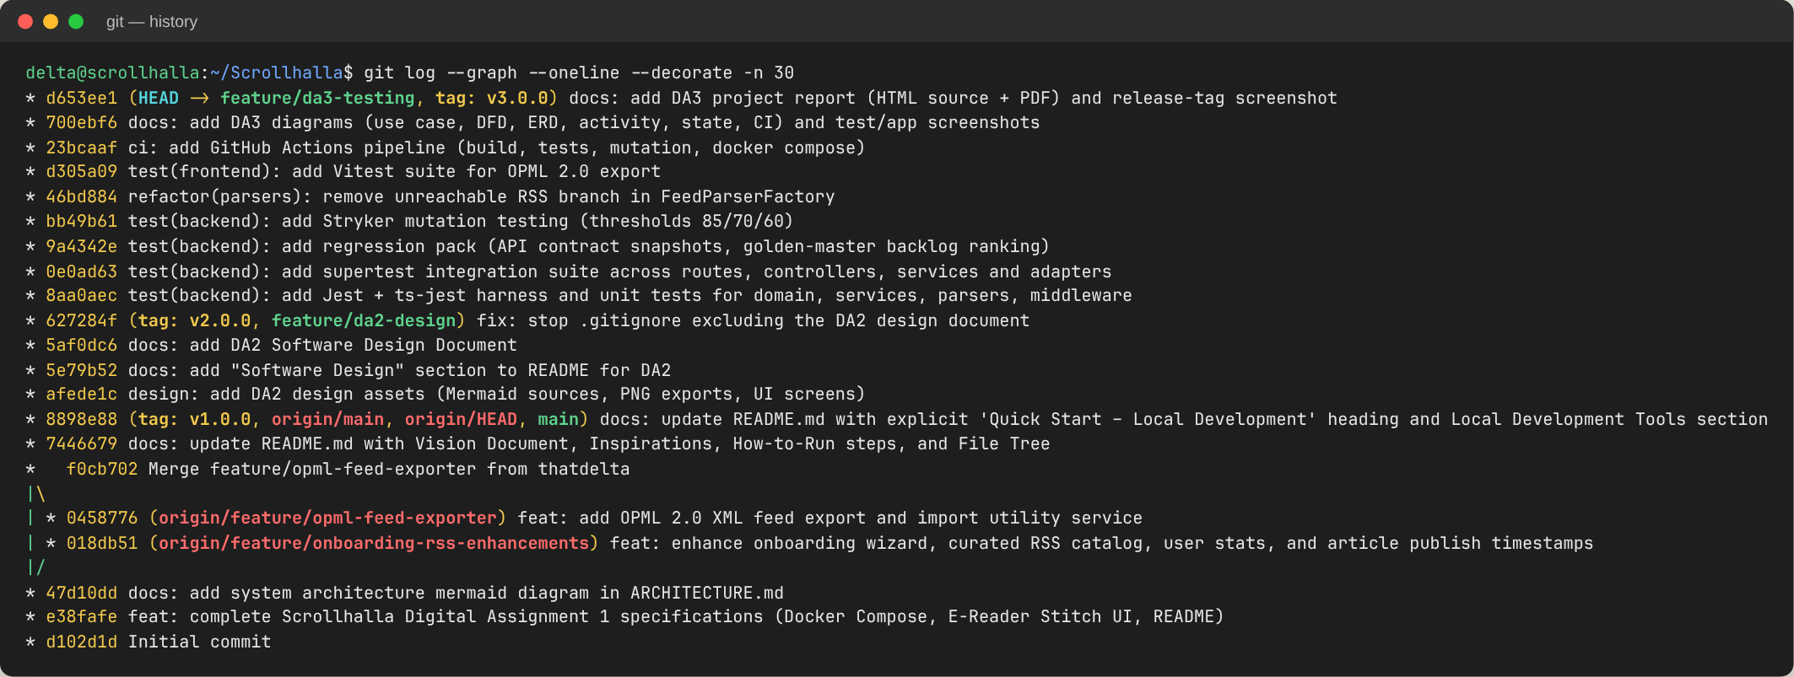
Figure 10 — Commit graph: feature branches merged into main; DA3 work as small, single-purpose commits.
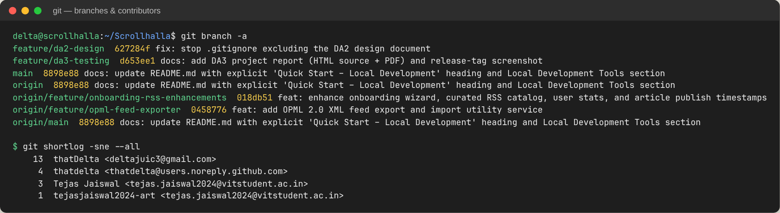
Figure 11 — Local and remote branches with upstream tracking, and contributors.
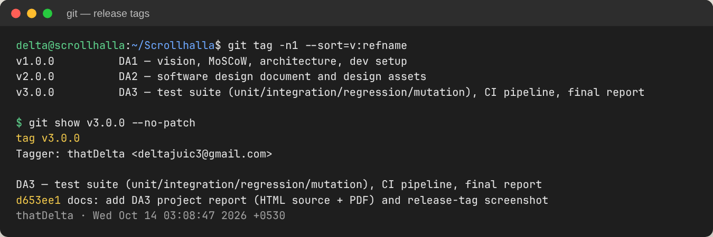
Figure 12 — Annotated release tags, one per review milestone.

2.2 System building
The system is built at three levels, and each one is reproducible from a clean checkout:
- Component builds. The backend runs npm run build, which is prisma generate followed by tsc, the type-check gate. The frontend runs npm run build, which is a Vite production bundle of 215 kB (65 kB gzip).
- Container images. The backend uses a multi-stage Dockerfile, with a build stage and a slim runtime stage on node:20-alpine. The frontend Vite bundle is served by Nginx, which also reverse-proxies /api.
- System composition. docker compose up --build starts four services: postgres:15, redis:7, the backend and the frontend. They share one network, and health-checked dependencies control the start order.
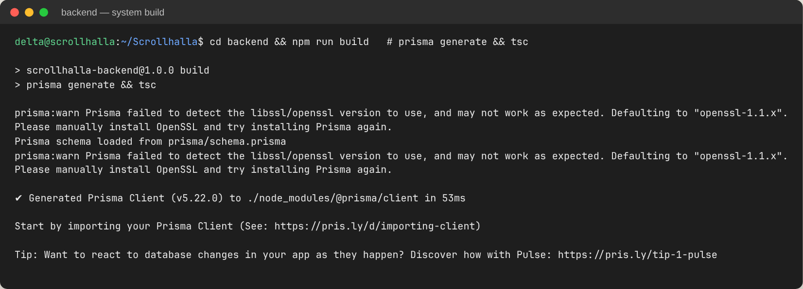
Figure 13 — Backend build (Prisma client + tsc).
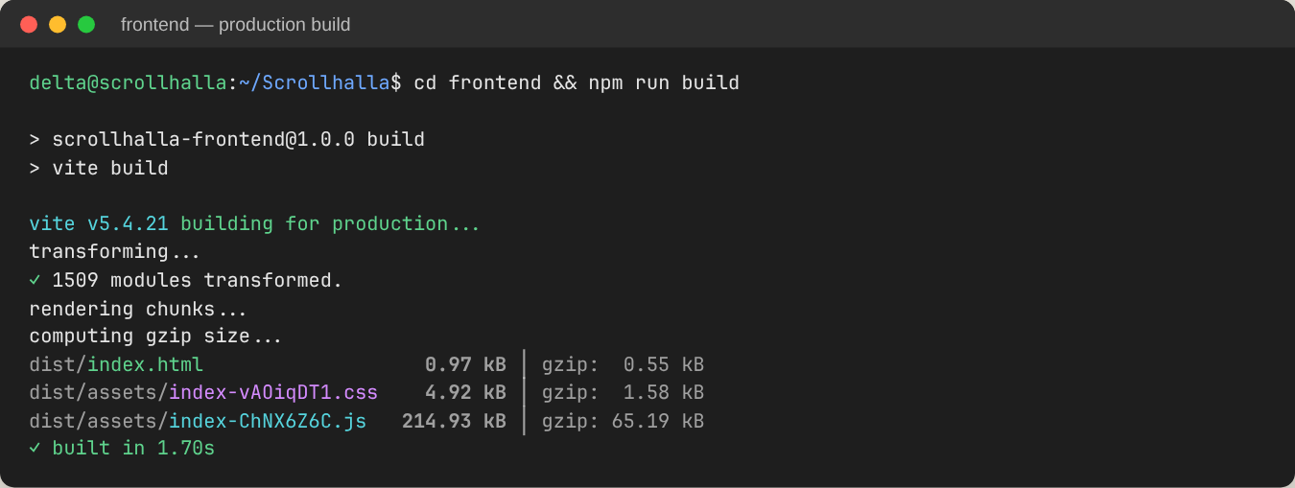
Figure 14 — Frontend production build.

2.3 Continuous integration
A GitHub Actions workflow (.github/workflows/ci.yml) runs on every push to main and feature/**, on every pull request and on every v* tag. It has four jobs:
- backend builds the code, then runs the unit, integration and regression tests and coverage.
- mutation runs Stryker after the backend job and fails the pipeline if the score falls below 60%.
- frontend runs the Vitest tests and the production build in parallel with the backend job.
- docker builds the whole compose stack once both the backend and frontend jobs pass.
The coverage report, the mutation report and the frontend dist/ are uploaded as artifacts.
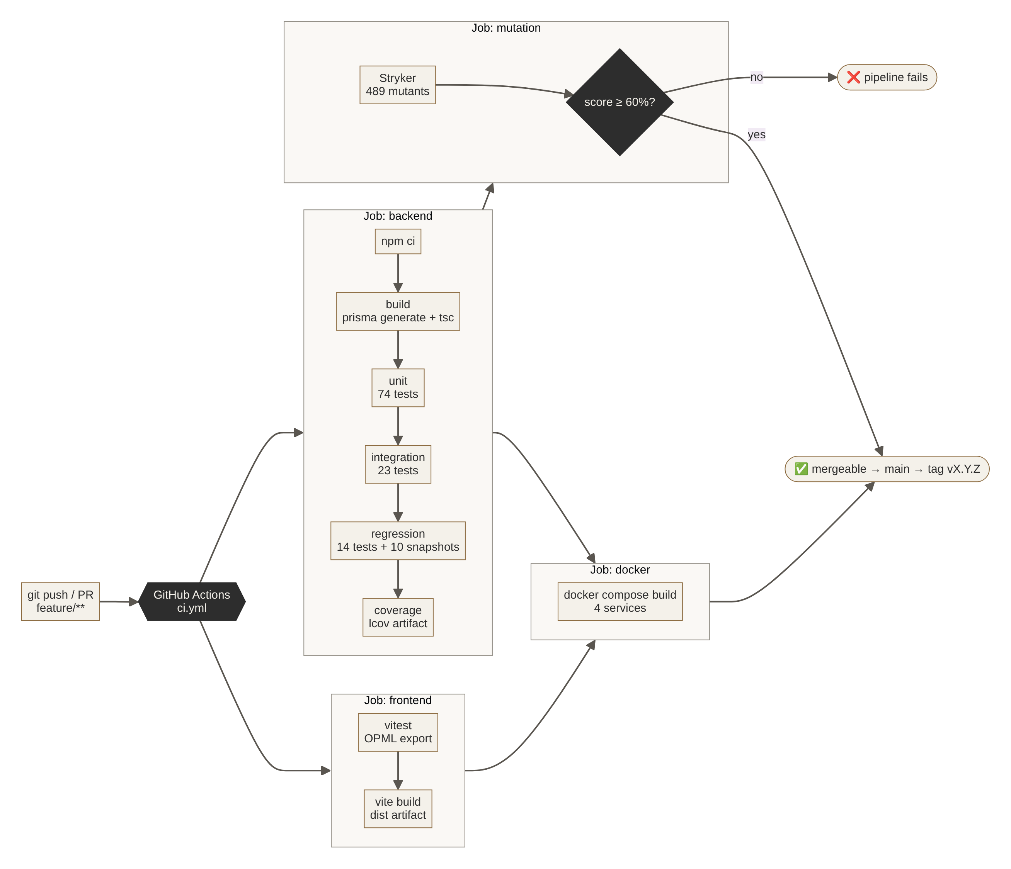
Figure 15 — CI pipeline: build → test levels → mutation gate → system build.
Listing 3 — Backend job of the CI pipeline (.github/workflows/ci.yml, excerpt)
backend:
runs-on: ubuntu-latest
defaults: { run: { working-directory: backend } }
steps:
- uses: actions/checkout@v4
- uses: actions/setup-node@v4
with: { node-version: 20, cache: npm, cache-dependency-path: backend/package-lock.json }
- run: npm ci
- run: npm run build # prisma generate + tsc (type-check gate)
- run: npm run test:unit
- run: npm run test:integration
- run: npm run test:regression -- --ci
- run: npm run test:coverage -- --ci

3. Screenshots of Developed Functionalities
All screenshots below come from the running system. The Vite frontend talks to the Express backend, which uses real PostgreSQL and Redis instances, and the articles shown are live items harvested from the DEV Community and Hacker News RSS feeds at the time of capture.
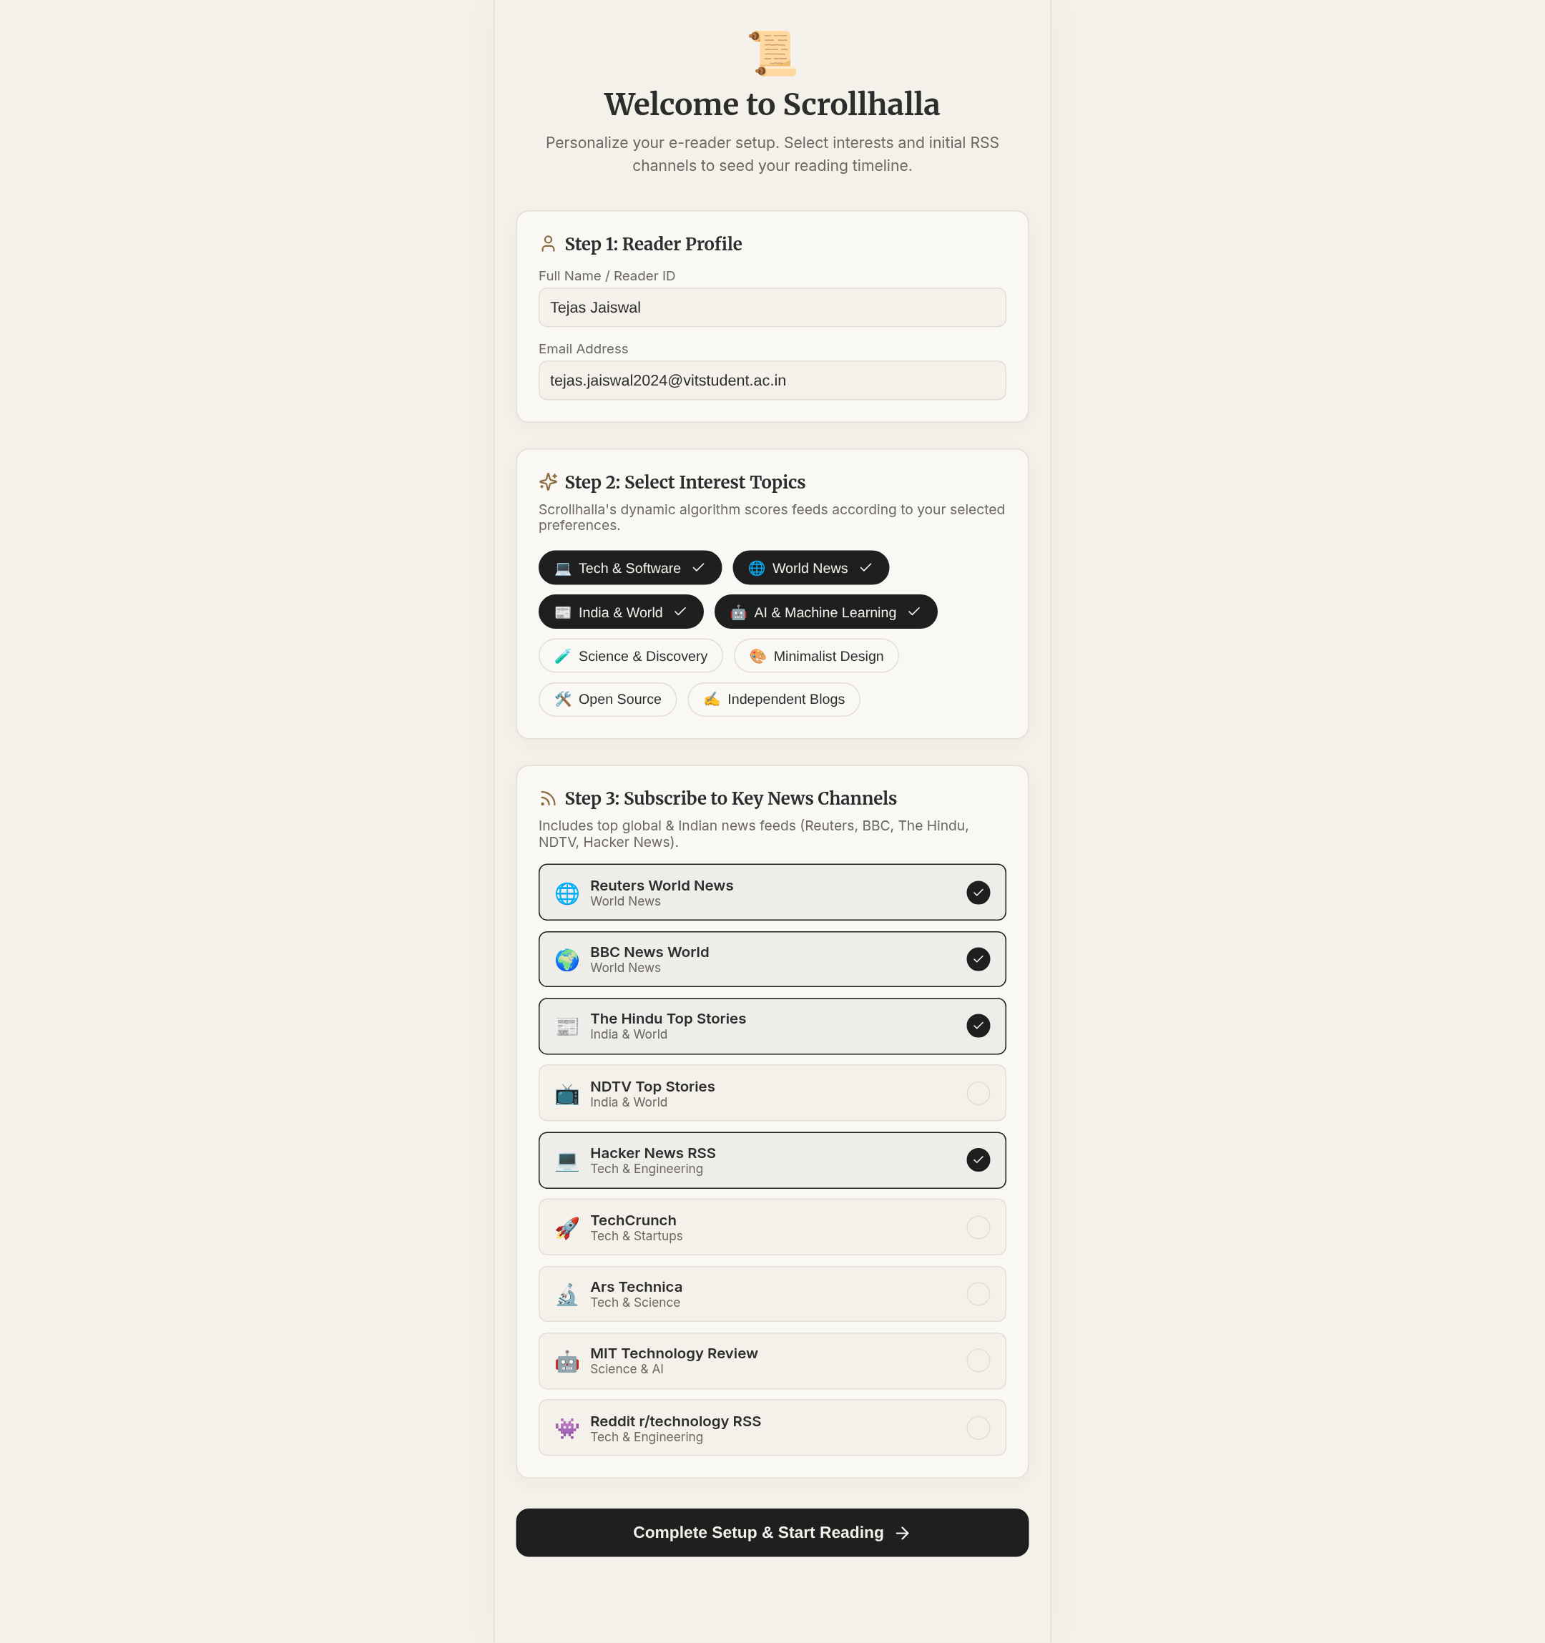
Figure 16 — Onboarding: reader profile, interest tags, seed channels (US #3).
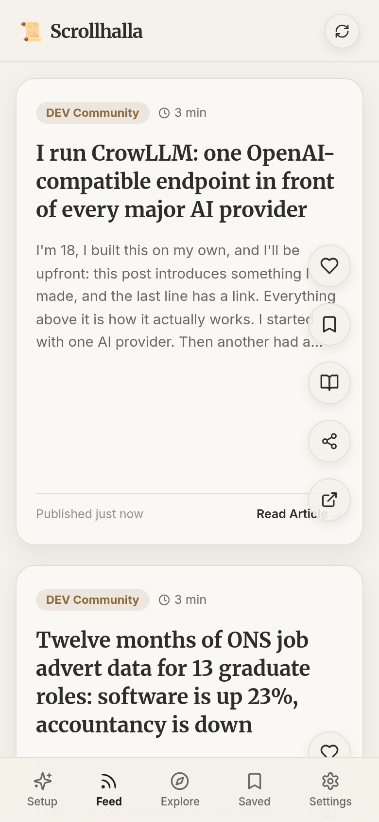
Figure 17 — Reels-style vertical feed, mobile viewport, bottom navigation (US #4, #18, #21).
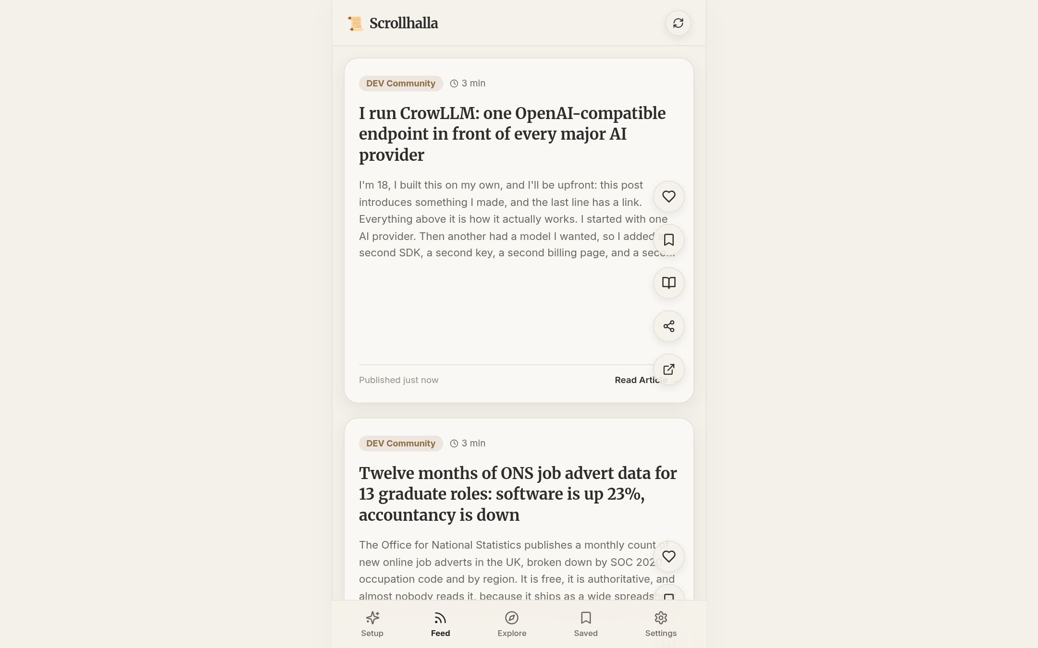
Figure 18 — Timeline served from the Redis cache, with overlay actions: Like, Save, Focus Reader, Share, Open (US #4, #7, #8, #25).
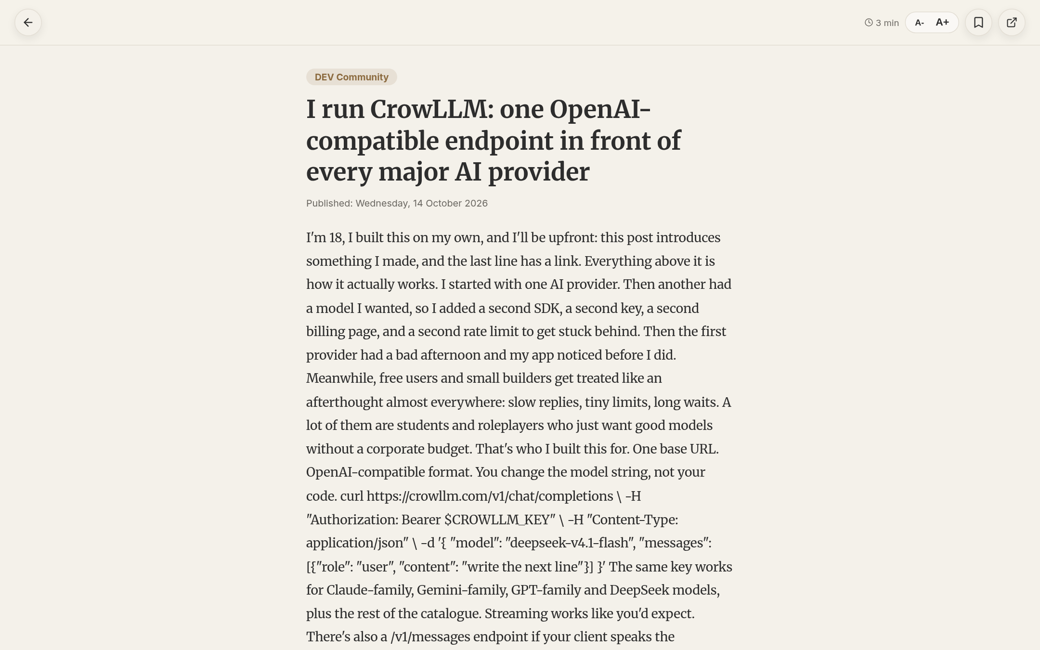
Figure 19 — Distraction-free reader view: serif body text, A-/A+ font size, bookmark (US #6, #12, #17).
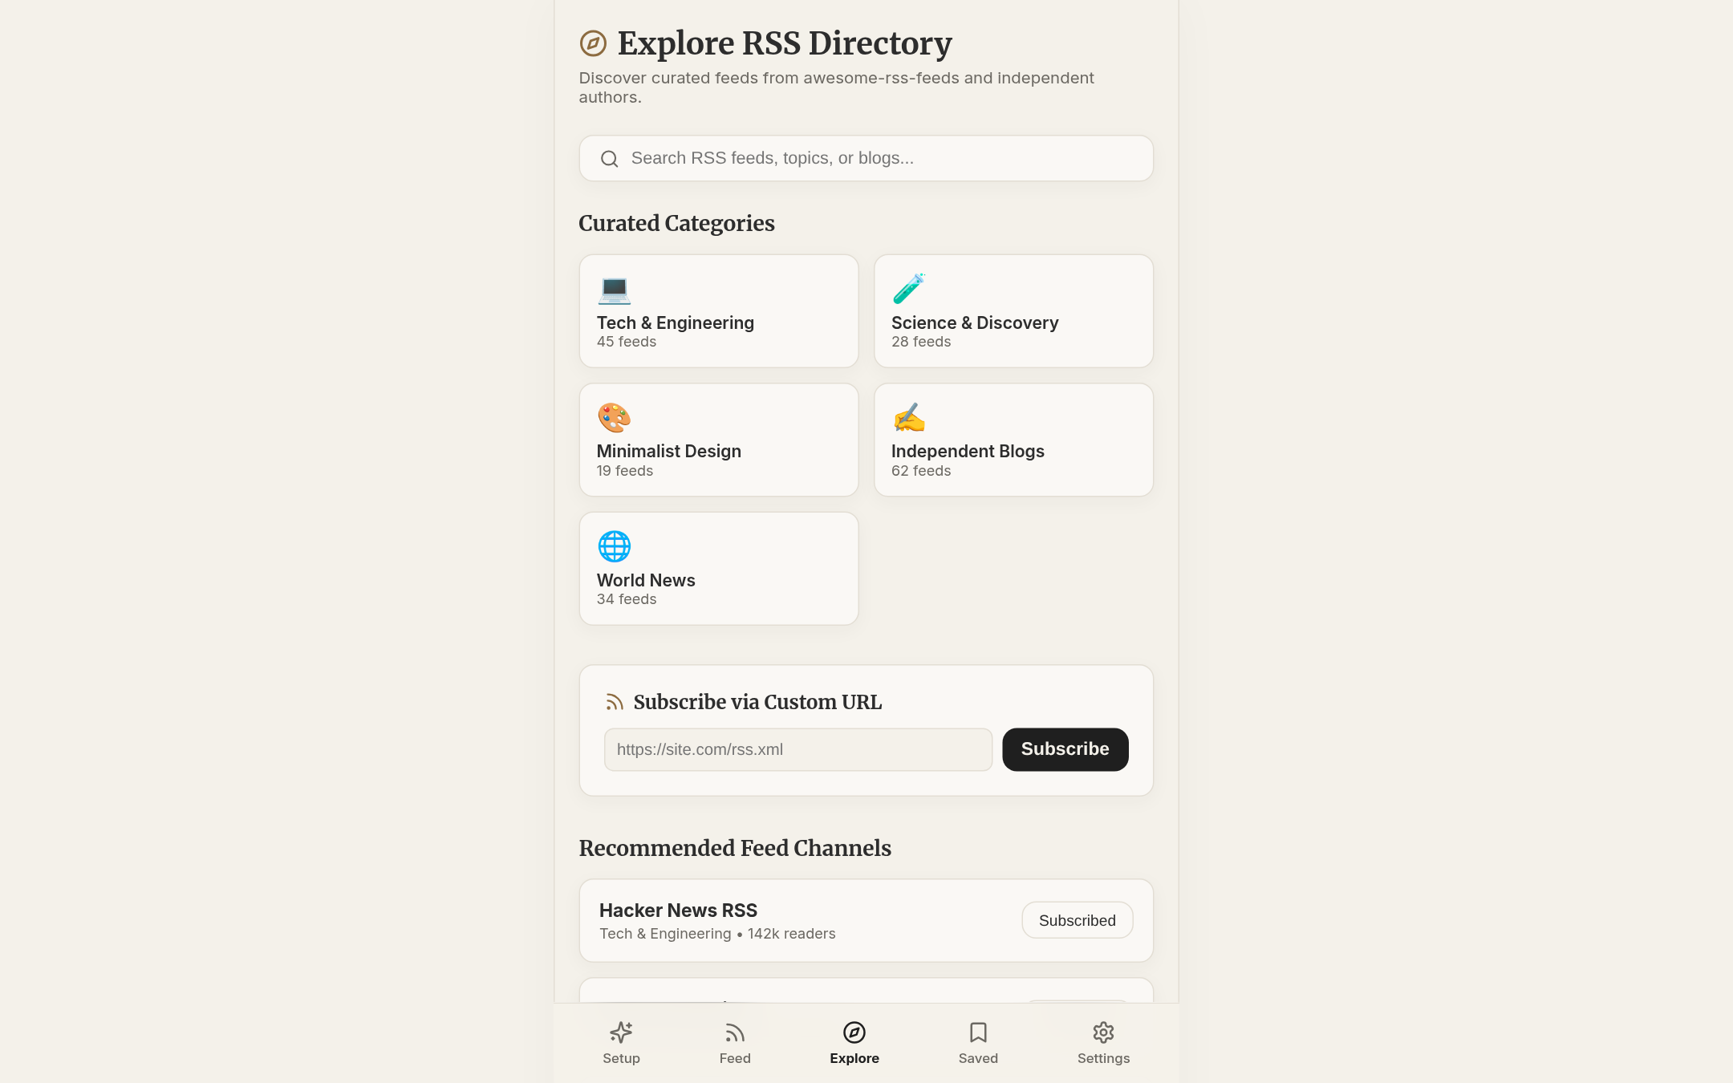
Figure 20 — Explore directory: curated categories, subscribe by custom RSS URL, recommended channels (US #10, #11).
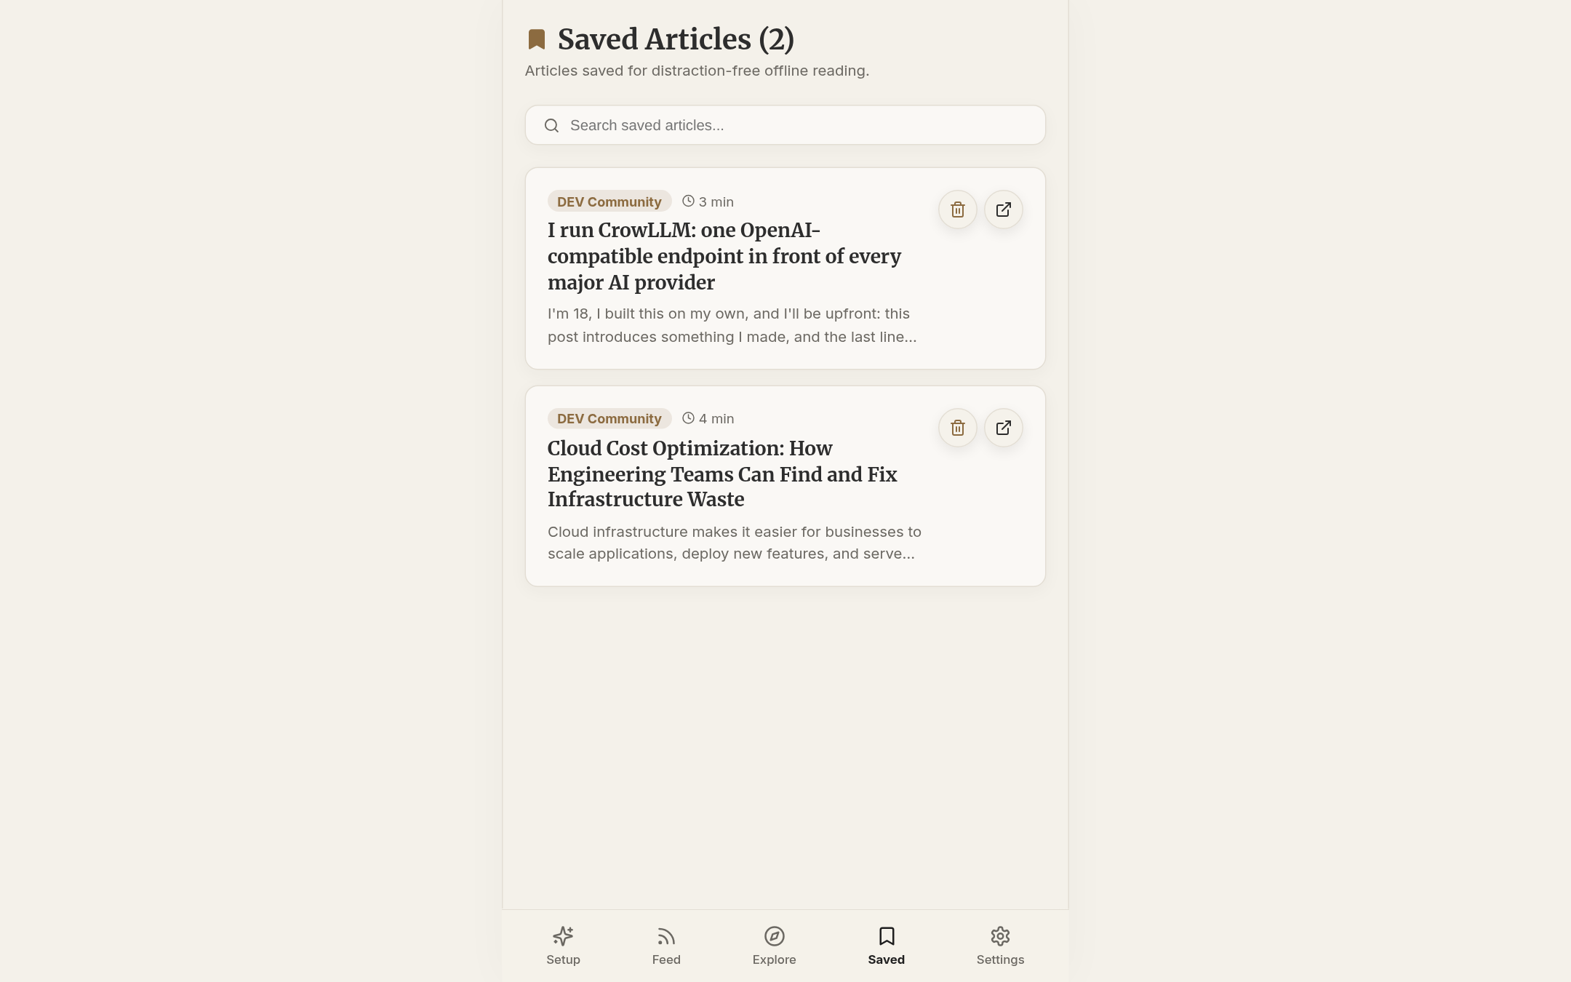
Figure 21 — Saved articles: bookmarked from the timeline, searchable, removable (US #9, #24).
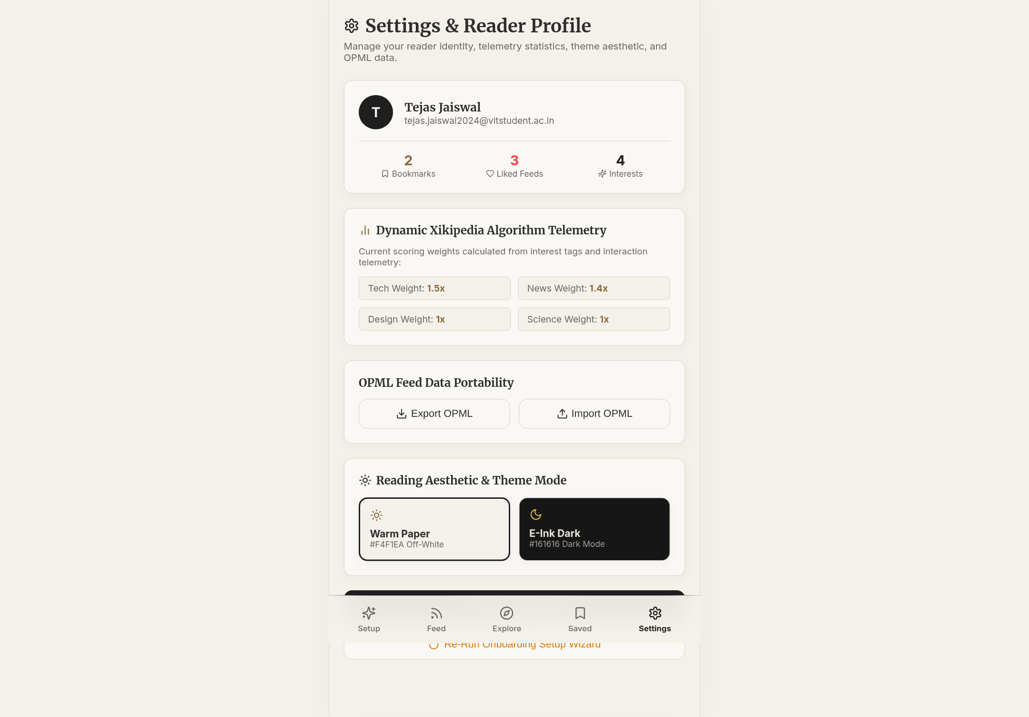
Figure 22 — Settings: reader profile, algorithm weights, OPML export/import, Warm Paper / E-Ink Dark theme (US #5).
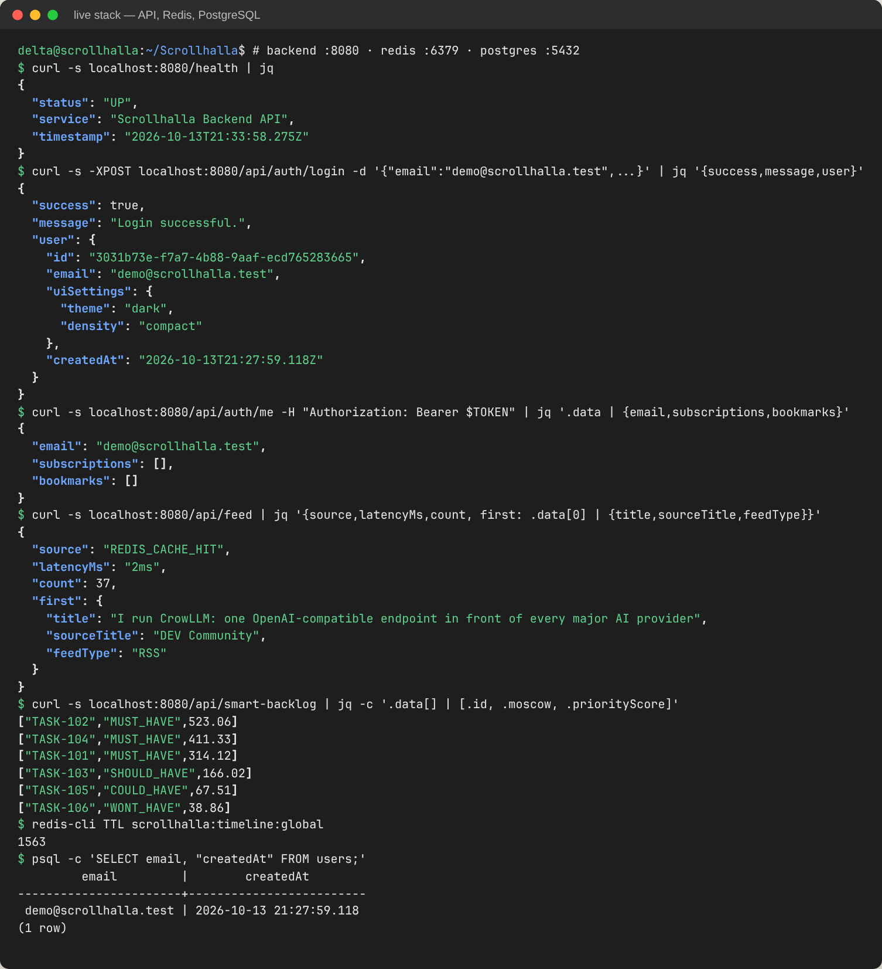
Figure 23 — Backend functionality on the live stack. Health check; login with bcrypt and JWT against PostgreSQL; protected profile; timeline served as REDIS_CACHE_HIT in 2 ms; Smart Backlog ranking; Redis TTL; user row in PostgreSQL (US #14, #15, #22).

4. Tools and Technologies Used
Area | Tool / technology | Purpose in Scrollhalla
Frontend | React 18, TypeScript, Vite 5, React Router 6, lucide-react | Single-page e-reader UI, client-side routing, icon set.
Backend | Node.js 20, Express 4, TypeScript 5 | REST API, controllers and domain services.
Feed parsing | rss-parser (behind BaseParser / FeedParserFactory) | RSS 2.0 and Atom 1.0 normalisation to one IFeedItem contract.
Scheduling | node-cron | Feed harvest every 15 minutes into Redis.
Database / ORM | PostgreSQL 15, Prisma 5 | Users, subscriptions, articles, bookmarks; type-safe queries; schema push.
Cache | Redis 7, ioredis | Pre-computed timeline (TTL 1800 s), with an in-memory fallback.
Security | bcryptjs, jsonwebtoken | Password hashing, stateless JWT authentication.
Unit / integration / regression testing | Jest 29, ts-jest, supertest, Jest snapshots | Backend test pyramid.
Mutation testing | Stryker Mutator 9 (jest-runner) | Test-suite effectiveness, mutation score gate.
Frontend testing | Vitest | OPML service unit tests.
Version control | Git, GitHub (GitHub Flow, PRs, Issues, Projects Kanban) | Branching, code review, user-story tracking.
CI | GitHub Actions | Build, test, mutation gate and container build on every push.
Containers | Docker, Docker Compose, Nginx | Four-service deployment and an /api reverse proxy.
Design | Google Stitch, Mermaid | UI screens (DA1); architecture and UML diagrams as code.

5. Project Demo Video
The demo of Scrollhalla is submitted as a recorded video:
Demo video: https://drive.google.com/file/d/1dn1QklxfcMb5wBnSkqFD3aOlN3gmukKV/view?usp=sharing
The video demonstrates the developed functionalities of the running system described in Sections 1–3.

6. Problem Statement
Readers face extreme algorithmic noise, cluttered interfaces and information overload in mainstream social media and news apps. Feeds are ranked by engagement rather than by the reader's intent, and long-form text is presented in high-contrast, ad-dense layouts that tire the eye. Standard RSS readers solve the control problem but keep a dated, list-heavy interface that discourages continuous reading.
Scrollhalla is a minimalist, mobile-first RSS/Atom aggregator that combines two things:
- the control of RSS, so readers decide which sources they follow;
- the frictionless discovery of a vertical, Reels-style scroll.
It presents articles in a calm e-reader aesthetic, with a warm paper background and serif reading text. Feeds are harvested in the background and cached, so opening the app never waits on third-party servers.
Target users.
- The Deep Thinker reads long-form essays, tech blogs and news, and wants a paper-like experience without eye strain.
- The Curator is tired of algorithms choosing their feed and wants to subscribe explicitly through tags and lists.
Success criteria.
- Feed loads under 500 ms. Measured at 0–2 ms from the Redis cache.
- Standard RSS 2.0 and Atom 1.0 feeds parse correctly. Verified by the parser unit tests.
- The system deploys with a single command through Docker Compose.

7. User Stories
User stories are tracked as GitHub Issues and on the GitHub Projects Kanban board, as set up in DA1. The table maps each story to its MoSCoW priority, its implementation status in this release, and the evidence for it: a test ID from Section 9 or a screenshot.
# | User story | MoSCoW | Status | Evidence
3 | As a new user, I want an onboarding screen with interest tags so I can bootstrap my initial feed. | Must | Done | Fig. 16
4 | As a user, I want my feed in a vertical, Reels-style scroll so I can move seamlessly between article snippets. | Must | Done | Fig. 17–18
5 | As a reader, I want an off-white, paper-like background to reduce eye strain. | Should | Done | Fig. 18, 22
6 | As a reader, I want a highly readable serif font for article content. | Should | Done | Fig. 19
7 | As a user, I want a “Like” button so the app learns my preferences. | Should | Done | Fig. 18; TC-U-SB
8 | As a user, I want a “Save” button on a feed item to read it later. | Should | Done | Fig. 18, 21
9 | As a user, I want a Saved/Bookmarks screen listing my saved articles. | Should | Done | Fig. 21
10 | As a user, I want an Explore page to discover feeds by topic. | Should | Done | Fig. 20
11 | As a user, I want to paste a custom RSS URL on Explore to add a blog. | Should | Done | Fig. 20
12 | As a reader, I want to open a snippet in a full-screen “Focus View”. | Should | Done | Fig. 19
13 | As a backend system, I want to fetch feeds automatically so content stays fresh. | Must | Done | node-cron every 15 min; TC-I-FEED
14 | As a backend system, I want to parse both RSS 2.0 and Atom feeds. | Must | Done | TC-U-PAR, TC-U-FAC
15 | As an application, I want to cache parsed feed JSON in Redis for instant load. | Could | Done | TC-I-FEED; Fig. 23
16 | As a user, I want to remove a feed from my subscriptions. | Should | Partial | Data model supports it (cascade); no UI yet
17 | As a user, I want to adjust the base font size for accessibility. | Could | Done | Fig. 19 (A-/A+)
18 | As a user, I want an estimated “Read Time” on each card. | Should | Done | Fig. 17–18
19 | As a user, I want to log out securely. | Must | Partial | JWT clear in apiService; no UI button
20 | As a user, I want a thumbnail next to the article title. | Could | Open | Deferred
21 | As a user, I want a minimalist bottom navigation bar (mobile). | Should | Done | Fig. 17
22 | As an Admin, I want to configure PostgreSQL via environment variables. | Must | Done | DATABASE_URL; Fig. 23
23 | As a developer, I want to deploy frontend and backend together with Docker Compose. | Must | Done | CI docker job; §2.2
24 | As a user, I want an empty state if I have no saved articles. | Could | Done | BookmarksView empty state
25 | As a user, I want to share an article link via a “Share” button. | Could | Done | Fig. 18
Summary: 20 of 23 stories are complete, 2 are partial and 1 is deferred. Every Must Have that the reader sees is complete. The two partial stories are already supported in the backend and data model and need only a UI control.

8. System Architecture and System Design

8.1 Architectural style
Scrollhalla is a layered (n-tier) architecture. It runs as four containers orchestrated by Docker Compose: an Nginx-served React SPA, an Express API, PostgreSQL and Redis. A layered style was chosen over microservices because the deciding constraint is team size, not scale. Two developers would pay the full coordination cost of independent services and gain nothing, since there is no independent scaling requirement.
One refinement is deliberate: the read path is inverted. A cron worker harvests the external feeds every 15 minutes and writes a normalised timeline to Redis, so GET /api/feed becomes a single key lookup. Freshness is traded for latency and for isolation from third-party servers.
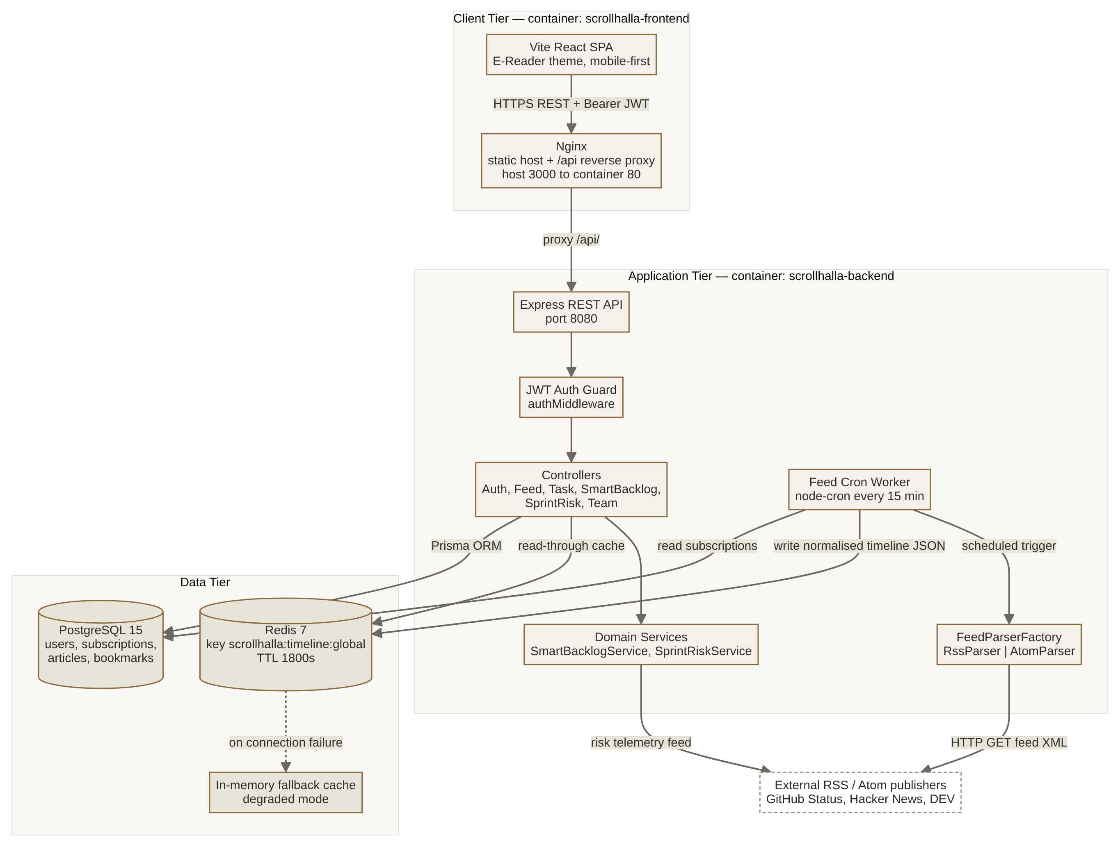
Figure 24 — Architecture and deployment view.

8.2 Design principles and patterns
- Abstraction and polymorphism. The abstract BaseParser defines one contract, parse(url): IFeedItem[]. RssParser and AtomParser implement it.
- Factory Method. FeedParserFactory keeps object creation out of the callers. DA3's mutation testing simplified it to a single Atom check (§1.5).
- Rich domain model. Task.getDaysInBacklog() and BacklogItem.getMoscowWeight() keep behaviour next to the data it uses.
- Strategy and configuration. SmartBacklogService takes injectable weights, which the tests exercise directly.
- Dependency injection. routes/api.ts is the composition root, and a single TaskController is shared by the Backlog and Team controllers.
- Resilience. CacheService falls back to an in-memory store, and SprintRiskService falls back to known telemetry.
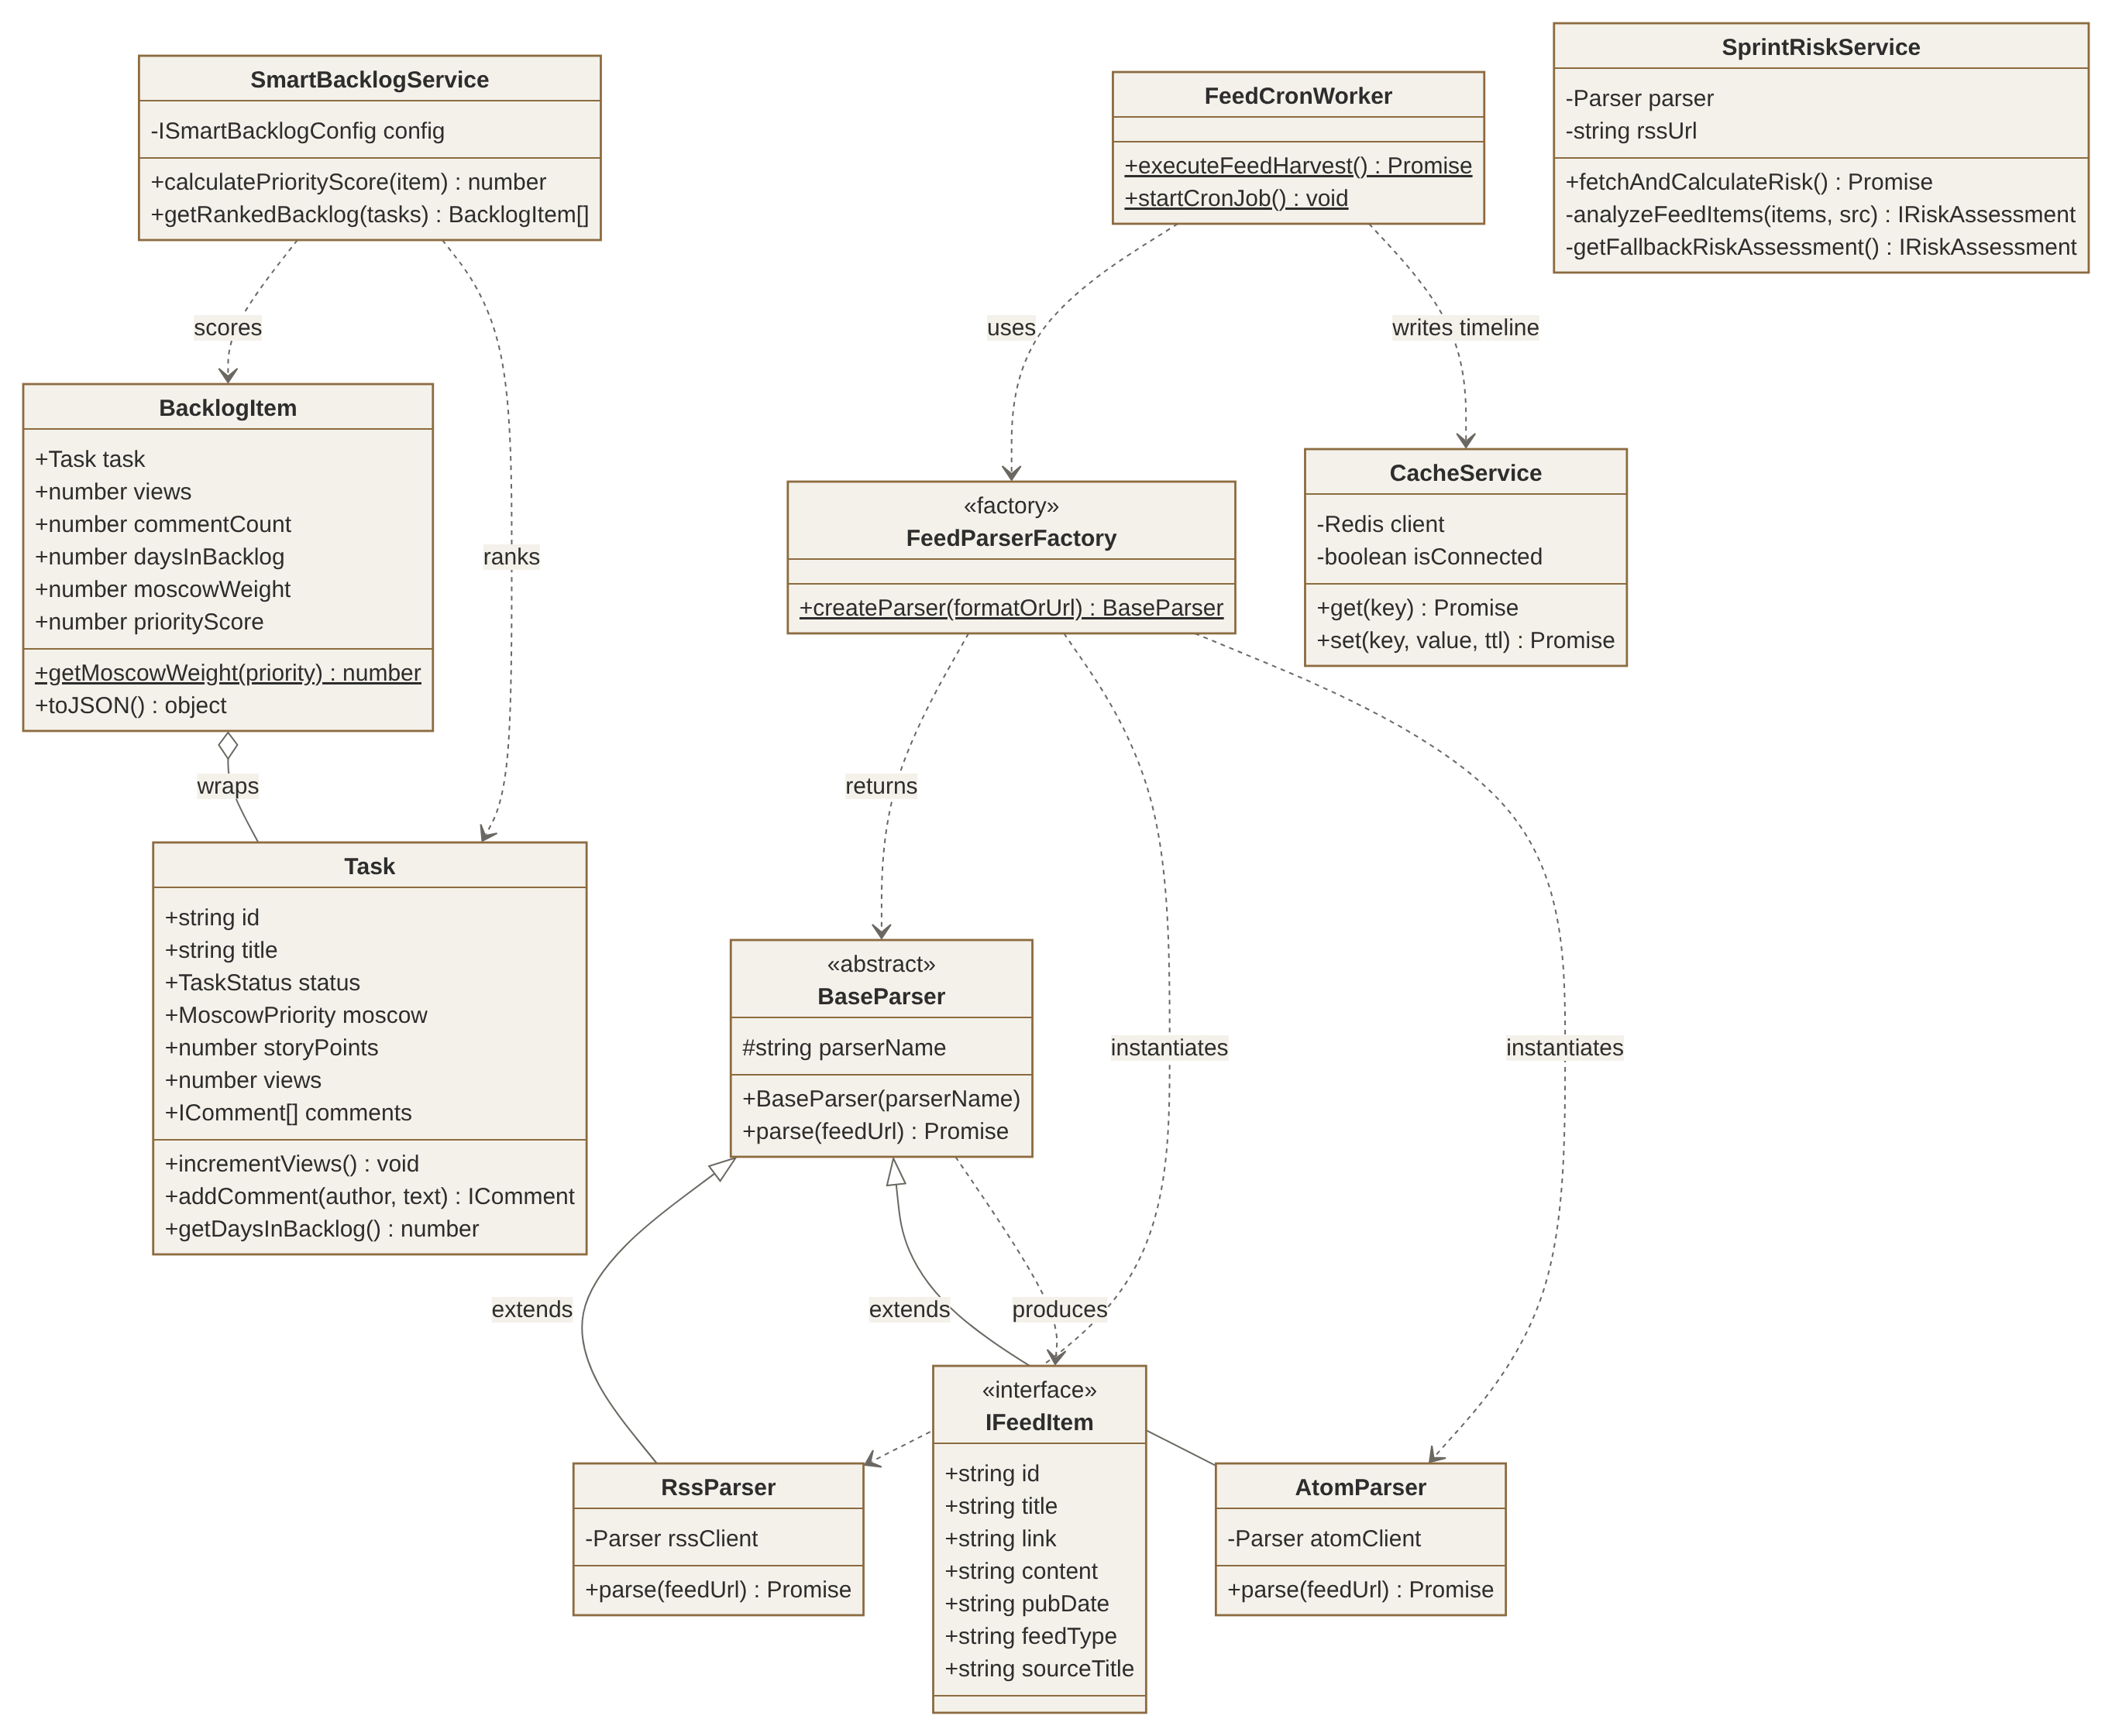
Figure 25 — Class diagram of the backend domain.
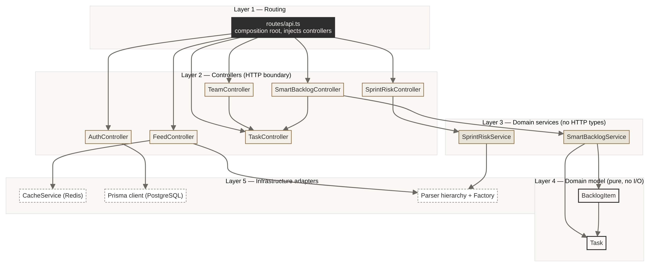
Figure 26 — Five-layer module dependencies. Arrows only point downward.

8.3 Key design decisions
Decision | Why | Cost
Abstract parser behind a factory | A new feed format means one new subclass plus one line in the factory. Callers stay closed to modification. | One extra layer of indirection.
Inverted read path (cron → Redis) | Takes seconds of third-party latency off the request path. | Content can be up to 15 minutes stale.
Cache with in-memory fallback | If Redis is down, performance degrades but the product still works. | Fallback state is per process.
Rich domain classes | The scoring rule cannot drift away from the fields it reads. | Objects must be rehydrated from JSON.
Nginx reverse proxy for /api | One origin, so no CORS configuration in production. | Local development needs a matching Vite proxy.
The full design rationale, the six UI screens and the design-system board are in the DA2 Software Design Document (design/Scrollhalla_DA2_Software_Design_Document.docx).

9. Design of Tests

9.1 Strategy
The test design follows the architecture's layers. Each level replaces exactly one boundary, which is why every failure points to a single place:
- Unit tests isolate a class from all I/O.
- Integration tests keep everything real except the Layer-5 adapters: Prisma, Redis and outbound HTTP are swapped for in-memory fakes with the same interface.
- Regression tests freeze the externally visible contract.
- Mutation testing then measures whether the three levels above would catch a real defect.
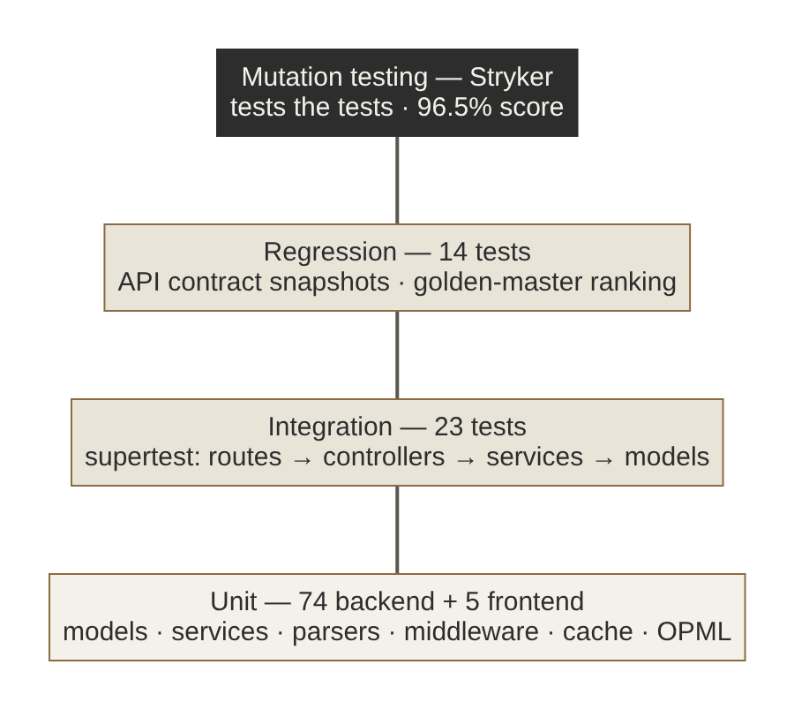
Figure 27 — Test pyramid, with mutation testing on top measuring the levels below.

9.2 Test-design techniques
- Equivalence partitioning. MoSCoW priorities (4 valid plus 1 unknown); feed URLs (Atom, RSS, generic); auth headers (missing, wrong scheme, forged, expired, valid).
- Boundary-value analysis. Risk thresholds at 19/20, 39/40 and 69/70 and the cap at 100; the risk floor of 5%; the 7-day incident window, exactly at the limit and one second over; getDaysInBacklog never below 1; team utilisation capped at 100%.
- Decision tables. Severity classification from title and body keywords (Table 9.3, TC-U-SR).
- State-based testing. The task lifecycle: create → read (views +1) → update → comment → delete → 404 on every verb.
- Error guessing and fault injection. Network failure for each parser and the risk service; one failing publisher among several; Redis unavailable; malformed JSON body.
- Golden master and contract snapshots. Used for the regression pack.

9.3 Test cases (representative)
ID | Unit under test | Input / condition | Expected result | Result
TC-U-T1 | Task constructor | Only title and description | TO_DO, SHOULD_HAVE, 3 points, “Unassigned”, id TASK-dddd | Pass
TC-U-T2 | Task.getDaysInBacklog | Created now; created 4.2 days ago | 1; 5 (rounded up, never below 1) | Pass
TC-U-B1 | BacklogItem.getMoscowWeight | MUST, SHOULD, COULD, WONT, unknown | 2.5, 1.8, 1.2, 0.5, 1.0 | Pass
TC-U-SB1 | SmartBacklogService | views 10, comments 2, 4 days, 5 points, MUST | (15 + 8 + 25·ln 5 + 6) × 2.5 | Pass
TC-U-SB2 | SmartBacklogService | Negative view weight | Score clamped to 0 | Pass
TC-U-SB3 | getRankedBacklog | Low, high and mid tasks in that order | HIGH, MID, LOW, non-increasing | Pass
TC-U-SR1 | SprintRiskService severity | “major” / “outage” / body “major outage” | CRITICAL (30) | Pass
TC-U-SR2 | SprintRiskService severity | “degraded” / “partial” / body “incident” | HIGH (20) | Pass
TC-U-SR3 | SprintRiskService thresholds | Weights summing to 15, 20, 40, 70, 120 | LOW, MEDIUM, HIGH, CRITICAL, capped at 100 | Pass
TC-U-SR4 | SprintRiskService window | Incident exactly 7 days old, and 7 days + 1 s | Counted, not counted | Pass
TC-U-SR5 | SprintRiskService fallback | Feed unreachable | 18%, LOW, two past incidents, “(Resilience Fallback Mode)” | Pass
TC-U-PAR1 | RssParser | Full RSS item | Normalised IFeedItem, ISO date, feedType RSS | Pass
TC-U-PAR2 | AtomParser | Entry with summary and updated | Content from summary, date from updated, ATOM | Pass
TC-U-PAR3 | Rss/AtomParser | Network error | Resolves to [] without throwing | Pass
TC-U-FAC | FeedParserFactory | ATOM, .atom, /atom, RSS, .rss, /feed, AUTO | AtomParser × 4, RssParser × 5 | Pass
TC-U-MW | authenticateJWT | No header; Basic; forged; expired; valid | 401; 401; 403; 403; next() with req.user | Pass
TC-U-C1 | CacheService | Redis down; set, get, TTL expiry | Value round-trips; null after TTL | Pass
TC-I-TASK | /api/tasks (CRUD) | Create → get ×2 → update → comment → delete | 201; views +1; partial update; 201; then 404 on every verb | Pass
TC-I-DI | /api/smart-backlog + /api/team | New task with 80 views and 20 comments; reassignment | Ranked first; member workload updated | Pass
TC-I-FEED | /api/feed pipeline | Cold cache, then a second call; one source failing | ON_DEMAND_HARVEST, newest first; then CACHE_HIT with no refetch; 2 of 3 sources still served | Pass
TC-I-AUTH | /api/auth/* | Register, duplicate, bad login, login, /me with and without token | 201 (no hash in body); 409; 401 with identical messages; 200; 200 / 401 | Pass
TC-R-01 | All endpoints | GET on 9 routes | Status and response shape match snapshot | Pass
TC-R-02 | Seed backlog | GET /api/smart-backlog | Order 102, 104, 101, 103, 105, 106 | Pass
TC-R-03 | Edge behaviours | storyPoints 0; utilisation over 100%; malformed JSON | 3; capped at 100; handled error with success: false | Pass
TC-F-OPML | generateOpmlXml | Title Tom & "Jerry's" <feed> | All five XML entities escaped; valid OPML 2.0 | Pass

9.4 Test doubles
Double | Replaces | Used by
rssParserMock | The rss-parser network client, with a programmable parseURL | Parser, risk service, integration and regression tests
prismaModuleMock | The Prisma client, backed by an in-memory users array | Integration and regression tests (auth)
cacheModuleMock | The Redis CacheService, backed by a Map | Integration and regression tests (feed)
Fake timers | The system clock | TTL expiry and 7-day boundary tests

9.5 Exit criteria
- All unit, integration and regression tests pass in CI.
- Mutation score is at least 60% (break threshold). The target band is 70–85% or above; achieved: 96.49%.
- Every surviving mutant is either killed or documented as equivalent (§1.5).
- The backend type-checks (tsc) and the frontend builds. The compose stack builds.

Appendix A — Software Requirements Specification

A.1 Purpose and scope
This SRS specifies Scrollhalla, a web-based RSS/Atom e-reader with a Reels-style reading feed. It is delivered as a React SPA and a REST API, deployed with Docker Compose. Out of scope for this release are full offline support, native iOS/Android apps and AI-generated summaries (the Won't Have items in DA1).

A.2 Overall description
- Users: the Reader (Deep Thinker and Curator personas) and the Admin/DevOps role. A cron scheduler and external publishers are system actors.
- Operating environment: a modern browser (desktop and mobile), Node.js 20, PostgreSQL 15, Redis 7, and Docker.
- Constraints: deployable with Docker Compose; configuration only through environment variables; no secrets committed.
- Assumptions: users have standard RSS/Atom URLs or use the in-app directory; publishers serve valid XML over HTTP(S).

A.3 Functional requirements
ID | Requirement | Priority | Story
FR-1 | The system shall let a user register and log in with email and password, store a bcrypt hash, and issue a JWT valid for 7 days. | Must | #19
FR-2 | The system shall reject protected requests without a valid Bearer token (401 when missing, 403 when invalid or expired). | Must | #19
FR-3 | The system shall provide onboarding where the reader enters a profile, selects interest tags and chooses seed channels. | Must | #3
FR-4 | The system shall parse RSS 2.0 and Atom 1.0 feeds into one normalised article format. | Must | #14
FR-5 | The system shall harvest all subscriptions every 15 minutes and cache the merged, newest-first timeline for 30 minutes. | Must | #13, #15
FR-6 | On a cache miss, the system shall harvest on demand. A failing publisher shall not prevent the other publishers' articles from being served. | Must | #15
FR-7 | The system shall present the timeline as a vertical, one-card-per-article scroll with read time, and Like, Save, Read, Share and Open actions. | Must | #4, #7, #8, #18, #25
FR-8 | The system shall provide a full-screen reader view with adjustable font size. | Should | #12, #17
FR-9 | The system shall list bookmarked articles with search and removal, and show an empty state when there are none. | Should | #9, #24
FR-10 | The system shall offer a categorised feed directory and subscription by custom URL. | Should | #10, #11
FR-11 | The system shall export subscriptions as OPML 2.0 with XML-escaped fields. | Could | —
FR-12 | The system shall offer Warm Paper and E-Ink Dark themes. | Could | #5
FR-13 | The system shall let a user remove a subscription. | Should | #16
FR-14 | The system shall rank backlog items by views, comments, age, story points and MoSCoW weight (Smart Backlog). | Should | —
FR-15 | The system shall compute a 0–100% sprint risk score from the GitHub status feed, with an offline fallback. | Could | —

A.4 Non-functional requirements
ID | Category | Requirement | Verification
NFR-1 | Performance | Timeline API responds in under 500 ms when the cache is warm. | Measured 0–2 ms (Fig. 23)
NFR-2 | Availability | If Redis is unavailable, the system degrades to an in-memory cache instead of failing. | TC-U-C1
NFR-3 | Security | Passwords are never stored or returned in plain text. Login errors do not reveal whether an account exists. | TC-I-AUTH, TC-R-03
NFR-4 | Usability | Warm paper palette (#F4F1EA / #2D2D2D); one primary action per screen; navigation within thumb reach on mobile. | Fig. 16–22
NFR-5 | Portability | The whole stack starts with docker compose up. All configuration comes from the environment. | CI docker job
NFR-6 | Maintainability | Adding a feed format needs no change to callers. Mutation score stays at or above 60% in CI. | TC-U-FAC; Stryker gate
NFR-7 | Interoperability | Subscriptions can be exchanged with other readers through OPML 2.0. | TC-F-OPML

A.5 External interfaces
Method | Endpoint | Description | Auth
GET | /health | Service liveness | —
POST | /api/auth/register, /api/auth/login | Create account / obtain JWT | —
GET | /api/auth/me | Profile with subscriptions and bookmarks | JWT
GET | /api/feed | Cached combined timeline (source, latency, count, data) | —
GET/POST/PUT/DELETE | /api/tasks[/:id[/comments]] | Backlog task CRUD and comments | —
GET | /api/smart-backlog, /api/sprint-risk, /api/team | Ranked backlog, risk telemetry, team workload | —

Appendix B — Data Flow Diagrams
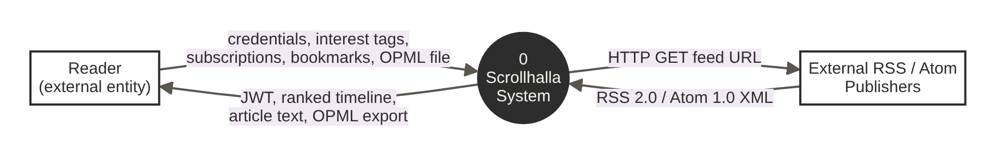
Figure B1 — DFD Level 0 (context diagram).
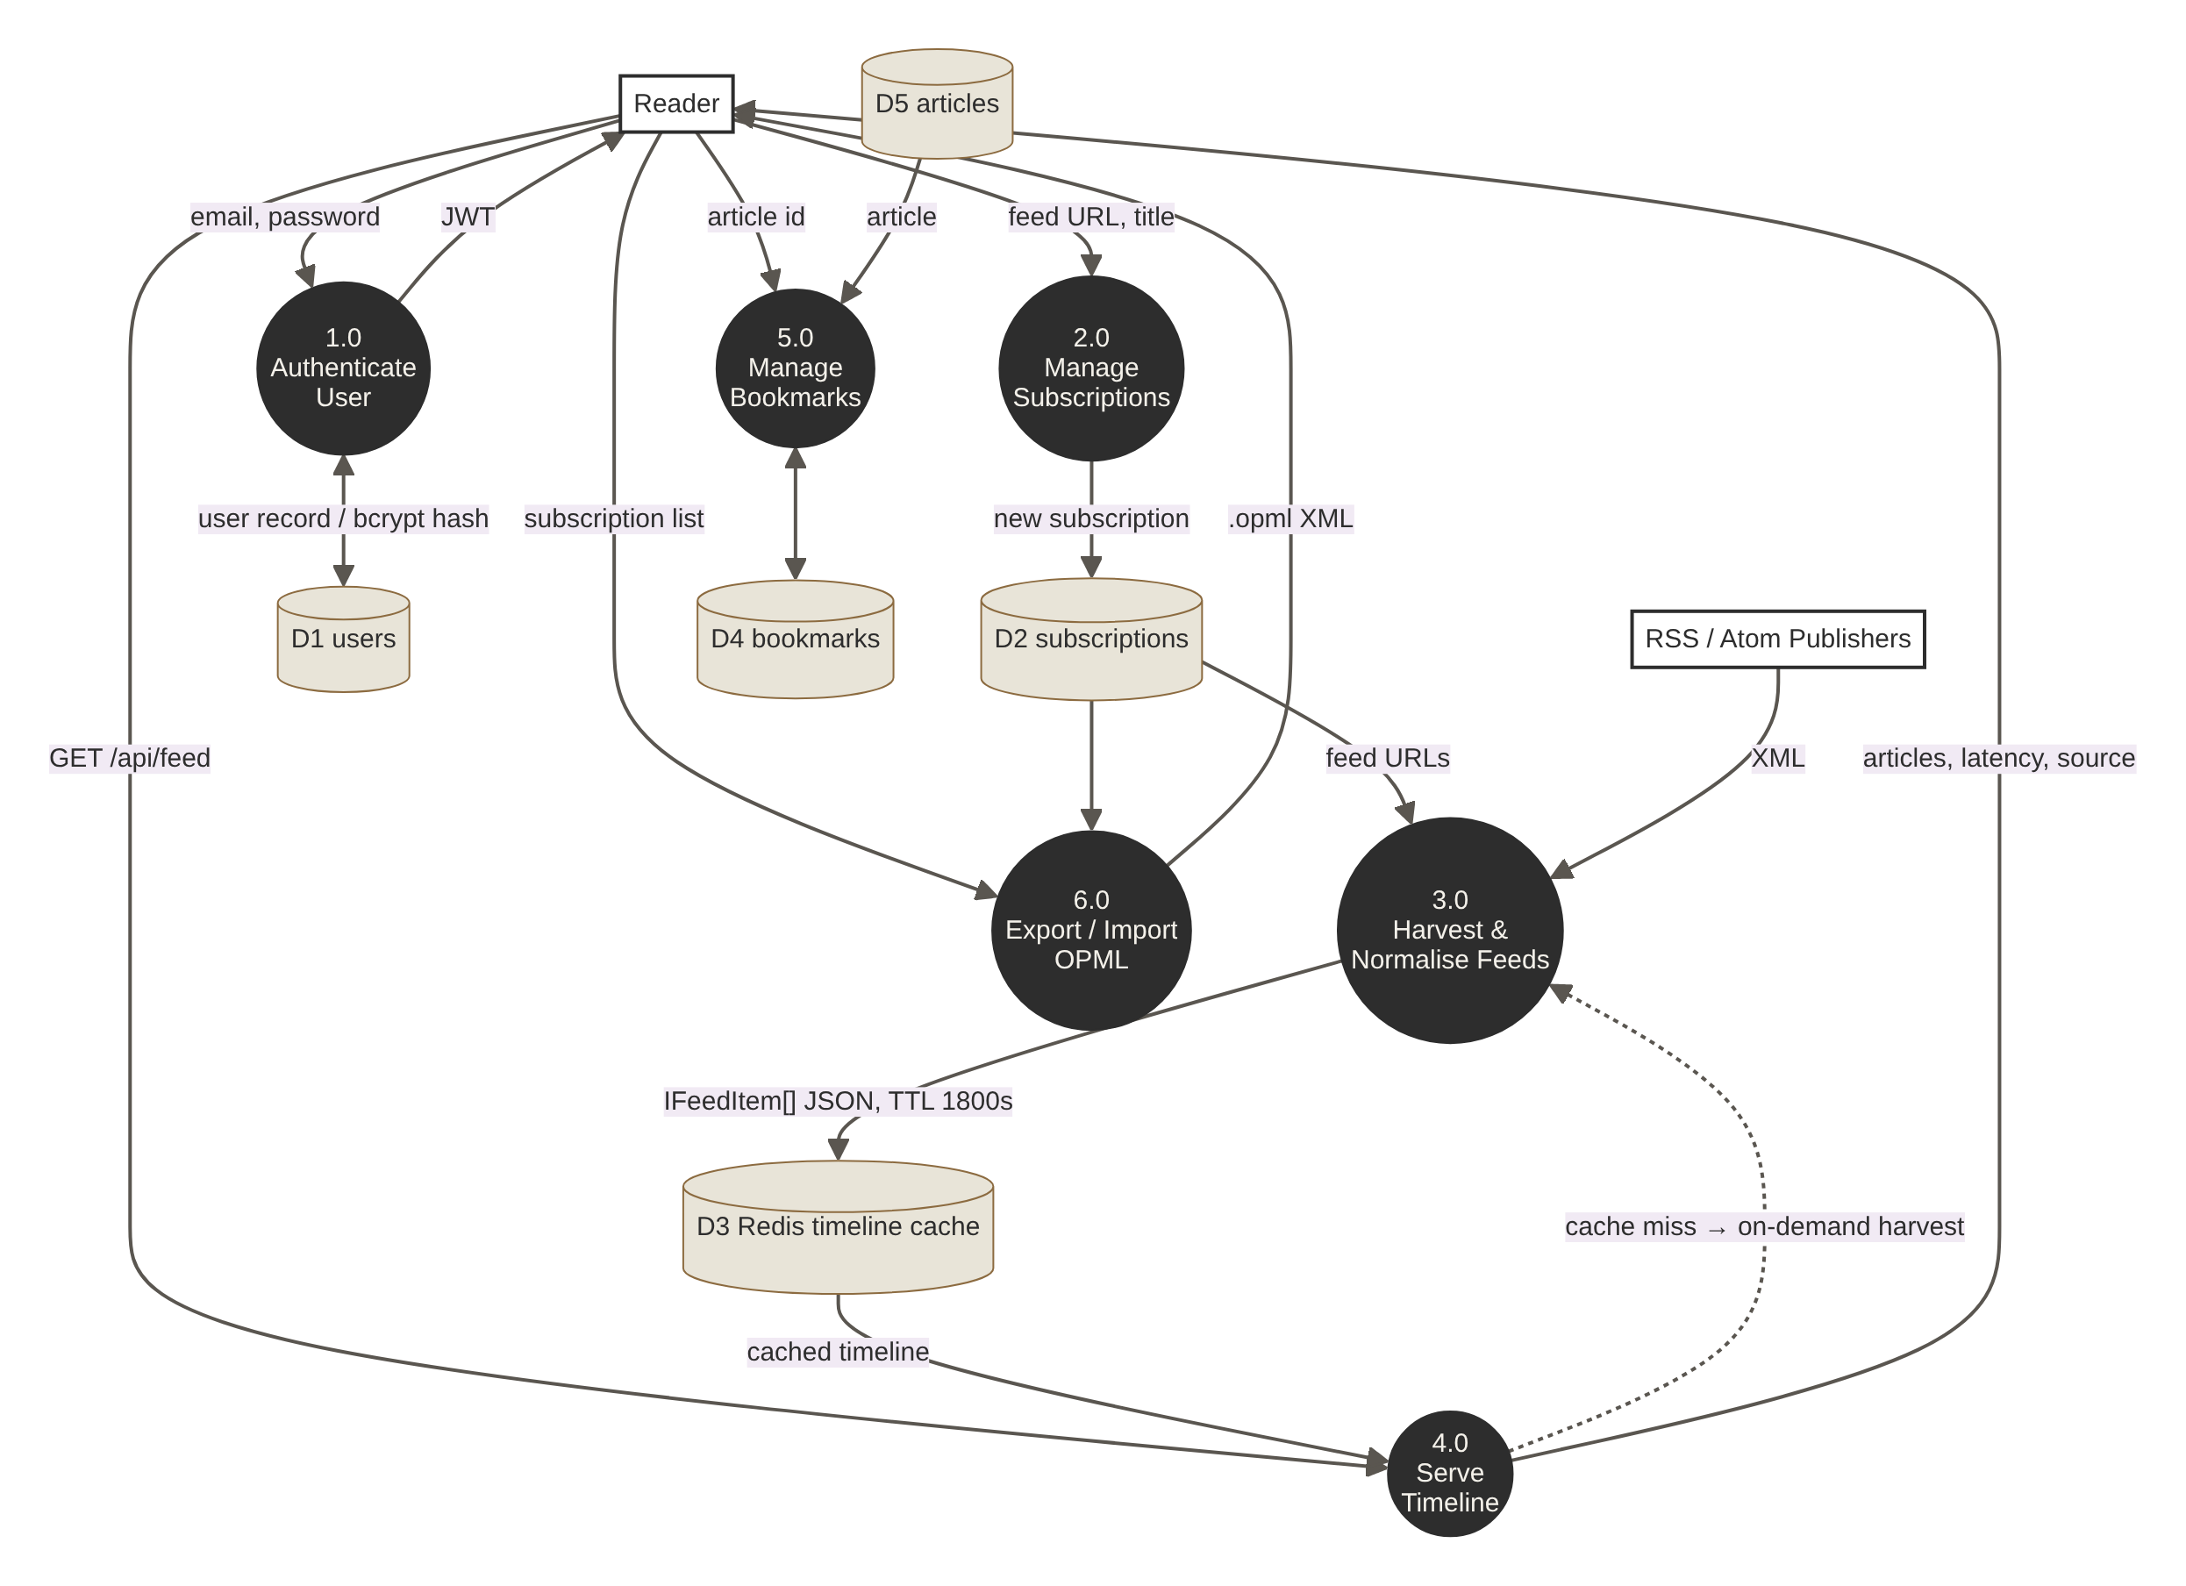
Figure B2 — DFD Level 1: six processes and five data stores. The dotted flow is the cache-miss path.

Appendix C — Entity Relationship Diagram
The ERD is derived directly from backend/prisma/schema.prisma:
- a User has many Subscriptions and many Bookmarks;
- a Subscription has many Articles;
- a Bookmark links one User to one Article, and the pair (userId, articleId) is unique.
All foreign keys cascade on delete.
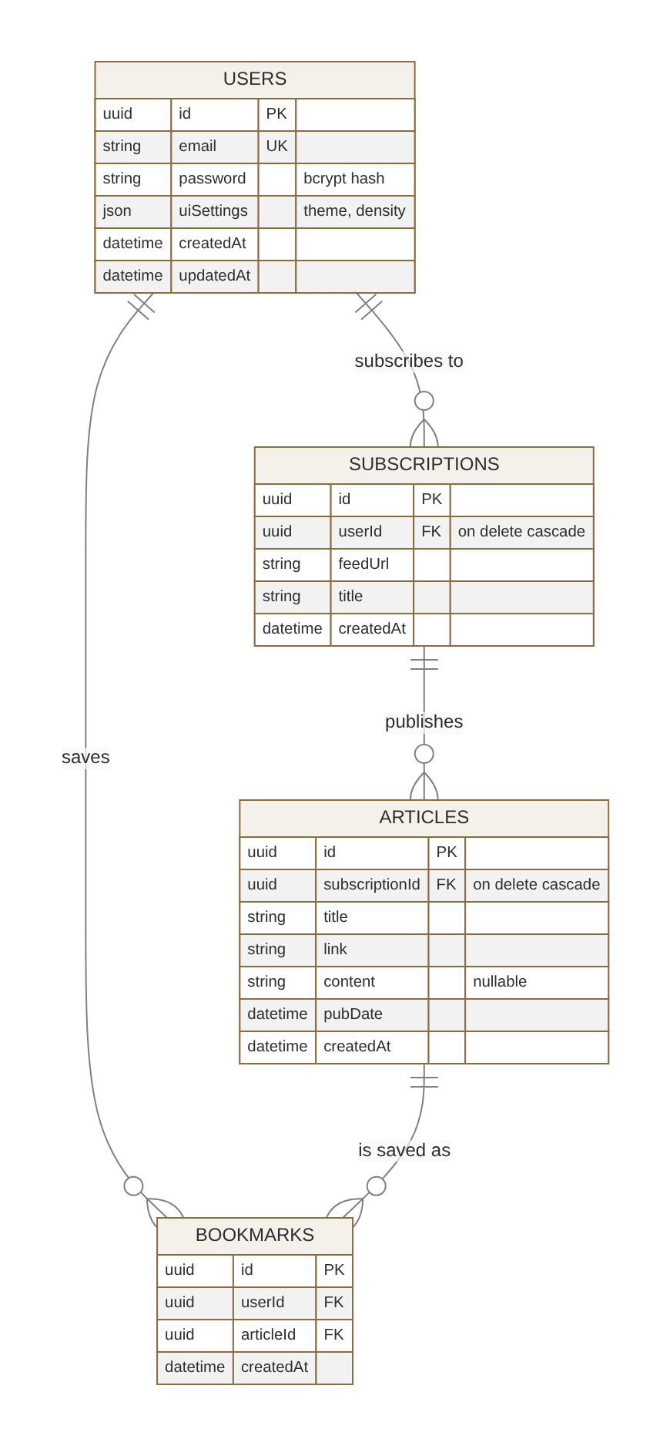
Figure C1 — Entity relationship diagram (PostgreSQL via Prisma).

Appendix D — UML Diagrams
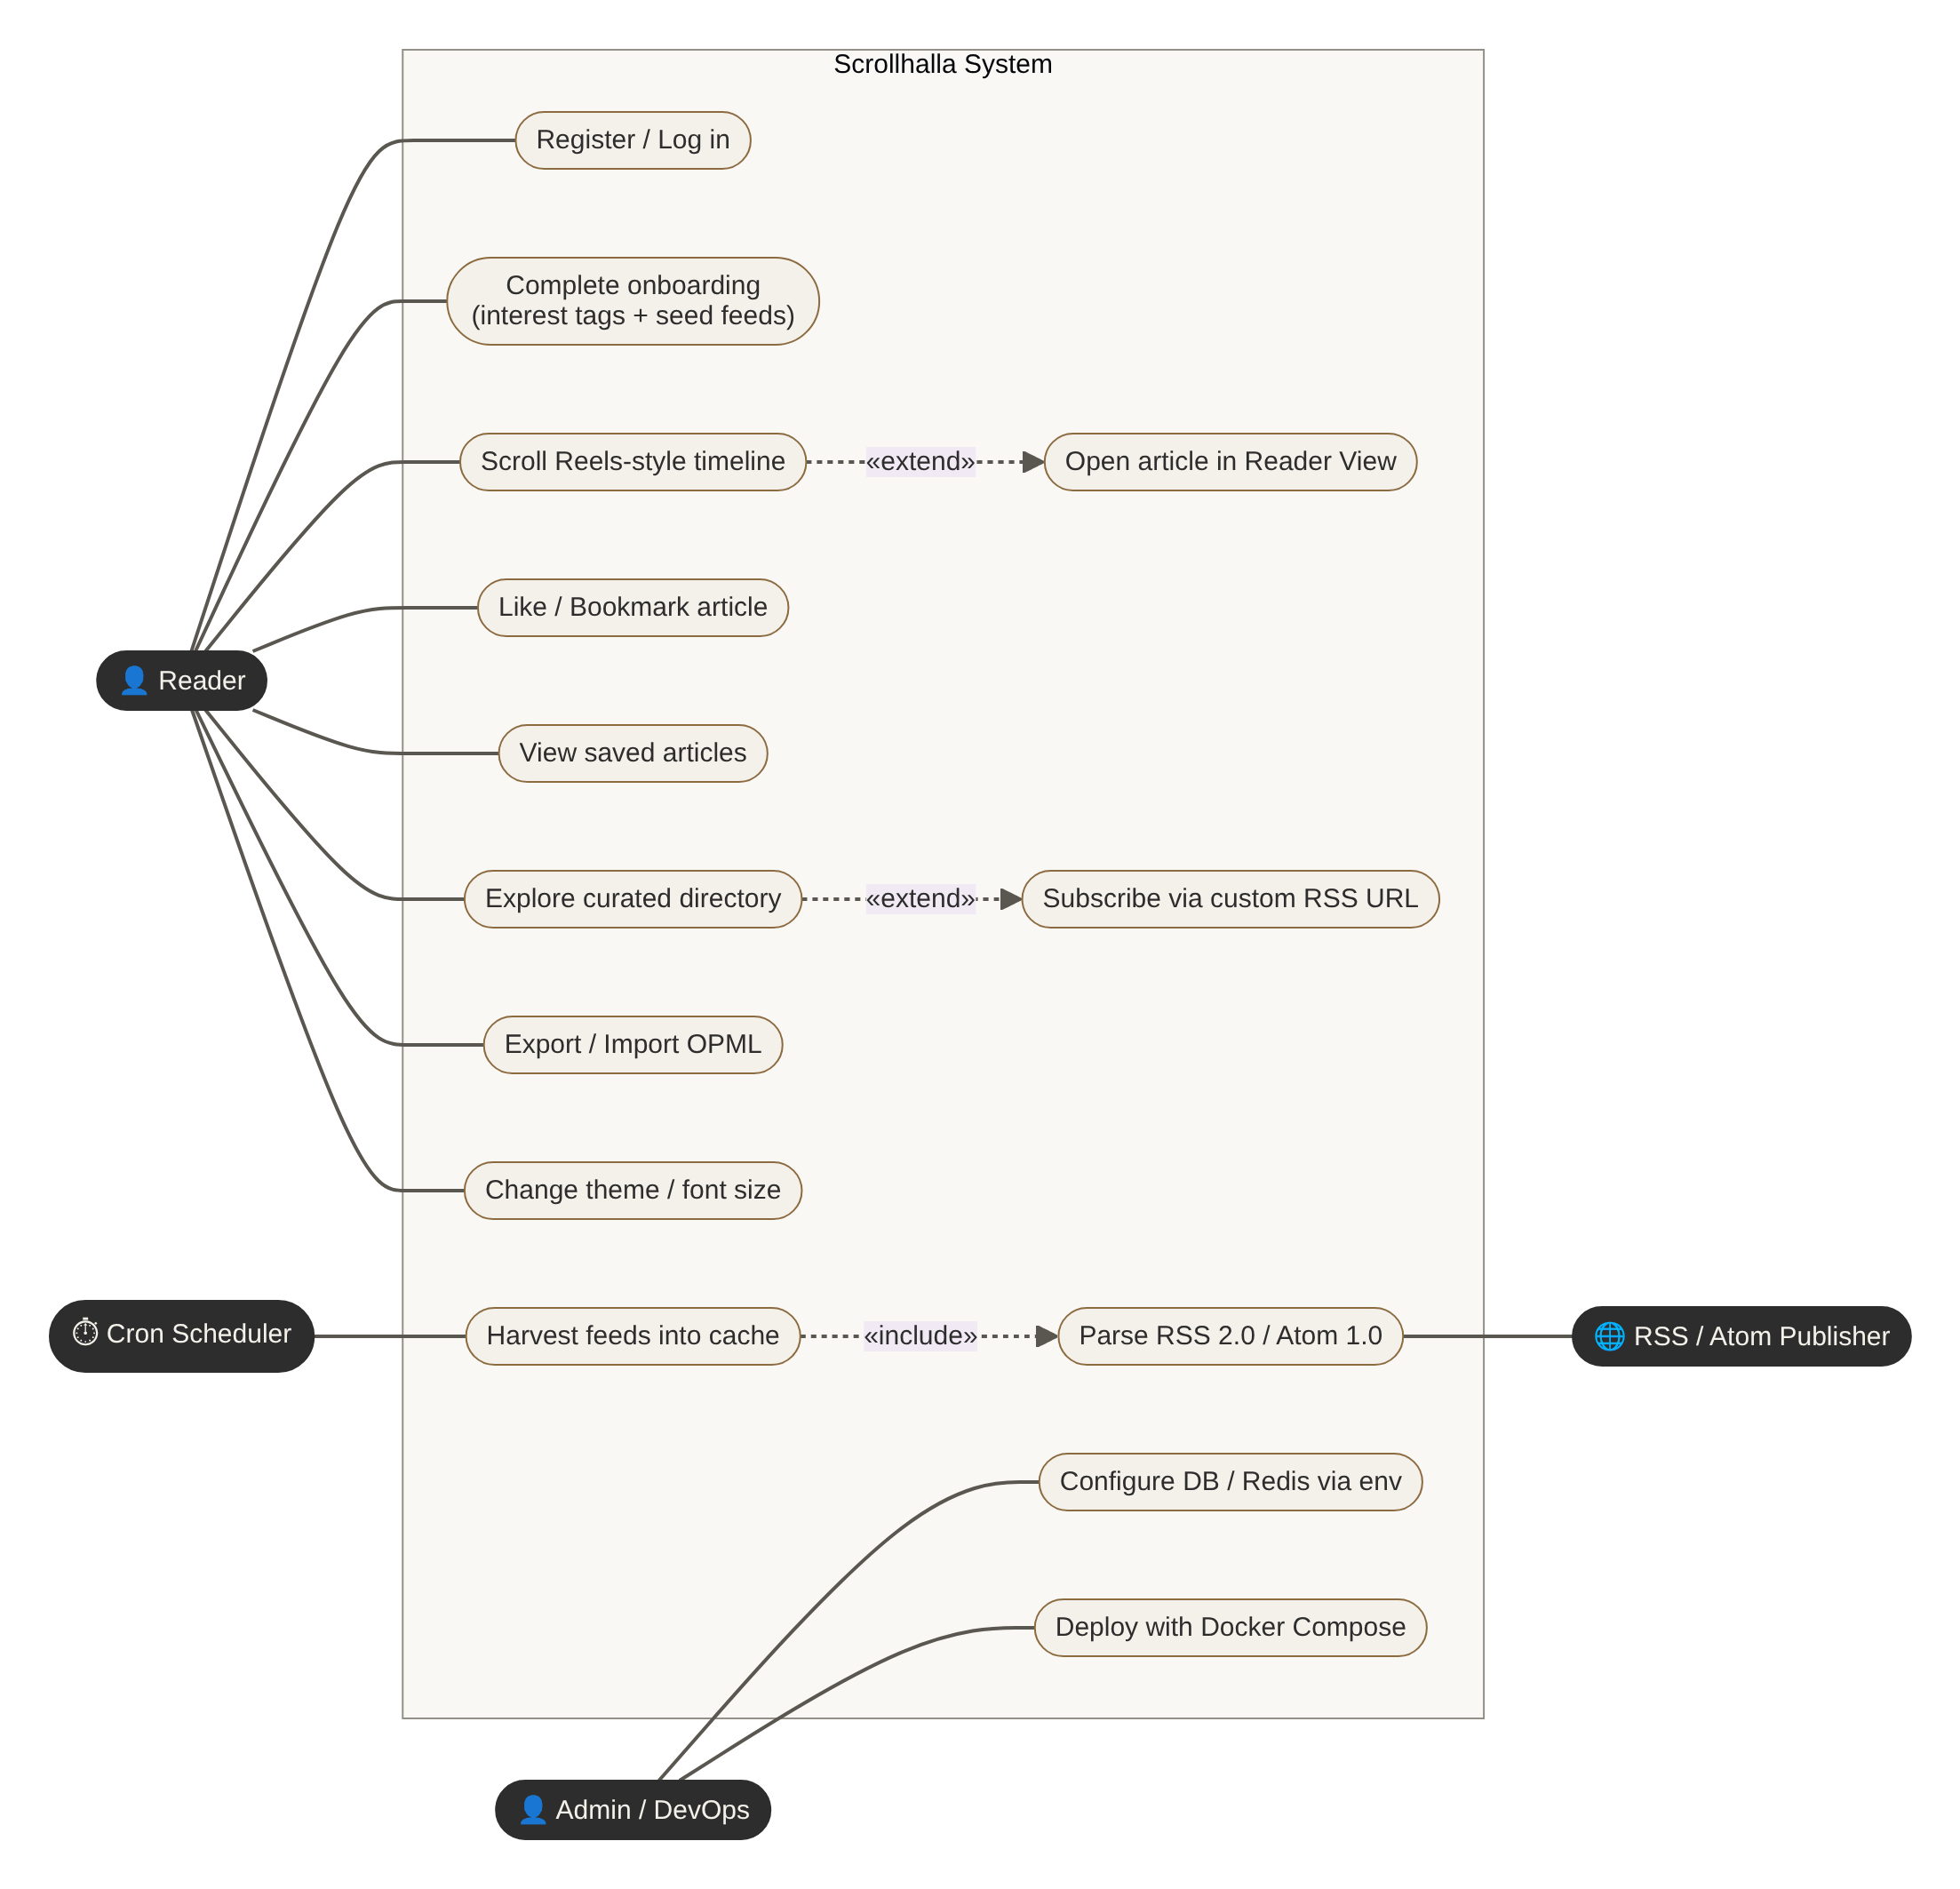
Figure D1 — Use case diagram.
Figure D2 — Class diagram.
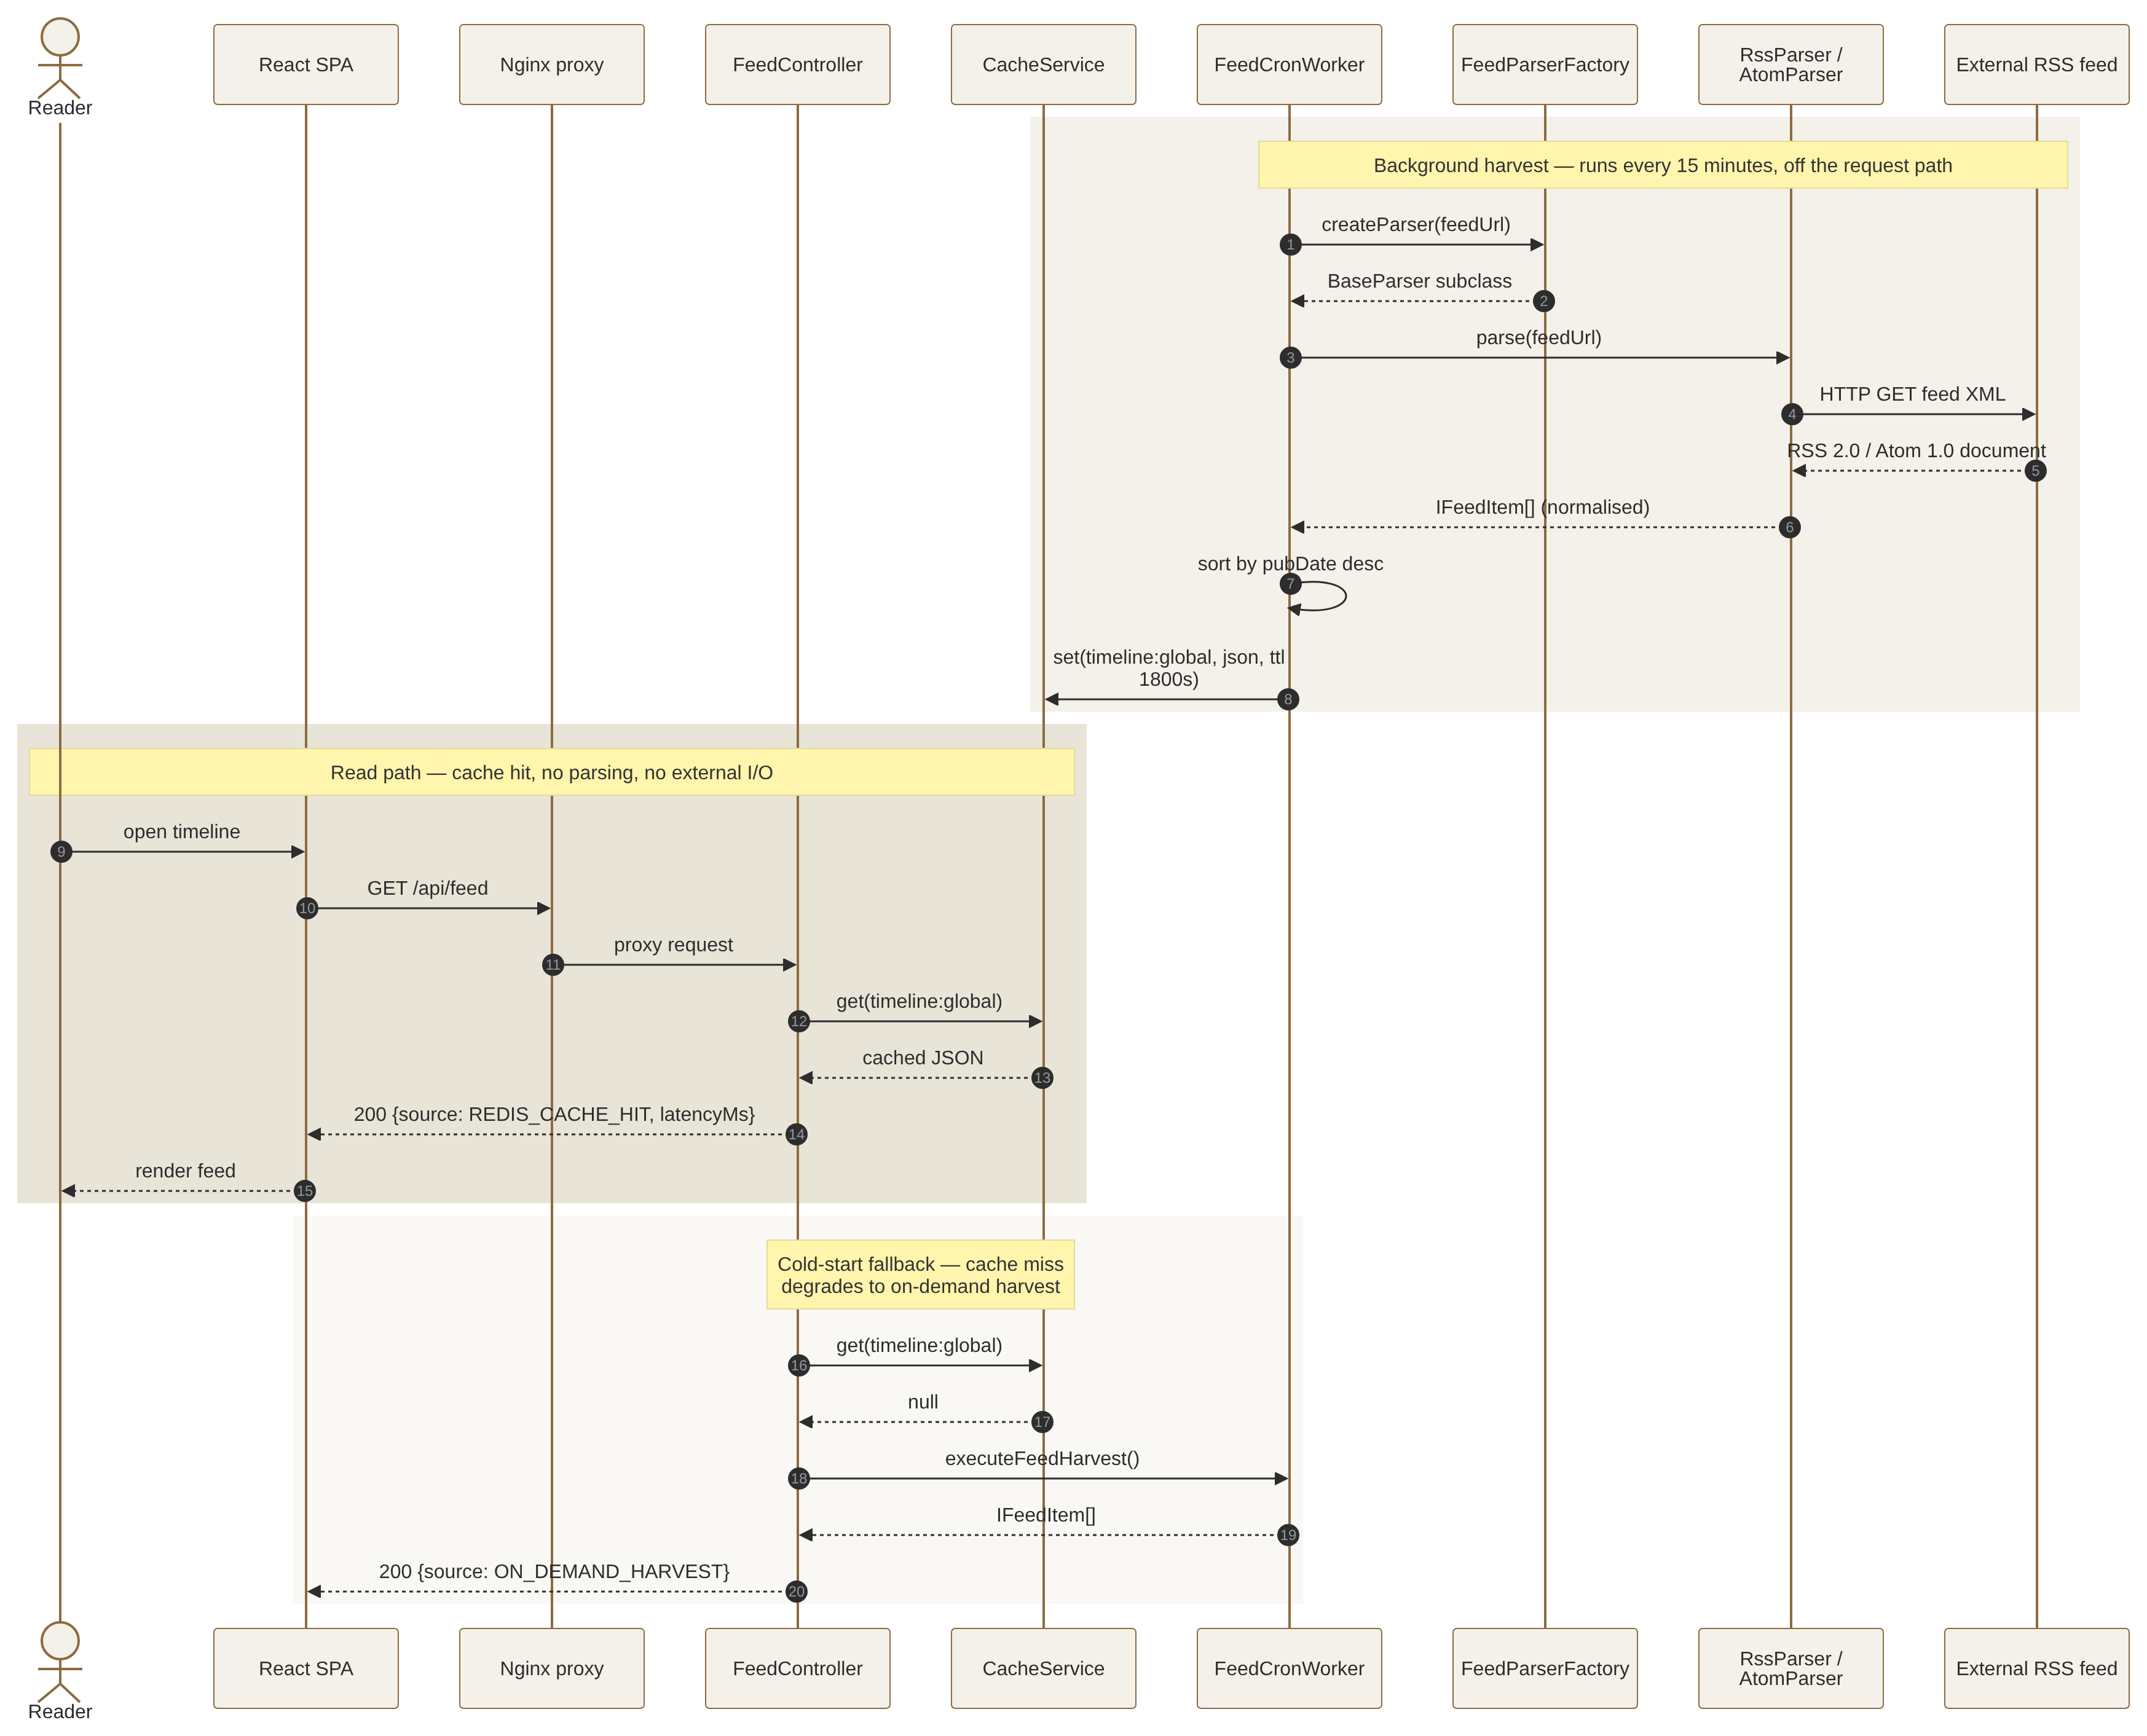
Figure D3 — Sequence diagram: cron harvest, cached read and cold-start fallback.
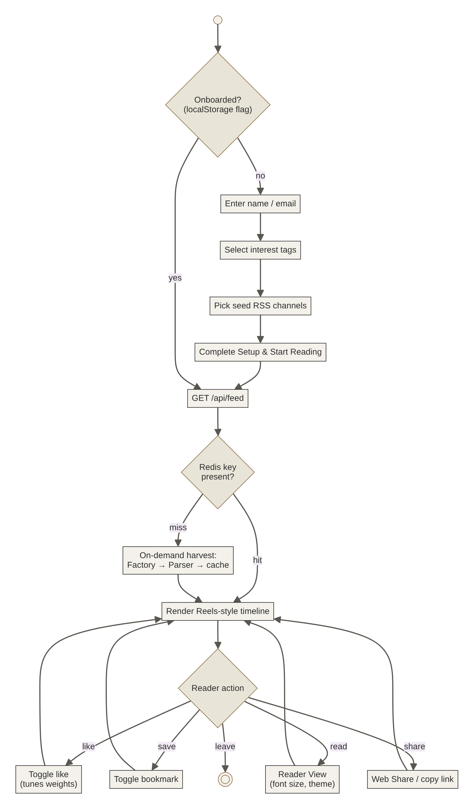
Figure D4 — Activity diagram: onboarding and reading session.
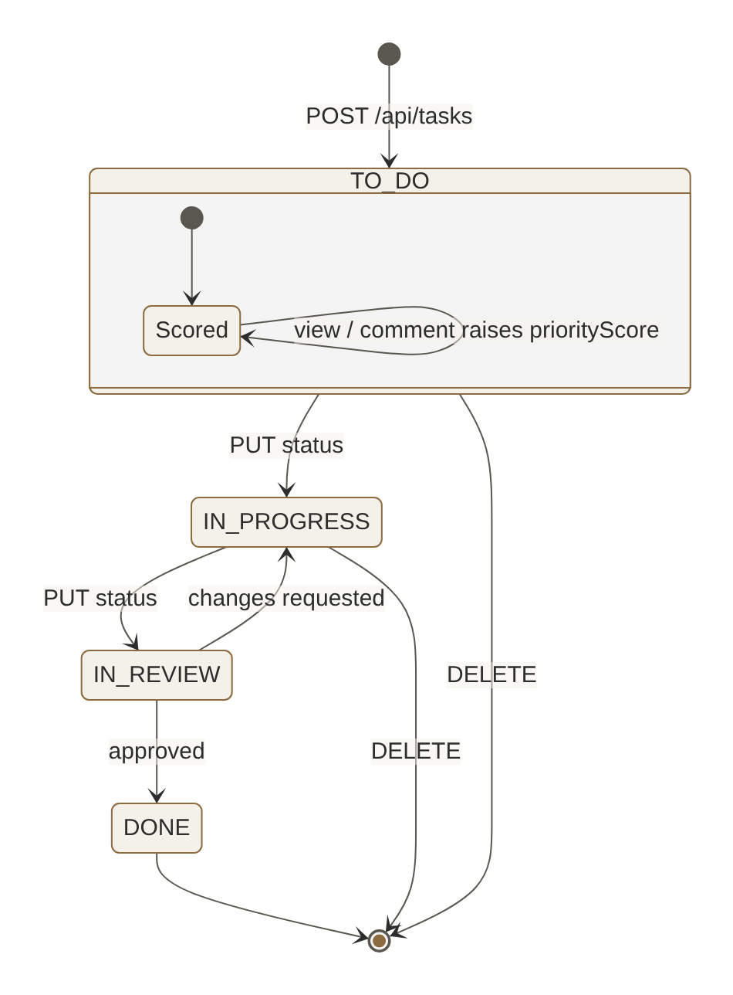
Figure D5 — State machine diagram: backlog task lifecycle.
Figure D6 — Component/package diagram: layered module dependencies.
Figure D7 — Deployment diagram: four Docker Compose containers.

Appendix E — Code Listing and GitHub Link
Repository: https://github.com/tejasjaiswal2024-art/Scrollhalla
DA3 branch: feature/da3-testing · Release tag: v3.0.0
Path | Contents
backend/src/ | Express app, controllers, services, models, parsers, middleware, cron worker, Prisma/Redis config
backend/prisma/schema.prisma | Database schema (Appendix C)
backend/tests/unit|integration|regression/ | Jest suites; tests/helpers/ holds the test doubles
backend/jest.config.js, stryker.config.json | Test runner and mutation configuration
frontend/src/ | React views, components, services (apiService, opmlService)
.github/workflows/ci.yml | CI pipeline
docker-compose.yml, */Dockerfile, frontend/nginx.conf | System build and deployment
design/ | Mermaid sources, PNG exports, UI screens, DA2 SDD
docs-da3/ | This report and all screenshots
Listing E1 — Factory Method after the mutation-driven refactor (backend/src/parsers/FeedParserFactory.ts)
export class FeedParserFactory {
public static createParser(formatOrUrl: string = 'AUTO'): BaseParser {
return FeedParserFactory.isAtom(formatOrUrl) ? new AtomParser() : new RssParser();
}
private static isAtom(formatOrUrl: string): boolean {
return formatOrUrl.toUpperCase() === 'ATOM' || formatOrUrl.includes('.atom') || formatOrUrl.includes('/atom');
}
}
Listing E2 — Smart Backlog scoring (backend/src/services/SmartBacklogService.ts)
public calculatePriorityScore(item: BacklogItem): number {
const viewScore = item.views * this.config.weightViews;
const commentScore = item.commentCount * this.config.weightComments;
// Logarithmic decay/growth for time in backlog to avoid extreme skew
const ageScore = Math.log(item.daysInBacklog + 1) * 10 * this.config.weightBacklogAge;
const complexityScore = item.storyPoints * this.config.weightStoryPoints;
const finalScore = (viewScore + commentScore + ageScore + complexityScore) * item.moscowWeight;
item.priorityScore = Math.max(0, finalScore);
return item.priorityScore;
}
Listing E3 — Read path served from Redis (backend/src/controllers/FeedController.ts, excerpt)
let cachedTimeline = await cacheService.get(REDIS_FEED_CACHE_KEY);
if (cachedTimeline) {
articles = JSON.parse(cachedTimeline);
} else {
// Cache miss: execute on-demand harvest & populate cache
articles = await FeedCronWorker.executeFeedHarvest();
}
res.json({ success: true, source: cachedTimeline ? 'REDIS_CACHE_HIT' : 'ON_DEMAND_HARVEST', latencyMs, count: articles.length, data: articles });
Listing E4 — Mutation testing configuration (backend/stryker.config.json)
{
"testRunner": "jest",
"jest": { "configFile": "jest.config.js", "enableFindRelatedTests": false },
"coverageAnalysis": "perTest",
"mutate": ["src/models/**/*.ts", "src/services/**/*.ts", "src/parsers/**/*.ts",
"src/middleware/**/*.ts", "src/controllers/TaskController.ts", "src/controllers/TeamController.ts"],
"thresholds": { "high": 85, "low": 70, "break": 60 }
}

Conclusion
Review 3 takes Scrollhalla from an untested codebase to one with a four-level automated test suite of 116 tests, 92% line coverage and a 96.5% mutation score, enforced by a CI pipeline that builds and tests every push. Mutation testing was the most informative of the levels. Besides measuring the suite, it found dead code in the parser factory and three blind spots that coverage figures had hidden. The system builds and runs end-to-end on PostgreSQL and Redis with live feeds. Twenty of twenty-three user stories are complete, and the remaining three are recorded with their current state.

