F | O | O | D | L | E
Design System and Product Specification
A daily food and drink guessing game for iOS, Android and the web
Version 1.0 | 15 October 2026
Build target: Expo (React Native) for the apps, Next.js for the website, one shared design system
Companion files: Foodle_Concept_Note.docx, Foodle_Starter_Repository.xlsx

Contents
§ | Section | What it covers
1 | Design principles | The five rules every screen follows
2 | Game rules | Exact, codeable rules for puzzles, guesses and feedback
3 | Visual foundations | Colour, type, spacing, grid, icons, wordmark
4 | Components | Every UI part with sizes, states and tokens
5 | Screens | Mockups and layout notes for each screen
6 | App and web | Responsive layout and platform differences
7 | Motion and haptics | Timings, easing and feedback
8 | Accessibility | Contrast, screen readers, input
9 | Photography | Image standard, licences and the sourcing pipeline
10 | Onboarding, stats and streaks | First run and progress
11 | Social and leaderboards | Friends, groups, ranking, sharing
12 | Voice and copy | Tone and the microcopy set
13 | Engineering handoff | Repo, tokens, types, database, API, algorithms, analytics, budgets, assets
14 | Open items | What is not yet in place

Every figure about content in this document (counts, longest names, coverage) is computed from the starter repository at the time of writing. Mockups are drawn to scale at iPhone width (390 pt) and desktop width (1440 px) and use the production colours and fonts. The food photo in the mockups is a placeholder.

1. Design principles
Principle | What it means in practice
One thing a day | One puzzle per mode per day, the same for everyone. Nothing on the game screen competes with it: no feeds, no banners, no badges.
Clues first, chrome last | The clue strip and the board take the screen. Navigation sits in a thin top bar and a drawer.
Colour is the scoreboard | Green, yellow and grey carry all game meaning, exactly as in Wordle. They are never used for decoration, buttons excepted (primary button = green).
Calm, not casino | White space, two typefaces, no gradients, no confetti. A win is marked by a short tile bounce and a line of copy.
Same game on every screen | Phone, tablet and desktop share one board, one set of tokens and one rules engine. Only the frame around the board changes.

2. Game rules

2.1 Modes and editions
Three modes, each in two editions, give six daily puzzles. Each has its own number, streak and stats.
Mode | Edition | Player guesses | Guess list (autocomplete) | Feedback tiles
Dish | Global | A dish | All 911 dishes | Country | Region | Course | Diet | Shared
Dish | India | A dish | 363 Indian dishes | Zone | State | Course | Diet | Shared
Drink | Global | A drink | All 247 drinks | Country | Region | Type | Alcohol | Shared
Drink | India | A drink | 41 Indian drinks | Zone | State | Type | Alcohol | Shared
Cuisine | Global | A country (clues are one dish's ingredients) | All 250 countries | Continent | Subregion | Distance | Neighbour
Cuisine | India | A state (clues are one dish's ingredients) | 28 states plus Pan-India | Zone | Distance

2.2 The daily puzzle
- Number. Puzzle No. = days since launch day + 1, counted in the player's local calendar. Launch day is No. 1.
- Reset. A new puzzle unlocks at 00:00 device local time. The countdown on the answer card counts to that moment.
- Answer. Drawn from puzzle-ready items only (at least 5 clues and 3 ingredients). The server holds the answer; the client never receives it before the puzzle ends.
- Guesses. Six. Clue 1 is shown at the start; each wrong guess reveals the next clue. A dish has up to 7 clues; once all are shown, further misses reveal nothing new.
- Valid guess. Must be picked from the autocomplete list for that mode and edition. Free text that matches no item is rejected with a shake and the toast "Pick a dish from the list". Repeating a guess is rejected with "Already guessed".
- End. Solved on a correct guess, failed after the sixth wrong guess. Either way the answer card opens with the photo, full ingredient list and origin.
- Archive. Past puzzles can be replayed from the archive. Archive plays do not change streaks or daily leaderboards.

2.3 Feedback colours
Every tile is one of three states. A glyph in the tile corner repeats the state so colour is never the only signal.
State | Glyph | Meaning
Correct (green) | ✓ | Exact match with the answer
Present (yellow) | ~ | Close: same wider group (continent, zone, family) or a partial match
Absent (grey) | × | No match

2.4 Feedback rules by tile
Rules are deterministic and evaluated in this order. "G" is the guess, "A" the answer.
Tile | Green | Yellow | Grey | Shown text
Country | G.country = A.country | Same continent (Countries.region) | Otherwise | Country name; when not green, an arrow and distance to the answer, e.g. "← 849 km"
Region | Same UN subregion | — | Otherwise | Short subregion, e.g. "SE Asia"
Zone (India) | Same zone (table 2.5) | — | Otherwise | Zone name
State (India) | Same state | — | Otherwise | State name (abbreviated over 10 characters)
Course | Same course | Same course family (2.5) | Otherwise | Course of the guess
Diet | Same diet | Both meat-free (Veg, Vegan, Egg) | One is Non-veg, the other not | Diet of the guess
Type (drink) | Same type | Same type family (2.5) | Otherwise | Type of the guess
Alcohol (drink) | Same alcoholic flag | — | Otherwise | "Alcoholic" / "Zero-proof"
Shared | G is the answer | At least one ingredient in common | None in common | "k / n": k shared, n = answer's ingredient count
Continent (cuisine) | Same continent | — | Otherwise | Continent
Subregion (cuisine) | Same subregion | — | Otherwise | Subregion
Distance (cuisine) | 0 km | ≤ 1,500 km | > 1,500 km | Arrow and km, centroid to centroid
Neighbour (cuisine) | Same country | Shares a land border | Otherwise | "Same" / "Borders" / "No"

Distance uses the haversine formula on the country centroids in the Countries sheet. The arrow is the initial bearing from the guess to the answer, rounded to eight points (↑ ↗ → ↘ ↓ ↙ ← ↖). Worked example from the dark-mode mockup: guessing Pho (Vietnam) when the answer is Pad Thai (Thailand) gives 849 km at a bearing of 262°, shown as "← 849 km".

2.5 Groupings used for yellow
India zones
Zone | States and regions
North | Delhi, Punjab, Himachal Pradesh, Jammu & Kashmir, Uttarakhand, Uttar Pradesh
West | Rajasthan, Gujarat, Maharashtra, Goa
South | Tamil Nadu, Kerala, Karnataka, Andhra Pradesh, Telangana
East | West Bengal, Odisha, Bihar
Northeast | Assam, Sikkim, Manipur, Meghalaya, Mizoram, Nagaland, Tripura, Arunachal Pradesh
Central | Madhya Pradesh, Chhattisgarh
Pan-India | Pan-India

Course families (dishes)
Family | Courses
Mains | Main, Rice, Soup
Light bites | Snack, Street, Breakfast, Side, Salad
Sweets | Dessert, Sweet
Breads & condiments | Bread, Condiment

Type families (drinks)
Family | Types
Mixed | Cocktail, Mocktail
Spirits | Spirit, Liqueur
Brewed | Beer, Wine, Fermented
Hot | Hot
Cold | Cold

Every course (12), drink type (9) and Indian state or region (29) in the repository maps to exactly one group above.

3. Visual foundations

3.1 Colour
The palette is Wordle's: green for correct, yellow for present, grey for absent, on a white or near-black page. Two values are adjusted for legibility because Foodle tiles carry words, not single letters. Light-mode grey moves from Wordle's #787C7E to #6E7174, and dark-mode green from #538D4E to #4B8246, so that tile text reaches 4.5:1. Text on green and yellow tiles is ink (#1A1A1B), not white: white on Wordle green measures 2.78:1 and on Wordle yellow 2.07:1.
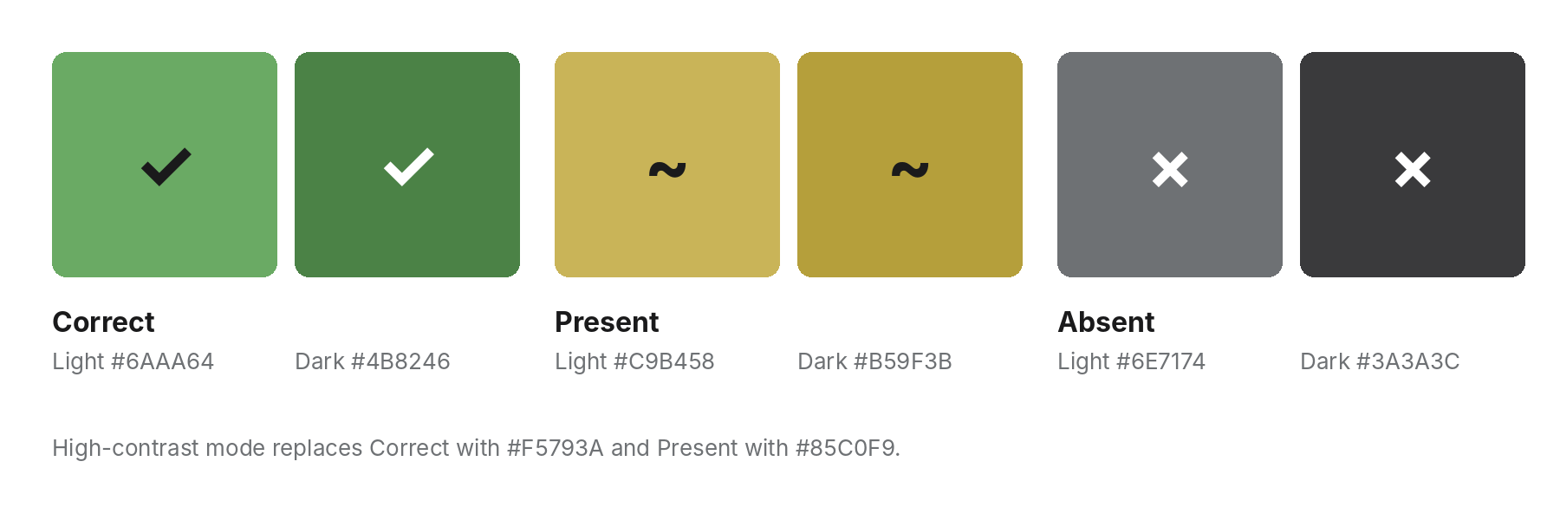
Tile colours, light and dark, with their state glyphs
Light theme
Correct  #6AAA64 | Present  #C9B458 | Absent  #6E7174 | Ink  #1A1A1B | Surface  #F6F7F8 | Border  #D3D6DA

Dark theme
Correct  #4B8246 | Present  #B59F3B | Absent  #3A3A3C | Page  #121213 | Surface  #1E1E20 | Text  #F8F8F8

High-contrast option (either theme)
Correct  #F5793A | Present  #85C0F9

Colour tokens
Token | Light | Dark | Use | Contrast (WCAG)
color.bg | #FFFFFF | #121213 | Page background | —
color.surface | #F6F7F8 | #1E1E20 | Chips, cards, selected rows | —
color.text | #1A1A1B | #F8F8F8 | Body and headings | 17.39 / 17.63 on bg
color.textMuted | #6E7174 | #818384 | Labels, meta, captions | 4.91 / 4.92 on bg
color.border | #D3D6DA | #3A3A3C | Dividers, empty tiles, inputs | —
color.borderStrong | #878A8C | #565758 | Focused input, outline buttons | —
color.correct | #6AAA64 | #4B8246 | Correct tiles, primary button | Text on it: 6.25 (ink) / 4.58 (white)
color.present | #C9B458 | #B59F3B | Present tiles | Text on it: 8.41 / 6.61 (ink)
color.absent | #6E7174 | #3A3A3C | Absent tiles, inactive bars | Text on it: 4.91 / 11.35 (white)
color.onCorrect | #1A1A1B | #FFFFFF | Text on correct
color.onPresent | #1A1A1B | #1A1A1B | Text on present
color.onAbsent | #FFFFFF | #FFFFFF | Text on absent
color.hc.correct | #F5793A | #F5793A | High-contrast correct | Ink on it: 6.36
color.hc.present | #85C0F9 | #85C0F9 | High-contrast present | Ink on it: 9.03
color.focus | #1A1A1B | #F8F8F8 | 2 px focus ring, 2 px offset

Contrast ratios were calculated with the WCAG 2.x relative-luminance formula.

3.2 Typography
Two typefaces, both under the SIL Open Font License and on Google Fonts. Inter sets everything functional. Lora, a contemporary serif, sets only the names of foods, screen titles and big numbers on the answer card: the one place the game should feel like a menu.
Style | Font | Size / line height | Weight | Use
display | Lora | 30 / 36 | SemiBold 600 | Answer name, onboarding headline
title | Lora | 24 / 30 | SemiBold 600 | Screen titles (Statistics, Leaderboard)
headline | Inter | 17 / 24 | Bold 700 | Section heads, card titles
body | Inter | 15 / 22 | Regular 400 | Paragraphs, input text
guessName | Inter | 13.5 / 18 | Bold 700 | Guess name above each row
tile | Inter | 13 / 16 | Bold 700 | Tile value
tileSub | Inter | 10 / 12 | SemiBold 600 | Second line in a tile (distance, "shared")
chip | Inter | 13 / 16 | SemiBold 600 | Clue chips
label | Inter | 11 / 14, +0.6 tracking, caps | Bold 700 | Column heads, section labels
meta | Inter | 12 / 16 | Regular 400 | Puzzle number line, captions
stat | Inter | 30 / 34, tabular figures | Bold 700 | Numbers on the stats sheet
button | Inter | 16 / 20 | Bold 700 | All buttons

Limits that the layout must hold: the longest item name is "Steamed Fish with Ginger and Scallion" (37 characters) and the longest clue is "grilled minced meat fingers" (27 characters). Guess names wrap to two lines at most; clue chips never truncate and wrap to the next line instead. Text must scale with the system font size up to 200%.

3.3 Spacing, radius and elevation
Token | Value | Use
space.1 … space.8 | 4, 8, 12, 16, 20, 24, 32, 40 | 4-point scale for all padding and gaps
space.gutter | 16 (phone), 24 (tablet), 32 (desktop) | Page side margin
space.tileGap | 6 | Between tiles in a row
radius.tile | 4 | Tiles
radius.button | 10 | Buttons, inputs (8)
radius.chip | 16 (full) | Clue chips, pills, segmented control
radius.sheet | 20 | Top corners of bottom sheets and modals
elevation.0 | none | Everything on the page
elevation.1 | 0 8 24 rgba(0,0,0,0.12) | Autocomplete list, popovers
elevation.2 | 0 16 48 rgba(0,0,0,0.20) + 45% scrim | Sheets and modals

3.4 Grid and breakpoints
Breakpoint | Width | Layout
compact | < 600 px | Single column, full width minus 16 px gutters. Board width = screen − 32.
medium | 600 – 1023 px | Single column, board fixed at 520 px, centred. Side panels open as sheets.
expanded | ≥ 1024 px | Three columns: left rail 260 px (modes, edition), centre board 520 px, right rail 300 px (streak, friends). Max page width 1440 px.

Tile size follows the board: tile width = (board width − 4 × 6) ÷ 5, fixed height 46 pt. At 390 pt screen width a tile is 66.8 × 46 pt; at 520 px it is 99.2 × 46 px. Touch targets are never smaller than 44 × 44 pt on iOS and 48 × 48 dp on Android.

3.5 Wordmark, icon and iconography
The wordmark is the word FOODLE set in six tiles: green, yellow, grey, green, yellow, green, Inter ExtraBold capitals at 58% of tile size, 3 pt radius, gap of 14% of tile size. It is the only logo. The app icon is a single green tile with an ink "F", 1024 × 1024, no transparency.
Icons come from Lucide (ISC licence), available as lucide-react-native and lucide-react: menu, circle-help, bar-chart-3, settings, share-2, archive, trophy, users, x, chevron-left. Stroke 2, size 22 in the top bar, 20 elsewhere, colour color.text.

4. Components
Each component is built once in the shared UI package and rendered natively on iOS and Android and as HTML on the web.
Component | Anatomy and states | Size (pt / px) | Tokens
Tile | Value (13 bold), optional sub-line (10), corner glyph (8.5). States: empty (2 px border), correct, present, absent, revealing (mid-flip). | W = board, H 46, radius 4 | color.correct/present/absent, color.on*
FeedbackRow | Guess name (1 line, max 2) above five tiles; cuisine modes use 4 or 2 tiles, same total width. | Row height 74 incl. name | type.guessName
EmptyRow | Dashed 1 px outline, height 46, one per unused guess. | 6 rows total | color.border
ClueChip | Number (11 bold, muted) + clue text (13 semibold). Locked: dashed outline with number only. | H 32, pad 13, radius 16, gap 8 | color.surface, color.border
ClueStrip | Label "CLUES" + "k of n"; chips wrap. New chip animates in on reveal. | Full board width | type.label
GuessInput | Field + "Guess" button pinned above the keyboard. Placeholder "Type a dish…" / "Type a drink…" / "Type a country…". | H 48, button 84 wide | color.borderStrong on focus
Autocomplete | Opens after 1 character. Max 5 rows: name left, "Country · Course" right. Matches name and aliases, ignoring case, accents and punctuation; prefix matches rank above infix. Keyboard: ↑ ↓ Enter Esc. | Row H 44 | elevation.1
Button | Primary: green fill, ink text. Secondary: 1.5 px strong outline. Ghost: text only. Disabled: 40% opacity. | H 52 (48 in rows), radius 10 | color.correct, color.onCorrect
SegmentedControl | Mode switch (Dish / Drink / Cuisine) and edition switch. Selected segment raised on page colour. | H 34, radius 17 | color.surface
ModeCard (desktop rail) | Mode name, edition, status pill (Not started, In progress = yellow, Solved in n = green, Missed = grey). | H 64, radius 10
AnswerCard | Photo 4:5, status pill + verdict word, name (display), aliases and origin (meta), ingredient pills, Share, See stats, countdown, photo credit. | Scrolls on small screens | type.display
BottomSheet / Modal | Sheet on phones, centred 480 px modal on desktop. Handle bar 40 × 5. Close on scrim tap, swipe down or Esc. | Radius 20 | elevation.2
Toast | Ink background, white text, top of board, 2 s. | H 40, radius 8
StatTile | Number (stat) over label (meta). | 4 per row | type.stat
DistributionBar | Guess number, bar with count at its end. Today's result in green, others in grey. Min width 26. | H 22
LeaderboardRow | Rank, avatar (initial on surface; you = yellow), name, result line, six mini squares, time. Your row on surface. | H 64
Avatar | Circle with first initial; no photos in v1. | 34 / 32 | color.border
Countdown | "Next Foodle in hh:mm:ss", updates each second. |  | type.meta
ShareCard | 1080 × 1350 image: wordmark, number and edition, "Solved in n of 6", tile grid, mode and streak, URL. | Rendered off-screen

5. Screens

5.1 Screen inventory and routes
Screen | App route (expo-router) | Web route (Next.js) | Notes
Onboarding | /welcome | — (How to play modal) | First launch only; three cards
Play | /[edition]/[mode] | /[edition]/[mode] | edition = global | india; mode = dish | drink | cuisine. "/" redirects to the last mode played
Answer card | Part of Play | Part of Play | Replaces the board when the puzzle ends
Statistics | /stats (sheet) | /stats (modal over Play) | Tabs per mode
Leaderboard | /leaderboard | /leaderboard | Friends | Groups | Global
Friends and groups | /friends, /groups/[id] | /friends, /groups/[id] | Requires sign-in
Invite | /invite/[code] | /invite/[code] | Deep link; adds friend or joins group after sign-in
Archive | /archive, /archive/[edition]/[mode]/[no] | Same | Calendar list of past numbers
How to play | /help (sheet) | /help (modal) | Same content as onboarding
Settings | /settings | /settings | Theme, high contrast, edition default, reduced motion, account
Sign in | /signin | /signin | Email magic link, Apple, Google. Play never requires an account

5.2 Onboarding and play
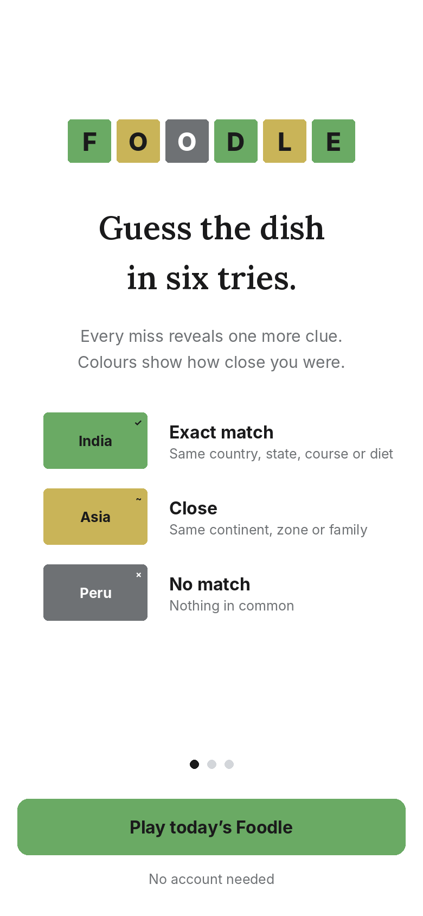  Onboarding, card 1 of 3 | 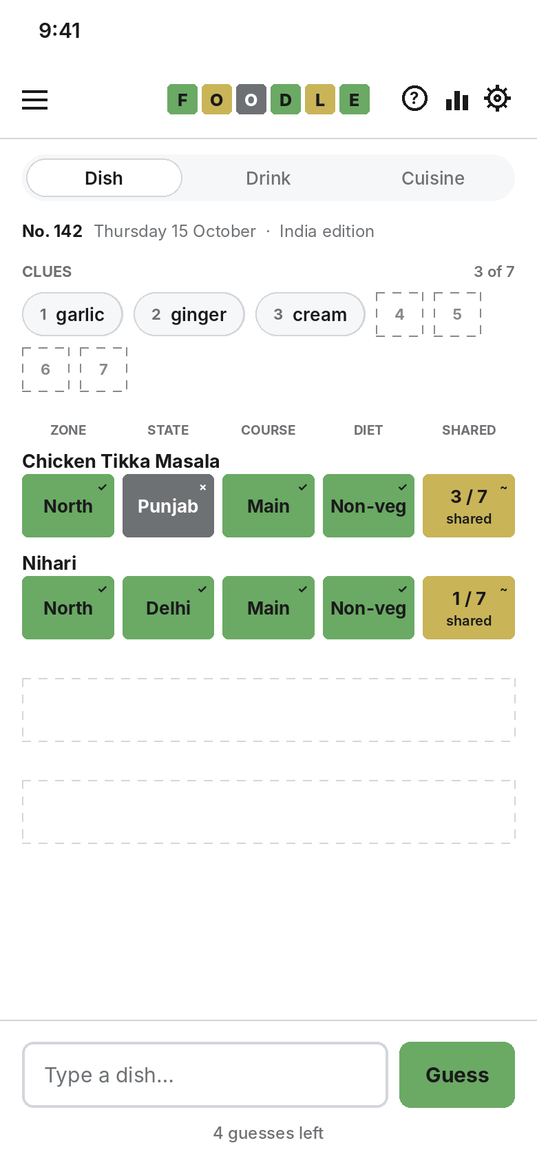  Play: India edition, two guesses in

- Onboarding cards: (1) "Guess the dish in six tries" with the colour legend; (2) "Each miss reveals a clue" with an animated clue strip; (3) "Pick your edition" with Global / India buttons. Skippable from card 1.
- Play, top to bottom: top bar (menu, wordmark, help, stats, settings) · mode switch · puzzle line (number, date, edition) · clue strip · column heads · six rows · input pinned to the bottom.
- In the example the answer is Butter Chicken (Delhi). Chicken Tikka Masala (Punjab) shares the North zone, course and diet, and 3 of 7 ingredients (garlic, cream, tomato). Nihari (Delhi) matches zone and state and shares 1 ingredient (ginger).

5.3 Autocomplete and dark theme
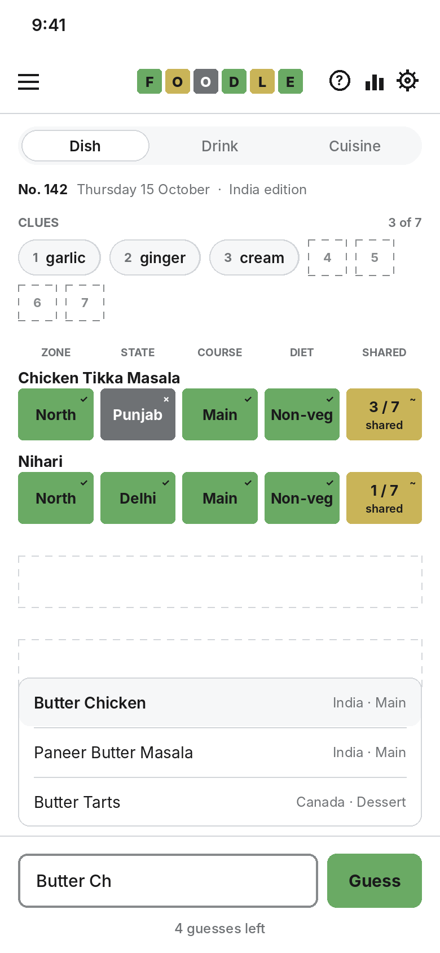  Autocomplete open above the input | 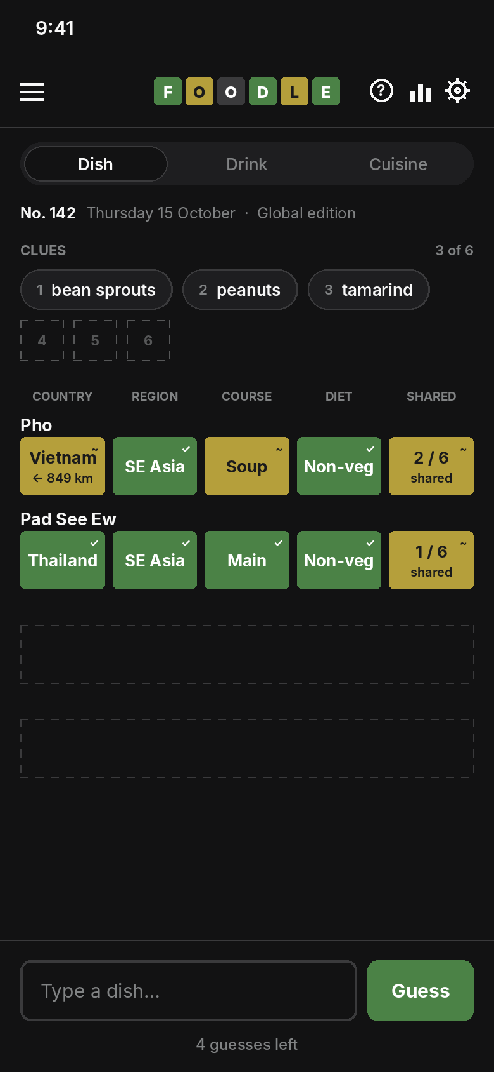  Dark theme: Global edition, answer Pad Thai

- Autocomplete sits above the input, so it stays visible over the phone keyboard. The first row is pre-selected; Enter or tapping a row submits.
- Dark example: Pho is yellow on Country (same continent) with "← 849 km", green on Region (both South-Eastern Asia) and yellow on Course (Soup and Main are both in Mains). Pad See Ew matches everything but the dish; it shares 1 of 6 ingredients (egg).

5.4 Answer and statistics
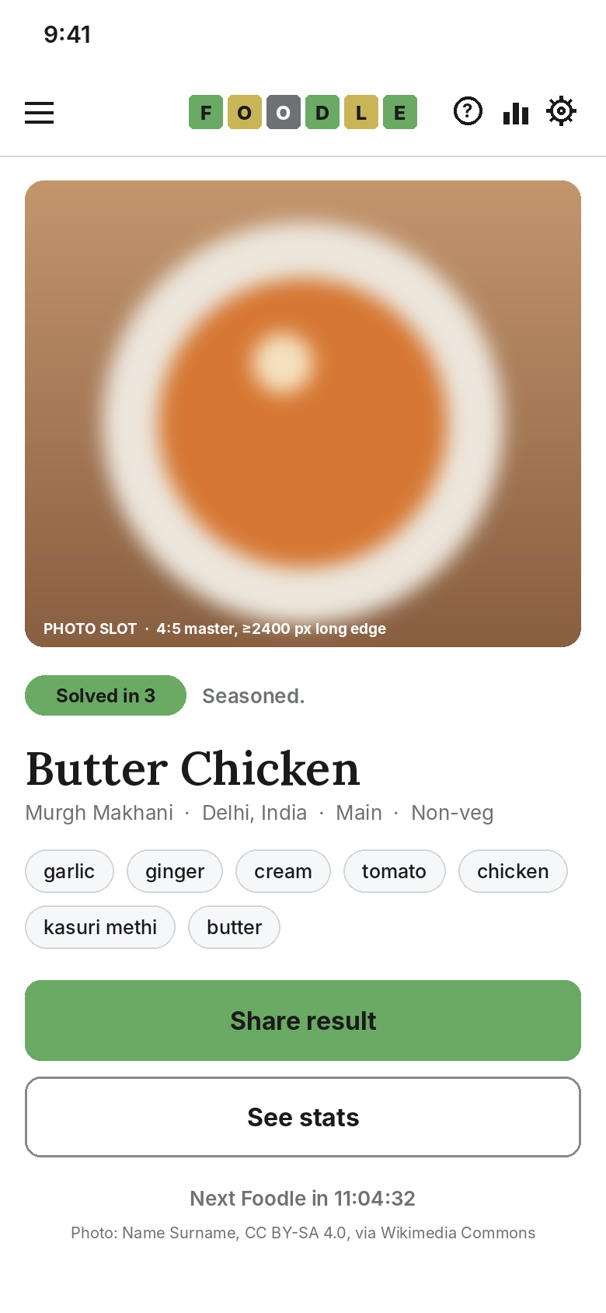  Answer card after a win | 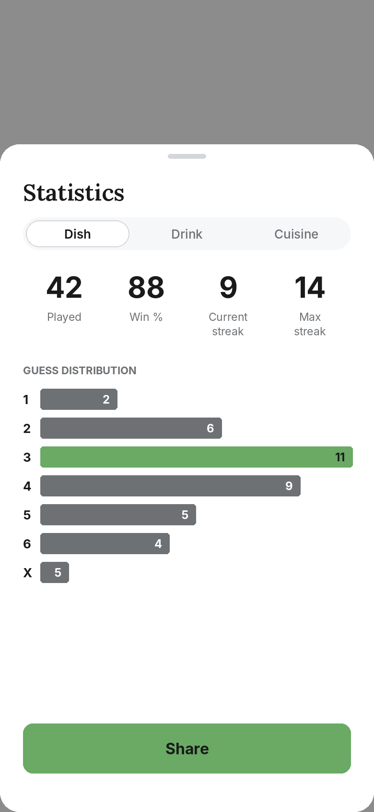  Statistics sheet

- Verdict words by guess count: 1 Chef's kiss, 2 Michelin, 3 Seasoned, 4 Well done, 5 Medium rare, 6 Just plated. Miss: Back to the kitchen.
- Statistics per mode and edition: Played, Win %, Current streak, Max streak, and guess distribution 1–6 plus X. The bar for today's result is green.

5.5 Leaderboard and share card
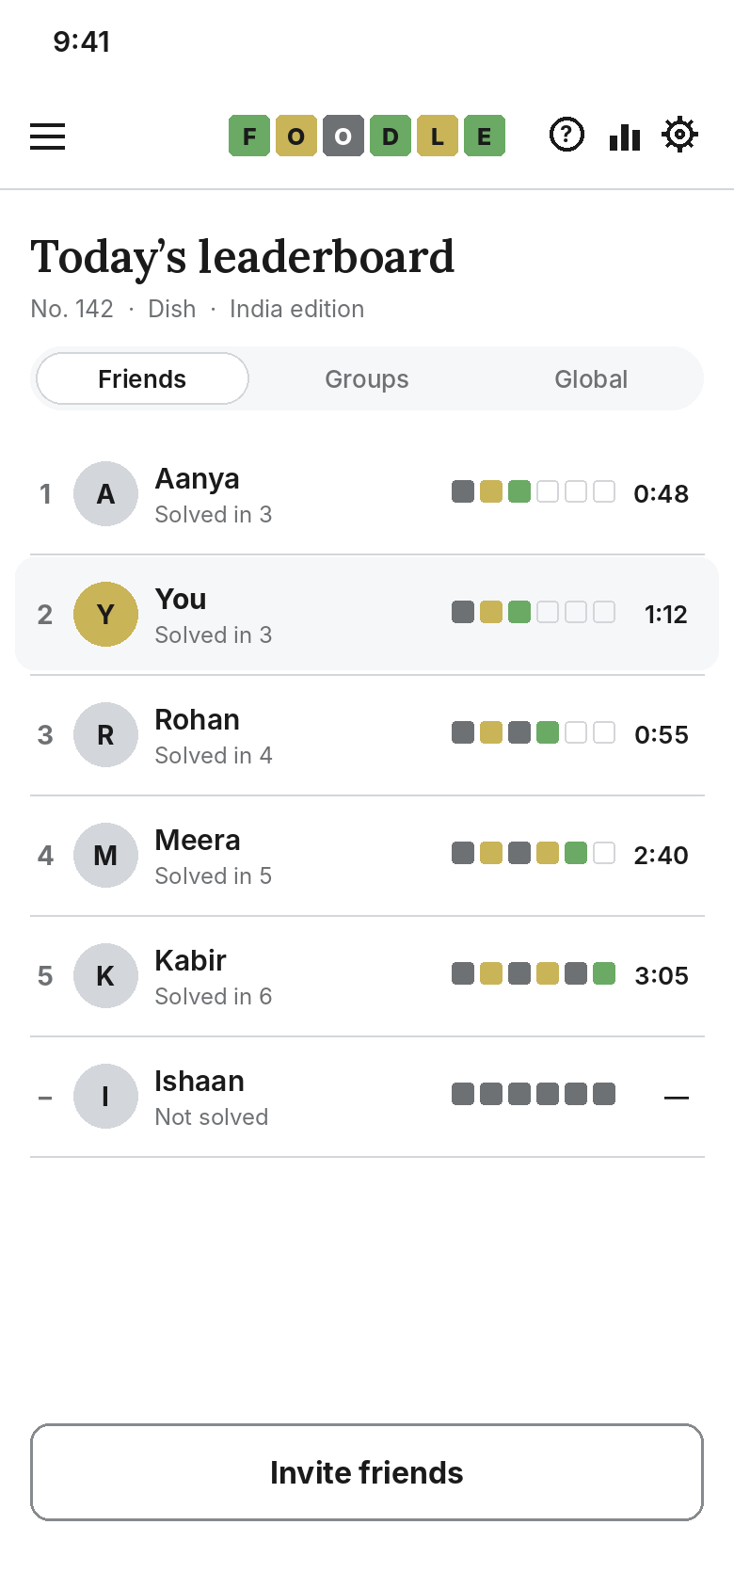  Friends leaderboard | 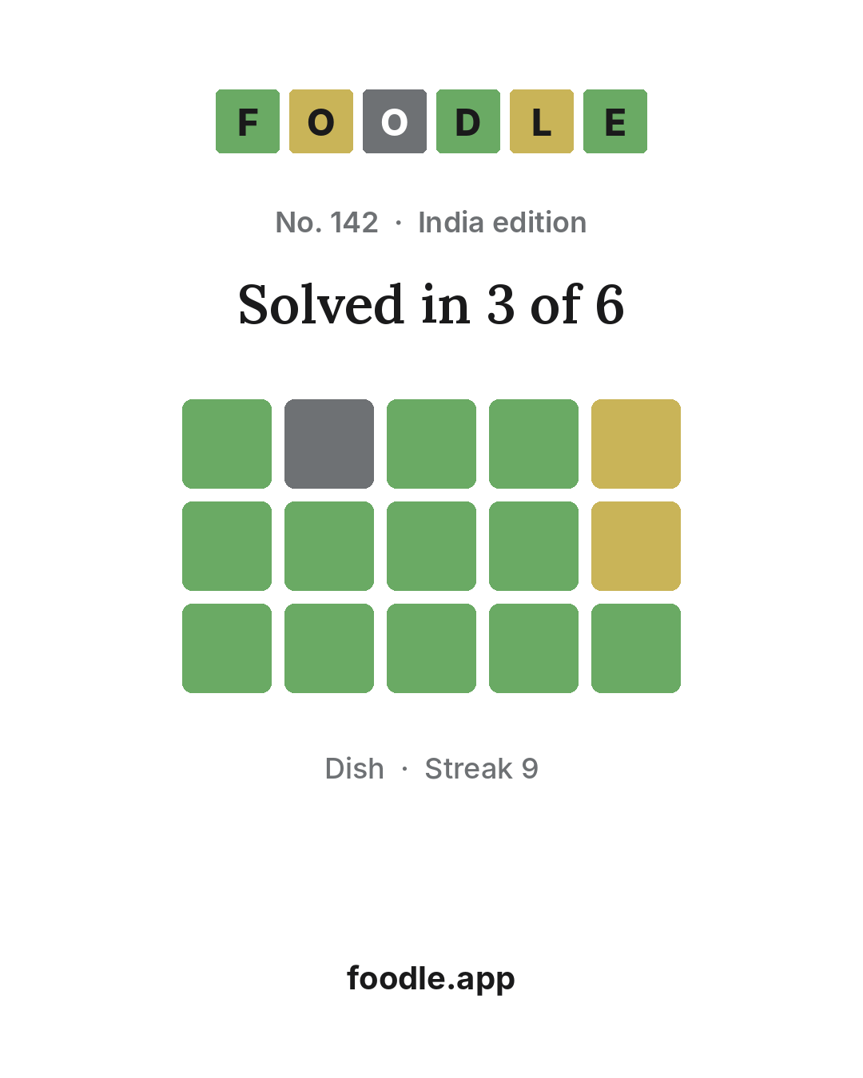  Share image (1080 × 1350)

5.6 Desktop
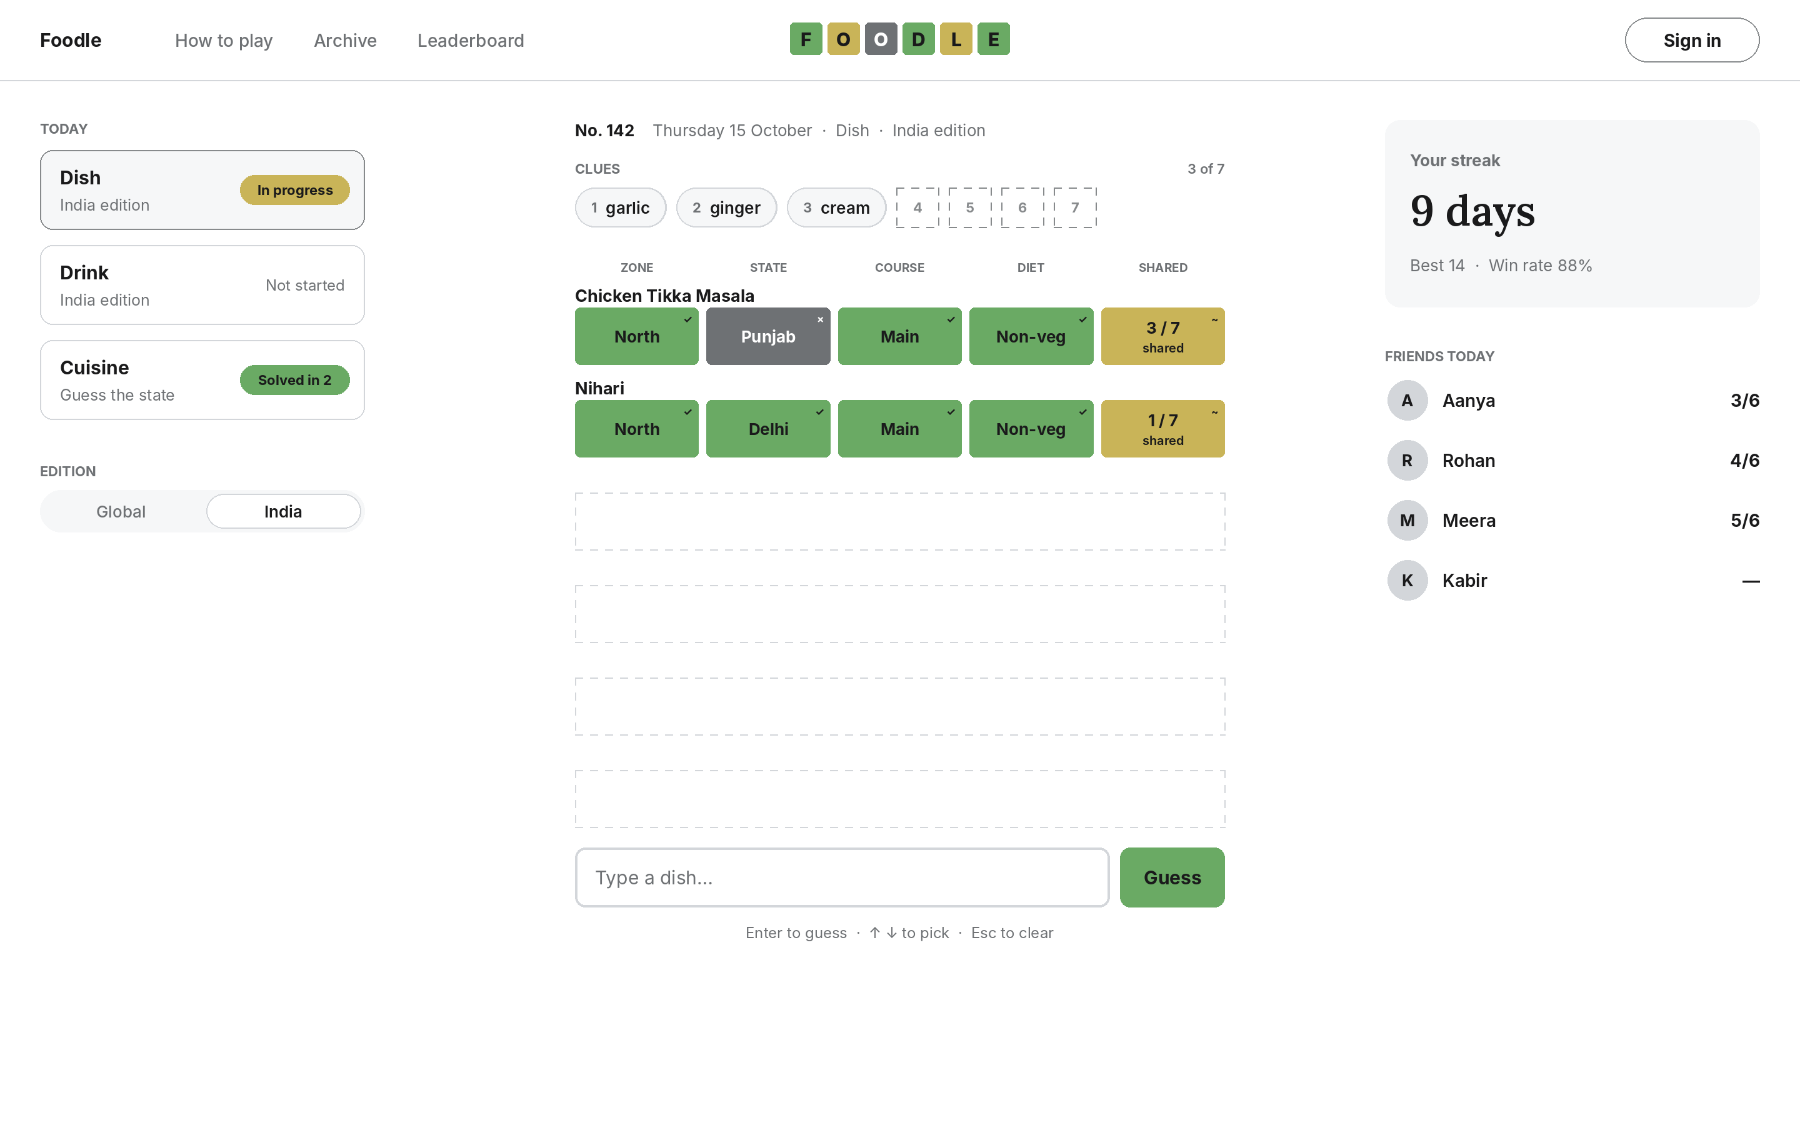
Website at 1440 px: modes on the left, board in the centre, streak and friends on the right
- On desktop the input sits directly under the last row, not at the bottom of the window. A hint line lists the keyboard controls.

6. App and web
One codebase per surface, one shared core. Behaviour that the platform does better is used natively.
Concern | iOS / Android (Expo) | Web (Next.js)
Navigation | Stack + drawer (menu icon). Sheets for stats and help. | Top nav on ≥ 1024 px; drawer below that. Modals for stats and help.
Input | System keyboard; input pinned with KeyboardAvoidingView. | Physical keyboard: type, ↑ ↓, Enter, Esc. Autofocus on load.
Share | Native share sheet: text + share-card image. | Web Share API where supported; otherwise copy text to clipboard and show "Copied".
Haptics | Yes (section 7). | None.
Storage (guest) | Local game state and stats in device storage; migrated on sign-in. | Same, in localStorage; migrated on sign-in.
Auth | Apple, Google, email magic link. | Google, Apple, email magic link.
Deep links | foodle://invite/[code]; universal and app links for the web URL. | Same paths over HTTPS.
Rendering | Native views; images via expo-image with blurhash placeholder. | Server-rendered shell, client board; next/image with blur placeholder.
Offline | Board shows "You're offline" and keeps state; guesses need a connection. | Same.
Install | App Store, Google Play. | Responsive site with a web app manifest (installable).

7. Motion and haptics
Event | Animation | Duration / easing | Haptic (app)
Guess submitted | Tiles flip on X axis left to right; colour applies at 90° | 300 ms each, 120 ms stagger, ease-in-out | Light impact on submit
Clue revealed | New chip fades in and rises 6 pt | 200 ms ease-out, after the last tile lands | None
Invalid guess | Input shakes horizontally ±6 pt, three cycles | 450 ms | Error notification
Win | Winning row tiles bounce up 8 pt in sequence | 100 ms per tile | Success notification
Loss | Board fades to 40%, answer card rises | 250 ms ease-out | Warning notification
Sheet open / close | Slide from bottom; scrim fades | 280 ms spring (damping 24) / 200 ms | None
Mode switch | Board cross-fades | 150 ms | Selection
Reduced motion on | All of the above become 150 ms fades; no flips, shakes or bounces | 150 ms | Unchanged

App animations run on the UI thread with react-native-reanimated. Web animations use CSS transitions and keyframes, with prefers-reduced-motion respected.

8. Accessibility
- Target. WCAG 2.2 level AA on web; the same contrast and target rules on the apps.
- Colour. Every tile carries a glyph (✓ ~ ×). High-contrast mode swaps green and yellow for orange and blue, as Wordle does. Share text uses 🟧 and 🟦 in that mode.
- Screen readers. Each tile has a label such as "Country: Vietnam, close, 849 kilometres west". Each row is announced as a whole after it flips. New clues are announced: "Clue 4 of 7: tomato".
- Text size. All text scales with system settings up to 200%. At large sizes tiles grow in height and the sub-line drops below the value.
- Focus. Visible 2 px focus ring on every interactive element on web; logical focus order: mode switch, clue strip, board, input.
- Targets. At least 44 × 44 pt (iOS) and 48 × 48 dp (Android); 24 × 24 CSS px minimum on web per WCAG 2.2, with 44 used in practice.
- Time. No timer pressure. Leaderboard time is recorded but never shown during play.

9. Photography
Every dish and drink gets one photograph, shown only after the puzzle ends. Photos are what people screenshot, so the standard is strict.

9.1 Image standard
Attribute | Requirement
Resolution | Master at least 2,400 px on the long edge; 3,000 px or more preferred. Anything smaller is rejected.
Sharpness | Food in sharp focus at 100% zoom; no motion blur, no heavy noise in the shadows, no upscaling.
Subject | The dish as it is classically served, clearly identifiable, filling 55–75% of the frame. One dish per photo.
Light and colour | Natural or soft light, neutral white balance, no colour filters. Converted to sRGB.
Background | Plain and uncluttered: table, plate, stone, wood or linen. No text, menus, logos, watermarks or packaging.
People | No recognisable faces. Hands are acceptable if they do not dominate.
Angle | Top-down for flat dishes, bowls and thalis; 30–45° for tall or layered dishes and drinks in glasses.
Authenticity | Real photographs only. No AI-generated images.
Crops | Three crops per master: 4:5 (answer card), 1:1 (thumbnails, share image), 16:9 (web header, link previews). A focal point (x, y) is stored per image for automatic cropping.
Delivery | AVIF with WebP and JPEG fallback, widths 320, 640, 960, 1280, 1920, 2560. Blurhash stored for the loading placeholder. EXIF removed except copyright.

9.2 Sources and licences
Source | Access | Licence terms that apply | Credit shown
Wikimedia Commons (primary) | Public API, no key | Set per file: public domain, CC0, CC BY or CC BY-SA are accepted | Author, licence and "via Wikimedia Commons" for CC BY / BY-SA
Pexels (secondary) | API, free key | Pexels licence: free to use, including commercially; credit not required | "Photo: Name / Pexels" (courtesy)
Unsplash (secondary) | API, free key | Unsplash licence: free commercial use, credit not required; excludes compiling images to replicate a similar or competing service | "Photo: Name / Unsplash" (courtesy)

Rejected licences: any non-commercial (NC), no-derivatives (ND), "fair use" or unknown licence. CC BY-SA images can be cropped and resized; under share-alike, the edited image keeps the CC BY-SA licence. The credit line sits under the photo on the answer card in type.meta.

9.3 Sourcing pipeline
- Search: for each item, query Wikimedia Commons by the item's Wikipedia/Wikidata image and category first, then by name; then Pexels and Unsplash by name and aliases. Keep the top 5 candidates.
- Filter automatically: long edge ≥ 2,400 px, accepted licence, no watermark keywords in title or description.
- Pick by hand: a reviewer chooses one image per item against section 9.1, or marks "none" for a re-shoot or later search.
- Crop: set the focal point; generate 4:5, 1:1 and 16:9.
- Process: export the six widths in AVIF, WebP and JPEG; compute the blurhash.
- Publish: upload to object storage behind an image CDN; write url, width, height, licence, author, source URL, focal point and blurhash to the item record and to the Image columns of the repository workbook.
Scope: 911 dishes and 247 drinks (1,158 items). Ingredient images are not required for the game.

10. Onboarding, stats and streaks

10.1 First run
- No sign-up wall. A new player sees the three onboarding cards, then today's Dish puzzle in the chosen edition.
- After the first finished puzzle, one prompt: "Save your streak? Sign in to keep it on every device." Dismissible; shown again only after a 3-day streak.
- The help icon reopens the onboarding content at any time.

10.2 Statistics
Metric | Definition
Played | Daily puzzles finished (won or lost) in this mode and edition. Archive plays excluded.
Win % | Won ÷ Played, rounded to a whole number.
Current streak | Consecutive puzzle numbers won, ending today or yesterday. A missed or lost day resets it to 0.
Max streak | Longest current streak ever reached.
Guess distribution | Count of wins solved on guess 1 to 6, plus X for losses.
All-mode streak | Consecutive days on which at least one daily puzzle was won. Shown in the desktop rail and on the share card.

10.3 Archive
A list of past puzzle numbers by month for each mode and edition, each marked won, lost or unplayed. Replaying is unlimited and does not affect stats, streaks or leaderboards.

11. Social and leaderboards

11.1 Friends and groups
- Friends: added through a personal invite link or a 6-character code. Friendship is mutual and needs acceptance.
- Groups: a named group with an owner, up to 50 members, joined by link or code. A player can be in up to 10 groups. Owners can remove members and reset the code.
- Profiles: display name (2–20 characters, filtered for offensive words) and an initial avatar. No real name, photo or contact list access in v1.

11.2 Leaderboards
Scope | Who appears | Period
Friends | You and your friends | Today's puzzle, per mode and edition
Group | Members of one group | Today and this week (sum of points)
Global | All signed-in players | Today's top 100 plus your own rank

- Daily ranking: solved before unsolved; then fewer guesses; then shorter solve time (first view of the puzzle to the correct guess).
- Weekly group points: 7 − guesses for a win (6 for a first-guess win down to 1 for a sixth-guess win), 0 for a loss or no play.
- Mini squares in a leaderboard row: one per guess. Green = the correct guess; yellow = a guess with the right country (Global) or zone (India); grey = other.
- Only daily plays count. Results are accepted only from the server-validated guess flow (section 13.6), so a result cannot be posted without playing.

11.3 Sharing
Share text, one line per guess with the tile colours, then a link:
Foodle No. 142 · India · Dish 3/6
🟩⬜🟩🟩🟨
🟩🟩🟩🟩🟨
🟩🟩🟩🟩🟩
foodle.app/142

Loss shows "X/6". High-contrast mode uses 🟧 for green and 🟦 for yellow. The share card image (section 5.5) is attached on the apps and in browsers that support file sharing. The domain shown is a placeholder.

12. Voice and copy
Short, warm, kitchen-flavoured, never punny twice in one screen. Sentence case everywhere except the column labels.
Moment | Copy
Input placeholder | Type a dish… / Type a drink… / Type a country… / Type a state…
Not in list | Pick a dish from the list
Repeat guess | Already guessed
Offline | You're offline. Your board is saved.
Win verdicts (1–6) | Chef's kiss · Michelin · Seasoned · Well done · Medium rare · Just plated
Loss | Back to the kitchen. It was Butter Chicken.
Countdown | Next Foodle in 11:04:32
Streak at risk (in app only) | Your 9-day streak ends at midnight.
Sign-in prompt | Save your streak? Sign in to keep it on every device.
Empty friends | Foodle is better with friends. Share your invite link.
Copied | Copied to clipboard

13. Engineering handoff

13.1 Repository layout
foodle/ pnpm workspaces + Turborepo
├─ apps/mobile/ Expo (expo-router) – iOS & Android
├─ apps/web/ Next.js (App Router)
├─ packages/tokens/ tokens.json → CSS variables + TS constants
├─ packages/ui/ shared components (NativeWind on mobile, Tailwind on web)
├─ packages/game/ pure TypeScript: feedback rules, puzzle number, share text
├─ packages/content/ importer: repository workbook → database seed
└─ supabase/ migrations, row-level security, edge functions

13.2 Libraries
Need | Mobile (Expo) | Web (Next.js)
Routing | expo-router | App Router
Styling | NativeWind with the shared Tailwind preset | Tailwind CSS with the same preset
Fonts | @expo-google-fonts/inter, @expo-google-fonts/lora | next/font/google (Inter, Lora)
Icons | lucide-react-native + react-native-svg | lucide-react
Motion | react-native-reanimated | CSS transitions / keyframes
Haptics | expo-haptics | —
Images | expo-image (blurhash) | next/image
Share image | react-native-view-shot + React Native Share | @vercel/og or canvas, Web Share API
Backend | @supabase/supabase-js | @supabase/supabase-js, @supabase/ssr
Local state | zustand + AsyncStorage | zustand + localStorage

13.3 Design tokens
{
"color": {
"light": {
"bg": "#FFFFFF", "surface": "#F6F7F8", "text": "#1A1A1B", "textMuted": "#6E7174",
"border": "#D3D6DA", "borderStrong": "#878A8C",
"correct": "#6AAA64", "present": "#C9B458", "absent": "#6E7174",
"onCorrect": "#1A1A1B", "onPresent": "#1A1A1B", "onAbsent": "#FFFFFF"
},
"dark": {
"bg": "#121213", "surface": "#1E1E20", "text": "#F8F8F8", "textMuted": "#818384",
"border": "#3A3A3C", "borderStrong": "#565758",
"correct": "#4B8246", "present": "#B59F3B", "absent": "#3A3A3C",
"onCorrect": "#FFFFFF", "onPresent": "#1A1A1B", "onAbsent": "#FFFFFF"
},
"highContrast": {
"correct": "#F5793A", "present": "#85C0F9", "onCorrect": "#1A1A1B", "onPresent": "#1A1A1B"
}
},
"font": { "sans": "Inter", "serif": "Lora" },
"space": [0, 4, 8, 12, 16, 20, 24, 32, 40],
"radius": { "tile": 4, "input": 8, "button": 10, "chip": 16, "sheet": 20 },
"size": { "tileH": 46, "tileGap": 6, "boardMax": 520, "rowH": 74, "inputH": 48, "buttonH": 52 },
"motion": { "flip": 300, "stagger": 120, "reveal": 200, "shake": 450, "bounce": 100, "reduced": 150 }
}

13.4 Types
type Edition = "global" | "india"; type Mode = "dish" | "drink" | "cuisine";
type TileState = "correct" | "present" | "absent";
interface Item { id: string; kind: "dish" | "drink"; name: string; aliases: string[];
country: string; iso2: string; continent: string; subregion: string; state?: string; zone?: string;
course?: string; diet?: "Veg" | "Vegan" | "Egg" | "Non-veg"; type?: string; alcoholic?: boolean;
fame: 1 | 2 | 3; clues: string[]; ingredients: string[]; puzzleReady: boolean;
image?: { url: string; w: number; h: number; blurhash: string; focal: [number, number];
licence: string; author: string; sourceUrl: string } }
interface Tile { key: string; state: TileState; value: string; sub?: string; a11y: string }
interface GuessResult { guessId: string; tiles: Tile[]; correct: boolean;
nextClue?: string; finished: boolean; answer?: Item } // answer only when finished

13.5 Database (Supabase Postgres)
Table | Key columns | Client access (row-level security)
items | id, kind, name, aliases[], country, state, zone, course, diet, type, alcoholic, fame, puzzle_ready, image jsonb | Read all except clues and ingredients
item_clues | item_id, position, text, kind | None (served by edge function)
ingredients / item_ingredients | id, name, category / item_id, ingredient_id | None
countries | iso2, name, region, subregion, lat, lng, borders[] | Read
states | name, zone, lat, lng | Read
puzzles | number, mode, edition, item_id (or country / state), date | Read number and date only
plays | user_id, puzzle, guesses jsonb, clues_seen, won, started_at, finished_at | Own rows
profiles | user_id, display_name, created_at | Read all display names; write own
friendships | user_a, user_b, status | Own rows
groups / group_members | id, name, owner, code / group_id, user_id | Members read; owner writes
leaderboard_daily (view) | puzzle, user_id, won, guesses, solve_ms, rank | Read, filtered to friends / groups / global top 100

13.6 API (edge functions)
Endpoint | Input | Returns
GET /puzzle | mode, edition, date (local) | number, first clue, clue count, guess-list version
POST /guess | puzzle number, mode, edition, guess item id | GuessResult (13.4). Rejects unknown or repeated guesses
GET /guess-list | mode, edition, version | id, name, aliases, country, course or type (cached on device)
GET /leaderboard | scope, puzzle or week, group id | Ranked rows
POST /invite | kind (friend | group), id | Code and link

Guests play through the same endpoints with an anonymous session, so the answer never reaches the device early and results can be attached to an account later.

13.7 Feedback algorithm
function feedback(G, A, mode, edition): Tile[]
if mode == "cuisine": return cuisineTiles(G, A, edition)
tiles = []
if edition == "global":
tiles += tile("country", G.country == A.country ? correct : G.continent == A.continent ? present : absent,
G.country, G.country == A.country ? null : arrow(bearing(G, A)) + " " + km(haversine(G, A)))
tiles += tile("region", G.subregion == A.subregion ? correct : absent, short(G.subregion))
else:
tiles += tile("zone", G.zone == A.zone ? correct : absent, G.zone)
tiles += tile("state", G.state == A.state ? correct : absent, abbreviate(G.state))
if A.kind == "dish":
tiles += tile("course", G.course == A.course ? correct : fam(G.course) == fam(A.course) ? present : absent, G.course)
tiles += tile("diet", G.diet == A.diet ? correct : (meatFree(G) && meatFree(A)) ? present : absent, G.diet)
else:
tiles += tile("type", G.type == A.type ? correct : fam(G.type) == fam(A.type) ? present : absent, G.type)
tiles += tile("alcohol", G.alcoholic == A.alcoholic ? correct : absent, G.alcoholic ? "Alcoholic" : "Zero-proof")
k = |G.ingredients ∩ A.ingredients|; n = |A.ingredients|
tiles += tile("shared", G.id == A.id ? correct : k > 0 ? present : absent, k + " / " + n, "shared")
return tiles

13.8 Analytics events
Event | Properties
app_open | platform, edition default, signed_in
puzzle_view | mode, edition, number
guess_submit | mode, edition, number, guess_no, correct, via (tap | enter)
guess_rejected | reason (not_in_list | repeat)
clue_reveal | mode, edition, number, clue_no
puzzle_end | won, guesses, solve_ms
share | channel (native | clipboard | image), mode
onboarding_step | step, skipped
signin | method
invite_sent / invite_accepted | kind
archive_play | mode, edition, number

13.9 Performance budgets
- Web: Largest Contentful Paint under 2.0 s and Interaction to Next Paint under 200 ms on a mid-range Android phone over 4G; initial JavaScript under 150 KB gzipped.
- App: cold start to interactive board under 2 s on a mid-range Android phone; guess round trip under 300 ms at the 75th percentile.
- Answer photo: blurhash shown instantly; the 1280 px AVIF (typically under 250 KB) loads while the tiles flip.

13.10 Store and web assets
Asset | Size
iOS app icon | 1024 × 1024 PNG, no transparency
Android adaptive icon | 108 × 108 dp foreground and background layers
Google Play icon / feature graphic | 512 × 512 / 1024 × 500
Web favicon / Apple touch icon | 32 × 32 and SVG / 180 × 180
Web app manifest icons | 192 × 192 and 512 × 512 (maskable)
Link preview (Open Graph) | 1200 × 630
Share card | 1080 × 1350 (feed) and 1080 × 1920 (stories)
Store screenshots | Per current App Store Connect and Play Console size lists

14. Open items
- Photos: no images are attached yet. All free photo sources were blocked from the workspace where this document was prepared; the pipeline in section 9.3 is ready to run once access is open.
- State coordinates: the India cuisine mode needs a latitude and longitude for each state to show distance. The repository does not have them yet.
- Zone data: the zone mapping in section 2.5 is defined here and is not yet a column in the repository workbook.
- Content check: every repository row is still a draft awaiting an editorial fact check.
- Name: availability of "Foodle" as a domain, app store name and trademark has not been checked; other food-guessing games have used the name. The domain foodle.app in this document is a placeholder.
- Mockups are drawn to spec in this document; there is no Figma file yet.

