**1. PROJECT TITLE:**

Designing a Flexible Security and Privacy Model for Healthcare Data

**2. HARDWARE REQUIREMENTS**

OS-Windows 10

RAM-8GB

ROM-More than 100 GB

GPU-No

CPU-1.7 GHz

**3. SOFTWARE REQUIREMENTS**

Software name(**Python**): Version: 3.9.11

(Download link: <https://www.python.org/downloads/release/python-3911/>)

Click -> Windows installer (64-bit).

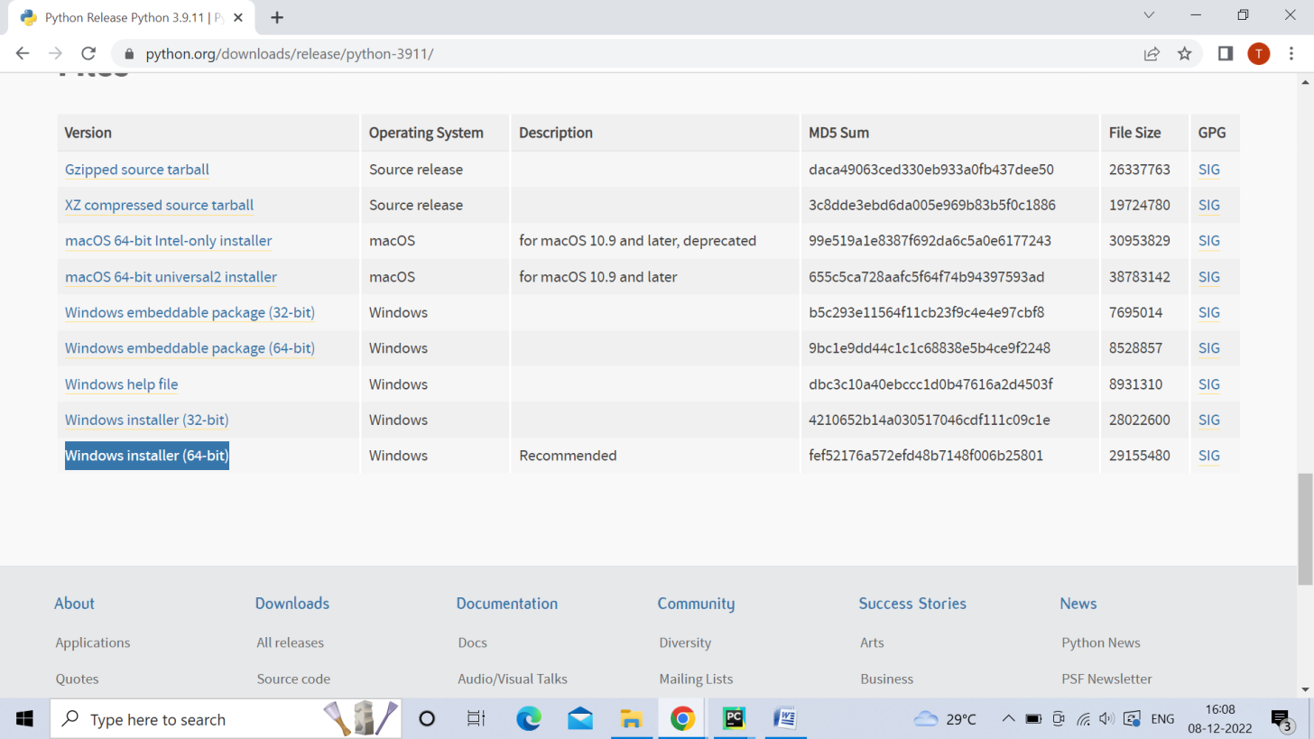

Software name: **PyCharm**: Version: 2020.3.3

(Download link: <https://www.jetbrains.com/pycharm/download/other.html>)

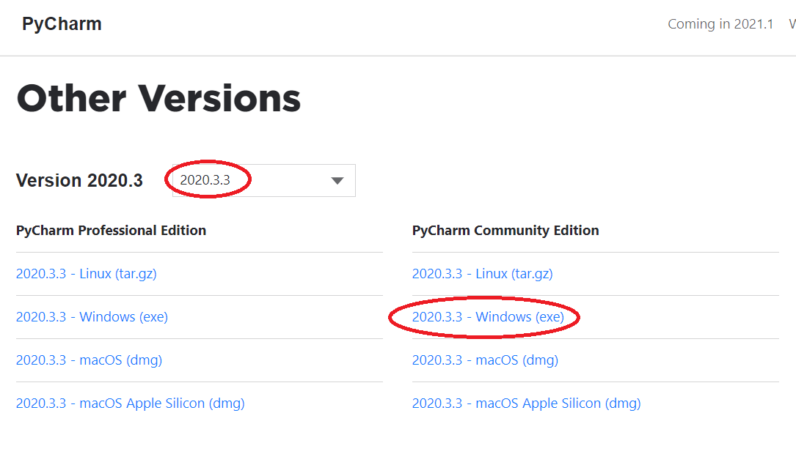

(For installation procedure, please refer the doc “steps to install python.doc”)

**4. HOW TO RUN**

**Step 1**: Loading the project in PYCHARM

* Open pycharm
* Go to File, select Open browse the project from your drive and select it. So that the project will get loaded into the Pycharm.
* For the first time, Pycharm will take some time to load the settings.
* Please wait if any process is loading on the bottom of the screen.
* Check the Project Interpreter (File -> Settings -> Project: **Subhadra Perumalla (39329) - Conference paper 3->code**-> Project Interpreter).

If this location “(C:\Users\---\AppData\Local\Programs\Python\Python39-64\python.exe) is not presented, then add this ‘python.exe’ from the installed location.

* In Pycharm Terminal(bottom left), type the comment “pip install -r requirements.txt”

**Step 2**: Run the program and getting the results

* From 'current project folder' window in pycharm, Open ‘**Harshika Mishra (292911)\Only_Implementation> Main.py**’ and click run button
* In GUI window,
* Give the user details(patient id ,age,etc….)

**5. IMPORTANT PYTHON FILE AND DESCRIPTION:**

**Main.py**: User Interface, code starts here

Enter the key size: it will be displayed in the terminal. the user need to enter the key size.

Data owner:

Then enter the user details.

Certificate_Authorities:

Defines the Certificate Authorities class responsible for key generation and sharing. It also contains methods for managing keys and communication with Attribute Authorities.

Blockchain:

Implements the Blockchain class for managing the blockchain data structure. It includes methods for adding blocks, transactions, proof of work, and hashing.

AttributeAuthority:

Represents the Attribute Authority responsible for participant verification, key sharing, and access control using ABE.

Data user:

Doctor, nurse retrieve the data through BC.