**ASSIGNMENT 19.1**

**PROBLEM STATEMENT:**

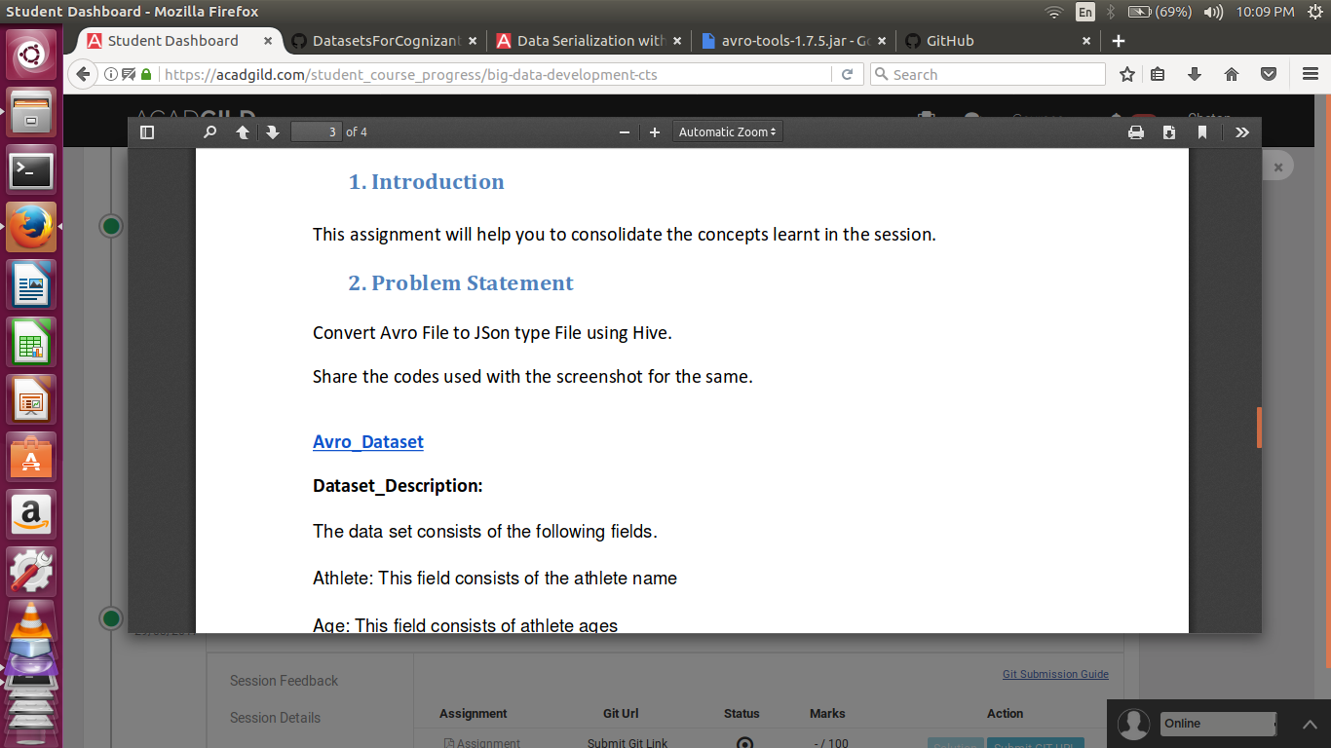

SOLUTION:

