**ASSIGNMENT 19.2**

**PROBLEM STATEMENT:**

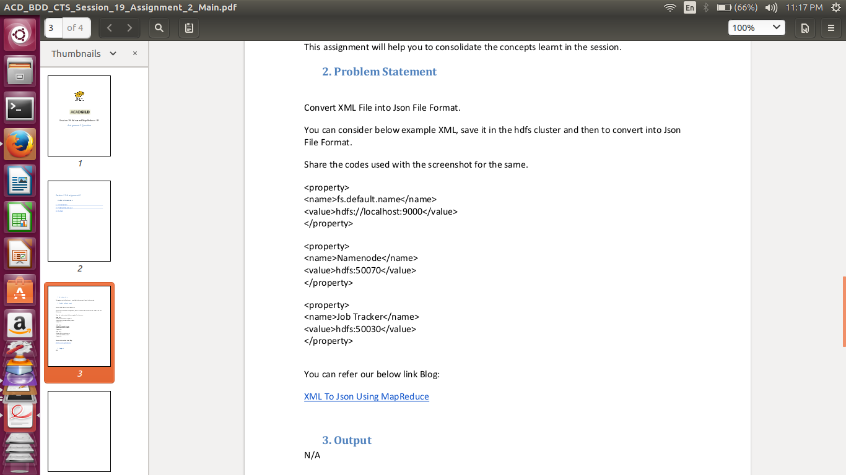

**PROGRAM:**

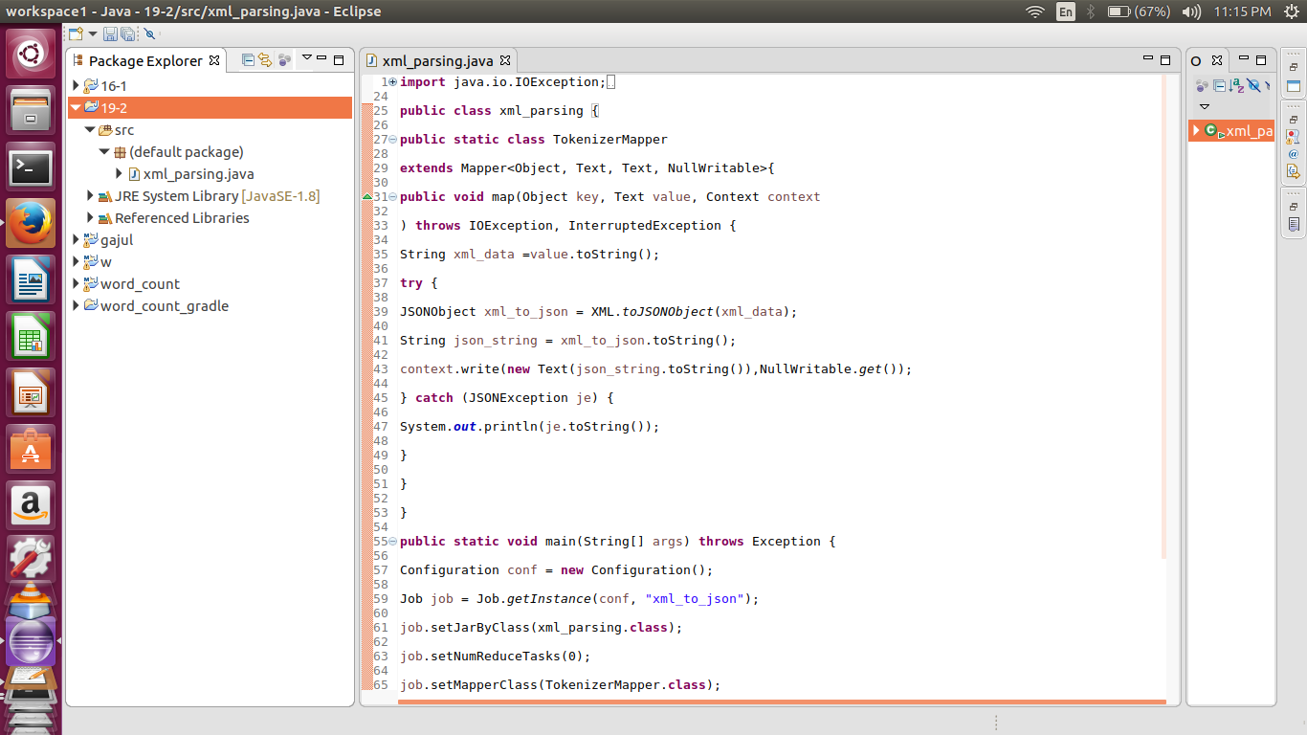

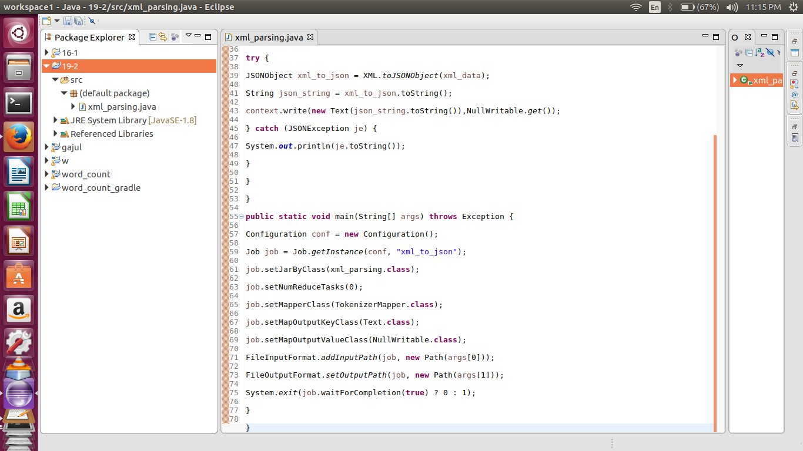

**EXECUTION COMMAND:**

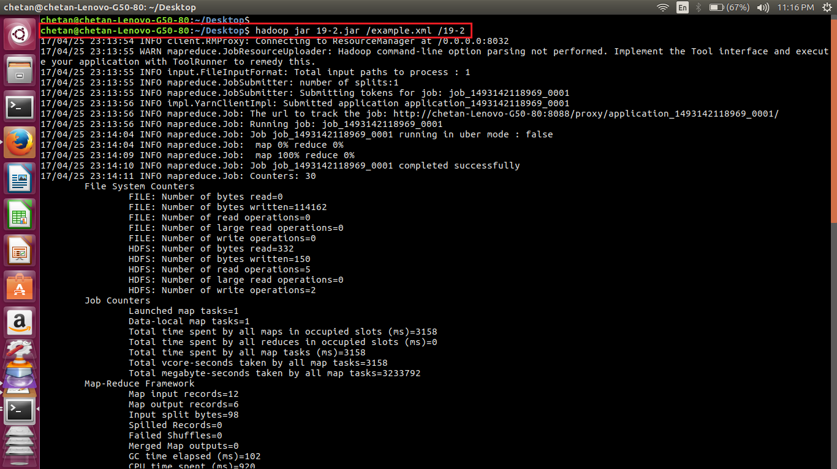

**OUTPUT:**

