**ASSIGNMENT 24.1**

**Explain with an example in brief.**

**● Hive Data Definitions**

**● Hive Data Manipulations**

**● HiveQL Manipulations**

**Solution:**

**Hive Data Definitions:**

Hive DDL commands are used to create, alter, drop databases and tables.

1. create database, drop database, show databases

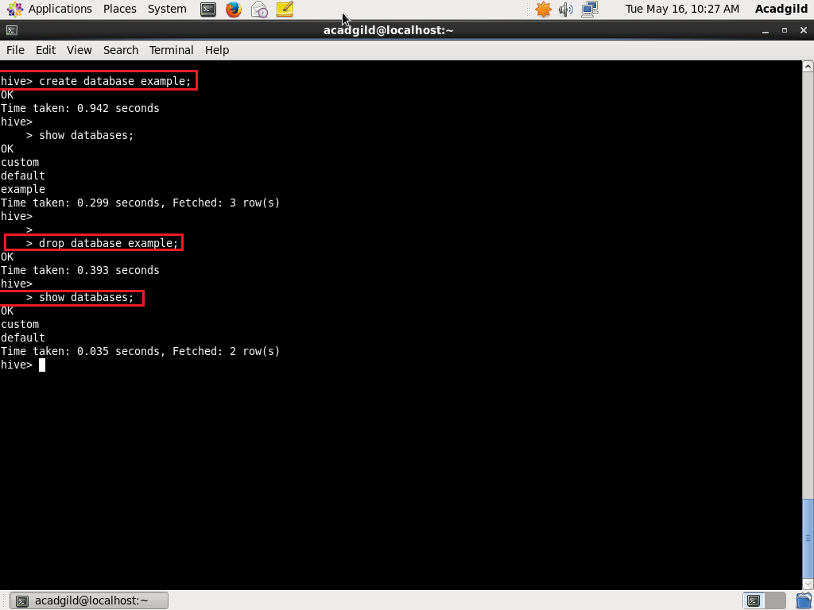

2. use database, create table , describe table

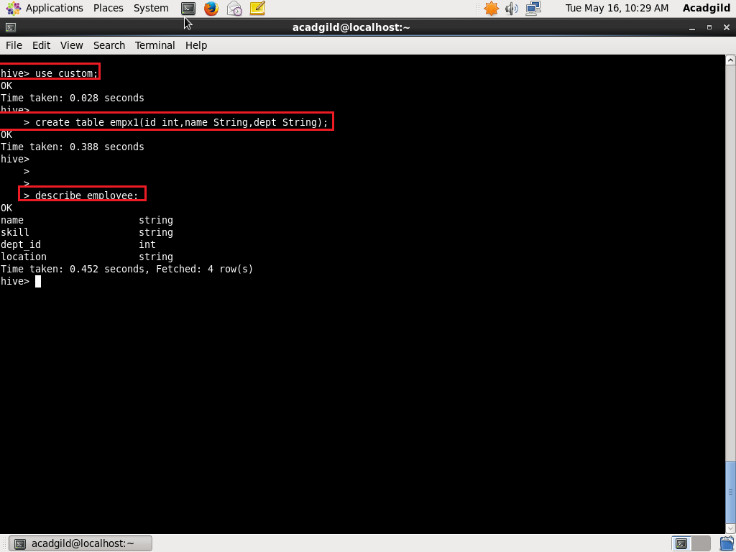

3. drop table

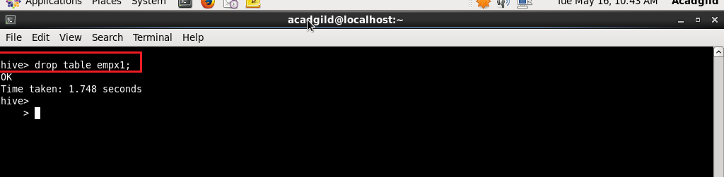

**Hive Data Manipulations:**

These commands are used to load, insert, update and delete data in the table.

1. load

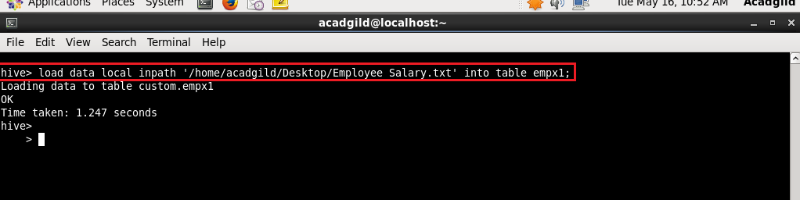

2. insert

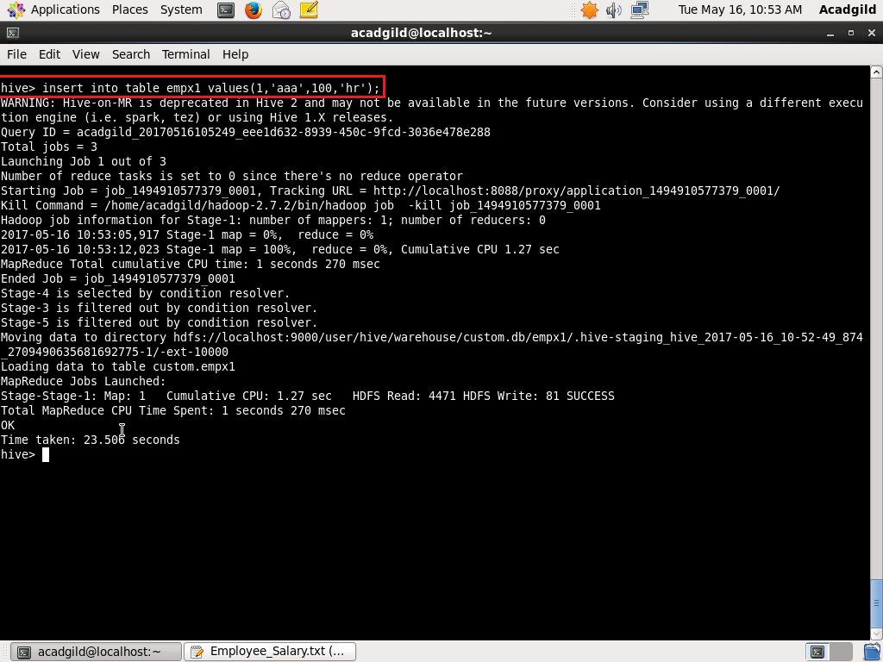

3. update

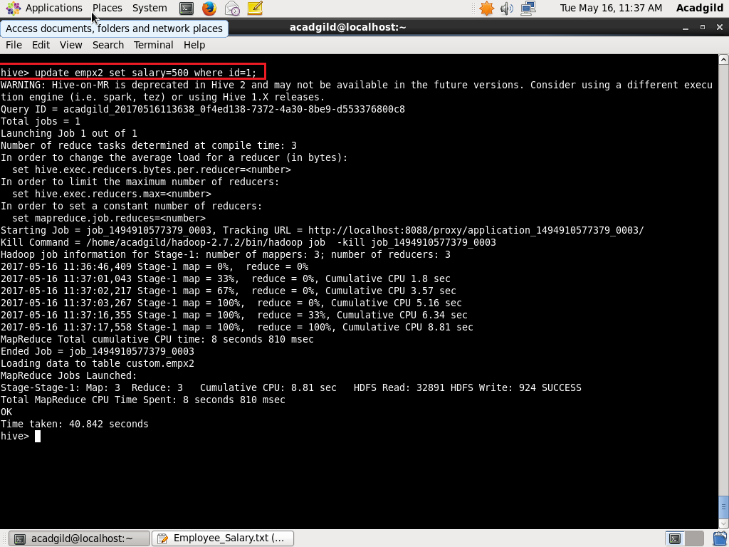

4. delete



**HiveQL Manipulations:**

The Hive Query Language (HiveQL) is a query language for Hive to process and analyze structured data in a Metastore.

SELECT statement is used to retrieve the data from a table. WHERE clause works similar to a condition. It filters the data using the condition and gives you a finite result. The built-in operators and functions generate an expression, which fulfils the condition.

1. select where

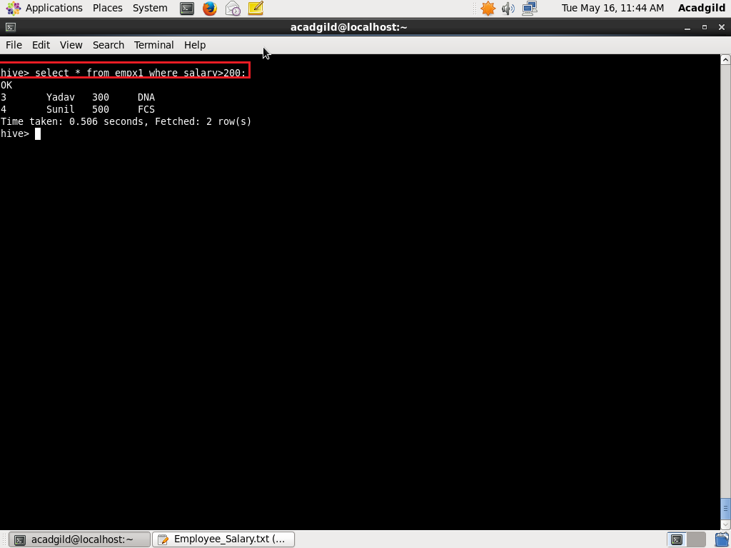

2. order by

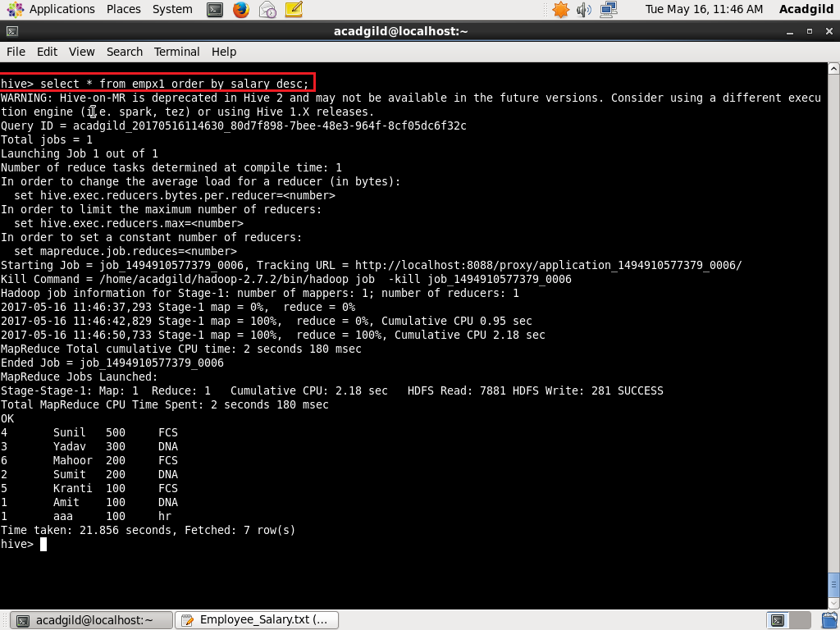

3. Group by

